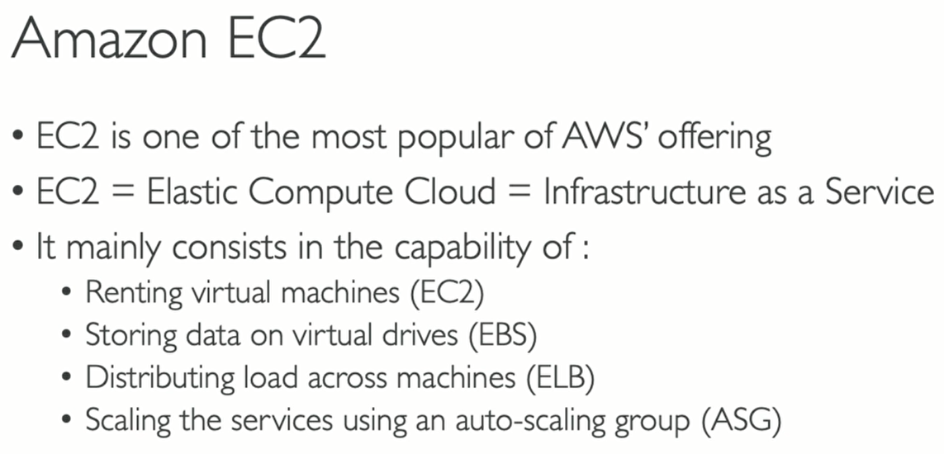



# EC2 User Data:

EC2 user data is a feature of Amazon EC2 instances that allows you to pass arbitrary data to an EC2 instance during launch. This data can be in the form of a script or other configuration information that is executed or processed by the instance as it starts up

The user data can be used for various purposes, such as:

* Configuring the instance or installing software packages.
* Running custom scripts or commands to set up the environment.
* Passing metadata or settings to an application running on the instance.

The user data is typically passed to the instance using the EC2 metadata service, which makes it available to the instance through a special URL. Once the instance is launched, the user data is executed or processed by the instance's operating system as specified.

