GitLab is source code management system just like Github, but unlike github It has a CI/CD pipeline.

**Git vs GitLab:**

Git keeps track of changes of a source code files in a codebase.

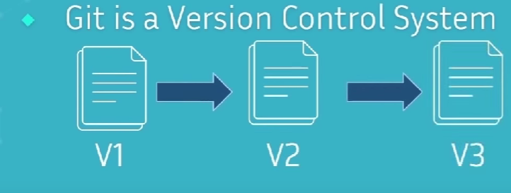

GitLab hosts the git repositories.

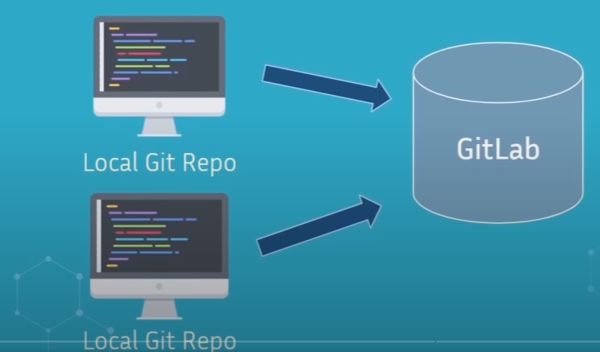

Basic Git Commands:

* **git init:** this will initiate the git in current folder.
* **git status**: this will check the current status of the repository, it gives information about what branch, commits and untracked file area. If files are red in untracked file area, it is not in staging area, just in the working directory. But if its green its in the staging area.
* **Git add** <file name>: add a file from working directory to stage area
* **Git rm –cached <**file name**>:** remove a file from the staging area.
* **Git commit -m** <message>**:** Commits the files from staging area to the git repo. Message is a concise metadata for the changes made. So, if later someone comes and check the commits, they will know what was done.
* **Git log:** Shows all commit
* **Git branch my-feature:**