**JDBC (Java Database Connectivity)**: JDBC is a Java API to connect and execute the query with the database.

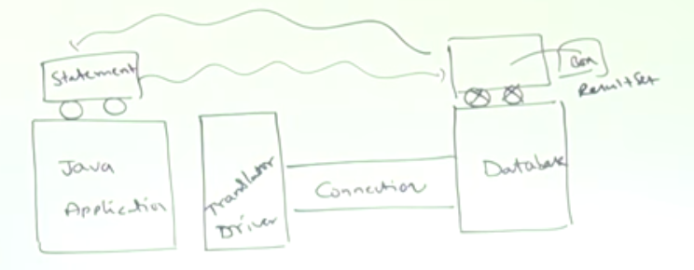

**Driver:** It converts database and java specific calls into each other.

**Connection:** It is the session between application and database.

**Statement:** This object sends our SQL query to database and bring back the result.

**Resultset:** After getting the result of the SQL query, java places the result in the resultset object.

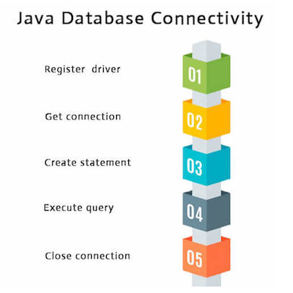 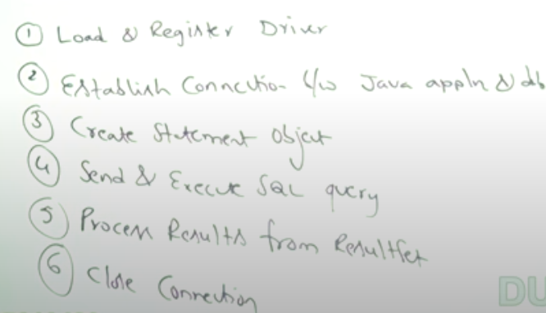

* We can exclude the **close connection** step by using the **try-with-resource** (which automatically close the connection)

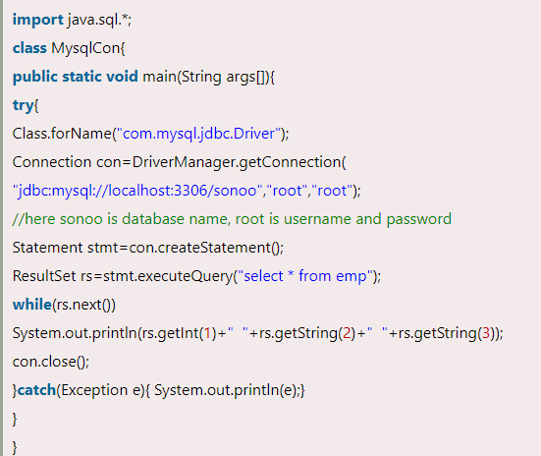 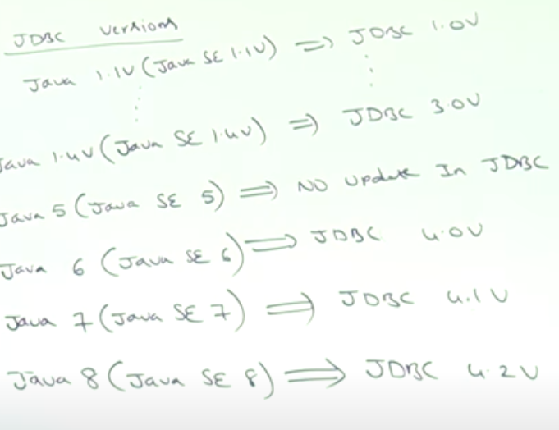

* Difference between ODBC (open database connectivity) and JDBC:
  1. ODBC can be used for any language, JDBC is used for only java language
  2. ODBC is window platform only, JDBC is platform independent.
  3. ODBC drivers are developed mostly in native languages like C/C++ etc. JDBC drivers are developed in java language.
  4. ODBC isn’t recommended for java application because performance issues due to internal conversion and application becomes platform independent.
* Java is Database independent language. Because the driver class takes care of the database related calls and terminology, the driver is database dependent but java itself is not.

