High-Precision AV Stimulation Manual

High-Precision Audio-Visual Stimulus Presentation with PTB: Hardware–Software–Algorithm Manual
Beginner-friendly edition · Distilled from long-running measurements on several rigs. Goal: make the interval between “the computer says go” and “the participant really sees/hears it” short, stable, and audio-visually aligned.

0. The core idea in one paragraph
MEG resolves milliseconds. Before each stimulus we send a square wave (Trigger) to the sync acquisition circuit and treat its rising edge as “stimulus onset”.
But in reality:
sequenceDiagram
participant P as Stimulus program (PTB)
participant T as Trigger Box / serial
participant D as Display / sound card / earphone
participant S as Participant (eye/ear)
participant N as NI acquisition card
P->>T: IOPort Write(255)
T->>N: square-wave rising edge (t0)
P->>D: Flip frame / Start audio
D->>S: light/sound truly arrives (t1)
S->>N: photodiode / microphone records t1
Note over T,N: delay = t1 - t0; must be measured and compensated
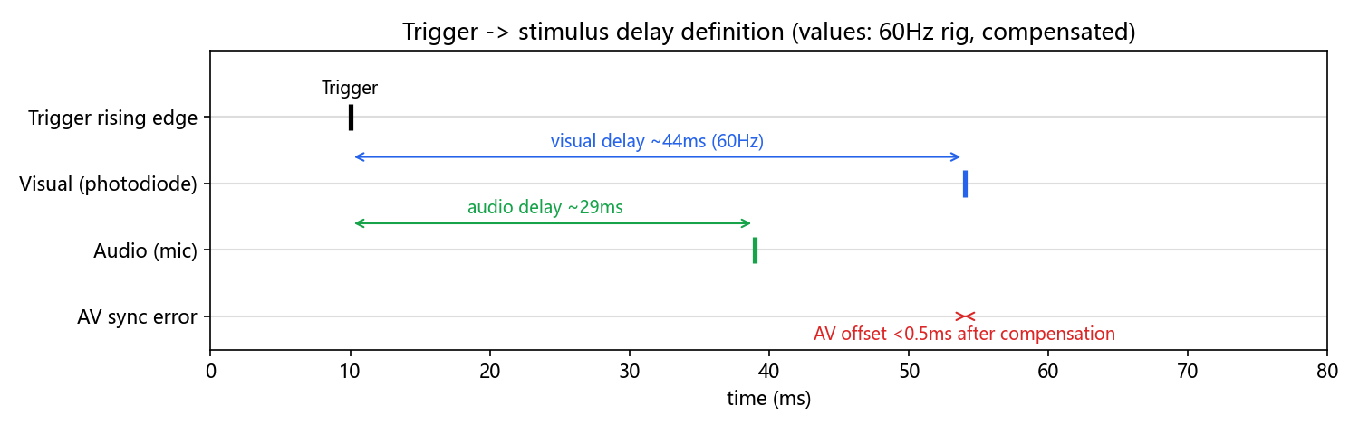
Delay definition
- Delay = physical arrival − Trigger rising edge. Tens of ms is normal.
- Jitter = delay wobbling trial to trial. That is the killer. Averaging needs jitter <1 ms; AV alignment needs <0.5 ms.
- Everything in this manual exists to push jitter below 1 ms while keeping absolute delay small and compensable.
Representative results (measured):
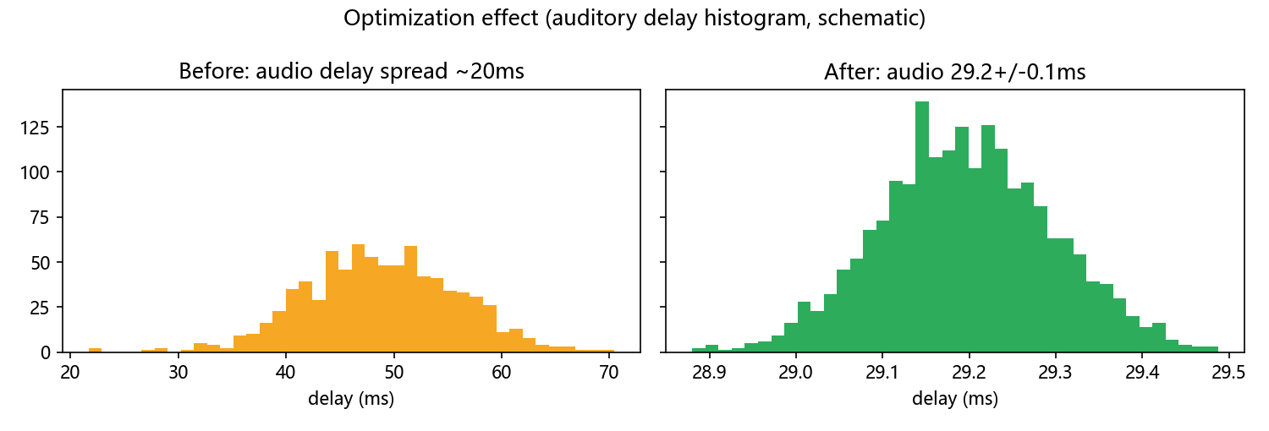
Jitter before vs after
Condition | Visual delay | Auditory delay | AV offset | Verdict
Starting point (Win + defaults) | 47 ms ±1 ms | 49 ms ±20 ms | — | audio unusable
Optimized 60 Hz (Ubuntu + AMD) | 44–69 ms ±0.1–0.4 ms | 29.2 ms ±0.1 ms | ±0.2 ms | passes, ready for experiments
144 Hz high-refresh | ~19→12→8 ms ±0.2 ms | ~21 ms ±0.1 ms | ±0.1 ms | faster = smaller
240 Hz (AOC panel / Optoma projector) | ~5.6 ms ±0.05 ms | — | — | full-speed B/W alternation limit
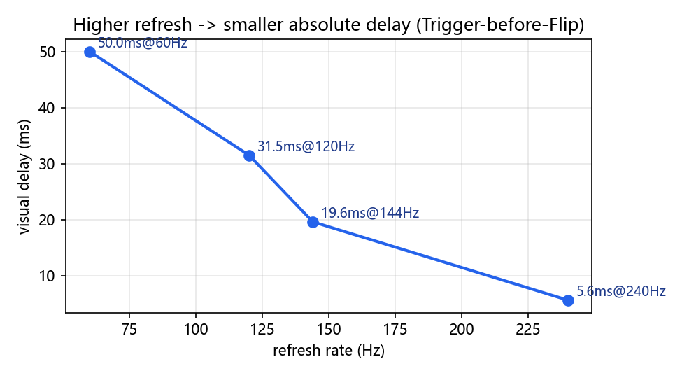
Higher refresh, smaller delay
These delays are essentially one screen refresh, because the trigger is sent before the flip. Send the trigger after the flip and the delay no longer tracks the refresh rate. The reason is in §4.

1. Hardware: what to buy and how to wire it

1.1 Don’t confuse the two systems
flowchart LR
subgraph A[Stimulation system]
PC[Desktop PC + discrete AMD GPU]
PROJ[Projector / high-refresh screen]
HP[Earphone / air tube]
TB[Trigger Box<br/>serial]
PC --> PROJ
PC --> HP
PC -->|/dev/ttyUSB0| TB
end
subgraph B[Calibration rig - only for delay measurement]
PD[Photodiode on white patch]
MIC[Microphone at earphone outlet]
NI[NI cDAQ9171<br/>10 kHz 3-channel sync]
PD --> NI
MIC --> NI
TB --> NI
end
PROJ -.light.-> PD
HP -.sound.-> MIC
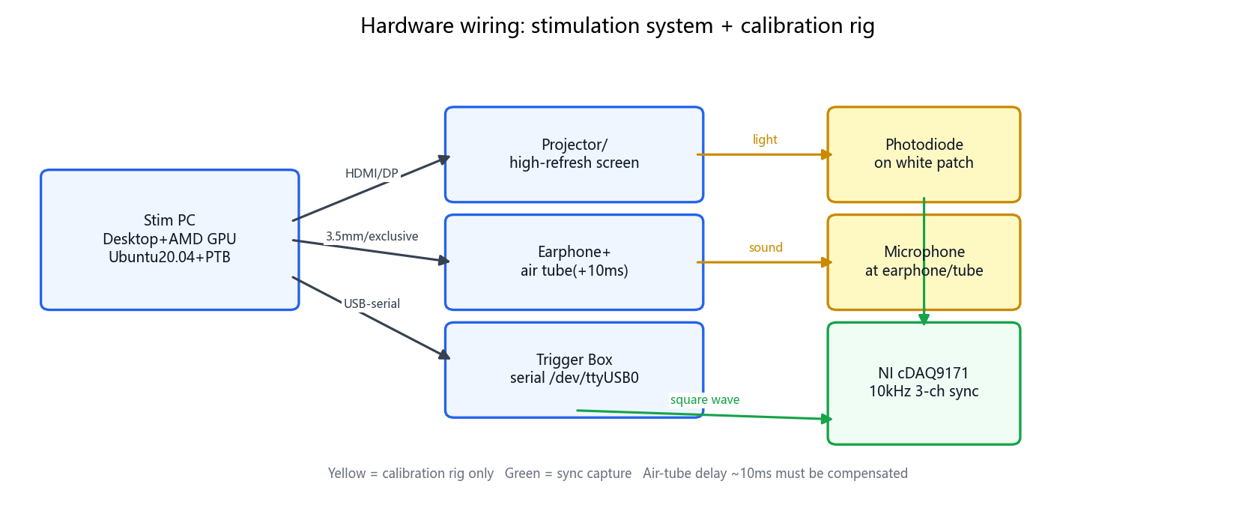
Hardware wiring overview
Real photos (from 实验记录2024_11.docx, Fig. 1) — left: microphone fixed at the earphone / air-tube outlet to record sound; right: photodiode fixed on the white patch of the screen to record light. Both plus the Trigger square wave go into the NI cDAQ9171 (10 kHz, 3 channels in sync):
Microphone mounting | Photodiode mounting
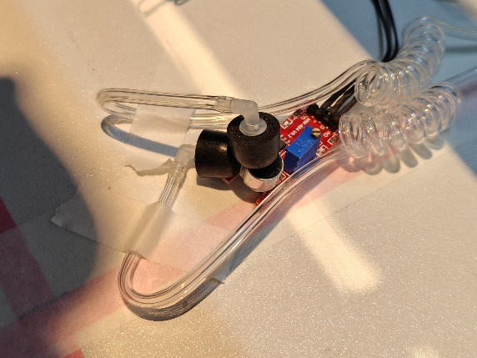 | 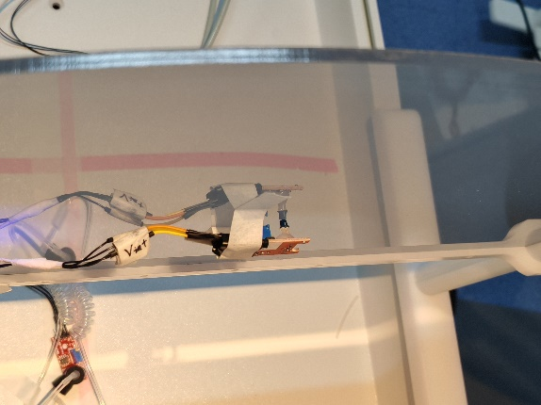
Photo checklist: mic capsule faces the sound outlet (move it to the adapter-box outlet when using an air tube); photodiode face sits flush on the white patch with black tape blocking stray light; tape all cables down — one wiggle = one outlier.
- Stimulus PC: must be a desktop + discrete GPU, preferably an older AMD card (e.g. RX 5700 XT, released before 2020, so the stock Ubuntu driver still supports it). Reason: PTB works best with open-source drivers (amdgpu/mesa); Nvidia proprietary drivers, hybrid laptop graphics and Intel iGPUs all raise sync errors.
- Display: a plain 60 Hz projector works; high-refresh screens/projectors (144/240 Hz) give smaller absolute delay. Keep all screens at the same resolution, otherwise PTB sync degrades.
- Audio: an air tube into the shielded room adds ~10 ms acoustic delay — compensate it. The sound card must be exclusively owned by PTB (see the code in §4).
- Trigger: USB-to-serial to the Trigger Box. On Ubuntu it is /dev/ttyUSB0; add your user to the dialout group.
- Calibration rig (only connected during characterization, not every session): photodiode + microphone + NI card recording Trigger/Sound/Light at 10 kHz. The light sensor bandwidth is ~1.75 kHz (0.2 ms fall time) — plenty; low SNR is fixed by filtering (§5).
Beginner traps: no laptops for real sessions; a mirrored screen image breaks up during fast black–white flicker; cheap esports panels flash at random and throw outliers. AOC panels and the ViewSonic projector were stable in these measurements; some no-name and CFORCE panels were not.

2. Software: the one worry-free combo
flowchart TD
U[Ubuntu 20.04.6 LTS] --> K[linux-lowlatency kernel]
K --> M[MATLAB 2020b / Octave]
M --> P[PTB 3.0.21 unzip + setuppsychtoolbox]
U --> G[Full GStreamer stack]
U --> X[XOrg + Wayland disabled<br/>XOrgConfCreator for screens]
P --> C[PsychLinuxConfiguration<br/>Priority elevation]
- Pin Ubuntu 20.04: after 22.04 the desktop moved from XOrg toward Wayland. When I last surveyed this (about two years ago) PTB had not followed that move; it may be under development now. The bugs were real either way (the well-known 24.04 “click the top-right corner to restore pageflipping” bug; 25.04 dual-screen looks fine but PTB sync can still fail). 20.04 + the stock open-source driver is the combination that stayed stable.
- Key switches:
  - Disable Secure Boot in BIOS; WaylandEnable=false in /etc/gdm3/custom.conf; launch with plain matlab, never sudo matlab.
  - sudo apt install linux-lowlatency.
  - Install the full GStreamer set per the official guide (needed for video stimuli).
  - Don’t apt-install PTB (too slow) — download the zip, unzip to a normal folder (not inside the MATLAB toolbox), cd there and run SetupPsychtoolbox, then PsychLinuxConfiguration.
- GPU driver: with AMD just use the stock open-source driver; don’t chase proprietary ones. If you insist on Nvidia, blacklist nouveau and install the .run from tty with gdm3 stopped — but expect worse sync than AMD.

3. Display configuration: Single vs Multi screens, explained once
Mode | How | Pros | Cons
Single screen | XOrgConfCreator merges projector + monitor into one big screen, Screen('OpenWindow',0) fullscreen | best sync, exact refresh | all screens must share one resolution; drawing X must be offset by half a screen; refresh is dragged down by the slowest panel
Multi X-Screen | each output is its own Screen (Screen 0/1/2) | per-screen refresh (e.g. main 60 + stim 144) | slightly worse timing, needs ScreenToHead to pick the sync reference
% Single-screen exclusive + sync source (middle numbers are found by trial; DP3 often gives 3)
Screen('Preference','ScreenToHead',0,1,3,0);
Screen('Preference','SkipSyncTests',0); % 0 = run the sync check; only pass counts
[window, rect] = Screen('OpenWindow', 0, black); % fullscreen, covers every other GUI
HideCursor; % must come AFTER OpenWindow
- Toolchain: with no Conf file, set resolution/refresh in the desktop Display panel → generate with XOrgConfCreator in MATLAB → pick with XOrgConfSelector. If it breaks, just delete the new Conf under /etc/X11/xorg.conf.d/ and reboot.
- Can’t see the extended screen’s modes? Query per screen: xrandr --screen 2; set rate e.g. xrandr --screen 2 --output HDMI-2 --mode 2560x1440 --rate 144.
- Done = SkipSyncTests=0 passes with no Synchronization Failure/Trouble and no didn't use pageflipping. On 24.04, if pageflip is reported, click the desktop’s top-right/notification area once and rerun (a confirmed GNOME bug).

4. Core algorithm: seven PTB rules to memorize
These are what survived thousands of measured trials. Breaking one of them can push jitter back to ±5 ms, or to ±50 ms.
- Desktop + discrete AMD GPU + Ubuntu + MATLAB/Octave. No Nvidia proprietary driver, no laptop iGPU, no Windows for a real session (Windows, at its best, still wandered by about 2 ms, and SyncTest was a coin toss).
- Exclusive sound card, smallest buffer: handle=PsychPortAudio('Open',[],1,3,sf,2,1). The 3 is latency class 3 (lowest-latency exclusive mode). Set the buffer size to 1; PTB raises it to the device minimum (often 14). Classes 1, 2 and 4 were all tried. Only 3 held the jitter inside 1 ms. Class 1 split into two delay clusters 10 ms apart, which is the card’s high output latency.
- One screen owns the GPU, and every screen uses the same resolution and refresh (§3). Offset drawing in X by half a screen.
- Schedule the audio. Lock the picture to a frame. PTB’s clock is fine. It wanders only when you never tell it when to run. Audio can start as soon as the waveform is in the buffer, so pick a time that is in the future — far enough ahead that the buffer is already filled — and start there: PsychPortAudio('Start', pahandle, 1, tonset+delay, 0). tonset is an anchor you chose; delay is the wait that makes the start reliable.
- Audio only, no picture. Two ways to place the anchor. Preferred:
- PsychPortAudio('FillBuffer', pahandle, [myBeep; myBeep]);
[nwritten, tonset] = IOPort('Write', handle, uint8(255)); % trigger, and take the anchor
PsychPortAudio('Start', handle, 1, tonset+0.015, 0); % 15 ms later, buffer filled, time fixed
- The other way:
- PsychPortAudio('FillBuffer', pahandle, [myBeep; myBeep]);
tonset = GetSecs;
PsychPortAudio('Start', handle, 1, tonset+0.015, 1); % waitForStart = 1 blocks until playback
IOPort('Write', handle, uint8(255));
- waitForStart = 1 holds the thread until the sound actually starts, so a trigger written on the next line lands almost on the sound. Don’t do this. Anything that sits on the thread makes the rest of the paradigm fragile. Use the first form.
- A picture is stricter. Think of a metronome: the image can change only on a tick, and a tick is a Screen('Flip'). Knowing “now” is not enough. You also need to know where the metronome is. PredictVisualOnsetForTime does that. Once a picture is in the trial, the audio has to use the same anchor, because the frame grid is the tighter constraint:
- t1 = GetSecs;
tonset = PredictVisualOnsetForTime(window, t1); % when the next frame will show
PsychPortAudio('Start', pahandle1, 1, tonset+delay, 0);
onset = Screen('Flip', window, tonset+(n+0.5)*ifi); % show on frame n+1
[nwritten, when] = IOPort('Write', handle, uint8(255));
- ifi is one frame (16.67 ms at 60 Hz). n is an integer, so n+0.5 lands in the middle of the interval and the picture appears on frame n+1 rather than slipping to n+2. Once a picture is involved, write the trigger after the flip. That is what stops a missed frame from showing up as a wandering trigger-to-image delay.
- Audio and picture share tonset in this snippet, which is what makes them line up. See §6 for the offset you still have to trim.
- Warm up. Run the script once before the real session so the mex files are loaded, and do not change folders afterwards.
- Button timing. KbWait polls about every 5 ms. For a tighter reaction time, loop KbCheck and read deltaSec. Better still, record the button electrically on the same NI or MEG clock.
- Preload video. At the start of each trial, PlayMovie to start decoding, then block in GetMovieImage(...,1,[],2). Draw the first frame into the back buffer before you schedule it. Later frames use onset+ifi*(holdFrames-0.5): the 0.5 sits mid-refresh so you do not straddle a boundary. See examples/Video_Sound_Sync. The still-image version of the same schedule is examples/Image_Sound_Sync.

5. Measuring and validating delay: learn to characterize your own rig
flowchart TD
R[NI 3-channel sync @10kHz] --> F{Filter}
F -->|audio| T1[Threshold rising edge]
F -->|light| T2[Notch 48-52Hz + lowpass<br/>then threshold/peak]
T1 --> D[delay = t_stim - t_trigger]
T2 --> D
D --> S[Mean±SD + drop first trial + count outliers]
- Record what: visual_N.txt / audio_N.txt / visual_audio_N.txt with 3 columns Trigger/Sound/Light.
- How to find the edge: audio by direct threshold; light after a [48,52] Hz notch + 60/70/80 Hz lowpass (2nd-order Butterworth), then threshold/peak. Just switching the edge criterion once shrank variance from 0.49 ms to 0.2 ms — when variance is big, fix the detector before blaming PTB.
- What to report:
  - Mean±SD (e.g. 44.805±0.165 ms), Gaps (Trigger intervals: 33.36±0.07 ms @60 Hz, 13.89±0.08 ms @144 Hz, 8.34±0.05 ms @240 Hz).
  - Outlier fraction (e.g. 35/1309 = 2.67%), and whether PTB’s missed deadline x/y matches the outlier count.
  - Standard 5-step validation: ① full-speed Flip for refresh + Trigger stability → ② random ISI + timed Flip for vision → ③ random ISI + timed audio → ④ all three + button load for sync → ⑤ long run (1000–8000 trials).
- The big first-trial wobble is normal: the first 5–10 trials run long; declare “first trial dropped” in your statistics.

6. AV sync: aligning light and sound within 0.5 ms
The hard part: vision is frame-quantized (16.67 ms steps at 60 Hz) while audio can be scheduled freely; and an air tube makes audio slower than vision — the toughest case.
flowchart TD
A[Free run once, no compensation<br/>measure natural light-sound gap D] --> B{Who is faster?}
B -->|audio faster, usual without a tube| C[PredictVisualOnset pushes vision 1 frame later<br/>Start audio at that later time plus a trim]
B -->|audio slower, air tube about +10 ms| D[PredictVisualOnset pushes vision N frames later<br/>until vision is the slower one<br/>then add audio delay to catch up]
C --> E[Trim audioExtraDelay by ±1 ms<br/>until sound minus light is about 0 ±0.2 ms]
D --> E
Field-tested code (high-refresh, or with an air tube):
t1 = GetSecs; % an anchor, not something to call at a high rate inside the loop
tonset = PredictVisualOnsetForTime(window, t1);
audioWhen = tonset + p.audioExtraDelay;
PsychPortAudio('Start', pahandle, 1, audioWhen, 0);
visualOnset = Screen('Flip', window, tonset + ifi*5.5); % 5.5 frames: vision is safely later
[nwritten, triggerWhen] = IOPort('Write', portHandle, uint8(stimN));
- The 0.5 in ifi*5.5 keeps the request off a refresh boundary. Trim audioExtraDelay in steps of 1–2 ms until sound − light is about 0 ± 0.2 ms. The tightest run in the notes was −0.02 ± 0.08 ms.
- If at 144 Hz you are stuck about 8 ms off (one frame) no matter what you try, the audio wait has overrun the flip window. Drop to 60 Hz, where a frame is 16.67 ms and there is room to trim. High refresh makes the absolute delay small and the sync fiddly. 60 Hz is the easier sync.
- After it looks aligned, repeat a long run. Pass means vision peak-to-peak under 1 ms, audio within ±0.1 ms, and the light–sound gap peak-to-peak under 1 ms.
One run after that trim. On a single trial the light edge and the sound edge sit on top of each other, both about 11 ms after the trigger. The sound is a tone of about 50 ms. The photodiode rises slowly, but the edge picked off it coincides with the audio onset:
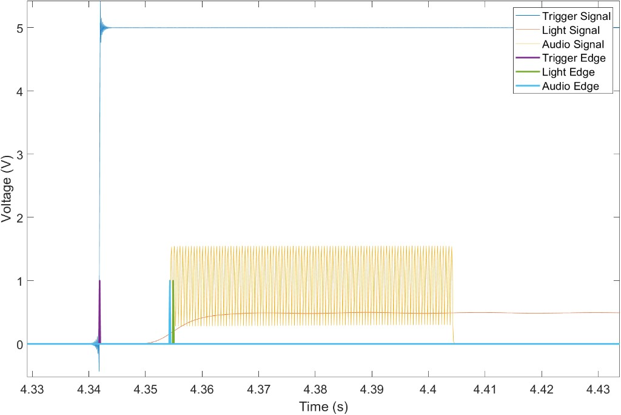
Single-trial light and sound edges
Across trials, sound minus light. Negative means the sound is slightly early. About 260 trials, each sitting on a 0.1 ms step (10 kHz sampling). The mass is between −0.6 and −0.3 ms, a few points reach −0.1 ms, and the whole range is about 0.5 ms:
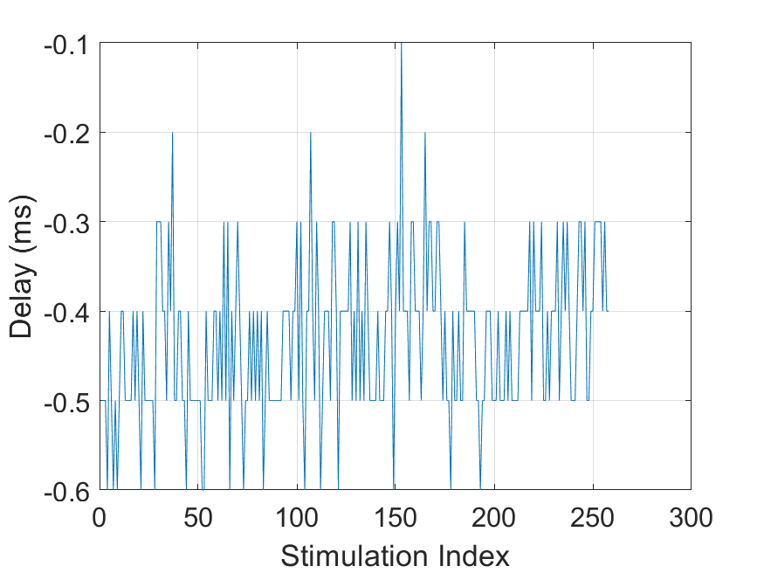
Trial-by-trial light–sound offset

7. Troubleshooting table (check here before reinstalling anything)
Symptom | Most likely cause | Fix
Synchronization Failure / Trouble, mass missed deadline | wrong GPU/driver/screen wiring; Nvidia proprietary / iGPU / laptop | switch to discrete AMD; rerun XOrgConfCreator/Selector; try ScreenToHead variants; single-screen mode; restart MATLAB; on 24.04 click the top-right notification area
didn't use pageflipping | GNOME compositor won’t yield fullscreen | click top-right + notification once; try KDE; fall back to 20.04; disable Wayland
Two delay clusters (~10 ms apart) | latencyclass≠3 / buffer too big / card busy | Open(...,3,...,1) + exclusive + buffer=1; kill other audio apps; max-out power plan
First trials huge, density jump mid-run | MATLAB warm-up + first-frame penalty + resolution changed without restart | warm-up run, drop first trial, restart MATLAB/PC after display changes
Jitter as soon as WaitSecs is added | thread fight with Flip (iron rule) | replace all waits with Flip(when); keep KbCheck, move GetSecs/now out of the loop
Constant one-frame AV gap (16.6/6.9/8.3 ms) | Flip-before vs after Trigger convention / audio compensation out of window | unify convention; retune audioExtraDelay/frame count per §6; tune at 60 Hz if needed
Projector 127 ms ±8 ms, high-refresh won’t lock | old machine + Nvidia + too-ambitious refresh | AMD-era card + 20.04; characterize projector at its native 60 Hz; use validated AOC/ViewSonic/Optoma 240 Hz for high-refresh
libGL fail to open nouveau/swrast | driver symlink lost | ln -s /usr/lib/x86_64-linux-gnu/dri/nouveau_dri.so /usr/lib/dri/ plus the MATLAB libstdc++.so.6 symlink
Serial port missing | user not in dialout | locate with ls /dev/ttyUSB* + dmesg\|grep ttyUSB, usermod -aG dialout <user>, reboot

8. Standard operating flow: from power-on to experiment
flowchart TD
S1[Boot Ubuntu-XOrg<br/>confirm res/refresh with xrandr] --> S2[Click top-right once - anti-pageflip bug]
S2 --> S3[Open MATLAB, cd to PTB folder, warm-up run]
S3 --> S4[Attach photodiode/mic, start NI]
S4 --> S5[100-trial short calibration: Mean±SD + miss count]
S5 -->|out of spec| T[Troubleshoot per §7]
T --> S5
S5 -->|in spec| S6[1000+ formal trials, drop first, archive]
S6 --> S7[Offline filter + edge stats, write report]
Repeat the whole flow whenever you change screens, cables, refresh rates or PCs. Name captures visual/audio/visual_audio_<N>.txt plus gaps_<N>.txt (PTB-readback when/onset) for traceability.

Appendix A. Parameter cheat card
- Audio: PsychPortAudio('Open',[],1,3,sf,2,1), FillBuffer before Trigger, Start(...,when+0.015,0) (waitForStart=0 schedules instead of blocking).
- Vision: Flip(window, when+0.015); hold with Flip(window, onset+ifi*(hold-0.5)).
- Sync: PredictVisualOnsetForTime + ifi*5.5 + fine audioExtraDelay.
- Statistics: drop first trial; targets: vision ±0.4 ms / audio ±0.1 ms / AV ±0.25 ms; 240 Hz full-speed reaches ±0.05 ms.
- Yardsticks to keep in mind: air tube +10 ms; one frame = 16.67 ms @60 Hz, 6.94 ms @144 Hz, 4.17 ms @240 Hz — compensate with this ruler in hand.
Closing line: good hardware (AMD + Ubuntu 20.04) × code that names the time and the frame × calibration (NI, three channels, filtering, long runs) = high temporal precision. May your first run be stable.

