National Tsing Hua University

Fall 2023 11210IPT 553000

Deep Learning in Biomedical Optical Imaging

Homework 3

Author One1

1Peer Review, Publications Department, Optica, 2010 Massachusetts Avenue NW, Washington, DC 20036, USA

Student ID:

1. Introduction

Adherence to the specifications listed in this style guide is essential for the efficient review and publication of submissions. Please note the references should appear at the end of the article after the Funding, Acknowledgment, and Disclosure sections. For submissions to the Optica Open preprint server, many of the style and format guidelines described in this template are not applicable. Although, adhering to the instructions in this template will ease the process to convert a preprint to an Optica Publishing Group journal submission.

1. Page layout and length

For journal submissions, paper size should be U.S. Letter, 21.505 cm x 27.83 cm (8.5 in. x 11 in.). The printing area should be set to 13.28 cm x 21.54 cm (5.25 in. x 8.5 in.); margins should be set for a 3.3-cm (1.3 in.) top/bottom and 4.11-cm (1.625 in.) left/right.

Authors should refer to the [Publication Charge](https://opg.optica.org/submit/review/pub_charge.cfm) page for journal-specific information about article processing charges (APCs), open access options, and overlength fees.

Authors using this template for preprint submissions should turn off line numbering.

1. Typographical style

3.1 Title

Use initial cap for the first word in the title or for proper nouns. Use lowercase following a colon. Title should not begin with an article or contain the words "first," "new" or "novel."

3.2 Author names

Author names should appear as used for conventional publication, with first and middle names or initials followed by surname. Every effort should be made to keep author names consistent from one paper to the next as they appear within our publications.

3.3 Main text

Section headings may be numbered consecutively and consistently throughout the paper in Arabic numbers and typed in bold. Use an initial capital letter followed by lowercase, except for proper names, abbreviations, etc. Do not include references to the literature, illustrations, or tables in headings.

Subsection headings may be numbered consecutively in Arabic numbers to the right of the decimal point, with the section number to the left of the decimal point as shown in this paper.

Numbering of section headings and subsection headings is optional but must be used consistently throughout papers in which it is applied. *Optics Letters* papers should not have section headers.

3.4 Equations

All display equations should be created in MathType or the Microsoft Equation editor included in Microsoft Word 2013 and later. Inline equations can be created with these tools or by using a keyboard and Unicode characters where needed for the best quality line spacing. We strongly encourage authors to use MathType 6.9. Note that LaTeX users can type LaTeX code directly into MathType for rendering in Word.

Please refer to the [online style guide](https://opg.optica.org/submit/style/optica-styleguide.cfm) for detailed instructions for including equations in your paper.

1. Figures, supplementary materials, and tables

4.1 Figures

Figures should be included directly in the document. All illustrations must be numbered consecutively (i.e., not by section) with Arabic numbers. The size of a figure should be commensurate with the amount and value of the information conveyed by the figure.

Authors must use one image file per figure. Figures must be inserted as objects that are fixed and move with the text, not as floating objects. Figures should never be placed in a table environment, embedded inside the text, or included within a list. All the figures should be centered. No part of a figure should go beyond the typing area. Place figures as closely as possible to where they are mentioned in the text. Figures should be numbered consecutively in the order of appearance and citation in the text. Be sure to cite every figure.

The abbreviation “Fig.” for figure should appear first followed by the figure number and a period.

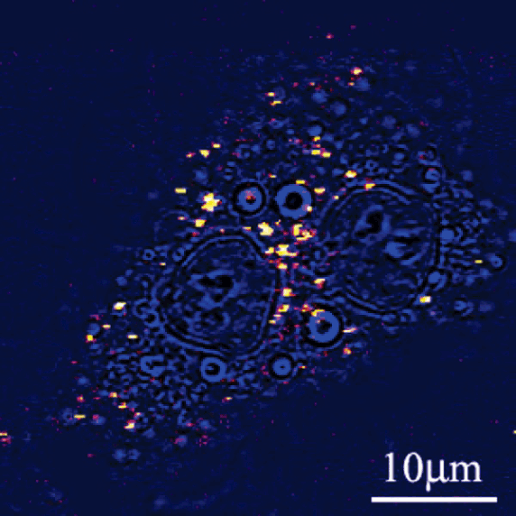

Fig. 1. Sample caption (Ref. [4], Fig. 2).

4.2 Tables

Tables should be centered and numbered consecutively. Authors must use Word’s Table editor to insert tables. Authors must not import tables from Excel. All content for each table should be in a single Word table (do not split content for a single table across multiple Word tables). Tables should use horizontal lines to delimit the top and bottom of the table and column headings. Detailed explanations or table footnotes should be typed directly beneath the table, but not in a table cell. Table footnote labels should be alphabetical; numbers or special characters are not permitted. Position tables as closely as possible to where they are mentioned in the main text.

Table 2. Optical Constants of Thin Films of Materials*a*

|  |  |  |  |  |  |
| --- | --- | --- | --- | --- | --- |
|  | 83.4 nm | |  | 121.6 nm | |
| Material | n | K |  | n | k |
| Ir | 1.182 | 0.865 |  | 1.450 | 1.040 |
| MgF2 | 1.584 | 0.487 |  | 1.682 | 0.0627 |
| Al | 0.09874 | 0.1915 |  | 0.0424 | 1.137 |
| Mo | 0.98 | 1.08 |  | 0.78 | 1.03 |
| C | 1.16 | 1.29 |  | 1.85 | 1.10 |

1. References

Optica Publishing Group journals use numerical notation in brackets for bibliographic citations. At the point of citation within the main text, designate the reference by typing the number in after the last corresponding word [1]. Reference numbers should precede a comma or period [2]. Two references [3,4], should be included together, separated by a comma, while three or more consecutive references should be indicated by the bounding numbers and an en-dash [1–4]. List up to three authors, and if there are more than three use *et al*. after that.

References

1. P. J. Harshman, T. K. Gustafson, and P. Kelley, “Title of paper,” J. Chem. Phys. **3**, (to be published).
2. K. Gallo and G. Assanto, “All-optical diode based on second-harmonic generation in an asymmetric waveguide,” J. Opt. Soc. Am. B **16**(2), 267–269 (1999).
3. B. R. Masters, “Three-dimensional microscopic tomographic imagings of the cataract in a human lens in vivo,” Opt. Express **3**(9), 332–338 (1998).
4. D. Yelin, D. Oron, S. Thiberge, *et al*., “Multiphoton plasmon-resonance microscopy,” Opt. Express **11**(12), 1385–1391 (2003).