Login

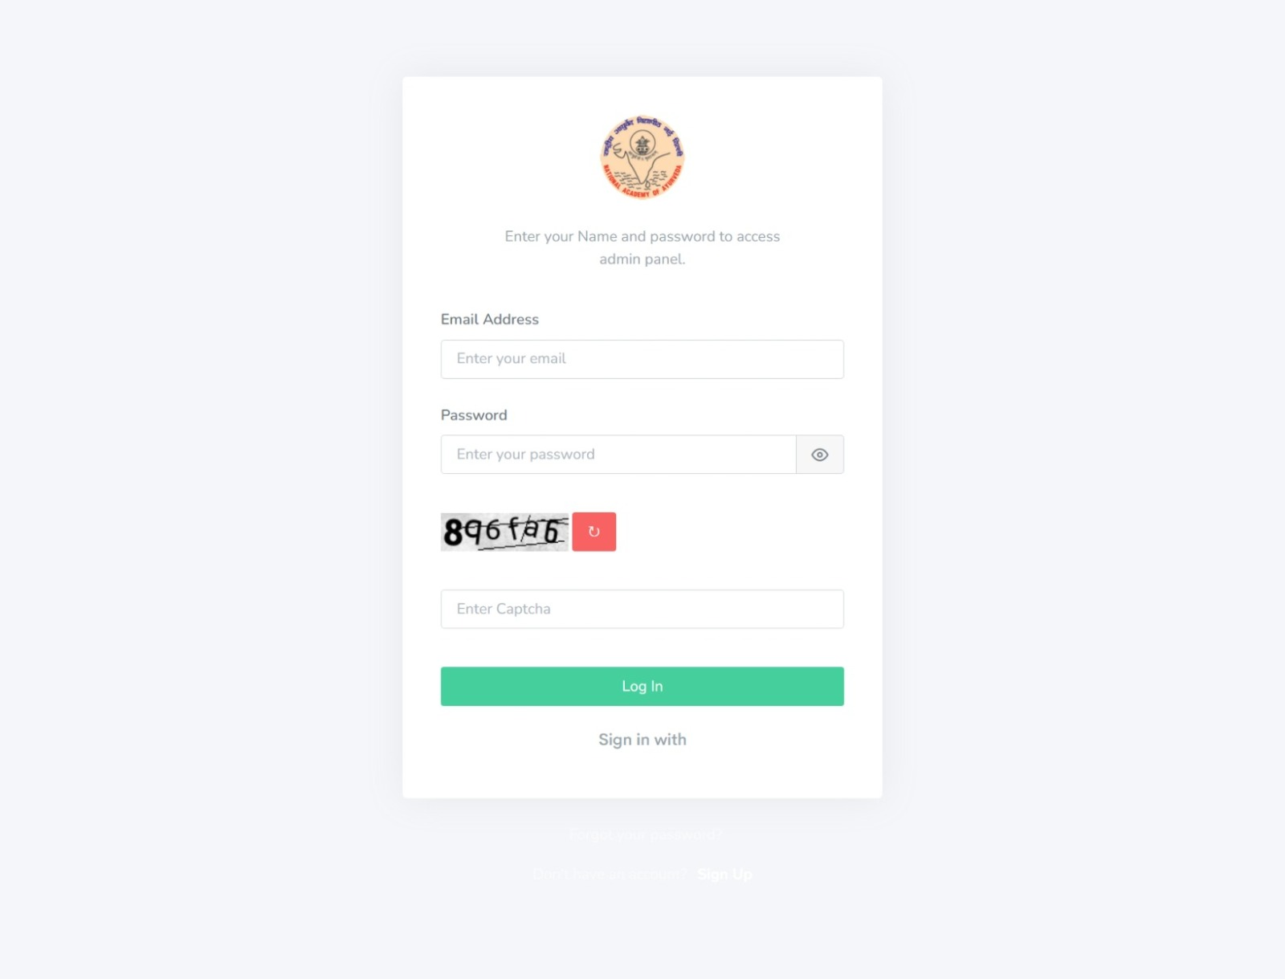

Register

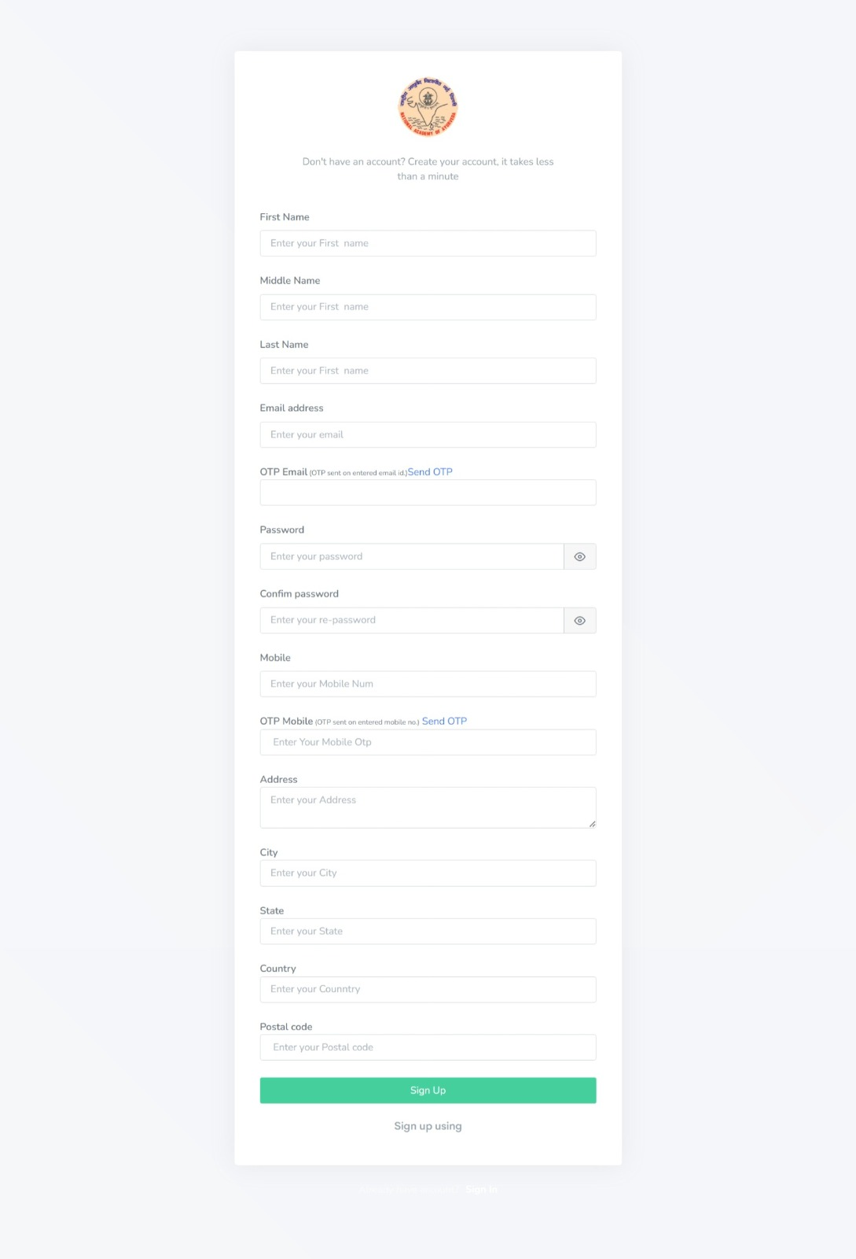

Users List

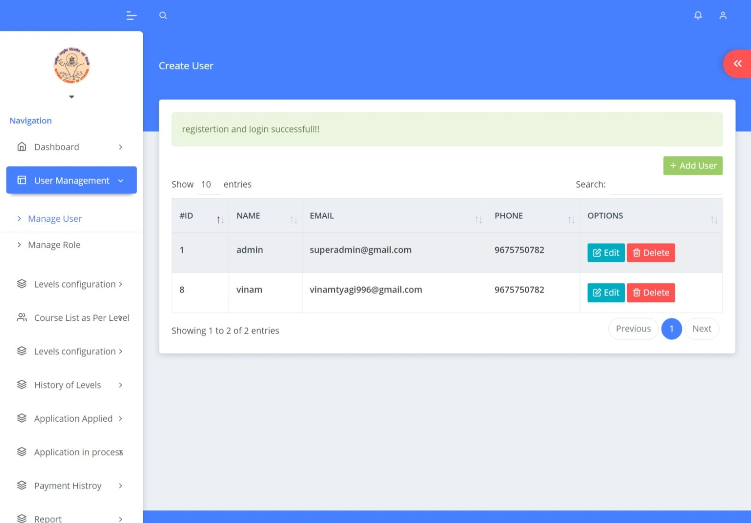

User Register:

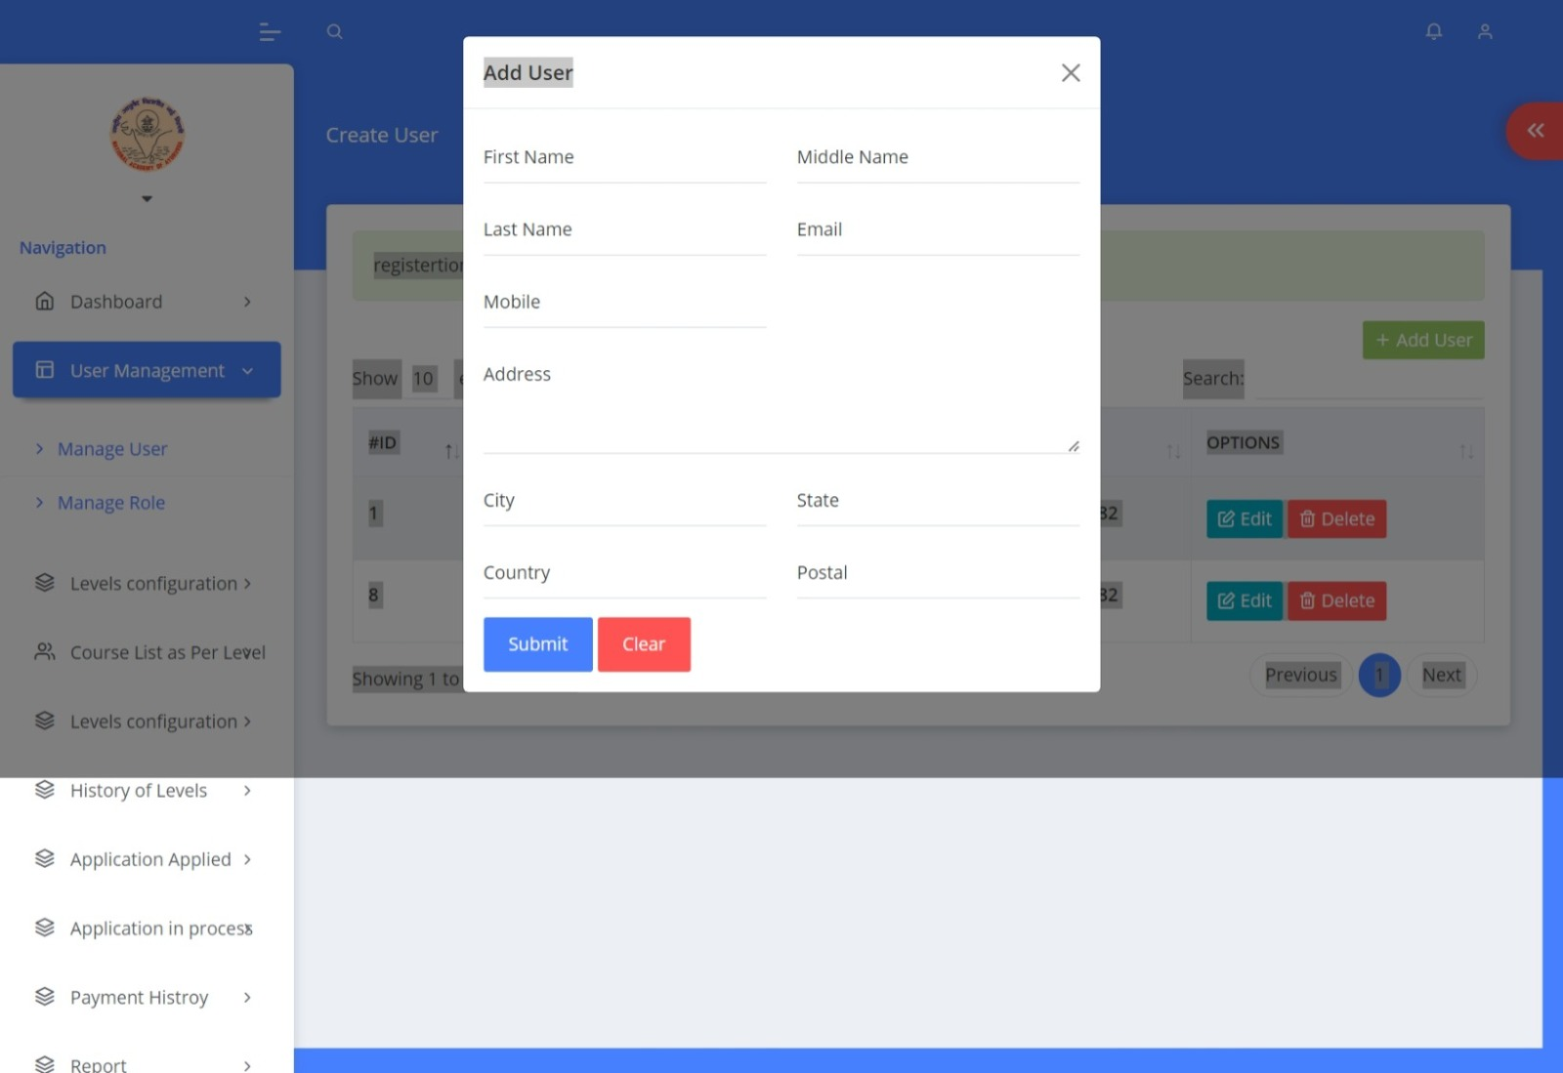

|  |  |  |
| --- | --- | --- |
| S. No. | Title | Page no |
| 1 | Secretariat Login | 3 |
| 2 | Training Provider Register | 4 |
| 3 | User Management after Login as Secretariat | 6 |
| 4 |  |  |
| 5 |  |  |
| 6 |  |  |
| 7 |  |  |
|  |  |  |
|  |  |  |
|  |  |  |
|  |  |  |
|  |  |  |
|  |  |  |
|  |  |  |
|  |  |  |
|  |  |  |
|  |  |  |
|  |  |  |
|  |  |  |
|  |  |  |
|  |  |  |
|  |  |  |
|  |  |  |
|  |  |  |
|  |  |  |
|  |  |  |
|  |  |  |
|  |  |  |
|  |  |  |
|  |  |  |
|  |  |  |
|  |  |  |
|  |  |  |

Secretariat Login

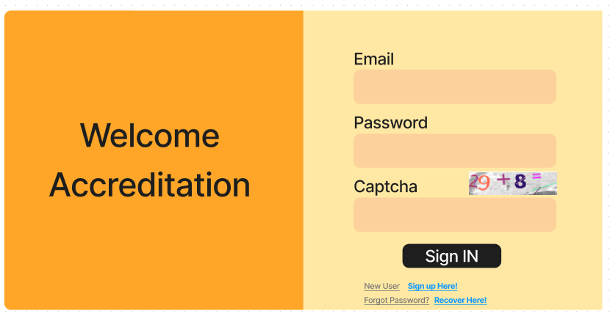

* This login web page has implemented for secretariat to login. A superadmin(Secretariat) account is already exist in this system.
* There are 3 fields to input email id, password and captcha as credentials
* All fields are mandatory.
* Input Email id. Email id which was given at the time of account creation? It is user unique email id.
* Input password. It is secret keywords which were given at the time of account creation?
* Input Captcha. Need to input alphabets and numbers those are generating as image automatically.

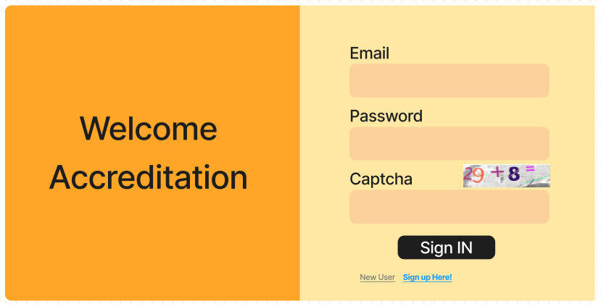

TP Register

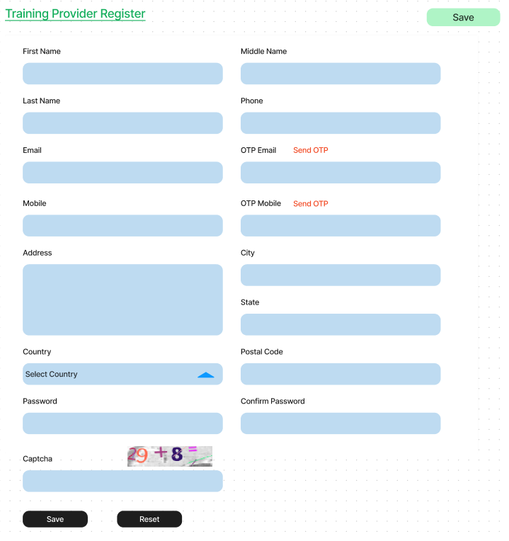

* This is Form related to Training provider.
* All fields are mandatory. Training Provider need to input all these fields to register.
* Password minimum length is 7 characters and maximum length is 15 characters
* Need to input captcha which is showing on captcha image?
* Training provider need to verify their email id and mobile by sending OTP
* Email and Mobile OTP need to input here which are sending to email and mobile as sms.
* Duplicate email ID and Mobile no. are not allowed.
* Click Save button to register account.

User Management under Secretariat Login

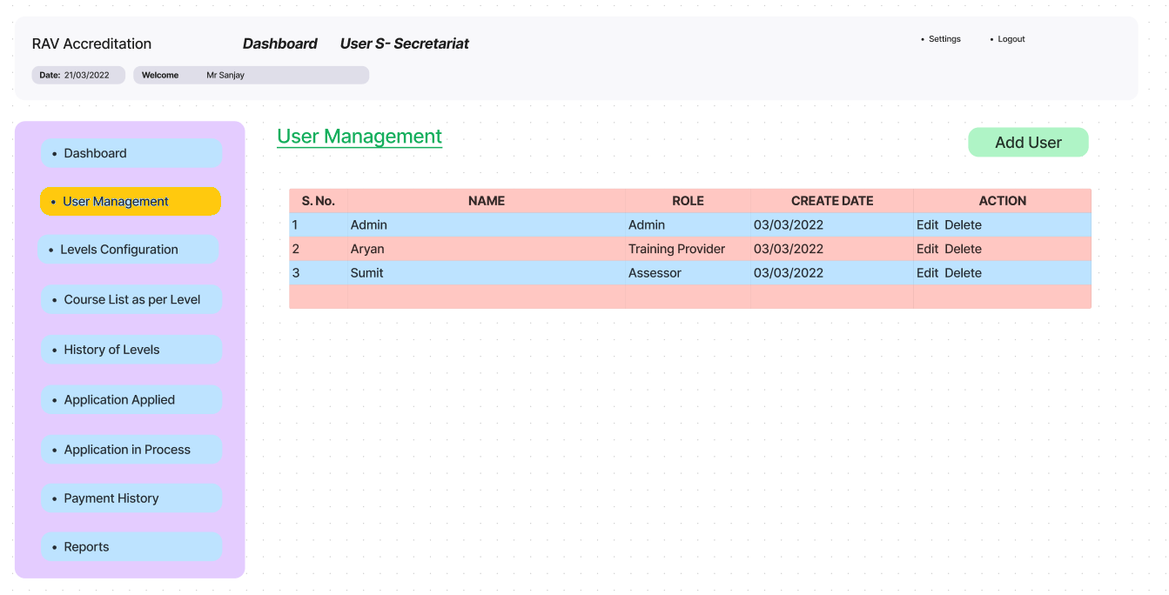

* All the accounts which are created by Training Providers are listing under User Management menu of Secretariat Login.
* Secretariat Admin can create new user account also here and can assign Role to user.
* User Roles are the permissions for users for which sections they can access.