

CEF488: Systems and Network Programming

LAB2: NAMED PIPES, ADVANCED MULTIPLEXING AND REAL_TIME SIGNAL

GROUP 8 MEMBERS
ECHUNDIP CARL-LAWRENCE | FE23A040
OBIOMA OBI FODJO | FE23A133
TAMBE RAMSON | FE23A156
BERINYUY GILLES KILALON | FE23A024
NSEMEN PHILLIS NANA | FE25A679

Lecturer: Mr Forcha Glen
2025-2026 academic year
29/04/2026

Table of Contents
1. Honesty report 3
2. Abstract: 3
3. Objectives: 3
4. Pre-lab questions: 4
5. Code structure: 5
6. Libraries and External Tools 6
7. TASK1: Basic Logging Server Multiple FIFOs 6
8. TASK2: Clients Programs: 9
9. TASK3: Dynamic FIFO Addition: 12
10. Task 4: Real_Time Signals: 14
11. Conclusion: 16

Honesty report
Task | Responsible member | Contributions | Reviewers
Prelab Questions | ECHUNDIP CARL-LAWRENCE | TAMBE RAMSON | OBIOMA OBI FODJO
Implementations | TAMBE RAMSON | ECHUNDIP CARL-LAWRENCE | BERINYUY GILLES KILALON
Testing and debugging | OBIOMA OBI FODJO | BERINYUY GILLES KILALON | NSEMEN PHILLIS NANA
Report Writing | BERINYUY GILLES KILALON  ECHUNDIP CARL-LAWRENCE | NSEMEN PHILLIS NANA | TAMBE RAMSON  OBIOMA OBI FODJO

Abstract:
Our lab aids in investigating the implementation of a high-performance, proper and scalable logging architecture using the advanced Linux Inter-Process communication (IPC) and sophisticated I/O multiplexing. The project makes use of Named Pipes (FIFOs) to facilitate communication between unrelated processes, ensuring reliable data transfer while relating to “PIPE_BUF” limits for write atomicity. At the middle of this project’s server’s efficiency is the integration of the “epoll” mechanism in Edge-triggered mode. This allows the system to manage a dynamic set of life descriptors with minimal CPU overhead, fundamentally optimizing Process Management by preventing the “busy-waiting” common in basic polling designs.
This lab also introduces us to introduces us to the concepts of Asynchronous notifications and IPC through the use of Real-time signals. Using the “sigqueue()” enables us demonstrate how the signals can carry informative payloads to notify the parent process of specific event arrivals and this helps enhance the responsiveness of the event loop. Generally, our system has the ability to register new FIFOs at runtime without service interruption.

Objectives:
The main goal of our lab is to design and implement a high-performance, scalable logging system utilizing advanced Linux Inter-Process Communication (IPC) mechanisms. The project aims to master the use of Named Pipes (FIFOs) for communication between unrelated processes and to optimize server responsiveness through epoll-based I/O multiplexing in Edge-Triggered mode.

Pre-lab questions:

- The difference between a named pipe and unnamed pipe is that unnamed pipes have no name in the filesystem and exist only in memory while the named pipes appear as a special file in the directory tree and any process in the directory with a good permission can open them.
A good scenario is can be seen as a named pipe is more suitable for a centralized system logger (like our pre-lab) where independent applications (clients) started at different times need to send logs to a background service (server) without being children of that service.

- PIPEBUF is a constant (usually 4096 bytes on Linux) that defines the maximum number of bytes that can be written to a pipe atomically.
Importance: If a message is greater than or equal to PIPEBUF, the kernel guarantees the message will be written as one continuous block.

- Level-Triggered (LT): The default mode. epoll_wait will keep telling you a file descriptor is ready as long as there is data in the buffer. While the Edge-Triggered (ET) is triggered only when a change occurs (e.g., new data arrives). You are notified once and must read until the buffer is empty. We will choose Edge-Triggered for high-performance servers with many connections to reduce the number of times the kernel has to wake up the process, preventing "spurious" wakeups.

- System Call: mkfifo(const char *pathname, mode_t mode); Permissions: Typically set to 0666 (read and write for all users), though the final permissions are modified by the process umask. In a secure environment, 0600 or 0660 might be used to restrict access.

- To add a new FIFO we:
- Open the FIFO in non-blocking mode:
int fd = open(path, O_RDONLY | O_NONBLOCK);.
- Initialize the epoll_event structure, setting the desired events
(e.g., EPOLLIN | EPOLLET).
- Execute the epoll_ctl system call with the EPOLL_CTL_ADD flag: epoll_ctl(epoll_fd, EPOLL_CTL_ADD, fd, &event);

- Standard Signals: (e.g. SIGINT) are not queued, if multiple identical signals arrive, some may be lost while with the Real-Time Signals (e.g. SIGRTMIN) are queued, ensuring every signal is handled in the order it was received.
“sigqueue” allows the senders to attach an integer or a pointer to the signal which the receiver can then use to identify which specific resource triggered the event.

- If a client writes a message larger than PIPEBUF:
The write may be fragmented and Part of the message might be written, then another process’s data might be inserted in the middle, and finally, the rest of the first message appears.
T o guarantee atomic delivery, we can implement Application-Level Framing (e.g., using a fixed-size header that states the message length) or use a mutex/locking mechanism to ensure only one process writes to the pipe at a time.

- It is important to handle EAGAIN when reading from FIFO in non-blocking mode because: In non-blocking mode, if you try to read() and there is no more data currently available in the pipe's internal buffer, the system call won't wait, Instead, it immediately returns -1 and sets errno to EAGAIN. Also, Handling this is critical in Edge-Triggered epoll because it serves as the signal that you have finished processing all currently available data and can safely go back to waiting with epoll_wait.
Methodology:
We implemented this task following a modular design mainly focused on high performance I/O and process independence.
For some major decision we decided on following:
IPC Mechanism (Named Pipes/FIFOs): which was Chosen to allow communication between unrelated processes. Unlike unnamed pipes, FIFOs exist in the filesystem, enabling independent clients to find and write to the server at any time.
We decided on using the Concurrency Model (I/O Multiplexing with epoll): Instead of using multi-threading (one thread per pipe), which is resource-heavy, I implemented a single-threaded event loop using epoll.
The Edge Triggered mode is used to minimize system call overhead. In this mode, the server is only notified when new data arrives, requiring the application to read until the buffer is empty.
To prevent log message corruption, I ensured all log entries remain under the PIPE_BUF limit (4096 bytes). This guarantees that individual write operations from multiple clients are not interleaved by the kernel.

Code structure:

File | Function | Description
common.h | Header file | Defines shared constants like BUFFER_SIZE and paths for the control and alert FIFOs.
logserver.c | main.c | Initializes FIFOs, sets up the epoll instance, and runs the main event loop.
 | add_to_epoll() | Configures file descriptors for non-blocking I/O and registers them with the epoll set.
 | process_message() | Parses logs and forwards any message containing "CRITICAL" to the alert pipe.
logclient.c | main .c | Opens a specified pipe in write-only mode and sends an atomic log message.
control_client.c | Main.c | Creates a new FIFO and sends an "ADD" command to the server's control pipe to register it dynamically.
Makefile | Build script | Automates compilation with -Wall and -Wextra flags and provides a clean target

Libraries and External Tools
- Standard C Libraries:
- <sys/epoll.h>: Used for the epoll multiplexing interface.
- <sys/stat.h> & <fcntl.h>: Used for FIFO creation (mkfifo) and file descriptor manipulation.
- <unistd.h>: Used for standard system calls like read(), write(), and close().
- Compilers/Tools:
  - GCC: The GNU Compiler Collection was used to compile the source code.
  - Make: Used to manage the build process and dependencies.
  - Ubuntu Terminal: Used for running the server and multi-terminal client demonstrations.

TASK1: Basic Logging Server Multiple FIFOs

The first step here was creating a folder which will hold all various files. Within this, we created the log_server.c which contains the headers, globals and signal handler. The file containes:
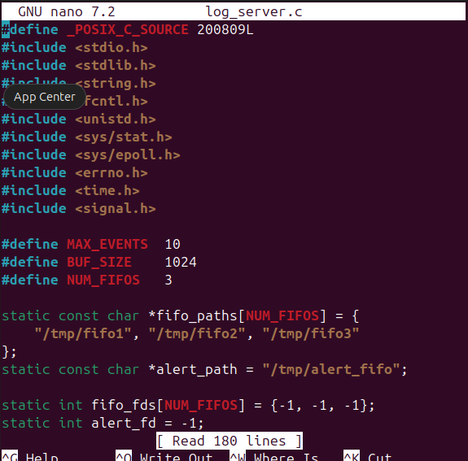

We can see it sets read+write for owner, group, and others
“mkfifo()” creates a named pipe in the filesystem. No data is stored on disk; it's purely an IPC conduit.

We use the “gcc -Wall -Wextra -o log_server log_server.c” to compile our code getting ready for execution.

The next step is to open another terminal were we will be able to send messages while monitoring from the 1st terminal

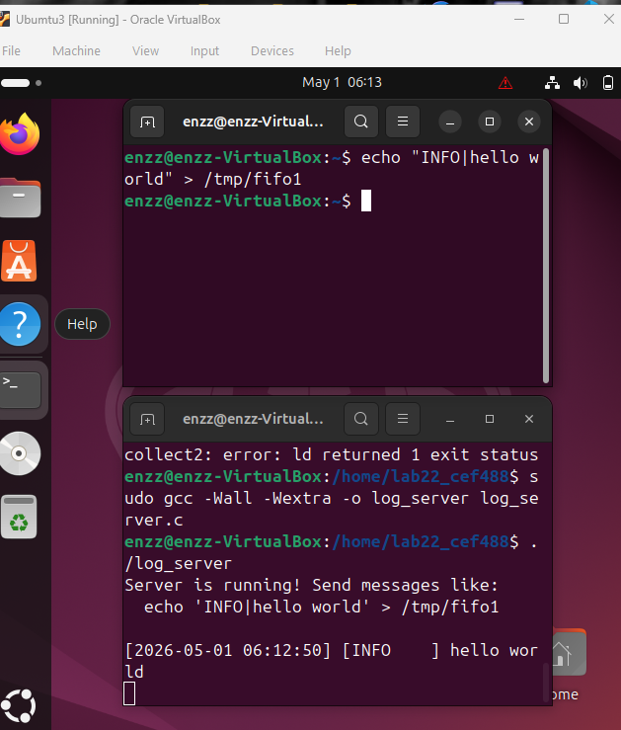
As seen from above, after lunching my server from the first terminal with the “./log_server” command, then iputed “ echo "INFO|hello world" > /tmp/fifo1” into the second terminal, i received a “Hello world” from my server terminal with a corresponding time and date.
As seen from below i sent different messages to the different pipes to test them and it worked.

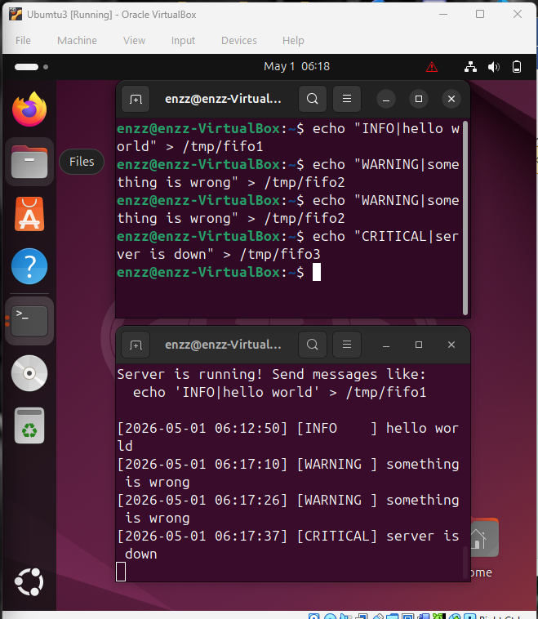

TASK2: Clients Programs:

Task 2 is about writing a client program that sends log messages to the server we built in Task 1.

We begin by creating the client’s code inside thesame directory as the server’s:

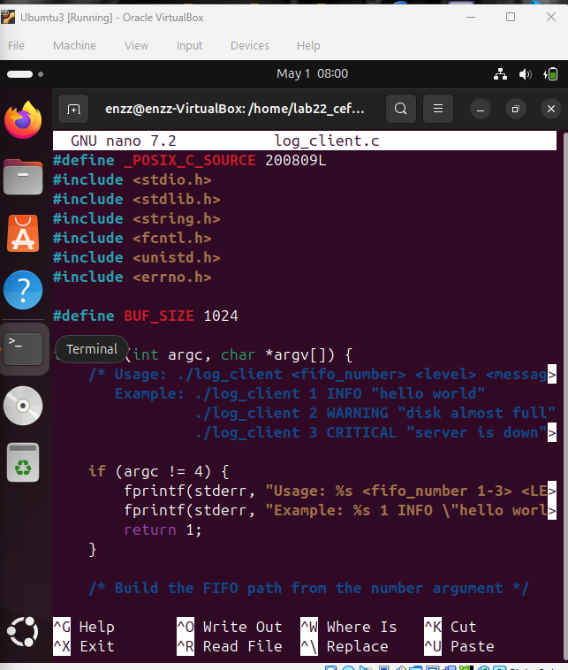
Then we build our code:
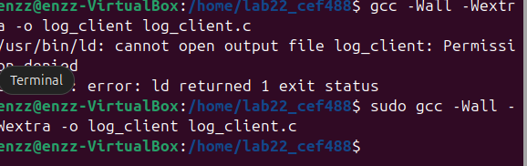

Then the next task is starting the code and opening 2 other terminals, one for the start alert reading and the other to handle the job as a client.
This is also a way of testing the FIFOs created:
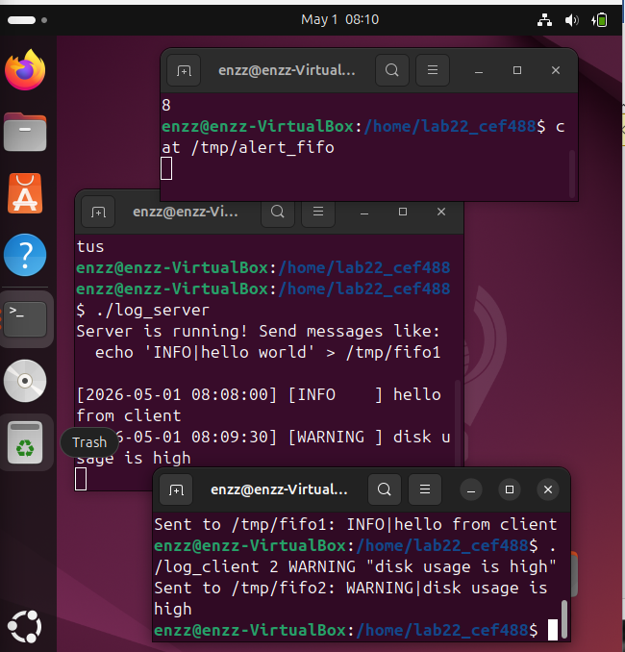
client

Alert reader

Server

We can end the processing by using a control+c.
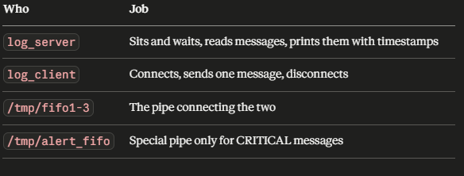

TASK3: Dynamic FIFO Addition:

Task 3 upgrades our server so we can add new FIFOs while the server is already running without stopping and restarting it.

Picture it this way:

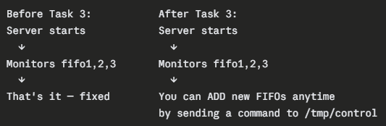

In other to proceed with task 3, it is important to clear what we have worked on already, but I rather created a different folder due to my drive in research.
The updated log_server.c code seen as that below:

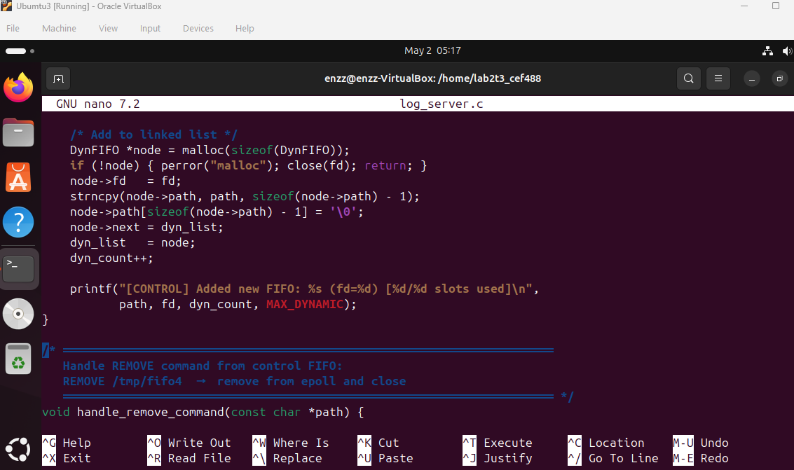

Compiling the code we need to use our sudo command:
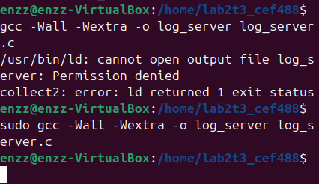
We used the existing client code and built it, then opened up 3 terminals, 1acting as our server, the other acting as the client while the last terminal is considered to be the alert reader.
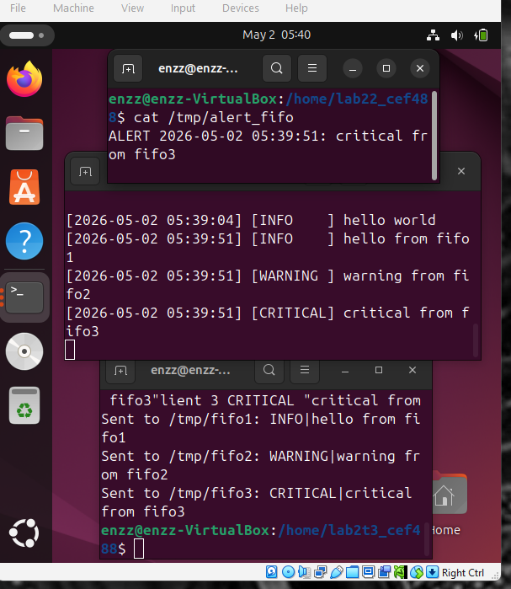
client

Server

Alert reader

Task 4: Real_Time Signals:

Task 4 replaces epoll's direct FIFO monitoring with real-time signals. Instead of epoll watching the FIFOs directly, each FIFO gets its own thread that watches it and sends a signal to the main thread when data arrives.
We simply went into editing the code to obtain that which makes use of threads and compiled.

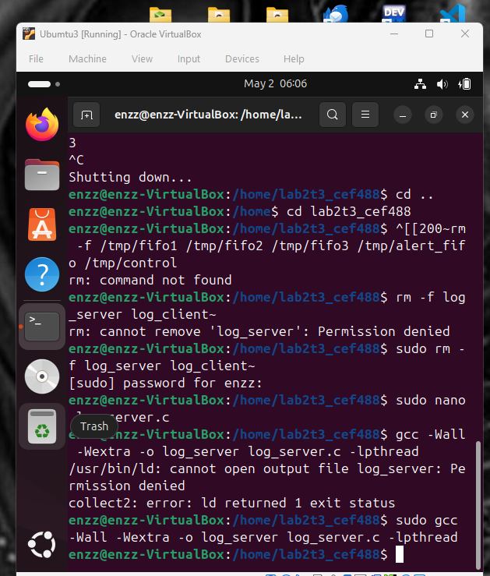

Implementation using 4 different terminals this time:
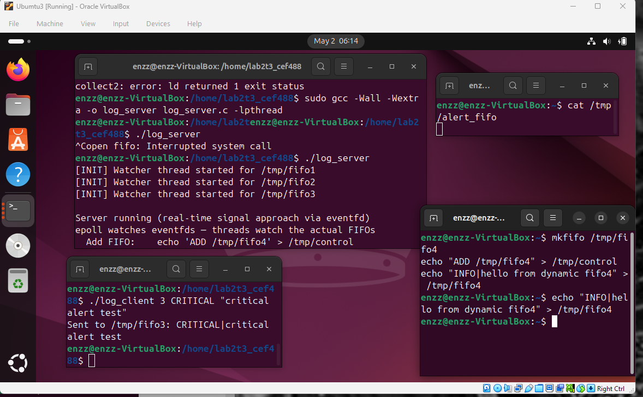
Handling dynamic runtime

Conclusion:

In conclusion, this lab project successfully demonstrated the design and implementation of a scalable and efficient logging server using advanced Linux Inter-Process Communication mechanisms. Throughout the project, we explored the use of Named Pipes (FIFOs), epoll-based I/O multiplexing, dynamic FIFO registration, and Real-Time Signals to create a responsive and high-performance logging system.

In Task 1 we introduced the foundation of the logging server by enabling communication between multiple processes through FIFOs. In Task 2, we developed client programs capable of sending log messages and alert notifications to the server, proving reliable communication between independent processes. Meanwhile in Task 3 improved the flexibility of the system by allowing new FIFOs to be added dynamically at runtime without restarting the server. Finally, Task 4 demonstrated the use of Real-Time Signals and multithreading to provide asynchronous event notifications and improve responsiveness.

This project greatly improved our understanding of Linux system programming concepts such as process communication, non-blocking I/O, concurrency handling, signal management, and efficient resource utilization. We also learned the importance of atomic writes using PIPE_BUF, the advantages of Edge-Triggered epoll for high-performance systems, and the role of proper event handling in scalable server design.

