

TITLE:
MOBILE APP DEVELOPMENT PROCESS
CEF 440, Internet programming and Mobile Programming
Lecturer: Dr Valery Nkemeni
Report by Group 21

S/N | NAME | Specialisation | Matricule
1 | CHE RANDY FANG | Software | FE23A030
2 | ECHUNDIP CARL-LAWRENCE N. | Networking | FE23A040
3 | MAKANE THANKS MOSAKA | Software | FE23A085
4 | NUMFOR PRECIOUS LUM | Software | FE23A126
5 | TEMFA NKOMBONG FORTUNEE | Software | FE23A168

Table of Contents
1. Stake holder Identification: 2
a. Primary Stakeholders (Direct Users) 2
b. Secondary Stakeholders (Support & Management) 3
c. External Stakeholders 3
d. Importance of the stakeholder identification process: 3
2. Requirement Gathering Techniques 5
2.1 Student Surveys 5
2.2 Instructor Interviews 5
2.3 Brainstorming 6
2.4 Reverse Engineering 6
2.5 Conclusion on requirement gathering process: 7
3. Data Gathering Process 7
3.1 Survey Data Collection 7
3.2 Interview Data Collection 8
3.3 Brainstorming Sessions 9
3.4 Reverse Engineering 9
4. Data Cleaning 10
4.1 Definition of data cleaning 10
4.2 Importance of Data Cleaning in our E-learning Platform 10
4.3 Steps to Ensure Data Accuracy and Usability 10
4.4 Process through data cleaning: 11
4.5 Data Virtualisation: 13
4.5 Conclusion 14
5. User Reluctance Assessment and Mitigation Strategies 15
5.1 Definition 15
5.2 User Reluctance Factors 15
5.3 Mitigation Strategies 15
6. References: 16

Task 2: Requirement Gathering
Our main goal here is to gather as much data as we can, prepare and clean it , to later understand the workflow in building our adaptive e-learning platform.

1. Stake holder Identification:
A stakeholder is any person, group, or organization that has an interest in a system, is affected by it, or can influence its success or failure. In simple terms, a stakeholder is: Someone who uses the system, builds, manages, or maintains it, or someone who is impacted by its outcomes. With respect different roles they play and depending on their relationship with the system. Generally, they:
- Provide requirements (what the system should do)
- Give feedback during development
- Use the system in real life
- Help in decision-making
- Ensure the system meets user needs and goals
- Influence design, implementation, and evaluation
Our project is titled: Adaptive Mobile E-learning Platform based on Quality of Experience (QoE)
It is a system which provides adaptive e-learning mobile platform for low-resource environments. Here the stakeholders can be grouped into categories:

Primary Stakeholders (Direct Users)
These users act directly with the system, and as such are most important. They include;
- Students (Learners): People using the app to study. They have access course materials (videos, notes, quizzes), attend live or recorded classes and deal with first hand experience with any potential short coming in video quality adjustment, audio mode and text displays. These users provide the data to valuate Quality of Experience (QoE) and their feedback helps improve usability and performance.
- Instructors / Teachers: They are people who create and deliver educational content. Their interaction with the system consists of uploading videos, notes and quizzes, conducting live classes and monitoring student performance. In conclusion, they provide learning content and ensure the system supports effective teaching.

Secondary Stakeholders (Support & Management)
These stakeholders support the system but may not use it directly all the time. They include;
    - System Administrators: These are the technical personnel in charge of managing the functioning of the platform. They manage user accounts (students/instructors), monitor system performance and handle security and data management thus ensuring the system runs smoothly and securely.
    - Developers (Group 21_Project_Team): The actual people designing and building the application. Our role is to implement features (adaptive streaming, QoE monitoring), fix bugs, improve performance and integrate algorithms for decision-making.

External Stakeholders
These persons are indirectly involved but still influence the system. Such as;
    - Internet Service Providers (ISPs): The companies providing internet connectivity, delivering network services (bandwidth, latency conditions).
    - Government Regulatory Bodies: It involves the authorities overseeing education and technology. They set policies for digital education and ensure accessibility and inclusiveness. They influence adoption and compliance.
    - Content Providers: They are organizations or private individuals providing external learning materials: videos, course PDFs and other resources. Which can be accessed independently by learners using the platform.

d. Importance of the stakeholder identification process:
1. Comprehensive Recognition of Interests
- Identifies internal stakeholders (employees, managers, shareholders) and external stakeholders (clients, regulators, community).
- Ensures no critical voice or interest is ignored, reducing blind spots in project planning.
2. Improved Communication & Engagement
- Enables tailored communication strategies so the right messages reach the right people at the right time.
- Builds trust and transparency, which increases stakeholder buy-in and cooperation.
3. Risk Management
- Early identification highlights potential conflicts, resistance, or risks.
- Allows proactive mitigation strategies, preventing issues from derailing the project.
4. Better Decision-Making
- Provides insights into stakeholder priorities, expectations, and influence.
- Ensures decisions are aligned with both project goals and that decided by stakeholder.

2. Requirement Gathering Techniques
To ensure that the system requirements are comprehensive, accurate, and aligned with real-world challenges, multiple requirements gathering techniques were employed. These include student surveys, instructor interviews, brainstorming sessions, and reverse engineering of existing systems.

Student Surveys
Structured questionnaires were administered to students to collect quantitative and limited qualitative data regarding their online learning experience.
The survey focused on:
- Type of devices used for learning
- Internet connectivity and stability
- Frequency of network interruptions
- Challenges faced during online classes
- Preferred learning formats (video, audio, text)
- Willingness to adopt an adaptive learning platform
This technique enabled the collection of data from a large number of respondents, making it suitable for identifying general trends and patterns. For example, it helped determine how many students experience unstable internet connections and what content formats they prefer under poor network conditions.
This survey was made to take to emails so as to ensure responders where limited to a single response so as to avoid data redundancy and inconsistency.
However, surveys provided limited depth in understanding user experiences, as responses were mostly predefined.
The link to the questions used to conduct the survey is given below.
https://forms.gle/JM4ACEmzTFhukJja9

Instructor Interviews
Semi-structured interviews were conducted with instructors to obtain in-depth qualitative insights into their online teaching experiences.
The interviews explored:
- Platforms used for online teaching
- Challenges faced during content delivery
- Impact of poor network conditions on teaching
- Student-related issues during online classes
- Strategies used to support students with poor connectivity
- Opinions on adaptive e-learning systems
- Security, interactive or any other major concerns being faced
This method provided detailed explanations and real-world perspectives that could not be captured through surveys. It helped identify critical issues such as difficulty in delivering live lectures and the need for flexible content formats.
The limitation of this technique is that it involves fewer participants and requires more time to conduct and analyse.

Brainstorming
Brainstorming sessions were conducted among group members to generate ideas and define potential system features. During these sessions, the team identified key problems faced in existing e-learning systems, proposed solutions for handling poor network conditions especially when dealing with real-time teaching sessions.
Suggested adaptive features such as:
- Automatic video quality adjustment
- Switching to audio-only mode
- Adding subtitles to videos or audios
- Enabling the option for instructor to choose how adaptations are done base on the content or structure of their lessons.
This technique encouraged creativity and collaboration, allowing the team to explore multiple possible solutions. It also helped in refining the project scope and aligning ideas with the identified user needs.
However, brainstorming is subjective and depends on the participants’ knowledge and assumptions.

Reverse Engineering
Reverse engineering was carried out by analysing existing e-learning platforms such as Huawei Talent Online, Moodle, Coursera, Udemy, Google meet and zoom.
The analysis focused on:
- System features and functionalities
- Content delivery mechanisms
- User interface and interaction
- Performance under varying network conditions
This process helped identify:
- Strengths, such as structured course delivery and user-friendly interfaces
- Limitations, particularly the lack of adaptive mechanisms for low-bandwidth environments
- Reverse engineering allowed the team to build upon existing solutions while addressing their shortcomings.

Conclusion on requirement gathering process:
The combination of these techniques ensured a balanced approach to requirement gathering:
- Surveys provided broad, quantitative insights
- Interviews offered deep, qualitative understanding
- Brainstorming generated innovative ideas
- Reverse engineering revealed practical system limitations
Together, these methods provided a solid foundation for defining system requirements and designing an adaptive e-learning platform suitable for low-resource environments.

3. Data Gathering Process
The data gathering process for our E-learning Platform based on Quality of Experience (QoE) was carried out systematically to ensure that the system requirements reflect the real challenges faced by users in low-resource environments such as Cameroon. The objective of this phase was to collect accurate, relevant, and diverse data from multiple sources in order to guide the design of a responsive, inclusive, and adaptive learning platform.
To achieve this, a combination of surveys, interviews, brainstorming sessions, and reverse engineering techniques was employed. Using multiple methods ensured that both quantitative and qualitative data were obtained, thereby providing a well-rounded understanding of user needs, system limitations, and environmental constraints.

3.1 Survey Data Collection
Surveys were conducted primarily among students who are the main users of the proposed e-learning platform. The surveys were distributed electronically using online forms to ensure accessibility across different locations.
The questionnaire was designed to capture both quantitative data (measurable responses) and qualitative data (user opinions and experiences). Key areas covered in the survey included:
- Internet connectivity quality (stable, unstable, very poor)
- Average data affordability and limitations
- Preferred learning formats (video, audio, text-based materials)
- Challenges faced when using existing e-learning platforms
- Frequency of interruptions during online classes
- Willingness to use adaptive features such as automatic video quality adjustment
The survey results revealed that a significant percentage of students rely on mobile data, with many experiencing frequent network disruptions and high data costs. A large number of respondents indicated a preference for low-data-consuming content formats, such as text and audio, especially under poor network conditions.
These findings directly informed system features such as:
- Dynamic video quality adjustment
- Audio-only mode switching
- Provision of downloadable and low-resolution content
A sample of our findings can be seen below
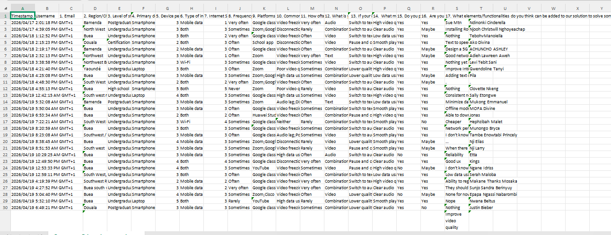
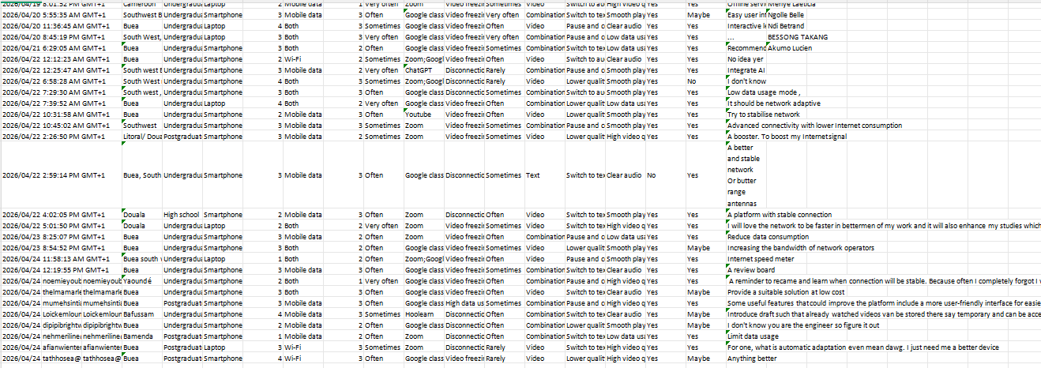

3.2 Interview Data Collection
To complement the survey data, structured interviews were conducted with lecturers and instructors who are responsible for delivering course content.
The interviews focused on understanding:
- Current methods used to deliver online lectures
- Challenges faced when teaching in low-bandwidth environments
- Difficulties in student engagement and participation
- Issues related to real-time video conferencing tools
- Preferred features for managing and delivering adaptive content
Lecturers reported that:
- Live video sessions are often disrupted by poor connectivity
- Students frequently miss parts of lectures due to network instability
- There is limited flexibility in existing platforms to adjust content delivery dynamically
They also emphasized the need for:
- Systems that can automatically adapt to students’ network conditions
- Tools for monitoring student participation and experience
- Alternative delivery modes such as recorded lectures and audio-based teaching
The insights obtained from these interviews were crucial in defining features such as:
- Live/recorded lecture switching
- QoE monitoring and logging
- Adaptive communication modes

3.3 Brainstorming Sessions
Brainstorming sessions were conducted within our group to consolidate ideas and align the system design with the data collected from users.
During these sessions, team members:
Key ideas generated included:
- Real-time monitoring of network parameters (bandwidth, latency, packet loss)
- Intelligent switching between video, audio, and text content
- Buffering optimization techniques to minimize interruptions
These collaborative discussions helped refine raw data into practical system requirements and ensured that the final design decisions were both user-centered and technically feasible.

3.4 Reverse Engineering
Reverse engineering was carried out within the group. This was done by analysing existing e-learning platforms such as Moodle, Google Classroom, Udemy and other popular online learning systems.
Key observations from this analysis included:
- Most platforms assume stable and high-speed Internet connectivity
- Limited support for automatic adaptation to network fluctuations
- Heavy reliance on high-bandwidth video streaming
- Lack of QoE-focused optimization mechanisms
These findings highlighted the gap between existing systems and the needs of users in low-resource environments.
The data gathering process provided a comprehensive understanding of both user requirements and environmental constraints. The combination of multiple techniques ensured the collection of reliable and diverse data.

4. Data Cleaning

4.1 Definition of data cleaning
Data cleaning is the process of detecting, correcting, or removing inaccurate, incomplete, or irrelevant data from a dataset to ensure that the data is accurate, consistent, and usable. It involves tasks such as removing duplicates, fixing errors, standardizing formats, and validating data entries. This process is essential to improve the quality of data for analysis, decision-making, and system performance.

4.2 Importance of Data Cleaning in our E-learning Platform
Data cleaning ensures that the information stored in the Adaptive Mobile E-learning Platform is correct, consistent, and usable. Without proper cleaning, the system risks storing messy or invalid data, which can lead to errors in performance evaluation, poor user experience, and unreliable analytics.

4.3 Steps to Ensure Data Accuracy and Usability
1. Removing Duplicate Records
- Duplicate student accounts will be detected and eliminated.
- This prevents redundancy and ensures each learner has a unique profile.
2. Validating Email Addresses
- Emails must contain the '@' symbol and follow standard formats.
- Invalid or incomplete email addresses will be rejected during registration.
3. Preventing Empty Submissions
- Mandatory fields (e.g., name, matricule, email) must be filled before submission.
- The system will enforce input validation to avoid incomplete records.
4. Standardizing Data Formats
- Dates will follow a consistent format (e.g., YYYY-MM-DD).
- Names will be standardized (e.g., capitalization rules).
- Matricule numbers will follow a fixed structure to ensure uniformity.
5. Handling Inconsistent Data
- Automated checks will flag unusual entries (e.g., invalid matricule codes).
- Administrators will review flagged data for correction.
6. Regular Audits
- Periodic data audits will be conducted to identify and correct errors.
- Logs will track changes to maintain accountability.

4.4 Process through data cleaning:
After obtaining the form we carried out the following processes on our data to properly get an understandable fixture, this includes:
- Checking for duplicates, that’s to see if an individual filled the form more than once.
- Open Ends method: Here we simply check the variety of how individuals fill the form. Some wont accurately fills by clicking the first box in each question or clicking the 1st, 2nd, 3rd, as the questions go by simultaneously. All of this were checked for and none was seen
- Removing or hiding responses which are not very important for our aim e.g. Date and time of submissions, Names of participants (might be important, but not in our case), etc

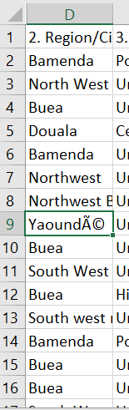
- Correcting wrong formats or spellings into the right spellings or so. For an example, we faced and individual putting in the wrong spelling of YAOUNDE, this might produce false results during virtualisation of data, so correcting this is really necessary.

- The next was Dividing the data into Qualitative and Quantitative.
Qualitative is simply the part of data which tells us what is actually happening e.g. “On a scale of 1-10” or “yes or no questions”, etc
Quantitative is the part of our data telling us why an instance is happening, e.g. Open-ended questions.
Generally, we have the form as:
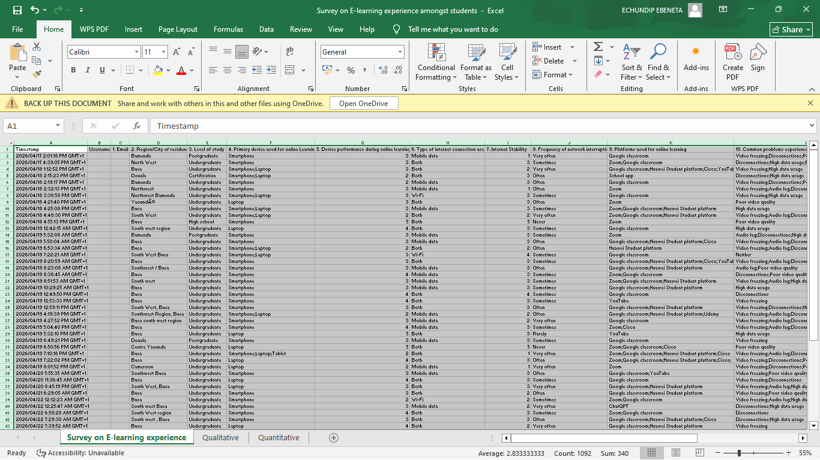
- Qualitative and Quantitative sheets were created and the next was hiding the various unimportant information. Each part turns out to look like:
Qualitative:

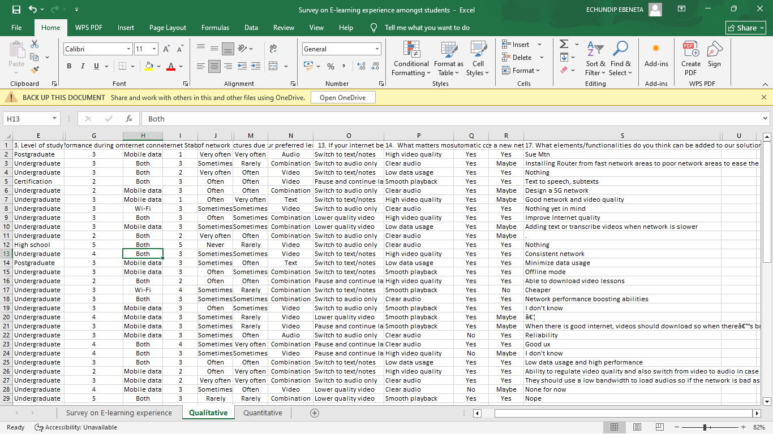

Quantitative:
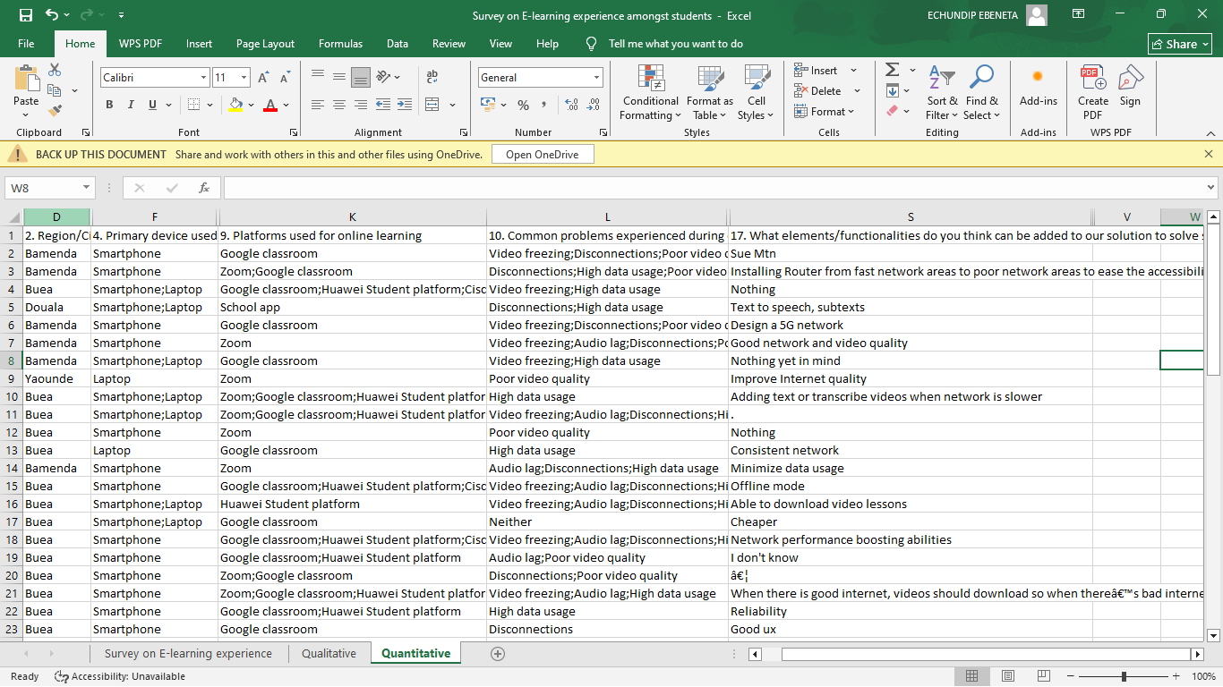

4.5 Data Virtualisation:
Usually, individuals do not consider Data Virtualisation under the cleaning process. This makes the cleaning process incomplete, as “why would you clean and not check to see if its clean?”
Virtualisation here will simply allow us see the work done so far and prepare for the Analysis face or redo the cleaning if it comes out short.
We review the virtualisation face by equipping our processing with some few charts: A Box Plot which represents “data spread” and A Histogram which is for unusual data, displayed in shapes or frequency.
For the Quantitative part, we secured a diagram showing the variation of the type of devices usually used for E-learning by students.
Comparing the diagram to the input will clearly show us that the greatest value is attributed to the phones which is actually what was chosen by the population.
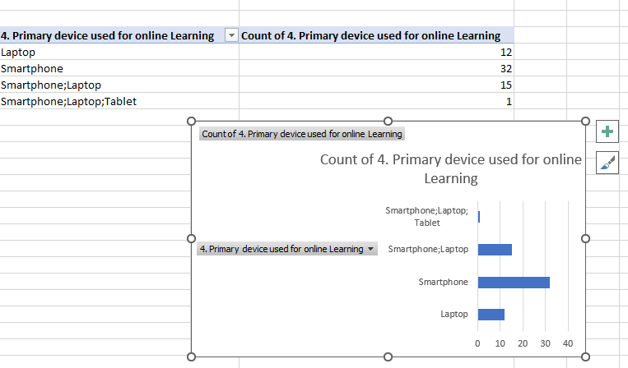
For the Qualitative part of this project visualizing the Question on the type of internet connection used and we go onto obtaining the histogram chart for that:

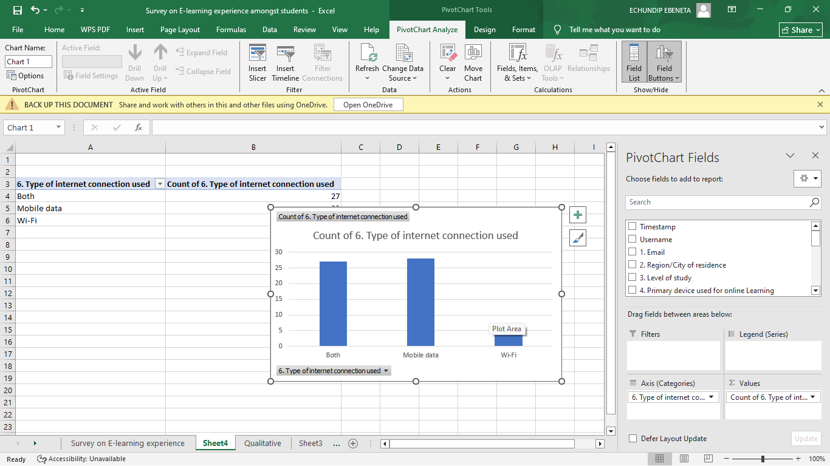

4.5 Conclusion
By implementing these data cleaning measures, the system ensures that only valid, consistent, and reliable data is stored. This improves the accuracy of Quality of Experience (QoE) evaluations, enhances user trust, and supports effective decision-making.

5. User Reluctance Assessment and Mitigation Strategies

5.1 Definition
User reluctance refers to the reasons why users may hesitate or refuse to use a mobile application. For this project, understanding these concerns is very important because the application depends on users willingly sharing their experience data. If users are not comfortable using the app, the system will not be effective.
Based on analysis and general user behaviour, several key reluctance factors have been identified.

5.2 User Reluctance Factors
- High Data Costs
Many users are sensitive to mobile data usage, especially in low-resource environments. If the application consumes too much data, users may avoid installing or using it.
- Poor Digital Literacy
Some users may not be familiar with mobile applications or may find it difficult to navigate complex interfaces. This can discourage them from using the system.
- Lack of Trust in New Platforms
Users may not trust new applications, especially when they are asked to share personal or network-related data. They may worry about how their data will be stored or used.
- Perceived System Complexity
If the application looks complicated or requires too many steps to use, users may lose interest quickly and abandon it.
- Privacy Concerns
Users may be uncomfortable sharing sensitive information such as location, device details, or network usage data. This is one of the biggest barriers to adoption.
- Battery Consumption Concerns
Since the application runs in the background, users may fear that it will drain their battery quickly.
- Frequent Notifications and Interruptions
If the app prompts users too often for feedback, it may become annoying and lead to users disabling or uninstalling the app.

5.3 Mitigation Strategies
To ensure user acceptance and encourage active participation, the following strategies will be implemented:
- Minimize Data Usage
The application will be optimized to use very little mobile data. Data collection will be lightweight and efficient to reduce cost concerns.
- Simple and User-Friendly Interface
The app will be designed with a clean and simple interface that is easy to understand, even for users with low digital literacy.
- Build User Trust
Clear information will be provided about how user data is collected, stored, and used. Transparency will help build confidence in the system.
- Ensure Data Privacy and Security
User data will be anonymized and protected using secure methods. Users will also have control over what data they choose to share.
- Optimize Battery Usage
The application will be designed to run efficiently in the background with minimal impact on battery life.
- Limit Notifications
Feedback requests will be sent at reasonable intervals to avoid disturbing users.
- Provide User Control
Users will be able to enable or disable certain features such as location tracking or background data collection.

6. References:
Pressman, R. S., & Maxim, B. R. (2020). Software engineering: A practitioner’s approach (9th ed.). McGraw-Hill.
Sommerville, I. (2016). Software engineering (10th ed.). Pearson.
Griffiths, D., & Griffiths, D. (2019). Head first Android development (3rd ed.). O’Reilly Media.
Holzner, S. (2020). React Native for beginners. McGraw-Hill.
Cursa. (n.d.). Mobile App Architecture Basics: Choosing Patterns that Scale (MVC, MVVM, Clean, and More)

