
REPUBLIC OF CAMEROON
PEACE-WORK-FATHERLAND
UNIVERSITY OF BUEA
FACULTY OF ENGINEERING AND TECHNOLOGY

TITLE:
MOBILE APP DEVELOPMENT PROCESS
CEF 440, Internet programming and Mobile Programming
Lecturer: Dr Valery Nkemeni
Report by Group 21

Names of Group members
S/N | NAME | Specialisation | Matricule
1 | CHE RANDY FANG | Software | FE23A030
2 | ECHUNDIP CARL-LAWRENCE N. | Networking | FE23A040
3 | MAKANE THANKS MOSAKA | Software | FE23A085
4 | NUMFOR PRECIOUS LUM | Software | FE23A126
5 | TEMFA NKOMBONG FORTUNEE | Software | FE23A168

Table of Contents
Task 3: Requirement Analysis 2
3.1 INTRODUCTION 2
3.2 REQUIREMENT REVIEW AND ANALYSIS 3
3.2.1 Completeness Analysis 3
DATA ANALYSIS: 5
For Quantitative: 5
3.2.2 Clarity Analysis 8
3.2.3 Technical Feasibility Analysis 9
3.2.4 Dependency Relationship Analysis 10
3.3 IDENTIFICATION OF INCONSISTENCIES, AMBIGUITIES, AND MISSING INFORMATION 10
3.3.1 Inconsistencies 10
3.3.3 Missing Information 11
3.4 REQUIREMENT PRIORITIZATION 11
3.5 REQUIREMENT CLASSIFICATION 12
3.5.1 Functional Requirements 12
3.5.2 Non-Functional Requirements 14
3.6 REQUIREMENT VALIDATION 15
3.7 CONCLUSION 15
3.8 REFERENCES 16

Task 3: Requirement Analysis

3.1 INTRODUCTION
Requirement analysis is a critical phase in software engineering that involves examining, organizing, refining, and validating the requirements gathered from stakeholders before system development begins. The purpose of this process is to ensure that the proposed system requirements are complete, clear, achievable, and aligned with user expectations.
In the context of this project (an Adaptive Mobile E-learning Platform based on Quality of Experience (QoE)), requirement analysis is especially critical. The system is intended to serve learners and instructors in bandwidth-constrained environments such as those prevalent in Cameroon, where mobile data costs are high, network connectivity is volatile, and digital literacy varies widely. These environmental realities mean that a superficial collection of requirements is insufficient; each requirement must be carefully examined to confirm that it accurately reflects stakeholder needs, is technically achievable using current technologies, and aligns with the broader goal of inclusive, adaptive digital education.
The requirement analysis process involved reviewing collected requirements, identifying ambiguities and inconsistencies, prioritizing requirements, classifying them into functional and non-functional categories, developing a Software Requirement Specification (SRS), and validating the final requirements with stakeholders.

3.2 REQUIREMENT REVIEW AND ANALYSIS
The requirements gathered during Task 2 were critically reviewed and analyzed to ensure that the proposed adaptive e-learning platform satisfies stakeholder needs, supports low-resource learning environments, and can be realistically implemented within the project scope.
The requirements gathered through surveys, interviews, brainstorming, and reverse engineering are subject to rigorous examination across four dimensions: completeness, clarity, technical feasibility, and dependency relationships. Each sub-section provides not a repetition of what was gathered, but a critical evaluation of its quality, coherence, and readiness for use in system design and development.

3.2.1 Completeness Analysis
The completeness analysis was performed to determine whether all essential functionalities required for the operation of the e-learning platform had been identified.
The analysis confirmed that the major system requirements were included. These requirements covered the needs of students, lecturers, and administrators.
The requirements successfully addressed were:
- Student learning needs
- Lecturer teaching requirements
- Course management
- Assessment and quiz functionality
- Communication and notifications
- Administrative management
- Security and authentication
- Performance optimization
Special attention was given to challenges associated with low-resource environments such as unstable internet connectivity, and expensive mobile data.
The completeness review also identified additional requirements that were initially overlooked during requirement gathering. These included:
- Password recovery functionality
- Offline access to learning materials
- Course search functionality
- Backup and recovery mechanisms
- User profile management
Coverage Assessment
The analysis confirmed that the gathered requirements adequately addressed the critical operational domains of the platform.
Requirement Domain | Coverage Assessment
Student needs | Fully addressed — surveys captured device usage, data costs, connectivity quality, content format preferences, and frequency of disruption.
Instructor needs | Addressed — interviews revealed challenges with live delivery, desire for adaptive tools, and the need for student participation monitoring.
Adaptive learning requirements | Addressed — automatic quality switching, audio-only fallback, and text-based alternatives were explicitly identified.
Content delivery modes | Fully addressed — video, audio, text, and downloadable offline materials were all identified as necessary delivery mechanisms.

DATA ANALYSIS:
By employing this descriptive and predictive analytics, the system transforms these data points into comprehensive visualizations and reports. For instructors, this phase identifies "at-risk" students through early-warning indicators and highlights content bottlenecks where learners frequently struggle.
As seen below the analysis done for each part of the data obtained during the requirement gathering face is show below, represented on pie-charts.

For Quantitative:
We mainly have 2:
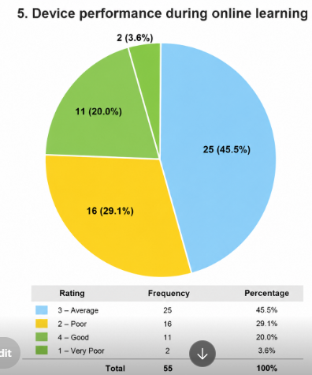
- Device performance during online learning: Which from the diagram indicates averagely for each device

- Internet stability: Which indicates averagely stable
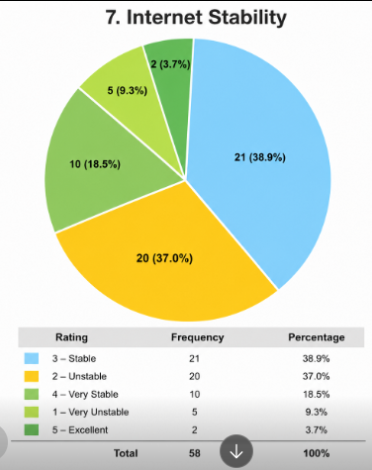

And for qualitative we have the following: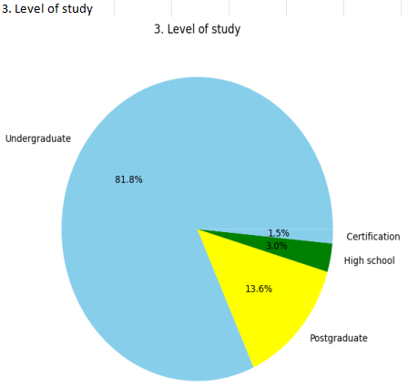

- A high percentage showed most of the answers were gotten from undergraduates
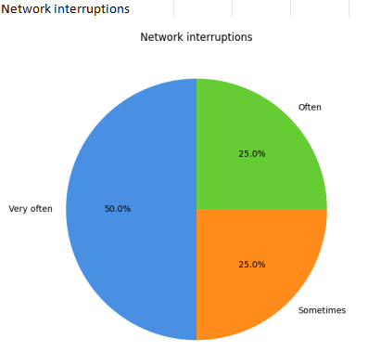
- Most individuals get interruptions very often than others
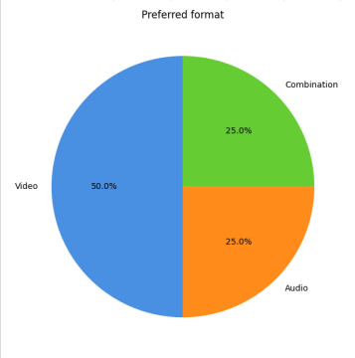
- Most learners prefer using videos for online studying
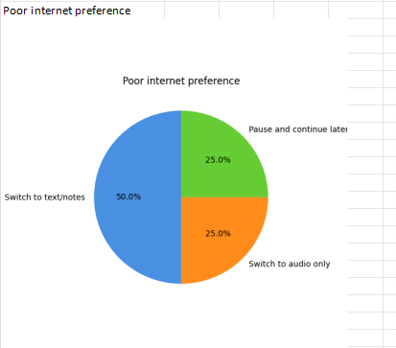

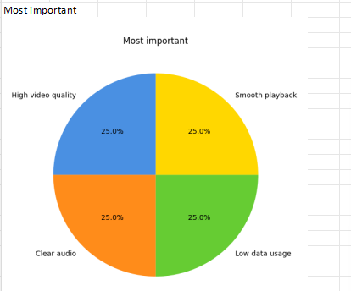
- All individuals will love having smooth playback, low data usage, high video quality and clear audio.

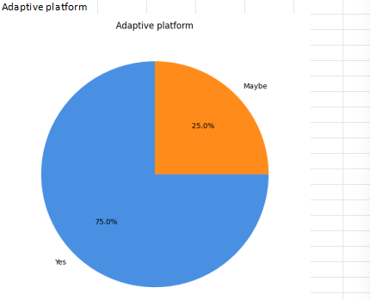
- A high majority prefered using an adaptive platform over one which is inflexible.

3.2.2 Clarity Analysis
Clarity analysis was conducted to ensure that all gathered requirements were understandable, specific, measurable, and free from ambiguity.
Several initial requirements collected during interviews and brainstorming sessions were found to be vague and difficult to implement directly. These requirements were refined into clearer and more measurable statements.
Original (Vague) Statement | Clarified Requirement Statement
The system should improve learning. | The system shall dynamically adapt content delivery switching between video, audio-only, and text modes, based on real-time network bandwidth measurements.
The platform should reduce interruptions. | The system shall automatically switch from video streaming to audio-only mode when available bandwidth falls below a configurable threshold, without requiring user intervention.
Users should be able to see their progress. | The system shall provide each student with a persistent dashboard displaying completed modules, quiz scores, and time-on-task metrics, updated after each session.
The app should be easy to use. | The system shall provide a user interface navigable by a first-time user within five minutes of installation, using a maximum of three taps to reach any primary function.

The refinement process improved the readability, consistency, and implementation feasibility of the requirements.
The clarity analysis also ensured that technical terms and stakeholder expectations were interpreted consistently throughout the requirement specification.

3.2.3 Technical Feasibility Analysis
Technical feasibility analysis evaluated whether the proposed requirements could realistically be implemented using the available technologies, project timeline, financial resources, and development skills.
The analysis confirmed that the proposed adaptive e-learning platform can be implemented using widely available and affordable development technologies.

Feature | Feasibility
User authentication & role management | High
Course content delivery | High
Real-time live lecture adaptation | Moderate
Offline content & synchronization | Moderate
Instructor adaptation control panel | Moderate

The feasibility review further determined that advanced artificial intelligence features such as predictive learning recommendations may require additional resources and could therefore be implemented in future system upgrades rather than the initial version.
The technical feasibility analysis confirmed that the proposed system can be developed within the available project scope and resource limitations.

3.2.4 Dependency Relationship Analysis
Dependency relationship analysis reveals the logical ordering and coupling between requirements. Some features cannot function without the prior existence of other capabilities. Mapping these dependencies is essential for sequencing development work correctly.
The analysis established that several platform operations depend on the successful completion of other operations.
For example:
- Users must register accounts before accessing the login system.
- Courses must be created before students can enroll.
- Students must enroll in a course before accessing quizzes.
- Learning progress tracking depends on recorded student activities.
- Certificate generation depends on successful course completion.
- Uploading learning materials depends on lecturer authentication.
The dependency analysis helped define the logical workflow of the platform and provided guidance for implementation sequencing.
The identified dependencies also improved understanding of how different system modules interact during operation.

3.3 IDENTIFICATION OF INCONSISTENCIES, AMBIGUITIES, AND MISSING INFORMATION
The requirement analysis process also involved identifying issues that could affect system implementation.

3.3.1 Inconsistencies
Some stakeholders proposed conflicting requirements regarding access to courses and learning materials.
Examples included:
- Some students preferred unrestricted access to all courses.
- Lecturers and administrators preferred controlled enrollment and restricted access.
To resolve this inconsistency, the platform was designed to allow lecturers and administrators to manage enrollment permissions.

3.3.2 Ambiguities
Some gathered requirements lacked specificity and required clarification.
Ambiguous Requirement | Improved Requirement
The system should work well | The platform should maintain stable performance under low-bandwidth conditions
Users should easily navigate the platform | The system should provide intuitive mobile friendly navigation menus
The platform should support online learning | The platform should support video lessons, quizzes, downloads, and assignments.

These ambiguities were resolved by rewriting the requirements into clear and measurable statements.

3.3.3 Missing Information
The analysis identified several missing but important system requirements.
The missing requirements included:
- Password recovery functionality
- Notification and announcement management
- Course search functionality
- Accessibility support
- Backup and recovery mechanisms
- User profile editing
These requirements were added to the final requirement specification.

3.4 REQUIREMENT PRIORITIZATION
The requirements were prioritized according to their importance and implementation feasibility.
Requirement Prioritization Table
Requirement | Priority Level | Reason
User registration and login | High | Essential for system access
Course management | High | Core learning functionality
Quiz and assessment system | High | Supports academic evaluation
Student progress tracking | High | Enables performance monitoring
Mobile responsiveness | High | Necessary for accessibility
Notification system | Medium | Improves communication
Offline learning support | Medium | Important in low resource settings
Discussion forums | Medium | Supports interaction
AI recommendations | Low | Advanced optional feature
Dark mode support | Low | Optional user enhancement

The prioritization process ensured that the most essential and feasible functionalities would be implemented first.

3.5 REQUIREMENT CLASSIFICATION
The system requirements were classified into functional and non-functional requirements.

3.5.1 Functional Requirements
Functional requirements define the specific behaviors and operations the system must perform. Each requirement is expressed using the 'The system shall…' convention to ensure unambiguity, testability, and traceability.

- User Authentication and Account Management
- The system shall allow students and instructors to register using a valid email address and a secure password.
- The system shall authenticate registered users via encrypted credential verification before granting access to any system resource.
- The system shall assign role-based access permissions distinguishing between student, instructor, and administrator accounts.
- The system shall allow authenticated users to reset their passwords via a verified email recovery process.
- Authenticated users should be able to log into the platform

- Course Content Access and Management
- The system shall provide students with access to video lectures, audio recordings, written notes, quizzes, and downloadable resources per enrolled course.
- Instructors should be able to create and manage courses
- The system shall allow instructors to upload, edit, delete, and organize course materials within assigned course channels.
- The system shall support downloading of course materials for offline access on the student's device.
- The system shall provide students with a searchable course catalogue to locate content by title, subject, or instructor.
- The system should calculate quiz scores automatically

- Adaptive Content Delivery
- The system shall dynamically adjust video stream quality selecting from a minimum of three resolution tiers (e.g., 1080p, 480p, 144p), based student / Instructor’s choice
- The system shall automatically switch from video streaming to audio-only mode when measured bandwidth falls below a system-defined minimum threshold.
- The system shall allow instructors to define preferred content delivery modes per lesson
- The system shall add on-screen subtitles as an accessibility fallback when audio quality is degraded.

- Live Lecture Support
- The system shall support live video lecture sessions initiated by instructors and accessible to enrolled students.
- The system shall provide real-time chat functionality during live sessions.
- The system shall automatically record live sessions and make recordings available to enrolled students after the session ends.

- Student Progress and Analytics
- The system shall maintain a persistent student dashboard displaying completed modules, quiz scores, and cumulative time-on-task per enrolled course.
- The system shall notify students of upcoming deadlines, newly uploaded content, and instructor announcements via in-app notifications.
- The system shall generate instructor-facing analytics reports summarizing student engagement and completion rates per course.

- System Administration
- The system shall allow administrators to create, suspend, and delete user accounts across all roles.
- The system shall provide administrators with system-wide performance monitoring including server load, active sessions, and error logs.
- The system shall enforce data validation rules during registration and content submission to prevent malformed or duplicate entries.

3.5.2 Non-Functional Requirements
Non-functional requirements specify the quality attributes the system must exhibit, not what it does, but how well it performs. These are equally binding as functional requirements and must be verifiable through testing, benchmarking, or inspection.

- Performance
- The system shall support a minimum of 200 concurrent user sessions without measurable degradation in response time.
- The platform should load pages within few seconds under normal conditions
- The system should be mobile responsive
- Course content pages shall load within few seconds

- Reliability and Availability
- The system shall maintain a minimum uptime of 99.5% measured monthly, excluding scheduled maintenance windows.
- Content downloads shall support pause-and-resume without requiring restart after interruption.
- The system shall queue user actions during temporary connectivity loss and synchronize them upon reconnection.

- Usability and Accessibility
- A first-time user shall be able to locate and begin their first content module within five minutes of account creation, without external instruction.
- The primary navigation path to any core function shall require no more than three taps from the home screen.
- The system shall support both English and French language interfaces.

- Security
- All data transmitted between client and server shall be encrypted
- User passwords shall be stored using a cryptographically secure hashing algorithm (e.g., bcrypt).
- User interaction data used for analytics shall be anonymized before storage.
- The system shall enforce rate limiting on authentication endpoints to mitigate brute-force attacks.

- Efficiency (Data and Battery)
- The application shall not consume too much mobile data during when learning
- Background QoE monitoring processes shall use interrupt-driven measurement to minimize CPU wake events and battery drain.
- The application shall implement local content caching to reduce repeated data downloads.

- Scalability and Maintainability
- The system architecture shall accommodate a tenfold increase in user base without requiring re-architecture of core components.
- System modules shall be loosely coupled to allow independent updating of the adaptation engine, content delivery, or analytics module.

3.6 REQUIREMENT VALIDATION
The analyzed requirements were validated with representative stakeholders including students and lecturers.
Stakeholders confirmed that the proposed system functionalities addressed the major challenges associated with online education in low-resource settings.

3.7 CONCLUSION
The requirement analysis process helped refine, organize, and validate the requirements for the adaptive e-learning platform. Through completeness analysis, feasibility assessment, prioritization, classification, and stakeholder validation, the gathered requirements were transformed into a structured and implementable specification.
The final Software Requirement Specification provides a strong foundation for the next phases of system design and implementation. The analysis also ensured that the platform aligns with the educational realities and technological limitations of low-resource settings, thereby improving the feasibility, accessibility, and effectiveness of the proposed solution.

3.8 REFERENCES
Pressman, R. S., & Maxim, B. R. (2020). Software engineering: A practitioner's approach (9th ed.). McGraw-Hill.
Sommerville, I. (2016). Software engineering (10th ed.). Pearson.
ISO/IEC 25010:2011. (2011). Systems and software quality models. International Organization for Standardization.
ITU-T Recommendation G.1010. (2001). End-user multimedia QoS categories. International Telecommunication Union.
Cohn, M. (2004). User stories applied: For agile software development. Addison-Wesley.

