Structure of Master’s thesis

**„A Bayesian Model for Pediatric Chronic Pain“**

1. Background
   1. Chronic Pain   
      Definitions (functional & time-based) and distinctions from acute pain, epidemiology, economic impact Etiology (Vlaeyen’s fear avoidance model), the role of expectations, 🡪 Interoceptive predictive coding
   2. (Interoceptive) Predictive Coding and Computational Psychiatry   
      Basic ideas of the Bayesian Brain and predictive coding, describe insights from interoceptive predictive coding   
      Applications to clinical psychology (pain, “hysteria”): Evidence for Bayesian pain (sensations ≠ perceptions…)   
      The role of attention, attention from a free energy perspective, Free energy learning 🡪 Model parameters   
      Why computational approaches to clinical psychology and psychiatry?
2. Model (HMM)
   1. Model requirements   
      Fokus: Übersetzung des psychologischen backgrounds in ML slang   
      time-series with message passing (expectations 🡪 perceptions) to illustrate learning and attention.   
      Hierarchies: hidden (latent) conditions and sensations (observable)   
      Introduction of HMM: advantages of HMM and why it is so cool for the purpose of modeling chronic pain etiology
   2. Model parameters   
      Hidden variables, factor structure, sensations, free energy learning, attention   
      Sum-product algorithm for message-passing in Bayesian networks   
      Introduce Bayesian Network (and/ or factor graph)
   3. Hypotheses  
      Parameterräume: wie kommen wir in chronic pain an?
3. Simulations
   1. Hypotheses tests   
      The role of a heightened pain prior, the role of learning over time, the role of a bad sample and what parameter settings will lead to the development of chronic pain starting from that sample, the role of attention and interoceptive sampling differences
   2. Results and visualization   
      Plotten: distributions. Lerntrajektorien wenn wir noch zu dem Lernen kommen. In welchen Regionen gibt es Pain, in welchen keinen???
   3. Discussion and conclusion: simulation results
4. Chronic Pain Questionnaire Data: Model comparison
   1. Questionnaire description   
      Expectations and likelihood stuff and how it is assessed in the questionnaire
   2. Model comparison   
      Introduce Information criteria and Bayesian model comparison framework   
      Results 🡪 minimal surprise: wo wird sie am kleinsten also die surprise der Daten?   
      Trajektorien im Raum… Mit Start und Endpunkten…
   3. Discussion and conclusion: model comparison
5. Experimental data (Probably not)
   1. Description of experimental paradigm
   2. Model comparison
   3. Discussion and conclusion

**Welche Simulationen wären sinnvoll?**

Healthy controls: prior 500, 0.8 no pain,   
100, pain-pain = 0.3, nopain – pain = 0.2,   
100, pain-noci=0.9, nopain,tickle=0.9

1. Healthy parameters: keine observations
2. Healthy parameters: gute observations
3. Healthy prior: very precise (1000), gemischte observations (0-5 tickle, 12-18 noci)
4. 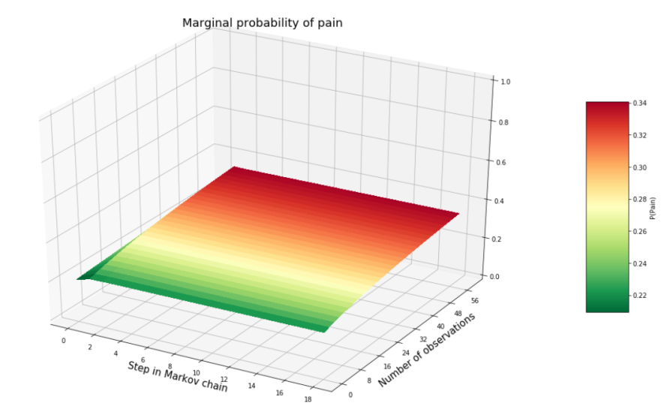Healthy prior: imprecise (1), gemischte observations (0-5 tickle, 12-18 noci)

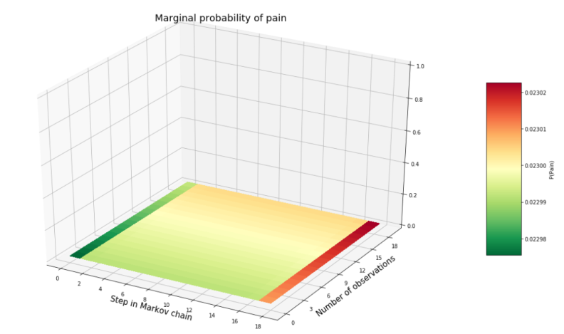

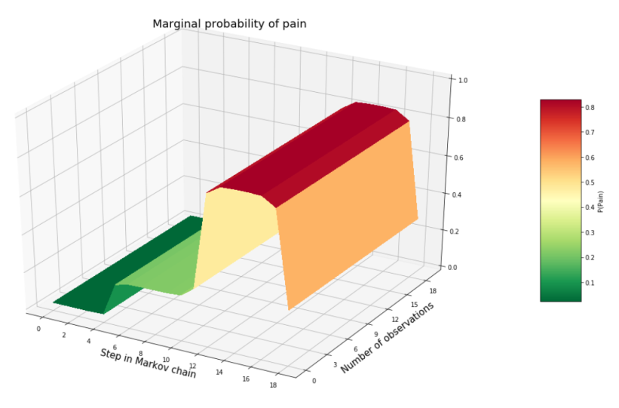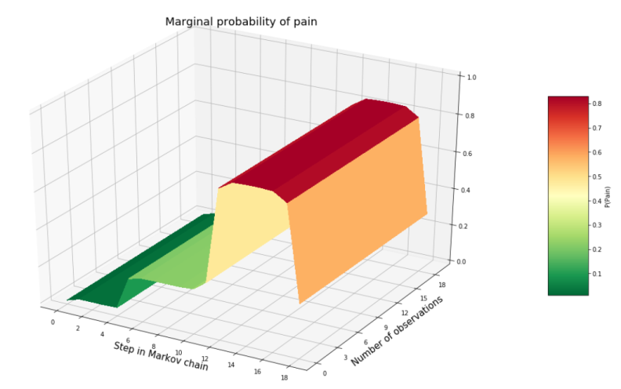

Patient:

1. Keine observations
2. Gute observations: Sick likelihood, sick prior, tickle all
3. Gute observations, healthy likelihood, nur die ersten 15 tickle
4. Sick prior, healthy likelihood, all tickle 🡪 wie lange, bis dann kein pain mehr?
5. Sick prior: very precise, gemischte observations (0-5 tickle, 12-18 noci)
6. Sick prior: imprecise, gemischte observations (0-5 tickle, 12-18 noci)
7. Sick hidden prior

Keine observations:

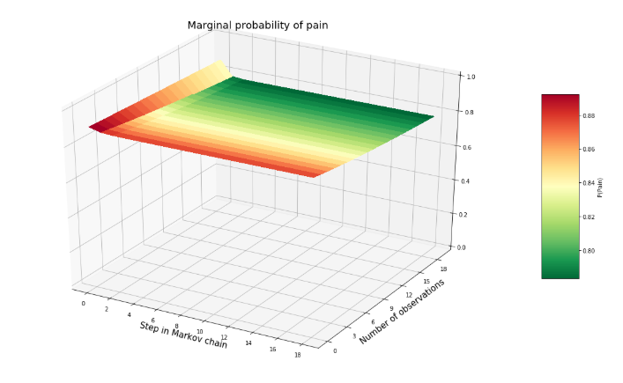

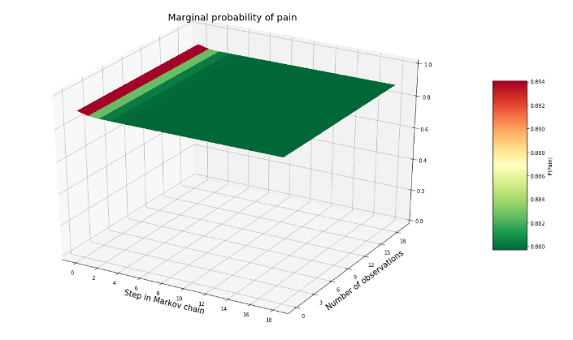Sick likelihood and prior but all tickle:

Sick prior and healthy likelihood and all tickle: 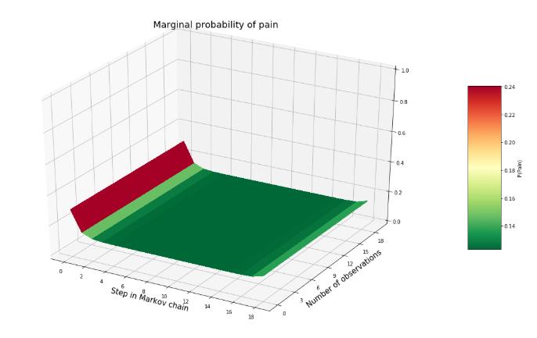

Nur die ersten 15 tickle:

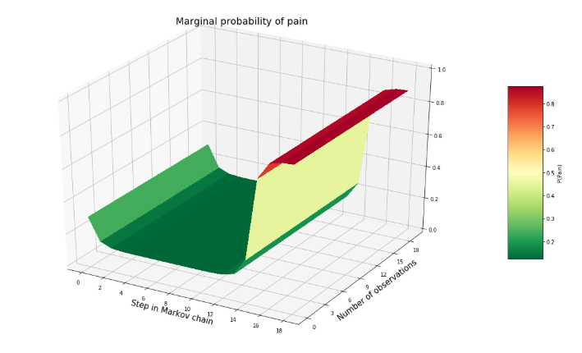

Precise prior, gemische Beobachtungen (0-5 tickle, 12-18 noci)

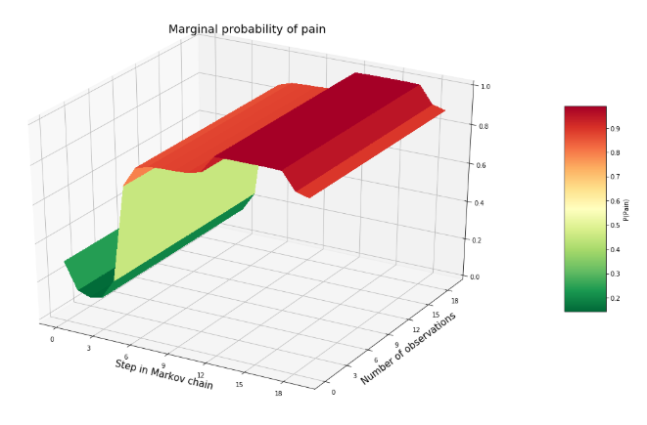

Imprecise prior, gemische Beobachtungen (0-5 tickle, 12-18 noci)

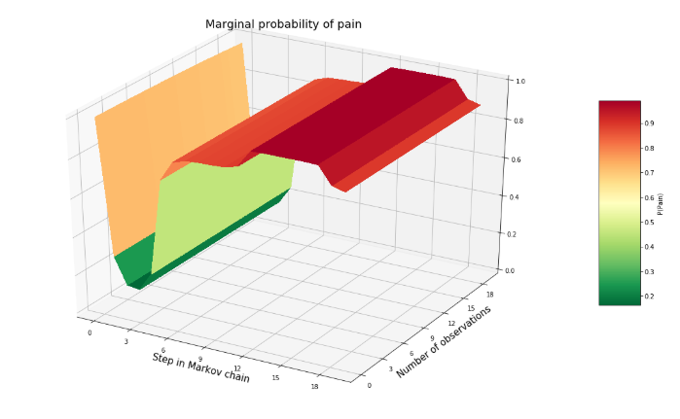

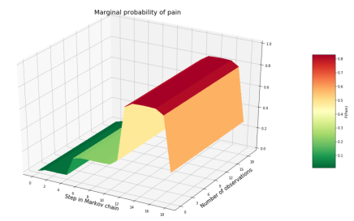

Healthy: