Tone 1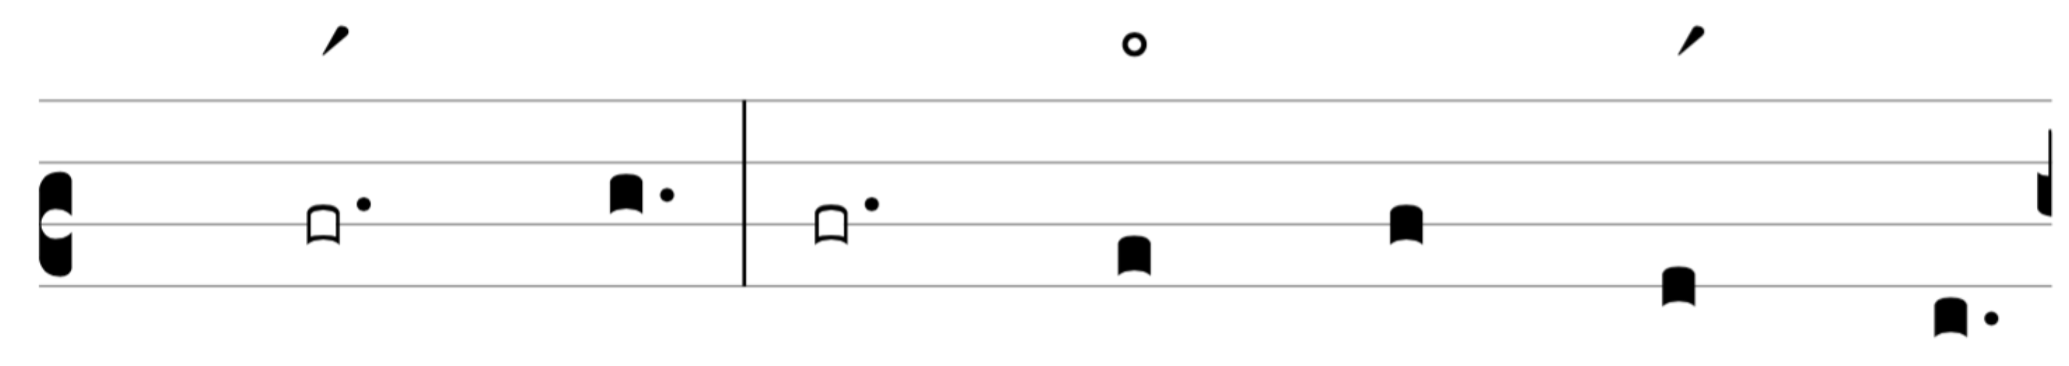

Tone 2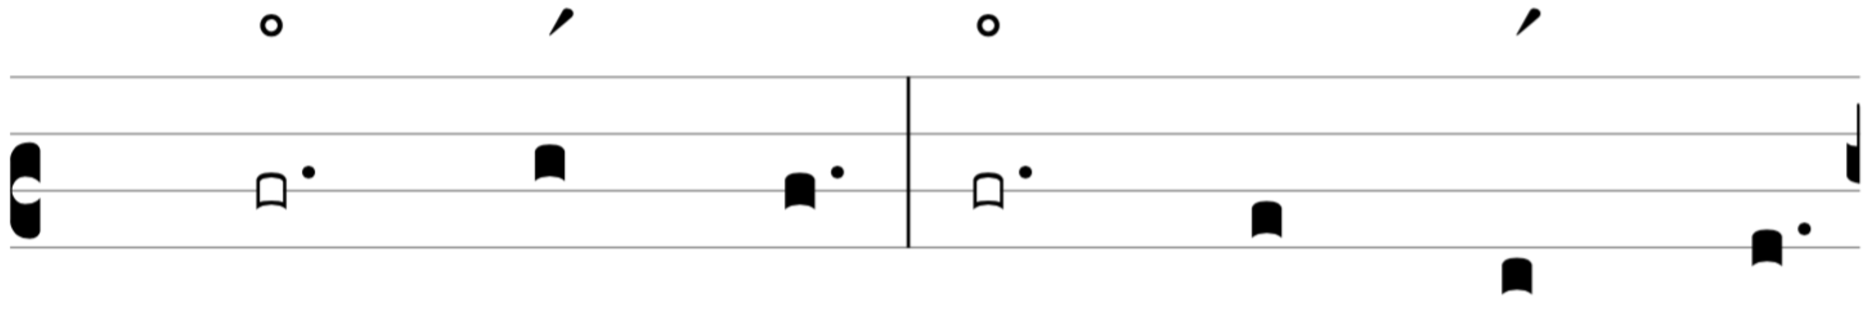

Tone 3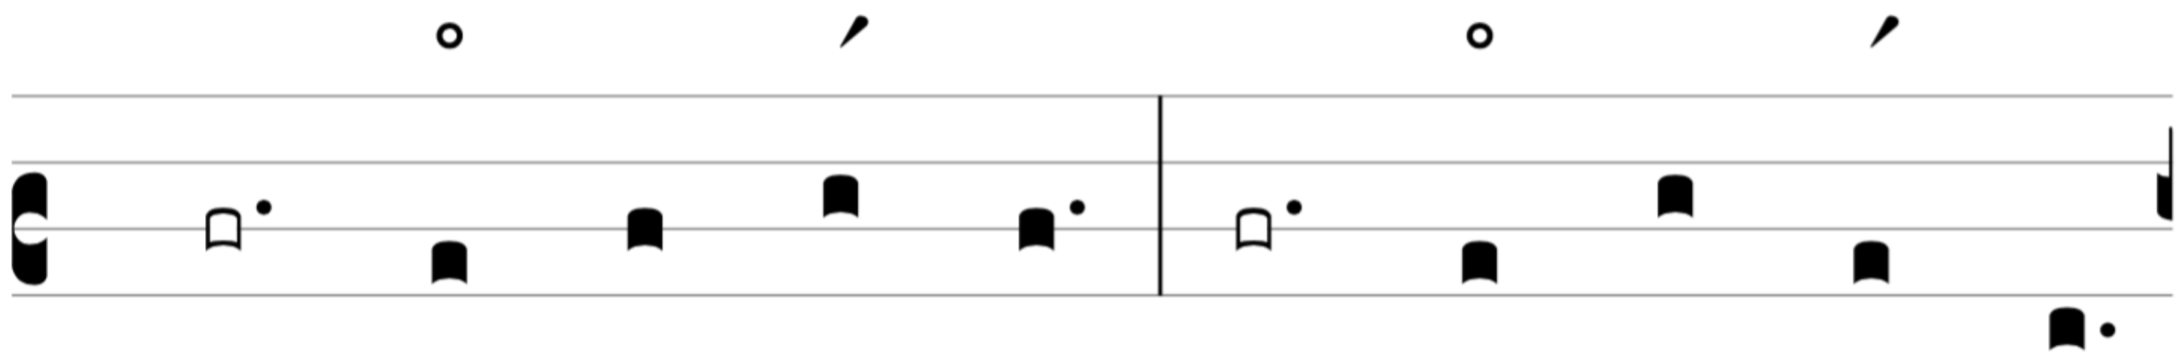

Tone 4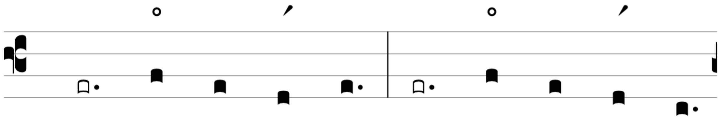

Tone 5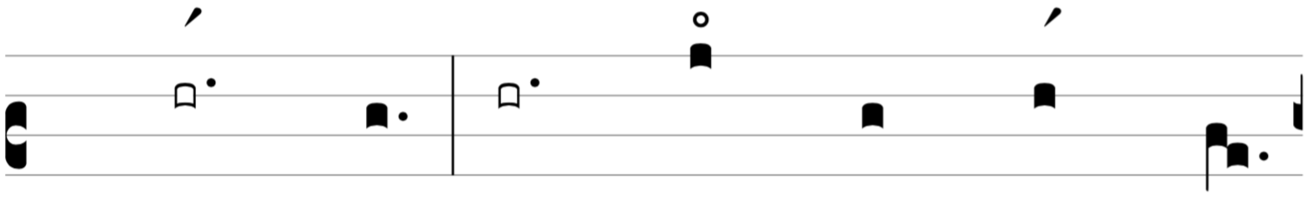

Tone 6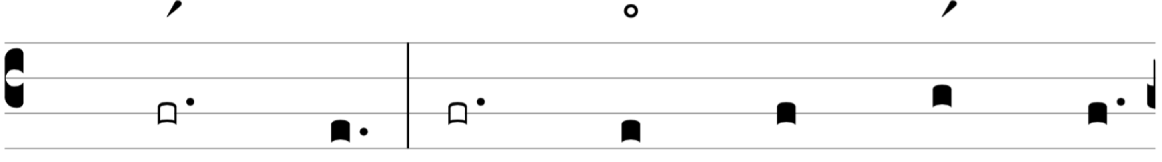

Tone 7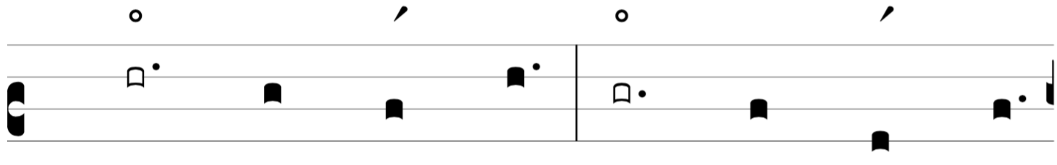

Tone 8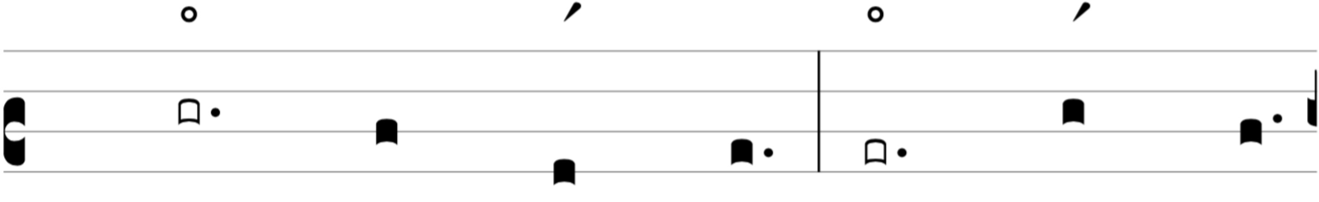

Tone 9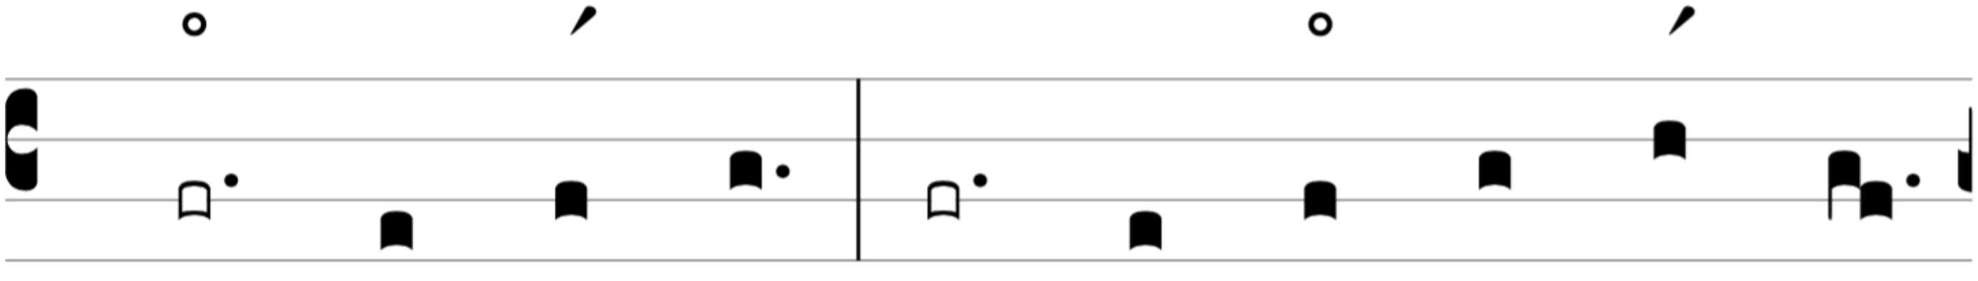

Tone 10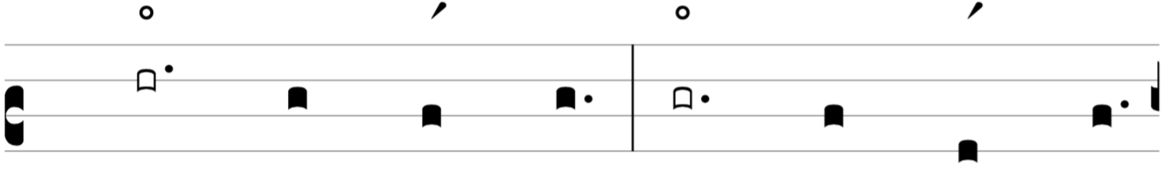

Tone 11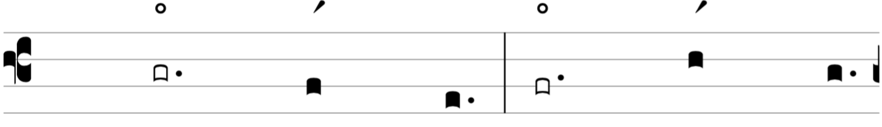

Tone 12