# COSC 3318: Database Management Systems

# (Assignment 1)

**Assigned on September 11, 2017 Hardcopy due at the start of class on September 25, 2017.**

Consider the following tables:

Student (sid, sname)

Enrolled (sid, cid）

Course (cid, professor)

×, ∞, π, σ, ≥, ∩, -, Ս, ≤

Give the following queries in **Relational Algebra** (50 points).

1. **What are the names of students enrolled in ‘cs3020’?**

∏ sname (σ cid = ‘cs3020’ (student ∞ enrolled))

1. **Which courses is ‘Victor’ taking?**

∏ cid(σ sname = ‘victor’ (student ∞ enrolled)

1. **Who teaches ‘cs1500’?**

Π professor(σ cid = ‘cs1500’ (course))

1. **Who teaches ‘cs1500’ or ‘cs3020’?**

Π sname (σ cid = ‘cs1500’ or cid = ‘3020’ (course))

1. **What are the names of students in ‘cs1500’ or ‘cs3010’?**
2. Π professor (σ cid = ‘cs1500’ (student ∞ enrolled ) ) Ս Π sname (σ cid = ‘cs3010’ (student ∞ enrolled ) )

**Given the following table schema of student, enrolledIn, and subject:**

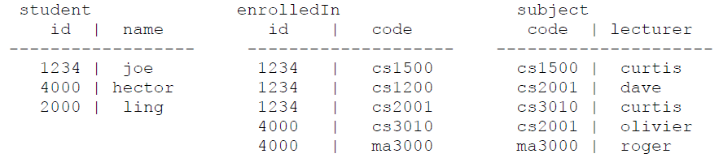

**Figure out which Relational Algebra expressions were used to obtain each of the following tables (50 points).**

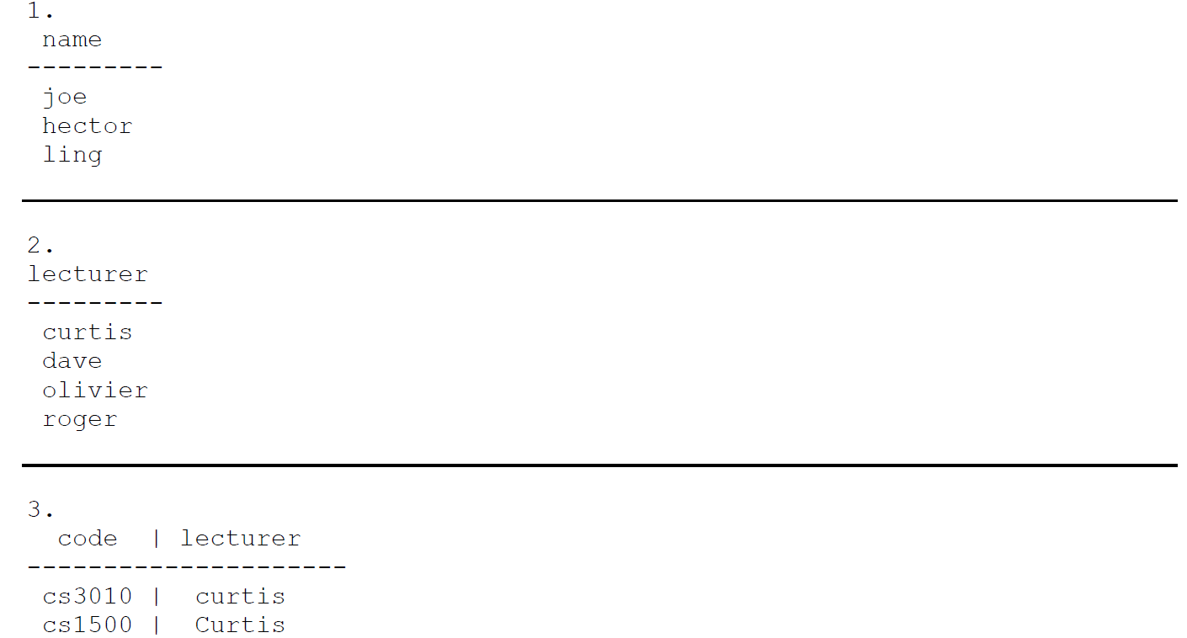

1. Π name(student)
2. Π name(lecturer)
3. σ code = ‘cs1500’ or code = ‘cs3020’ (subject)

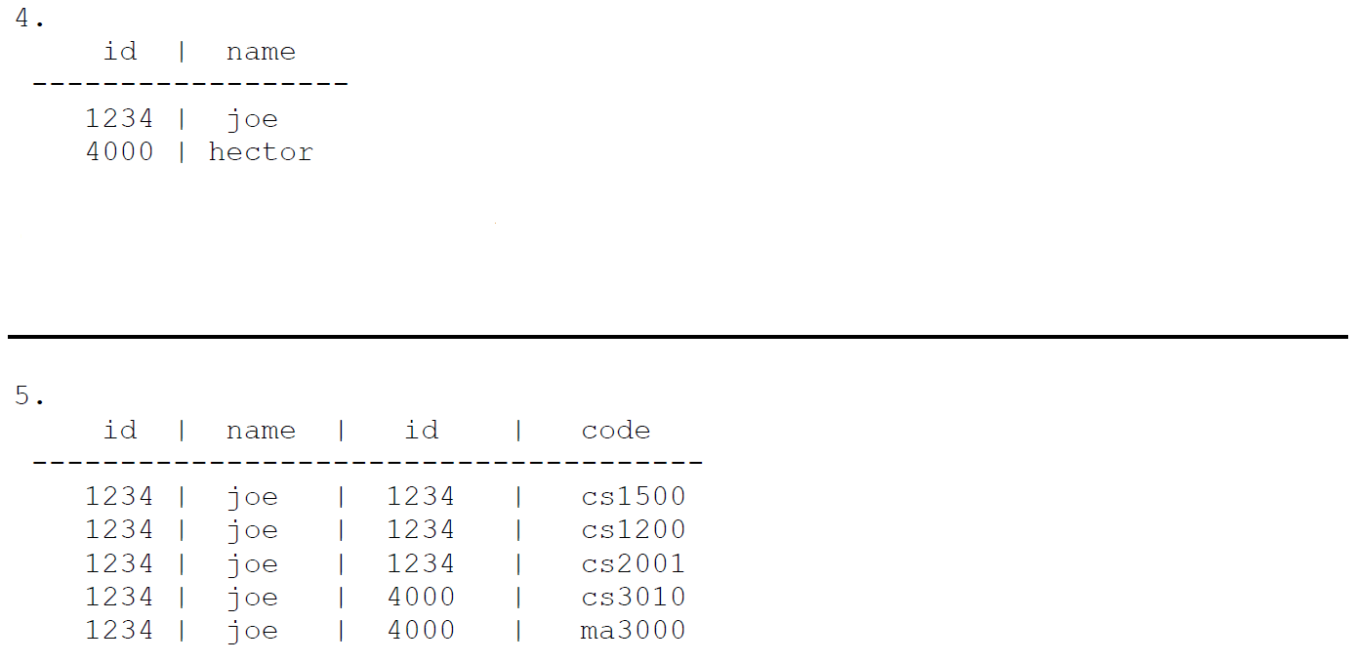

1. σ name = joe or name = hector (student)
2. σ id = ‘1234’ (student ∞ enrolledIn)