1. 1. SELECT login from “Table” where name=’Madayan’ or name=’guldu’;
   2. You would receive just Guldu’s table:

|  |  |  |  |  |
| --- | --- | --- | --- | --- |
| **sid** | **name** | **login** | **age** | **gpa** |
| 53832 | Guldu | guldu@music | 12 | 2.0 |

1. 1. 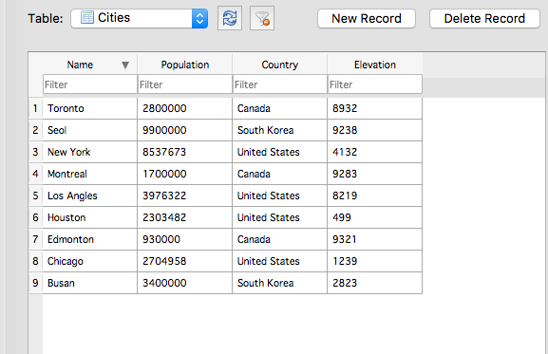
   2. 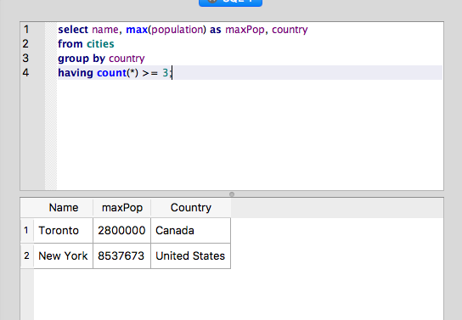

Product (make, model, type)

PC (model, speed, ram, hd, price)

Laptop (model, speed, ram, hd, screen, price)

Printer (model, color, type, price)



SELECT *

FROM laptops

WHERE speed < ALL

(SELECT speed FROM PC)







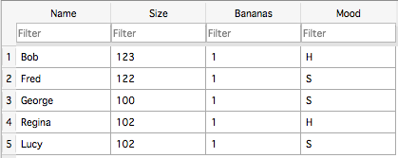

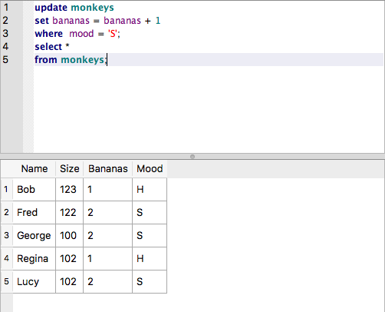

1. 1. It looks like since ‘model’ is in all the tables, it’ll be the primary key in table ‘Product’ and both primary and foreign keys in ‘PC’ , ’ Laptop’ , and ‘Printer’

CREATE TABLE PC (

"model" Integer,

"speed" double precision,

"ram" double precision,

"hd" text,

"price" numeric,

PRIMARY KEY ("model") ,

FOREIGN KEY ("model") REFERENCES "Product"("model")

);



CREATE TABLE Printer (

"model" Integer,

"color" text,

"type" text,

"price" numeric,

PRIMARY KEY ("model"),

FOREIGN KEY ("model") REFERENCES "Product"("model"),

CHECK (price <= 450)

);