Note: the software I was using was LucidChart. As far as I could tell, there is no way to draw only lines. The arrows when I use them are the fat arrows. The smaller regular arrows are just how I connected them. I’m sorry.

1

A



B

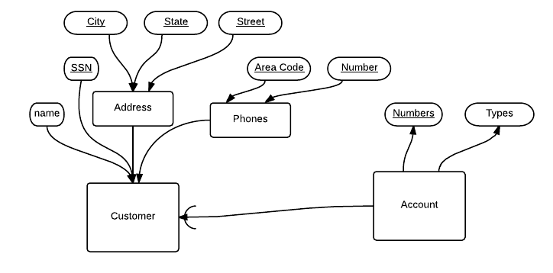

C

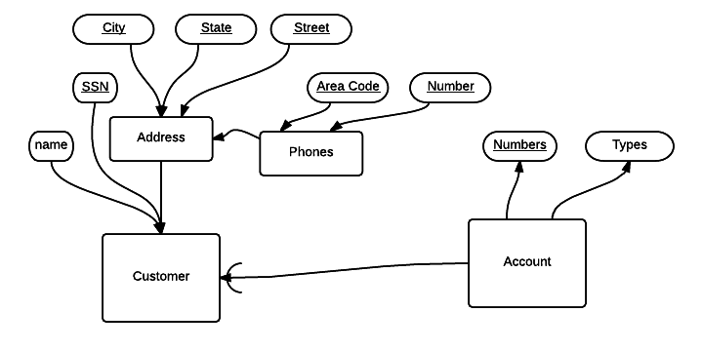

2

A



B



5.1) 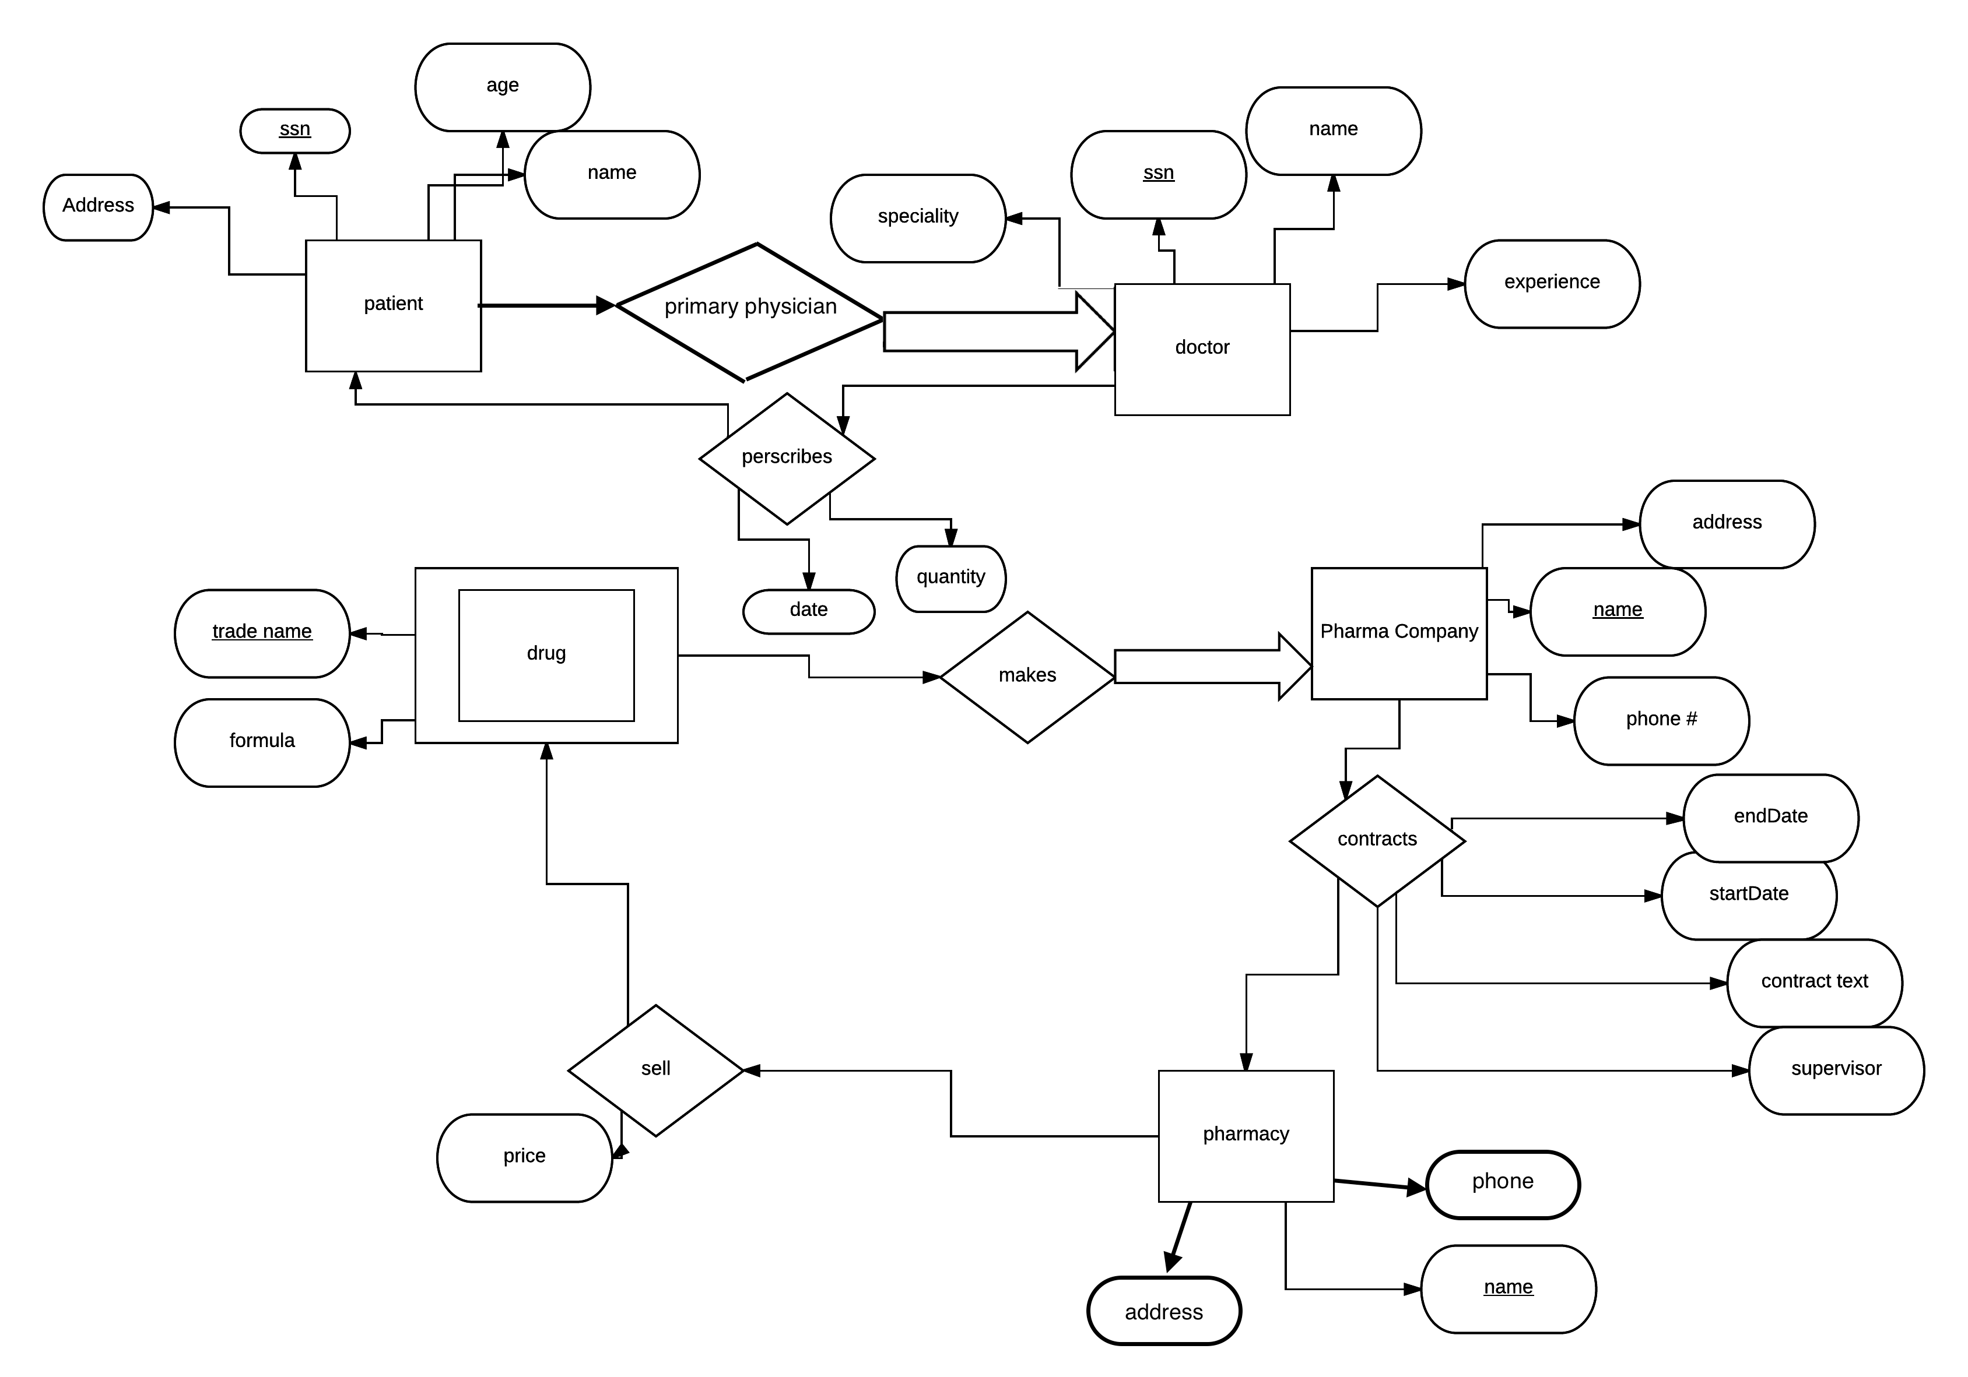

5.2) I would place price on the pharmacy instead of the sells.

5.3) I would show the duplicates under prescribes