**\COSC3331 Human-Computer Interaction**

**QUIZ-3 (Take Home)**

**Assigned on April 20, 2017. Submit your assignment through blackboard by midnight on April 21, 2017.**

1. Make your own dialog app. A dialog as shown below pops up when you click on the “Show Dialog” button. The dialog dismisses when you click on the “Ok” button.

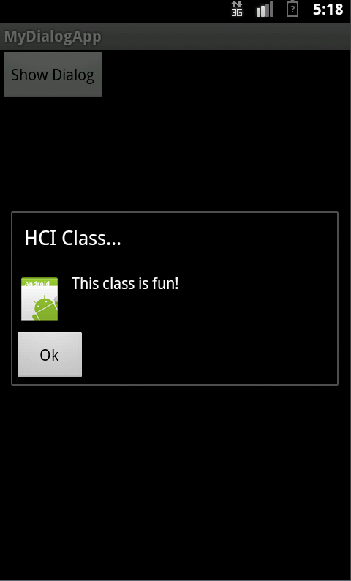

**How to turn your work in:**

1. Zip your project folder and submit the zipped file to blackboard.
2. Capture the screen of your Emulator with the final testing results and submit the screen shot to blackboard.