Buoy Problem

The Texas Department of Gulf Resources has decided to install a network of 200 buoys in the Gulf of Mexico to aid navigation and help commercial fisherman in tracking fish migrations. Each buoy is to be equipped with a variety of wind direction, wind speed, air temperature, current direction current speed, water temperature, and salinity. Each buoy is equipped with a radio transmitter and receiver as well as a global positioning system. The buoys are free-floating. Passing ships may radio the buoy to transmit its weather and ocean conditions for the past 24 hours or to initiate and SOS broadcast. An SOS broadcast may also be started by physically engaging a switch on the side of the buoy. Buoy software must be written to:

• Maintain the current average wind direction, air temperature, wind velocity, water temperature, salinity and direction of current. Wind and current readings are to be taken every 30 seconds and averaged in groups of 4 to give a true reading. Air and water temperature readings are to be taken every 15 seconds and averaged in groups of 20. All other readiness are to be taken once a minute and averaged in groups of 5.

• Broadcast the most current data to a land based station every hour.

• Broadcast all available data to passing ships on demand. This is to take precedence over periodic broadcast.

• Activate the emergency SOS broadcast when requested by radio or the emergency switch being physically engaged. The SOS is to be broadcast every 10 seconds until the system is reset. This broadcast is to take priority over all other activities.

NCC - 767 ENTERPRISE

The Starship Enterprise is equipped with a variety of lighting, temperature, CO2, oxygen, and radiation sensors. Each sensor operates independently. However, we have the flexibility of polling each sensor for its most recent data point (average reading) or having the sensor post the reading to us automatically. Sensor and control software must be written to:

• Maintain the current average lighting, temperature, CO2, oxygen, and radiation level readings. Lighting, temperature, and CO2 readings are to be taken every 30 seconds and averaged in groups of 10 to produce true readings. Oxygen must be measured every 2 seconds and averaged in groups of 5 readings. Radiation readings are to be taken every 20 seconds and averaged in groups of three readings. Readings must be maintained for a 24 hour period.

• Readings for the preceding hour are to be broadcast to Star Fleet Command every hour.

• Allow technicians to browse the last 24 hours worth of data on demand from the system console.

• Readings should be made available to the central computer on demand. These requests are to take priority over all other requests.

Data Flow Diagram

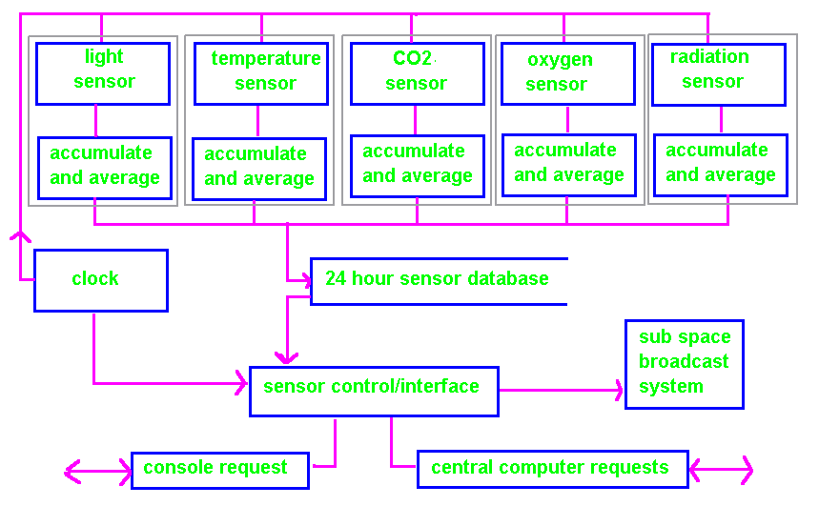

POTENTIAL REUSE:

• The 24 hour database.

• The function to accumulate and calculate averages.

Note the data flow diagram does not reflect timing considerations or how the system appears from the users point of view. A timing model and user model are required to complete the design.
Object Oriented Solution

Light Sensor |  | Temp Sensor |  | CO2 Sensor
data structures: |  | data structures: |  | data structures:
methods:  calibrate();  turn-on();  turn-off(); |  | methods:  calibrate();  turn-on();  turn-off(); |  | methods:  calibrate();  turn-on();  turn-off();

Oxygen Sensor |  | Radiation Sensor |  | Database
data structures: |  | data structures: |  | data structures:  must be able to  tailor data type
methods:  calibrate();  turn-on();  turn-off(); |  | methods:  calibrate();  turn-on();  turn-off(); |  | methods:  put(x);  get(x);  end-of-data();

The following design and implementation decisions have been made:

• each instrument will deposit average (true) readings in the database automatically as they become available, and

• there will be a separate database for each sensor type.

These decisions imply that each instrument can access the system clock.

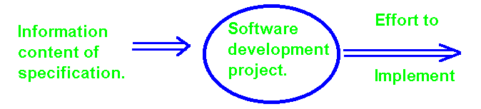

Object Diagram

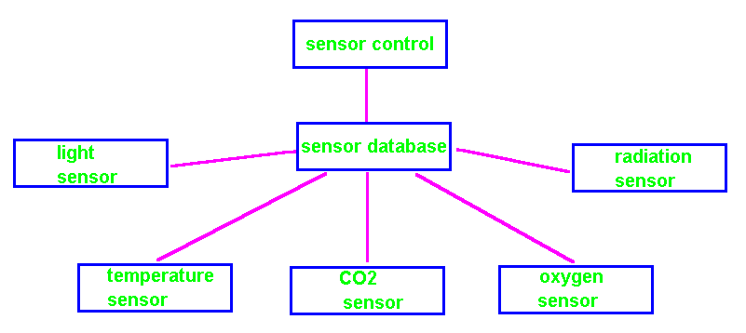

Class Diagram
Refinement of Class Sensor!

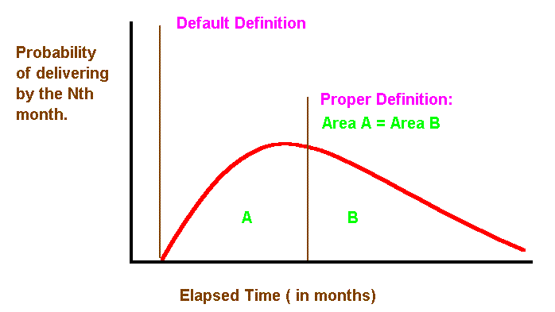

All sensor classes will have to know how to direct deposit into the database.

