Halstead’s Software Science

Summary by

David S Burris

Ph.D. in Computing Science

Certified Computer Programmer

Certified Systems Professional

Certified Computing Professional

csc_dsb@shsu.edu

Permission is granted to students in my classes to use any or all of the material in this document for their personnel educational in conjunction with course textbooks. All other rights reserved. Materials may not be transmitted to individuals not registered in my classes.

“Elements of Software Science”

by

Maurice H. Halstead

ISBN 0-444-00205-7,, North Holland, 1977

(Halst1.doc)

Bohrer, Robert, Halstead’s Criterion and Statistical Algorithms, Proceedings if the Eigth Annual Computer Science/Statistics Interface Symposium, Los Angeles, February 1975, pp 262-266.

CENTRAL HYPOTHESIS:
The information content of the output (of a coded system) is a well-behaved function of the information content of the input (the specification).

It follows from this project implementation effort is a function of the information content of the specified requirements.
Elements of Software Science
Define:
n1 = number of unique operators
n2 = number of unique operands
N1 = total usage of all operators
N2 = total usage of all operands
f_{1,j} = number of occurrences of the jth most frequently occurring operator, where j = 1, 2, ..., n1.
f_{2,j} = number of occurrences of the jth most frequently used operand, where j = 1, 2, .., n2.

Define the vocabulary n = n1 + n2.

Define the implied length N = N1 + N2. The length of a computer program is measured by the sum of its operators (N1) and operands (N2).

Example: Euclid Algorithm or GCD by Clausen, Communications of the ACM in early form of Algol:

IF(A=0)
LAST: BEGIN GCD := B; RETRUN END;
IF(B=0)
BEGIN GCD := A; RETURN; END;
HERE: G := A/B; R := A - B x G;
A := B; B:= R; GO TO HERE;
IDEA: An algorithm consists of operators and operands, and nothing else.
Operator | j | f_{1,j} |  | Operand | j | f_{2,j}
; | 1 | 9 |  | B | 1 | 6
:= | 2 | 6 |  | A | 2 | 5
( ) or BEGIN ... END | 3 | 5 |  | 0 | 3 | 3
IF | 4 | 3 |  | R | 4 | 3
= | 5 | 3 |  | G | 5 | 2
/ | 6 | 1 |  | GCD | 6 | 2
- | 7 | 1
x | 8 | 1
GO TO HERE | 9 | 1
GO TO LAST | 10 | 1
 | n1 = 10 | N1 = 31 |  |  | n2 = 6 | N2 = 21

The length N = N1 + N2 may be apporximated as

Nh = n1 log₂ n1 + n2 log₂ n2.

For Euclid’s Algorithm, Nh = 10 log₂ 10 + 6 log₂ 6 = 33 + 16 = 49.

Testing Length Algorithm 1 - 14 from CACM
Alg # | N | Nh |  | Alg# | N | Nh
1 | 104 | 104 |  | 8 | 131 | 117
2 | 82 | 77 |  | 9 | 314 | 288
3 | 453 | 300 |  | 10 | 46 | 52
4 | 132 | 139 |  | 11 | 53 | 52
5 | 123 | 123 |  | 12 | 59 | 62
6 | 98 | 101 |  | 13 | 59 | 57
7 | 59 | 62 |  | 14 | 186 | 163

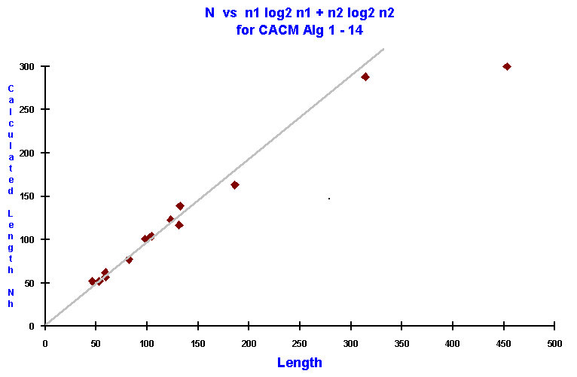

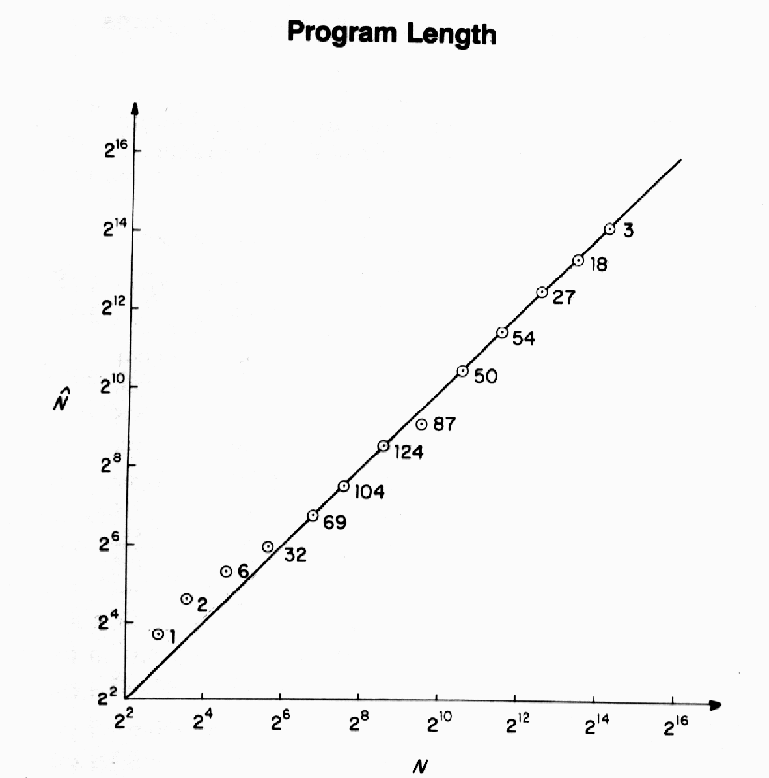
Elshoff’s independent validation of the length equation for 120 commercial PL/1 programs at General Motors with a combined total of 100,000 statements. Elshoff reported a correlation between N and Nh of 0.98, summarizing the data as follows:

Class  2^{I} < N < 2^{i+1}  I | Number of  Programs in  Class | Mean | Values
 |  | N | Nh
14 | 3 | 18,592 | 19,091
13 | 17 | 10,685 | 11,049
12 | 23 | 5,751 | 6,005
11 | 39 | 3,165 | 3,318
10 | 17 | 1,590 | 1663
9 | 11 | 831 | 911
8 | 4 | 369 | 522
7 | 5 | 198 | 195
6 | 1 | 122 | 129
----- | ----- | --------- | ---------
Totals | 120 | 41,303 | 42,883
Independent confirmations of the length equation were made by Robert Bohrer (1975) at the University of Illinois, and at the University of Purdue using 429 Fortran library routines (0.95 corr).

Program Volume:
V = N log2 (n1 + n2) = N log2 n where n = n1 + n2

V should be thought of as the number of bits needed to represent a given program in the main memory of a special-purpose computer designed to execute the program.

V is highly correlated with:
- Expected effort in writing and debugging programs
- The expected number of bugs (errors) in the development process.
- Residual bugs.

V* = n* log2 n* where n* = n2* + 2 and n2 is the number of input/output parameters in the subprogram call.

V* represents a hypothetical lower bound in program volume which can only be obtained when an algorithm is represented by its name and its input/output parameters.

V* is calculated from the minimum number of input and output parameters needed to specify the operation of an algorithm and return the result.

Normally V can only be directly measure and V* is not discernable from knowledge of the algorithm.

Halstead introduced an alternate measure for L denoted as Lh where

Lh = (2/n1) * (n2/N2).

n1 = number of distince operators, subprogram calls, and jump desitinations used in the program.

n2 = number of distinct variables, data constants, and table or array names used.

N2 = total operands

Halstead then demonstrated that, for algorithms programmed in a selected language, such as Fortran, PL/1, or assembler, a value λ can be found such that (Lh)**2 * V = λ over all algorithms programmed in the language.

Fortran λ = 1.14

PL/1 λ = 1.53

Assembler λ = 0.88

English λ = 2.16

Programming Effort:

T = V / (18 * L) where T is the time in seconds to code and proffread an algorithm from its detailed description.

T = (V*)³ / (18 * λ² )

Correlation on the time to program algorithms above 0.85 are common.

