Prototyping

by

David S Burris

Ph.D. in Computing Science

Certified Computer Programmer

Certified Systems Professional

Certified Computing Professional

csc_dsb@shsu.edu

Permission is granted to students in my classes to use any or all of the material in this document for their personnel educational in conjunction with course textbooks. All other rights reserved. Materials may not be transmitted to individuals not registered in my classes.

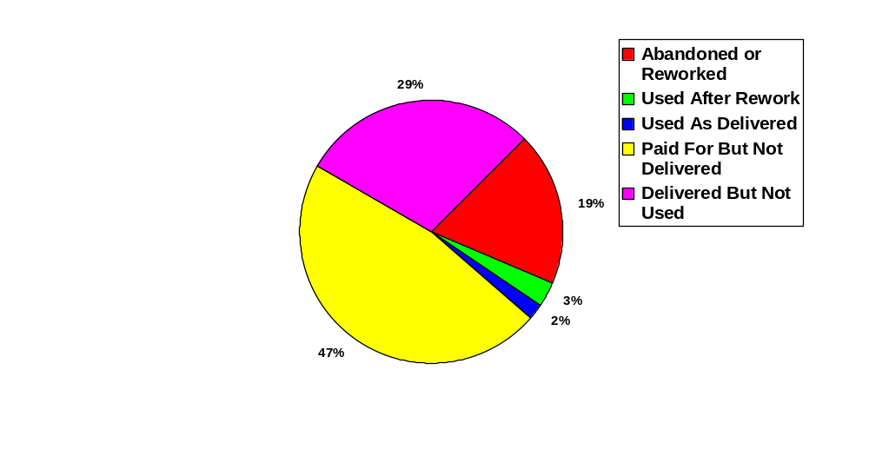
47% or $3.2 million paid for but not delivered.

29% or $2.0 million delivered but not use.

19% or $1.3 million abandoned or reworked.

3% use after rework.

Less than 2% used as delivered.

U.S. Government Accounting office, 1979, report (FGMSD-80-4) for $6.8 million in nine federal software projects:

Poor Success Rate in Large Projects!
Requirements analysis is a software engineering function that bridges the gap between system level software allocation and software design.

While it may seem relatively simple, even trivial, chances for misinformation abound.

Analyst's Task

1) Problem Definition.

2) Evaluation and synthesis.

3) Specification.

4) Review.

Software Myths

Myth: A general statement of objectives is sufficient to begin writing programs. The details can be filled in latter as they become available.

Reality: Poor initial definition is a major cause of development failure. A detailed formal description of information domain, function, interfaces, design constraints, and validation criteria is essential.

Myth: Project requirements are subject to continual change, but change can be accommodated easily because software is flexible.

Reality: The impact of change varies with the time it is introduced.
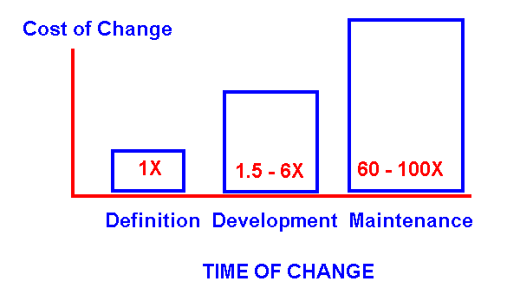
We continually under estimate the value of including the customer in the development of software throughout the entire life cycle.

REASONS FOR FUNCTIONAL PROTOTYPES AS OPPOSED TO FULLY FUNCTIONAL DESIGNS

Classic Waterfall Life Cycle
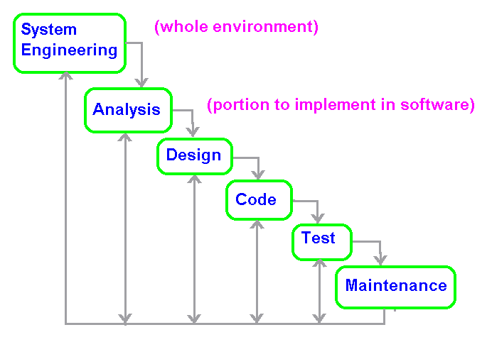
The paradigm demands a systematic, sequential approach to development.

Problems:
1) Real projects rarely follow the sequential flow proposed by the model. Iteration always occurs and creates problems in model application.

2) It is frequently difficult or impossible for the customer to state all requirements explicitly. The waterfall model has difficulty accommodating this natural uncertainty.

3) The customer must be patient. A working version of the software will not be available until late in the project. A major blunder not detected until the software is reviewed means disaster.

Roger S. Pressman, "Software Engineering A Practitioner's Approach," 3rd ed., pp. 25-28, ISBN 0-07-050814-3.
Prototyping Life Cycle
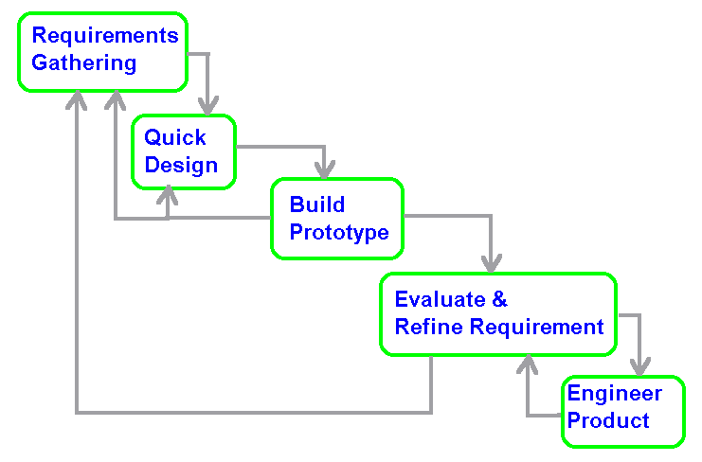
Prototyping appears to best if:

1) The customer has a set of general objectives for software, but cannot identify all the detailed inputs and / or outputs, or processing requirements.

2) May not be sure of the efficiency of an algorithm or the best approach to solving the problem.

3) Not sure of the operating environment or its adaptability.

4) Unsure of the form that the man-machine interaction should take.

Prototypes may be:

• a fully or partially functional model,
• a paper model (picture show) displaying user screens and interactions.

One Attempt: Agile Development
Frederick Brooks:
"The Mythical Man-Month"

"In most projects, the first system built is barely usable. It may be too slow, too big, awkward, or all three. There is no alternative but to start again, smarting but smarter, and build a redesigned version in which these problems are solved. - - - When a new system concept or new technology is used, one has to build a system to throw away, for even the best planning is not so omniscient as to get it right the first time. The management question, therefore, is not whether to build a pilot system and throw it away. You will do that. The only question is whether to plan in advance to build a throwaway, or to promise to deliver the throwaway to customers."

1975: ISBN 0-201-00650-2
Reasons for Functional Prototypes as Opposed to Fully Functional Designs / Implementations

1) User needs can normally only be partially defined with respect to the development of new systems. The ideal solution or best compromises are not normally obvious.

2) Prototyping encourages end user involvement. Their participation helps to produce a higher quality design with higher probability of user acceptance.

3) Prototypes cost less to build than fully functional systems and allow the end user to interact in days or weeks rather than months or years.

4) Prototypes allow the systems analysts and systems designer to validate the logical and technical system specification in conjunction with the user. It serves as a blueprint for the final product.

5) The use of stubs, code generators, simplistic coding techniques (e.g., sequential search versus a binary search) database products and query languages as opposed to custom implemented file systems, typically reduce cost in building the model.

PROTOTYPING PROBLEMS

1) The customer sees a working model, s/he is unaware that it is held together with "chewing gum and baling wire," that no thought was given to quality, maintenance, modification, documentation or efficiency. The customer cries "foul" - what do you mean that the implementation is only about to begin! The customer expects you to make any necessary modifications to the prototype and deliver the software without any additional hidden cost.

2) The developer often makes implementation compromises in order to get a prototype working. An inappropriate operating system or programming language may be used to facilitate the development time or cost. A less than optimal algorithm may be used to demonstrate capability. After awhile the developer become comfortable with the inappropriate choices and forgets why they were made. Under pressure to produce the final product, parts of the system are never converted to the proper form. The less-than-ideal choices have now become an integral part of the final system.
PROTOTYPING PARADIGM RULE

The user and developer must agree at the start on the role of the prototype. Normally the proper role is to determine and refine system requirements. It must be understood at the start that the prototype will in all probability be discarded when the final system is built.

It is almost never possible to use a prototype in whole or part in the final system. Remember it was developed ignoring:

1) efficiency,
2) maintainability,
3) modifiability, or
4) proper choice of tools and algorithms.

Prototypes are developed without regard for quality.

One Solution: Agile Program/System Development?
FORTH GENERATION TECHNIQUES

4GT encompasses a broad category of software tools that have at least one feature in common: each enables the developer to specify some characteristic of the software at a high level. The tool then automatically generates source code, entire programs, or documentation based on the developers specification. The higher the level that the software can be specified, the faster a program can be built.

4GT includes at least some of the following tools:

1) non procedural languages

2) database products that relieve the user of most of the file related activities

3) automated report generators and screen painters

4) automated screen painters

5) code generators

6) automated design and documentation aids

8) spreadsheets

Examples: CASE tools and most DBMS products.
Interpretive versus compiled!
FORTH GENERATION TECHNIQUES

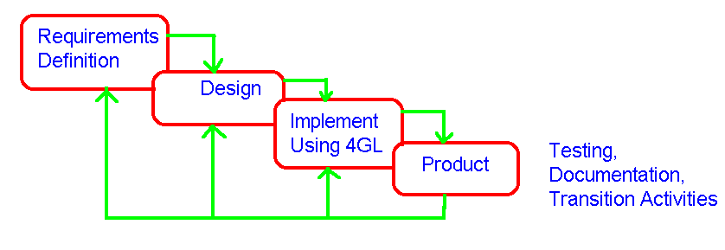

1) There are no 4GL's available that cover all application areas.

2) A frequent problem is that the customer is unsure of what is required, may be unnecessarily ambiguous in specifying facts that are know, or may be unable or unwilling to specify information in a manner that a 4GL tool can consume, e.g., SQL, Texaco implementation of Jackson’s technique.

3) It is difficult to merge new work with old work. 4GL's seem to work best on stand alone applications.

4) Proponents claim dramatic reductions in software development time and greatly improved productivity for people.

5) Opponents claim that it is not really easier than using programming languages, the software is inefficient, and very hard to maintain/modify and integrate with new or existing products. In large projects more time is required for design, and testing is especially aggravated (much more difficult).
4GL SUMMARY

1) Currently the best results have occurred in large database applications with a high incidence of report generation particularly in business data processing.

2) Preliminary data collected from companies using 4GL's seems to indicate that the time required to produce software is greatly reduced for small to intermediate size applications. The amount of time required for analysis and design for small applications is also reduced.

3) The use of 4GL for large software development efforts demands as much or more effort for analysis, design, and testing negating the substantial time savings achievable through the elimination of coding.

Additional difficulties are frequently encountered in merging a new application with existing applications, and / or in extending the application in the future when compared to traditional software implementation techniques. Such possibilities should be carefully analyzed.

4) Customer implemented applications as opposed to professionally designed and implemented applications are frequently only functional if they remain disjoint. Users seldom consider the needs of the business as a whole when developing software for themselves. Maintenance and modification are particularly hard when the non professional leaves (e.g., SSAN with and without hyphens).
Complementary Approaches

Requirements Gathering
 |  |  |  |  |  |  |  |  | Engineer Product
 |  |  | Prototyping
 |  |  | Apply  4GL |  |  | Prototype |  |  |  | Classic  Life  Cycle

The development paradigm used should be dictated by the problem.

- If the requirements for software function and performance are reasonably well understood – the classic waterfall life cycle may be best.
- If the application requires heavy person-machine interaction, unproven algorithms or output / control techniques – prototyping may be best.
- Many projects will benefit from a classic implementation cycle after prototyping has been utilized to establish what is needed (the requirements).

Spiral Model

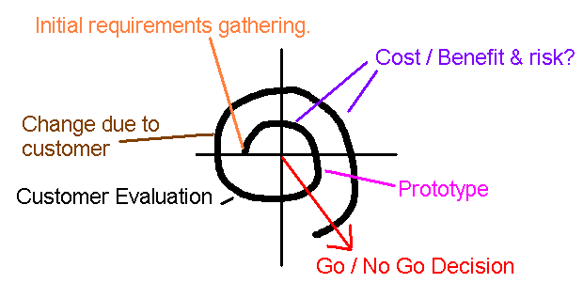

The project alternately gathers information followed by an evaluation of the risks and benefits. If the benefits exceed the risk, a prototype is built. The prototype is evaluated by the customer’.

The customer’s evaluation is used for another information gather stage followed by risk analysis, building a new prototype, and another customer evaluation.

This process is repeated until a final product is determined or the cost becomes prohibitive and the project is abandoned.

Three cycles are sufficient to evaluate many projects.

This open-ended approach to evaluation and implementation is hard to sell in many environments even though it is the best and most cost effective method for the problem.

