WebSockets
And Their Usage
Cameron Green
COSC 2327
Intro to Computer Networks
cxg087@shsu.edu

Abstract—This research is focused upon the usability and power of WebSockets within various programs and projects. WebSockets are used as the primary communication protocol between browsers or between a client and a server. They can also be used for basic communication before upgrading to more complex protocol. WebSockets were first created inside Google_{[1]} and were used for the collaboration in Google Docs. However, their usage is open to the public and have been used in a multitude of projects. Below are short summaries and conclusions based upon projects, research, and lectures on WebSockets in various programs.
Keywords—WebSocket; HTTP; HTTPS; TCP; tunneling; client/server

Inside Websockets [1]
Inside Websockets is a Video from 2016 CodeMash. This talk focuses on how WebSockets work, the details of the protocol, and why they are the way they are. Protocol design is about tradeoffs, and if you pick the wrong tradeoff, you may regret it for a very long time. We’re going to take a look at the tradeoffs that the WebSockets protocol made and talk about how you can apply the same principles to your own protocols. This talk was for educational content. To get current developers up to speed, not necessarily breaking any new ground. It helped me get a good grasp upon the subject for other more difficult articles.

Real-time Collaborative scientific WebGL Visualization with WebSocket [2]
This paper presents the archeticheture of a proposed system built with WebGL and WebSocket. It covers the initial implementiataion expirement and a comparison with current technologies. It also discusses the proposed future and potential improvements that they believe will work.

Research and Results
The primary motivator for this article was to be able to synchronously collaborate with partners in your field in the most simple and efficient way possible. Their example used 3D virtual anatomies of anonymous patients but the example could be used for many cases. The first argument necessary is why is this necessary? There are many collaborative ways to share data and there is only input from the owner of the document/model. A great and already proliferated alternative is screen sharing using common and free video calls. However, Video calls need a large amount of data to share both the audio and video. If the viewers just use a web browser that updates data that it already knows about then the amount of data transmitted is decreased considerably.

The researchers tested the same data between AJAX and Websocket. The benchmark conclusions are below:
- Benchmark Results
Results Comparing AJAX vs WebSocket
Table column subhead | AJAX | WebSocket
Average Latency | 332.4ms | 149.5
Synchronization Rate (per second) | 5.89 | 59.1
Master Rendering Rate (per second) | 60 | 60
AJAX vs. WebSocket

The data shows a remarkable diference between the two systems. While the rendering rate was the same, websockets had about half the latency and almost 10x the synchronization rate.

Evaluating two approaches for browser-based real-time multimedia communication [3]
Identify applicable sponsor/s here. If no sponsors, delete this text box (sponsors).
This article focuses on evaluating WebRTC to create two multimedia messaging APIs. The developers used two different approaches, but both used WebSockets. The project’s usage prototype was to make a Skype clone on the web browser. WebRTC was used for the media portion, but WebSockets were used for all text and information transmission. The browsers would connect dirrectly without the use of any servers. This connection would immedately upgrade to a WebSocket transmission. And would stay as a websocket for all text and information transmission, but if any audio or video mesaging is enabled then it would upgrade to WebRTC for the Multimedia Messaging. Below is a graph of two different connections based upon the reliability of the servers for initation of connections between browsers: 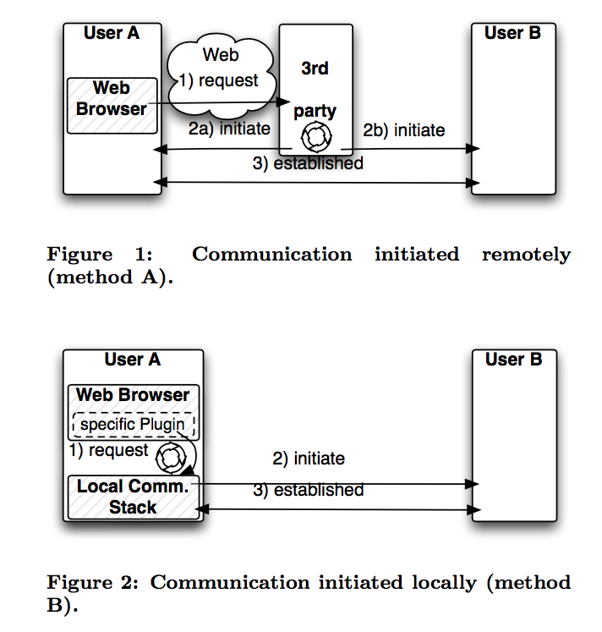
This is a very cool project to illustrate the power of WebSockets for rapid growth and connectivity. I believe the two APIs are out in the wild now being used for multitudes of multimedia communication projects.

Rapid Authoring of Web-Based Multiplayer Online Games [4]
This project is focused upon rapid updates between a client and server in an online game. The team devoloping this first attempted this same project using AJAX, however the delay was far to slow to be of any use. They then used websockets as the communication tool between the clients and servers and the efficiency was much highter. The server runs node.js and has a WebSocket plugin for the updates of the programs. Below is a communication diagram between the client 1, the server, and client 2:
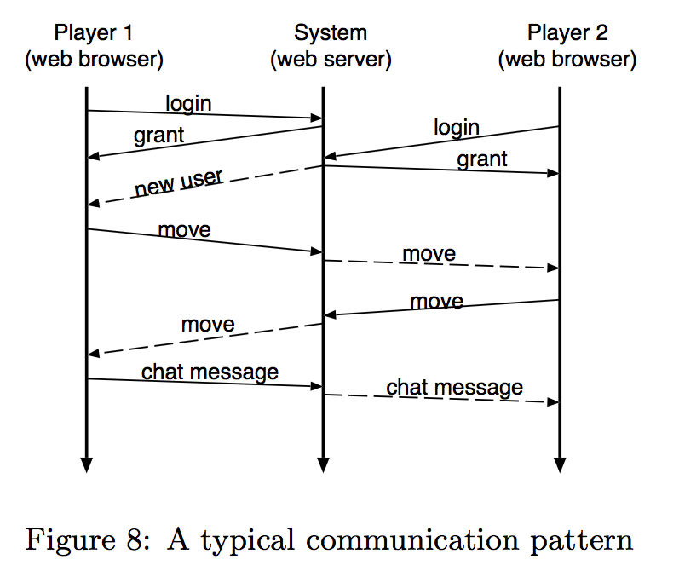
This system is extremely basic but is able to preform effeciently through the open pipes that websockets uses.

My conclusions and solutions
The research summaries here are examples of the poer of websockets for commucation. These include power to rapidly and efficiently communicate between browsers, clients, or servers; or any combination of those. The protocol has been used for games, education, document collaboration, multimedia messaging, and scientific study. There were also examples of WebSockets used for databases, cloud computing and online storage. The possibilities for this protocol have not been capped yet. I can not find any problems with the use this protocol. The largest worry is security, however it is secured through RSA/TRSA and AES-256 encrypted with masking. I believe WebSockets and their variant are wonderful in special use cases for small rapid communication, I do not believe it replaces AJAX completely. However for small text-only messages this protocol is found to be much more performant than others.

- 2016. Inside Websockets. In Applicative 2016 (Applicative 2016). ACM, New York, NY, USA, -. DOI: http://dx.doi.org/10.1145/2959689.2960084
- Charles Marion and Julien Jomier. 2012. Real-time collaborative scientific WebGL visualization with WebSocket. In Proceedings of the 17th International Conference on 3D Web Technology (Web3D '12). ACM, New York, NY, USA, 47-50. DOI=http://dx.doi.org/10.1145/2338714.233872
- Marcin Davies, Joachim Zeiss, and Rene Gabner. 2012. Evaluating two approaches for browser-based real-time multimedia communication. In Proceedings of the 10th International Conference on Advances in Mobile Computing & Multimedia (MoMM '12), Ismail Khalil (Ed.). ACM, New York, NY, USA, 109-117. DOI=http://dx.doi.org/10.1145/2428955.2428982
- Shusuke Okamoto, Masaru Kamada, Masaki Kohana, and Tatsuhiro Yonekura. 2013. Rapid Authoring of Web-based Multiplayer Online Games. In Proceedings of International Conference on Information Integration and Web-based Applications & Services (IIWAS '13). ACM, New York, NY, USA, , Pages 639 , 5 pages. DOI: http://dx.doi.org/10.1145/2539150.2539227
- Junjie Feng and Aaron Harwood. 2015. BrowserCloud: A Personal Cloud for Browser Session Migration and Management. In Proceedings of the 24th International Conference on World Wide Web (WWW '15 Companion). ACM, New York, NY, USA, 1491-1496. DOI: http://dx.doi.org/10.1145/2740908.2743043
- Wael Cherif, Youenn Fablet, Eric Nassor, Jonathan Taquet, and Yuki Fujimori. 2015. DASH fast start using HTTP/2. In Proceedings of the 25th ACM Workshop on Network and Operating Systems Support for Digital Audio and Video (NOSSDAV '15). ACM, New York, NY, USA, 25-30. DOI=http://dx.doi.org/10.1145/2736084.2736088

