Activity 3 Report: Cross-Group Deployment and Verification
COMP 018 Database Administration | Project tested: Park It (Parking Management System) (PHP + PostgreSQL) | Date of testing: 7 November 2026

1. Cover and links
Item | Value
Testing group | G08: Borreta, Joshua; Bola, Martin Lawrence; Juatchon, Joaquin Phillip; Marcos, Karl Raphael; Pacheco Jr., Sancho; Vera Cruz, Euan Joseph
Project tested | Park It (Parking Management System)
Owning group | Group 2 (member names are not listed in the project files)
Repository | park-it-database (project zip park-it-database-main; the repository link is not included in the files we received)
Tracker | https://github.com/EclipseChan/bwisIT-Solutions---Campus-Canteen-Pre-Order-and-Queue-Management-System/tree/main/other_group_tests
Evidence files | a3_deploy.txt, a3_app.txt, screenshots

Every result below comes from this run on a freshly created database.

2. Test environment
Item | Value
Operating system | Windows 11
PostgreSQL | 18.6 (x86_64 Windows), psql on PATH
PHP | 8.2.12 CLI with pdo_pgsql and pgsql enabled
Web server | The README uses XAMPP Apache. We served the same park-it folder with the PHP built-in server (php -S) from a folder laid out like htdocs (www\park-it), so the /park-it path in config\database.php works unchanged
Database | grp_parkitdb, the name the README uses
Browser | Web browser on Windows (Figures 1 to 5)

3. Installation procedure and result
Step | Action | Result
1 | Extracted the zip | park-it folder, schema.sql, user-role.md, a PDF of the project documentation
2 | CREATE DATABASE grp_parkitdb | OK
3-4 | Ran schema.sql with psql, unedited. The README tells pgAdmin users to delete the \restrict and \unrestrict lines (2 such lines exist); psql reads them without trouble | OK. 5 tables, 5 sequences and 9 indexes, no errors
7-8 | config\database.php: set DB_PASS to the postgres password, as README Step 8 says | The file ships with DB_USER postgres and DB_PASS 12345678. The README says to replace it. Done in the test copy
9-10 | Started the web server and opened config/seed.php | "Database initialization completed successfully!". Created the Main Parking Lot zone (50 spaces) and the admin and staff accounts. A second run also succeeds (accounts and zone are not duplicated)
11 | Opened the app root | Redirected to the login page. admin / admin123 and staff / staff123 log in as the README says

The setup worked first time. The only difference from the README is the web server (PHP built-in instead of XAMPP).

4. Database verification
Check | Result
Tables | Exactly the 5 in the README: parking_zone, payment, staff_user, transaction, vehicle
Constraints | 2 check, 3 foreign key, 5 primary key, 4 unique, 22 not null
Rules in the database | Unique plate, username, zone name; one payment per transaction (unique transaction_id); amount >= 0; active count not above capacity. Foreign keys from payment to transaction and from transaction to vehicle and zone
Not in the database | No CHECK on transaction.status, vehicle.vehicle_type or staff_user.role (free text). Lost ticket is a boolean. No triggers
Account used | postgres (superuser), as config\database.php and the README say. Objects are owned by postgres, database ACL empty
Password storage | bcrypt hashes ($2y$10$, 60 characters) created with password_hash in seed.php
Pages without login | dashboard, vehicles, payments, payment history and monitoring all redirect to the login page (HTTP 302). The monitoring JSON endpoint answers HTTP 401
Output escaping | 50 htmlspecialchars calls in the pages; no external scripts, fonts or stylesheets are loaded
Request forgery protection | None. No CSRF token appears anywhere in the PHP files

5. Application checks
The pages were exercised with curl and a cookie jar for each user (98 requests logged), with database checks after the risky steps, then looked at in the browser (Figures 1 to 5).
Test | Result
Wrong password, unknown user, empty fields, SQL text as username | Rejected with a generic message. No error details, no access
Admin and staff logins | Pass. Both land on the dashboard
Register car ABC-1234 and motorcycle MOT-001 | Pass. A ticket is created and the zone counter goes up
Same plate in lower case while the vehicle is still parked | Blocked: "Duplicate Entry Blocked ... already has an active parking transaction"
Plate with a space (XYZ 777) | Accepted
Plate AB@#1, empty plate, 21 characters, type Truck, zone 0, zone 999 | Each rejected with a clear message
SQL text in the plate | Rejected (too long and has other characters); nothing reached the database
Plates "---" and " - " (only hyphens or spaces) | Accepted. They became vehicles named "---" and "-" with active tickets (visible in Figure 3)
Edit a vehicle: valid; plate used by another; invalid type; id that does not exist | Pass; blocked with a message; blocked; "Vehicle record not found"
Change the type of a parked vehicle (Car to Motorcycle and back) | Accepted. This changes its fee while it is parked
Delete a vehicle that has a transaction | Blocked, with a message about preserving history
Delete a vehicle with no transactions (created with SQL) | Deleted. Delete by a GET request does nothing
Search an active plate; search a plate that is not parked | Pass; "No active parking transaction found"
Fee, car parked 2 h 0 min | PHP 50.00 (correct)
Fee, car parked 2 h 59 min 59 s | PHP 50.00 (correct). The clock kept running, so exactly 3 hours was not hit; the next test covers the boundary
Fee, car parked 3 h 1 min | PHP 60.00 (correct: 3 hours 50 plus one more hour 10)
Fee, car parked 4 h 59 min 59 s | PHP 70.00 (correct, 5 billed hours)
Fee, motorcycle 2 h and 6 h | PHP 30.00 and PHP 70.00. The 6 h case ran a fraction over six hours, so it is billed as 7 hours (30 + 4 x 10). Any part of an hour counts as a full hour
Lost ticket on a car parked 9 h | PHP 200.00 flat (correct)
Payment methods Cash, GCash, Maya, Credit/Debit Card | All accepted. Bitcoin is rejected
Payment for a transaction that does not exist, id 0, the same transaction twice, process page opened with GET | Each rejected or redirected with a message; no duplicate payment
Payment as staff | Pass. Staff can take payments and exit vehicles
Capacity: 44 of 50 occupied | Monitor shows "LOW SPACE WARNING (6 Left)"
Capacity: 50 of 50 | Monitor and Module 1 show FULL, the entry form is disabled (Figures 2 and 5). A new entry (OVER-1) created no rows
One vehicle exits, then a new entry | Warning shows 1 space left and the new entry (OVER-2) is accepted
Counter recount | After 40 vehicles were added directly with SQL, parking_zone.current_active_count still said 4. The first dashboard or monitor request recounted the real transactions and set it to 44, so the counter repairs itself

Direct database tests (what the database allows on its own):
Test | Result
transaction with status "Banana" | Accepted
vehicle with type "Truck" | Accepted
exit_time one day before entry_time | Accepted
payment of amount 0 with method "x" | Accepted (the check is amount >= 0)
current_active_count = -5 | Accepted
current_active_count = 51 (above capacity 50) | Rejected by parking_zone_check
Vehicles with two active transactions / paid but still active | 0 / 0 (the application keeps these consistent)

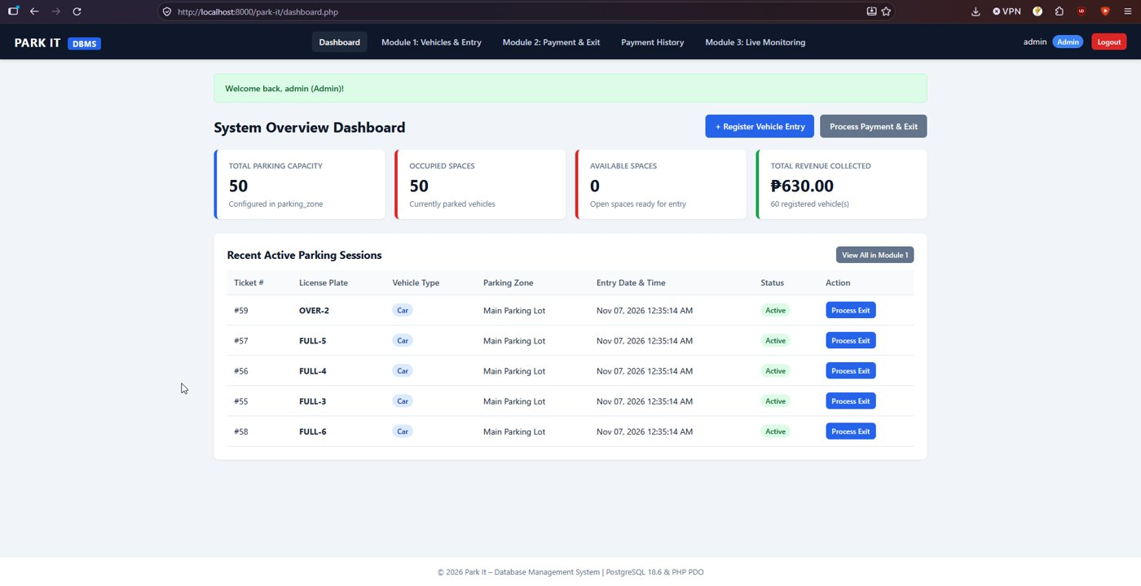
Figure 1. Dashboard with the lot full: 50 of 50 occupied, revenue 630.00.
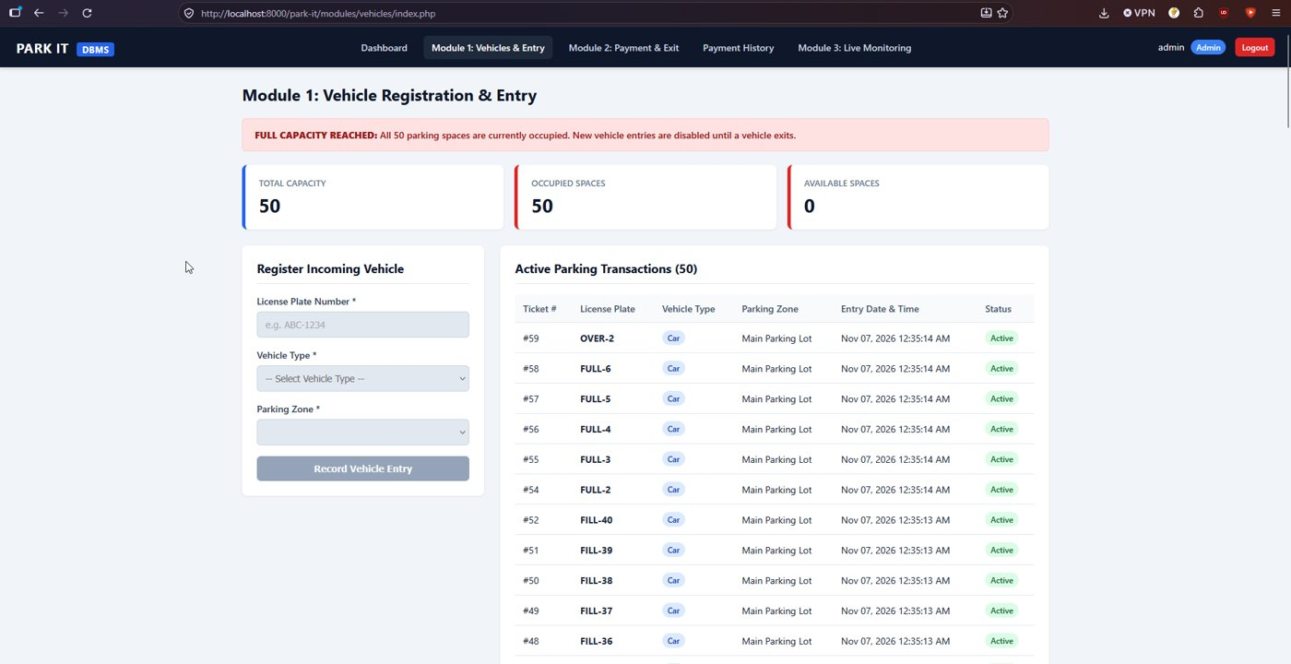
Figure 2. Module 1 when the lot is full: the capacity banner and the disabled entry form.
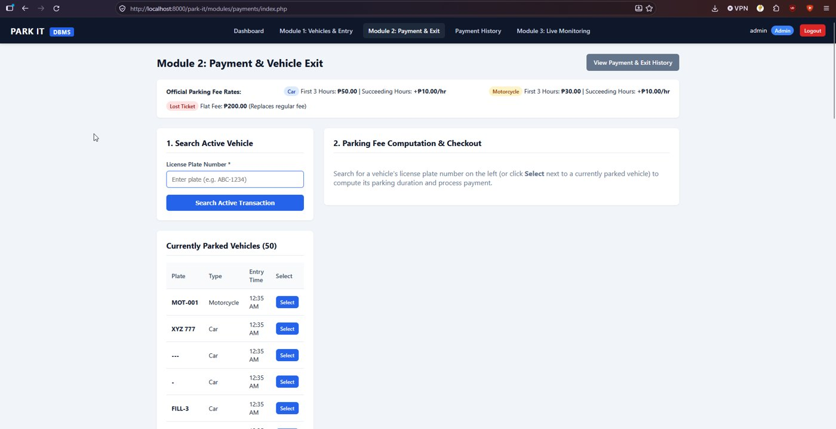
Figure 3. Module 2 with the fee table. The parked list includes the plates "---" and "-" that the app accepted.
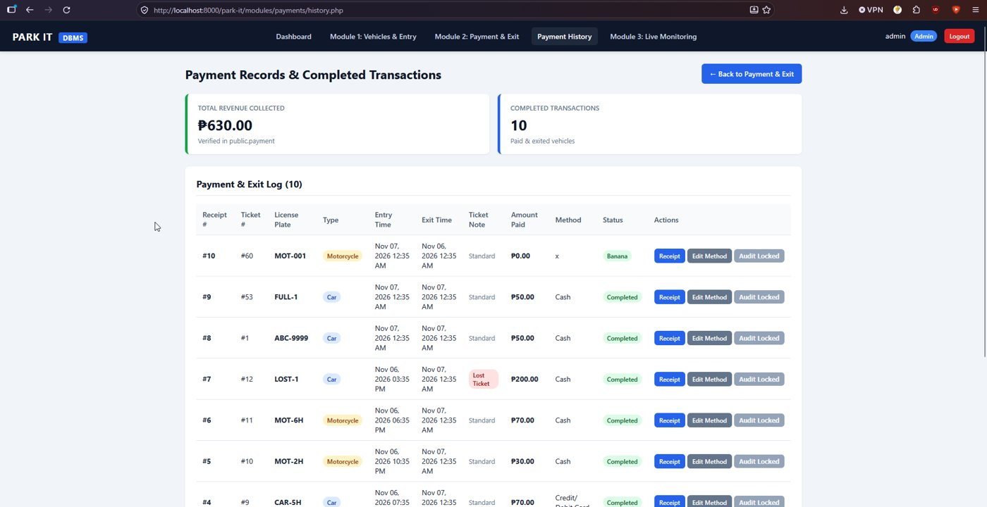
Figure 4. Payment history. Receipt #10 (method "x", status Banana, 0.00) was entered directly in the database during the direct tests.
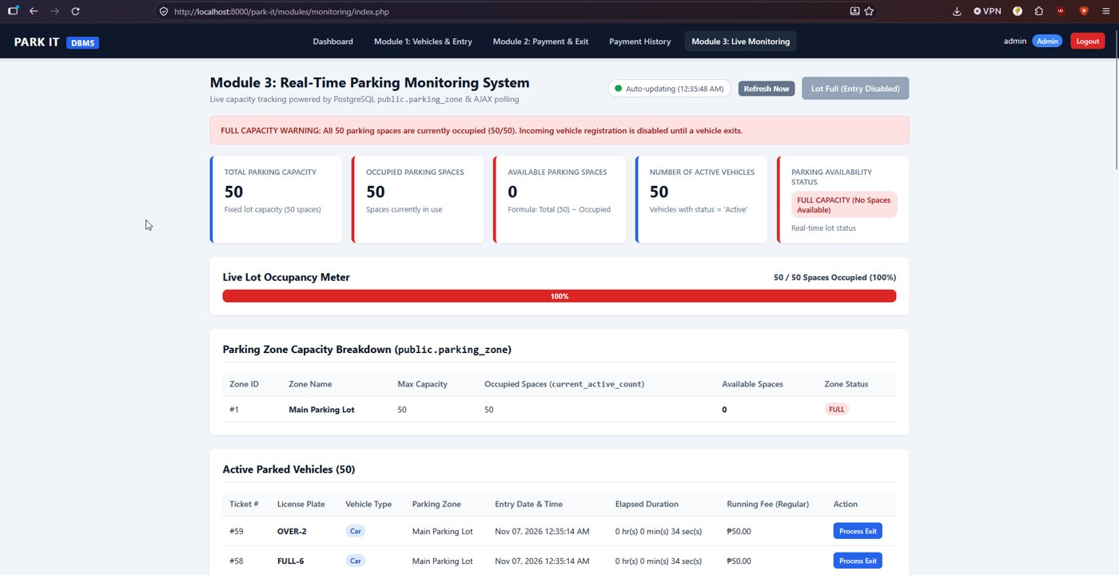
Figure 5. Live monitor at 100%, FULL CAPACITY WARNING.

6. Issues found
# | Issue | Impact and suggestion
1 | config/seed.php can be opened by anyone, at any time, with no login. It still runs after setup and, on first run, prints the default usernames and passwords | Delete or block seed.php after setup, or require the Administrator. Force a password change on first login
2 | No CSRF protection (no token, no origin check). See Activity 4 for the forged request that was accepted | Add a token to the entry, edit, delete and payment forms. Set SameSite on the session cookie
3 | Plates made only of hyphens or spaces are accepted ("---", "-") | Require at least one letter or digit
4 | The database has no CHECK on status, vehicle type or role, accepts a payment of 0 and an exit time before the entry time | Add CHECK constraints (status Active or Completed, type Car or Motorcycle, amount > 0, exit_time >= entry_time). The PHP validates these, but the database does not
5 | The type of a parked vehicle can be changed, which changes the fee | Lock the type once the vehicle has an active ticket, or log the change
6 | The README gives the postgres password as postgres in Step 1 while config\database.php ships with 12345678, and the password sits in a tracked file | Use a placeholder in the repository and keep the real value outside Git
7 | The session cookie shows no HttpOnly marker in the cookie jar and no SameSite attribute | Set session.cookie_httponly and SameSite
8 | Any part of an hour is billed as a full hour (6 h 0 min 0.7 s was billed as 7 hours) | This follows the code comment, but the README table only says "each succeeding hour". Say so in the README

The fee rules, lost-ticket rule, duplicate-entry rule, capacity limit and the database constraints all behaved as described in the README.

7. Feedback for the owners
Issues 1 to 3 are the ones worth fixing first. The setup steps needed no changes.

8. Reproducibility conclusion
Reproducible. From an empty database the README steps gave a working system with no errors, and every feature in the guide worked as described.

AI usage declaration
- Tool: Claude (Anthropic).
- Tasks: interpreting the results of the testing.
- Validation: the commands were run by the group on its own computer, and every result in this report comes from the saved output files.

