Activity 3 Report: Cross-Group Deployment and Verification
COMP 018 Database Administration | Project tested: HabalGo (Ride and Booking Management System) (PHP + PostgreSQL) | Date of testing: 7 November 2026

1. Cover and links
Item | Value
Testing group | G08: Borreta, Joshua; Bola, Martin Lawrence; Juatchon, Joaquin Phillip; Marcos, Karl Raphael; Pacheco Jr., Sancho; Vera Cruz, Euan Joseph
Project tested | HabalGo (Ride and Booking Management System)
Owning group | Group 6 (member names are not listed in the repository)
Repository | https://github.com/jeanaroyo/HabalGo
Tracker | https://github.com/EclipseChan/bwisIT-Solutions---Campus-Canteen-Pre-Order-and-Queue-Management-System/tree/main/other_group_tests
Evidence files | a3_deploy.txt, a3_app.txt, screenshots

This is a re-test. The database was dropped and rebuilt from the repository files, and every result below comes from this run.

2. Test environment
Item | Value
Operating system | Windows 11
PostgreSQL | 18.6 (x86_64 Windows), psql on PATH
PHP | 8.2.12 CLI with pdo_pgsql and pgsql enabled (README asks for 8.0 or newer)
Web server | PHP built-in server, php -S localhost:8000 (README Option A)
Database | grp00_habalgodb, the name the README uses
Browser | Web browser on Windows (screenshots in Figures 1 to 6)

3. Installation procedure and result
The README was followed in its own order. The point where it breaks is Step 2 and Step 4, explained after the table.
Step | Action | Result
1 | Extracted the zip and checked the files | README, api.php, config.php, schema.sql, "sample data.sql", .env.example, js and css present. There is also a database folder (01_schema.sql, 02_seed.sql, 03_roles_and_privileges.sql) that the README does not mention
2 | CREATE DATABASE grp00_habalgodb | OK
3 | psql -f schema.sql | OK. 8 tables and 5 indexes, no errors
4 | psql -f "sample data.sql" | OK. INSERT 0 10, ten drivers, nothing else is seeded
5 | Ran schema.sql a second time | Notices that objects already exist and are skipped, no errors
6 | Ran "sample data.sql" a second time | ERROR: duplicate key value violates unique constraint "driver_license_no_key". The data script cannot be repeated, the database stays at 10 drivers
7 | cp .env.example .env and set the password | Done, but the application never reads this file (see below)
8 | php -S localhost:8000 with no other setup, as the README says | The page opens (HTTP 200) but every API call fails: HTTP 500, "Database connection failed: SQLSTATE[08006] fe_sendauth: no password supplied"
9 | Restarted the server with DB_NAME, DB_USER and DB_PASS set as environment variables | Works. Dashboard and options return HTTP 200

Why step 8 fails. config.php reads the settings with getenv() and falls back to dbname "habalgo", user "postgres" and an empty password. Nothing in the PHP code loads the .env file (a search for parse_ini, dotenv and file_get_contents found no .env loader), so editing .env has no effect with php -S. On top of that the names do not match: the README and .env.example use DB_PASSWORD and, in the README, DB_SCHEMA, while config.php reads DB_PASS. And the default database name is habalgo, not the grp00_habalgodb the README tells you to create. A person who follows the README exactly gets a page that loads and then fails. The tests below were run after setting the variable names config.php actually reads.

4. Database verification
Check | Result
Tables | 8 in schema habalgo: customer, driver, vehicle, driver_vehicle, location, booking, payment, rating_feedback
Constraints | 4 check, 9 foreign key, 8 primary key, 4 unique, 33 not null
Rules in the database | booking status limited to Pending, Confirmed, In Progress, Completed, Cancelled. Payment amount > 0. Rating 1 to 5. One rating per booking and customer. Unique email, licence number and plate number. Assignment end date not before start date
Foreign keys | Deleting a customer, location, booking or driver_vehicle parent is RESTRICTed. Deleting a driver sets booking.driver_id to NULL
Indexes | 17 including keys. Extra ones: idx_booking_customer, idx_booking_date, idx_booking_driver, idx_payment_booking, idx_rating_booking
Triggers | None
Account used | postgres (superuser) in all the tests so far, as the README and .env.example say. Object owner is postgres, database ACL empty
database folder versus the root files | schema.sql and database\01_schema.sql differ only by a two-line comment header. "sample data.sql" has 10 drivers, database\02_seed.sql has 2. Two copies of the same thing, and the README mentions only the root ones

5. Application checks
The API (api.php?t=customers, vehicles, bookings, payments, ratings, dashboard, options) was exercised with curl, 71 requests in all, and then looked at in the browser. Database state was checked after each risky call.
Test | Result
Empty database: every list, dashboard and options | Pass, HTTP 200 with empty lists and zero totals
Create a customer; duplicate email; missing email | Pass; 400 "That value already exists"; 400 "fill in all required fields"
Phone "abc" and email "not-an-email" | Accepted (HTTP 200). There is no format validation, so the record is stored with those values (visible in Figure 2)
101-character name | Rejected, but the message is only "Database error."
SQL text in a name (x'); DROP TABLE habalgo.customer;--) | Stored as plain text, the table is still there. Queries use prepared statements
Client sends its own customer_id | Ignored, the database assigned id 7
PATCH with a full body | HTTP 200 and a new customer was created. Any method other than GET and DELETE is treated as a create or update
Update with an empty body / without an id | 400 "Database error." / 400 "fill in all required fields"
Vehicle create, duplicate plate | Pass; 400 "That value already exists"
Booking with a new customer name | A customer is created automatically with phone 09000000000 and an email made from the name (juandelacruz@mail.com). The same name in lower case matched the existing customer
Two different names that give the same email (Ana Cruz and AnaCruz) | The second one fails with "That value already exists", so a real person cannot be booked
Pickup equal to drop-off (different case) | Pass, 400 with a clear message
Booking with a driver | Status moved from Pending to Confirmed automatically
Unknown driver, unknown customer, invalid status | 400 with a clear message each time
City that is not in the list (Atlantis) | Accepted and stored as a new location
Status changes (Pending to Completed to Pending to Cancelled to Completed) | All accepted. The API does not stop a completed trip from going back to Pending or a cancelled one from being completed
Payment: amount 0, negative, above numeric(10,2) | 400 each time (the huge one with "Database error.")
Payment with method "Bitcoin" and status "Whatever" | Accepted. Method and status are free text (Figure 4 shows the "Whatever" status)
Same booking paid twice with 250.50 | Accepted. Three payments were stored on booking 1 totalling 511.00
Rate a booking that is not completed / unknown booking | 400 "Only completed bookings can be rated."
Rating 6 and 0, second rating of one booking | 400 each time
Delete a customer with bookings / a booking with payments | 400, blocked by the foreign keys, with the message "Database error."
Delete a payment and a rating | Pass, HTTP 200
Delete a customer id that does not exist / DELETE with no id | HTTP 200 {"ok":true} although nothing was deleted
Delete a vehicle with assignment history | Pass, the app removes the assignment rows first
Unknown resource (drivers), SQL text in t | 404 "Unknown resource."
Malformed JSON body | 400 "Database error."
Response headers and cross-origin | Only X-Powered-By: PHP/8.2.12 and Content-Type. There is no Access-Control header, so the API is not offered to other origins, but it has no login either
Driver assignment on a vehicle | Not proven. The test sent only {"driver_id":N}, and the API turns that into an UPDATE vehicle with no columns, which PostgreSQL rejects ("syntax error at or near WHERE" in the log). The web form always sends all four fields, so this call is not what the screen does. This is a gap in my test, listed under limitations

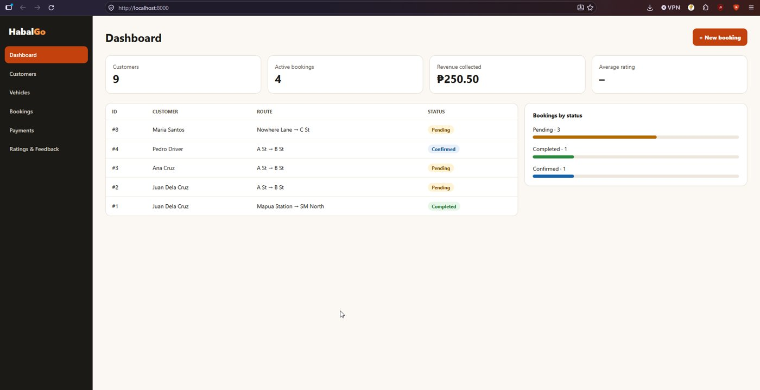
Figure 1. Dashboard after the tests: 9 customers, 4 active bookings, revenue 250.50.
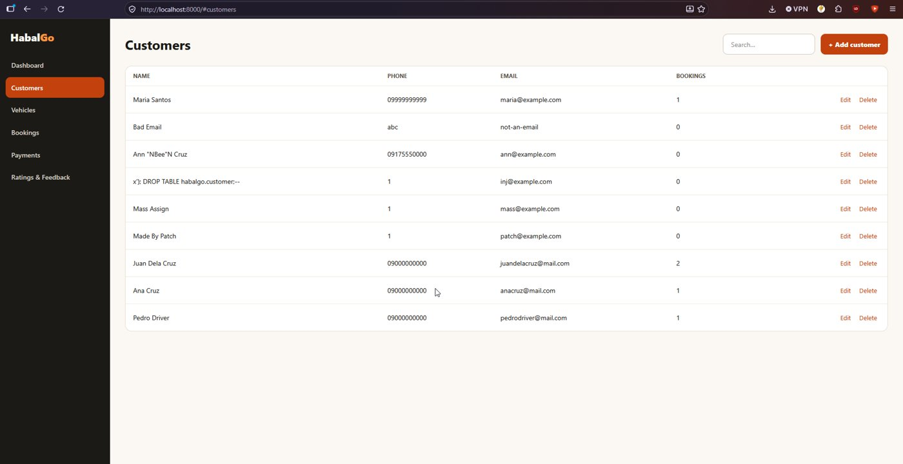
Figure 2. Customers. "Bad Email" with phone abc, the SQL text name and the other test rows are stored as typed.
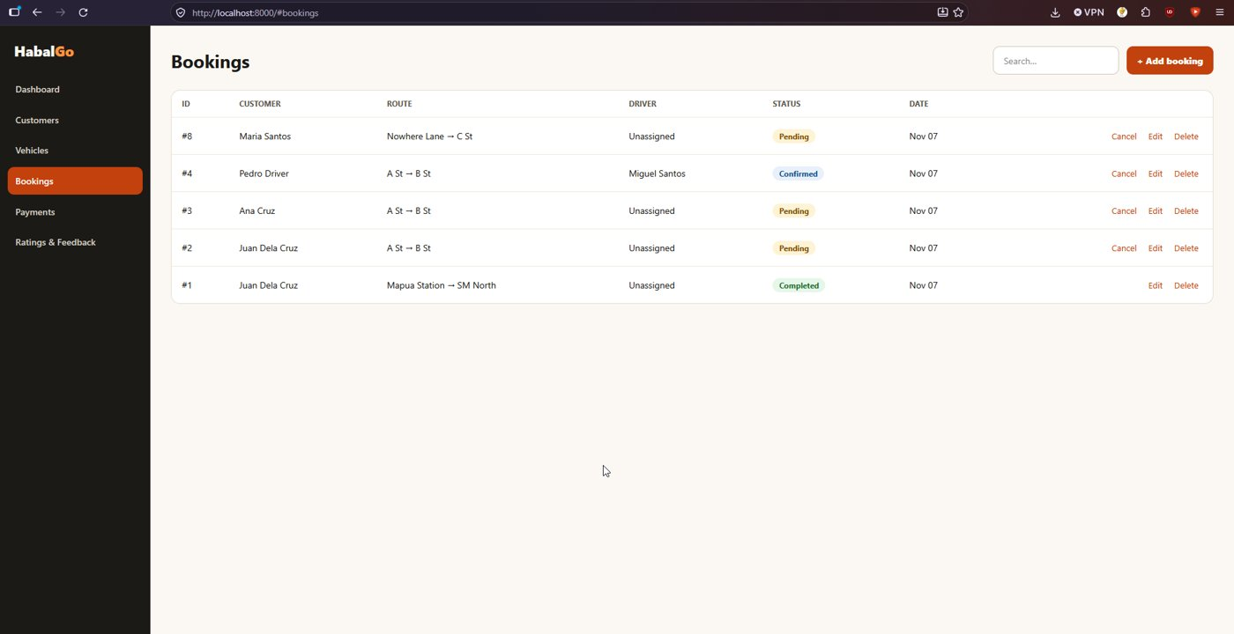
Figure 3. Bookings. Booking #8 goes to a city that is not in the list (Atlantis) and was accepted.
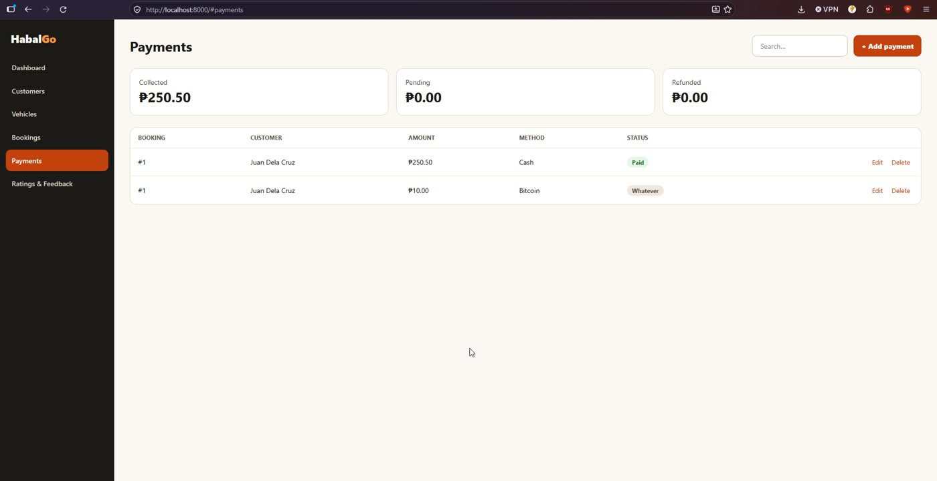
Figure 4. Payments. A Bitcoin payment with the status "Whatever" and a second payment on booking #1.
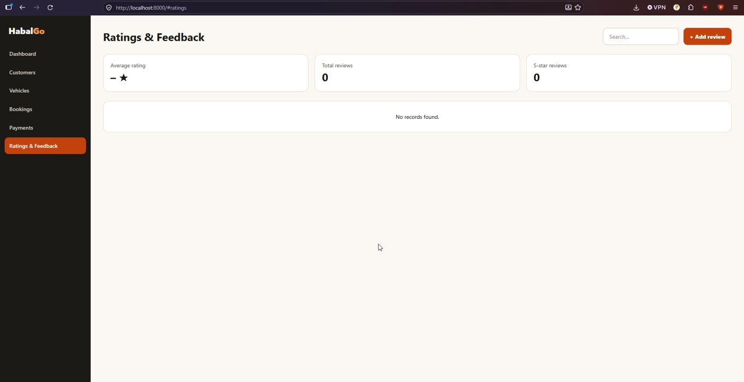
Figure 5. Ratings and feedback. Empty at this point, because the rating test was removed again.
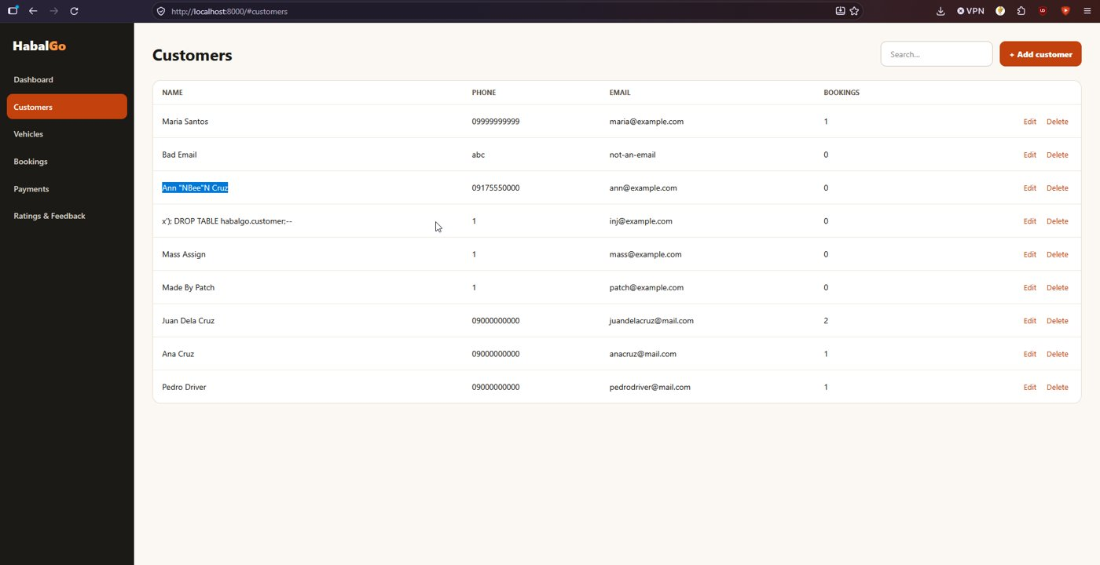
Figure 6. The customer Ann "Bee" Cruz is displayed as Ann "NBee"N Cruz.

6. Issues found
# | Issue | Impact and suggestion
1 | Following the README exactly fails. The .env file is not loaded by any PHP code, the variable names differ (DB_PASSWORD in .env.example and README, DB_PASS in config.php), the README lists a DB_SCHEMA that nothing uses, and the default database name is habalgo, not grp00_habalgodb | Anyone who clones the project gets "no password supplied". Make config.php load .env (or tell the user to set the variables), use one set of names, and default to grp00_habalgodb
2 | "sample data.sql" can only be run once (second run: duplicate licence number) | Add ON CONFLICT DO NOTHING so the setup can be repeated
3 | Two sets of SQL files (root and database folder) with different seed data (10 drivers versus 2) and only one set in the README | Keep one copy, or mention the folder in the README
4 | The API has no login. Every call was made with no cookie, token or password and all worked, including deleting records | See Activity 4
5 | Names with a double quote are shown wrongly: esc() in js/app.js maps " to &quot;N (a stray N), so Ann "Bee" Cruz appears as Ann "NBee"N Cruz (Figure 6) | Remove the N in the esc() table. The escaping itself is otherwise right (9 innerHTML uses all go through esc)
6 | A booking creates a customer from the typed name, with a made-up phone and email. Two people whose names reduce to the same email (Ana Cruz, AnaCruz) cannot both book | Ask for the customer from a list or require an email
7 | Payment method and status are free text; the same booking can be paid several times; a completed booking can return to Pending | Add CHECK constraints for method and status, and a rule for status changes
8 | Phone and email are not validated | Check the format in the API and with a CHECK constraint
9 | Error messages hide the cause: a long name, an empty body and bad JSON all return "Database error." | Return a specific 400 message for each case
10 | Deleting an id that does not exist returns success | Return 404 when no row was deleted
11 | The page loads fonts from fonts.googleapis.com | Fine online, but the page looks different offline

Once the environment variables are set, the application and the database rules work as the screens show, and the database constraints stopped every bad value that reached them.

7. Feedback for the owners
Issues 1, 2 and 5 are quick fixes. Issue 1 matters most because it stops a new user at the first page.

8. Reproducibility conclusion
Partly reproducible. The database part of the README works from a clean server. The application part only works after the connection settings are passed as environment variables with the names config.php reads, which the README does not say. After that, the pages and API behaved as expected.

AI usage declaration
- Tool: Claude (Anthropic).
- Tasks: interpreting the results of the testing.
- Validation: the commands were run by the group on its own computer, and every result in this report comes from the saved output files.

