Activity 3 Report: Cross-Group Deployment and Verification
COMP 018 Database Administration | Project tested: BoardTrack (Boarding House and Rental Management) (Node.js + PostgreSQL) | Date of testing: 6 November 2026

1. Cover and links
Item | Value
Testing group | G08: Borreta, Joshua; Bola, Martin Lawrence; Juatchon, Joaquin Phillip; Marcos, Karl Raphael; Pacheco Jr., Sancho; Vera Cruz, Euan Joseph
Project tested | BoardTrack (Boarding House and Rental Management)
Owning group | Group 11 (BoardTrack)
Repository | https://github.com/karlrobertc-art/BoardTrack
Tracker | https://github.com/EclipseChan/bwisIT-Solutions---Campus-Canteen-Pre-Order-and-Queue-Management-System/tree/main/other_group_tests
Evidence files | a3_deploy.txt, a3_app.txt, screenshots of the application

Only the repository and its documentation were used. Setup was done on the tester's own PostgreSQL server.

2. Test environment
Item | Value
Operating system | Windows 11
PostgreSQL | PostgreSQL 18.6 (x86_64 Windows), psql on PATH
Node.js | Node v26.13.0 and npm 11.20.0. The README asks for Node 20.12 or later
Packages | express, express-session, ejs, pg (94 packages installed, 0 vulnerabilities reported)
Database used | boardtrack_db (the name in .env.example)

3. Installation procedure and result
Step | Action | Result
1 | Extracted the zip and read README.md and docs/ | Clear guide with a quick test script. Two setup methods are offered
2 | npm install | OK, 94 packages in 3 seconds
3 | Copied .env.example to .env and filled DATABASE_URL and SESSION_SECRET | OK. The tester used the postgres account, as the README example suggests
4 | npm start (automatic setup) | Printed: Created database "boardtrack_db", migrated 001_schema.sql, seeded 001_sample_data.sql, BoardTrack running at http://localhost:3000
5 | npm run db:setup again | Printed: skip 001_schema.sql and "seed skipped (database already has data)". Nothing was duplicated, as the README promises
6 | Other documented method: db/boardtrack_full_setup.sql run with psql on an empty database | OK, 8 tables, the same as the automatic method

4. Database verification
Check | Result
Tables | 8: property, room, tenant, lease, payment, utility_bill, app_user and schema_migrations
Constraints | 70 in total: 8 primary keys, 6 foreign keys, 3 unique, 15 check, 36 not null, 1 exclusion constraint (ex_lease_no_overlap, no two ACTIVE leases overlap on one room)
Triggers and view | trg_lease_sync_room on lease, trg_room_status_guard on room, view v_lease_summary
Extensions | btree_gist 1.8, pgcrypto 1.4
Indexes | 16, including idx_lease_room, idx_lease_tenant, idx_payment_lease and idx_utility_lease
Sample data | app_user 3, property 2, room 6, tenant 4, lease 4, payment 6, utility_bill 4
Demo accounts | landlord (admin), caretaker (staff), juan (tenant). Passwords are stored with bcrypt through pgcrypto (prefix $2a$06$, cost 6)

5. Application roles checked
The README quick test script was run through HTTP calls and the main screens were checked in a browser (Figures 1 to 6).
Test | Result
Log in as landlord, caretaker and juan | Pass (Figures 1, 2, 5 and 6)
1. Add an ACTIVE lease that overlaps room 101 | Pass. HTTP 400, "That room already has an ACTIVE lease overlapping these dates." (Figure 3)
2. Add a lease for room 103 | Pass. Accepted, room 103 became OCCUPIED (set by the trigger)
3. Set that lease to TERMINATED | Pass. Room 103 returned to AVAILABLE
3b. Set room 101 to AVAILABLE by hand while it has an ACTIVE lease | Pass. Rejected: "This room has an ACTIVE lease, so it cannot be AVAILABLE."
4. Add a payment of 1,000 | Pass. total_paid of lease 1 changed from 7,000.00 to 8,000.00
5. Delete a lease that has payments | Pass. Blocked by the foreign key (error 23503 in the app log), the page returns to the list
Reversed dates, negative rent, zero payment amount | Pass. All rejected by CHECK constraints with a friendly message
Invalid date text, duplicate tenant email | Pass. "Invalid date." and "Duplicate value..."
/rooms/abc/edit and /rooms/999999/edit | Pass. HTTP 404 "Record not found."
Not logged in, wrong password, SQL text in the username | Pass. Redirected to /login each time

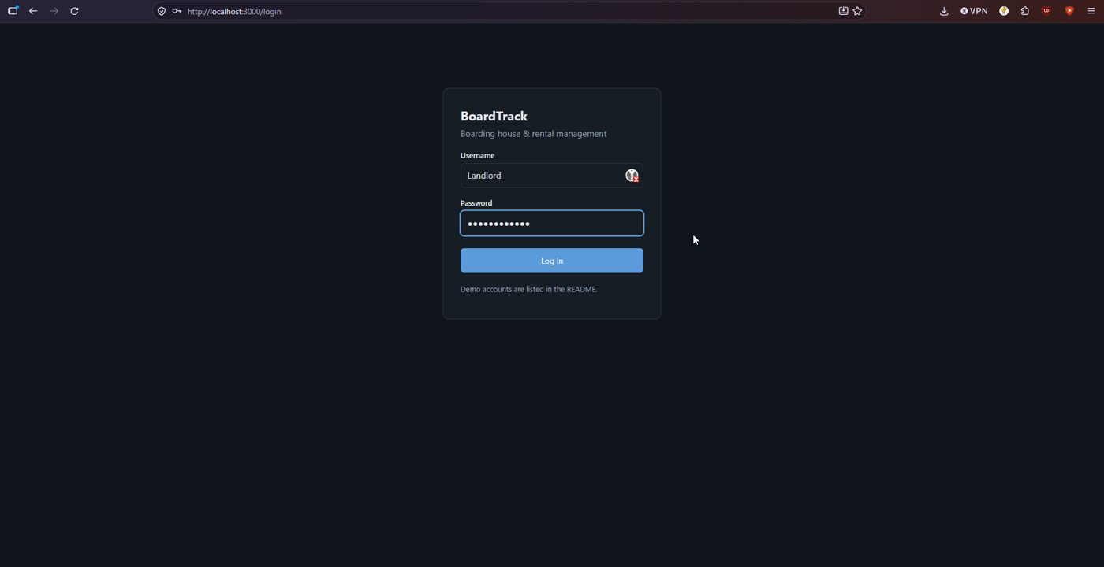
Figure 1. Login page.
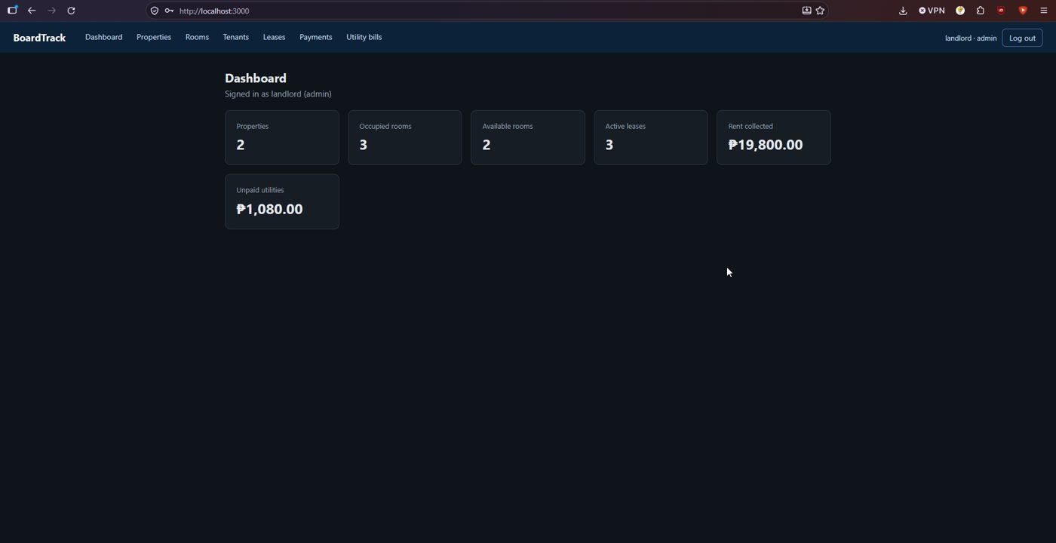
Figure 2. Landlord dashboard.
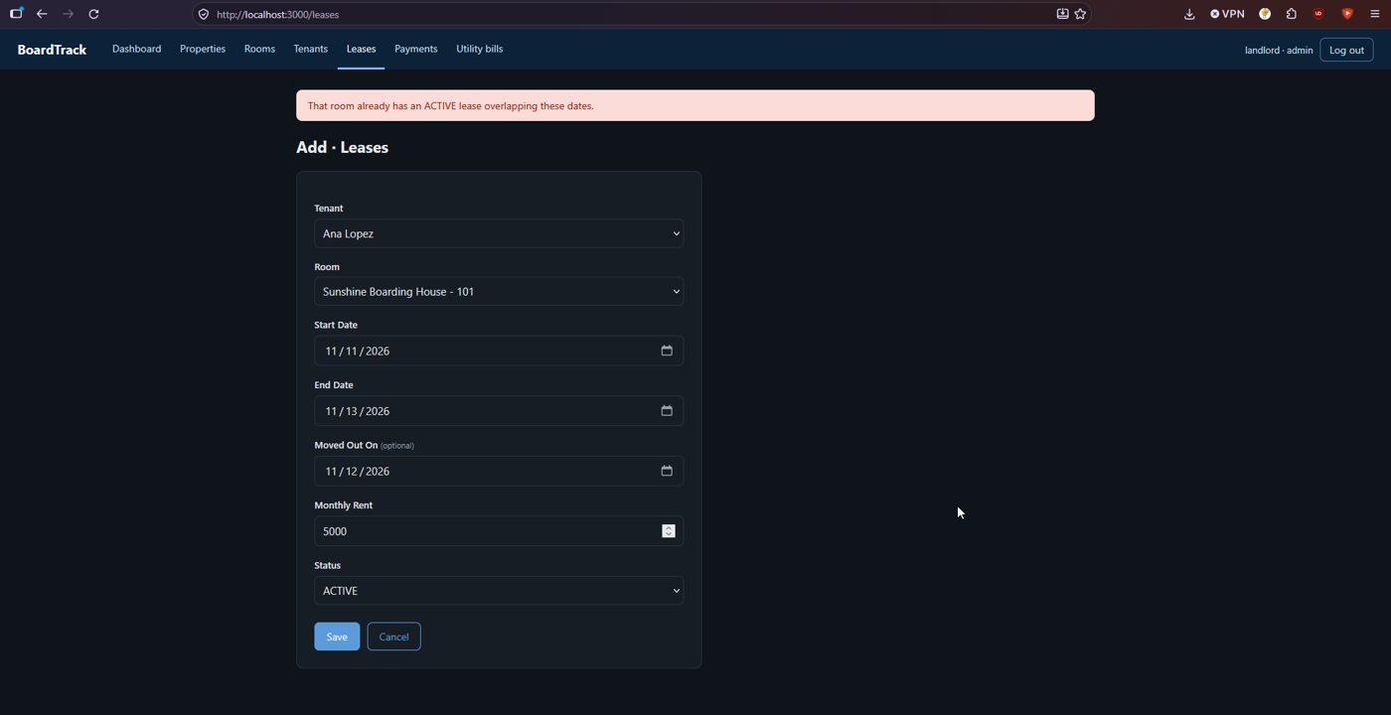
Figure 3. Overlapping lease rejected by the exclusion constraint.
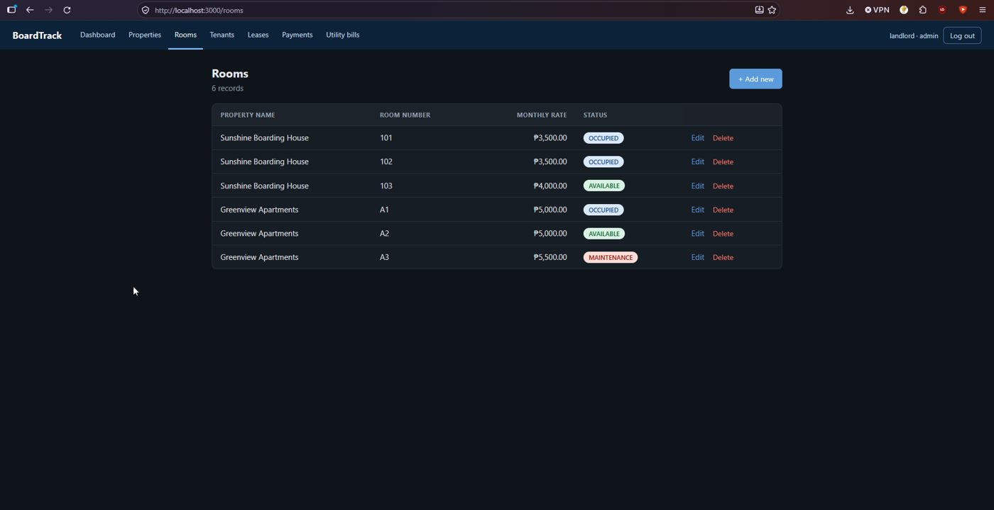
Figure 4. Rooms list with occupancy kept by the trigger.
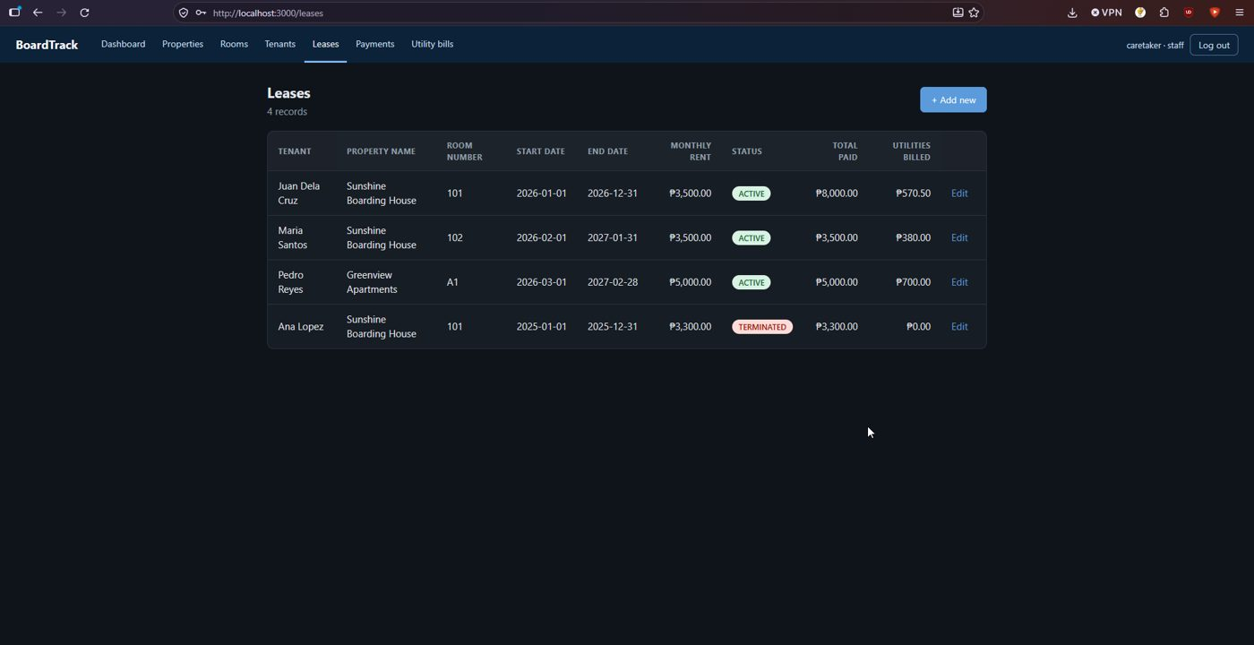
Figure 5. Caretaker view of Leases (no Delete buttons).
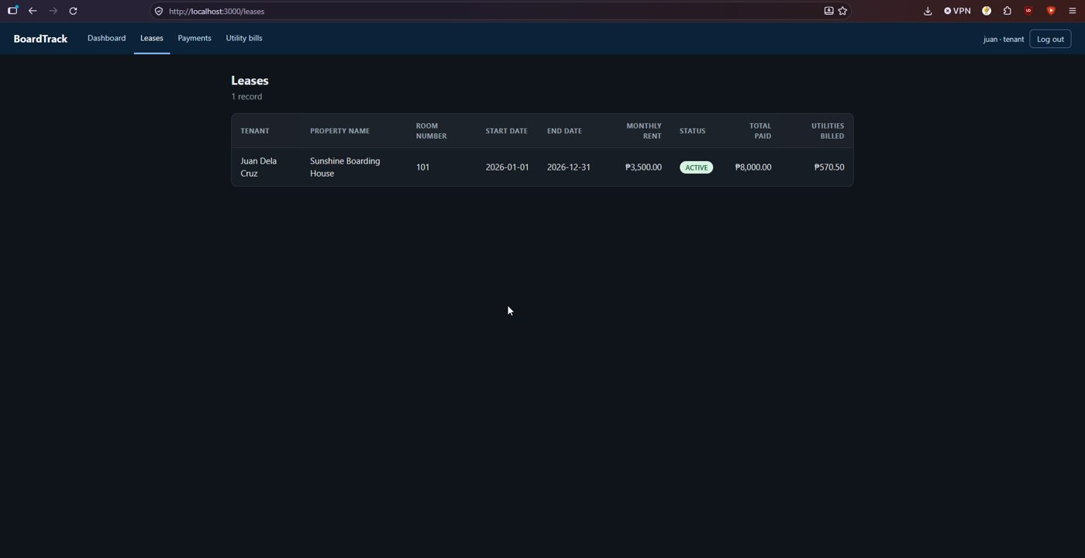
Figure 6. Tenant view of Leases (only his own lease).

6. Issues found
# | Issue | Impact and suggested fix
1 | The app has no CSRF protection, no helmet headers and no login rate limiting. The response header X-Powered-By: Express is sent. The session cookie has HttpOnly but no Secure or SameSite attribute | A malicious page could trigger actions of a logged-in user, and passwords can be guessed without limit. Add csurf-style tokens, helmet and rate limiting, and set cookie flags
2 | SESSION_SECRET falls back to a fixed text (dev-only-change-me) when the variable is missing, and sessions use the default in-memory store | Predictable secret if .env is forgotten; sessions are lost on restart. Fail at start-up when no secret is set
3 | Demo passwords are the same for all accounts (ChangeMe123!) and are published in the README. The bcrypt cost is 6 (the pgcrypto default) | Acceptable for sample data. Use cost 10 or more for real accounts
4 | The README clone line uses the placeholder <REPOSITORY_URL> and the .env example uses placeholder credentials | Minor. Put the real URL in the README
5 | Database access control is missing from the repository (see Activity 4) | The app runs as the account in DATABASE_URL, which the README example sets to postgres

What worked well: both setup methods worked first time, setup is repeatable, and every business rule is enforced in the database (exclusion constraint, two triggers, foreign keys, CHECK constraints) with clear messages.

7. Feedback sent to owners
Sent on 6 November 2026: issues 1 to 3 and 5. The setup was otherwise complete.

8. Reproducibility conclusion
Reproducible. A fresh install following the README gave a working system in one pass, both automatically and with the plain SQL file, and running setup again changed nothing.

AI usage declaration
- Tool: Claude (Anthropic).
- Tasks: interpreting the results of the testing.
- Validation: the commands were run by the group on its own server, and every result in this report comes from the saved output files.

