Activity 3 Report: Cross-Group Deployment and Verification
COMP 018 Database Administration | Project tested: Binary Sisters, Restaurant Online Ordering & Table Reservation System | Date of testing: 6 November 2026

1. Cover and links
Item | Value
Testing group | G08: Borreta, Joshua; Bola, Martin Lawrence; Juatchon, Joaquin Phillip; Marcos, Karl Raphael; Pacheco Jr., Sancho; Vera Cruz, Euan Joseph
Project tested | Group 10 (G10), Binary Sisters, Restaurant Online Ordering & Table Reservation System
Repository and branch tested | https://github.com/kathlenmaecallos11-arch/Restaurant-Online-Ordering-Table-Reservation-System
Tracker | https://github.com/EclipseChan/bwisIT-Solutions---Campus-Canteen-Pre-Order-and-Queue-Management-System/tree/main/other_group_tests
Evidence files | a3_verify_privs.txt, a3_tests.txt, screenshots of the setup output and the application
Only the repository and its documentation were used. The repository was not modified.

2. Test environment
Item | Value
Operating system | Windows 11
PostgreSQL | PostgreSQL 18.6 (x86_64 Windows) with psql on PATH. The setup output shows pg_maintain was granted, which the project only does on PostgreSQL 17 or newer
PHP | 8.2.12 with pdo_pgsql and pgsql enabled
Database | grp_binarysisters_projectdb, kept separate from other projects
Documents reviewed | README.md, docs/RUN_LOCALLY.md, docs/user-roles.md, docs/user-role-setup.md, docs/database-documentation.md, docs/testing-guide.md, docs/troubleshooting.md

3. Installation procedure and result
Step | Action | Result
1 | Extracted the project and opened PowerShell in the project folder | OK
2 | Ran .\database\setup.ps1 -WithRoles (scripts were blocked by the PowerShell execution policy, so Set-ExecutionPolicy -Scope Process -ExecutionPolicy Bypass was used for that session) | Database, tables, constraints, views, indexes and seed data created
3 | Role scripts 01_create_roles.sql and 02_grants.sql ran | OK
4 | Password step: database/roles/03_set_passwords.psql | Failed. The file is missing from the repository
5 | Setup continued, ran 04_verify_privileges.sql and printed that the database is ready | 26 of 26 PASS
6 | Set a password for each rors_ login manually with ALTER ROLE | OK
7 | Copied .env.example to .env with DB_USER=rors_app and the rors_app password | OK
8 | Enabled the pdo_pgsql and pgsql extensions in php.ini (documented in the project's troubleshooting guide) | OK
9 | php tools\test-connection.php | OK Connected as rors_app (file a3_tests.txt)
10 | psql -f tests\crud_tests.sql | 25 PASS, 0 failed, run as postgres inside a transaction that ended in ROLLBACK, so row counts afterwards were unchanged (62 orders, 171 order lines, 58 payments, 53 reservations). Run as rors_app it stopped at line 16 with: permission denied to create temporary tables in database
11 | php -S localhost:8000 -t app/public and http://localhost:8000/health | OK, the health endpoint returned status ok (see the health figure)
Overall setup result: Success with issues. A reader following the README cannot complete the role setup without the missing file.
Figure 1. Application health check at http://localhost:8000/health, returning status ok, database grp_binarysisters_projectdb, account rors_app and 8 tables.
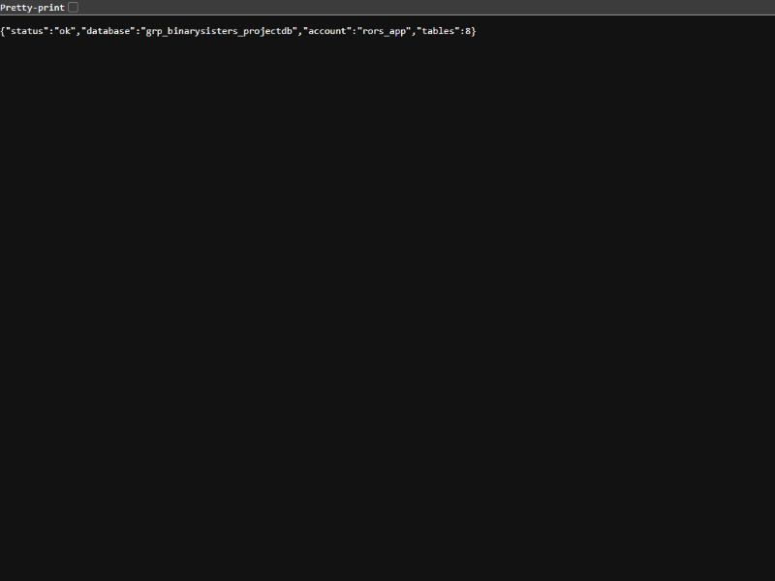

4. Database verification
Seed data loaded (setup output):
customers | staff | menu items | tables | orders | order items | payments | reservations
51 | 10 | 50 | 20 | 60 | 167 | 56 | 50
Objects found with \dt+, \dv, \ds and \dx:
- 8 tables: customer, menu_item, order_item, orders, payment, reservation, restaurant_table, staff.
- 4 views: v_customer_directory, v_order_summary, v_reservation_schedule, v_staff_directory.
- 7 sequences, one per SERIAL column.
- Extensions: btree_gist 1.8, pgcrypto 1.4, plpgsql.
- The migrations define 6 foreign keys, 16 CHECK constraints, a double-booking exclusion constraint (ex_reservation_no_overlap) on reservation, and 4 triggers (trg_order_item_keep_one, trg_order_item_total, trg_orders_require_items, trg_reservation_capacity) that keep orders.total_amount in sync and require at least one order item. Activity 6 confirmed that all of these survive a restore.
The project's own privilege check (04_verify_privileges.sql) passed 26 of 26 tests. No rors_ role is a superuser or has CREATEDB or CREATEROLE, and no privileges remain for PUBLIC on the tables.
Figure 2. pgAdmin Object Explorer for grp_binarysisters_projectdb, showing the 8 tables and 4 views in schema public.
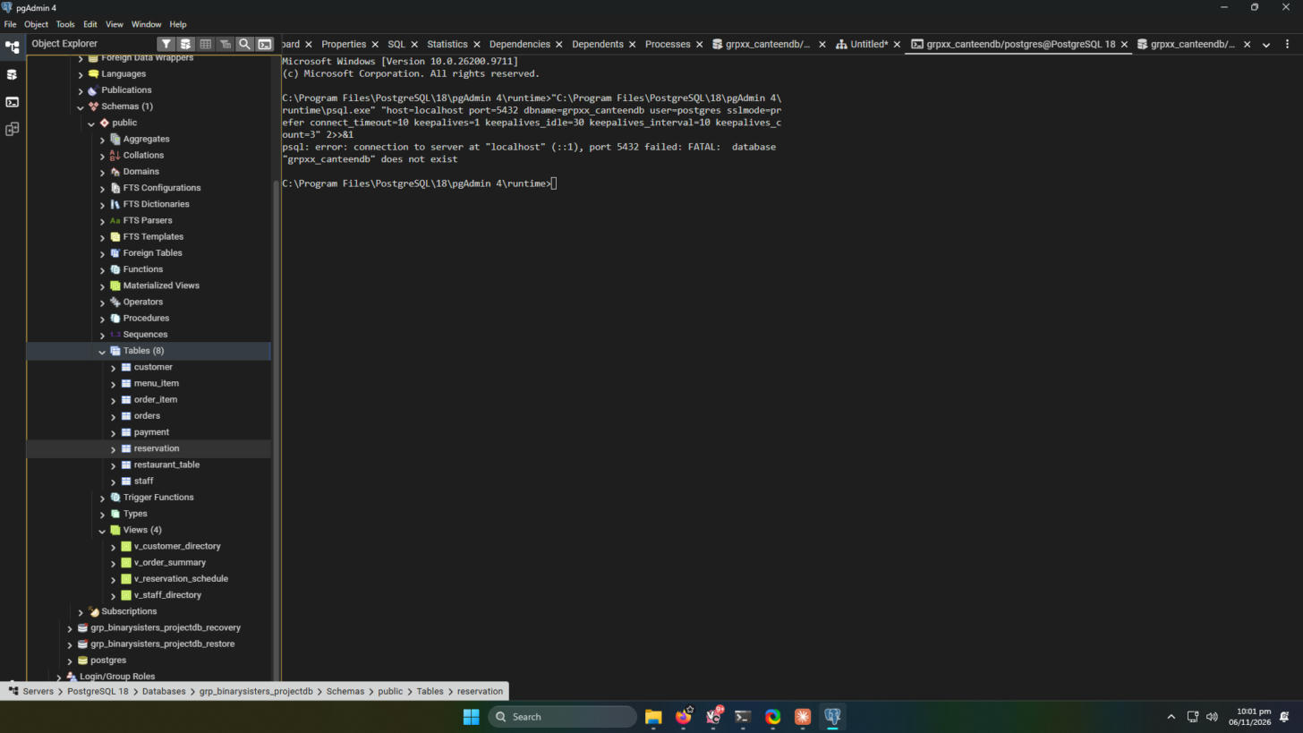

5. Application roles checked
Application role | Login used | Actions exercised | Result
Customer | maria.santos@rors.example | Browse menu, add 2 dishes, place an order, reserve a table | Pass. Added Calamares and Cheesy Dynamite and placed order #65 (PHP 390.00, Cash, Pending). It appears under My orders. Reserved Table 1 for 2 guests on 11 Nov 2026 at 10:00 AM (Confirmed). Once reserved, the table no longer appears in the free-table list (figures 5 to 10)
Staff | staff@rors.example | Change an order status, record a payment, open /admin/staff (should be denied) | Pass. An order status was changed (order #64 shows Confirmed) and a payment was recorded. The Orders and Payments pages loaded with data. /admin/staff showed Access denied (figures 11 to 13)
Administrator | admin@rors.example | Create, edit or delete a menu item, open the table form, open /admin/staff | Pass. Menu item changes were made (item 52, test2), and the menu item editor, the New table form and the Staff accounts list all loaded (figures 14 to 16)
The application ran with the least-privilege account rors_app, not a superuser. None of the captured screens showed a database permission denied message. The only denial was the designed Access denied page for Staff on /admin/staff. The second reservation attempt on the same table and time could not be made through the interface, because reserved tables are removed from the availability list. The database-level protection (exclusion constraint ex_reservation_no_overlap) is separate from the interface and was confirmed present after restore in Activity 6.
Figure 3. The running application home page (Mesa, order and reserve) at http://localhost:8000/.
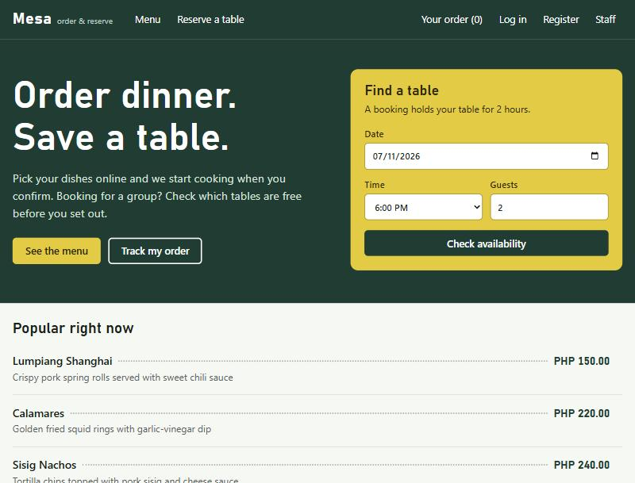
Figure 4. The menu page loaded from the database through the rors_app account.
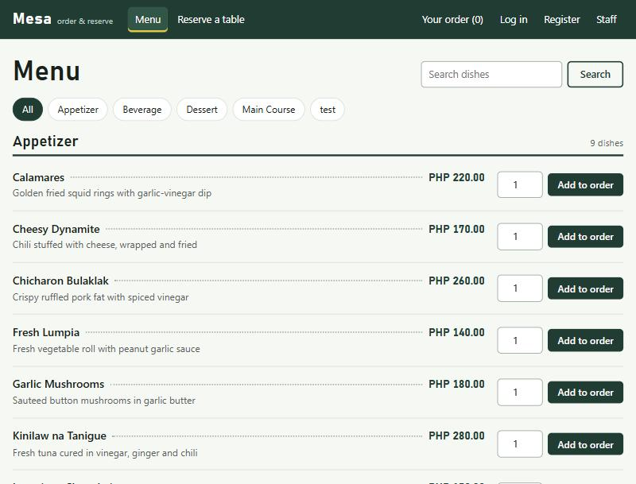
Customer workflow (rors_app connection)
Figure 5. Cart with two dishes, total PHP 390.00.
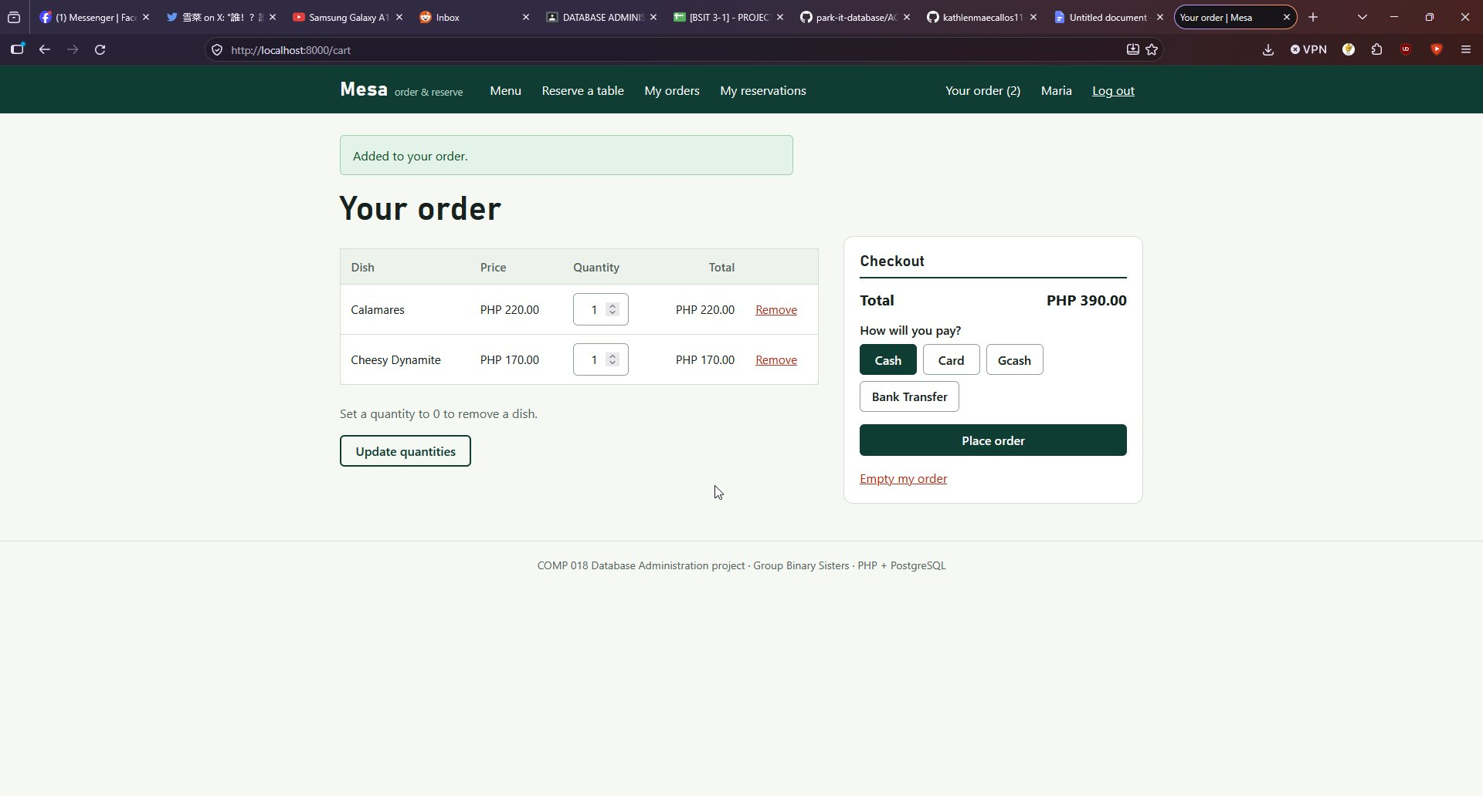
Figure 6. Order #65 placed, status Pending.
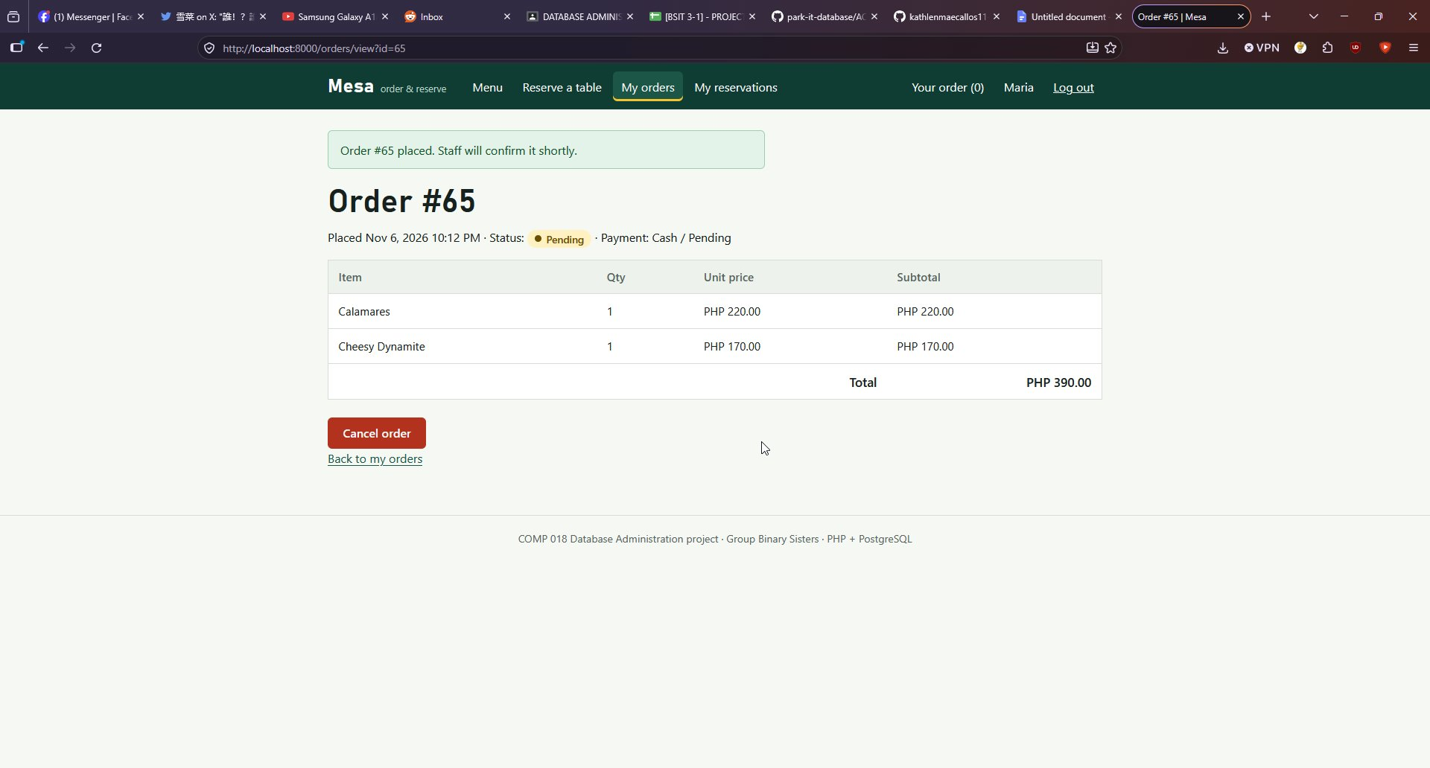
Figure 7. My orders listing order #65.
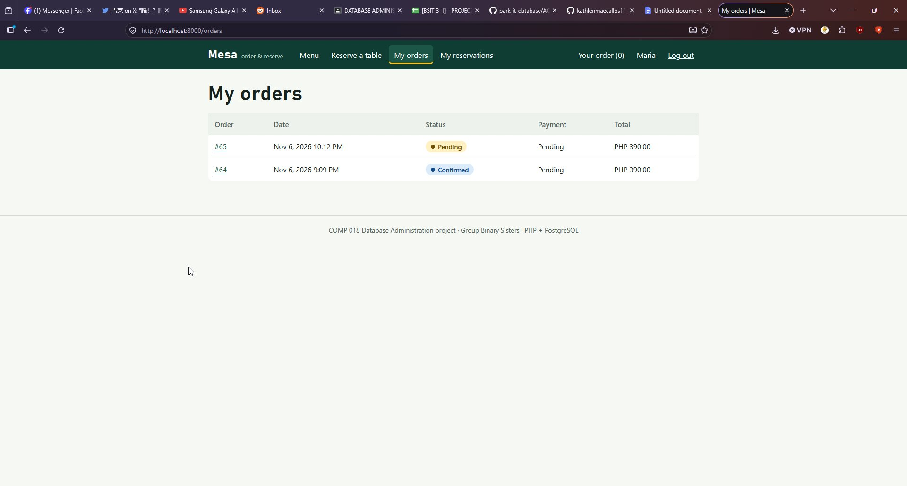
Figure 8. Reservation form with the free tables for 11 Nov 2026 at 10:00 AM, before booking.
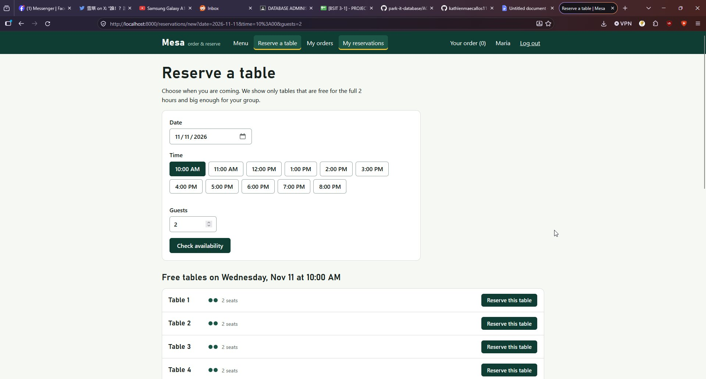
Figure 9. Reservation confirmed for Table 1.
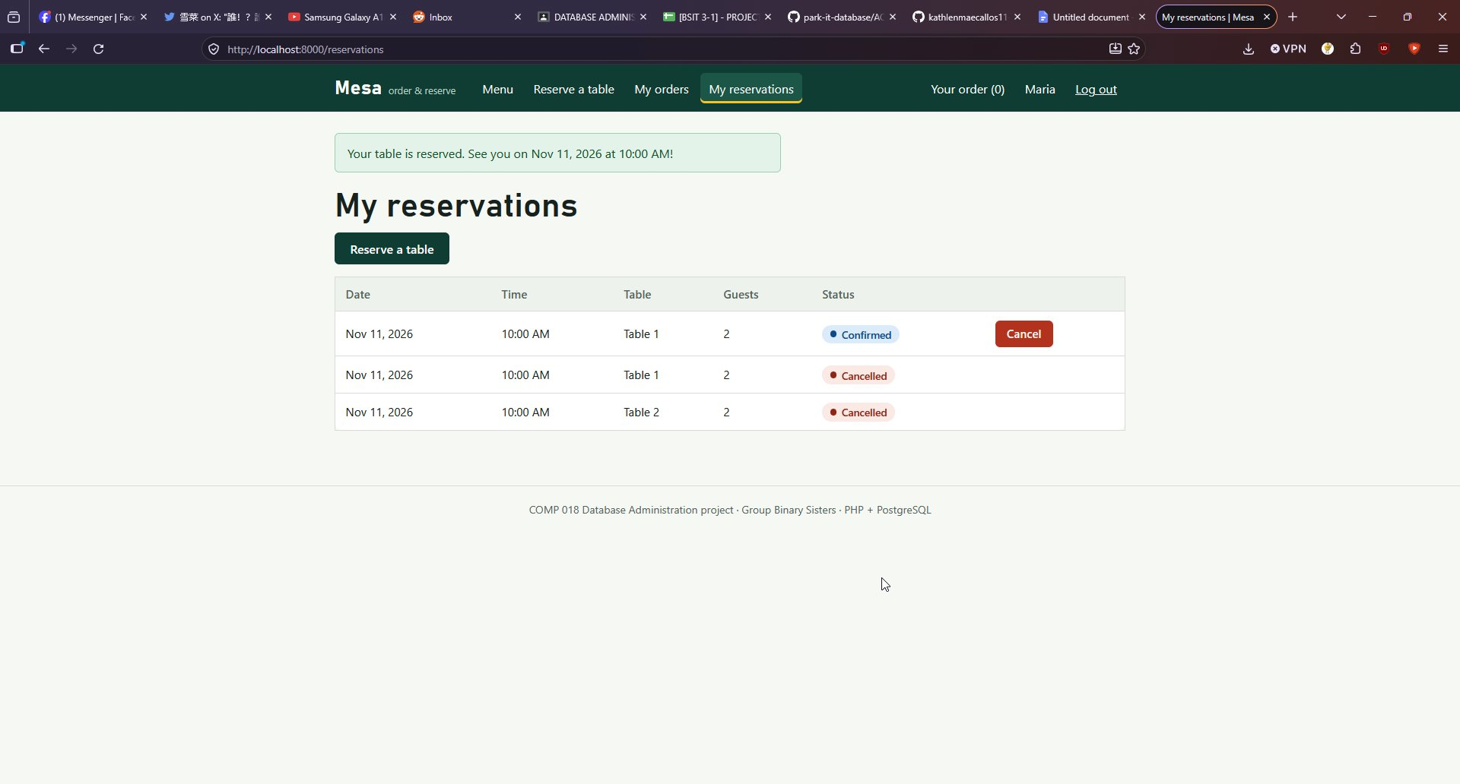
Figure 10. The same date and time afterwards. Table 1 is no longer offered.
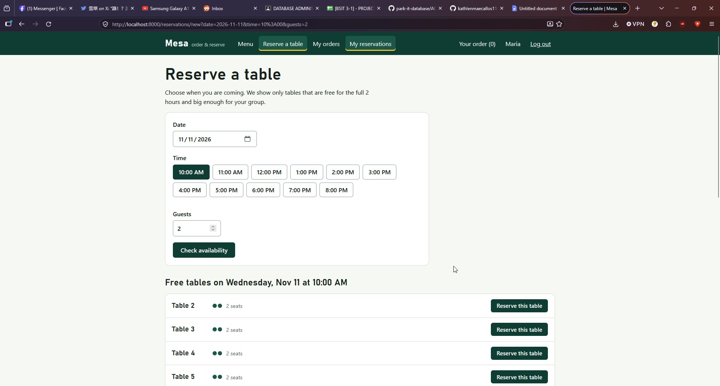
Staff workflow (staff@rors.example)
Figure 11. Orders management page.
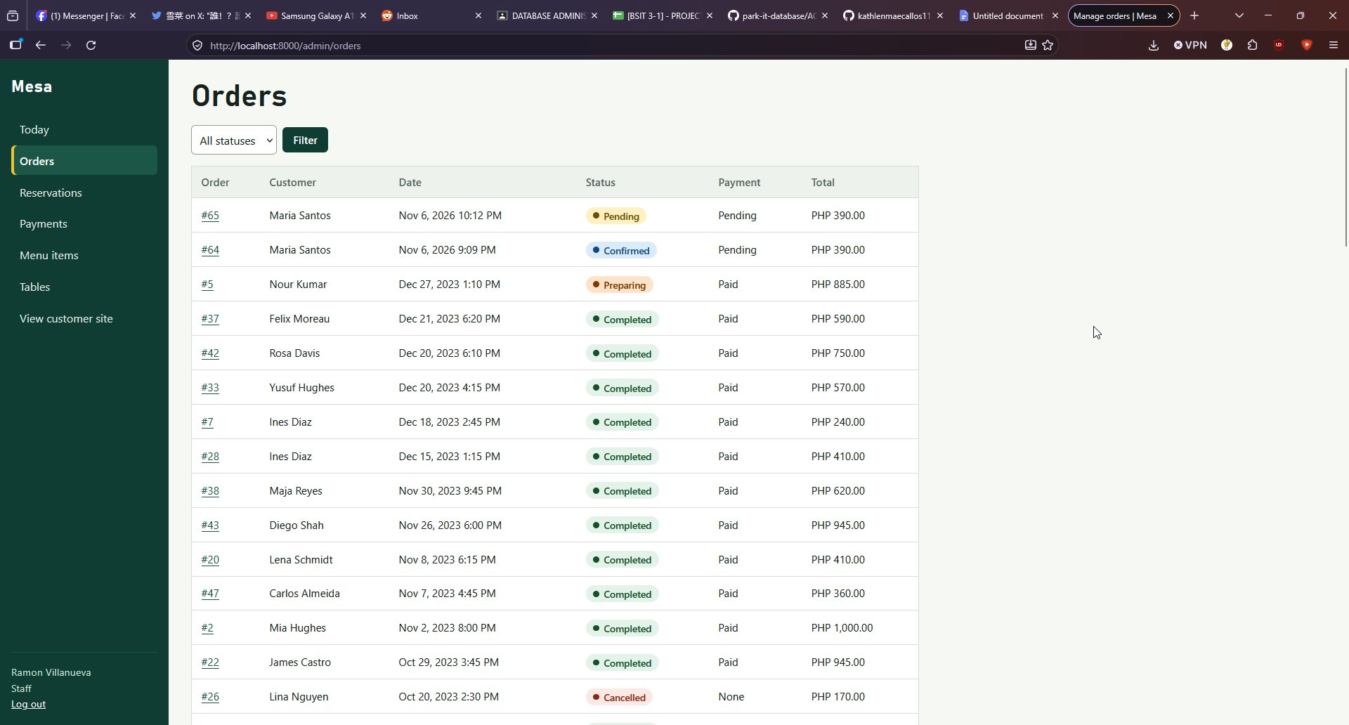
Figure 12. Payments page.
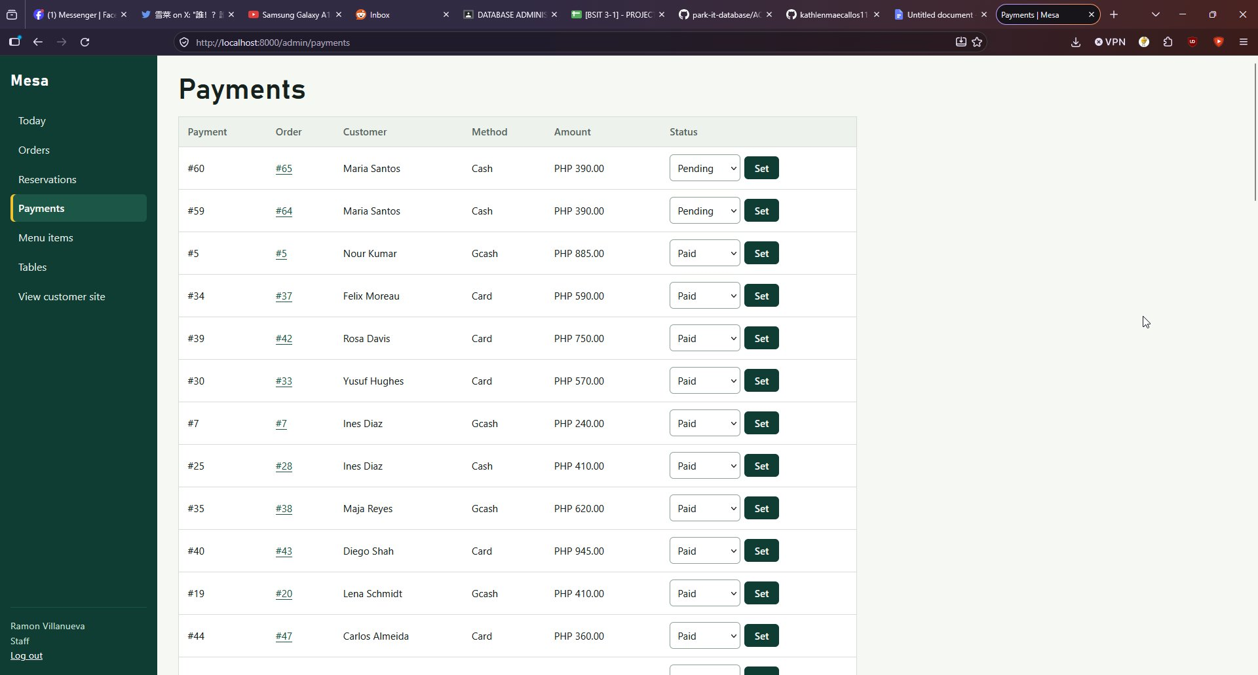
Figure 13. /admin/staff denied for the Staff role.
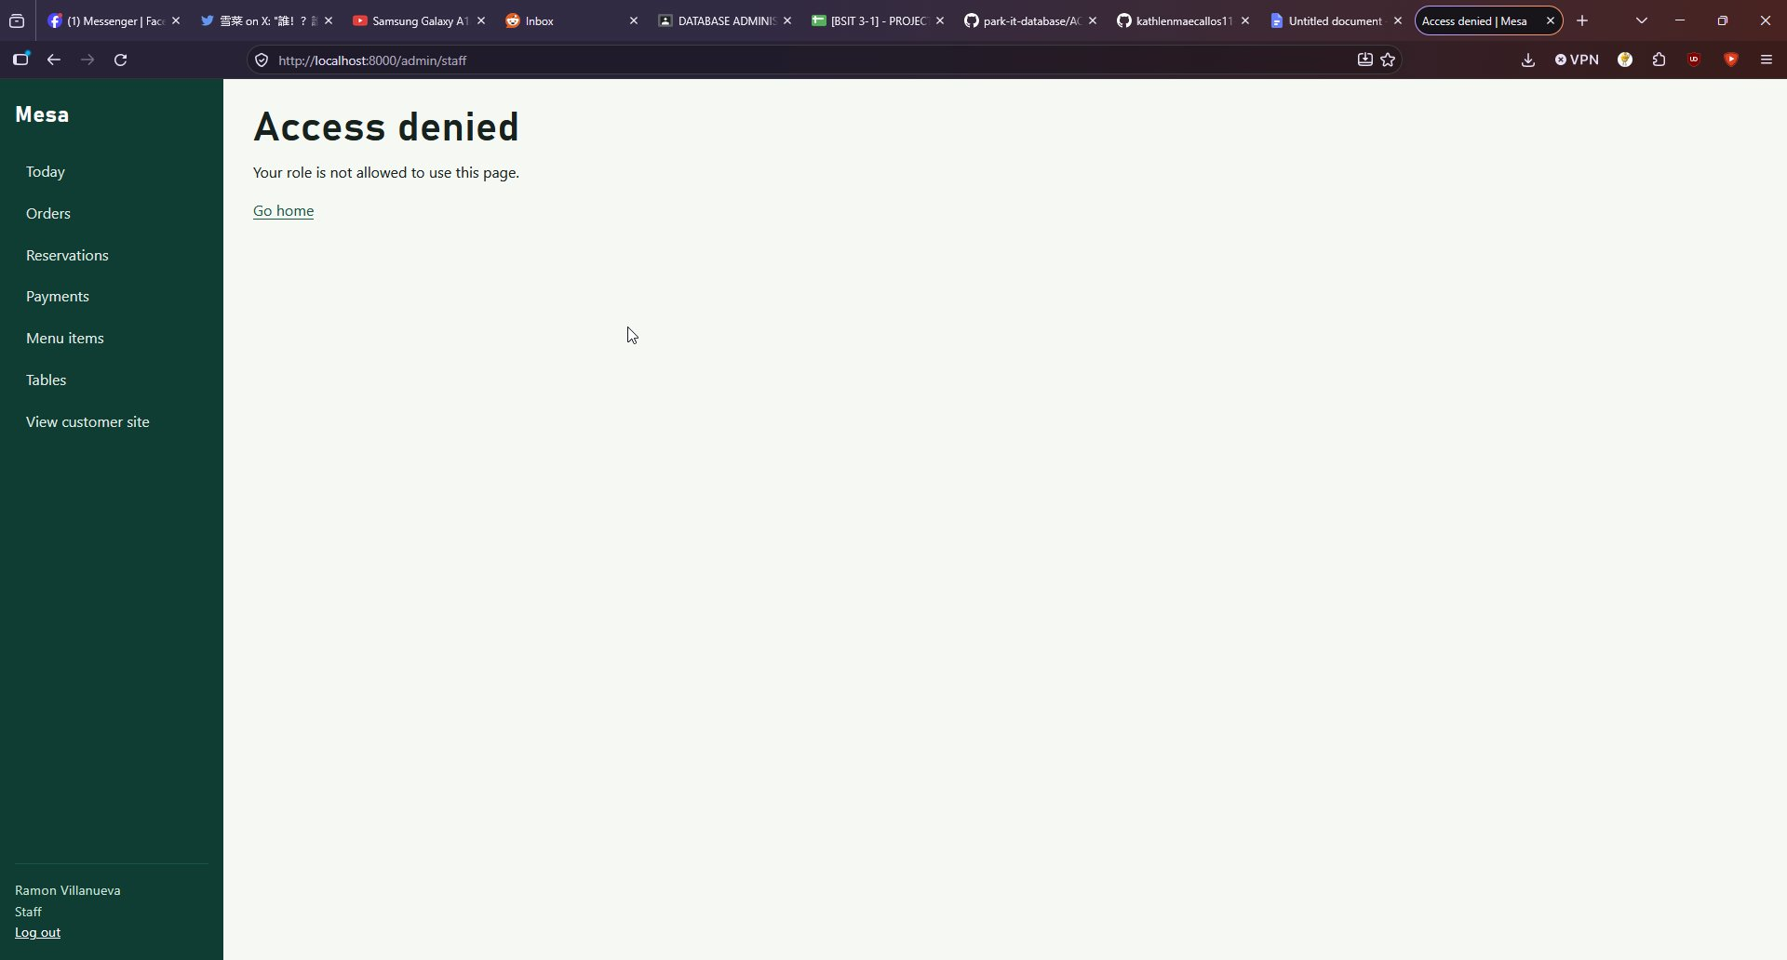
Administrator workflow (admin@rors.example)
Figure 14. Menu item editor.
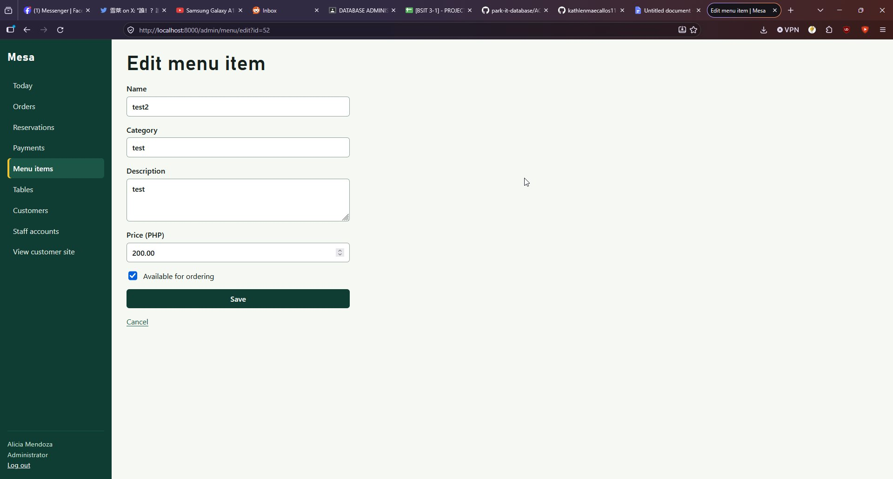
Figure 15. New table form.
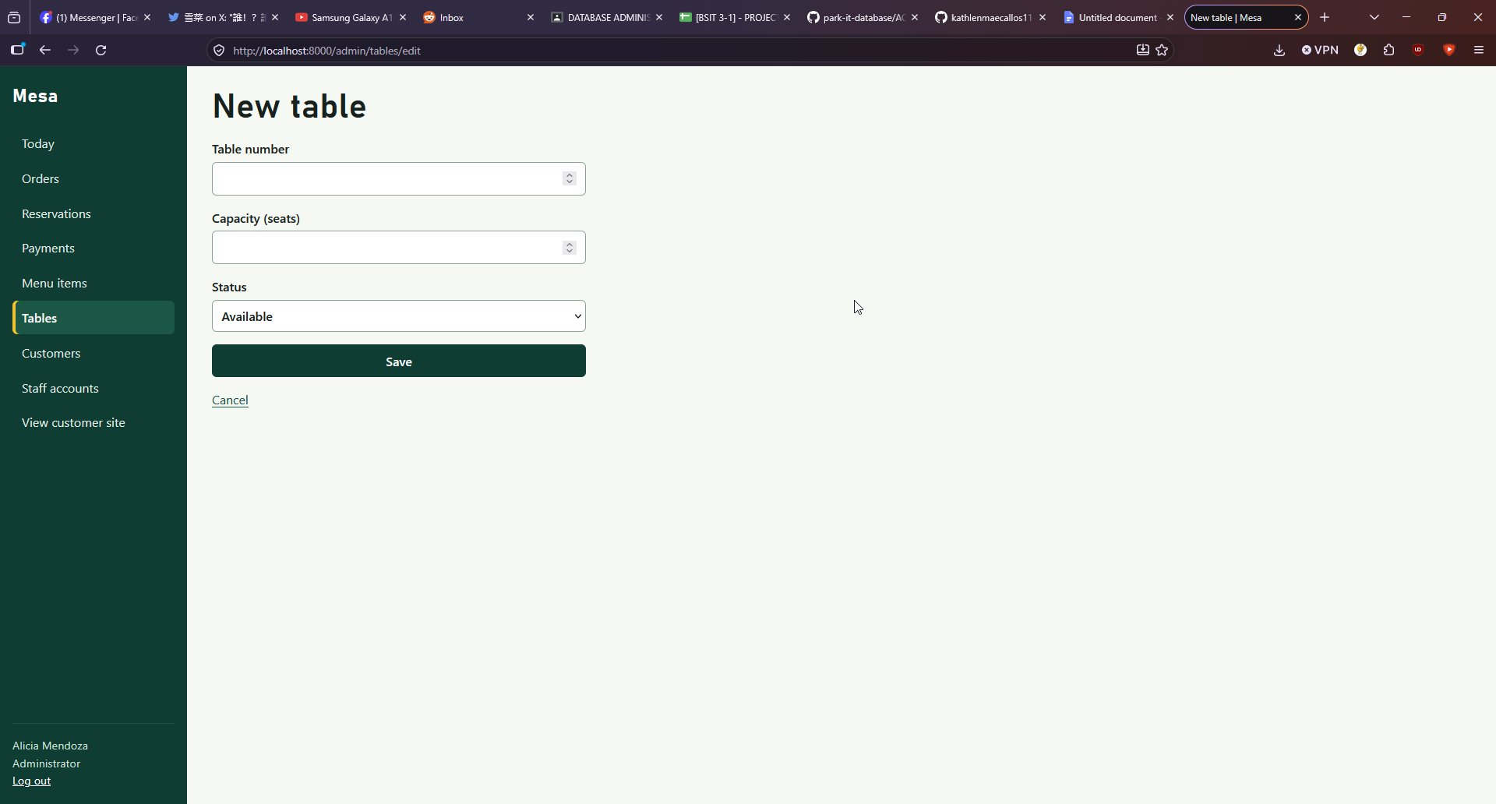
Figure 16. Staff accounts list, available to the Administrator only.
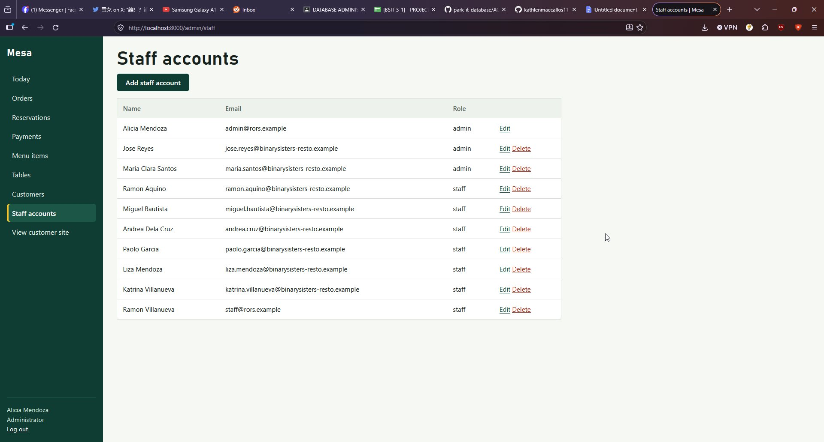

6. Issues found
# | Issue | Type | Impact | Suggested fix
1 | database/roles/03_set_passwords.psql is missing, although setup.ps1, setup.sh, the README and the troubleshooting guide all refer to it | Missing instruction or file | All five login accounts are created without a password, so rors_app cannot connect and the application cannot start | Add the file to the repository
2 | setup.ps1 continues after the failed password step and ends with a message that the database is ready | Script behaviour | The error is easy to miss and the instructions look as if they succeeded | Stop the script on a failed step, or check the exit code
3 | The pdo_pgsql PHP extension was not enabled in our PHP installation | Our environment | None for the owners. The project documents this in the README prerequisites and troubleshooting guide | None needed

7. Feedback sent to owners
Sent to Binary Sisters on 6 November 2026: issues 1 and 2 with the exact error text. A further note: tests/crud_tests.sql fails under the documented runtime account rors_app, which has no TEMP privilege, so the testing guide should say to run it as the administrator. The README, user roles documentation and troubleshooting guide were otherwise clear and complete.

8. Reproducibility conclusion
The project can be reproduced on another Windows machine. The database objects and sample data load correctly and the role verification passes. One undocumented manual step (setting the passwords) is needed because of the missing file.

9. AI usage declaration
- Tool: Claude (Anthropic).
- Tasks: interpreting the results of the testing.
- Validation: every command was run by the group against its own PostgreSQL server, and the results above come from that output.
- Correction made: the AI first expected the setup script to stop at the missing file. The real output showed it continued, so that behaviour is recorded as issue 2.

