Activity 3 Report: Cross-Group Deployment and Verification
COMP 018 Database Administration | Project tested: OJT Management System (Java Swing + PostgreSQL) | Date of testing: 6 November 2026

1. Cover and links
Item | Value
Testing group | G08: Borreta, Joshua; Bola, Martin Lawrence; Juatchon, Joaquin Phillip; Marcos, Karl Raphael; Pacheco Jr., Sancho; Vera Cruz, Euan Joseph
Project tested | OJT Management System
Owning group | [Owning group no. and name]
Repository | [Repository URL of the OJT Management System]
Tracker | https://github.com/EclipseChan/bwisIT-Solutions---Campus-Canteen-Pre-Order-and-Queue-Management-System/tree/main/other_group_tests
Evidence files | a3_deploy.txt, a3_app.txt, screenshots of the application

Only the repository and its documentation were used. Setup was done on the tester's own PostgreSQL server.

2. Test environment
Item | Value
Operating system | Windows 11
PostgreSQL | PostgreSQL 18.6 (x86_64 Windows), psql on PATH
Java and tools | OpenJDK 21.0.13 (Temurin), javac 21.0.13, Apache Maven 3.9.16. The README asks for JDK 17
JDBC driver | postgresql-42.7.4.jar downloaded from Maven Central, because the zip does not include one
Database used | ojt_management (the name used in the README)

3. Installation procedure and result
Step | Action | Result
1 | Extracted the zip and read README.md | The README describes a Maven project in an ojt-console folder with src/main/java. The zip has no pom.xml and no ojt-console folder. The sources are in system/ and compiled classes in target/classes
2 | CREATE DATABASE ojt_management | OK
3 | Ran Part 1 (tables) from database/sample sql.pdf exactly as written | All 12 tables created, with 2 syntax errors: a stray ");" at line 113 and a hidden zero-width character at line 197 (end of the pasted text)
4 | Ran Part 2 (roles and grants) as written | OK. 5 login roles and the grants were created. The roles have no password (see Activity 4)
5 | Compiled system/*.java with javac and the JDBC driver, pointed db.properties at ojt_management, and started ojt.Main | The app started, then showed "Could not create the account: column employee_number of relation academic_supervisors does not exist" (Figure 1)
6 | Added the missing columns (workaround, see section 6) and restarted | The login window opened (Figure 2) and the five demo accounts were created after one reset of the seed data

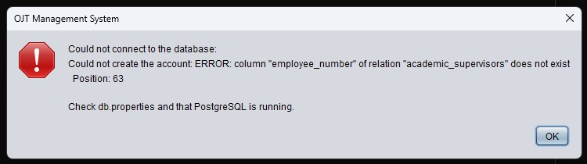
Figure 1. First start of the application, as documented. It cannot create its demo accounts.
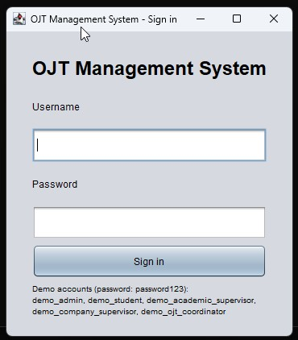
Figure 2. The login window after the workaround, with the five demo accounts listed.

4. Database verification
After running the SQL as documented: 12 tables (users, audit_log, students, companies, academic_supervisors, company_supervisors, requirements, ojt_applications, student_requirements, ojt_placements, attendance, evaluations), 49 constraint rows including the composite foreign key from ojt_placements to ojt_applications and the CHECK constraints on status, hours and dates, and the 5 ojt_ login roles. The database has no views and no triggers. Counts come from a3_deploy.txt.

5. Application roles checked
The app connects with one owner account (postgres). Each role was tested through the application, logged in as the demo account for that role.
Role | Action tested | Result
Administrator | List accounts, create a student account (Figures 3 to 5) | Pass
Student | Apply to Acme Corp (Figure 6), submit requirements, record 1 hour of attendance (Figure 10) | Pass
OJT coordinator | Approve the application, create a placement (Figure 7) | Pass
Academic supervisor | Verify one requirement and reject another with a reason (Figures 8 and 9) | Pass
Company supervisor | See the intern, verify the attendance (Figure 11), save an evaluation (Figure 12) | Pass. Verified hours changed from 0 to 1.00 for the placement

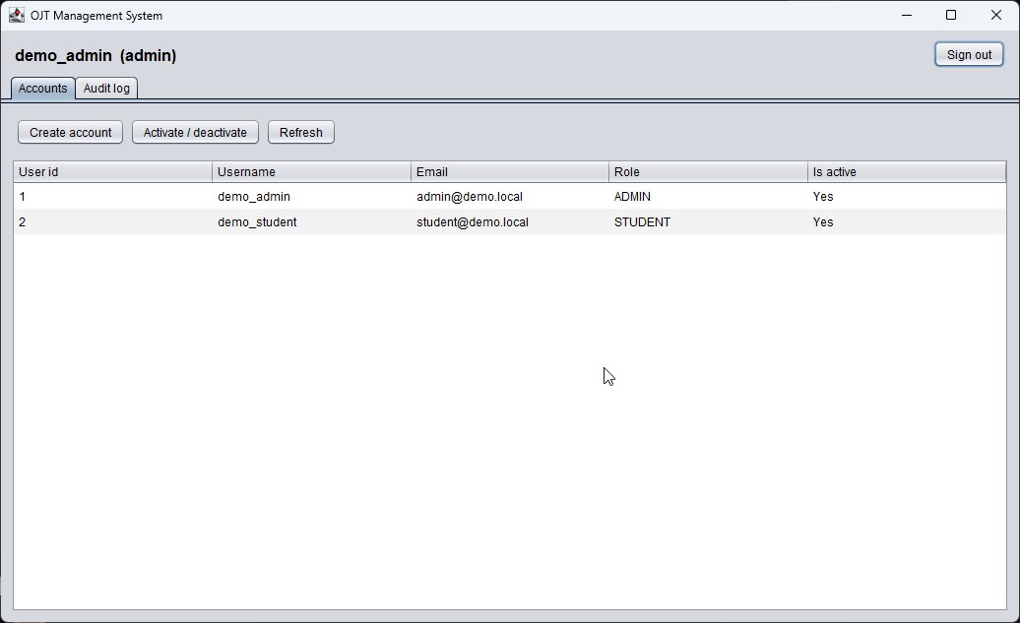
Figure 3. Administrator account list.
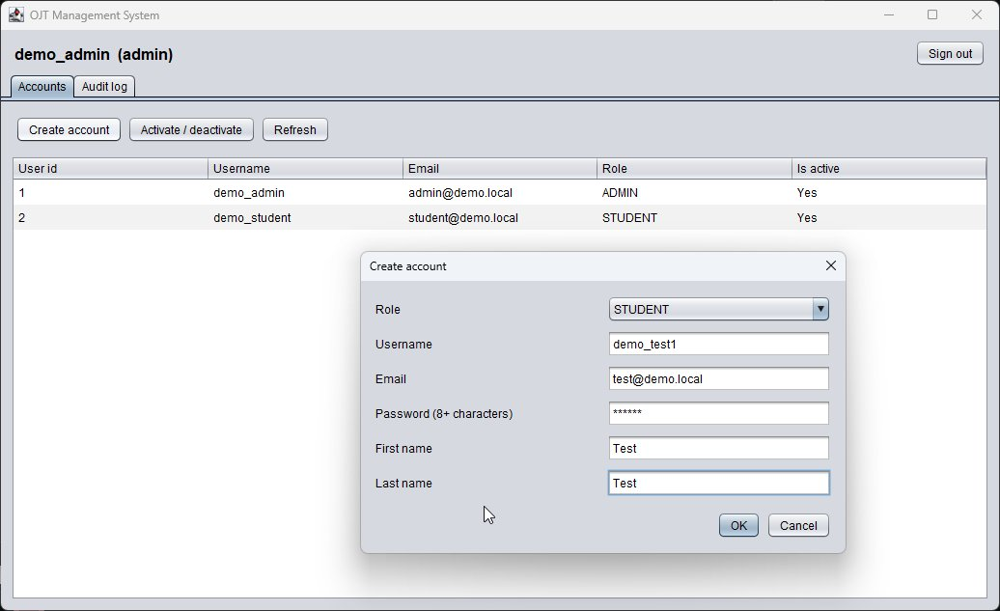
Figure 4. Administrator creating a student account.
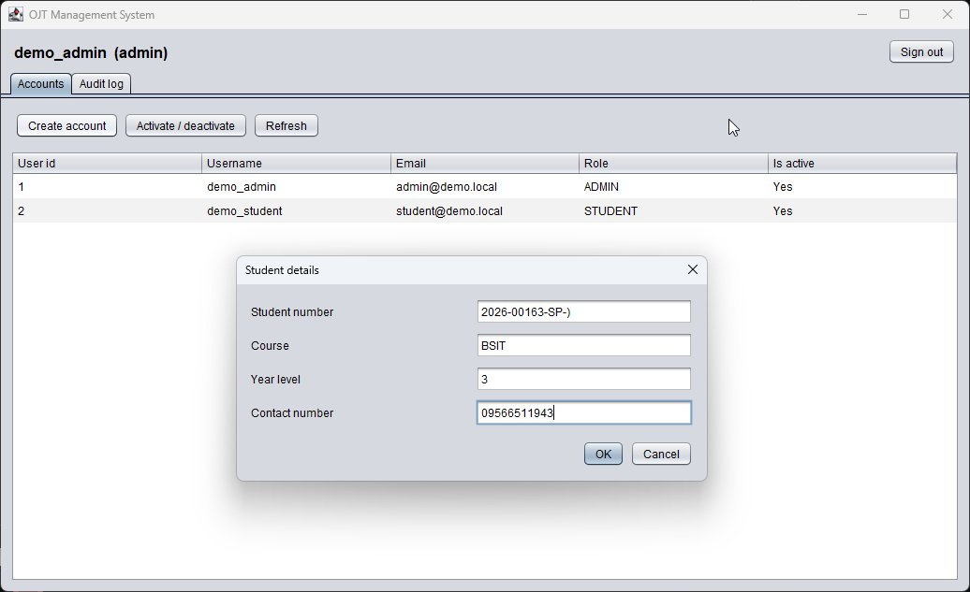
Figure 5. Student details requested by the application.
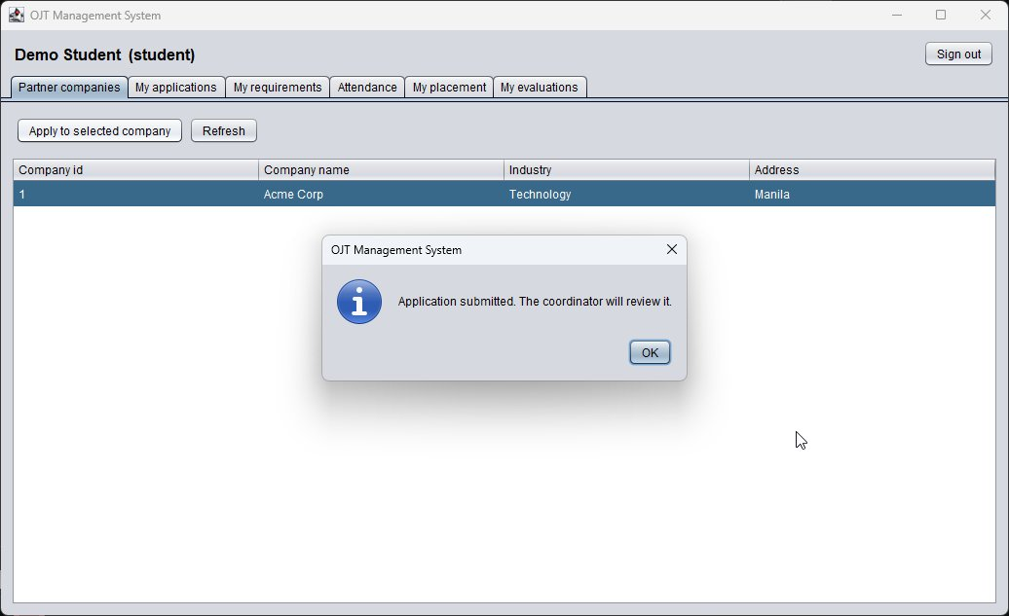
Figure 6. Student application submitted.
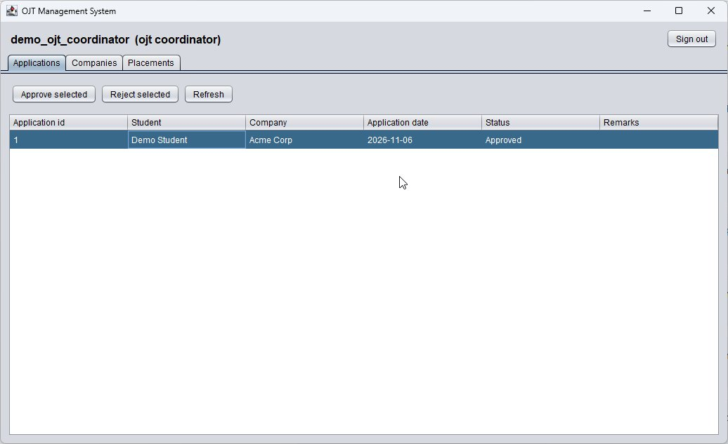
Figure 7. Coordinator view with the application approved.
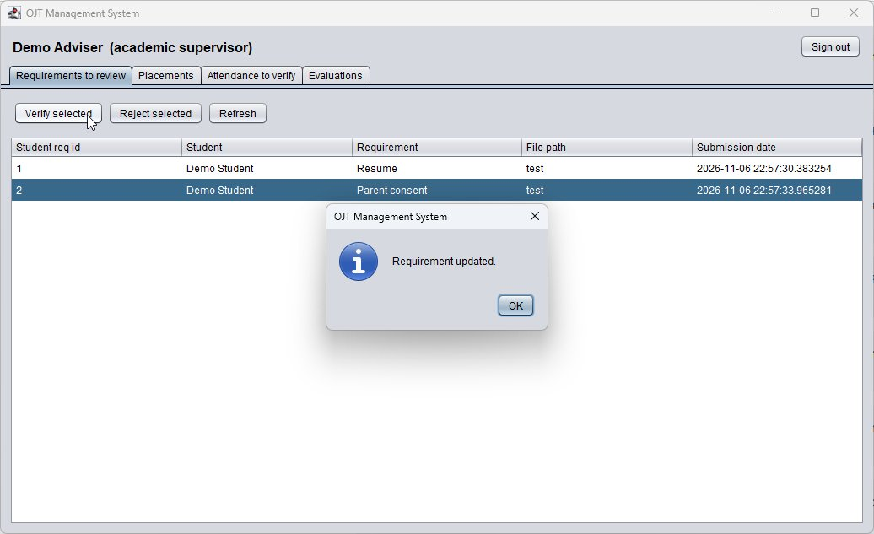
Figure 8. Academic supervisor verified a requirement.
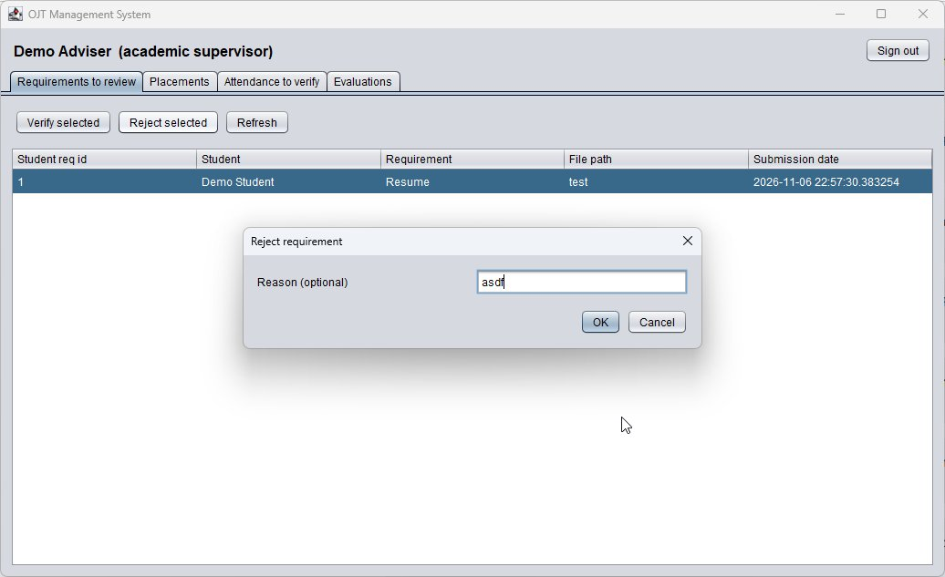
Figure 9. Academic supervisor rejecting a requirement.
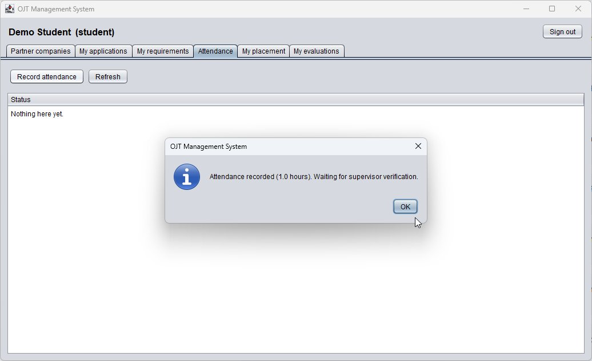
Figure 10. Student attendance recorded (1.0 hours).
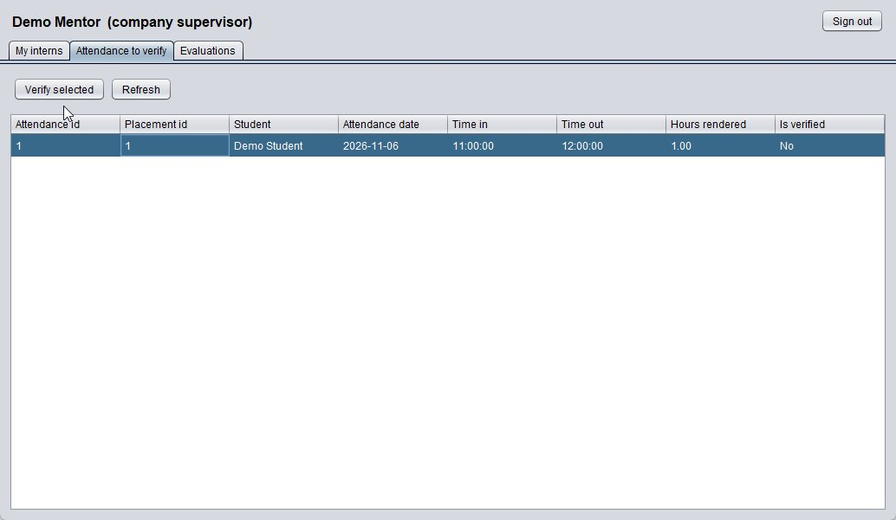
Figure 11. Company supervisor attendance to verify.
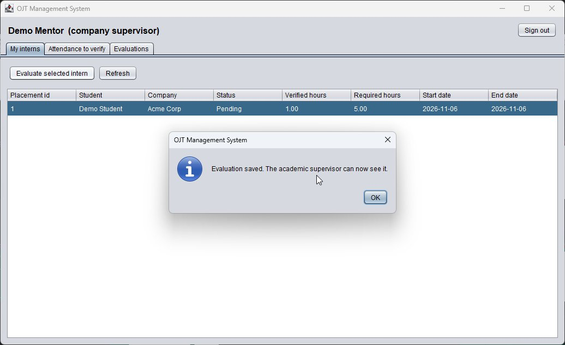
Figure 12. Evaluation saved.

6. Issues found
# | Issue | Impact and fix
1 | The schema in database/sample sql.pdf is missing columns the code inserts: academic_supervisors.employee_number, department and contact_number, and company_supervisors.department | The app cannot start on a fresh database. Workaround used: ALTER TABLE ... ADD COLUMN for those four columns. The schema or the code must be corrected
2 | The demo account seeding is not repeatable: it stops when demo_admin exists. After the failed first start only demo_admin and demo_student existed and the other three accounts were never created | Fix needs a manual TRUNCATE of the seed tables. The seed should check each account
3 | The only SQL is in a PDF with a stray ");" and a hidden character | Two syntax errors when run as written. Provide a plain .sql file
4 | database/OJT Database.sql is a binary PostgreSQL custom-format archive, not a SQL script, and its text names a database called Demo, so it appears to belong to another project | It cannot be run with psql. Replace it with the real script
5 | No pom.xml, no ojt-console folder and no JDBC driver in the zip, so "mvn compile exec:java" from the README cannot work | Built with javac and a downloaded driver. Add the Maven project
6 | Database name differs: README ojt_management, shipped db.properties OJT_Mangementdb (misspelled), comment in Db.java OJT_Managementdb | Connection fails unless the tester edits the file
7 | The README shows CREATE ROLE ... PASSWORD but the SQL creates the roles without a password. The README also says the app uses one owner account, so the ojt_ roles are never used by the app | See Activity 4

7. Feedback sent to owners
Sent on 6 November 2026: issues 1 to 6 with the exact error text. The README was otherwise clear and the application worked after the workaround.

8. Reproducibility conclusion
Not reproducible as documented. After adding four missing columns, correcting the database name, building with javac and resetting the seed data, all five roles worked. A clean install needs a working schema file, a build file and an idempotent seed.

AI usage declaration
- Tool: Claude (Anthropic).
- Tasks: interpreting the results of the testing.
- Validation: the commands were run by the group on its own server, and every result in this report comes from the saved output files.
- Correction made: the AI first expected the SQL file in the database folder to be a plain script. Reading its header showed it is a binary archive, and the report says so.

