Activity 3 Report: Cross-Group Deployment and Verification
COMP 018 Database Administration | Project tested: CampusSafe (Campus Hazard and Safety Reporting System) (PHP + PostgreSQL) | Date of testing: 7 November 2026

1. Cover and links
Item | Value
Testing group | G08: Borreta, Joshua; Bola, Martin Lawrence; Juatchon, Joaquin Phillip; Marcos, Karl Raphael; Pacheco Jr., Sancho; Vera Cruz, Euan Joseph
Project tested | CampusSafe (Campus Hazard and Safety Reporting System)
Owning group | Group 7 (member names are not listed in the project files)
Repository | grp07-campussafe (project zip grp07-campussafe-main; the repository link is not included in the files we received)
Tracker | https://github.com/EclipseChan/bwisIT-Solutions---Campus-Canteen-Pre-Order-and-Queue-Management-System/tree/main/other_group_tests
Evidence files | a3_deploy.txt, screenshots

Every result below comes from this run on a freshly created database.

2. Test environment
Item | Value
Operating system | Windows 11
PostgreSQL | 18.6 (x86_64 Windows), psql on PATH. The README states PostgreSQL 14+
PHP | 8.2.12 CLI with pdo_pgsql, pgsql, fileinfo and session enabled
Web server | PHP built-in server (php -S localhost:8000 -t public), one of the two options the README lists
Database | grp07_campussafedb, the name in .env.example
Browser | Web browser on Windows (Figures 1 to 6)

3. Installation procedure and result
The README offers a one-click wizard (start.bat or setup.bat) and a manual guide. We followed the manual guide so that every step could be recorded.
Step | Action | Result
1 | Copy .env.example to .env and set DB_NAME, DB_USER, DB_PASSWORD | Done. The template already names grp07_campussafedb and campussafe_app. We first connected as postgres, as the README says for the initial scripts
2 | CREATE DATABASE grp07_campussafedb | OK
3 | Run database/01_schema.sql | No errors. 9 tables, 24 indexes. A second run produced no errors either, so the script is repeatable
4 | Run database/02_seed.sql | No errors. Roles, categories, locations, 16 reports, assignments, history and attachments loaded. A second run also gave no errors
5 | Run database/seed_users.php | Creates six demo users with bcrypt hashes. Run twice: the second run updates the same users instead of duplicating them
6 | Start the server and open the app | Login page shown. All six demo accounts log in with the demo password from the README
7 | database/verify.sql (shipped with the project) | Row counts, status distribution and integrity checks all pass (0 violations)

The setup worked first time with no changes to the project files.

4. Database verification
Check | Result
Tables | 9: role, app_user, hazard_category, campus_location, hazard_report, assignment, report_status_history, maintenance_action, attachment
Constraints | 7 check, 14 foreign key, 9 primary key, 5 unique, 47 not null
Rules in the database | Status limited to the 6 lifecycle values; priority limited to Low, Medium, High, Critical; a verified report needs both verifier and time; a Resolved or Closed report needs a resolved time
Triggers | None
Seed data | 5 roles, 6 users, 6 categories, 10 locations, 16 reports, 12 assignments, 60 history rows, 9 maintenance actions, 5 attachments
Owner | postgres owns all 9 tables during setup (the roles script comes in Activity 4)
Password storage | bcrypt hashes ($2y$10$, 60 characters) for all six users

Direct database tests: status "Banana" rejected by hazard_report_status_check; Resolved with no resolved time rejected by chk_resolved_has_date; priority "Urgent" rejected by hazard_report_priority_check.

5. Application checks
The pages were exercised with scripted web requests and a cookie jar per user, with database checks after the workflow steps, then looked at in the browser (Figures 1 to 6).
Test | Result
Anonymous visit to list, new report, all admin and maintenance pages | Each redirects to the login page (HTTP 302). Only the home page and login page are open
Wrong password, unknown user, empty fields, SQL text as the username | Rejected with "Invalid username or password" or "Please enter both ..." No details leaked
Login post without the CSRF token | HTTP 403
Role gating: all five account types against every page | Administrator: all admin pages and the shared pages. Maintenance: only its own two pages. Student and Faculty: shared pages only. Auditor: shared pages and Statistics only. Anything else answered HTTP 403
Student submits a report | Pass. Report #17 was created, status Submitted, and the status history gained a row
Empty description | Rejected: "Please fill out all required fields"
Category id 9999 (nonexistent) | Rejected, but the page shows the raw database message "SQLSTATE[23503] Foreign key violation ... hazard_report_category_..."
Script tag and SQL text in the description | Accepted and stored as plain text (report #19). It is shown as text in the report page (Figure 4), so it is escaped on output, and the table was not dropped
Report post without the CSRF token | HTTP 403
Admin verifies report #19 as High | Pass. Redirects to the assign page
Verify with priority "Urgent" | Not accepted; the form is shown again and the report stays High
Admin assigns the report to demo_maint1 | Pass
Technician logs progress, then resolves | Pass. Report #19 became Resolved with a resolved time, and the action log shows two entries (Figure 4)
Response headers and session cookie | Cache-Control: no-store. Session cookie has HttpOnly and SameSite=Lax. X-Powered-By shows the PHP version. No other security headers

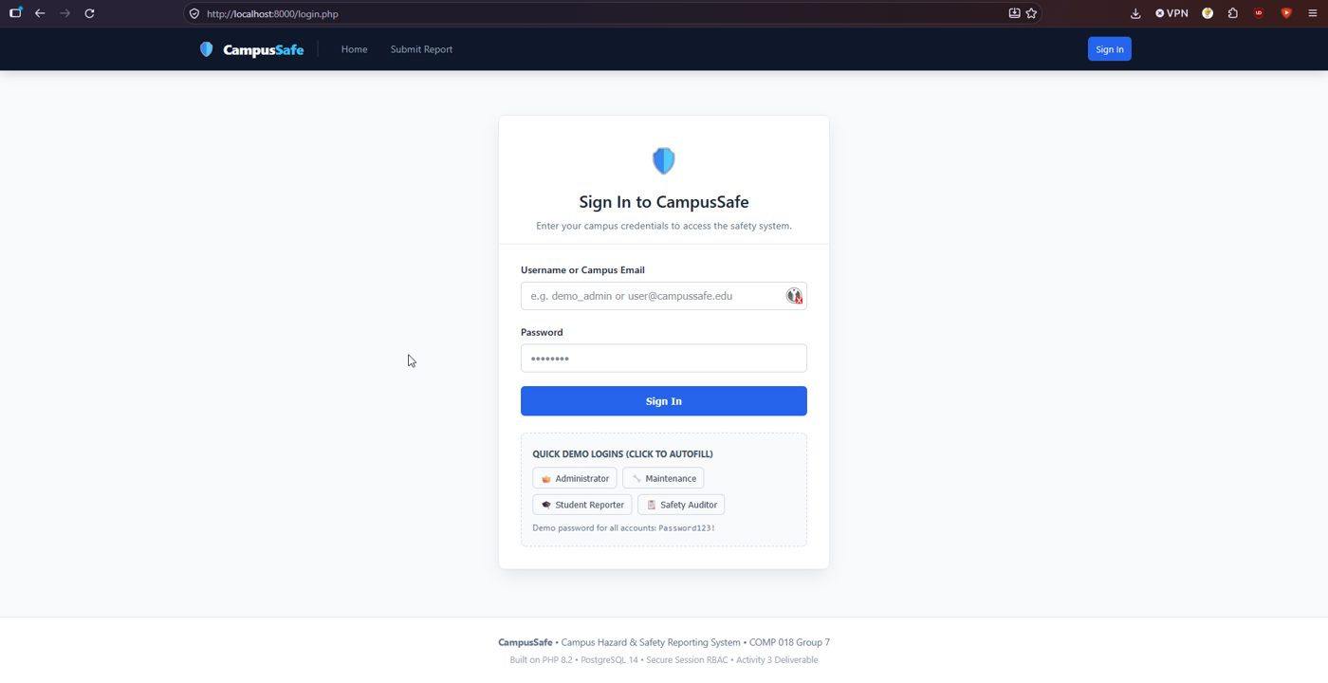
Figure 1. Login page, with the quick demo logins and the demo password shown.
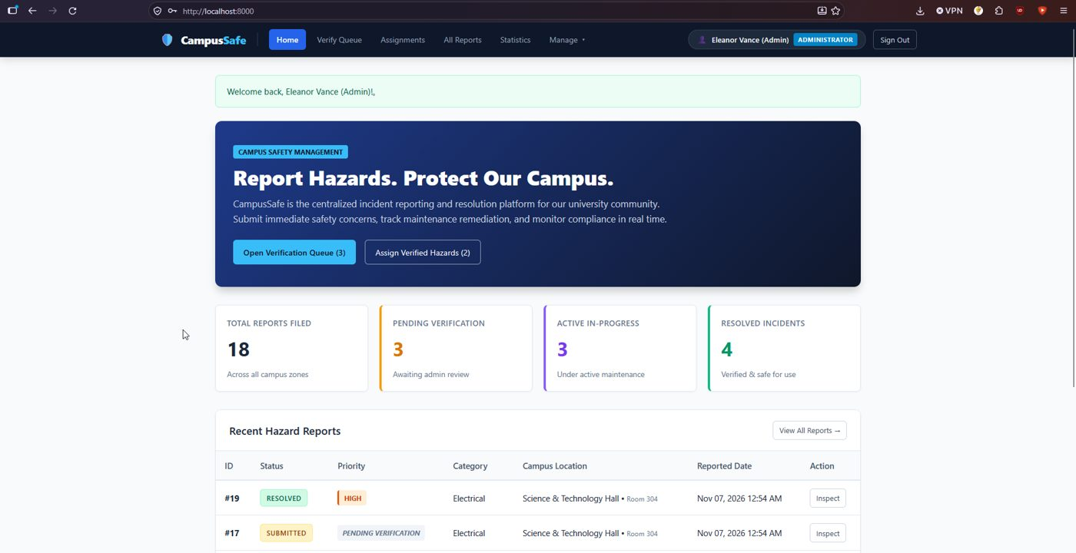
Figure 2. Administrator home page: counts and the recent hazard reports.
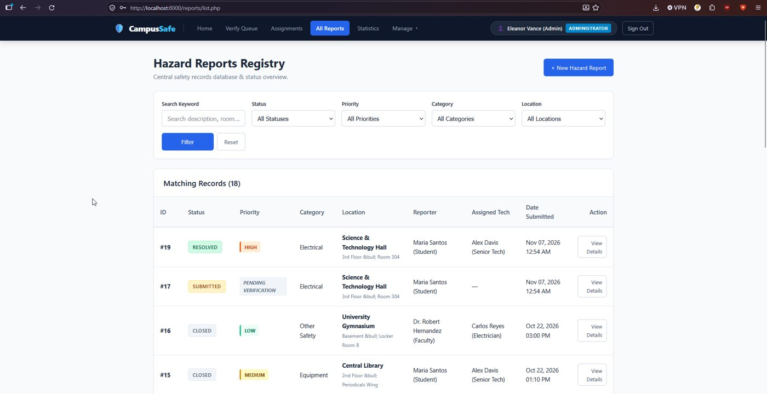
Figure 3. Hazard report list with filters. The location line shows "&bull;" as text.
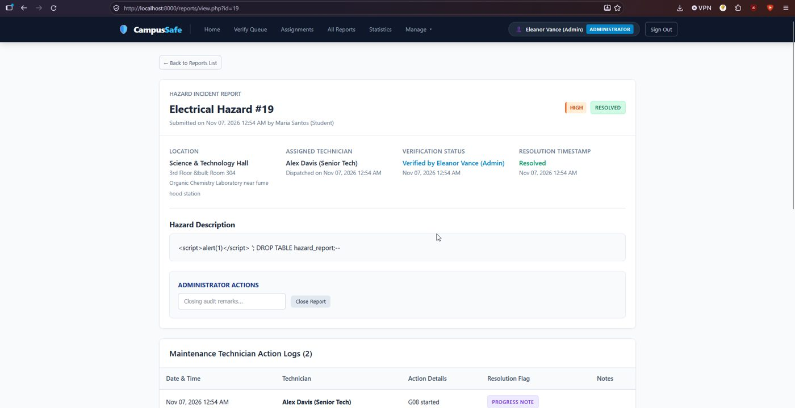
Figure 4. Report #19 after the full workflow, with the script text from the test shown as plain text.
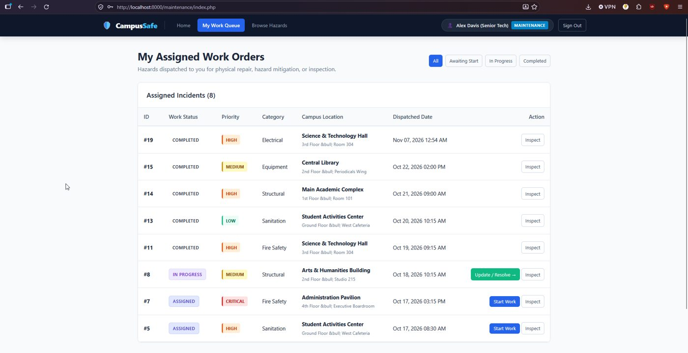
Figure 5. Technician work queue (demo_maint1).
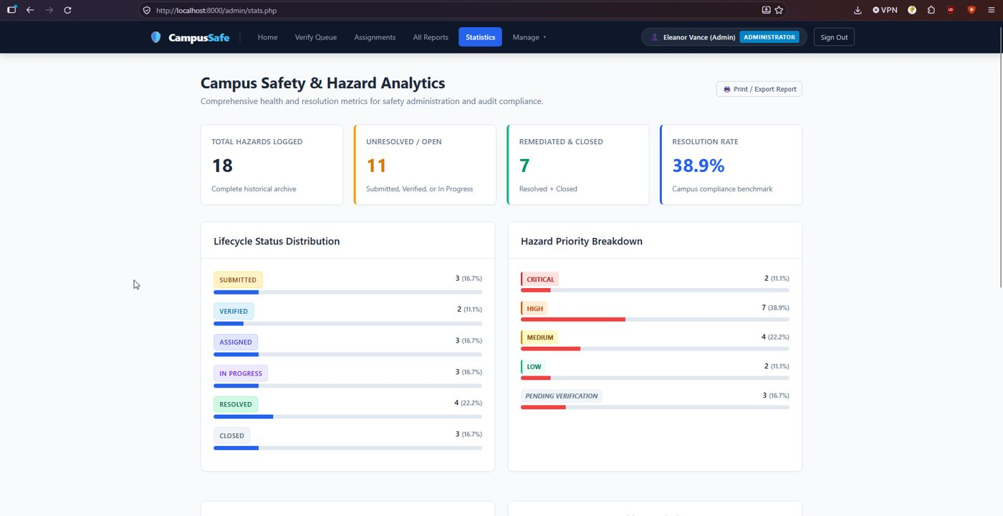
Figure 6. Statistics page: status and priority breakdown.

6. Issues found
# | Issue | Impact and suggestion
1 | public/install.php is still reachable without a login after setup (it showed the installation wizard) | Anyone could reach the installer. Delete it after setup or refuse to run once the database exists
2 | The login page lists the demo accounts and the demo password Password123! | Fine for a classroom demo. Remove it before any real use
3 | A database foreign key error message is shown to the user when a report is filed with a bad category | Reveals table and constraint names. Check the category in PHP and show a short message
4 | The location line shows a literal "&bull;" in the list, the home page and the work queue (Figures 3 and 5) | The text is escaped twice. Escape once
5 | No login lockout (see Activity 4) | Add a delay or limit after repeated failures
6 | X-Powered-By header shows the PHP version | Set expose_php = Off

The lifecycle (submit, verify, assign, resolve), the role pages, the CSRF check and the database constraints all behaved as described in the README.

7. Feedback for the owners
Issues 1 and 3 are worth fixing first. The manual setup steps needed no changes.

8. Reproducibility conclusion
Reproducible. From an empty database the manual README steps gave a working system with no errors, and the workflow ran end to end.

9. Limitations
The photo and document upload feature (JPG, PNG, WEBP, PDF) was not tested in this run, only the five attachment rows that come with the seed data.

AI usage declaration
- Tool: Claude (Anthropic).
- Tasks: interpreting the results of the testing.
- Validation: the commands were run by the group on its own computer, and every result in this report comes from the saved output files.

