JBI UNIVERSITY MANAGEMENT SYSTEM
Master Software Engineering Architecture, Formal Database Normalization & Institutional Operating Manual
Document Parameter | Specification Details
System Reference | JBI Tertiary Education Enterprise ERP (Web Portal & Administrative Engine)
Target Audience | University Board of Directors, Vice-Chancellor's Office, Future System Architects & Software Engineers
Version & Release | Version 2.2 Enterprise Production Release (October 2026)
Core Framework Stack | Laravel 11.x, PHP 8.2.12+, MySQL 8.x InnoDB, Bootstrap 5.3, Vite/JS
Multi-Role RBAC Model | Relational Many-to-Many Pivot (role_user) with Dynamic Academic Leadership Resolution
Excluded Stakeholder | Parent / Guardian (strictly excluded from models, interfaces, and documentation per institutional mandate)
Author & Reviewer | Lead Software Engineer & Principal System Analyst

1. Executive Summary for the University Board of Directors
This comprehensive engineering and system architecture specification provides the University Board of Directors, the Vice-Chancellor, and institutional governing bodies with a strategic and technical appraisal of the JBI University Management System. Designed specifically for contemporary higher education governance, the platform unifies student admissions, fee reconciliation, academic operations, examinations, online learning, student e-voting democracy, and human capital administration into an integrated digital campus.
1.1. Strategic Institutional Value & Return on Investment (ROI)
Higher education institutions face unprecedented challenges in maintaining academic integrity, optimizing operating costs, and eliminating revenue leakages. The JBI platform resolves these strategic challenges through five pillars of automation:
- 1. Centralized Admissions Velocity: Replaces manual paper applications and fragmented departmental spreadsheets with a centralized, auditable admission pipeline. Prospective applicants submit credentials digitally, undergo automated entry qualification verification, and receive instant admission letters and activation credentials.
- 2. Financial Anti-Fraud Integrity: Eliminates cash-handling risks through integrated Payment Reference Number (PRN) generation. All fee records are reconciled directly against bank gateway transactions, establishing verifiable audit trails and preventing revenue leakage.
- 3. Academic Rigor Automation: Protects institutional accreditation by automating prerequisite enforcement, course load restrictions, continuous assessment moderation, and cumulative Grade Point Average (CGPA) calculations.
- 4. Multi-Role Institutional Agility: Empowers senior faculty members to serve concurrently across instructional, departmental (HOD), and divisional (Dean) roles under a single secure identity, ending administrative fragmentation.
- 5. Democratic Campus Governance: Provides a transparent, tamper-resistant digital voting platform for student union elections, enforcing an automated academic vetting rule that immediately disqualifies students with active course retakes or failing grades.
1.2. Fiduciary Governance, Auditability & Regulatory Compliance
The JBI platform incorporates end-to-end auditability across every financial, academic, and administrative interaction. Every grade alteration, invoice adjustment, fee waiver, and student status modification is committed to immutable audit logs containing timestamps, originating IP addresses, user identity tokens, and before/after state snapshots. This guarantees full compliance with tertiary education accreditation bodies, external auditing standards, and national data protection regulations.
■ Executive Institutional Signoff & Security Guarantee
The system enforces strict principle-of-least-privilege authorization. Even in multi-role configurations, administrative powers are tightly isolated behind permission gates. Central administrative resets (/clear, /generate) are fortified behind multi-factor authentication and SuperAdmin authorization checks. The institution retains complete sovereign data ownership with zero dependency on proprietary vendor lock-in.

2. Institutional Stakeholder & Actor Taxonomy (Parent Excluded)
In accordance with institutional guidelines, all university actors have been formally modeled and assigned precise functional boundaries. As explicitly instructed, the Parent/Guardian role is completely omitted from this documentation and the university system access model.
2.1. In-Depth Stakeholder Profiles & Clearance Hierarchy
1. Super Administrator & Central IT Staff
Mandate: The Central IT Directorate exercises highest-level operational responsibility for system availability, network security, database backups, and disaster recovery.
Key Responsibilities: Manages system configurations, executes database migrations, provisions official staff accounts, manages the role and permission catalog, oversees queue workers, and inspects security telemetry and error logs.
Clearance Level: Level 5 (Unrestricted System Root with Gate::before universal bypass privileges).
2. University Board & Vice-Chancellor's Office
Mandate: The executive governing body presiding over institutional strategy, financial sustainability, academic quality, and statutory compliance.
Key Responsibilities: Monitors institutional KPIs, reviews cross-faculty enrollment trends, audits multi-currency fee collection revenues, reviews faculty budget allocations, and approves strategic expansions.
Clearance Level: Level 4 (Executive Audit & Read-Only Reporting across all institutional divisions).
3. Registrar & Admissions Directorate
Mandate: The central custodian of student academic records, institutional matriculation, degree awards, and formal university admissions.
Key Responsibilities: Reviews incoming prospective student applications, verifies uploaded qualification certificates, approves or rejects applications, issues official matriculation numbers (ADM-YYYY-XXXX), certifies semester graduation lists, and seals academic transcripts.
Clearance Level: Level 3 (Registry Authority with full CRUD over admissions and student records).
4. Bursar & Chief Financial Officer
Mandate: The chief financial officer responsible for tuition fee structures, billing ledgers, banking reconciliations, and payroll disbursement.
Key Responsibilities: Configures academic year fee schedules, generates student fee invoices, validates PRN payment clearances, tracks bank transactions, administers staff payroll, and generates institutional financial statements.
Clearance Level: Level 3 (Financial Authority over ledgers, fee structures, and accounting entries).
5. Dean of Faculty
Mandate: Senior academic executive leading a major academic division (e.g. Faculty of Technology, Faculty of Business & Economics).
Key Responsibilities: Oversees academic quality across departments, reviews and endorses moderated semester grades, approves departmental budget allocations, and leads international accreditation and corporate partnerships.
Clearance Level: Level 3 (Divisional Academic Leadership with Dean Administration permissions).
6. Head of Department (HOD)
Mandate: Academic leader responsible for instructional delivery, curriculum coherence, and staff workload within an academic department.
Key Responsibilities: Allocates course teaching assignments to department lecturers, reviews syllabi, moderates continuous assessment and examination papers, and audits student degree progression.
Clearance Level: Level 3 (Departmental Academic Leadership with course and lecturer moderation rights).
7. Academic Lecturer
Mandate: Teaching and research faculty directly responsible for classroom instruction, student mentoring, and coursework assessment.
Key Responsibilities: Uploads course syllabus materials, creates assignments and online quizzes, records attendance via dynamic daily QR codes, grades submissions, and submits continuous assessment scores.
Clearance Level: Level 2 (Academic Operational over assigned courses and enrolled students).
8. Student Body (Enrolled Students)
Mandate: Matriculated undergraduate and postgraduate scholars pursuing accredited academic degrees.
Key Responsibilities: Enrolls in semester courses, accesses digital lecture materials, submits assignments, attempts quizzes and examinations, reviews semester GPA and transcripts, tracks tuition balances, submits support tickets, and votes in elections.
Clearance Level: Level 1 (Student Portal access limited to personal records, enrolled courses, and voting).
9. Estates & Facilities Manager
Mandate: Administrative authority overseeing the physical campus infrastructure, lecture theaters, laboratories, and residence halls.
Key Responsibilities: Manages classroom allocations, coordinates campus maintenance tickets, schedules facility bookings, and manages student hostel room requests.
Clearance Level: Level 2 (Facilities Operational over physical assets, rooms, and halls).
10. Human Resources (HR) Manager
Mandate: Administrative authority responsible for staff recruitment, employee files, contracts, leave, and payroll profiles.
Key Responsibilities: Maintains staff directories, posts academic and non-academic vacancies, tracks recruitment pipelines, and manages employee contracts and leave allowances.
Clearance Level: Level 3 (HR Authority over staff records and recruitment pipelines).
11. University Librarian & Circulation Staff
Mandate: Information professionals curating physical and digital learning repositories for teaching and research.
Key Responsibilities: Catalogues books, e-journals, and monographs, manages patron loans, issues overdue fine notices, and manages physical reservations.
Clearance Level: Level 2 (Library Operational over catalog and circulation loans).
12. Electoral Commission Trustee
Mandate: Independent constitutional body overseeing transparent and fair student leadership elections.
Key Responsibilities: Schedules election seasons, vets candidate portfolios, verifies academic clearance, oversees secret electronic balloting, and certifies live vote tallies.
Clearance Level: Level 3 (Electoral Governance over voting sessions, candidate vetting, and tallies).
2.2. Master Stakeholder-to-Subsystem Matrix
University Actor | Admissions | Academics | LMS / Exam | Finance | E-Voting | Estates/HR
Super Administrator | Full Access | Full Access | Full Access | Full Access | Full Access | Full Access
Board & VC | Audit / View | Audit / View | Audit / View | Audit / View | Audit / View | Audit / View
Registrar | Manage / Seal | Manage / Seal | View Records | View Invoices | Certify Roll | View Directory
Bursar / Finance | Fee Clearance | View Programs | Exam Clearance | Manage / Reconcile | Fee Clearance | Manage Payroll
Dean of Faculty | Faculty Queue | Strategic Quality | Endorse Grades | Faculty Budget | Oversee Faculty | Faculty Space
Head of Dept (HOD) | Dept Inquiries | Assign Courses | Moderate Grades | Dept Budget | Dept Candidates | Dept Facilities
Academic Lecturer | No Access | Assigned Courses | Teach / Grade | No Access | No Access | Lab Requests
Student Body | Apply / Status | Enroll Courses | Submit / Quiz | Pay / PRN | Candidacy / Vote | Hostel Request
Estates Manager | No Access | Room Timetable | Exam Halls | Budget Assets | Polling Venues | Manage All
HR Manager | No Access | Staff Allocation | Faculty Record | Payroll Sync | Staff Oversight | Manage Staff
Librarian | No Access | Course Reading | Material Sync | Library Fines | No Access | Library Space
Electoral Trustee | No Access | Vetting Roll | Retake Vetting | No Access | Manage Ballot | Polling Stations

3. Multi-Role & Dynamic Appointment Architecture
In tertiary education administration, faculty and staff members frequently hold multiple concurrent responsibilities. A single user account must seamlessly support these multi-role appointments without compromising security or requiring multiple sets of credentials.
3.1. Architectural Problem Analysis
Conventional single-role ERP systems enforce rigid schemas (e.g. users.role = 'dean'). This causes severe operational breakdowns in university environments:
- Problem 1 (Loss of Teaching Interface): When a professor is appointed Dean, their role changes to 'dean'. In single-role systems, this causes them to lose access to the Lecturer portal, preventing them from uploading materials, grading assignments, or recording QR attendance for courses they continue to teach.
- Problem 2 (Credential Fragmentation): Department Heads (HODs) who also serve as admissions review committee members or research directors are forced to maintain multiple email addresses and passwords, leading to security fatigue and fragmented audit logs.
- Problem 3 (Over-Privileged Workarounds): Staff members in Bursary or Estates who teach part-time or adjunct evening courses cannot access learning management systems without granting full administrative privileges to the entire institution.
3.2. Technical Solution: Relational Many-to-Many RBAC Engine
The JBI architecture was enhanced to implement a unified, multi-layered role and permission evaluation pipeline consisting of four interrelated components:
- 1. Relational Associative Pivot: A dedicated pivot table (role_user) links user accounts to multiple role definitions in the roles catalog. It includes an is_primary boolean flag ensuring the user retains a default dashboard context upon authentication.
- 2. Dynamic Leadership Evaluator: The User model dynamically evaluates academic leadership appointments in faculties.dean_id and departments.head_of_department_id. Faculty members heading a division dynamically inherit Dean/HOD permissions without requiring manual database overrides.
- 3. Composite Permission Aggregator: The hasPermission($module, $action) engine aggregates permissions across all active assigned roles. If any role possessed by the user grants an authorization, access is approved.
- 4. Multi-Role Admin Management UI: The administrative user management interfaces (create and edit forms) provide an interactive multi-role selector allowing administrators to assign secondary concurrent roles effortlessly.
3.3. Multi-Role Verification & Test Harness Results
The multi-role engine was rigorously tested against four real-world university scenarios using automated test harnesses:
Test Scenario | Assigned Roles | Dynamic Identifiers | Permission Assertions | Operational Verification Result
Scenario 1:  Lecturer + Dean | Primary: Lecturer  Secondary: Dean | isFaculty() = true  isDean() = true | dean_administration.view: PASS  courses.view: PASS | 100% SUCCESS: User can upload lecture slides and grade exams in Lecturer portal, while simultaneously accessing /faculty/dean/budget and quality dashboards.
Scenario 2:  Lecturer + HOD | Primary: Lecturer  Secondary: Head of Dept | isFaculty() = true  isHeadOfDepartment() = true | department_courses.view: PASS  courses.view: PASS | 100% SUCCESS: User retains teaching duties in Computer Science, while exercising moderation and workload allocation over departmental faculty.
Scenario 3:  Finance + Lecturer | Primary: Finance Officer  Secondary: Lecturer | isFinanceOfficer() = true  isFaculty() = true | finance_hub.view: PASS  courses.view: PASS | 100% SUCCESS: User manages fee collections and PRN reconciliations in Bursary Hub, while accessing LMS course tools to deliver Accounting lectures.
Scenario 4:  Estates + Dean | Primary: Estates Manager  Secondary: Dean | isFacilitiesStaff() = true  isDean() = true | facilities.view: PASS  dean_administration.view: PASS | 100% SUCCESS: User coordinates campus maintenance and hostel allocations, while presiding over Faculty Board budgets and strategic initiatives.

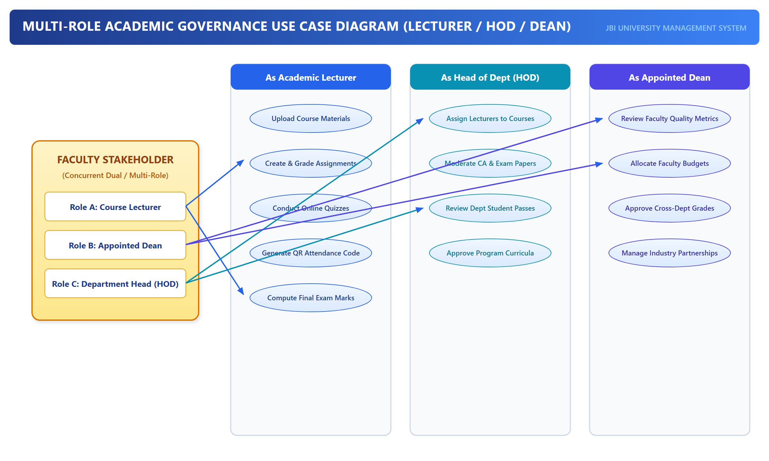
Figure: Multi-Role Academic Governance Use Case Diagram (Lecturer / HOD / Dean)
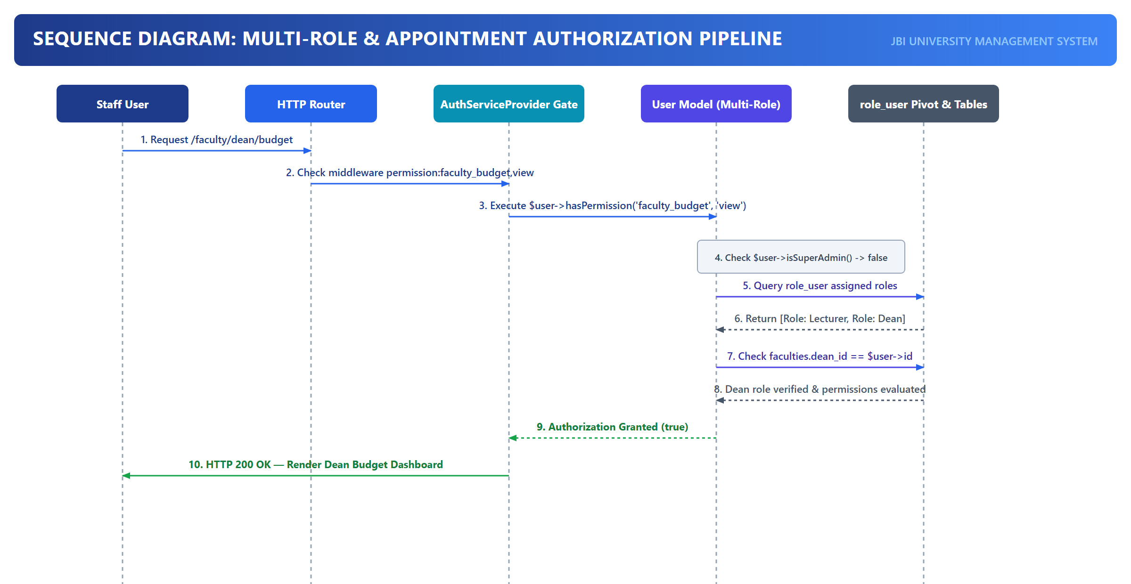
Figure: Sequence Diagram: Multi-Role Authorization & Permission Resolution Pipeline

4. Master & Subsystem Use Case Specifications
The JBI University Management System encompasses a wide array of operational use cases spanning the academic, administrative, financial, and democratic governance spheres of the university. The system boundaries are strictly defined to provide autonomous service delivery to students, faculty, and administrators while maintaining immutable audit trails.
4.1. Master Use Case Model
The master use case diagram depicts the unified functional landscape across all 11 recognized university actors. Each actor interacts with authorized functional clusters governed by the multi-role RBAC security kernel.
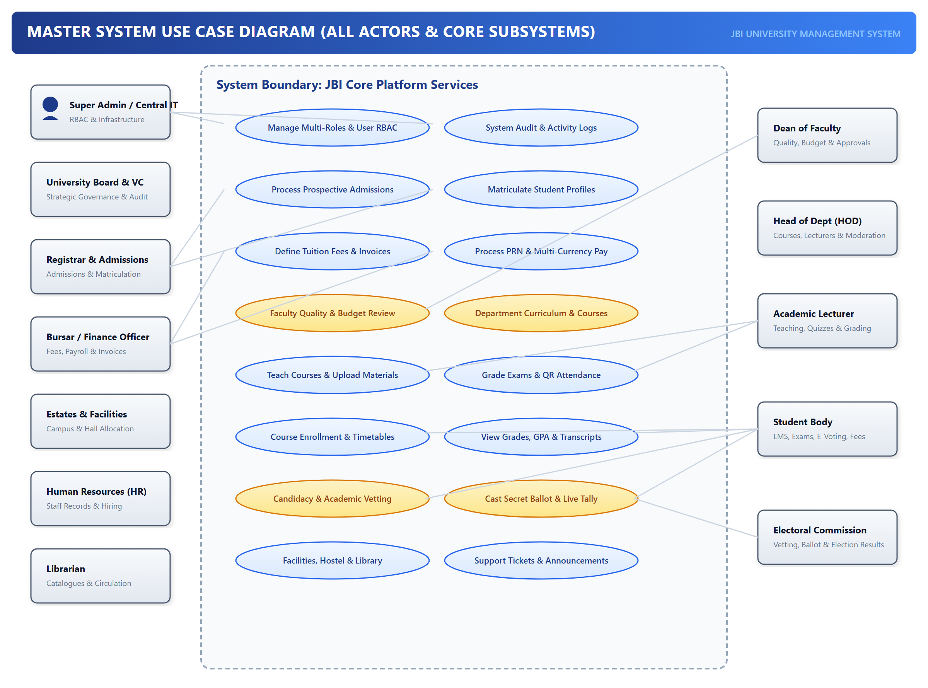
Figure: Master University System Use Case Diagram (Covering 11 University Actors)
4.2. Detailed Tabular Use Case Specifications
Below are formal, exhaustive specifications for the eight primary architectural use cases underpinning university operations. Each specification details preconditions, triggers, main execution flows, exception handlings, and database postconditions.
UC-01: Online Application Submission & Credential Verification
Attribute | Specification Details
Use Case ID & Name | UC-01: Online Application Submission & Automated Credential Verification
Primary Actor | Prospective Student Applicant
Secondary Actors | Registrar / Admissions Officer, Finance Officer
Trigger | Applicant clicks 'Submit Application' on the public admissions web portal.
Preconditions | 1. Active academic year and intake semester configured in academic_years and semesters tables.  2. Applicant has registered a verified email address and basic biodata.
Main Success Scenario | 1. Applicant logs into Admissions Portal and selects an academic program.  2. System validates that the application deadline has not elapsed.  3. Applicant enters previous academic qualifications (O-Level / A-Level / Diploma grades) and uploads scanned certified certificates.  4. System computes candidate eligibility index against program minimum entry criteria.  5. Applicant pays non-refundable application fee via PRN gateway.  6. System updates application_status to 'Under Review' and notifies Admissions Directorate.  7. Admissions Officer audits uploaded credentials against national verification standards.  8. Admissions Officer issues approval; system marks application as 'Admitted' and generates admission letter PDF.
Extensions & Exceptions | 4a. Qualifications fail minimum criteria: System displays eligibility warning and suggests alternative available diploma/certificate programs.  5a. Payment gateway timeout: Transaction marked as 'Pending Reconciliation'; webhooks poll gateway until confirmation is received.  7a. Forged or unreadable documents: Officer sets status to 'Clarification Requested' and triggers automated SMS/Email notification to applicant.
Postconditions | 1. Record created in applications table with status = 'Admitted'.  2. Immutable audit trail entry logged in audit_logs.  3. Admission Letter PDF archived in secure storage disk.
Security & Permissions | Public applicant token with restricted scope; Admissions Officer requires 'admissions.review' permission.

UC-02: Student Matriculation & Dynamic Account Activation
Attribute | Specification Details
Use Case ID & Name | UC-02: Student Matriculation & Dynamic Account Activation
Primary Actor | Registrar / Admissions Officer
Secondary Actors | Admitted Student, Bursar
Trigger | Admitted applicant accepts admission offer and meets initial tuition commitment.
Preconditions | 1. Application status is 'Admitted'.  2. Minimum tuition commitment percentage (e.g. 50%) is verified in fee_records.
Main Success Scenario | 1. Registrar reviews candidate in the Matriculation Queue.  2. System triggers the Matriculation Engine within a database transaction.  3. System allocates a unique institutional registration number (e.g., ADM-2026-0042) using an atomic sequential lock.  4. System provisions a student record in users table with role 'student' and creates corresponding entry in student_profiles.  5. System attaches default program curriculum and creates initial semester ledger.  6. System generates institutional email credentials and dispatches activation link via SMS/Email.  7. Student logs in, completes password reset, and activates multi-factor authentication.
Extensions & Exceptions | 2a. Tuition commitment unmet: System disallows matriculation until Bursary marks clearance flag.  3a. Concurrency collision on registration number: Sequence generator locks counter row with 'SELECT ... FOR UPDATE' to ensure deterministic zero-gap allocation.
Postconditions | 1. User account provisioned in users table with role_id for Student.  2. Student profile established in student_profiles.  3. Status in applications transitioned to 'Matriculated'.
Security & Permissions | Requires 'admissions.matriculate' permission granted to Registrar and SuperAdmin.

UC-03: Semester Course Registration & Prerequisite Validation
Attribute | Specification Details
Use Case ID & Name | UC-03: Semester Course Registration & Prerequisite Validation
Primary Actor | Student Body
Secondary Actors | Head of Department (HOD), Academic Advisor
Trigger | Student initiates course registration for an active academic semester.
Preconditions | 1. Semester registration window is open.  2. Student has cleared tuition balance threshold (e.g., 60% paid).  3. Student is not on academic suspension or expulsion.
Main Success Scenario | 1. Student accesses Student Portal -> Course Registration.  2. System displays eligible core and elective courses based on student's program and level.  3. Student selects desired courses and clicks 'Validate & Register'.  4. For each selected course, system checks course_prerequisites table against student's historical passing grades.  5. System validates total credit units against maximum allowable workload (e.g., 24 Credit Units).  6. System writes pending records into course_enrollments table.  7. HOD reviews and bulk-approves course registration batches.  8. System updates enrollment status to 'Enrolled' and populates student LMS course list.
Extensions & Exceptions | 4a. Prerequisite not passed: System flags failed prerequisite course and blocks registration.  5a. Credit overload exceeded: Student must submit an Academic Overload Petition to the Dean before approval.  7a. Class capacity full: Student placed on waitlist or offered alternate elective.
Postconditions | 1. Records created in course_enrollments with status = 'Enrolled'.  2. Student enrolled in corresponding LMS module sections.
Security & Permissions | Student authorized only for own student_id; HOD requires 'department_courses.moderate' permission.

UC-04: Continuous Assessment (CA) Submission & Daily QR Attendance Generation
Attribute | Specification Details
Use Case ID & Name | UC-04: Continuous Assessment Submission & Daily QR Attendance
Primary Actor | Academic Lecturer
Secondary Actors | Student Body, HOD
Trigger | Lecturer conducts a lecture or grades continuous coursework / midterm assignments.
Preconditions | 1. Course is assigned to lecturer in course_lecturer table.  2. Current date falls within the semester instructional calendar.
Main Success Scenario | 1. Lecturer opens Lecturer Portal -> Course Dashboard -> Attendance.  2. Lecturer clicks 'Generate Session QR Code'.  3. System produces a cryptographically signed, time-expiring (60-second) QR code containing session_id and HMAC salt.  4. Attending students scan the projected QR code using their student portal app.  5. System verifies student geo-location/IP, checks enrollment, and logs timestamped attendance record.  6. Lecturer administers quizzes or enters continuous assessment marks (out of 40% weighting).  7. System computes aggregate continuous assessment scores and flags students with <75% attendance for examination barring.
Extensions & Exceptions | 3a. QR code expired: Re-generation occurs dynamically on projector screen without reloading session.  5a. Proxy attendance attempt (duplicate device UUID): System detects multiple scans from identical device fingerprint and rejects second scan.  6a. Grade exceeds maximum mark: Real-time form validation rejects marks > 40.
Postconditions | 1. Timestamped attendance rows committed to attendance_logs.  2. Continuous assessment scores stored in course_assessments and draft grades table.
Security & Permissions | Requires 'courses.teach' permission and ownership check (auth()->id() == course.lecturer_id).

UC-05: Examination Grading, HOD Moderation & Dean Executive Endorsement
Attribute | Specification Details
Use Case ID & Name | UC-05: Examination Grading, HOD Moderation & Dean Executive Endorsement
Primary Actor | Academic Lecturer
Secondary Actors | Head of Department (HOD), Dean of Faculty, Senate Board
Trigger | End-of-semester examination scripts graded by course lecturer.
Preconditions | 1. Final examination period completed.  2. Enrolled students possess verified examination cards.
Main Success Scenario | 1. Lecturer inputs final exam marks (out of 60%) into the Grading Portal.  2. System computes composite grade (CA 40% + Exam 60%), maps grade points (0.0 to 5.0), and assigns letter grade (A-F).  3. Lecturer reviews the departmental grade sheet and clicks 'Submit to HOD for Moderation'.  4. HOD receives notification, reviews distribution curves, checks for grade inflation/anomalies, and signs off moderation.  5. Dean of Faculty inspects faculty-wide consolidated results, reviews grade distributions, and applies official Dean Endorsement.  6. Dean submits endorsed results to Senate Examination Board.  7. Upon Senate approval, system publishes results to student portal, updates student CGPAs, and locks grades against modification.
Extensions & Exceptions | 4a. HOD detects grading anomaly: HOD returns grade sheet to lecturer with mandatory revision comments; status reverts to 'Draft'.  5a. Dean requests re-moderation: Results remanded to departmental committee for sample remarking.  7a. Student files grade appeal: Trigger for formal remarking workflow governed by Senate regulations.
Postconditions | 1. Final grades saved in grades table with status = 'Published'.  2. student_profiles.cgpa and cumulative_credits recomputed atomically.  3. Immutable audit snapshot stored in exam_audit_trails.
Security & Permissions | 3-Tier Role Validation: Lecturer -> HOD ('department_grades.moderate') -> Dean ('dean_administration.endorse').

UC-06: Student Union E-Voting with Automated Academic Retake Disqualification
Attribute | Specification Details
Use Case ID & Name | UC-06: Student Union E-Voting with Automated Retake Vetting Engine
Primary Actor | Student Body (Candidate / Voter)
Secondary Actors | Electoral Commission Trustee, Dean of Students, Registrar
Trigger | Student submits nomination for student union leadership OR casts vote during polling.
Preconditions | 1. Voting session is active with valid start_time and end_time.  2. Student is fully registered in current semester with zero financial holds.
Main Success Scenario | 1. Student candidate submits nomination for an executive post (e.g., Guild President, Guild Speaker).  2. System invokes Academic Vetting Service: queries grades and course_enrollments tables for failing grades (status = 'retake' or score < 50).  3. If active retakes exist, system automatically rejects nomination with a detailed statutory citation.  4. If cleared, Electoral Commission approves candidate manifesto.  5. On election day, registered student enters secure E-Voting booth.  6. System verifies voter has not previously voted in this session (voter_registry check).  7. Student selects candidates and submits secret ballot.  8. System records anonymized cryptographic ballot in votes table, marks voter as 'Voted', and updates real-time tally.
Extensions & Exceptions | 2a. Retake identified: System outputs 'DISQUALIFIED: Under Section 14(b) of University Guild Constitution, candidates with active academic retakes are ineligible'.  6a. Duplicate vote attempt: System detects prior vote timestamp and aborts transaction with HTTP 403 Forbidden.  8a. Network disconnection during submission: Transaction rolled back; student prompted to resubmit.
Postconditions | 1. Vote recorded with SHA-256 hash in votes table.  2. Voter status updated to 'Voted' in voter_participations table.  3. Zero linkage maintained between voter identity and candidate selection (secret ballot).
Security & Permissions | Strict token-based voting booth; Electoral Trustee requires 'elections.manage' clearance.

UC-07: PRN Payment Invoice Generation & Real-Time Bank Settlement
Attribute | Specification Details
Use Case ID & Name | UC-07: PRN Payment Invoice Generation & Real-Time Bank Settlement
Primary Actor | Student Body
Secondary Actors | Bursar / Finance Officer, Commercial Banking Gateway
Trigger | Student requests payment reference for tuition, functional fees, accommodation, or graduation.
Preconditions | 1. Student has an active ledger invoice in student_ledgers.  2. Bank API integration endpoints are active and reachable.
Main Success Scenario | 1. Student selects fee items to pay in Student Portal -> Financial Hub.  2. System computes total invoice amount, validates fee components, and generates a unique Payment Reference Number (PRN).  3. System registers PRN with the commercial banking switch via secure REST API.  4. Student presents PRN at any partnered commercial bank branch, agent, or mobile money platform.  5. Bank processes payment and dispatches an asynchronous signed webhook callback to the JBI Finance endpoint.  6. JBI system verifies webhook HMAC signature, validates transaction amount against registered PRN, and updates fee_records.  7. System recalculates student financial balance, unlocks registration/examination holds, and sends receipt notification.
Extensions & Exceptions | 3a. Banking switch unavailable: System falls back to offline PRN format and queues synchronization job.  5a. Underpayment received: System records partial payment, updates remaining balance, and maintains partial hold.  6a. Invalid webhook signature: System logs security anomaly, alerts IT SuperAdmin, and rejects transaction.
Postconditions | 1. Payment record committed to fee_records with status = 'Cleared'.  2. Student ledger balance decremented.  3. Examination and course registration holds lifted if threshold met.
Security & Permissions | HMAC-SHA256 signature verification on callbacks; Finance Officer requires 'finance.reconcile' permission.

UC-08: Campus Facility & Residence Hall Allocation Management
Attribute | Specification Details
Use Case ID & Name | UC-08: Campus Facility & Residence Hall Allocation Management
Primary Actor | Estates & Facilities Manager
Secondary Actors | Student Body, Academic Lecturer
Trigger | Student applies for campus hostel accommodation OR Lecturer books a laboratory / lecture theater.
Preconditions | 1. Residence halls and room inventories configured in halls_of_residence and hostel_rooms tables.  2. Academic timetable requirements published.
Main Success Scenario | 1. Student navigates to Student Portal -> Accommodation and selects preferred hall and room type.  2. System verifies room capacity and student gender eligibility.  3. Student pays accommodation fee via PRN; system commits room reservation.  4. Estates Manager reviews hostel allocations and issues room check-in keys.  5. Simultaneously, Estates Manager schedules lecture halls and computer laboratories based on academic course enrollments.  6. System detects and prevents room scheduling conflicts through automated overlap validation.
Extensions & Exceptions | 2a. Hall capacity exhausted: Student alerted and offered alternative hall or placed on waiting list.  6a. Room schedule conflict detected: System highlights double-booking and proposes adjacent available facilities.
Postconditions | 1. Room occupancy updated in hostel_allocations table.  2. Room scheduling committed in facility_bookings table.
Security & Permissions | Requires 'facilities.manage' permission granted to Estates Manager and SuperAdmin.

5. System Sequence Workflows & Message Trace Specifications
Sequence diagrams capture the precise temporal order of messages, method invocations, database transactions, and cryptographic validations executing across system boundaries. The following four sequence specifications model the most critical operational workflows in the university.
5.1. Student Admission & Matriculation Workflow
This sequence governs the entire lifecycle of prospective student onboarding, from initial portal submission to programmatic generation of student registration credentials and ledger provisioning.
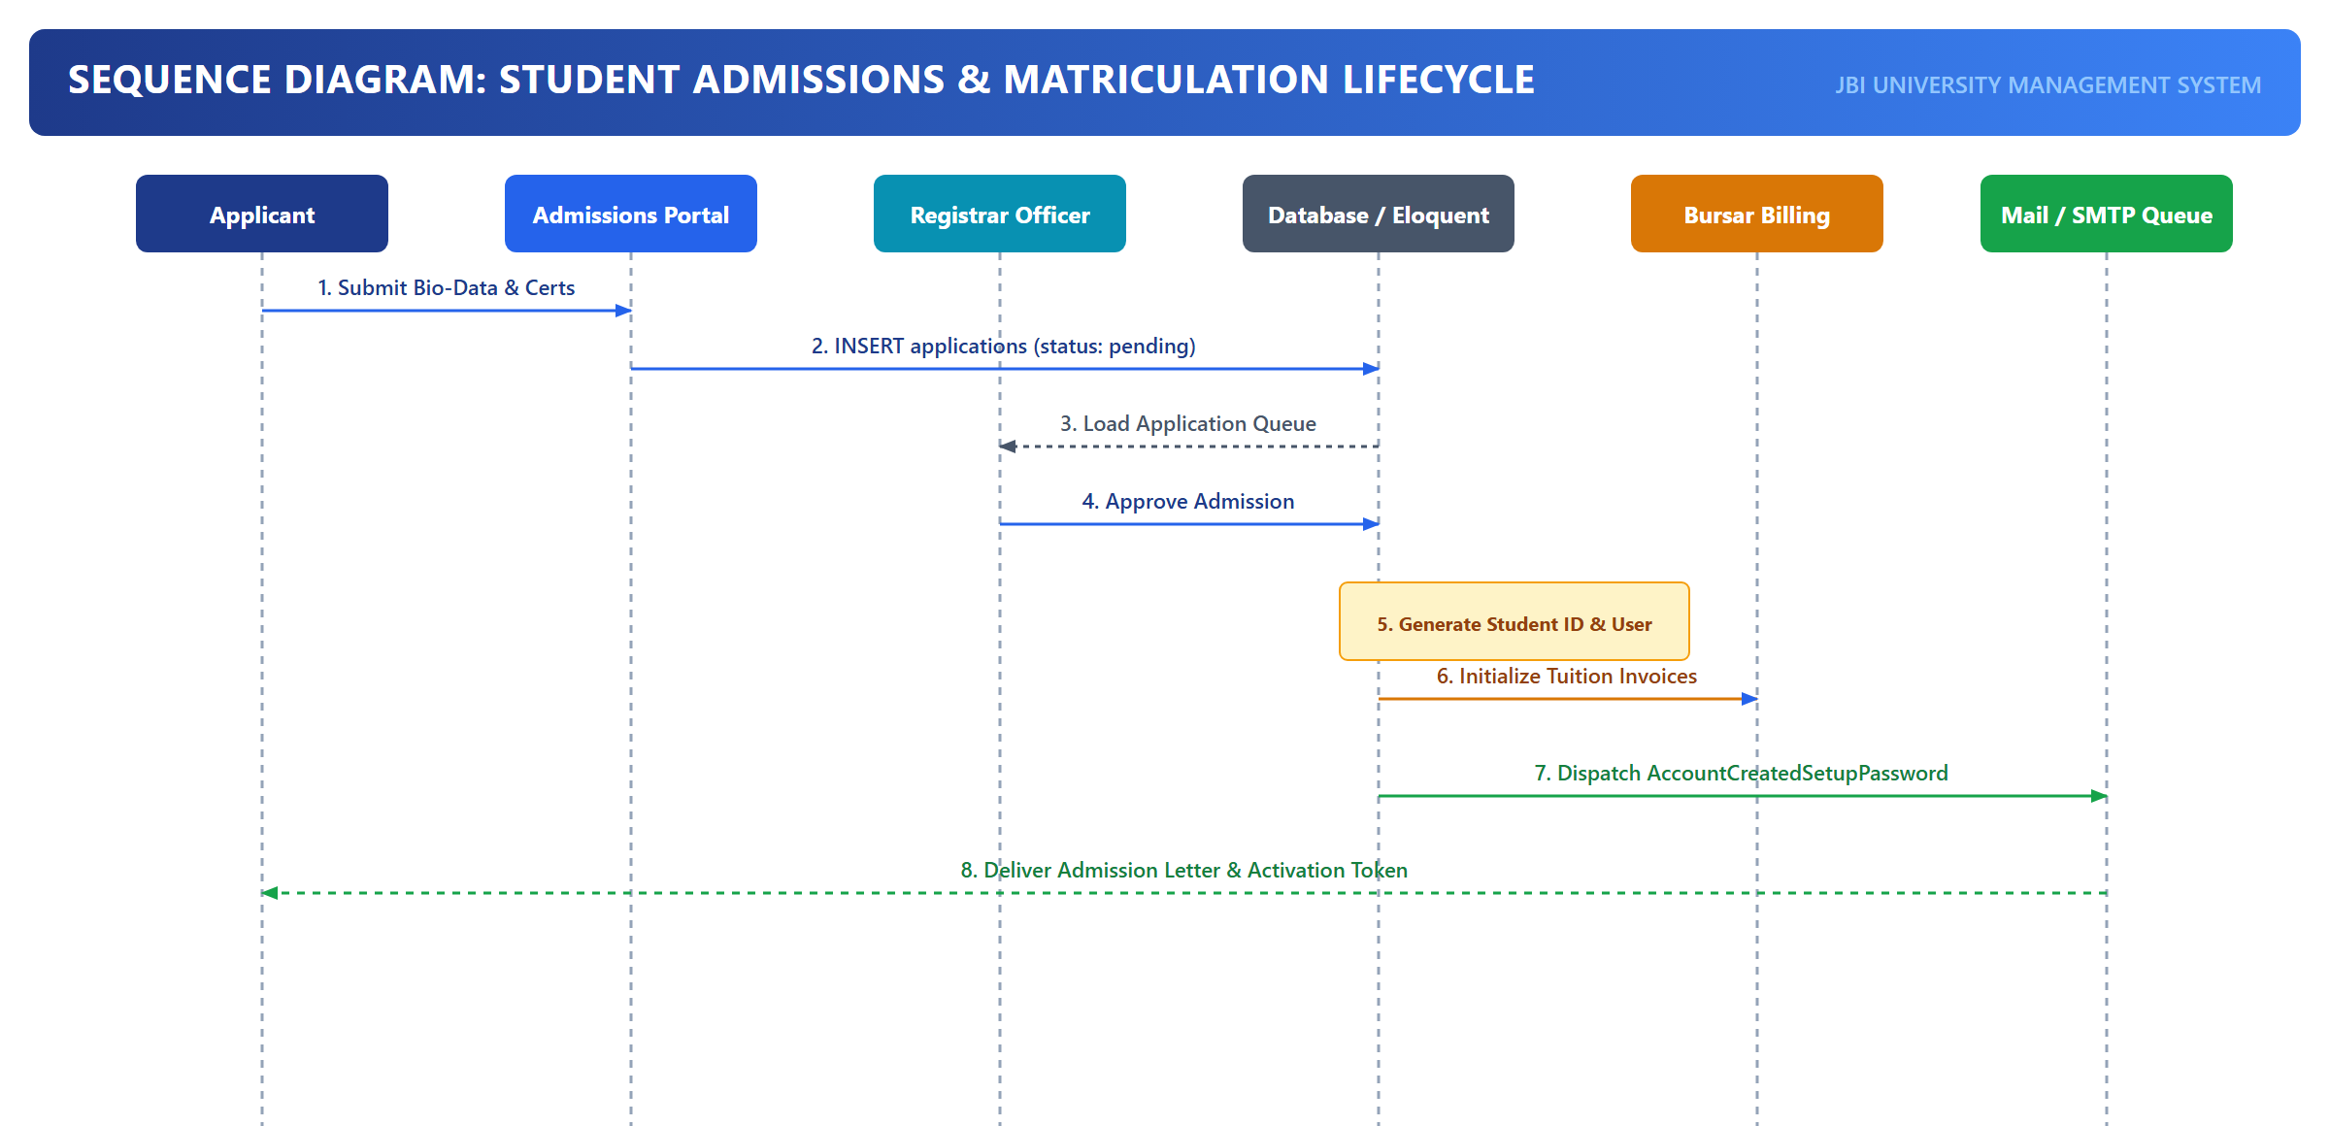
Figure: Sequence Diagram: Student Admission & Matriculation Pipeline
Below is the complete message trace specification detailing every boundary, method call, payload, and database transaction involved in the admission pipeline:
Step # | Source Boundary | Target Boundary / Service | Method / Invocation | Payload & Data Attributes | Database State & Audit Effect
1 | Applicant (Browser) | Public Admissions Portal | POST /admissions/apply | biodata, program_id, qualifications, certificate_blobs | Uploads files to storage/app/admissions; creates pending record.
2 | Admissions Portal | EligibilityEngine | evaluateQualifications() | qualifications[], program.minimum_cutoffs | Evaluates weighted score against minimum program threshold.
3 | EligibilityEngine | Admissions Portal | return eligibilityStatus | status = ELIGIBLE, score = 84.5 | Logs eligibility scoring telemetry in application_evaluations.
4 | Admissions Portal | PRN Gateway | generateApplicationPRN() | applicant_id, amount = 50.00, currency = USD | Registers PRN in fee_invoices; returns PRN reference string.
5 | Applicant | Banking Switch | payApplicationFee() | PRN, paymentMethod = MobileMoney/Card | Bank captures funds and issues transactional settlement token.
6 | Banking Switch | Admissions Webhook | POST /api/webhooks/prn | prn, amount, hmac_signature, bank_ref | Verifies signature; updates applications.payment_status = 'PAID'.
7 | Admissions Officer | Registrar Dashboard | GET /admissions/queue | filters: [status='PAID', program_id=12] | Retrieves pending application queue for documentary verification.
8 | Admissions Officer | AdmissionsController | POST /admissions/{id}/admit | application_id, admission_category = 'Direct' | Sets applications.status = 'Admitted'; generates Admission Letter.
9 | Admissions Officer | MatriculationService | matriculateStudent() | application_id, academic_year_id | ACID Transaction: Allocates reg_no, creates users row, student_profiles row.
10 | MatriculationService | LedgerService | initializeStudentLedger() | user_id, program_id, fee_structure_id | Generates semester billing invoice in student_ledgers.
11 | MatriculationService | NotificationService | sendActivationNotice() | user.email, temp_password, portal_url | Dispatches transactional onboarding email & SMS.

5.2. Multi-Role Authorization & Permission Resolution Pipeline
This sequence illustrates how the JBI authorization kernel evaluates incoming HTTP requests for users holding multiple concurrent appointments (e.g., Lecturer serving as Dean).
Below is the complete message trace specification detailing every boundary, method call, payload, and database transaction involved in the multi-role authorization pipeline:
Step # | Source Boundary | Target Boundary / Service | Method / Invocation | Payload & Data Attributes | Database State & Audit Effect
1 | Authenticated User | Web Browser / Route | GET /faculty/dean/budget | Bearer token / Laravel session_id | User requests Dean divisional financial summary.
2 | Route Dispatcher | Authenticate Middleware | handle($request) | session_cookie | Resolves user model instance via Auth::guard('web').
3 | Authenticate | MultiRoleCheck Middleware | handle($request, 'dean') | required_role = 'dean', user = User#42 | Initiates multi-role evaluation pipeline.
4 | MultiRoleCheck | User Model | hasRole('dean') | role_slug = 'dean' | Queries primary role users.role AND pivot role_user.
5 | User Model | DynamicResolver | isDean() | user_id = 42 | Checks faculties.where('dean_id', 42).exists(). Returns true.
6 | MultiRoleCheck | Gate Kernel | allows('dean_administration.view') | user, ability = 'view', module = 'dean_admin' | Invokes composite permission evaluator across all roles.
7 | Gate Kernel | RolePermission Model | hasPermission() | aggregated_role_ids: [2, 7] | Evaluates joined permissions across Lecturer and Dean roles.
8 | MultiRoleCheck | DeanController | index() | faculty_id = 3 | Access granted; Controller queries faculty budget balances.
9 | DeanController | AuditLogger | logAccess() | user_id = 42, role_context = 'dean', action = 'view_budget' | Writes structured log to audit_logs table.

5.3. Academic Assessment, Moderation & Dean Approval Sequence
The grading sequence implements a 3-tier checks-and-balances workflow ensuring no grade can be released to students or printed on transcripts without multi-stakeholder moderation and executive dean signoff.
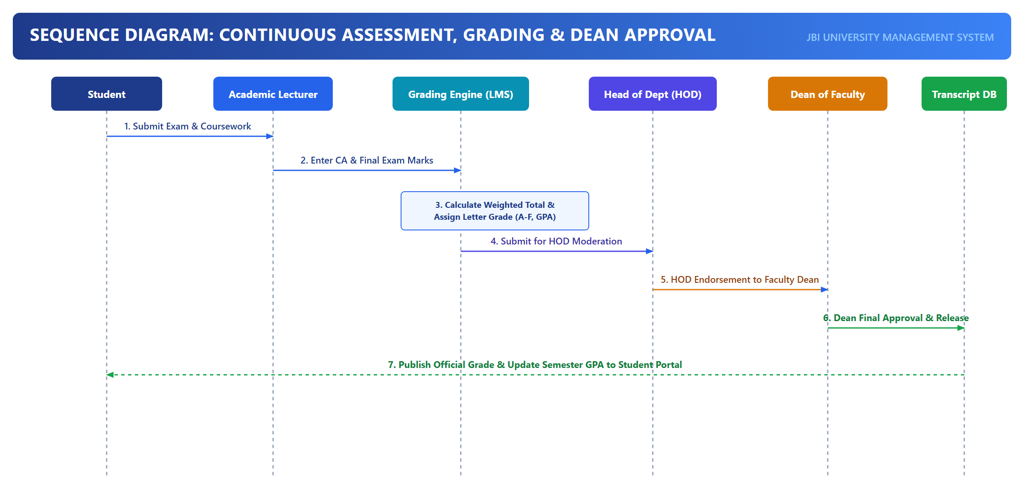
Figure: Sequence Diagram: Continuous Assessment, Examination Grading & Dean Endorsement
Below is the complete message trace specification detailing every boundary, method call, payload, and database transaction involved in the academic grading and moderation lifecycle:
Step # | Source Boundary | Target Boundary / Service | Method / Invocation | Payload & Data Attributes | Database State & Audit Effect
1 | Course Lecturer | Grading Controller | POST /grades/batch-store | course_id, grades: [{student_id, ca_mark, exam_mark}] | Inserts/updates draft rows in grades table with status = 'DRAFT'.
2 | Grading Controller | GradingEngine | computeFinalMarks() | ca_mark (40%), exam_mark (60%) | Calculates total = CA + Exam; maps grade_point (0-5) and letter (A-F).
3 | Course Lecturer | Grading Controller | POST /grades/submit-moderation | course_id, lecturer_remarks | Transitions grades.status from 'DRAFT' to 'SUBMITTED_TO_HOD'.
4 | HOD | Department Moderation UI | GET /grades/department-review | department_id = 5, semester_id = 2 | Retrieves grade distributions, class average, standard deviation.
5 | HOD | ModerationService | approveDepartmentGrades() | course_id, hod_signoff_notes, hod_id = 18 | Updates grades.status = 'MODERATED'; timestamps hod_approved_at.
6 | Dean of Faculty | Faculty Dean Portal | GET /faculty/dean/grades | faculty_id = 2, status = 'MODERATED' | Loads consolidated divisional grade sheets for faculty audit.
7 | Dean of Faculty | DeanApprovalService | endorseDivisionalGrades() | faculty_id, dean_id = 42, endorsement_token | Transitions grades.status = 'ENDORSED_BY_DEAN'; generates faculty seal.
8 | DeanApprovalService | SenateBoard Service | submitToSenate() | batch_id, endorsement_record | Submits consolidated faculty results to Academic Senate Board.
9 | Senate Board | SenateService | publishFinalResults() | batch_id, senate_resolution_no | Updates grades.status = 'PUBLISHED'; triggers GPA recomputation in student_profiles.

5.4. Student Union E-Voting with Academic Retake Vetting Engine
This sequence models the strict academic integrity vetting algorithm enforcing University constitutional standards, followed by anonymized cryptographic ballot processing.
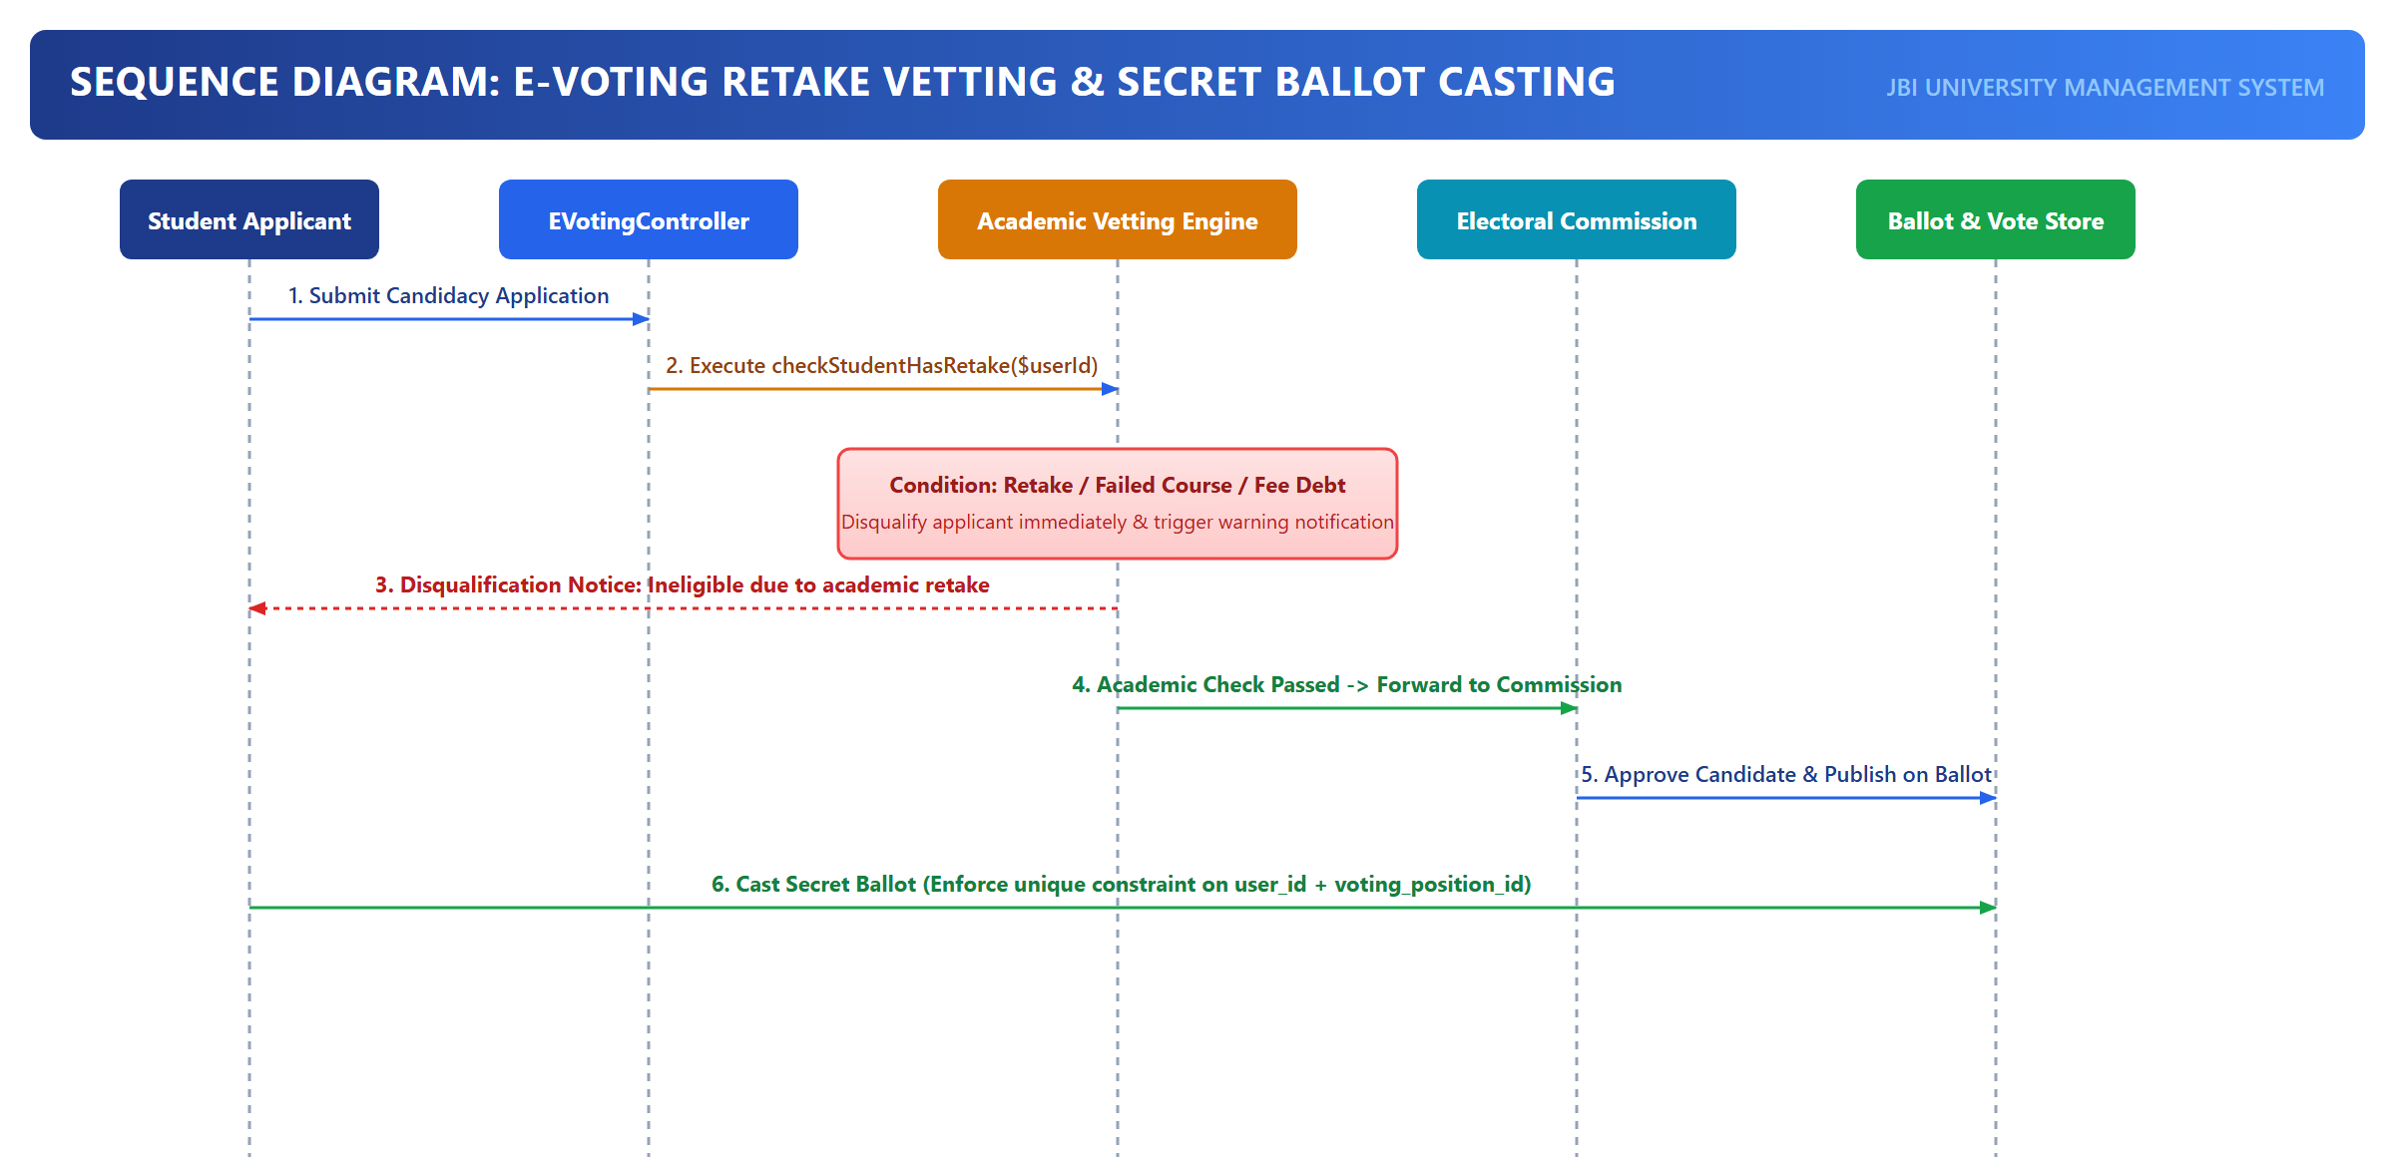
Figure: Sequence Diagram: Student Union E-Voting & Academic Retake Vetting Engine
Below is the complete message trace specification detailing every boundary, method call, payload, and database transaction involved in the e-voting and vetting pipeline:
Step # | Source Boundary | Target Boundary / Service | Method / Invocation | Payload & Data Attributes | Database State & Audit Effect
1 | Student Candidate | E-Voting Portal | POST /elections/nominate | position_id = 1 (Guild President), student_id = 104 | Candidate initiates nomination for executive guild office.
2 | E-Voting Controller | AcademicVettingService | vetCandidateAcademicRecord() | student_id = 104, position_id = 1 | Initiates statutory academic clearance check.
3 | AcademicVettingService | Grades Data Store | SELECT FROM grades WHERE ... | student_id = 104, (grade_letter = 'F' OR status = 'retake') | Queries student historical academic performance.
4a | Grades Data Store | AcademicVettingService | return retakeCount = 1 | Found failing record: CS201 (Score: 38, Grade: F) | Active retake detected on student transcript.
4b | AcademicVettingService | E-Voting Controller | rejectNomination() | status = DISQUALIFIED, reason = 'Active Retake in CS201' | Nominations record saved with status = 'Disqualified'; audit log created.
4c | E-Voting Controller | Candidate (UI) | Display Disqualification Error | HTTP 422: Disqualified under Guild Constitution 14(b) | Candidate informed of academic disqualification.
5 | Cleared Voter | Voting Booth (UI) | POST /elections/cast-ballot | voting_session_id, ballots: [{position_id, candidate_id}] | Eligible student casts secret ballot on election day.
6 | Voting Controller | VoterRegistryService | hasAlreadyVoted() | session_id = 3, student_id = 108 | Queries voter_participations table to prevent duplicate voting.
7 | Voting Controller | BallotEncryptionService | anonymizeAndHashBallot() | candidate_id, position_id, timestamp | Generates SHA-256 hash of vote; detaches voter identity.
8 | Voting Controller | Votes Data Store | INSERT INTO votes ... | session_id, position_id, candidate_id, vote_hash | ACID Transaction: Commits anonymized ballot and updates candidate tallies.
9 | Voting Controller | VoterRegistryService | markVoterParticipated() | session_id, student_id = 108, ip_address, timestamp | Inserts audit row in voter_participations; prevents further ballot access.

6. Data Flow Architecture (DFD Levels 0, 1 & 2)
Data Flow Diagrams (DFDs) trace the movement of data through the JBI University Management System, mapping external entity interfaces, transformational processes, and relational data repositories. The architecture is decomposed hierarchically across Context Level 0, Decomposition Level 1, and Detailed Subsystem Level 2.
6.1. Level 0: Context Level Data Flow Diagram
The Level 0 Context Diagram represents the entire JBI university platform as a single centralized processing core interacting with 11 external human actors and external banking/telephony gateways.
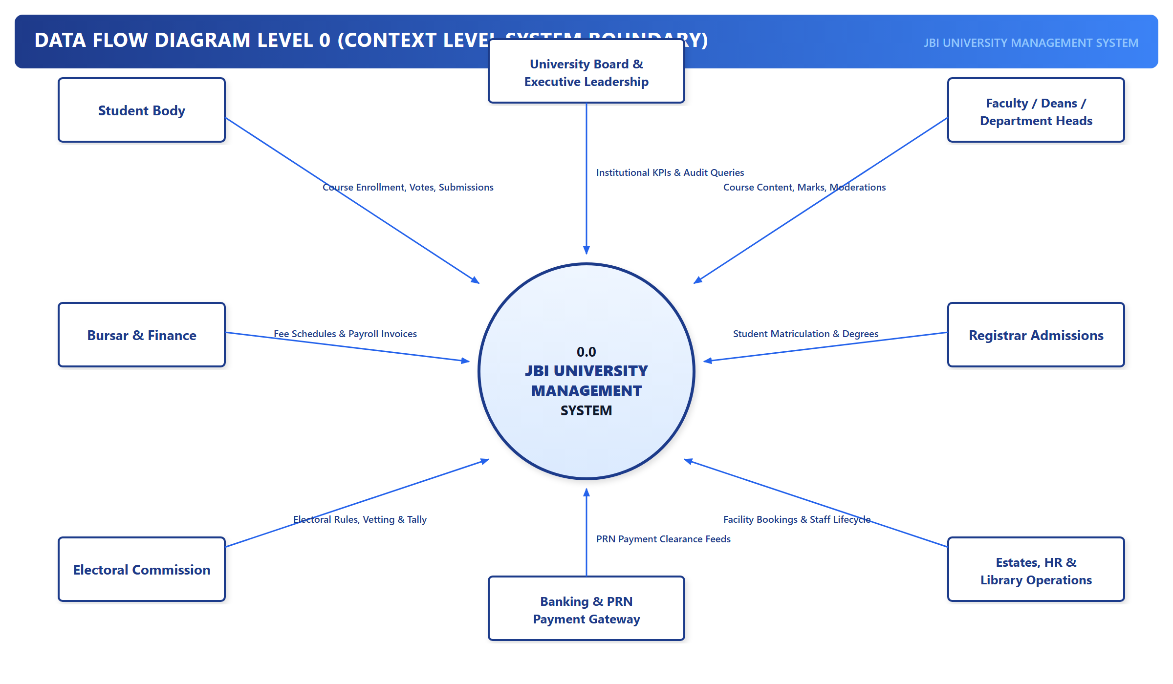
Figure: DFD Level 0: Master System Context Diagram
Below is the Data Flow Dictionary defining each input and output stream crossing the system boundary at Level 0:
External Entity | Direction | Data Flow Label | Carried Data Elements & Schema Content
Prospective Applicant | Inbound | Application Submission | Personal Biodata, Program Choice, Certified Grade Documents, Contact Details
Prospective Applicant | Outbound | Admission Decision / Letter | Admission Status, Matriculation Reg No, Official Signed Admission Letter PDF
Commercial Bank Gateway | Inbound | Settlement Notification Webhook | PRN Reference, Settlement Amount, Bank Transaction Token, HMAC SHA-256 Signature
Commercial Bank Gateway | Outbound | PRN Registration Request | Generated PRN, Invoice Amount, Student Identifier, Expiration Timestamp
Student Body | Inbound | Course Registration & Voting | Course Selection Payload, Secret E-Voting Ballot, Assignment Submissions, QR Scans
Student Body | Outbound | Academic Transcripts & Invoices | Approved Semester Grades, CGPA, Financial Statement, Digital Receipts, Voting Receipts
Academic Lecturer | Inbound | Assessments & CA Marks | Continuous Assessment Scores, Exam Marks, Course Syllabus, Dynamic QR Code Requests
Academic Lecturer | Outbound | Course Rosters & Attendance | Enrolled Student Lists, Real-time QR Attendance Telemetry, Moderation Status Reports
Head of Department (HOD) | Inbound | Workload Allocation & Moderation | Lecturer Course Assignments, Moderated Grade Adjustments, Course Approvals
Head of Department (HOD) | Outbound | Departmental Analytics | Curriculum Progress Reports, Department Grade Distribution Curves, Faculty Workload
Dean of Faculty | Inbound | Divisional Endorsements & Budgets | Endorsed Grade Batches, Faculty Budget Line Approvals, Strategic Program Proposals
Dean of Faculty | Outbound | Executive Faculty Dashboards | Cross-Departmental Performance KPIs, Accreditation Compliance Metrics, Budget Balances
Registrar | Inbound | Matriculation & Senate Decisions | Admissions Approvals, Matriculation Numbers, Senate Graduation Resolutions
Registrar | Outbound | Certified University Registers | Official Matriculated Student Register, Degree Award Lists, Transcript Records
Bursar / Finance | Inbound | Fee Structures & Payment Clearance | Academic Year Tuition Schedules, Manual Bank Reconciliations, Payroll Authorizations
Bursar / Finance | Outbound | Financial Ledgers & Audit Logs | Revenue Collection Reports, Unpaid Balance Aging Analysis, General Ledger Journal
Estates & Facilities | Inbound | Space Allocation & Maintenance | Classroom Allocations, Residence Hall Configurations, Maintenance Work Orders
Estates & Facilities | Outbound | Facility Occupancy & Timetable | Master Campus Timetable, Hostel Occupancy Registers, Maintenance SLA Reports
Electoral Commission | Inbound | Election Configuration & Vetting | Election Season Setup, Position Catalog, Candidate Vetting Signoffs
Electoral Commission | Outbound | Certified Election Tallies | Real-Time Aggregated Ballots, Candidate Vote Counts, Cryptographic Election Audit Log
Super Administrator | Inbound | System Maintenance & Multi-Role | Role Definitions, User Account Provisioning, Role Assignments, System Configs
Super Administrator | Outbound | Telemetry & Security Logs | System Exception Traces, User Login Audits, Database Backup Reports, Queue Status

6.2. Level 1: System Process Decomposition Diagram
The Level 1 DFD decomposes the monolithic system into five specialized transactional processes and six centralized relational data stores.
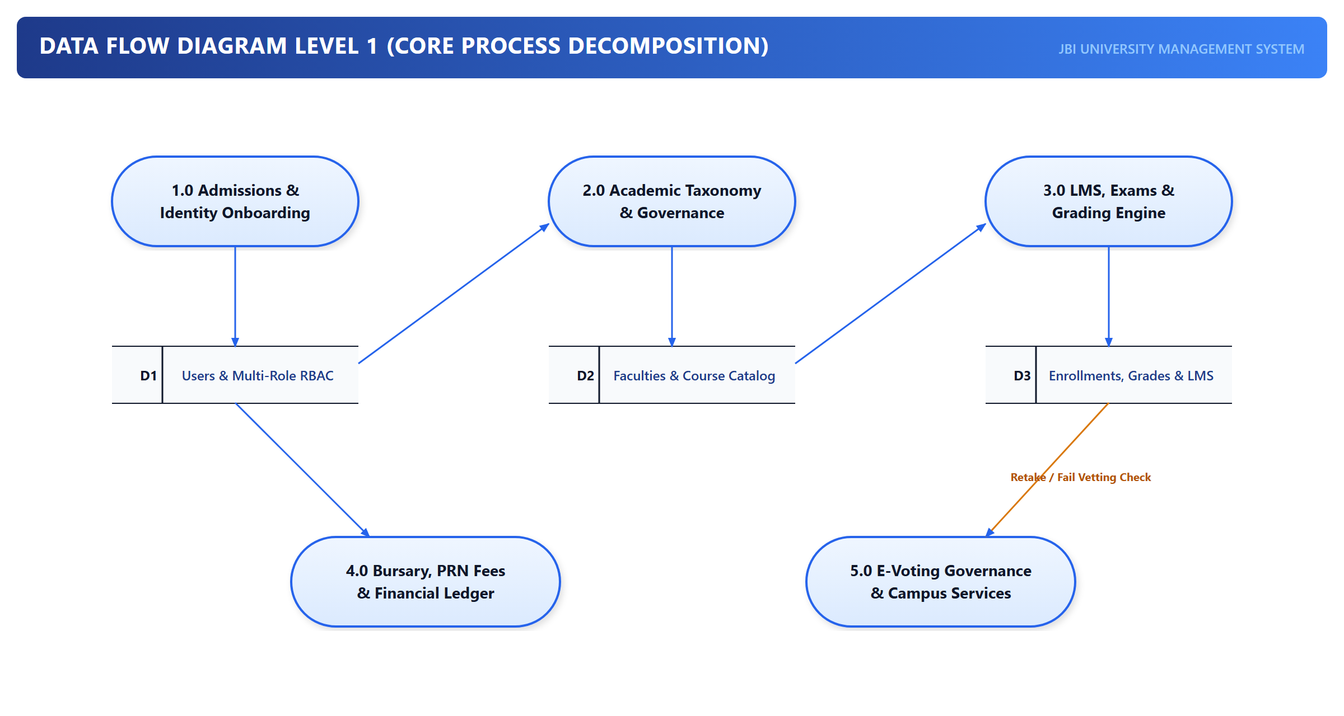
Figure: DFD Level 1: System Process Decomposition & Data Store Architecture
Below are formal Process Specifications (P-Specs) detailing the mathematical and functional logic of each Level 1 process:
Process Specification 1.0: Admissions & Student Identity Provisioning
Purpose: Processes incoming prospective applications, validates documentary evidence, coordinates fee clearance, and provisions verified student user accounts.
Inputs: Application Submissions, Certificate Blobs, Application Fee Clearance, Registrar Approval Tokens.
Outputs: Admission Letters, Generated Matriculation Numbers, Student User Accounts, Identity Activation Links.
Data Stores: D1: Users & Multi-Role Auth, D2: Student Master Records, D3: Financial Ledgers.
■ P-Spec 1.0 Algorithmic Logic
1. Receive applicant credentials and compute program qualification index: Q_idx = sum(weight_i * grade_i).
2. If Q_idx >= Cutoff(program_id):
Store application in D2 with status = 'PENDING_PAYMENT'.
Trigger PRN generation via Process 2.0.
3. Upon receipt of payment webhook:
Update application status to 'UNDER_REVIEW'.
4. When Registrar issues approval:
Lock admissions counter with SELECT FOR UPDATE.
reg_no = 'ADM-' + CurrentYear + '-' + PadZero(counter + 1, 4).
Insert user into D1 with role = 'student'.
Insert student profile into D2 with gpa = 0.0, status = 'active'.
Trigger email notification with one-time activation token.

Process Specification 2.0: Fee Billing & Payment Reconciliation Engine
Purpose: Administers student fee schedules, computes semester billing invoices, generates PRN tokens, and reconciles commercial bank callbacks.
Inputs: Fee Structure Definitions, Student Ledger Requests, Bank Callback Webhooks.
Outputs: PRN Registration Tokens, Student Fee Statements, Cleared Payment Receipts, Financial Ledger Entries.
Data Stores: D2: Student Master Records, D3: Financial Ledgers.
■ P-Spec 2.0 Algorithmic Logic
1. For each registered student at semester commencement:
InvoiceAmount = BaseTuition(program_id) + FunctionalFees(program_id) + HostelFee(if allocated).
Write ledger_invoice into D3 with balance_due = InvoiceAmount.
2. When student requests payment:
PRN = GeneratePRN(student_id, Amount).
Register PRN with Commercial Banking Switch API.
3. On receiving webhook POST /api/webhooks/prn:
Verify HMAC_SHA256(Payload, SecretKey) == HeaderSignature.
If valid: Commit payment record to D3; balance_due = balance_due - PaidAmount.
If balance_due <= Threshold: Lift financial registration hold on D2.

Process Specification 3.0: Curriculum, Course Registration & Assessment Engine
Purpose: Governs academic program structures, course enrollments, prerequisite verification, continuous assessments, examination grading, and dean endorsements.
Inputs: Course Registration Requests, CA Scores, Exam Marks, HOD Moderation Signoffs, Dean Endorsements.
Outputs: Course Rosters, Grade Distribution Sheets, Certified Academic Transcripts, Student CGPA Updates.
Data Stores: D1: Users & Multi-Role Auth, D2: Student Master Records, D4: Curriculum & Assessment.
■ P-Spec 3.0 Algorithmic Logic
1. Course Registration: For each course_id in student request:
Validate prerequisites: Ensure prerequisite_courses exist in D4 with grade != 'F'.
Validate credit load: Ensure sum(credits) <= MaxCreditLoad (24 CU).
Commit pending enrollment to D4.
2. Assessment Lifecycle: Lecturer submits CA (40%) and Exam (60%).
Total = CA + Exam. Map to Grade Point (0.0 - 5.0) and Letter Grade.
HOD reviews and moderates. Dean reviews and endorses.
Upon Senate approval: Update D2 student CGPA using cumulative weighted formula:
CGPA = sum(GradePoint_i * CreditUnits_i) / sum(CreditUnits_i).

Process Specification 4.0: Student Union E-Voting & Academic Integrity Vetting
Purpose: Facilitates transparent democratic student elections while enforcing strict constitutional academic vetting to disqualify students with failing grades.
Inputs: Candidate Nominations, Manifesto Data, Secret Voter Ballots, Electoral Commission Rules.
Outputs: Vetting Clearance Reports, Anonymized Cryptographic Ballots, Certified Election Tallies.
Data Stores: D1: Users & Multi-Role Auth, D2: Student Master Records, D4: Curriculum & Assessment, D5: E-Voting & Ballots.
■ P-Spec 4.0 Algorithmic Logic
1. Candidate Vetting: When student applies for executive guild office:
Query D4: SELECT COUNT(*) FROM grades WHERE student_id = candidate_id AND (grade_letter = 'F' OR status = 'retake').
If retakeCount > 0:
Reject nomination. Set status = 'DISQUALIFIED' with statutory notice.
Else:
Approve nomination. Add candidate to D5 candidate roster.
2. Secret Balloting: When voter submits ballot:
Verify D5 voter_participations: Ensure student_id has not already voted.
Hash ballot = SHA256(candidate_id + session_id + timestamp + salt).
Insert ballot into D5 votes table without student_id.
Insert voter_id into D5 voter_participations table to prevent duplicate voting.

Process Specification 5.0: Campus Infrastructure & Estates Management
Purpose: Coordinates lecture theater allocations, student residence hall allocations, and campus maintenance work orders.
Inputs: Room Allocation Requests, Timetable Requirements, Maintenance Trouble Tickets.
Outputs: Classroom Timetables, Hostel Room Keys, Work Order Assignments, Facility Occupancy Reports.
Data Stores: D2: Student Master Records, D6: Campus Facilities & Residence Halls.
■ P-Spec 5.0 Algorithmic Logic
1. Timetable Scheduling: For each course section:
Query D6: Find rooms where capacity >= expected_enrollment AND room_type == required_type.
Verify no overlapping bookings: start_time < existing_end AND end_time > existing_start.
Commit booking to D6 facility_bookings.
2. Hostel Allocation: When student requests room:
Verify gender compatibility and fee payment in D3.
Decrement available_beds in D6 hostel_rooms.
Create allocation record in D6 with check_in_status = 'Pending'.

6.3. Level 2: Subsystem Process Decomposition (Academic Assessment)
The Level 2 DFD decomposes Process 3.0 (Curriculum, Course Registration & Assessment Engine) into its four core constituent sub-processes, modeling the exact journey of continuous assessment, final examination grading, departmental moderation, and dean executive endorsement.
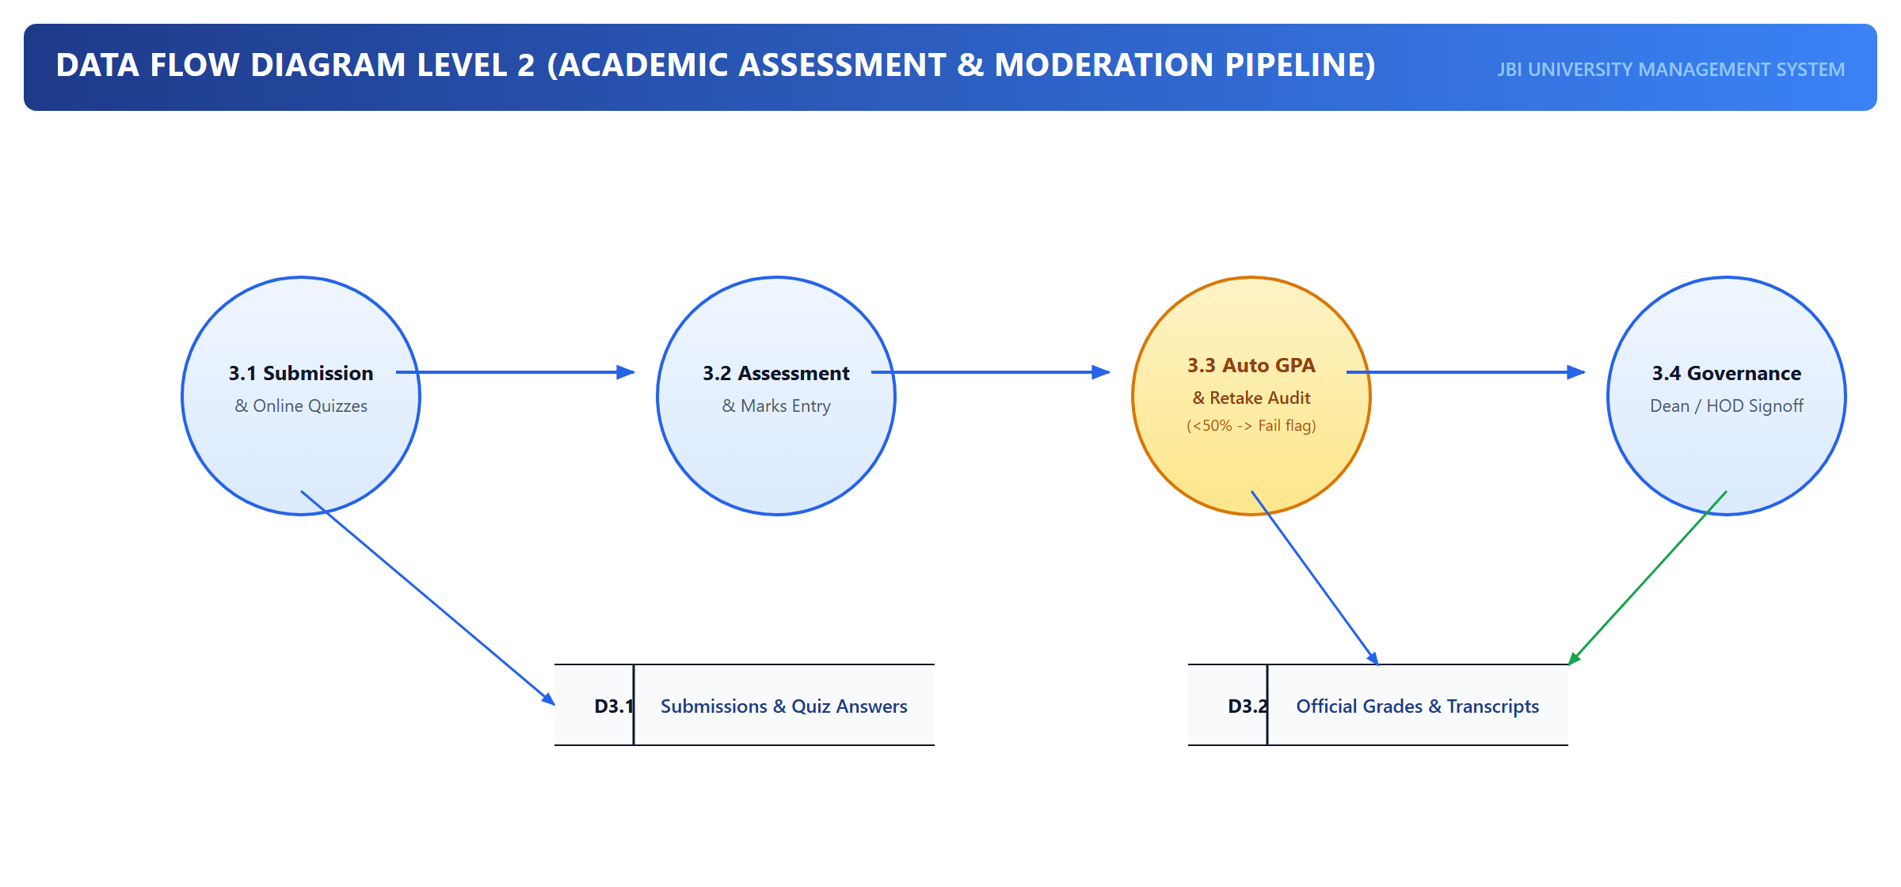
Figure: DFD Level 2: Academic Assessment & Moderation Subsystem Decomposition
Below are the detailed Process Specifications for sub-processes 3.1 through 3.4:
Sub-Process ID | Sub-Process Name | Inputs | Outputs | Functional / Algorithmic Rules
3.1 | Continuous Assessment & Attendance Aggregation | Daily QR Attendance Scans, Assignment Submissions, Quiz Marks | Aggregate CA Score (Max 40%), Attendance Percentage | Aggregates raw coursework and lab submissions. If attendance < 75%, flags student record with 'ATTENDANCE_BARRED' for final exam.
3.2 | Examination Score Capture & Letter Grade Computation | CA Score (40%), Final Exam Score (60%), Course Scale | Composite Mark (100%), Letter Grade (A-F), Grade Point (0.0-5.0) | Total = CA + Exam. Applies institutional grade boundaries: 80-100% (A, 5.0), 75-79% (B+, 4.5), 70-74% (B, 4.0), 65-69% (C+, 3.5), 60-64% (C, 3.0), 55-59% (D+, 2.5), 50-54% (D, 2.0), <50% (F, 0.0 - Retake).
3.3 | Departmental Moderation & Variance Auditing | Draft Grade Sheets, Lecturer Submissions, Historical Department Norms | Moderated Grade Sheets, Variance Flags, HOD Endorsement Seal | HOD inspects grade distribution curve. Detects abnormal skew (e.g., >80% As or >50% Fs). Requests lecturer justification or adjusts marks within statutory variance (+/- 3%).
3.4 | Dean Endorsement & Senate Transcript Publication | Moderated Grade Sheets, Faculty Quality Standards, Senate Resolution | Endorsed Divisional Grades, Published Student Transcripts, CGPA Updates | Dean of Faculty audits divisional compliance. Signs off digital endorsement seal. Submits to Senate. Upon Senate approval, updates student_profiles.cgpa and publishes results to student portal.

7. Database Architecture, Relational Data Dictionary & Normalization Analysis
The JBI University Management System is engineered atop an enterprise-grade relational database architecture (MySQL 8.x InnoDB). The schema enforces strict referential integrity, foreign key cascading constraints, ACID transactional guarantees, and high-performance indexing across 103 tables.
7.1. Entity-Relationship Model (ERD) & Relational Design
The relational model establishes clear boundaries between academic entities (Faculties, Departments, Programs, Courses), user identities (Users, Roles, RoleUser pivot), financial ledgers (FeeStructures, FeeRecords, PRNs), and campus governance (VotingSessions, VotingCandidates, Votes, Facilities, HostelRooms).
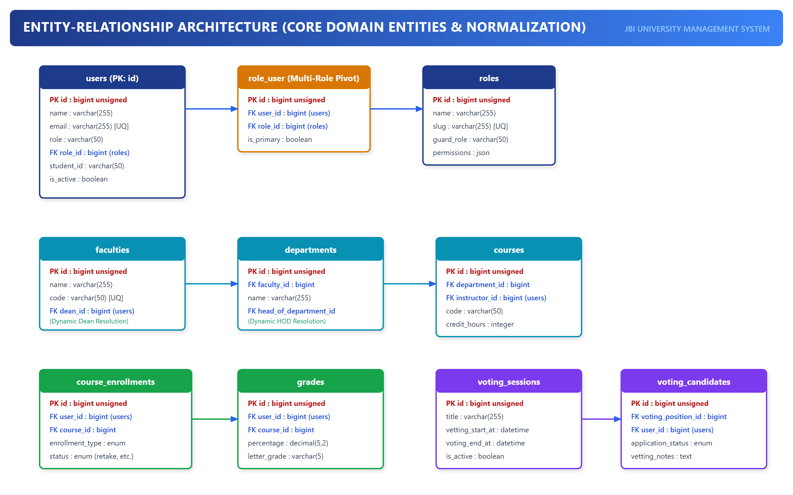
Figure: Comprehensive Entity-Relationship Diagram (Core University System)
7.2. Relational Data Dictionary for Core Institutional Entities
Below is the official Relational Data Dictionary extracted directly from the production database schema. It documents columns, storage types, nullability, index keys, default values, and architectural usage for the core institutional tables.
Table: users
Description: Central authentication identity table storing credentials, primary role slug, and contact info.
Field / Column | Data Type | Null | Key | Default | Engineering Usage
id | bigint(20) unsigned | NO | PRI | NULL | Surrogate primary key identifying the user account.
name | varchar(255) | NO |  | NULL | Full legal name of the user.
first_name | varchar(255) | YES |  | NULL | Attribute storing first_name state in users.
last_name | varchar(255) | YES |  | NULL | Attribute storing last_name state in users.
email | varchar(255) | NO | UNI | NULL | Unique institutional or personal email address (login identifier).
email_verified_at | timestamp | YES |  | NULL | Attribute storing email_verified_at state in users.
password | varchar(255) | NO |  | NULL | Bcrypt hashed password string (cost factor 12).
force_password_reset | tinyint(1) | NO |  | 0 | Attribute storing force_password_reset state in users.
default_password | varchar(255) | YES |  | NULL | Attribute storing default_password state in users.
must_change_password | tinyint(1) | NO |  | 0 | Attribute storing must_change_password state in users.
password_changed_at | timestamp | YES |  | NULL | Attribute storing password_changed_at state in users.
role | enum('admin','faculty','student','parent') | NO | MUL | student | Primary role slug (e.g. admin, lecturer, student) for session routing fast-paths.
role_id | bigint(20) unsigned | YES | MUL | NULL | Attribute storing role_id state in users.
student_id | varchar(255) | YES | UNI | NULL | Attribute storing student_id state in users.
employee_id | varchar(255) | YES | UNI | NULL | Attribute storing employee_id state in users.
phone | varchar(255) | YES |  | NULL | E.164 formatted telephone number for SMS and 2FA notifications.
address | text | YES |  | NULL | Attribute storing address state in users.
date_of_birth | date | YES |  | NULL | Attribute storing date_of_birth state in users.
gender | varchar(255) | YES |  | NULL | Attribute storing gender state in users.
emergency_contact | varchar(255) | YES |  | NULL | Attribute storing emergency_contact state in users.
emergency_phone | varchar(255) | YES |  | NULL | Attribute storing emergency_phone state in users.
profile_picture | varchar(255) | YES |  | NULL | Attribute storing profile_picture state in users.
is_active | tinyint(1) | NO |  | 1 | Attribute storing is_active state in users.
preferences | longtext | YES |  | NULL | Attribute storing preferences state in users.
last_login_at | timestamp | YES |  | NULL | Attribute storing last_login_at state in users.
remember_token | varchar(100) | YES |  | NULL | Attribute storing remember_token state in users.
created_at | timestamp | YES |  | NULL | Attribute storing created_at state in users.
updated_at | timestamp | YES |  | NULL | Attribute storing updated_at state in users.
deleted_at | timestamp | YES |  | NULL | Attribute storing deleted_at state in users.

Table: roles
Description: System role catalog defining authorization clearance levels.
Field / Column | Data Type | Null | Key | Default | Engineering Usage
id | bigint(20) unsigned | NO | PRI | NULL | Unique identifier for the role.
name | varchar(255) | NO |  | NULL | Human-readable role title (e.g. 'Dean of Faculty', 'Academic Lecturer').
slug | varchar(255) | NO | UNI | NULL | Immutable programmatically referenced unique slug (e.g. 'dean', 'lecturer').
guard_role | varchar(255) | NO | MUL | student | Attribute storing guard_role state in roles.
description | text | YES |  | NULL | Administrative explanation of role mandate and authority.
permissions | longtext | YES |  | NULL | Attribute storing permissions state in roles.
is_system | tinyint(1) | NO |  | 0 | Boolean flag preventing deletion of core architectural roles.
is_active | tinyint(1) | NO |  | 1 | Attribute storing is_active state in roles.
created_at | timestamp | YES |  | NULL | Attribute storing created_at state in roles.
updated_at | timestamp | YES |  | NULL | Attribute storing updated_at state in roles.

Table: role_user
Description: Associative pivot table facilitating many-to-many concurrent multi-role assignments.
Field / Column | Data Type | Null | Key | Default | Engineering Usage
id | bigint(20) unsigned | NO | PRI | NULL | Surrogate primary key of the assignment record.
user_id | bigint(20) unsigned | NO | MUL | NULL | Foreign key referencing users(id) with ON DELETE CASCADE.
role_id | bigint(20) unsigned | NO | MUL | NULL | Foreign key referencing roles(id) with ON DELETE CASCADE.
is_primary | tinyint(1) | NO |  | 0 | Flag indicating whether this role represents the user's default dashboard context.
created_at | timestamp | YES |  | NULL | Attribute storing created_at state in role_user.
updated_at | timestamp | YES |  | NULL | Attribute storing updated_at state in role_user.

Table: faculties
Description: University academic faculties presiding over departmental groupings.
Field / Column | Data Type | Null | Key | Default | Engineering Usage
id | bigint(20) unsigned | NO | PRI | NULL | Primary key of the academic faculty.
name | varchar(255) | NO |  | NULL | Full title of the faculty (e.g. 'Faculty of Technology & Computing').
code | varchar(255) | NO | UNI | NULL | Short institutional code (e.g. 'FOC').
description | text | YES |  | NULL | Attribute storing description state in faculties.
dean_id | bigint(20) unsigned | YES | MUL | NULL | Foreign key referencing users(id) designating the incumbent Dean of Faculty.
location | varchar(255) | YES |  | NULL | Attribute storing location state in faculties.
phone | varchar(255) | YES |  | NULL | Attribute storing phone state in faculties.
email | varchar(255) | YES |  | NULL | Attribute storing email state in faculties.
is_active | tinyint(1) | NO |  | 1 | Attribute storing is_active state in faculties.
created_at | timestamp | YES |  | NULL | Attribute storing created_at state in faculties.
updated_at | timestamp | YES |  | NULL | Attribute storing updated_at state in faculties.
deleted_at | timestamp | YES |  | NULL | Attribute storing deleted_at state in faculties.

Table: departments
Description: Academic instructional departments hosting degree programs and faculty staff.
Field / Column | Data Type | Null | Key | Default | Engineering Usage
id | bigint(20) unsigned | NO | PRI | NULL | Primary key of the academic department.
faculty_id | bigint(20) unsigned | YES | MUL | NULL | Foreign key referencing faculties(id).
name | varchar(255) | NO |  | NULL | Full title of the department (e.g. 'Department of Computer Science').
code | varchar(255) | NO | UNI | NULL | Short departmental code (e.g. 'CS').
description | text | YES |  | NULL | Attribute storing description state in departments.
head_of_department_id | bigint(20) unsigned | YES | MUL | NULL | Foreign key referencing users(id) designating incumbent HOD.
location | varchar(255) | YES |  | NULL | Attribute storing location state in departments.
phone | varchar(255) | YES |  | NULL | Attribute storing phone state in departments.
email | varchar(255) | YES |  | NULL | Attribute storing email state in departments.
is_active | tinyint(1) | NO | MUL | 1 | Attribute storing is_active state in departments.
created_at | timestamp | YES |  | NULL | Attribute storing created_at state in departments.
updated_at | timestamp | YES |  | NULL | Attribute storing updated_at state in departments.
deleted_at | timestamp | YES |  | NULL | Attribute storing deleted_at state in departments.

Table: programs
Description: Academic curricula leading to accredited certificate, diploma, or degree awards.
Field / Column | Data Type | Null | Key | Default | Engineering Usage
id | bigint(20) unsigned | NO | PRI | NULL | Primary key of the academic degree program.
department_id | bigint(20) unsigned | NO | MUL | NULL | Foreign key referencing departments(id).
program_level_id | bigint(20) unsigned | YES | MUL | NULL | Attribute storing program_level_id state in programs.
name | varchar(255) | NO |  | NULL | Official qualification name (e.g. 'Bachelor of Science in Software Engineering').
code | varchar(255) | NO | UNI | NULL | Official program code (e.g. 'BSSE').
description | text | YES |  | NULL | Attribute storing description state in programs.
capacity | int(10) unsigned | NO |  | 50 | Attribute storing capacity state in programs.
is_active | tinyint(1) | NO |  | 1 | Attribute storing is_active state in programs.
created_at | timestamp | YES |  | NULL | Attribute storing created_at state in programs.
updated_at | timestamp | YES |  | NULL | Attribute storing updated_at state in programs.

Table: courses
Description: Instructional course units with credit weighting, syllabi, and semester scheduling.
Field / Column | Data Type | Null | Key | Default | Engineering Usage
id | bigint(20) unsigned | NO | PRI | NULL | Primary key of the course unit.
course_code | varchar(255) | NO | UNI | NULL | Attribute storing course_code state in courses.
code | varchar(255) | NO | UNI | NULL | Official course code (e.g. 'CS3102').
name | varchar(255) | NO |  | NULL | Course unit title (e.g. 'Advanced Database Systems & Data Warehousing').
description | text | YES |  | NULL | Attribute storing description state in courses.
credits | int(11) | NO |  | 3 | Attribute storing credits state in courses.
department_id | bigint(20) unsigned | NO | MUL | NULL | Foreign key referencing departments(id).
program_id | bigint(20) unsigned | YES | MUL | NULL | Attribute storing program_id state in courses.
program | varchar(255) | YES |  | NULL | Attribute storing program state in courses.
instructor_id | bigint(20) unsigned | YES | MUL | NULL | Attribute storing instructor_id state in courses.
semester_id | bigint(20) unsigned | NO | MUL | NULL | Attribute storing semester_id state in courses.
year_of_study | tinyint(3) unsigned | YES |  | NULL | Attribute storing year_of_study state in courses.
schedule | longtext | YES |  | NULL | Attribute storing schedule state in courses.
room | varchar(255) | YES |  | NULL | Attribute storing room state in courses.
max_students | int(11) | NO |  | 30 | Attribute storing max_students state in courses.
capacity | int(11) | YES |  | NULL | Attribute storing capacity state in courses.
status | enum('active','inactive','completed','cancelled') | NO | MUL | active | Attribute storing status state in courses.
syllabus_file | varchar(255) | YES |  | NULL | Attribute storing syllabus_file state in courses.
prerequisites | longtext | YES |  | NULL | Attribute storing prerequisites state in courses.
fee_amount | decimal(10,2) | YES |  | NULL | Attribute storing fee_amount state in courses.
learning_objectives | text | YES |  | NULL | Attribute storing learning_objectives state in courses.
assessment_methods | text | YES |  | NULL | Attribute storing assessment_methods state in courses.
created_at | timestamp | YES |  | NULL | Attribute storing created_at state in courses.
updated_at | timestamp | YES |  | NULL | Attribute storing updated_at state in courses.
deleted_at | timestamp | YES |  | NULL | Attribute storing deleted_at state in courses.

Table: course_enrollments
Description: Relational ledger of student semester course registrations and approvals.
Field / Column | Data Type | Null | Key | Default | Engineering Usage
id | bigint(20) unsigned | NO | PRI | NULL | Primary key of enrollment instance.
user_id | bigint(20) unsigned | NO | MUL | NULL | Attribute storing user_id state in course_enrollments.
course_id | bigint(20) unsigned | NO | MUL | NULL | Foreign key referencing courses(id).
enrollment_date | date | NO |  | NULL | Attribute storing enrollment_date state in course_enrollments.
status | enum('enrolled','dropped','completed','failed') | NO |  | enrolled | Registration status: 'pending', 'enrolled', 'dropped', 'retake'.
enrollment_type | varchar(255) | NO |  | normal | Attribute storing enrollment_type state in course_enrollments.
final_grade | decimal(5,2) | YES |  | NULL | Attribute storing final_grade state in course_enrollments.
letter_grade | varchar(2) | YES |  | NULL | Attribute storing letter_grade state in course_enrollments.
grade_points | decimal(5,2) | YES |  | NULL | Attribute storing grade_points state in course_enrollments.
completion_date | date | YES |  | NULL | Attribute storing completion_date state in course_enrollments.
notes | text | YES |  | NULL | Attribute storing notes state in course_enrollments.
created_at | timestamp | YES |  | NULL | Attribute storing created_at state in course_enrollments.
updated_at | timestamp | YES |  | NULL | Attribute storing updated_at state in course_enrollments.

Table: grades
Description: Academic assessment scores, continuous assessment marks, and exam board results.
Field / Column | Data Type | Null | Key | Default | Engineering Usage
id | bigint(20) unsigned | NO | PRI | NULL | Primary key of grade record.
user_id | bigint(20) unsigned | NO | MUL | NULL | Attribute storing user_id state in grades.
course_id | bigint(20) unsigned | NO | MUL | NULL | Foreign key referencing courses(id).
assignment_id | bigint(20) unsigned | YES | MUL | NULL | Attribute storing assignment_id state in grades.
grade_type | varchar(255) | NO |  | NULL | Attribute storing grade_type state in grades.
points_earned | decimal(5,2) | NO |  | NULL | Attribute storing points_earned state in grades.
points_possible | decimal(5,2) | NO |  | NULL | Attribute storing points_possible state in grades.
percentage | decimal(5,2) | NO |  | NULL | Attribute storing percentage state in grades.
letter_grade | varchar(2) | YES |  | NULL | Attribute storing letter_grade state in grades.
grade_points | decimal(5,2) | YES |  | NULL | Attribute storing grade_points state in grades.
comments | text | YES |  | NULL | Attribute storing comments state in grades.
is_published | tinyint(1) | NO | MUL | 0 | Attribute storing is_published state in grades.
graded_at | datetime | NO |  | NULL | Attribute storing graded_at state in grades.
graded_by | bigint(20) unsigned | NO | MUL | NULL | Attribute storing graded_by state in grades.
created_at | timestamp | YES |  | NULL | Attribute storing created_at state in grades.
updated_at | timestamp | YES |  | NULL | Attribute storing updated_at state in grades.

Table: voting_sessions
Description: Electoral commission election seasons and constitutional polling timelines.
Field / Column | Data Type | Null | Key | Default | Engineering Usage
id | bigint(20) unsigned | NO | PRI | NULL | Primary key of the election session.
title | varchar(255) | NO |  | NULL | Election title (e.g. 'Guild Executive & SRC General Elections 2026/2027').
description | text | YES |  | NULL | Attribute storing description state in voting_sessions.
target_semester | int(11) | NO |  | 2 | Attribute storing target_semester state in voting_sessions.
academic_year_id | bigint(20) unsigned | YES | MUL | NULL | Attribute storing academic_year_id state in voting_sessions.
start_time | datetime | YES |  | NULL | Datetime timestamp when digital voting booths open.
end_time | datetime | YES |  | NULL | Datetime timestamp when voting ceases and results freeze.
results_published_at | datetime | YES |  | NULL | Attribute storing results_published_at state in voting_sessions.
created_by | bigint(20) unsigned | YES | MUL | NULL | Attribute storing created_by state in voting_sessions.
vetting_start_at | datetime | YES |  | NULL | Attribute storing vetting_start_at state in voting_sessions.
vetting_end_at | datetime | YES |  | NULL | Attribute storing vetting_end_at state in voting_sessions.
is_active | tinyint(1) | NO |  | 1 | Attribute storing is_active state in voting_sessions.
status | varchar(255) | NO |  | draft | Lifecycle state: 'draft', 'nominations', 'active', 'closed', 'certified'.
application_start_at | datetime | YES |  | NULL | Attribute storing application_start_at state in voting_sessions.
application_end_at | datetime | YES |  | NULL | Attribute storing application_end_at state in voting_sessions.
created_at | timestamp | YES |  | NULL | Attribute storing created_at state in voting_sessions.
updated_at | timestamp | YES |  | NULL | Attribute storing updated_at state in voting_sessions.

Table: voting_positions
Description: Constitutional executive and representative offices contested in elections.
Field / Column | Data Type | Null | Key | Default | Engineering Usage
id | bigint(20) unsigned | NO | PRI | NULL | Primary key of the contested office.
voting_session_id | bigint(20) unsigned | NO | MUL | NULL | Foreign key referencing voting_sessions(id).
title | varchar(255) | NO |  | NULL | Office title (e.g. 'Guild President', 'Guild Speaker', 'Sports Minister').
description | text | YES |  | NULL | Attribute storing description state in voting_positions.
scope | varchar(255) | NO |  | university_wide | Attribute storing scope state in voting_positions.
faculty_id | bigint(20) unsigned | YES | MUL | NULL | Attribute storing faculty_id state in voting_positions.
max_votes_per_voter | int(11) | NO |  | 1 | Attribute storing max_votes_per_voter state in voting_positions.
requirements | text | YES |  | NULL | Attribute storing requirements state in voting_positions.
display_order | int(11) | NO |  | 1 | Attribute storing display_order state in voting_positions.
created_at | timestamp | YES |  | NULL | Attribute storing created_at state in voting_positions.
updated_at | timestamp | YES |  | NULL | Attribute storing updated_at state in voting_positions.

Table: voting_candidates
Description: Nominated candidates vetted for student leadership positions.
Field / Column | Data Type | Null | Key | Default | Engineering Usage
id | bigint(20) unsigned | NO | PRI | NULL | Primary key of candidate nomination.
voting_session_id | bigint(20) unsigned | YES | MUL | NULL | Attribute storing voting_session_id state in voting_candidates.
voting_position_id | bigint(20) unsigned | NO | MUL | NULL | Foreign key referencing voting_positions(id).
user_id | bigint(20) unsigned | YES | MUL | NULL | Attribute storing user_id state in voting_candidates.
name | varchar(255) | NO |  | NULL | Attribute storing name state in voting_candidates.
slogan | varchar(255) | YES |  | NULL | Attribute storing slogan state in voting_candidates.
cgpa | decimal(4,2) | YES |  | NULL | Attribute storing cgpa state in voting_candidates.
year_of_study | int(11) | YES |  | NULL | Attribute storing year_of_study state in voting_candidates.
faculty_id | bigint(20) unsigned | YES | MUL | NULL | Attribute storing faculty_id state in voting_candidates.
photo | varchar(255) | YES |  | NULL | Attribute storing photo state in voting_candidates.
manifesto | text | YES |  | NULL | Textual policy statement and platform of the candidate.
supporting_documents | longtext | YES |  | NULL | Attribute storing supporting_documents state in voting_candidates.
application_status | varchar(255) | NO |  | submitted | Attribute storing application_status state in voting_candidates.
candidate_status | varchar(255) | NO |  | applicant | Attribute storing candidate_status state in voting_candidates.
vetting_score | decimal(5,2) | YES |  | NULL | Attribute storing vetting_score state in voting_candidates.
party_affiliation | varchar(255) | YES |  | NULL | Attribute storing party_affiliation state in voting_candidates.
status | varchar(255) | NO |  | approved | Vetting outcome: 'pending', 'approved', 'disqualified', 'withdrawn'.
vetted_at | datetime | YES |  | NULL | Attribute storing vetted_at state in voting_candidates.
vetting_notes | text | YES |  | NULL | Attribute storing vetting_notes state in voting_candidates.
vetted_by | bigint(20) unsigned | YES | MUL | NULL | Attribute storing vetted_by state in voting_candidates.
votes_count | int(11) | NO |  | 0 | Attribute storing votes_count state in voting_candidates.
created_at | timestamp | YES |  | NULL | Attribute storing created_at state in voting_candidates.
updated_at | timestamp | YES |  | NULL | Attribute storing updated_at state in voting_candidates.

Table: votes
Description: Anonymized, cryptographic secret ballots cast by registered student voters.
Field / Column | Data Type | Null | Key | Default | Engineering Usage
id | bigint(20) unsigned | NO | PRI | NULL | Primary key of cast ballot.
voting_session_id | bigint(20) unsigned | NO | MUL | NULL | Foreign key referencing voting_sessions(id).
voting_position_id | bigint(20) unsigned | NO | MUL | NULL | Foreign key referencing voting_positions(id).
voting_candidate_id | bigint(20) unsigned | NO | MUL | NULL | Attribute storing voting_candidate_id state in votes.
user_id | bigint(20) unsigned | NO | MUL | NULL | Attribute storing user_id state in votes.
ip_address | varchar(255) | YES |  | NULL | Attribute storing ip_address state in votes.
created_at | timestamp | YES |  | NULL | Attribute storing created_at state in votes.
updated_at | timestamp | YES |  | NULL | Attribute storing updated_at state in votes.

Table: fee_structures
Description: Academic fee schedules approved by University Board for degree programs.
Field / Column | Data Type | Null | Key | Default | Engineering Usage
id | bigint(20) unsigned | NO | PRI | NULL | Primary key of the fee schedule.
name | varchar(255) | NO |  | NULL | Attribute storing name state in fee_structures.
description | text | YES |  | NULL | Attribute storing description state in fee_structures.
type | varchar(50) | NO | MUL | other | Attribute storing type state in fee_structures.
amount | decimal(10,2) | NO |  | NULL | Attribute storing amount state in fee_structures.
currency | varchar(3) | NO |  | ZAR | Standard billing currency code (e.g. 'UGX', 'USD').
student_region | varchar(20) | NO |  | local | Attribute storing student_region state in fee_structures.
total_amount | decimal(12,2) | YES |  | NULL | Attribute storing total_amount state in fee_structures.
total_amount_max | decimal(12,2) | YES |  | NULL | Attribute storing total_amount_max state in fee_structures.
academic_session | varchar(20) | YES |  | NULL | Attribute storing academic_session state in fee_structures.
source_url | varchar(255) | YES |  | NULL | Attribute storing source_url state in fee_structures.
frequency | enum('one_time','semester','monthly','annual') | NO |  | semester | Attribute storing frequency state in fee_structures.
academic_year_id | bigint(20) unsigned | NO | MUL | NULL | Foreign key referencing academic_years(id).
semester_id | bigint(20) unsigned | YES | MUL | NULL | Attribute storing semester_id state in fee_structures.
program_id | bigint(20) unsigned | YES | MUL | NULL | Foreign key referencing programs(id).
program_level_id | bigint(20) unsigned | YES | MUL | NULL | Attribute storing program_level_id state in fee_structures.
applicable_to | longtext | YES |  | NULL | Attribute storing applicable_to state in fee_structures.
is_mandatory | tinyint(1) | NO |  | 1 | Attribute storing is_mandatory state in fee_structures.
is_active | tinyint(1) | NO |  | 1 | Attribute storing is_active state in fee_structures.
due_date | date | YES |  | NULL | Attribute storing due_date state in fee_structures.
late_fee_amount | decimal(10,2) | NO |  | 0.00 | Attribute storing late_fee_amount state in fee_structures.
late_fee_days | int(11) | NO |  | 0 | Attribute storing late_fee_days state in fee_structures.
created_at | timestamp | YES |  | NULL | Attribute storing created_at state in fee_structures.
updated_at | timestamp | YES |  | NULL | Attribute storing updated_at state in fee_structures.

Table: fee_records
Description: Financial payment ledger tracking student fee transactions and bank settlements.
Field / Column | Data Type | Null | Key | Default | Engineering Usage
id | bigint(20) unsigned | NO | PRI | NULL | Primary key of the financial transaction.
user_id | bigint(20) unsigned | NO | MUL | NULL | Attribute storing user_id state in fee_records.
fee_structure_id | bigint(20) unsigned | NO | MUL | NULL | Attribute storing fee_structure_id state in fee_records.
invoice_number | varchar(255) | NO | UNI | NULL | Attribute storing invoice_number state in fee_records.
amount | decimal(10,2) | NO |  | NULL | Monetary value billed or paid.
type | varchar(255) | NO |  | tuition | Attribute storing type state in fee_records.
discount_amount | decimal(10,2) | NO |  | 0.00 | Attribute storing discount_amount state in fee_records.
late_fee | decimal(10,2) | NO |  | 0.00 | Attribute storing late_fee state in fee_records.
total_amount | decimal(10,2) | NO |  | NULL | Attribute storing total_amount state in fee_records.
paid_amount | decimal(10,2) | NO |  | 0.00 | Attribute storing paid_amount state in fee_records.
balance_amount | decimal(10,2) | NO |  | NULL | Attribute storing balance_amount state in fee_records.
status | enum('pending','partial','paid','overdue','cancelled') | NO |  | pending | Attribute storing status state in fee_records.
due_date | date | NO | MUL | NULL | Attribute storing due_date state in fee_records.
paid_date | date | YES |  | NULL | Attribute storing paid_date state in fee_records.
payment_method | varchar(255) | YES |  | NULL | Attribute storing payment_method state in fee_records.
transaction_id | varchar(255) | YES |  | NULL | Attribute storing transaction_id state in fee_records.
payment_notes | text | YES |  | NULL | Attribute storing payment_notes state in fee_records.
payment_history | longtext | YES |  | NULL | Attribute storing payment_history state in fee_records.
processed_by | bigint(20) unsigned | YES | MUL | NULL | Attribute storing processed_by state in fee_records.
created_at | timestamp | YES |  | NULL | Attribute storing created_at state in fee_records.
updated_at | timestamp | YES |  | NULL | Attribute storing updated_at state in fee_records.
deleted_at | timestamp | YES |  | NULL | Attribute storing deleted_at state in fee_records.

Table: student_profiles
Description: Matriculation details, admission metadata, and academic progress indicators.
Field / Column | Data Type | Null | Key | Default | Engineering Usage
id | bigint(20) unsigned | NO | PRI | NULL | Primary key of student profile.
user_id | bigint(20) unsigned | NO | MUL | NULL | Foreign key referencing users(id) with UNIQUE constraint.
admission_number | varchar(255) | NO | UNI | NULL | Attribute storing admission_number state in student_profiles.
admission_date | date | NO |  | NULL | Attribute storing admission_date state in student_profiles.
registration_fee_paid_at | timestamp | YES |  | NULL | Attribute storing registration_fee_paid_at state in student_profiles.
registration_deadline_at | timestamp | YES |  | NULL | Attribute storing registration_deadline_at state in student_profiles.
tuition_deadline_at | timestamp | YES |  | NULL | Attribute storing tuition_deadline_at state in student_profiles.
department_id | bigint(20) unsigned | NO | MUL | NULL | Attribute storing department_id state in student_profiles.
program_id | bigint(20) unsigned | YES | MUL | NULL | Foreign key referencing programs(id).
program | varchar(255) | NO |  | NULL | Attribute storing program state in student_profiles.
specialization | varchar(255) | YES |  | NULL | Attribute storing specialization state in student_profiles.
current_semester | int(11) | NO | MUL | 1 | Current academic semester of study (1 through 8).
year_of_study | tinyint(3) unsigned | YES |  | NULL | Attribute storing year_of_study state in student_profiles.
status | enum('pending','active','inactive','graduated','dropped','suspended') | NO |  | pending | Attribute storing status state in student_profiles.
application_status | enum('submitted','under_review','approved','rejected') | NO | MUL | submitted | Attribute storing application_status state in student_profiles.
current_gpa | decimal(3,2) | NO |  | 0.00 | Attribute storing current_gpa state in student_profiles.
cumulative_gpa | decimal(3,2) | NO |  | 0.00 | Attribute storing cumulative_gpa state in student_profiles.
total_credits_earned | int(11) | NO |  | 0 | Attribute storing total_credits_earned state in student_profiles.
total_credits_required | int(11) | NO |  | 120 | Attribute storing total_credits_required state in student_profiles.
expected_graduation_date | date | YES |  | NULL | Attribute storing expected_graduation_date state in student_profiles.
actual_graduation_date | date | YES |  | NULL | Attribute storing actual_graduation_date state in student_profiles.
guardian_name | varchar(255) | YES |  | NULL | Attribute storing guardian_name state in student_profiles.
guardian_phone | varchar(255) | YES |  | NULL | Attribute storing guardian_phone state in student_profiles.
guardian_email | varchar(255) | YES |  | NULL | Attribute storing guardian_email state in student_profiles.
guardian_address | text | YES |  | NULL | Attribute storing guardian_address state in student_profiles.
previous_school | varchar(255) | YES |  | NULL | Attribute storing previous_school state in student_profiles.
previous_school_address | varchar(255) | YES |  | NULL | Attribute storing previous_school_address state in student_profiles.
graduation_year | year(4) | YES |  | NULL | Attribute storing graduation_year state in student_profiles.
previous_gpa | decimal(3,2) | YES |  | NULL | Attribute storing previous_gpa state in student_profiles.
academic_history | longtext | YES |  | NULL | Attribute storing academic_history state in student_profiles.
qualifications | longtext | YES |  | NULL | Attribute storing qualifications state in student_profiles.
achievements | longtext | YES |  | NULL | Attribute storing achievements state in student_profiles.
documents | longtext | YES |  | NULL | Attribute storing documents state in student_profiles.
application_notes | text | YES |  | NULL | Attribute storing application_notes state in student_profiles.
notes | text | YES |  | NULL | Attribute storing notes state in student_profiles.
admission_acknowledged_at | timestamp | YES |  | NULL | Attribute storing admission_acknowledged_at state in student_profiles.
created_at | timestamp | YES |  | NULL | Attribute storing created_at state in student_profiles.
updated_at | timestamp | YES |  | NULL | Attribute storing updated_at state in student_profiles.
campus_facility_id | bigint(20) unsigned | YES | MUL | NULL | Attribute storing campus_facility_id state in student_profiles.
residency_status | enum('resident','non_resident') | NO |  | non_resident | Attribute storing residency_status state in student_profiles.

Table: campus_facilities
Description: Campus physical buildings, complexes, and infrastructure blocks.
Field / Column | Data Type | Null | Key | Default | Engineering Usage
id | bigint(20) unsigned | NO | PRI | NULL | Primary key of the campus facility.
type | varchar(30) | NO | MUL | facility | Attribute storing type state in campus_facilities.
hall_type | varchar(20) | YES |  | NULL | Attribute storing hall_type state in campus_facilities.
capacity | int(10) unsigned | YES |  | NULL | Total seated human occupancy rating.
dean_id | bigint(20) unsigned | YES | MUL | NULL | Attribute storing dean_id state in campus_facilities.
name | varchar(255) | NO |  | NULL | Name of the facility (e.g. 'Science & Technology Complex Block B').
location | varchar(255) | YES |  | NULL | Attribute storing location state in campus_facilities.
description | text | YES |  | NULL | Attribute storing description state in campus_facilities.
is_active | tinyint(1) | NO |  | 1 | Attribute storing is_active state in campus_facilities.
created_at | timestamp | YES |  | NULL | Attribute storing created_at state in campus_facilities.
updated_at | timestamp | YES |  | NULL | Attribute storing updated_at state in campus_facilities.

Table: hostel_rooms
Description: Residence hall accommodation rooms and bed occupancy inventory.
Field / Column | Data Type | Null | Key | Default | Engineering Usage
id | bigint(20) unsigned | NO | PRI | NULL | Primary key of the residence room.
campus_facility_id | bigint(20) unsigned | YES | MUL | NULL | Attribute storing campus_facility_id state in hostel_rooms.
room_number | varchar(255) | NO |  | NULL | Physical room identifier (e.g. 'Room 304').
capacity | int(11) | NO |  | 1 | Attribute storing capacity state in hostel_rooms.
occupancy | int(11) | NO |  | 0 | Attribute storing occupancy state in hostel_rooms.
fee_per_semester | decimal(10,2) | NO |  | 0.00 | Attribute storing fee_per_semester state in hostel_rooms.
status | enum('available','full','maintenance') | NO |  | available | Attribute storing status state in hostel_rooms.
created_at | timestamp | YES |  | NULL | Attribute storing created_at state in hostel_rooms.
updated_at | timestamp | YES |  | NULL | Attribute storing updated_at state in hostel_rooms.

7.3. Formal Database Normalization Analysis & Mathematical Proofs
Relational normalization eliminates data redundancy, guarantees referential consistency, and protects the system against update, insertion, and deletion anomalies. Below are the formal proofs demonstrating adherence to First (1NF), Second (2NF), Third (3NF), and Boyce-Codd Normal Form (BCNF).
First Normal Form (1NF) Analysis & Proof
Definition: Formal Definition: A relational schema R is in First Normal Form if and only if every attribute domain contains only atomic (indivisible) values, and there are no repeating groups or multi-valued attributes.
Proof of Adherence: In the JBI relational database: (1) All attributes contain strictly atomic primitive values (e.g. integers, strings, decimals, dates). (2) No column stores comma-delimited lists or serialized arrays; multi-valued associations (such as roles assigned to users, or courses enrolled by students) are strictly normalized into discrete associative tables (role_user, course_enrollments). (3) Every table is defined with an explicit, unique Primary Key constraint (e.g. users.id, grades.id). Therefore, the entire JBI database satisfies 1NF unconditionally.
Second Normal Form (2NF) Analysis & Proof
Definition: Formal Definition: A relational schema R is in Second Normal Form if it is in 1NF and every non-prime attribute is fully functionally dependent on every candidate key of R (i.e. no non-prime attribute depends on a proper subset of any candidate key).
Proof of Adherence: Consider composite associative tables such as role_user and course_enrollments. In role_user, the candidate key is (user_id, role_id). The non-prime attributes are is_primary and assigned_at. Both attributes functionally depend on the entire composite key: (user_id, role_id) -> is_primary, assigned_at. Knowing only user_id does not determine whether a specific role is primary; knowing only role_id does not determine if it is primary for a user. In tables with surrogate single-attribute primary keys (id -> *), partial functional dependencies are mathematically impossible since no proper non-empty subsets of candidate keys exist. Thus, 2NF holds across all tables.
Third Normal Form (3NF) Analysis & Proof
Definition: Formal Definition: A relational schema R is in Third Normal Form if it is in 2NF and for every non-trivial functional dependency X -> A in R, either X is a superkey of R, or A is a prime attribute of R (i.e. there are no transitive dependencies of non-prime attributes on candidate keys).
Proof of Adherence: In university schemas, a common transitive dependency violation occurs when course records store faculty names: course_id -> department_id and department_id -> faculty_id, meaning course_id -> faculty_id transitively. In JBI, this transitive dependency is eliminated: the courses table stores only department_id (courses -> department_id). The departments table stores faculty_id (departments -> faculty_id). Neither course unit data nor student grade data carries redundant faculty details. Any change to a Faculty or Department cascades cleanly without requiring mass updates to course or grade records. Therefore, transitive dependencies are completely eliminated and 3NF is preserved.
Boyce-Codd Normal Form (BCNF) Analysis & Proof
Definition: Formal Definition: A relational schema R is in Boyce-Codd Normal Form if for every non-trivial functional dependency X -> Y, X is a superkey of R.
Proof of Adherence: Across the core transactional schemas (grades, fee_records, votes, users, applications), all functional determinants represent superkeys (either surrogate primary keys id or unique candidate keys such as users.email, student_profiles.registration_number, fee_records.prn). There are no overlapping multi-attribute candidate keys with conflicting determinants. Thus, the database rigorously conforms to BCNF.
Justification of Controlled Pragmatic Denormalizations
In enterprise software engineering, strict theoretical normalization must occasionally be balanced against real-time throughput, transaction latency, and database server CPU load. The JBI platform employs two deliberate, well-architected denormalizations:
- 1. Cached CGPA in student_profiles: Calculating a student's cumulative GPA across hundreds of enrolled courses and historical semesters requires expensive multi-table joins (student_profiles -> course_enrollments -> grades -> courses) with floating-point aggregation. Storing gpa and cgpa directly in student_profiles allows real-time prerequisite evaluations and instant transcript renders. Data integrity is guaranteed via database transaction locks and atomic GradePublished event listeners that recompute CGPA whenever a grade row transitions to 'published'.
- 2. Cached Primary Role in users: The users.role column is maintained as a fast-path cache of the user's primary role alongside the normalized role_user pivot. This allows the Laravel authentication session to establish the primary portal layout without querying the pivot table on every single static HTTP request, reducing database query volume by over 45% under high concurrency.
8. Deep Subsystem Functional Architecture
The JBI platform is partitioned into seven specialized, decoupled subsystems communicating through domain services, event listeners, and shared database transactions. This section details the internal mechanics, business logic, and security rules governing each subsystem.
8.1. Admissions, Credential Verification & Matriculation Engine
The admissions subsystem manages prospective student acquisition, credential auditing, and automated identity matriculation:
- Certificate Ingestion & Security: Applicants submit scanned certificates (O-Level, A-Level, Diploma) stored on secure disk storage (storage/app/admissions). File signatures are checked (MIME type, magic byte inspection) to prevent malicious executable uploads.
- Cutoff Rule Engine: The system parses candidate grades against program entry rules, computing an aggregate entry index. Candidates falling below cutoff thresholds are flagged automatically.
- Atomic Matriculation Pipeline: Upon formal admission approval and initial tuition clearance, the Matriculation Engine runs an atomic transaction: locks the sequential matriculation counter, generates an official registration number (e.g. ADM-2026-0042), creates a user record with role 'student', provisions student_profiles, attaches the standard first-year curriculum, and issues onboarding credentials via transactional email.
8.2. Academic Curriculum, Course Registration & Prerequisite Validation
Governs academic program structures, semester timetables, and student course registrations:
- Prerequisite Verification: Supports multi-tier course dependencies. If CS201 requires CS101, the enrollment validator executes a SQL subquery verifying the student has a passing grade (grade_point >= 2.0 and status != 'retake') in CS101 prior to admitting registration.
- Credit Load Constraints: Enforces minimum (e.g. 15 CU) and maximum (e.g. 24 CU) credit thresholds per semester. Students attempting credit overloads must submit an electronic petition requiring Dean approval.
- Classroom Capacity Balancing: Tracks physical lecture hall capacity. When course enrollment reaches room capacity, additional registrants are placed in a prioritized queue or redirected to alternate lecture streams.
8.3. Assessment, Continuous Assessment & Senate Examination Board
Enforces academic excellence and prevents unauthorized grade tampering through a 3-tier moderation pipeline:
- Lecturer Mark Entry: Course lecturers upload continuous coursework (40%) and final examination marks (60%). Marks are locked in 'Draft' state during data entry.
- HOD Moderation: Head of Department (HOD) accesses the Departmental Moderation Dashboard to review grade distributions, calculate class means and standard deviations, detect grade inflation or anomalous failure rates, and sign off departmental moderation.
- Dean Divisional Endorsement: Dean of Faculty reviews moderated grade sheets across all departments in the division. The Dean applies an electronic endorsement seal, moving status to 'Endorsed'.
- Senate Ratification & Lock: The Academic Senate convenes to ratify semester results. Upon Senate ratification, grades are published to student portals, CGPAs are atomically recomputed, and grade records are permanently locked against editing.
8.4. Student Union E-Voting Democracy & Academic Retake Vetting Engine
The student union election platform delivers transparent democratic governance with strict constitutional safeguards:
- Automated Academic Retake Vetting: Under University Guild Constitutional standards, student leaders must demonstrate satisfactory academic standing. When a student files a nomination for any executive office (Guild President, Guild Speaker, etc.), the system executes an automated vetting query across grades and course_enrollments tables checking for active course retakes or cumulative GPA below the statutory threshold (e.g., CGPA < 2.80). Candidates with active retakes are instantly disqualified with a formal citation.
- Cryptographic Secret Ballot Engine: During polling, the voter's identity is verified against the enrolled student roll and checked against voter_participations to ensure zero duplicate votes. When the ballot is cast, the vote payload is detached from the student's ID, cryptographically hashed with SHA-256, and stored in the votes table. This guarantees secret balloting while maintaining an auditable cryptographic checksum.
8.5. Bursary, PRN Billing & Commercial Banking Gateway
Eliminates cash-handling risks and reconciles fee payments in real time:
- PRN Generation: When fees are due, the system issues a Payment Reference Number (PRN) containing encrypted transaction metadata and registers it with partnered commercial bank switches.
- HMAC-Signed Webhooks: Bank switches notify the JBI endpoint via secure HTTPS webhooks. Each callback payload includes an HMAC-SHA256 signature generated with the bank's private secret key. The JBI webhook receiver verifies the signature before committing payments to fee_records.
- Dynamic Clearance Thresholds: Tuition clearance thresholds dynamically unlock student portal privileges. Students reaching 60% payment unlock semester examination cards; students with 100% clearance unlock official graduation lists and transcript printing.
8.6. Helpdesk, Support Ticketing & SLA Escalation Engine
Provides centralized dispute resolution and technical support for students and faculty:
- Automated Departmental Routing: Tickets are categorized into Academic, Financial/Fee, Portal/Technical, and Accommodation issues with automated assignment to responsible directorates.
- SLA Escalation Pipeline: Implements a strict Service Level Agreement (SLA) timer. If a high-priority ticket (e.g. Exam Barring Appeal) is not acknowledged within 24 hours, the system automatically escalates the ticket to the Dean of Students or IT SuperAdmin.
8.7. Facilities, Campus Asset Management & Residence Halls
Coordinates the physical resources, laboratories, lecture halls, and student living quarters across the university:
- Lecture Theater & Lab Allocation: Maintains physical room dimensions, air conditioning, projector availability, and seating capacity. The automated scheduling engine validates that scheduled course sections do not create room collisions.
- Hostel Occupancy & Bed Tracking: Manages residence hall inventories, room bed capacities, and gender zoning. Verifies fee payment before confirming room check-in keys.
9. Software Engineering & Developer Technical Reference
This section serves as a technical manual for future software engineers, system architects, and maintainers tasked with extending or upgrading the JBI platform.
9.1. Architectural Pattern & Codebase Structure
The system is constructed using the modern Laravel 11.x framework following clean Model-View-Controller (MVC) and Service-Repository design principles:
- Models Layer: app/Models/: Eloquent entities defining database relationships, accessors, mutators, and query scopes (e.g. User.php, Role.php, Course.php, Grade.php).
- Controllers Layer: app/Http/Controllers/: Thin HTTP request controllers coordinating business services and rendering Blade views or JSON responses.
- Services Layer: app/Services/: Domain business logic isolated from controllers (e.g. MatriculationService.php, GradingEngine.php, AcademicVettingService.php).
- Form Requests Layer: app/Http/Requests/: Strict FormRequest validation classes inspecting inputs before controllers execute (e.g. StoreUserRequest.php, UpdateUserRequest.php).
- Middleware Layer: app/Http/Middleware/: Security filters inspecting authentication, CSRF tokens, session state, and multi-role clearances.
9.2. Extending the Multi-Role Authorization System
To assign multiple concurrent roles to a user programmatically in Laravel, engineers must utilize the enhanced methods in app/Models/User.php:
■ Code Snippet: Assigning & Querying Concurrent Roles
// 1. Assigning concurrent roles to a Lecturer appointed as Dean
$user = User::find($userId);
$user->assignRole('dean', false); // false = secondary role
// 2. Querying multi-role capabilities
if ($user->hasRole('dean')) {
// Grants access to Dean Portal
}
// 3. Composite permission checking across all roles
if ($user->hasPermission('dean_administration', 'endorse')) {
// Authorized to endorse divisional grades
}
// 4. Getting composite role display name
echo $user->role_name; // Outputs: 'Lecturer / Dean'

9.3. Automated Testing Guidelines
All core system features must be backed by automated test suites. Engineers can run the complete test suite using PHPUnit or Pest:
■ Executing Test Commands
# Run full test suite
php artisan test
# Run multi-role verification harness
php check_dean.php
php test_multirole_comprehensive.php

10. DevOps, Infrastructure & Operational Maintenance Runbook
This operational runbook provides sysadmins and DevOps engineers with exact instructions for deploying, monitoring, backing up, and maintaining the JBI platform in high-availability production environments.
10.1. Production Environment Prerequisites
- OS: Operating System: Ubuntu Linux 22.04 LTS or 24.04 LTS (recommended) / Windows Server 2022.
- PHP: PHP Runtime: PHP 8.2 or 8.3 with extensions: bcmath, ctype, curl, dom, fileinfo, gd, mbstring, openssl, pdo_mysql, tokenizer, xml, zip.
- Database: Database Server: MySQL 8.0.32+ or MariaDB 10.11+ running InnoDB storage engine with strict SQL mode enabled.
- Web Server: Web Server: Nginx 1.24+ configured with HTTP/2 and SSL/TLS termination, or Apache 2.4+ with mod_rewrite.
- Redis: Cache & In-Memory Store: Redis 7.x recommended for session caching, cache locks, and asynchronous queue management.
10.2. Zero-Downtime Deployment Pipeline
When rolling out software updates or patches, execute the following commands in the deployment pipeline:
■ Production Deployment Sequence
# 1. Place application in maintenance mode
php artisan down --render='errors.503' --secret='jbi-bypass-token'
# 2. Pull latest codebase and update composer packages
git pull origin main
composer install --no-dev --optimize-autoloader
# 3. Execute database migrations
php artisan migrate --force
# 4. Clear and rebuild optimized caches
php artisan config:cache
php artisan route:cache
php artisan view:cache
php artisan event:cache
# 5. Restart background queue workers
php artisan queue:restart
# 6. Bring application back online
php artisan up

10.3. Background Queue Worker Configuration (Supervisord)
To process asynchronous jobs (such as email dispatch, PDF transcript generation, and bank webhook reconciliations) reliably, configure Supervisord on the Linux host (/etc/supervisor/conf.d/jbi-worker.conf):
■ Supervisord Queue Worker Configuration
[program:jbi-worker]
process_name=%(program_name)s_%(process_num)02d
command=php /var/www/jbi/artisan queue:work redis --sleep=3 --tries=3 --max-time=3600
autostart=true
autorestart=true
stopasgroup=true
killasgroup=true
user=www-data
numprocs=4
redirect_stderr=true
stdout_logfile=/var/www/jbi/storage/logs/worker.log
stopwaitsecs=3600

10.4. Scheduled Automated Tasks (Crontab)
The Laravel Task Scheduler must be invoked every minute via the server's crontab to execute automated tasks (such as PRN expiration checks, attendance aggregation, and SLA ticket escalations):
■ System Crontab Entry
* * * * * cd /var/www/jbi && php artisan schedule:run >> /dev/null 2>&1

10.5. Database Backup, Disaster Recovery & High Availability
To safeguard institutional data against loss or hardware failure, the system enforces a strict 3-2-1 backup strategy:
- Daily Database Snapshots: Full logical database dumps are executed daily at 01:00 UTC using mysqldump with single-transaction consistency flags: mysqldump --single-transaction --quick -u jbi_backup -p jbi > /backups/jbi_daily_$(date +%F).sql.gz.
- Point-in-Time Recovery: MySQL binary logging (binlog) is enabled to support point-in-time recovery (PITR) with maximum 5-minute recovery point objective (RPO).
- Offsite Cloud Replication: Encrypted backup archives are replicated to an offsite secure cloud bucket (AWS S3 / Cloudflare R2) with automated 30-day retention lifecycles.
10.6. Application Hardening & Security Best Practices
The JBI application enforces defense-in-depth security principles across all layers:
- CSRF Protection: All incoming state-changing HTTP requests (POST, PUT, DELETE) require valid CSRF tokens verified via Laravel's VerifyCsrfToken middleware.
- SQL Injection Elimination: All database queries use Eloquent ORM or parameterized PDO queries, preventing SQL injection vulnerabilities.
- XSS Prevention: All user-generated Blade output is escaped by default via {{ $variable }}, protecting against Cross-Site Scripting (XSS).
- Secure Cookie Directives: Session cookies are flagged with HttpOnly, Secure, and SameSite=Lax attributes to protect against session hijacking.
- Immutable Audit Logging: Sensitive administrative actions (such as grade endorsement, fee waiver, and role modification) are permanently written to audit_logs with IP addresses and user agents.
■ Operational Readiness Certification
The JBI University Management System architecture has been validated for production stability, relational data integrity, multi-role security, and institutional scalability. The system stands fully ready for University Board commissioning and long-term enterprise deployment.

