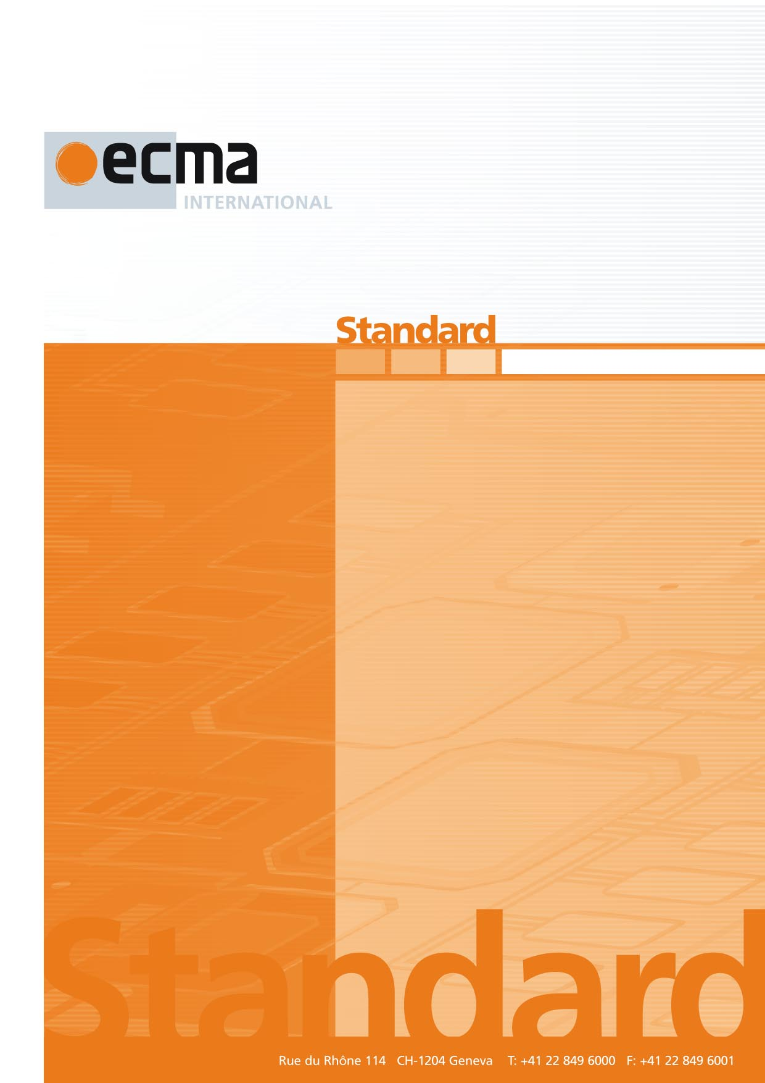

Title of Standard

1st Draft

ECMA-XXX

Edition / Date

Ecma/TCXY/<year>/NN

Contents Page

1 Scope 2

2 Conformance 2

3 Normative references 2

4 Terms and definitions 2

5 Clause title 2

5.1 Clause title 2

5.1.1 Clause title 2

Annex A (normative) Annex title 2

Annex B (informative) Annex title 2

Introduction

Text text text

This Ecma Standard was developed by Technical Committee <number> and was adopted by the General Assembly of <month> <year>.

*"COPYRIGHT NOTICE*

*© <year> Ecma International*

*This document may be copied, published and distributed to others, and certain derivative works of it may be prepared, copied, published, and distributed, in whole or in part, provided that the above copyright notice and this Copyright License and Disclaimer are included on all such copies and derivative works. The only derivative works that are permissible under this Copyright License and Disclaimer are:*

*(i) works which incorporate all or portion of this document for the purpose of providing commentary or explanation (such as an annotated version of the document),*

*(ii) works which incorporate all or portion of this document for the purpose of incorporating features that provide accessibility,*

*(iii) translations of this document into languages other than English and into different formats and*

*(iv) works by making use of this specification in standard conformant products by implementing (e.g. by copy and paste wholly or partly) the functionality therein.*

*However, the content of this document itself may not be modified in any way, including by removing the copyright notice or references to Ecma International, except as required to translate it into languages other than English or into a different format.*

*The official version of an Ecma International document is the English language version on the Ecma International website. In the event of discrepancies between a translated version and the official version, the official version shall govern.*

*The limited permissions granted above are perpetual and will not be revoked by Ecma International or its successors or assigns.*

*This document and the information contained herein is provided on an "AS IS" basis and ECMA INTERNATIONAL DISCLAIMS ALL WARRANTIES, EXPRESS OR IMPLIED, INCLUDING BUT NOT LIMITED TO ANY WARRANTY THAT THE USE OF THE INFORMATION HEREIN WILL NOT INFRINGE ANY OWNERSHIP RIGHTS OR ANY IMPLIED WARRANTIES OF MERCHANTABILITY OR FITNESS FOR A PARTICULAR PURPOSE."*

Title of the StandardINTERNATIONAL STANDARD© ISO/IEC 2008 – All rights reservedISO/IEC 10995:2008(E) 63Test method for the estimation of the archival lifetime of optical mediaInformation technology — Digitally recorded media for information interchange and storageTechnologies de l'information — Supports enregistrés numériquement pour l'échange et le stockage d'information — Méthode d'essai pour l'estimation de la durée de vie d'archivage des supports optiquesInformation technology — Digitally recorded media for information interchange and storage — Test method for the estimation of the archival lifetime of optical mediaE2008-02-22(60) PublicationISO/IECISO/IEC    International Standard 2008ISO/IEC 10995ISO/IEC 10995ISO/IEC 10995   Information technology  JTC1 2Heading 2Heading 1     0 CR6STD Version 2.260   4O:\Documents\JTC001\SC023\046554 - ISO_IEC CD 10995 (Ed 1)\60.00\310\046554e\C046554e.doc

# Scope

# Conformance

Text text text

# Normative references

The following documents are referred to in the text in such a way that some or all of their content constitutes requirements of this document. For dated references, only the edition cited applies. For undated references, the latest edition of the referenced document (including any amendments) applies.

ISO/IEC 12345:year, *Title*

ISO/IEC 12345:year, *Title*

ECMA-XXX, *Title*, xth edition (month year)

# Terms and definitions

For the purposes of this document, the following terms and definitions apply.

4.1

term

definition

4.2

term

definition

4.3

term

definition

NOTE Text text text.

4.4

term

definition

NOTE 1 Text text text.

NOTE 2 Text text text.

# Clause title

Text text text

## Clause title

Text text text

### Clause title

Text text text

#### Clause title

Text text text

##### Clause title

Text text text

Table 1 — Title

|  |  |  |  |  |
| --- | --- | --- | --- | --- |
|  | **DVD-R/RW, +R/+RW disk**  **(Single Layer / Dual Layer)** | | **DVD-RAM disk** | |
| 80 mm | 120 mm | 80 mm | 120 mm |
| Band 1 | 25,0 | 25,0 | 24,1-25,0 | 24,1-25,0 |
| Band 2 | 30,0 | 40,0 | 29,8-30,8 | 39,4-40,4 |
| Band 3 | 35,0 | 55,0 | 34,6-35,6 | 54,9-55,8 |



Figure 1 — Title

1. (normative)  
     
   Annex title

Text text text

1. (informative)  
     
   Annex title

Text text text

Bibliography (if any)

1. Experimental statistics, US National Bureau of Standards Handbook 91, 1963
2. Applied Regression Analysis, Draper and Smith, Wiley Edition 2
3. Statistical Methods for Reliability Data, Meeker, Escobar, 1998, John Wiley & Sons Inc.