**Title:** Using tree-ring records to simultaneously characterize the influence of tree size and climate drivers on annual growth

**Authors (not yet complete, final order TBD):**

Kristina J. Anderson-Teixeira1,2*, Valentine Herrmann1, Christy Rollinson3, Bianca Gonzalez1, Erika B. Gonzalez-Akre1, Neil Pederson4, Camille Piponiot1,2, Ross Alexander, Craig D. Allen, Raquel Alfaro-Sánchez, Taia Awada, Jennifer Baltzar, Patrick Baker, Sarayudh Bunyavejchewin, Paulo Cherubini, Justin Cooper, Stuart Davies2, Ryan Helcoski1, Vasickova Ivana, Kaspar Jakub, Kamil Kral, James Lutz, Ellis Q. Margolis, Justin Maxwell, Sean McMahon2, Helene Muller-Landau2, Samonil Pavil, Sabrina Russo, Anastasia Sniderhan, Alan J. Tepley1,#, Mart Vlam, Peter Zuidema

**Author Affiliations:**

1. Conservation Ecology Center; Smithsonian Conservation Biology Institute; Front Royal, VA 22630, USA
2. Center for Tropical Forest Science-Forest Global Earth Observatory; Smithsonian Tropical Research Institute; Panama, Republic of Panama
3. The Morton Arboretum, Lisle, Illinois, USA
4. Harvard Forest, Petersham, MA 01366, USA

X#. Canadian Forest Service, Northern Forestry Centre, Edmonton, Alberta, Canada

*corresponding author: [teixeirak@si.edu](mailto:teixeirak@si.edu); +1 540 635 6546

**Running headline:** [45 chars]

*NOTE TO COAUTHORS: The text is still pretty rough, so please don’t worry about word-smithing. However, I’d appreciate input on the content, and important references (especially “DENDRO REFS”, as most of you know that literature better than I do).*

*Target journal is MEE. We are already over the word limit, so I’d appreciate advice on what should be cut/moved to appendix.*

### Abstract

*NOTE TO COAUTHORS: I’d appreciate feedback on what you consider to be the most important results and conclusions to highlight in the abstract.*

1. Tree rings provide a valuable long-term record for understanding how climate shapes forest productivity. However, traditional analysis methods aggregate growth records of multiple trees into residual chronologies, and therefore cannot simultaneously account for the effects of tree size and climate. This has limited the potential to use tree-rings to understand forest productivity and its climate sensitivity.
2. Here, we develop a new method to simultaneously model non-linear effects of objectively determined principle climate drivers and tree diameter (). Specifically, we first identify the most important climate drivers and their appropriate time window of influence using the *climwin* R package. We then include these in generalized least squares models to model tree growth while accounting for the temporal autocorrelation inherent to each individual tree’s growth. We apply this method to tree-ring data from *#* trees representing *~40* species at ten globally distributed sites spanning a wide range of forest types.
3. Our analysis identified similar climate drivers to those obtained via traditional methods, but revealed that non-linear responses to climate variables were common. Radial growth increments, basal area increments, and biomass increments all varied non-linearly with . The relative importance of versus climate varied across sites, and interactions between and climate were prevalent (*~50%* of cases tested).
4. Our method provides a rigorous analytical framework for objectively identifying the most important climate drivers of tree growth and combining them with in nonlinear models. The need for such an approach is highlighted by our findings that nonlinear growth responses to climate variables are common, that growth rates vary nonlinearly with , and that significant - climate interactions are common. These findings imply that should be accounted for in analyses seeking to quantify the impacts of climate and other environmental drivers on tree growth. By providing a framework for such analyses, our approach opens the door for using tree-rings to improve our understanding of forest responses to climate change.

**Keywords**: climate sensitivity; diameter; environmental change; Forest Global Earth Observatory (ForestGEO); generalized least squares; nonlinear; tree-ring

### Introduction

**Tree rings provide a long-term record of annual growth increments that is invaluable for understanding forests in an era of global change.** Spanning time scales of decades to centuries or even millennia, they provide by far the most robust method for characterization of the interannual climate sensitivity of tree growth (REFS) and how it is changing (e.g., Sniderhan & Baltzer, 2016; Maxwell, Harley, & Robeson, 2016). Combined with forest censuses, they can be used to estimate forest woody productivity (; Graumlich, Brubaker, & Grier, 1989; Teets, Fraver, et al., 2018) and its climate sensitivity (Klesse et al., 2018; Teets et al., 2018; Helcoski et al., 2019). This information is critical to predicting forest responses to climate change, and thereby reducing the enormous uncertainty surrounding future contributions of Earth’s forests to the global carbon cycle (Friedlingstein et al., 2006). Yet, dendrochronological methods have been optimized to detect climate signals rather than to predict forest productivity and its climate sensitivity (Klesse et al., 2018). As a result, prevailing approaches hold a number of limitations for using tree-rings to address pressing questions concerning forest productivity in the current era of rapid environmental change.

**To predict annual tree growth or forest productivity based on climate, a necessary first step is identification of the most important climate variables, the time frames over which they have the strongest influence over annual growth, and their additive or interactive effects.** Traditional dendrochronological methods identify climate signals by examining month-by-month correlations of growth index chronologies to select climate variables–most commonly temperature and precipitation–over the current year and, typically, previous year (e.g., DENDRO_REFS). While appropriate for identifying the strongest signals for purposes such as historical climate reconstructions (e.g., DENDRO_REFS) and for describing how each month’s climate affects tree growth or productivity (e.g., Helcoski et al., 2019), this approach falls short of objectively identifying the most important climate drivers and their time windows of influence, which is needed for multivariate models of annual tree growth and forest productivity (e.g., Teets et al., 2018). Further, tree-ring studies generally do not consider additive or interactive effects of climate variables on annual growth (DENDRO_REFS; but see Foster, Finley, D’Amato, Bradford, & Banerjee, 2016). Such effects are expected based on observations that temperature and moisture jointly shape photosynthesis (REFS), tree growth (Foster et al., 2016), and forest productivity (e.g.,TREE_LEVEL_REFS; Banbury Morgan et al., n.d.). Thus, to model tree growth responses to climate, we need an objective approach to systematically evaluate numerous potential climate variables and time windows in order to select principle climate drivers appropriate for inclusion in multivariate models.

**Traditional methods characterize only linear climate responses, potentially missing important nonlinearities that have been widely observed at other spatio-temporal scales.** Over time frames of seconds to days, most biological rates—- from photosynthesis to plant and animal respiration—-display a unimodal relationship to temporal variation in temperature. Specifically, these rates generally increase exponentially with temperature up to a point (e.g., Brown, Gillooly, Allen, Savage, & West, 2004), typically reflective of the environment to which the organism is acclimated (Kumarathunge et al., 2019), and decrease at higher temperatures [e.g., REFS]. On the other end of the spatio-temporal spectrum, across regional to global climate gradients, annual forest productivity plateaus or decreases at high temperature, , and potential evapotranspiration, (Sullivan et al., 2020; Banbury Morgan et al., n.d.). Similarly, across global gradients, annual forest productivity increases with precipitation only up to a point, after which it plateaus or decreases (Banbury Morgan et al., n.d.). Filling a critical gap between short-term physiological responses and the global gradients representing millennia of community assembly and species adaptation, the annual growth records of tree-rings capture tree growth responses to interannual climatic variation. Yet, dendrochronological studies allowing for nonlinear or threshold responses of tree growth to climate are rare (Tolwinski-Ward, Anchukaitis, & Evans, 2013; Tumajer et al., 2017), and we therefore know little about what, if any, nonlinearities occur in tree growth responses to interannual variation in climate.

**Tree size (most commonly diameter breast height, ) is among the most important variables affecting tree growth rate (e.g., Muller-Landau et al., 2006; Foster et al., 2016) and its climate sensitivity (e.g., Bennett, McDowell, Allen, & Anderson-Teixeira, 2015; McGregor et al., n.d.), yet traditional methods do not characterize its effect or its potential interactions with climate.** For dendrological studies aimed at deciphering climate signals, is not typically a variable of interest, and its influence is removed through detrending (DENDRO_REFS). While convenient for identifying climate signals (DENDRO_REFS), this approach is not optimal for subsequent inference of the climate sensitivity of forest productivity. Although climate correlations can be transformed to climate sensitivity (*sensu* Charney et al., 2016) and scaled to characterize the climate sensitivity of $ANPP_{stem}$ based on the scaling of $Δr$ with $DBH$ (Helcoski et al., 2019), they cannot be used to characterize known interactive effects of $DBH$ and climate on tree growth. For example, larger trees tend to exhibit greater growth reductions in drought years (Bennett et al., 2015; McGregor et al., n.d.), and smaller trees can be more sensitive to temperature (*Rollinson et al. in review*). However, the removal of signals via detrending makes it impossible to account for such size differences in climate sensitivity. To use tree-rings to predict tree growth and , we need models that include and its potential climate interactions.

**Here, we develop a new method that allows simultaneous consideration of the effects of tree size, objectively determined principle climate drivers, and other environmental drivers on annual tree growth.** This allows us to ask: (1) What are the most important climate drivers of annual growth, and over which time windows? (2) What is the shape of the relationship between annual growth and climate drivers? (3) How do , , and aboveground biomass increments ($ΔAGB$) vary with ? (4) How do climate drivers and additively and interactively shape growth?

### Materials and Methods

#### Data sources and preparation

We analyzed previously collected tree-ring data from ten sites ranging from 9.15 to 61.30 N latitude and representing a wide range of forest and tree types: tropical broadleaf deciduous and evergreen, temperate broadleaf deciduous and needleleaf evergreen, and boreal needleleaf evergreen (Tables 1, S1-S2). Nine of these sites (exception: LT) are large forest dynamics plots of the Forest Global Earth Observatory (ForestGEO; Anderson-Teixeira, Davies, et al., 2015). Trees of species represented within the ForestGEO plots were cored within the plot (n=#) and/or in the vicinity (n=#; max distance: # km), following a variety of sampling protocols designed to meet the varied objectives of the original studies (Tables S1, S3). In using this diversity of data sources, we ensured that our approach was able to handle challenges presented by varying methodologies and forest types.

**Table 1 | Sites included in this analysis**. Here and throughout, sites are ordered by latitude. Additional site information is provided in Table S1, and species and their sample sizes are detailed in Tables S2-S3. *Climate will be filled in based on CRU data.* 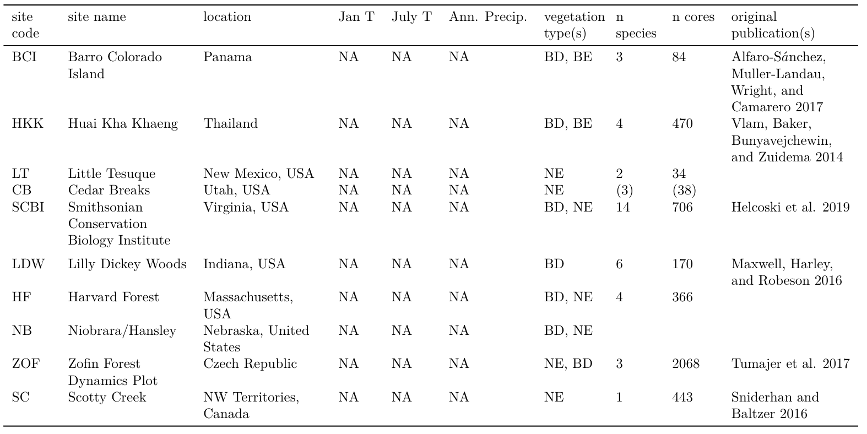

All tree cores (n=*#*) were measured and cross-dated by the original researchers using standard dendrochronological practices. The full record for all cores was retained for analysis, with the exception of records that had to be excluded due to insufficient sample size or anomalous growth patterns. Specifically, we excluded (1) species with <7 cores, (2) cores with <30 years of record, (3) contiguous portions of cores containing large outliers ( > mean plus 5 x SD of for the entire core), and (4) the final 20 years prior to death of trees cored dead. The final criteria was implemented to avoid periods of growth decline and potentially altered climate sensitivity prior to death (Cailleret et al., 2017; DeSoto et al., 2020). From analyses including (see below), we further excluded (1) trees for which we lacked data required to reconstruct , (2) trees for which there was a significant inconsistency between measured and the sum of ’s across the core (*Appendix S1*), and (3) parts of records where reconstructed (see below) was represented by <3 conspecific trees. In total, this resulted in inclusion of *#* cores, *#* of which could be included in analyses with (Table S3).

For each year in the tree-ring records, we reconstructed , as detailed in *Appendix S1*. In most cases, when a recent measurement was available, was reconstructed from the outside in. In cases where was not available, but when we knew that the core hit pith or could reasonably estimate how far off it was based on the curvature of the rings (DENDORO_REF), was reconstructed from the inside out. In either case, we used allometric equations between and bark thickness to account for changes in bark thickness as the tree grew (Appendix S1; Tables S2, S4).

Once had been reconstructed, we used biomass allometries to estimate the corresponding aboveground biomass and diameter to area equation to get the corresponding basal area. We then calculated aboveground biomass growth increments () as [] and basal area increment () as []. Biomass allometries for temperate and tropical sites were calculated using the R packages *allo-db* (Gonzalez-Akre et al. in prep) and *biomass* (Réjou‐Méchain, Tanguy, Piponiot, Chave, & Hérault, 2017), respectively.

Monthly climate data for 1901-2019 were obtained from CRU v.4.04 (Harris, Jones, Osborn, & Lister, 2014; Harris, Osborn, Jones, & Lister, 2020). *Variables considered here included average daily minimum, maximum, and mean temperatures ( / currently “TMN”, / currently “TMX”, / / currently “TMP”, respectively); potential evapotranspiration (); precipitation (/ currently “PRE”); and precipitation day frequency (/ currently “WET”).* For BCI, we calculated monthly and from daily precipitation readings made on BCI starting in 1929 (Paton, 2019). All ForestGEO climate records used here are archived in the ForestGEO Climate Data Portal, v1.0-alpha (Anderson-Teixeira et al., 2020).

#### Analysis methods

Our analysis consisted of two main steps: (1) identification of the most important climate drivers, and (2) combining and climate drivers into a multivariate model (Fig. **1**). The analysis was run separately for each site and each response variable (, , or ).

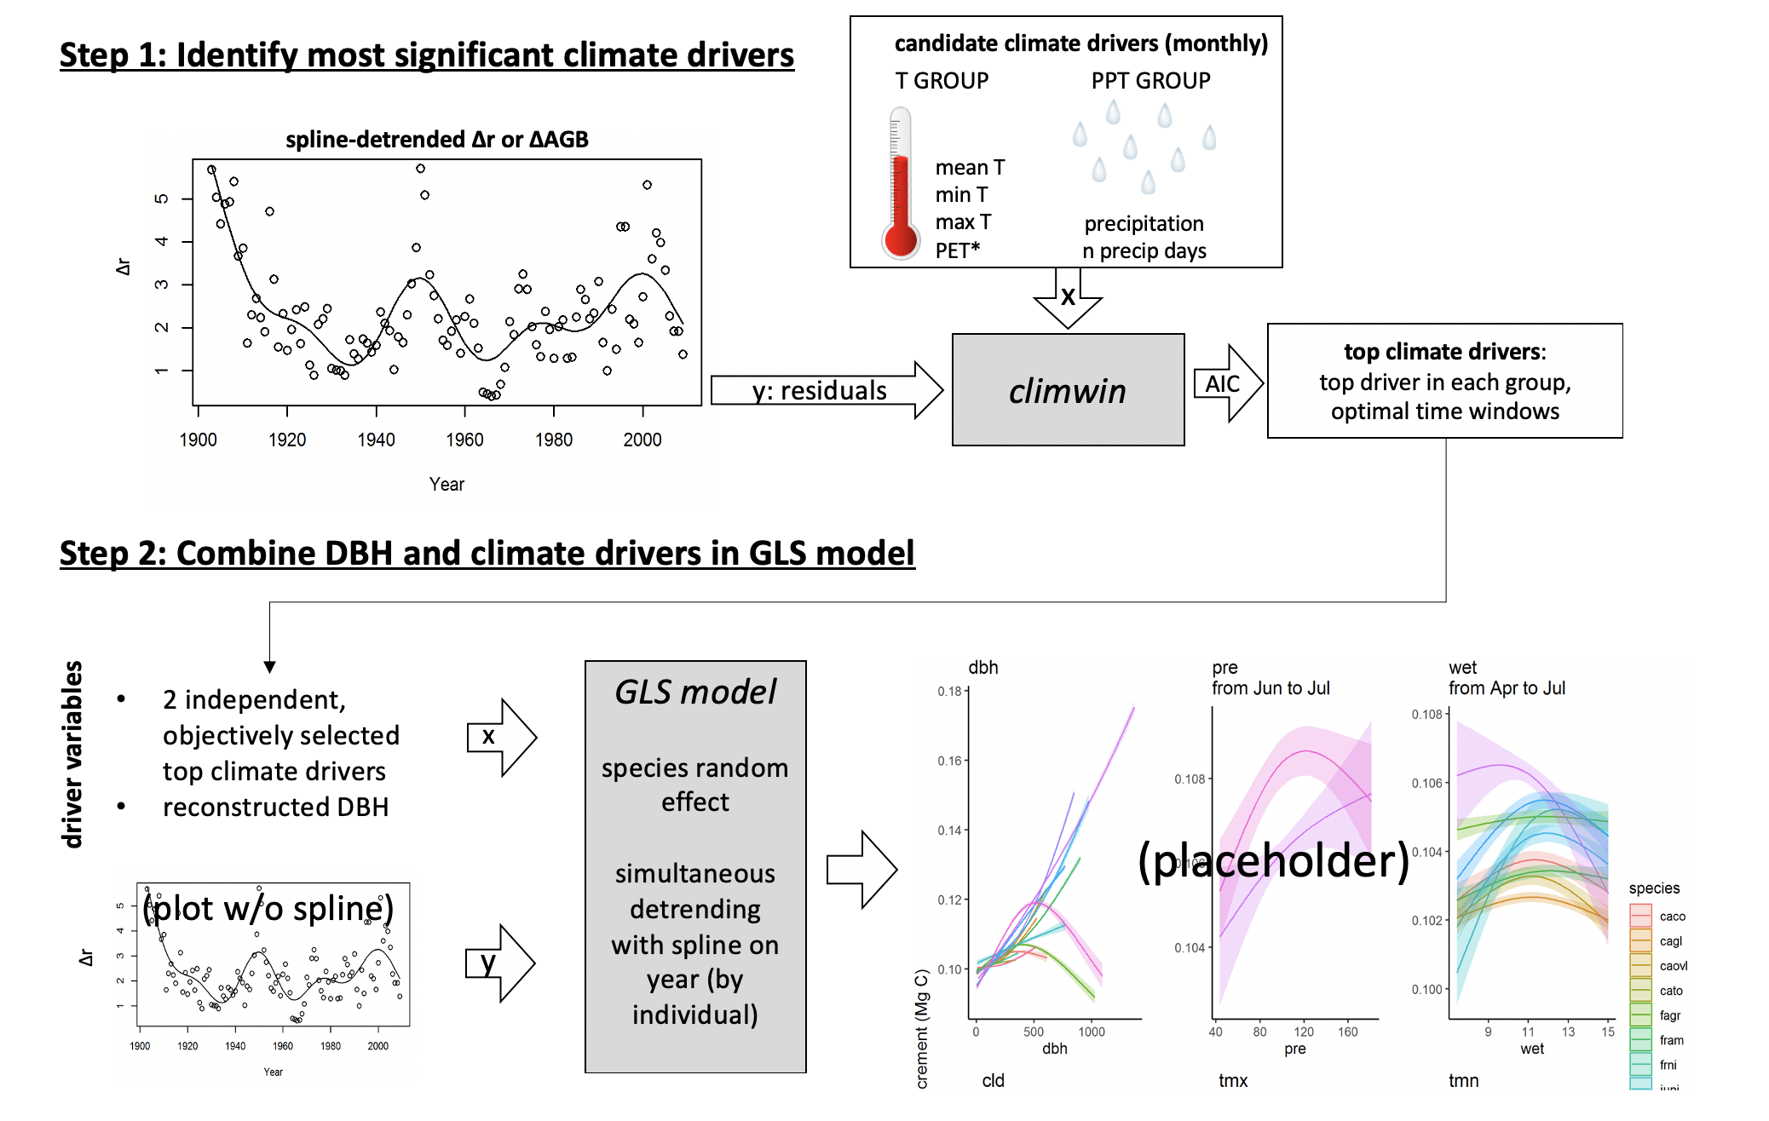

**Figure 1 | DRAFT Schematic illustrating our analysis process.** This analysis is conducted separately for each site.

*Identifying key climate drivers*

**We used the *climwin* package in R (Pol et al., 2016) to identify the most important climate driver and the time window over which its effect was strongest for each of two categories of variables: a temperature group (mean, min, and max temperature; PET) and a precipitation group (precipitation, number of days with precipitation).** For this, we detrended the response variable to remove the influence of all non-climatic drivers (*e.g.*, growth and aging of the tree, change in competitive dynamics, atmospheric pollution), which is essential for identifying climatic drivers (DENDRO_REFS). Specifically, we used a generalized additive model (GAM) to fit a spline to individual growth records (, , or ) from each core, thereby producing residuals. We then used *climwin* to identify the climate variables most strongly correlated to the residuals of , , or , specifying quadratic fits to allow for potential nonlinearities in the climate response. Within *climwin*, we specified a mixed effects model using species and core identity as random effects: residual ~ [climate] + (1 | sp) + (1 | treeID). Here, for each permutation, climate specifies one of the climate drivers in the climate variable group, analyzed over one of all possible combinations of time periods, at monthly resolution, over a 15 month period ending near the time of cessation of formation of each annual ring (*Table S1*). ([**ISSUE #51 in ForestGEO-climate-sensitivity**](https://github.com/EcoClimLab/ForestGEO-climate-sensitivity/issues/51)) *Climwin* runs all potential models to select the best fit (lowest AIC), and does k-fold cross-validation in its computation of AIC to guard against over-fitting (Pol et al., 2016). For each group of candidate climate variables, we move forward with the best variable over the time window identified by *climwin* as a candidate climate variable for the multivariate models.

A challenge to this system arose for the sites that have undergone the most rapid changes in climate and tree growth: SC and LT, where trees exhibit significant growth declines attributed to rising temperatures (Sniderhan & Baltzer, 2016) and increasing drought (REF), respectively. *(*[*ISSUE #25 in ForestGEO-climate-sensitivity*](https://github.com/EcoClimLab/ForestGEO-climate-sensitivity/issues/25)*)* Problematically, correlating tree growth residuals from which climate-driven trends had been removed against the climate signal with a strong directional trend would not necessarily identify the most relevant climate drivers. For these sites, we experimented with three approaches to identifying the most important climate drivers (1) the method described above, (2) detrending the climate variables prior to the climwin step, and (3) excluding *decades with the most pronounced climate change* from the climwin step of the analysis (Appendix S3). After determining that… , here we present results *(method)*.

We verified that this process identified similar climate variable-month combinations as what would be identified using traditional methods for individual species, as detailed in Appendix S2. ([**ISSUE #35 in ForestGEO-climate-sensitivity**](https://github.com/EcoClimLab/ForestGEO-climate-sensitivity/issues/35))

*Combining drivers in GLS model*

Having identified candidate climate drivers in temperature and precipitation variable groups, we next combined climate variables (all models) and (models with and its climate interactions) in a generalized least squares (GLS) model (Fig. **1**). Before running the models, we checked for collinearity among the candidate variables using the *vifstep* function (**REF**) and removed any variable with a variance inflation factor > 3 (none required removal). Within the GLS models, our response variables were , , or . Rather than detrending these variables to produce residuals, the temporal autocorrelation of individual tree’s growth was accounted for by the specifying an autocorrelation structure of order 1, with as a continuous time covariate and as a grouping factor, in the GLS’s model specification. For each species independently, we ran every combination of the candidate climate variables and , including both first- and second-order terms of polynomial for each. For models including interactive effects of climate and , we included only first-order linear terms for both and climate variables. ([*ISSUE #42 in ForestGEO-climate-sensitivity*](https://github.com/EcoClimLab/ForestGEO-climate-sensitivity/issues/42)) Within each of three categories of models run (climate only, +climate, x climate), we selected as the top model that with the lowest AIC.

The top model was used to visualize the effects of each variables while the others are kept constant at the median in the various figures of this manuscript. For these visualizing tools, we also fetched the t-test’s p-value for each term of the model and represented the significance using different line types. Model predictions represented were back-transformed to show the effect on the original scale of , , or .

*Data and code availability*

*Data*, code, and full results are available via the project repository in GitHub (github.com/EcoClimLab/ForestGEO-climate-sensitivity) and archived in Zenodo (DOI: TBD) . Data for # of the sites are archived in the The DendroEcological Network (DEN) database (Rayback et al., 2020).

### Results

*Identifying climate drivers*

**Our process picked out similar climate drivers to what would be obtained via traditional methods (Figs.** 2**,** S1**; Appendix S2), but with the advantage that *climwin* allowed objective selection of the strongest climate drivers and the time windows over which they were most influential.** The most commonly selected variables within the temperature group were and , each of which was identified by climwin as the top temperature-related driver *at four of the eight sites*. was the top driver at only *one site (BCI)*, and was never identified as the top variable within the temperature group (Fig. **3**). Within the precipitation group, precipitation amount (PRE) was identified as the top variable most frequently (n=*6 of 9* sites), but it was not uncommon that it was surpassed by precipitation frequency (WET; n=*3 of 8* sites). Optimal time windows often coincided with a site’s peak growing season (n= *# of 10* for temperature variables, *# of 10* for precipitation variables), but exceptions were common. At the *5 lowest latitude* sites (BCI, HKK, LT, CB, and SCBI), the optimal window for precipitation variables spanned 8 months, ending during the peak growing months of the year of ring formation. At the *3 highest latitude sites* (HF, ZOF, and SC), the optimal window for precipitation variables was a short ( 3 months) window during the previous growing season. Optimal windows for temperature variables tended to be shorter, the longest being a *6* month period during the summer (wet season) at HKK. At two of the higher-latitude temperate sites (HF and Zofin), temperatures were most influential during late winter/ early spring. There were also a few instances where previous growing season conditions had the strongest influence.

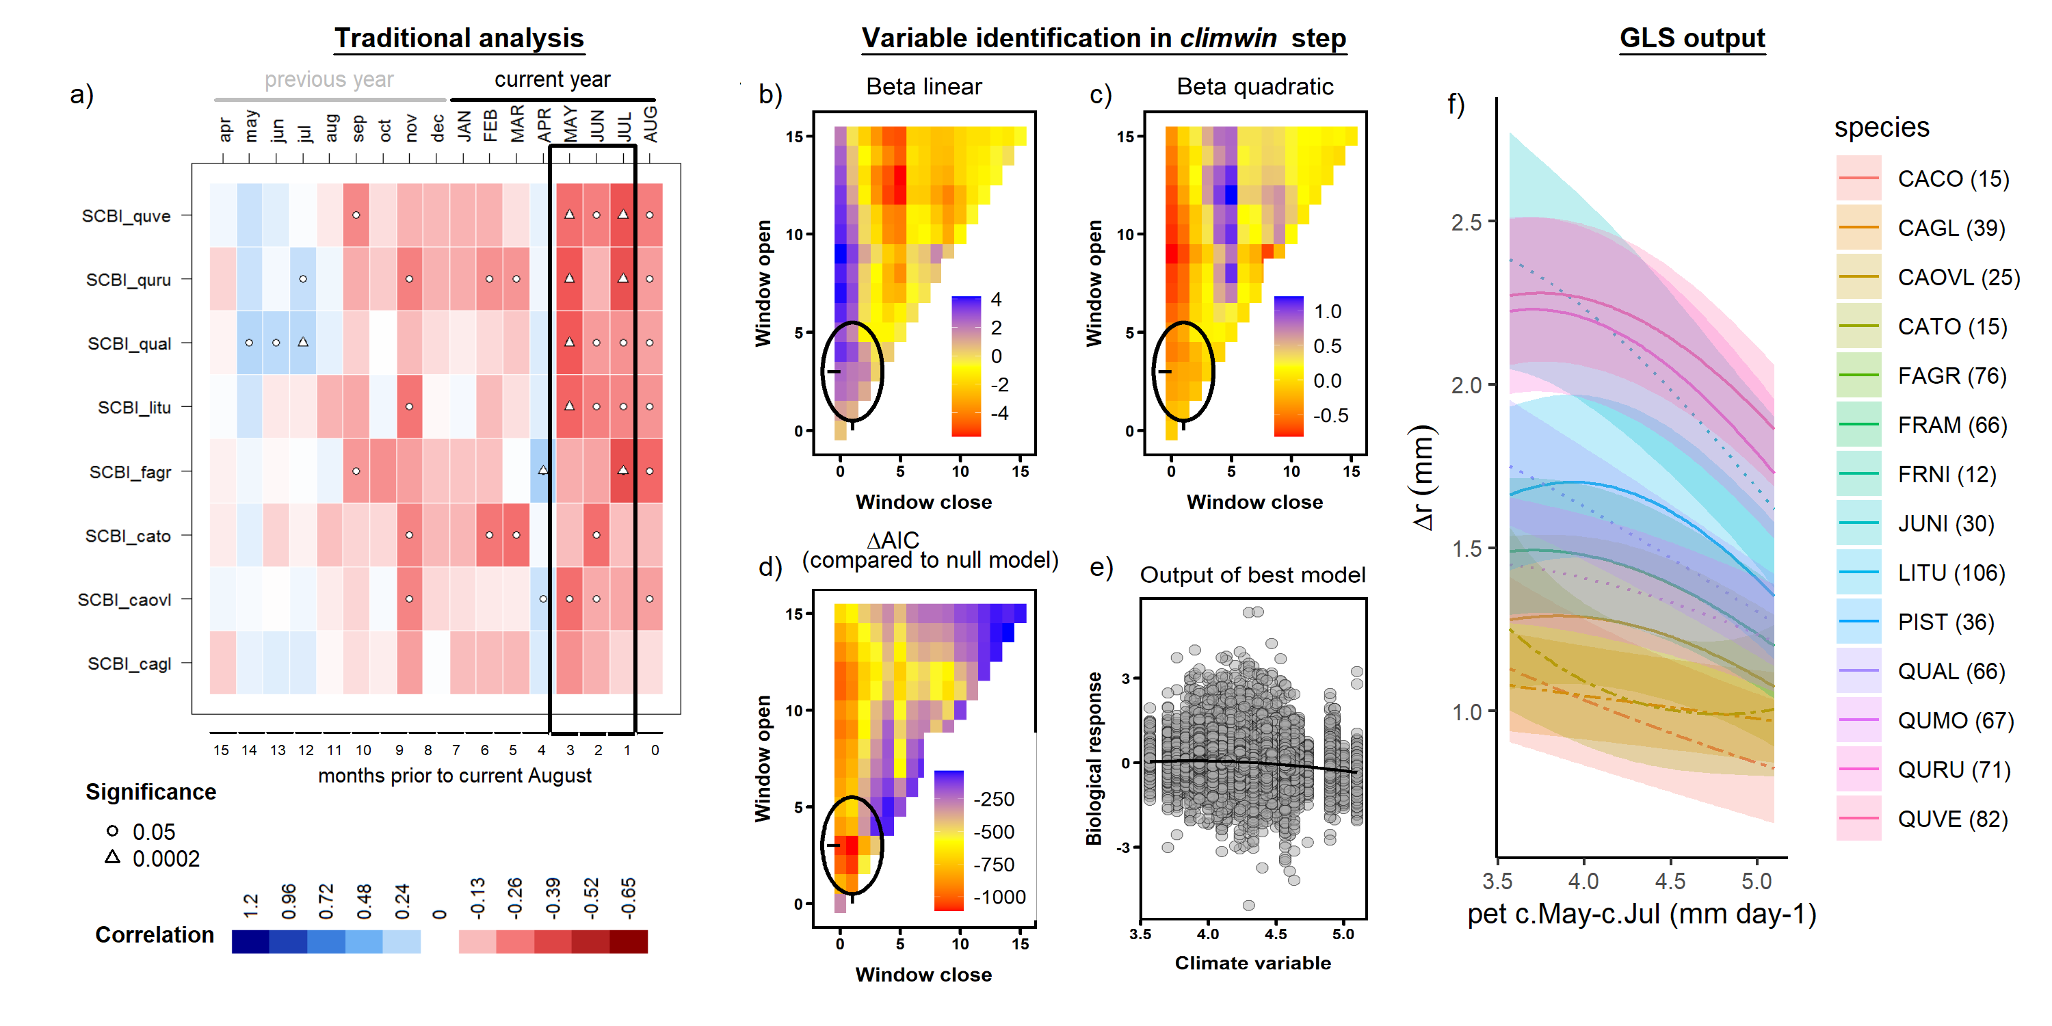

**Figure 2 | Example comparison of climate sensitivity derived via traditional methods (**a**) and our approach (**b-f**).** Example is for the sensitivity of 14 species at SCBI (codes given in Table S2) to potential evapotranspiration (). Panel (**a**) shows a matrix of Pearson correlations between ring-width index and monthly climate variables. Black rectangle represents the period selected by *climwin* as the most influential window. Panels (**b-d**) give statistics for time windows tested in *climwin*, where window open and close indicate months prior to current August, and cells across the lower diaganol indicate single-month tests (akin to panel **a**). Panels (**b**) and (**c**) give values of linear and quadratic terms for each time window, and (**d**) gives the for each. The time window with the minimum (0-3 months prior to August, or May-July; black circles), was identified as the optimal window. Panel (**e**) shows the correlation of individual-level residuals to PET, with the function fit in *climwin*. Finally, panel (**f**) shows GLS model output, where was a candidate driver variable (along with ; not included in this model). Plotted are responses of species for which was included in the top model, with best-fit polynomials plotted with solid lines when both first- and second-order terms are signficant, (CURRENTLY DOTTED/ TO BE DASHED) lines when only one term is signficant, and (CURRENTLY DASHED/ TO BE DOTTED) lines when neither is signficant. Transparent ribbons indicate 95% confidence intervals.

**Across the three metrics of growth, the “landscape” of climate effects over various time windows was generally similar, but the optimal time window or even the top climate variable sometimes differed (Figs.** S2**-**S4**).** Specifically, , , and consistently exhibited similar strength of correlation and direction of response to climate variables within the temperature and precipitation variable groups. In some cases (n= # of #), both the optimal climate variable and time window were identical across growth metrics (e.g., Fig. **S2**). In #cases, *climwin* identified the same climate variable but different (sometimes overlapping) time windows. In *2* cases (precipitation variable group at LT, temperature variable group at HKK), *climwin* identified different climate variables, but identical or overlapping time windows (e.g., Fig. **S3**). Finally, in *2* cases of variables that had only weak effects and mixed responses among species in the final models (temperature variable group at BCI, precipitation variable group at HF; Figs. **3, S5, S11**), *climwin* identified different climate variables and different time windows (e.g., Fig. **S4**). Henceforth, we focus on the climate drivers identified when was the growth metric and for the full set of cores (i.e., including those for which could not be reconstructed.)

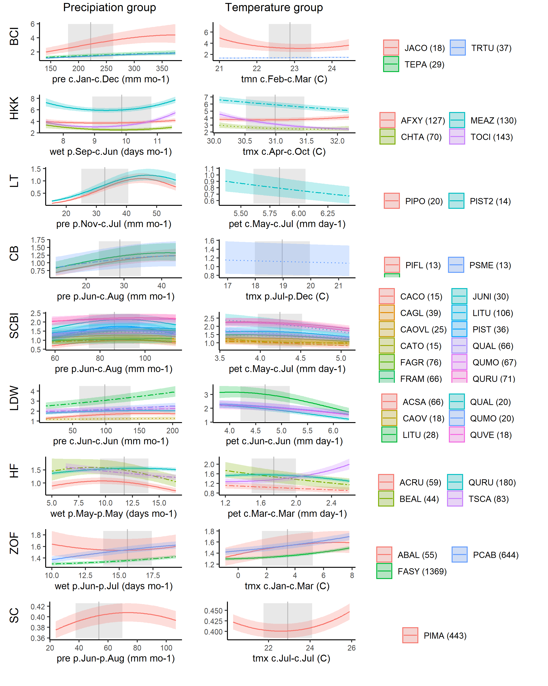

**Figure 3 | Species-level responses to climwin-selected variables in precipitation and temperature variable groups.** For each species (color-coded as in Fig. 4), relationships are plotted if included in top model. Best-fit polynomials are plotted with solid lines when both first- and second-order terms are signficant, DASHED lines when only one term is signficant, and DOTTED lines when neither is signficant. Transparent ribbons indicate 95% confidence intervals. Vertical grey lines indicate the long-term mean for the climate variable, shading indicates 1 SD.

*Climate sensitivity*

Precipitation responses were included in the best model at all sites and *for all but # species* (Fig. **3**). Responses were most commonly positive, and were most pronounced at the driest site (LT). Precipitation terms included in top models were non-linear #% of the time, and significantly better than first-order linear model #% of the time. In some cases, the non-linearity was quite pronounced (e.g., LT), with the most common pattern (#%) being a decelerating increase.

Temperature responses were included in the best model at all sites and *for the majority of species* (Fig. **3**). Specifically, a temperature term was included in the best model for # of # site-species combinations, with at least one polynomial term significant for #, and both for #. Among the relationships with at least one significant term, responses shifted from near-universally negative below 40 latitude (exception: AFXY at HKK) to positive above 45 latitude. Harvard Forest, at 42.5 N, exhibited a mix of responses. *(It will be interesting to see what happens with Indian Creek, at 42.8 latitude.)* *(Note that Scotty Creek was previously positive, later shifted negative;* [*ISSUE #25 in ForestGEO-climate-sensitivity*](https://github.com/EcoClimLab/ForestGEO-climate-sensitivity/issues/25)*)* Temperature terms included in top models were non-linear #% *(most)* of the time, and significantly better than first-order linear model #% of the time.

*Influence of DBH*

**All three growth metrics, , , and , varied with for most species at all sites (Fig.** 4**).** While varied significantly with for the majority of species-site combinations (n= # of #; Table **S#**), there was substantial variation in these trends, with patterns mixed across both forests and species within a single stand (Fig. **4**). On one end of the spectrum, *Melia azedarach* at HKK had extremely rapid growth at small , with ranging up to ~15mm yr-1, followed by fairly rapid declines with increasing . Similar patterns of approximately exponential decline in with were observed for conifer species at Little Tesuque and Scotty Creek–both relatively open forests–and a number of species in mesic temperate forests (Fig. **4**). At the other end of the spectrum, a number of species at sites where they presumably established under closed-canopy conditions (e.g., *Fagus* at SCBI and Zofin) had <1 mm yr-1 at small , increased to peak between # and # cm , and subsequently declined.

**The variable patterns in with translated into differences in variation in and with , although trends in both of these were more consistent across sites and species, typically increasing to a peak at intermediate and then declining (Fig.** 4**).**

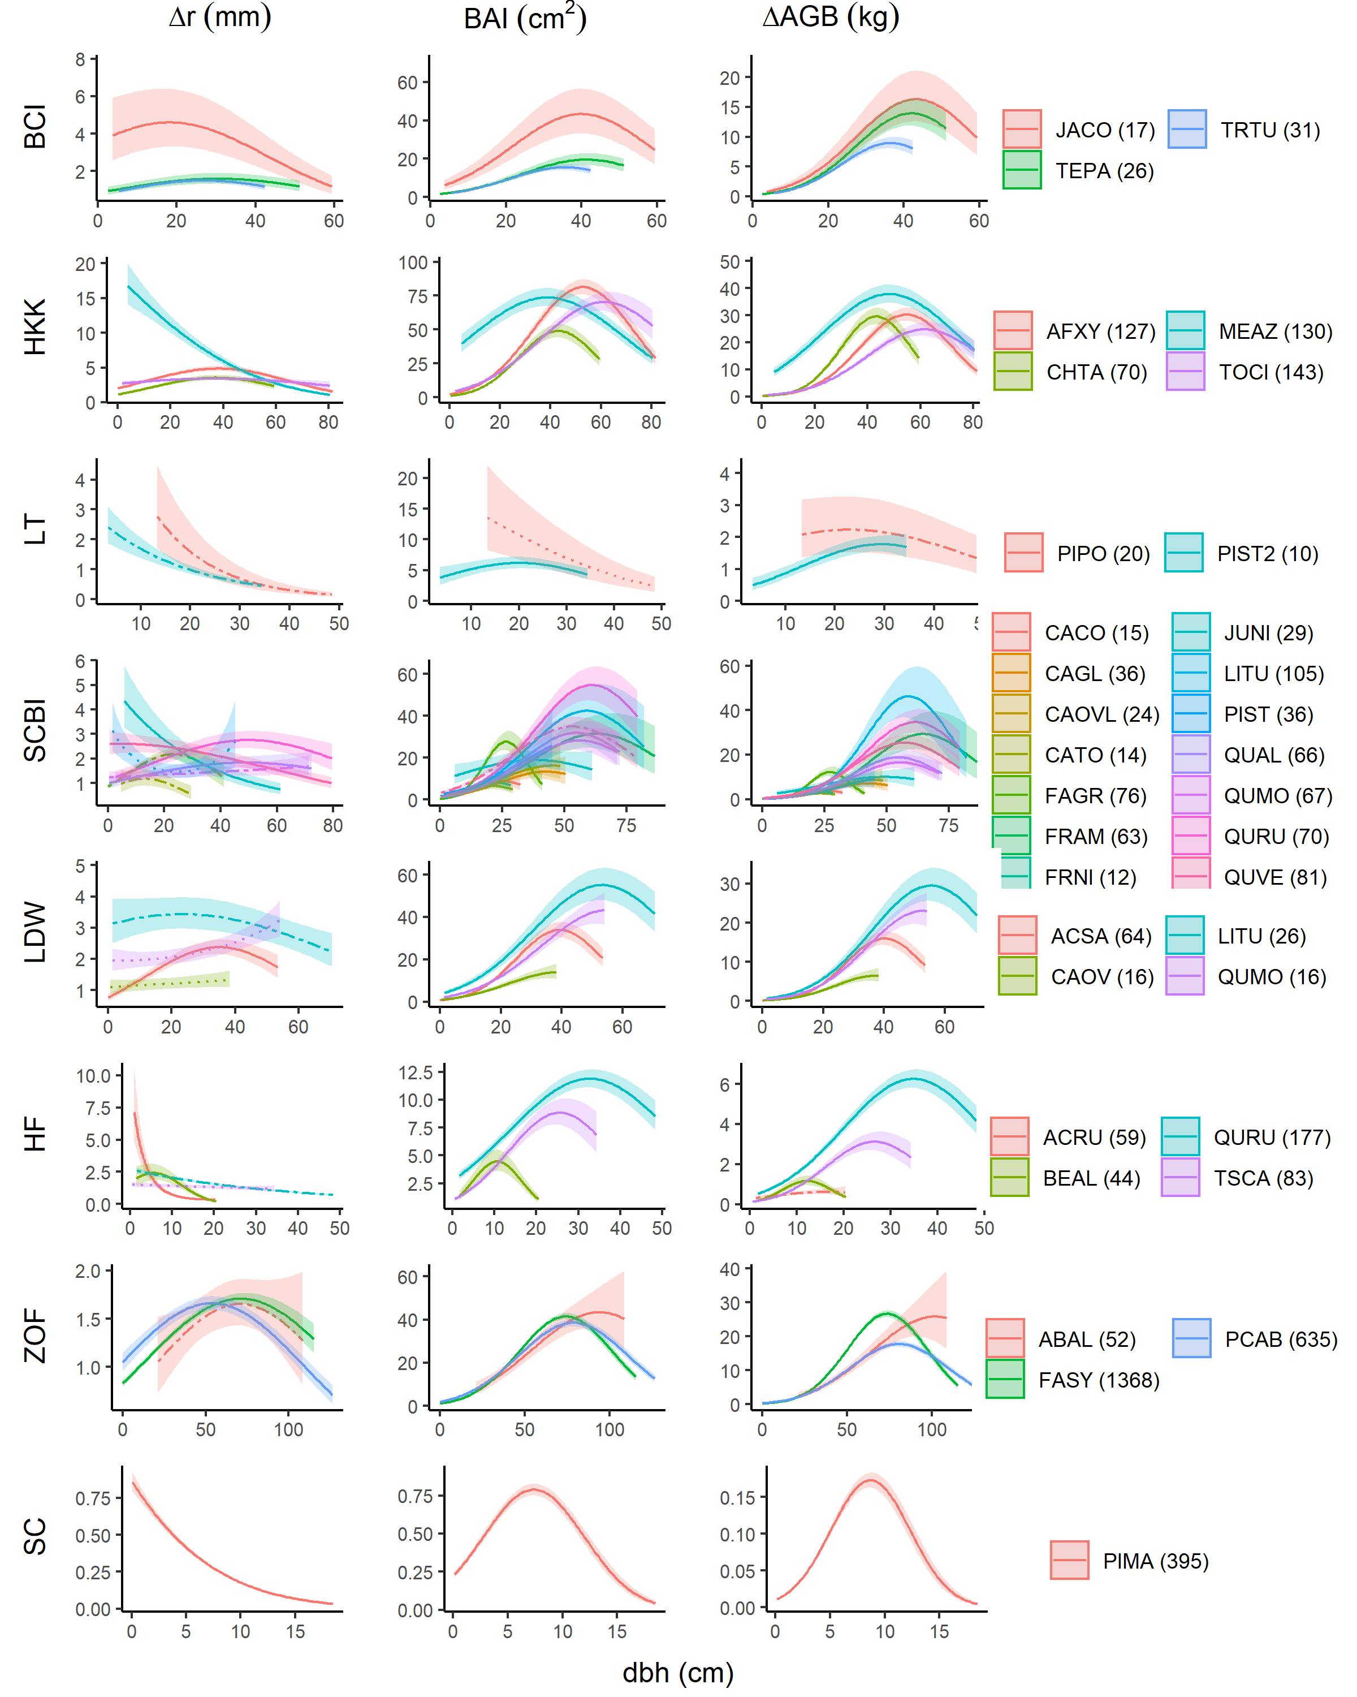

**Figure 4 | Growth sensitivity to DBH: (a) , (b) , (c) .** Relationships for species are plottend when included in the top model. Lines indicate a the optimal 3-knot spline fit, and transparent ribbons indicate 95% confidence intervals.

*Additive and interactive effects of climate and DBH*

**Both DBH and climate were included in the majority of top models, regardless of the growth metric used.** Specifically, was included in #% of top models for , #% of top models for , and #% of top models for . In general, explained more variation in growth rates than did climate (Fig. **5**).

**The relative importance of and climate shifted across growth metrics and climates (Figs.** 5**,** S5**-**S14**).** The relative importance of tended to be least for , intermediate for , and highest for (e.g., at SCBI; Fig. **5**). However, there were exceptions, particularly when decreased steeply with (e.g., at Little Tesuque; Fig. **5**). The relative importance of climate was modest at sites including SCBI (Fig. **5**), HF (Fig. **S11**), and SC (Fig. **S14**), and stronger at sites including LT (Fig. **5**) and BCI (Fig. **S5**).

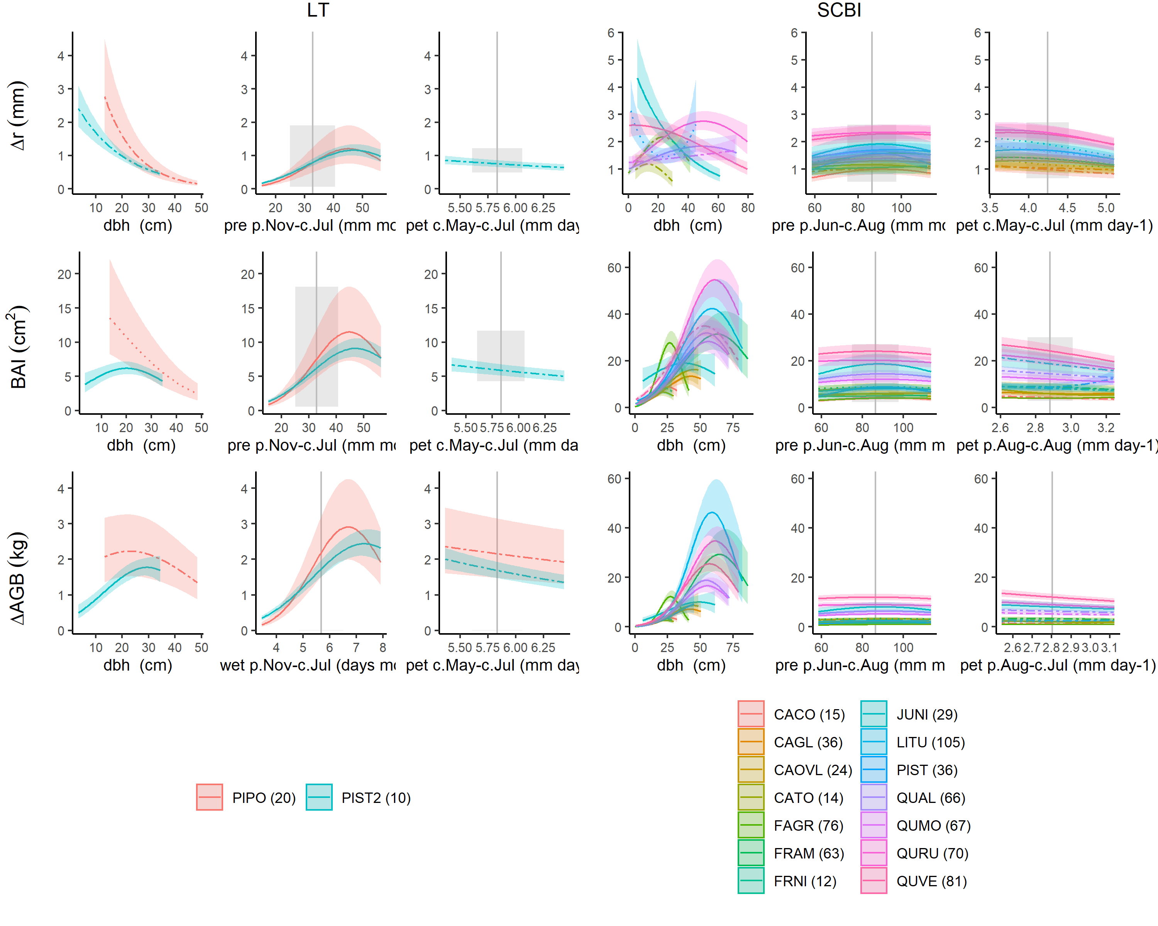

**Figure 5 | Comparison of full top models for each growth metric (, , ) at sites where climatic controls are strong (Little Tesuque, left panel) and modest (SCBI, right panel).** Plotted are best fit models for each species, with transparent ribbons indicating 95% confidence intervals. For climate variables, best-fit polynomials are plotted with solid lines when both first- and second-order terms are signficant, DASHED lines when only one term is signficant, and DOTTED lines when neither is signficant. Vertical grey lines indicate the long-term mean for the climate variable, shading indicates 1 SD.

**Interactive effects of and climate were found for #% of species-variable combinations**. Interactions were significant for over half of -precipitation variable interactions for all three growth metrics (*51% for all*; Table S5). The majority (#%) of these interactions were positive, indicating that larger trees generally respond more positively (or less negatively) to precipitation or it’s frequency (Fig. **6?**). Interactions between temperature variables and were significant for *~40%* of cases considered (Table S5). The majority (#%) of these interactions were positive, indicating that larger trees generally respond less negatively (or more positively) to or (Fig. **6?**).

**figure on climate - DBH interactions?** (*See* [*ISSUE #42 in ForestGEO-climate-sensitivity*](https://github.com/EcoClimLab/ForestGEO-climate-sensitivity/issues/42))

### Discussion

*NOTE TO COAUTHORS: The discussion in particular is still very rough. I’d appreciate feedback on what points to emphasize here.*

**We present a new method that allows simultaneous consideration of the effects of objectively determined principle climate drivers and tree size on annual growth.** Results are broadly consistent with those obtained by traditional methods, but offer several new insights.

*Climate sensitivity*

Ideas to discuss:

* and tend to be better variables than the more commonly used
* trees tend to be sensitive to water over longer time scales (makes sense– lags caused by soil moisture storage)
* temperature sensitivity shifts from neg in warm climates to positive in cold climates (although Sniderhan & Baltzer (2016) shows that the effect shifted to negative as warming progressed)
* additive effects are prevalent and should not be overlooked
* nonlinear effects are prevalent

*Influence of DBH*

**The diversity of growth trends in relation to observed here (Fig.** 4**) is largely attributable to species ecology and stand history (Fig. 4).** On one end of the spectrum, species that would have established in fairly open conditions–*i.e.*, shade-intolerant species and those at sites with more open canopies (e.g., LT, SC)– exhibited rapid initial growth followed by exponential decline. The most pronounced example of this pattern was *Melia azedarach* –a highly shade-intolerant species that generally establishes in the open (Baker & Bunyavejchewin, 2006) and was sampled opportunistically outside the ForestGEO plot at HKK (Vlam, Baker, Bunyavejchewin, & Zuidema, 2014), where it presumably established under open conditions. Such patterns are consistent with dendrochronology’s “textbook” patterns, which have been derived primarily from open-grown trees (DENDRO_REFS). On the other end of the spectrum, shade-tolerant species (e.g. *Fagus* at SCBI and Zofin) exhibited initially low, but increasing, . This pattern is consistent with patterns observed in stand-level census data from closed-canopy forests, including several in this analysis, where increases continuously with [Muller-Landau et al. (2006); Anderson-Teixeira, McGarvey, et al. (2015); Piponiot et al. in prep]. While the low community mean at small observed in closed-canopy forests is in large part driven by slow-growing small stems that will never enter the cohort of trees sampled by coring (e.g., 10cm DBH), increases in with have also been observed for most species at SCBI using the same tree-ring data set analyzed here, but comparing across individuals using only contemporary data (Helcoski et al., 2019). Thus, patterns of decreasing with are likely limited to open-grown trees or those establishing in gaps.  
– (*cite paper that I reviewed several years back;* [*Clark et al. 2007?*](https://esajournals-onlinelibrary-wiley-com.smithsonian.idm.oclc.org/doi/epdf/10.1890/06-1039.1)*;* [*Schleip et al. 2015*](https://onlinelibrary-wiley-com.smithsonian.idm.oclc.org/doi/abs/10.1002/env.2324)).

Contrary to the finding that increases continuously with , which was derived from census data from globally distributed forests (Stephenson et al., 2014) and has also been observed in tree-rings (Foster et al., 2016), we found evidence of saturation or decline in the majority **(77%)** of species-site combinations analyzed. declines at high are presumably because trees are investing fixed C elsewhere–for example, reproduction.

**These results have important implications for using tree-rings to infer growth responses to slowly-changing environmental drivers, including climate, atmospheric CO2, and deposition of sulfur dioxide (SO2) and nitrogen oxides (NOx) (e.g., Mathias & Thomas, 2018).** The observed trends in and with (Fig. **4**) imply that two of the most commonly used growth-trend detection methods, conservative detrending and basal area correction (see Peters, Groenendijk, Vlam, & Zuidema, 2015), are inappropriate. Specifically, conservative detrending, which applies stiff splines or mathematical functions (e.g., negative exponential) to remove trends in before analyzing residuals, would not be reliable across the diversity of - relationships observed here. Basal area correction – i.e., assuming that is fundamentally independent of tree size after the removal of the juvenile growth phase–is also problematic because shows a variety of trends with across large size classes. The most common pattern–an increase to a peak at intermediate sizes, followed by decrease–would imply that the basal area correction is most commonly biased towards finding positive trends for smaller trees and negative trends for larger trees. It is therefore not surprising that tree-ring studies examining the impact of rising CO2 on long-term growth growth trends reach inconsistent conclusions (Walker et al., n.d.).

*Additive and interactive effects of climate and DBH*

**We show that DBH is a strong driver of growth (any metric) relative to climate and that climate sensitivity often varies with DBH– findings that have important implications for understanding changes in forest productivity in response to climate change.** The observed importance of as a driver of tree growth reinforces the concept that changes in forest structure/ demography are critical to changes in forest productivity (REFS; McDowell et al., 2020). The prevalence of interactive -climate effects reinforces the concepts that large trees tend to be disproportionately sensitive to drought (Bennett et al., 2015; McGregor et al., n.d.) but less sensitive to high temperatures *(Rollinson et al. in review)*, implying that size should be considered in tree-ring analyses of climate sensitivity. However, the relatively strong importance of in no way negates the importance of climate, as its effect would dominate changes in productivity in stands with relatively constant size structure. Some studies have made a start at combining tree rings and forest census data to get at the climate sensitivity of whole-forest productivity (e.g., Helcoski et al., 2019), but have been limited in that they were not underlain by models of individual tree growth that simultaneously characterized the effects of tree size and climate, as we do here. Further work will be required to combine this model with forest census data in order to understand the climate sensitivity of whole-forest productivity.

All this points to the potential importance of considering DBH in climate reconstructions. Traditional dendro methods seek to remove the influence of , but our finding of prevalent - interactions indicate that it should not be ignored. DBH is not always collected when cores are taken, and is not routinely preserved alongside tree-ring data. For example, the International Tree-Ring Data Bank (ITRDB) contains no structure for storing DBH records. DEN is new alternative (Rayback et al., 2020).

*Conclusions*

Sets the foundation for considering other, slowly changing environmental drivers.

### Acknowledgements

Thanks to Pete Kerby-Miller for bark thickness data. Helpful feedback was provided by Albert Kim… This analysis was funded by a Smithsonian Scholarly Studies grant to KAT, SM, HCM, and CP.

### Authors’ contributions

KAT, VH, CR, RA, CP conceived the ideas and designed methodology; [most authors] collected the data; VH, BG, EGA organized and analysed the data; KAT led the writing of the manuscript. All authors contributed critically to the drafts and gave final approval for publication.

### References

Alfaro-Sánchez, R., Muller-Landau, H. C., Wright, S. J., & Camarero, J. J. (2017). Growth and reproduction respond differently to climate in three Neotropical tree species. *Oecologia*, *184*(2), 531–541. doi:[10.1007/s00442-017-3879-3](https://doi.org/10.1007/s00442-017-3879-3)

Anderson-Teixeira, K., Gonzalez, B., ForestGEO, McGregor, I., Gonzalez-Akre, E., RHelcoski, … Terrell, A. (2020, July). Forestgeo/Climate: Pre-release for collaborative review. Zenodo. doi:[10.5281/ZENODO.3958216](https://doi.org/10.5281/ZENODO.3958216)

Anderson-Teixeira, K. J., Davies, S. J., Bennett, A. C., Gonzalez-Akre, E. B., Muller-Landau, H. C., Joseph Wright, S., … Zimmerman, J. (2015). CTFS-ForestGEO: A worldwide network monitoring forests in an era of global change. *Global Change Biology*, *21*(2), 528–549. doi:[10.1111/gcb.12712](https://doi.org/10.1111/gcb.12712)

Anderson-Teixeira, K. J., McGarvey, J. C., Muller-Landau, H. C., Park, J. Y., Gonzalez-Akre, E. B., Herrmann, V., … McShea, W. J. (2015). Size-related scaling of tree form and function in a mixed-age forest. *Functional Ecology*, *29*(12), 1587–1602. doi:[10.1111/1365-2435.12470](https://doi.org/10.1111/1365-2435.12470)

Baker, P. J., & Bunyavejchewin, S. (2006). Suppression, release and canopy recruitment in five tree species from a seasonal tropical forest in western Thailand. *Journal of Tropical Ecology*, *22*(5), 521–529. doi:[10.1017/S0266467406003312](https://doi.org/10.1017/S0266467406003312)

Banbury Morgan, B., Herrmann, V., Kunert, N., Bond-Lamberty, B., Muller-Landau, H. C., & Anderson-Teixeira, K. J. (n.d.). Global patterns of forest autotrophic carbon fluxes. *Global Change Biology*.

Bennett, A. C., McDowell, N. G., Allen, C. D., & Anderson-Teixeira, K. J. (2015). Larger trees suffer most during drought in forests worldwide. *Nature Plants*, *1*(10), 15139. doi:[10.1038/nplants.2015.139](https://doi.org/10.1038/nplants.2015.139)

Brown, J. H., Gillooly, J. F., Allen, A. P., Savage, V. M., & West, G. B. (2004). Toward a Metabolic Theory of Ecology. *Ecology*, *85*(7), 1771–1789. doi:[10.1890/03-9000](https://doi.org/10.1890/03-9000)

Cailleret, M., Jansen, S., Robert, E. M. R., Desoto, L., Aakala, T., Antos, J. A., … Martínez‐Vilalta, J. (2017). A synthesis of radial growth patterns preceding tree mortality. *Global Change Biology*, *23*(4), 1675–1690. doi:[10.1111/gcb.13535](https://doi.org/10.1111/gcb.13535)

Charney, N. D., Babst, F., Poulter, B., Record, S., Trouet, V. M., Frank, D., … Evans, M. E. K. (2016). Observed forest sensitivity to climate implies large changes in 21st century North American forest growth. *Ecology Letters*, *19*(9), 1119–1128. doi:[10.1111/ele.12650](https://doi.org/10.1111/ele.12650)

DeSoto, L., Cailleret, M., Sterck, F., Jansen, S., Kramer, K., Robert, E. M. R., … Martínez-Vilalta, J. (2020). Low growth resilience to drought is related to future mortality risk in trees. *Nature Communications*, *11*(1). doi:[10.1038/s41467-020-14300-5](https://doi.org/10.1038/s41467-020-14300-5)

Foster, J. R., Finley, A. O., D’Amato, A. W., Bradford, J. B., & Banerjee, S. (2016). Predicting tree biomass growth in the temperate–boreal ecotone: Is tree size, age, competition, or climate response most important? *Global Change Biology*, *22*(6), 2138–2151. doi:[10.1111/gcb.13208](https://doi.org/10.1111/gcb.13208)

Friedlingstein, P., Cox, P., Betts, R., Bopp, L., Bloh, W. von, Brovkin, V., … Zeng, N. (2006). Climate–Carbon Cycle Feedback Analysis: Results from the C4MIP Model Intercomparison. *Journal of Climate*, *19*(14), 3337–3353. doi:[10.1175/JCLI3800.1](https://doi.org/10.1175/JCLI3800.1)

Graumlich, L. J., Brubaker, L. B., & Grier, C. C. (1989). Long-Term Trends in Forest Net Primary Productivity: Cascade Mountains, Washington. *Ecology*, *70*(2), 405–410. doi:[10.2307/1937545](https://doi.org/10.2307/1937545)

Harris, I., Jones, P. D., Osborn, T. J., & Lister, D. H. (2014). Updated high-resolution grids of monthly climatic observations - the CRU TS3.10 Dataset: UPDATED HIGH-RESOLUTION GRIDS OF MONTHLY CLIMATIC OBSERVATIONS. *International Journal of Climatology*, *34*(3), 623–642. doi:[10.1002/joc.3711](https://doi.org/10.1002/joc.3711)

Harris, I., Osborn, T. J., Jones, P., & Lister, D. (2020). Version 4 of the CRU TS monthly high-resolution gridded multivariate climate dataset. *Scientific Data*, *7*(1). doi:[10.1038/s41597-020-0453-3](https://doi.org/10.1038/s41597-020-0453-3)

Helcoski, R., Tepley, A. J., Pederson, N., McGarvey, J. C., Meakem, V., Herrmann, V., … Anderson‐Teixeira, K. J. (2019). Growing season moisture drives interannual variation in woody productivity of a temperate deciduous forest. *New Phytologist*, *223*(3), 1204–1216. doi:[10.1111/nph.15906](https://doi.org/10.1111/nph.15906)

Klesse, S., DeRose, R. J., Guiterman, C. H., Lynch, A. M., O’Connor, C. D., Shaw, J. D., & Evans, M. E. K. (2018). Sampling bias overestimates climate change impacts on forest growth in the southwestern United States. *Nature Communications*, *9*(1), 5336. doi:[10.1038/s41467-018-07800-y](https://doi.org/10.1038/s41467-018-07800-y)

Kumarathunge, D. P., Medlyn, B. E., Drake, J. E., Tjoelker, M. G., Aspinwall, M. J., Battaglia, M., … Way, D. A. (2019). Acclimation and adaptation components of the temperature dependence of plant photosynthesis at the global scale. *New Phytologist*, *222*(2), 768–784. doi:[10.1111/nph.15668](https://doi.org/10.1111/nph.15668)

Mathias, J. M., & Thomas, R. B. (2018). Disentangling the effects of acidic air pollution, atmospheric CO , and climate change on recent growth of red spruce trees in the Central Appalachian Mountains. *Global Change Biology*, *24*(9), 3938–3953. doi:[10.1111/gcb.14273](https://doi.org/10.1111/gcb.14273)

Maxwell, J. T., Harley, G. L., & Robeson, S. M. (2016). On the declining relationship between tree growth and climate in the Midwest United States: The fading drought signal. *Climatic Change*, *138*(1-2), 127–142. doi:[10.1007/s10584-016-1720-3](https://doi.org/10.1007/s10584-016-1720-3)

McDowell, N. G., Allen, C. D., Anderson-Teixeira, K., Aukema, B. H., Bond-Lamberty, B., Chini, L., … Xu, C. (2020). Pervasive shifts in forest dynamics in a changing world. *Science*, *368*(6494). doi:[10.1126/science.aaz9463](https://doi.org/10.1126/science.aaz9463)

McGregor, I., Helcoski, R., Kunert, N., Tepley, A. J., Gonzalez-Akre, E. B., Herrmann, V., … Anderson-Teixeira, K. J. (n.d.). Tree height and drought tolerance traits shape growth responses across droughts in a temperate broadleaf forest. *Target Journal: New Phytologist*.

Muller-Landau, H. C., Condit, R. S., Chave, J., Thomas, S. C., Bohlman, S. A., Bunyavejchewin, S., … Kiratiprayoon, S. (2006). Testing metabolic ecology theory for allometric scaling of tree size, growth and mortality in tropical forests. *Ecology Letters*, *9*(5), 575–588. Retrieved from <http://www.blackwell-synergy.com/doi/abs/10.1111/j.1461-0248.2006.00904.x>

Paton, S. (2019). Barro Colorado Island, Clearing_Precipitation, manual. doi:[10.25573/data.10042502.v3](https://doi.org/10.25573/data.10042502.v3)

Peters, R. L., Groenendijk, P., Vlam, M., & Zuidema, P. A. (2015). Detecting long‐term growth trends using tree rings: A critical evaluation of methods. *Global Change Biology*, *21*(5), 2040–2054. doi:[10.1111/gcb.12826](https://doi.org/10.1111/gcb.12826)

Pol, M. van de, Bailey, L. D., McLean, N., Rijsdijk, L., Lawson, C. R., & Brouwer, L. (2016). Identifying the best climatic predictors in ecology and evolution. *Methods in Ecology and Evolution*, *7*(10), 1246–1257. doi:[10.1111/2041-210X.12590](https://doi.org/10.1111/2041-210X.12590)

Rayback, S. A., Duncan, J. A., Schaberg, P. G., Kosiba, A. M., Hansen, C. F., & Murakami, P. F. (2020). The DendroEcological Network: A cyberinfrastructure for the storage, discovery and sharing of tree-ring and associated ecological data. *Dendrochronologia*, *60*, 125678. doi:[10.1016/j.dendro.2020.125678](https://doi.org/10.1016/j.dendro.2020.125678)

Réjou‐Méchain, M., Tanguy, A., Piponiot, C., Chave, J., & Hérault, B. (2017). Biomass: An r package for estimating above-ground biomass and its uncertainty in tropical forests. *Methods in Ecology and Evolution*, *8*(9), 1163–1167. doi:[10.1111/2041-210X.12753](https://doi.org/10.1111/2041-210X.12753)

Sniderhan, A. E., & Baltzer, J. L. (2016). Growth dynamics of black spruce ( *Picea mariana* ) in a rapidly thawing discontinuous permafrost peatland: Growth Dynamics Boreal Peatlands. *Journal of Geophysical Research: Biogeosciences*, *121*(12), 2988–3000. doi:[10.1002/2016JG003528](https://doi.org/10.1002/2016JG003528)

Stephenson, N. L., Das, A. J., Condit, R., Russo, S. E., Baker, P. J., Beckman, N. G., … Zavala, M. A. (2014). Rate of tree carbon accumulation increases continuously with tree size. *Nature*, *507*(7490), 90–93. doi:[10.1038/nature12914](https://doi.org/10.1038/nature12914)

Sullivan, M. J. P., Lewis, S. L., Affum-Baffoe, K., Castilho, C., Costa, F., Sanchez, A. C., … Phillips, O. L. (2020). Long-term thermal sensitivity of Earth’s tropical forests. *Science*, *368*(6493), 869–874. doi:[10.1126/science.aaw7578](https://doi.org/10.1126/science.aaw7578)

Teets, A., Fraver, S., Hollinger, D. Y., Weiskittel, A. R., Seymour, R. S., & Richardson, A. D. (2018). Linking annual tree growth with eddy-flux measures of net ecosystem productivity across twenty years of observation in a mixed conifer forest. *Agricultural and Forest Meteorology*, *249*, 479–487. doi:[10.1016/j.agrformet.2017.08.007](https://doi.org/10.1016/j.agrformet.2017.08.007)

Teets, A., Fraver, S., Weiskittel, A. R., & Hollinger, D. Y. (2018). Quantifying climate-growth relationships at the stand level in a mature mixed-species conifer forest. *Global Change Biology*, *24*(8), 3587–3602. doi:[10.1111/gcb.14120](https://doi.org/10.1111/gcb.14120)

Tolwinski-Ward, S. E., Anchukaitis, K. J., & Evans, M. N. (2013). Bayesian parameter estimation and interpretation for an intermediate model of tree-ring width. *Climate of the Past*, *9*(4), 1481–1493. doi:[10.5194/cp-9-1481-2013](https://doi.org/10.5194/cp-9-1481-2013)

Tumajer, J., Altman, J., Štěpánek, P., Treml, V., Doležal, J., & Cienciala, E. (2017). Increasing moisture limitation of Norway spruce in Central Europe revealed by forward modelling of tree growth in tree-ring network. *Agricultural and Forest Meteorology*, *247*, 56–64. doi:[10.1016/j.agrformet.2017.07.015](https://doi.org/10.1016/j.agrformet.2017.07.015)

Vlam, M., Baker, P. J., Bunyavejchewin, S., & Zuidema, P. A. (2014). Temperature and rainfall strongly drive temporal growth variation in Asian tropical forest trees. *Oecologia*, *174*(4), 1449–1461. doi:[10.1007/s00442-013-2846-x](https://doi.org/10.1007/s00442-013-2846-x)

Walker, A. P., Kauwe, M. G. D., Bastos, A., Belmecheri, S., Georgiou, K., Keeling, R., … Zuidema, P. A. (n.d.). Integrating the evidence for a terrestrial carbon sink caused by increasing atmospheric CO2. *New Phytologist*, *n/a*(n/a). doi:[10.1111/nph.16866](https://doi.org/10.1111/nph.16866)