**Title:** Using tree-ring records to simultaneously characterize the influence of climate, tree size, and slowly changing environmental drivers on annual growth

**Authors:**

Kristina J. Anderson-Teixeira1,2*, Valentine Herrmann1, Christy Rollinson3, Bianca Gonzalez1, Erika B. Gonzalez-Akre1, Neil Pederson4, Ross Alexander5, Craig D. Allen6, Raquel Alfaro-Sánchez7, Tala Awada8, Jennifer L. Baltzer7, Patrick J. Baker9, Sarayudh Bunyavejchewin10, Paolo Cherubini11, Justin Cooper12, Stuart J. Davies2, Cameron Dow1,13, Ryan Helcoski1, Jakub Kašpar14, James Lutz15, Ellis Q. Margolis6, Justin Maxwell16, Sean McMahon2,17, Camille Piponiot1,2,18, Sabrina Russo8, Pavel Šamonil14, Anastasia E. Sniderhan7, Alan J. Tepley1,19, Ivana Vašíčková14, Mart Vlam20, Peter Zuidema20

**Author Affiliations:**

1. Conservation Ecology Center; Smithsonian Conservation Biology Institute; Front Royal, Virginia 22630, USA
2. Center for Tropical Forest Science-Forest Global Earth Observatory; Smithsonian Tropical Research Institute; Panama, Republic of Panama
3. The Morton Arboretum, Center for Tree Science, Lisle, Illinois 60532 USA
4. Harvard University, Petersham, Massachusetts 01366 USA
5. Midwest Dendro LLC, Naperville, Illinois 60565 USA
6. U.S. Geological Survey, Fort Collins Science Center, Jemez Mountains Field Station, Los Alamos, NM 87544, USA
7. Biology Department, Wilfrid Laurier University, 75 University Ave W, Waterloo, ON, N2L 3C5
8. School of Natural Resources, University of Nebraska-Lincoln, Lincoln, NE 68583, USA
9. School of Biological Sciences, Monash University, Clayton, Victoria 3800, Australia
10. National Parks Wildlife and Plant Conservation Department, Chatuchak, Bangkok 10900, Thailand
11. Swiss Federal Institute for Forest, Snow and Landscape Research, CH-8903 Birmensdorf, Switzerland
12. University of Alberta; Edmonton, Alberta, Canada
13. Department of Forestry, Purdue University, West Lafayette, IN 47907, USA
14. Department of Forest Ecology, The Silva Tarouca Research Institute for Landscape and Ornamental Gardening, Lidická 25/27, 602 00 Brno, Czech Republic
15. S. J. & Jessie E. Quinney College of Natural Resources and the Ecology Center, Utah State University, Logan, UT 84322, USA
16. Department of Geography, Indiana University, Bloomington, Indiana, USA
17. Smithsonian Environmental Research Center, Edgewater, MD, USA
18. CIRAD, Montpellier, France
19. Canadian Forest Service, Northern Forestry Centre, Edmonton, Alberta, Canada
20. Forest Ecology and Forest Management Group, Wageningen; Wageningen, The Netherlands

*corresponding author: [teixeirak@si.edu](mailto:teixeirak@si.edu); +1 540 635 6546

**Running headline:** [45 chars]

# Abstract

Tree rings provide a uniquely valuable long-term record for understanding how climate and other environmental drivers shape forest productivity. However, traditional dendrochronology methods aggregate growth records of multiple trees–often limited to dominant canopy individuals–into residual chronologies, and therefore cannot simultaneously account for the effects of climate, tree size, and slowly changing environmental drivers. This has limited the potential to use tree-rings to understand forest productivity, its climate sensitivity, and its global change responses. Here, we develop a new method to simultaneously model non-linear effects of objectively determined principle climate drivers, reconstructed tree diameter (), and year in generalized least squares models that account for the temporal autocorrelation inherent to each individual tree’s growth. We apply this method to tree-ring data from 3811 trees representing 40 species at ten globally distributed sites. Our analysis identified similar climate drivers to those obtained via traditional methods. Growth responses were predominantly positive to precipitation and negative to temperature, with both included in 78% of top models, and with non-linear responses prevalent (*>50%* of relationships). Growth rates–expressed as ring widths, basal area increments, or biomass increments–varied non-linearly with . Interactions between and climate were common (44% of cases tested). Accounting for , growth rate varied directionally over time in most species– declining in 90%. These trends were largely attributable to successional stand dynamics as cohorts and stands age, which remain challenging to parse from global change drivers. As a rigorous analytical framework for statistically modeling tree growth responses to the most important climate drivers, , and year in nonlinear models, our method provides a parsimonious approach for characterizing multiple interacting drivers of tree growth, opening the door for novel analyses using tree-rings to improve our understanding of forest responses to global change.

**Keywords**: climate sensitivity; diameter; environmental change; Forest Global Earth Observatory (ForestGEO); generalized least squares (GLS); nonlinear; tree-ring

# Introduction

Tree rings provide a long-term record of annual growth increments that is invaluable for understanding forests in an era of global change (Amoroso et al., 2017; Fritts & Swetnam, 1989). Spanning time scales of decades to centuries or even millennia, they provide by far the most robust method for characterization of the interannual climate sensitivity of tree growth (Bräker, 2002; Fritts, 1976) and how it is changing (Babst et al., 2019; Maxwell et al., 2016; Sniderhan & Baltzer, 2016; Wilmking et al., 2020). Combined with forest censuses, they can be used to estimate forest woody productivity (Davis et al., 2009; Dye et al., 2016; , Graumlich et al., 1989; Teets, Fraver, Hollinger, et al., 2018) and its climate sensitivity (Helcoski et al., 2019; Klesse et al., 2018; Teets, Fraver, Weiskittel, et al., 2018). They also provide the long-term perspective critical to understanding how slowly changing environmental drivers including rising atmospheric carbon dioxide (CO2) concentrations and directional climate change are influencing tree growth and forest productivity (e.g., Levesque et al., 2017; Mathias & Thomas, 2018; Walker et al., 2020). This information is critical to predicting forest responses to climate change, thereby reducing the enormous uncertainty surrounding future contributions of Earth’s forests to the global carbon cycle (Friedlingstein et al., 2006). Yet, collection and analysis of dendrochronological records has traditionally been optimized to detect climate signals rather than to predict forest productivity, its climate sensitivity, and how it may be changing (Babst et al., 2018; Cherubini et al., 1998; Klesse et al., 2018; Nehrbass-Ahles et al., 2014; Wilmking et al., 2020). As a result, prevailing approaches hold a number of limitations for using tree-rings to address pressing questions concerning forest productivity in the current era of rapid environmental change.

Dendrochronological methods to characterize the climate sensitivity of tree growth have been optimized to obtain the strongest possible climate signal for climate reconstructions, but face limitations when it comes to characterizing the climate sensitivity of individual trees or . Traditional methods begin by fitting a function (commonly a spline) to the growth record captured by each core, extracting residuals around the long-term trends, and then standardizing and averaging the residuals across cores to form a species-level ring-width index chronology (Fritts, 1976; Speer, 2010). Climate signals are then identified by examining month-by-month or seasonal correlations of the ring-width index chronology to one or more climate variables over the current year and, typically, previous year (e.g., Fritts, 1976; Meko et al., 2011; Zang & Biondi, 2015). Following identification of the top climate driver(s), statistical models describing their relationships to tree growth can be used for applications such as climate reconstruction (e.g., Buntgen et al., 2011) or projection of tree growth responses to climate change (e.g., Charney et al., 2016). An important caveat for the latter, however, is that the slopes of correlations between climate variables and ring-width index chronologies are not identical to the mean sensitivity of individuals within the population, as the process of building species chronologies fundamentally alters and obfuscates individual-level responses (Pederson et al., 2020). Although population-level climate responses have been approximated based on climate sensitives derived from species chronologies (e.g., Charney et al., 2016; Helcoski et al., 2019), the removal of individual-level variation prior to analysis of climate sensitivity limits potential for using species chronologies to characterize the climate sensitivity of . In particular, analysis of species-level chronologies does not allow characterization of known variation in climate sensitivity in relation to tree size, canopy position, or microhabitat (e.g., Bennett et al., 2015; McGregor et al., 2020; Rollinson et al., 2021).

Dendrochronological studies most commonly focus on linear climate responses to single climate drivers and the settings in which these occur, thereby missing nonlinearities and additive or interactive climate effects known to be widespread within forest settings (Wilmking et al., 2020). Nonlinearities in climate sensitivities of tree metabolism and growth have been observed across a wide range of spatio-temporal scales. Over time frames of seconds to days, photosynthesis and respiration display unimodal relationships to temporal variation in temperature, typically peaking at temperatures reflective of the environment to which the plant is adapted and acclimated (Kumarathunge et al., 2019). Across broad climatic gradients, annual forest productivity generally increases with temperature, precipitation, and potential evapotranspiration () up to a point, after which it plateaus or decreases (Banbury Morgan et al., in press; M. J. P. Sullivan et al., 2020). Filling a critical gap between short-term physiological responses and the global gradients representing millennia of community assembly and species adaptation, the annual growth records of tree-rings capture tree growth responses to interannual climatic variation. Yet, because non-linearities are problematic for reconstructing climate variables (Esper & Frank, 2009), systems exhibiting these are typically avoided–e.g., by sampling climate-limited forest boundaries, and traditional analysis methods are designed around first-order linear growth-climate relationships (Fritts, 1976 **(dendro coauthors, does this ref work?)**). Dendrochronological studies allowing for nonlinear or threshold responses of tree growth to climate are less common (Cavin & Jump, 2017; Cook & Johnson, 1989; Ljungqvist et al., 2020; Rollinson et al., 2021; Tolwinski-Ward et al., 2013; Tumajer et al., 2017; Woodhouse, 1999), and we therefore know little about the nonlinearities in tree growth responses to interannual variation in climate. Furthermore, temperature and moisture are known to jointly shape tree growth (Beedlow et al., 2013; Foster et al., 2016) and forest productivity (e.g., Alexander et al., 2018; Banbury Morgan et al., in press), yet growth sensitivity to their additive or interactive effects, potentially operating over different time windows, is not commonly considered (but see Foster et al., 2016; Meko et al., 2011; Sánchez-Salguero et al., 2015).

Tree diameter at breast height () is closely correlated with numerous variables affecting tree growth rate (e.g., height, crown size and position, root mass, Enquist & Niklas, 2002) and therefore is one of the most important variables influencing growth (e.g., Foster et al., 2016; Muller-Landau et al., 2006) and its climate sensitivity (e.g., Bennett et al., 2015; McGregor et al., 2020). However, for dendrochronological studies aimed at deciphering climate signals, is not typically a variable of interest, and its influence is removed through detrending (Cook & Peters, 1997). Moreover, many studies constrain sampling to only larger size classes. While convenient for identifying climate signals (Fritts, 1976), this approach is not optimal for subsequent inference of the climate sensitivity of forest productivity (Babst et al., 2018). Although climate correlations can be transformed to climate sensitivity (*i.e.*, magnitude of response, *sensu* Charney et al., 2016) and scaled to characterize the climate sensitivity of based on the scaling of with (Helcoski et al., 2019), they cannot be used to directly model known interactive effects of and climate on tree growth (Trouillier et al., 2019). For example, larger trees tend to be relatively more sensitive to drought (Bennett et al., 2015; Gillerot et al., 2020; McGregor et al., 2020), and responses to temperature can also vary with tree size (Rollinson et al., 2021; Rossi et al., 2007). However, the removal of signals via detrending makes it impossible to account for such size differences in climate sensitivity in a systematic, integrative way. To use tree-rings to predict tree growth, , and forest dynamics, we need models that include (e.g., Evans et al., 2017; Klesse et al., 2020) and its potential climate interactions (e.g., Rollinson et al., 2021).

Characterizing how tree growth and forest productivity are responding to slowly changing environmental drivers is challenging and uncertain. Directional climate change (as opposed to interannual variation), rising atmospheric CO2 concentrations, and atmospheric deposition of sulfur dioxide (SO2) and nitrogen oxides (NOx) are all potentially influencing tree growth (e.g., Levesque et al., 2017; Mathias & Thomas, 2018; Walker et al., 2020). At the same time, stand dynamics influence growth: tree growth rates are sensitive to competition, the intensity of which tends to increase as forests mature, and to canopy position, which can change directionally as trees overtop or are overtopped by their neighbors. Moreover, carbon allocation to woody growth – as opposed to leaf or root production, reproduction, defenses, etc. – is known to decline as individual trees and forest stands stands age (Goulden et al., 2011; Pregitzer & Euskirchen, 2004; Thomas, 2011). However, tree size and time are almost inextricably linked (because each individual core increases in through time) and therefore difficult to disentangle, being subject to various sampling and analysis biases (Bowman et al., 2013; Brienen et al., 2017, 2012; Cherubini et al., 1998; Hember et al., 2019; Nehrbass-Ahles et al., 2014; Peters et al., 2015; P. F. Sullivan et al., 2016). Continued improvement of analytical methods, in combination with sampling approaches that minimize potential biases, will be important to disentangling from time and detecting directional growth trends.

Here, we develop a new method that allows simultaneous consideration of the effects of principle climate drivers (pre-selected in an objective manner), tree size, and year on annual tree growth. This approach allows us to ask: (1) What are the most important climate drivers (and their relevant time windows), and what is the shape of the relationship between annual growth and these drivers? (2) How do , , and aboveground biomass increments () vary with ? (3) How do climate drivers and additively and interactively shape tree growth? (4) How have growth rates of contemporary cohorts of trees changed through time?

# Materials and Methods

## Data sources and preparation

We analyzed tree-ring data, most of which was collected for earlier studies (see references in Table 1), from ten sites ranging from 9.15to 61.30 N latitude and representing a wide range of forest and tree types: tropical broadleaf deciduous and evergreen, temperate broadleaf deciduous and needleleaf evergreen, and boreal needleleaf evergreen (Tables 1, S1, S2). Nine of these sites (exception: LT) are large forest dynamics plots of the Forest Global Earth Observatory (ForestGEO, K. J. Anderson-Teixeira, Davies, et al., 2015; Davies et al., 2021). Trees of species represented within the ForestGEO plots were cored within the plot (n=5) and/or nearby within similar forest types (n=5), following a variety of sampling protocols designed to meet the varied objectives of the original studies (Tables S1, S3). Record start years varied substantially, which reflects–with some error–the age distribution of sampled trees (Figs. S1-S10). In using this diversity of data sources, we ensured that our approach could handle challenges presented by varying methodologies and forest types.

**Table 1 | Sites included in this analysis**. Here and throughout, sites are ordered by descending mean annual temperature. Additional site information is provided in Appendix S1 and Table S1, and tree species and sampling details are detailed in Tables S2-S3. 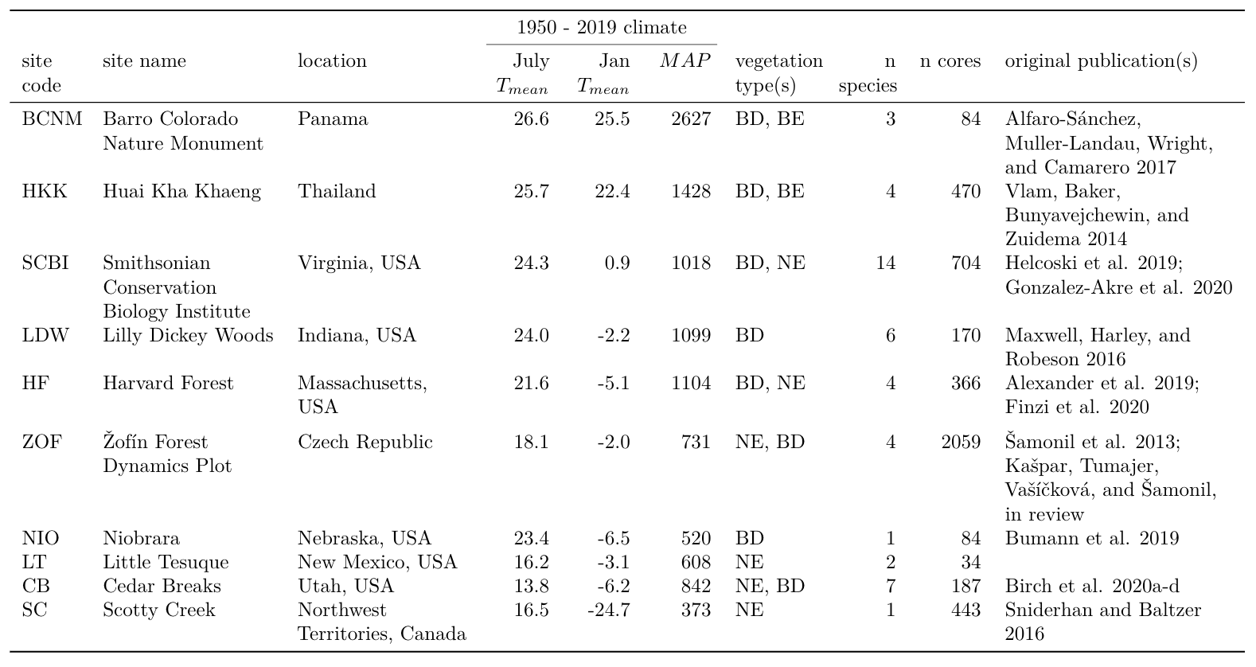

All tree cores were cross-dated and measured by the original researchers using standard dendrochronological practices (Stokes, 1968). From among the full set of original measurements, we excluded cores for which we detected errors (e.g., labeling inconsistencies, obvious dating errors) that could not be resolved before finalizing the analysis. We also excluded records that had to be excluded due to insufficient sample size or anomalous growth patterns, including (1) species with < 7 cores, (2) cores with < 30 years of record, (3) contiguous portions of cores containing large outliers ( > mean plus 5 x SD of for the entire core), and (4) the final 20 years prior to death of trees cored dead. The final criteria was implemented to avoid periods of growth decline and potentially altered climate sensitivity prior to death (Cailleret et al., 2017; DeSoto et al., 2020). From analyses including (see below), we further excluded (1) trees for which we lacked data required to reconstruct , (2) trees for which there was a significant inconsistency between measured and the sum of ’s across the core (Appendix S2), and (3) poorly represented edges of the range, starting where reconstructed (see below) included < 3 conspecific trees. In total, this resulted in inclusion of 4655 cores from 3811 trees, 4513 of which (from 3705 trees) could be included in analyses with (Table S3).

For each year in the tree-ring records, we reconstructed , as detailed in Appendix S2. We used allometric equations between and bark thickness to account for changes in bark thickness as the tree grew (Appendix S2; Tables S2, S4).

Once had been reconstructed, we used biomass allometries to estimate the corresponding aboveground biomass and diameter to area equation to get the corresponding basal area. We then calculated aboveground biomass growth increments () as [] and basal area increment () as []. Biomass allometries for temperate and tropical species were calculated using the R packages *allo-db* (Gonzalez-Akre et al. in revision) and *biomass* (Réjou-Méchain et al., 2017), respectively.

Monthly climate data for 1901-2019 were obtained from CRU v.4.04 (I. Harris et al., 2014; Ian Harris et al., 2020), and in a few cases corrected based on more local records (Appendix S3). Variables considered here included average daily minimum, maximum, and mean temperatures (, , , respectively); precipitation (); and, when deemed reliable (Appendix S3), potential evapotranspiration () and precipitation day frequency (). For the one riparian site, NIO, we tested for an effect of stream flow (), for which we obtained data for the Sparks, Nebraska station (station code: 06461500; 42°54’14“N, 100°26’13”W) from the U.S. Geological Survey (USGS) National Water Information System (<https://waterdata.usgs.gov/nwis/uv/?site_no=06461500&agency_cd=USGS&referred_module=sw>). All ForestGEO climate records used here are archived in the ForestGEO Climate Data Portal, v1.0 (K. Anderson-Teixeira et al., 2020).

## Analysis methods

Our analysis consisted of two main steps: (1) identification of the most important climate drivers and the time window over which they operate, and (2) combining and climate drivers into a multivariate model (Fig. 1). The analysis was run separately for each site (step 1), site-species combination (step 2), and each response variable (, , or ). We note that step 1 could be performed separately for each site-species combination, but for purposes of this analysis we sought to identify site-level climate drivers.

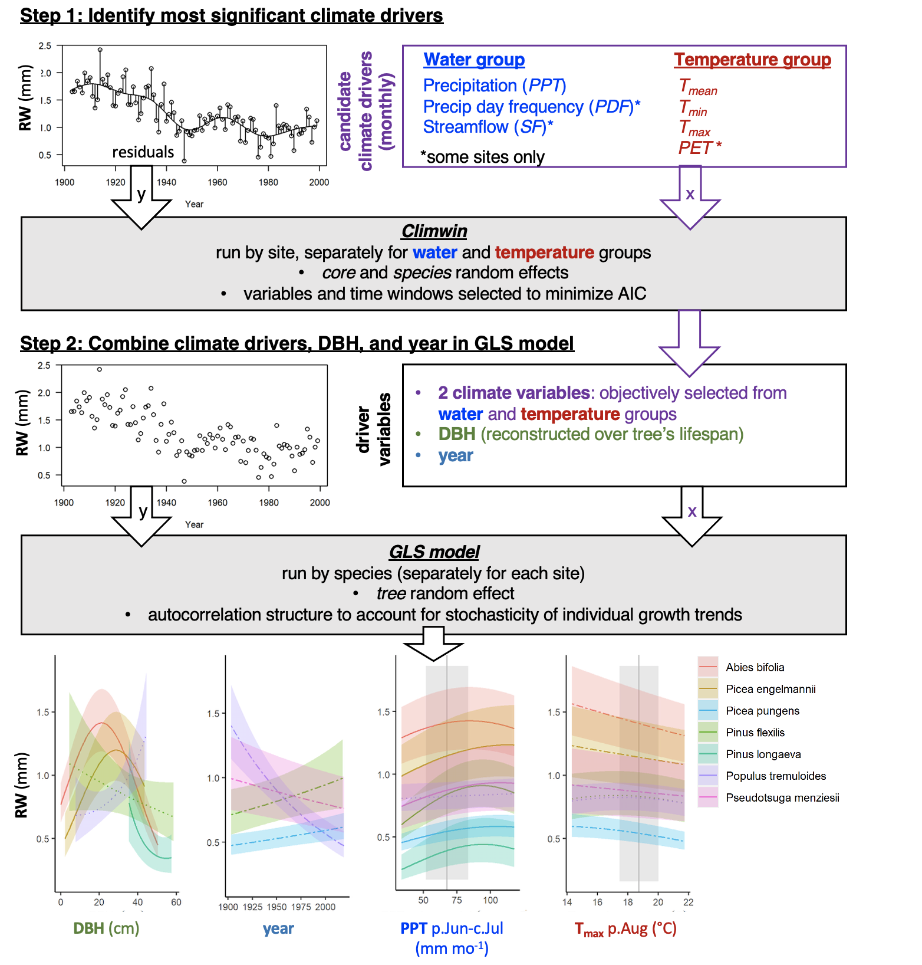

**Figure 1 | Schematic illustrating our analysis process.** In step 1, the R package climwin (van de Pol et al., 2016) is used to identify the most important climate drivers in water and temperature variable groups for each site, defined as the variable-time window combination that are most strongly correlated to the residual variation around splines fit to trends in growth (here, ring width, ) for all cores sampled at the site. In step 2, a GLS model is used to produce a combined model with the previously identified drivers, reconstructed DBH, and year.

### Climate variable selection

We used the *climwin* package in R (van de Pol et al., 2016) to identify the most important climate driver and the time window over which its effect was strongest for each of two categories of variables: a temperature group (, , , and ) and a precipitation group (, ). To remove low-frequency variation that most likely represents responses to non-climatic drivers (*e.g.*, growth and aging of the tree, change in competitive dynamics, atmospheric pollution), we detrended the response variables by fitting penalized thin plate regression splines in generalized additive models (GAM, function *gam* and *s* in R Package *mgcv*, Wood, 2011) to individual growth records (, , or ) from each core, thereby producing residuals. The smoothing parameters were automatically selected by the *gam* function with generalized cross-validation (GCV). We then used *climwin* to identify the climate variables that most strongly correlated to the residuals of , , or , specifying quadratic fits to allow for potential nonlinearities in the climate response. Within *climwin*, we specified a mixed effects model using species (when ) and core identity as random effects (noting that these effects should be minimal given that residuals are centered around zero): residual growth index ~ [climate] + (1 | sp) + (1 | treeID). Here, for each permutation, climate specifies one of the climate drivers in the climate variable group, analyzed over one of all possible combinations of consecutive months within a 15-month period ending near the time of cessation of formation of each annual ring (Table S1). *Climwin* runs all potential models to select the best fit (lowest AIC), and does k-fold cross-validation in its computation of AIC to guard against over-fitting (van de Pol et al., 2016). For each group of candidate climate variables, we selected the best variable over the time window identified by *climwin* as a candidate climate variable for the multivariate models.

We tested whether this process identified similar climate variable-month combinations as what would be identified using traditional methods for individual species (detailed in Appendix S4). Furthermore, we explored alternate methods of climate variable selection for the two sites that have undergone the most rapid changes in climate and tree growth: LT, where increasingly warm drought has dramatically reduced growth (Touchan et al., 2011; Williams et al., 2013), and SC, where rapidly rising temperatures are thawing permafrost, which limits access to soil moisture during summer months, and drives growth declines (Sniderhan & Baltzer, 2016). We ultimately determined that the method described above was adequate for the purposes of this analysis (Appendix S5).

### Combining drivers in GLS model

Having identified candidate climate drivers in temperature and precipitation variable groups, we next combined climate variables (all models) and (models with and its climate interactions) in a linear mixed-effects models (function *lme* in R package *nlme*), with core identity as random intercept and as continuous time covariate for the within-group correlation structure (function *corCAR1*). We will refer to this model as a generalized least squares (GLS) model (Fig. 1).

Before running the models, we checked for collinearity among the candidate variables using the *vifstep* function (Naimi et al., 2014) and removed any variable with a variance inflation factor > 3 (none required removal). Within the GLS models, our response variables were , , or .

For each species independently, we ran every combination of the candidate climate variables and , including both first- and second-order terms of polynomial for each. For climate responses, we allowed concave-down fits, but ignored any concave-up fits on the basis that these are not expected biologically and, when identified in initial analyses, often appeared to be cases of over-fitting.

As an example of a full model for would look like this in *R*:

*lme( ~ + I(^2) + + I(^2) + + I(^2)“, random = ~1|, correlation = corCAR1(form=~|), data = , na.action =”na.fail“, method =”ML")*

where is a complete data set (with no missing value) for one species at one site. The method is set to maximum likelihood (*ML*) during the model selection phase, but to restricted maximizing likelihood (*REML*) once the best model is identified.

For models including interactive effects of climate and , we tested for interactions between first-order linear terms for climate variables and .

To test for effects, we limited the analysis to species with reasonable coverage of an x year matrix. Specifically, we required that the species be represented by cores from 3 trees spanning 40% the total range for of the total time range analyzed. To avoid severe big-tree selection biases (Brienen et al., 2012), we also required that the minimum sampled be 25 cm, if present. Species that failed to meet these criteria (n= 8) were excluded from the analysis of temporal trends. We then ran models as described above, including a first-order linear effect of . We note that the random effect of tree should, in theory, avoid analytical biases arising from persistent growth differences among individuals (Brienen et al., 2017, 2012). To verify that GLS model trends for were real, as opposed to an artifact of inherent covariation between and within each core, we compared GLS results to an analysis of -growth relationships by decade (Figs. S58-S67). For simplicity and consistency with previous literature, we present only the models with as the growth metric, noting that responses were similar across growth metrics.

Within each of three categories of models run (climate only, climate + , climate , climate + + ), we selected as the top model that with the lowest AIC.

# Results

## Climate sensitivity

Using as the growth metric, our process identified similar climate drivers to those identified via traditional dendrochronological analysis methods (Figs. 2, S11-S14; Table S5; Appendix S4). While one-to-one correspondence of estimated climate coefficients was neither expected nor observed, estimates were correlated and rarely differed significantly (Appendix S4; S11-S14).

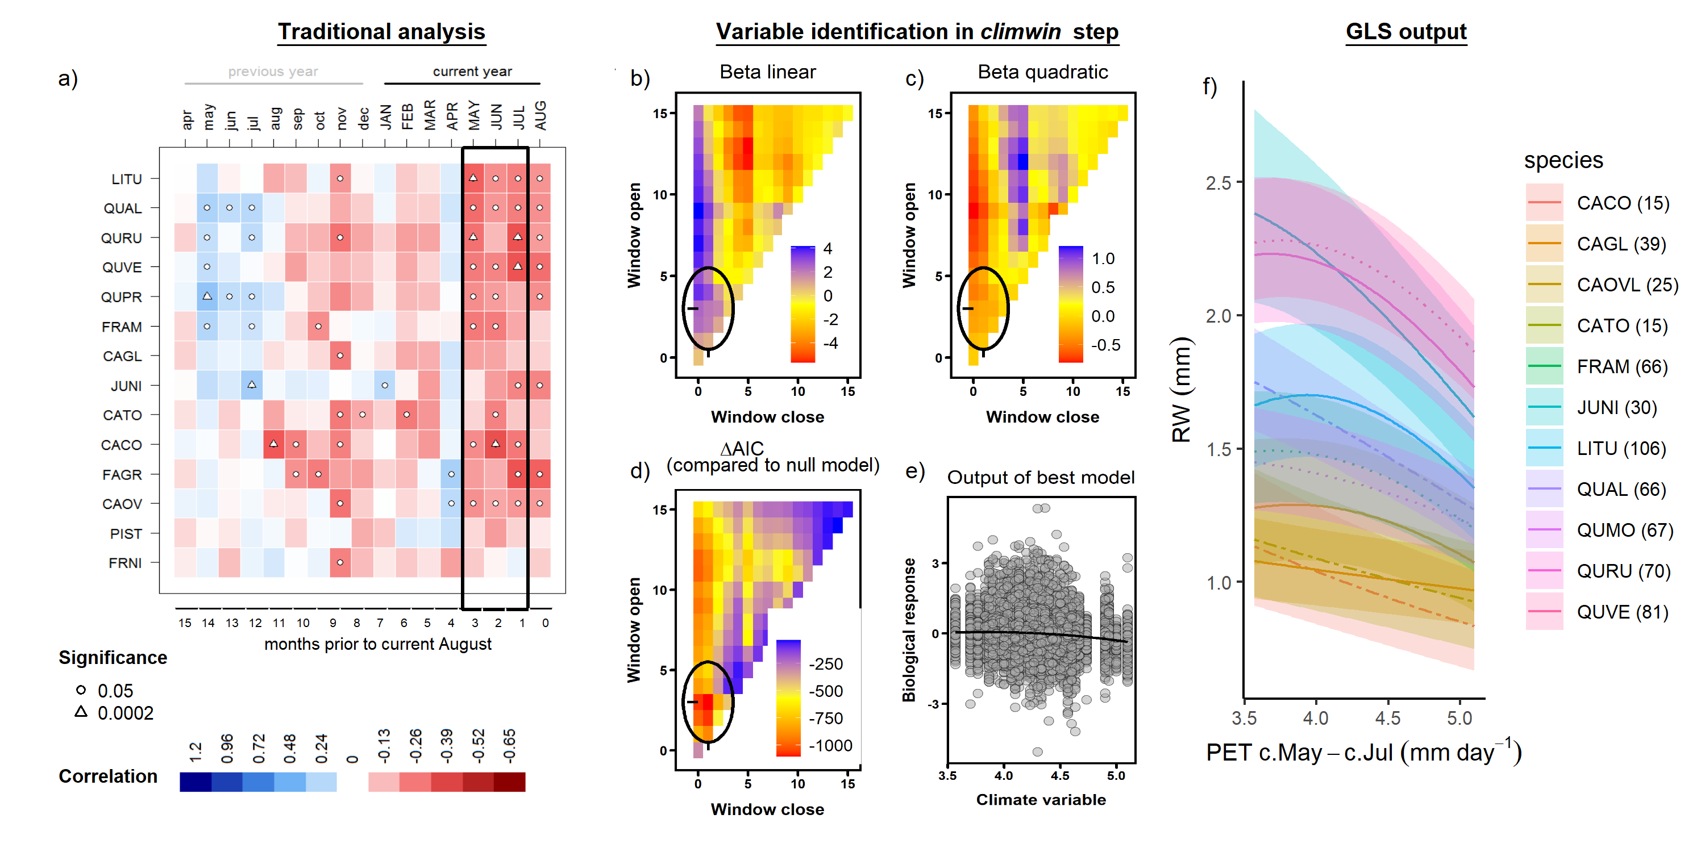

**Figure 2 | Example comparison of climate sensitivity derived via traditional methods (**a**) and our approach (**b-f**).** Example is for the sensitivity of 14 species at SCBI (codes given in Table S2) to potential evapotranspiration (). Panel (**a**) shows a matrix of Pearson correlations between ring-width index and monthly climate variables (produced using the bootRes package in R, Zang & Biondi, 2013). Black rectangle represents the period selected by climwin as the most influential window. Panels (**b-d**) give statistics for time windows tested in climwin, where window open and close indicate months prior to current August, and cells across the lower diagonal indicate single-month tests (akin to panel **a**). Panels (**b**) and (**c**) give values of linear and quadratic terms for each time window, and (**d**) gives the for each. The time window with the minimum (1-3 months prior to August, or May-July; black circles), was identified as the optimal window. Panel (**e**) shows the correlation of individual-level residuals to PET, with the function fit in climwin. Finally, panel (**f**) shows GLS model output, where was a candidate driver variable (along with ; not included in this model). Plotted are responses of species for which was included in the top model, with best-fit polynomials plotted with solid lines when both first- and second-order terms are significant, dashed lines when only one term is significant, and dotted lines when neither is significant. Transparent ribbons indicate 95% confidence intervals.

The three metrics of growth (, , and ) exhibited similar strength of correlation and direction of response to climate variables across the range of potential time windows, but the optimal time window or even the top climate variable sometimes differed (Figs. S15-S34). In 8 of 20 cases, both the optimal climate variable and time window were identical across growth metrics (e.g., Fig. S19). In 10 cases, *climwin* identified the same climate variable but different (often overlapping) time windows (e.g., Fig. S20). Finally, in two cases of variables that had only weak effects and mixed responses among species in the final models (temperature variable group at HKK, precipitation variable group at HF), *climwin* identified different climate variables and different time windows (Figs. S18, S24). Henceforth, unless otherwise noted, we focus on the climate sensitivities identified with as the growth metric and for the full set of cores (*i.e.*, including those for which could not be reconstructed).

Within the context of the GLS model, which tested for first- and negative second- order linear effects of both a precipitation and a temperature variable, both a precipitation and a temperature variable were included in the top model for 78% of site-species combinations (n=36 of 46; Fig. 3). There were seven site-species combinations for which only a precipitation term was significant (2 at BCNM, 3 at SCBI, and 2 at LDW), two for which only a temperature term was significant (*Chukrasia tabularis* at HKK and *Betula papyrifera* at NIO), and none with no significant climate responses. Precipitation and temperature variables were rarely influential over the same time window (exception: LDW). Below, we summarize the precipitation and temperature variables included in these models and their direction of response.

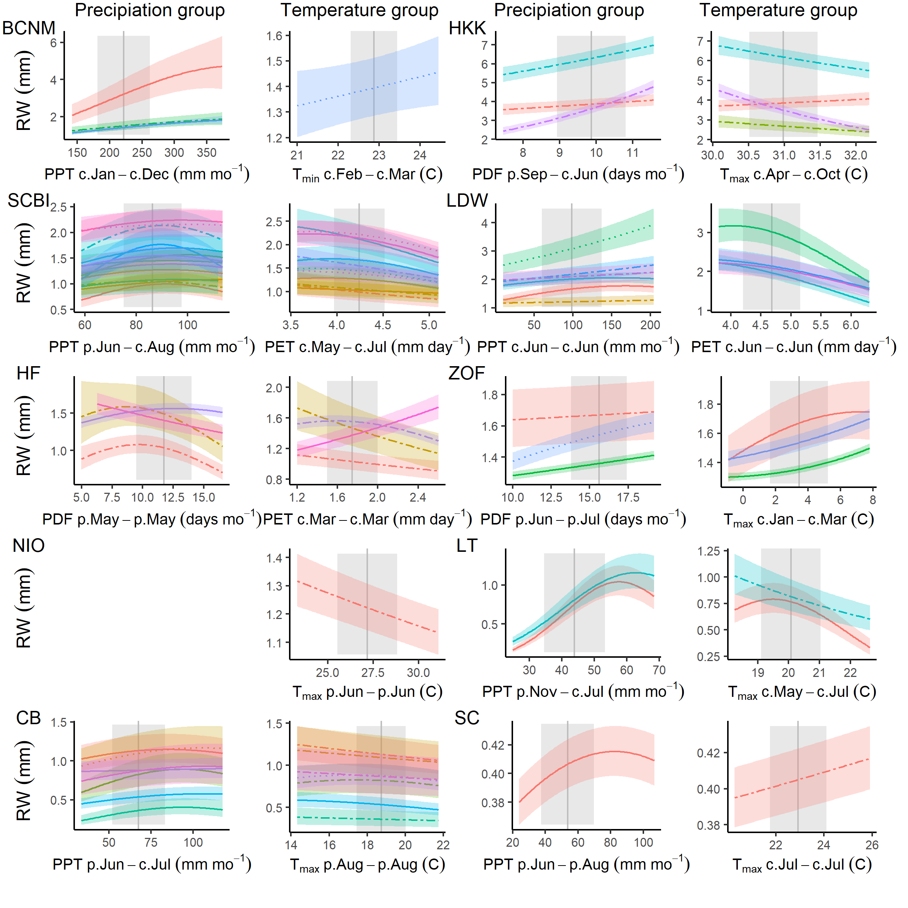

**Figure 3 | Species-level responses of to climwin-selected variables in precipitation and temperature variable groups.** Climwin-selected climate variables are coded on the x-axes as the climate variable name followed by the range of months (p=previous year, c=current year) over which it is most influential. For each species (color-coded as in Fig. 4), relationships are plotted if included in top model. For each relationship shown, other terms in the model are held constant at their median. Best-fit polynomials are plotted with solid lines when both first- and second-order terms are significant (t-test’s p-value <0.05), dashed lines when only one term is significant, and dotted lines when neither is significant. Transparent ribbons indicate 95% confidence intervals. Vertical grey lines indicate the long-term mean for the climate variable, shading indicates 1 SD.

Responses to precipitation amount () and frequency () were included in the best model for all but two species, and were predominantly positive (Fig. 3). was selected over as the top variable in five of the eight sites with both variables available (but had no significant main effect at one of these, NIO), and was the only option at two sites (LT and CB). Optimal time windows most commonly coincided at least partially with the months of most active growth in the current year (Fig. 3; Table S1): wet seasons in the tropics (BCNM and HKK) or late spring/ early summer in the extratropics (n= 5 of 8). In the tropics, the long time windows over which precipitation was influential (12 mo at BCNM, 9 mo at HKK) also included the majority (BCNM) or all (HKK) of the dry season. In the extratropics, the most influential windows were limited to the current spring and early summer at LDW, whereas optimal windows at three sites extended back to the previous fall (LT, CB) or summer (SCBI). At three sites (HF, ZOF, and SC), precipitation of the previous growing season was the most influential variable. Responses to or were predominantly positive, with positive first-order linear terms for all but one species (*Tsuga canadensis* at HF; Fig. 3). Negative second-order terms were commonly included in the best model (32 of 42 with positive first-order terms), generally resulting in a deceleration or decline at the highest levels of precipitation, but occasionally producing a unimodal (e.g., several species at SCBI) or predominantly negative response (e.g., BEAL at HF; Fig. 3).

A temperature variable was included in the best model for all but eight site-species combinations, with predominantly negative responses, particularly at the higher end of the temperature range (81%; 34% with negative first-order term, 47% with positive first-order term but negative second-order term; Fig. 3). The most commonly selected variables within the temperature group were and , which were identified by *climwin* as the top temperature-related driver at five and three of the ten sites, respectively, noting that was not available for two sites. and were each identified as the top driver at only one site (NIO and BCNM, respectively), noting that the effects of at BCNM were only marginally significant (Fig. 3). Optimal time windows most commonly occurred during the peak growing season of the current year (n= 5 of 10 sites), but there were cases where optimal windows occurred during the preceding dry season (BCNM), late winter/early spring (HF, ZOF), or the previous growing season (NIO, CB). Within the tropics, there was minimal effect of temperature at BCNM and a negative effect of wet season for three of four species at HKK. For temperate sites with optimal time windows covering the current and/or past growing season, responses were universally negative (*i.e.*, negative first-order linear or unimodal, peaking at temperatures lower than the long-term mean). In contrast, there were positive effects of Jan-March for all three species at ZOF and of March for *Tsuga Canadensis* at HF, the latter contrasting with a negative response of the other three species at HF (Fig. 3). At the highest-latitude site (SC), which has undergone rapid warming and permafrost melt, *Picea mariana* responded positively (but with wide 95% CI on the slope) to temperature over the full analysis period (1903-2013); however, responses were predominately positive prior to 1970 and predominantly negative afterwards (Fig. S55).

## Influence of DBH

All three growth metrics, , , and , varied with for most species at all sites (Fig. 4). For , was included in the best model for 81% of species-site combinations (n= 35 of 43), and the majority of best models also included a significant second-order linear term (n= 26, 21 of which were negative). There was substantial variation in these trends, with patterns mixed across both forests and species within a single stand (Fig. 4). On one end of the spectrum, some species exhibited maximum at low , followed by fairly rapid declines in with increasing . Species following this pattern either had low to at most intermediate shade tolerance (e.g., *Melia azedarach* at HKK, *Juglans nigra* at SCBI, *Acer rubrum* at HF, *Betula papyrifera* at NIO; *Populous tremuloides* at CB; Table S2) and/or grew in relatively open stands (e.g., both species at LT, *Picea mariana* at SC; Fig. 4). At the other end of the spectrum, some species had low at small , increased to peak at intermediate , and subsequently declined. These included, but were not limited to, shade-tolerant species at sites where they presumably established under closed-canopy conditions (e.g., *Trichilia tuberculata* and *Tetragastris panamensis* at BCNM; *Fagus* spp. at SCBI and Žofín, *Acer saccharum* at LDW, *Picea* spp. at Žofín and CB; Table S2).

Trends in both and were far more consistent across sites and species, most commonly increasing to a peak at intermediate and then declining (Fig. 4). Best models for included and for 42 of 43 species (exception: *Acer rubrum* at HF), with a positive coefficient for in 40 (exceptions: non-significant negative coefficients for *Pinus ponderosa* at LT and *Pinus longaeva* at CB, whose reconstructed s did not extend down to 0 cm within the time frame analyzed) and near-universally negative coefficients for (exception: *Pinus longaeva* at CB). For , models were even more consistent, with the best models for 98% of species containing a positive coefficient for and a negative coefficient for (exception: *Pinus longaeva* at CB).

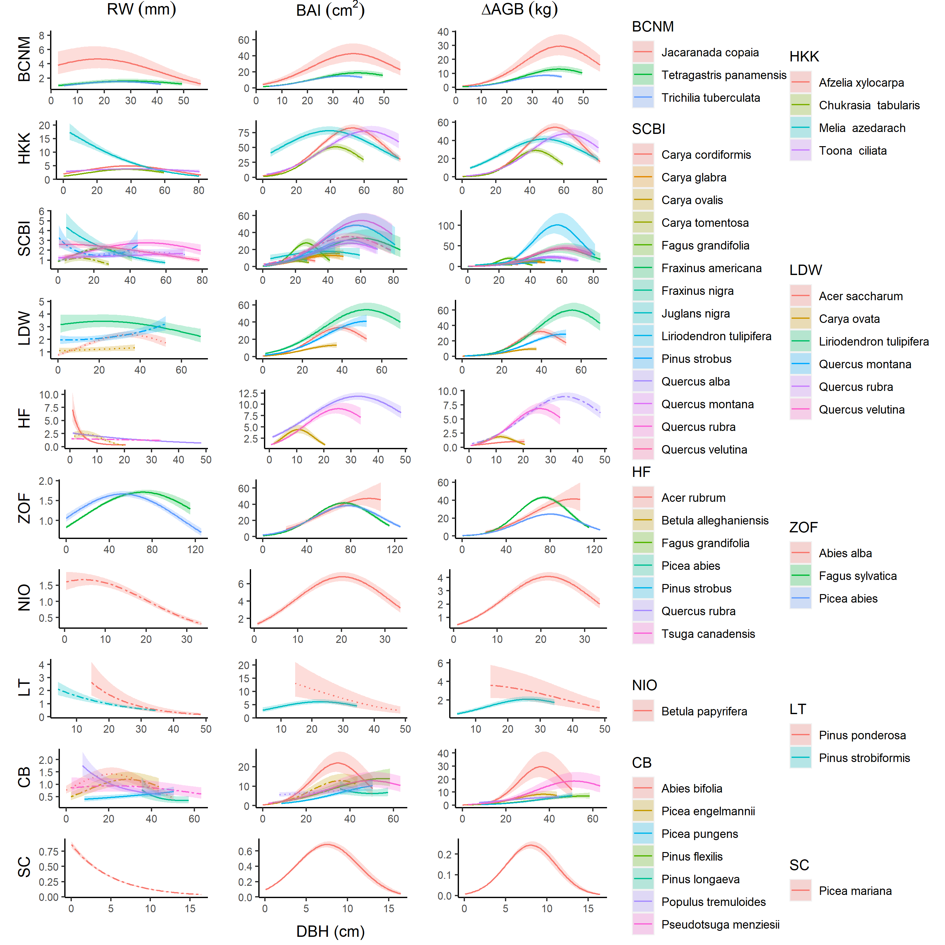

**Figure 4 | Growth sensitivity to DBH: (a) , (b) , (c) .** Relationships for species are plotted when included in the top model. Other terms in the model are held constant at their median. Best-fit polynomials are plotted with solid lines when both first- and second-order terms are significant (t-test’s p-value <0.05), dashed lines when only one term is significant, and dotted lines when neither is significant. Transparent ribbons indicate 95% confidence intervals.

## Additive and interactive effects of climate and DBH

When a precipitation variable, a temperature variable, and were all included as candidate variables in the GLS models, typically all three were included in the top model, regardless of the growth metric used. Climate responses were generally similar to those described above for models without a term, although some of the weaker climate responses were not consistently included in top models (e.g., responses at BCNM; Figs. 3, S35-S54). Responses to were as described above (Fig. 4).

In general, explained more variation in growth rates than did climate, but its relative importance varied across growth metrics and sites (Figs. S35-S54). The relative importance of tended to be least for , intermediate for , and highest for (e.g., at SCBI; Fig. S39). However, there were exceptions, particularly when decreased steeply with (e.g., LT; Fig. S49).

Interactive effects of climate and were found for 90 of the 203 (44%) species-variable combinations for which they were tested. For precipitation variables, interactions were significant for 16 of the 36 (44%) interactions with as the growth metric (Fig. S56) and for 17 of the 36 (47%) with as the growth metric (Fig. S57). The majority of these interactions were positive (75% for ; 65% for ), indicating that larger trees generally respond more positively to precipitation or its frequency (Fig. 5). Among the exceptions to this pattern (n=4 for , 6 for ), only a minority (n=1 for , 4 for ) occurred in species responding positively to precipitation in the current growing season.

Temperature variable interactions were significant for 38% of cases with as the growth metric (Fig. S56) and for 50% with as the growth metric (Fig. S57). Directions of these interactions were mixed, with 5 of 12 significant interactions negative with as the growth metric and 10 of 16 significant interactions negative when was the growth metric. For both and , the majority of significant negative interactions (*i.e.*, more negative/ less positive response of larger trees to higher temperatures) occurred in the more water-limited forests (HKK, LT, CB; Fig. 5), whereas positive interactions were more common in mesic forests (SCBI, HF, ZOF).

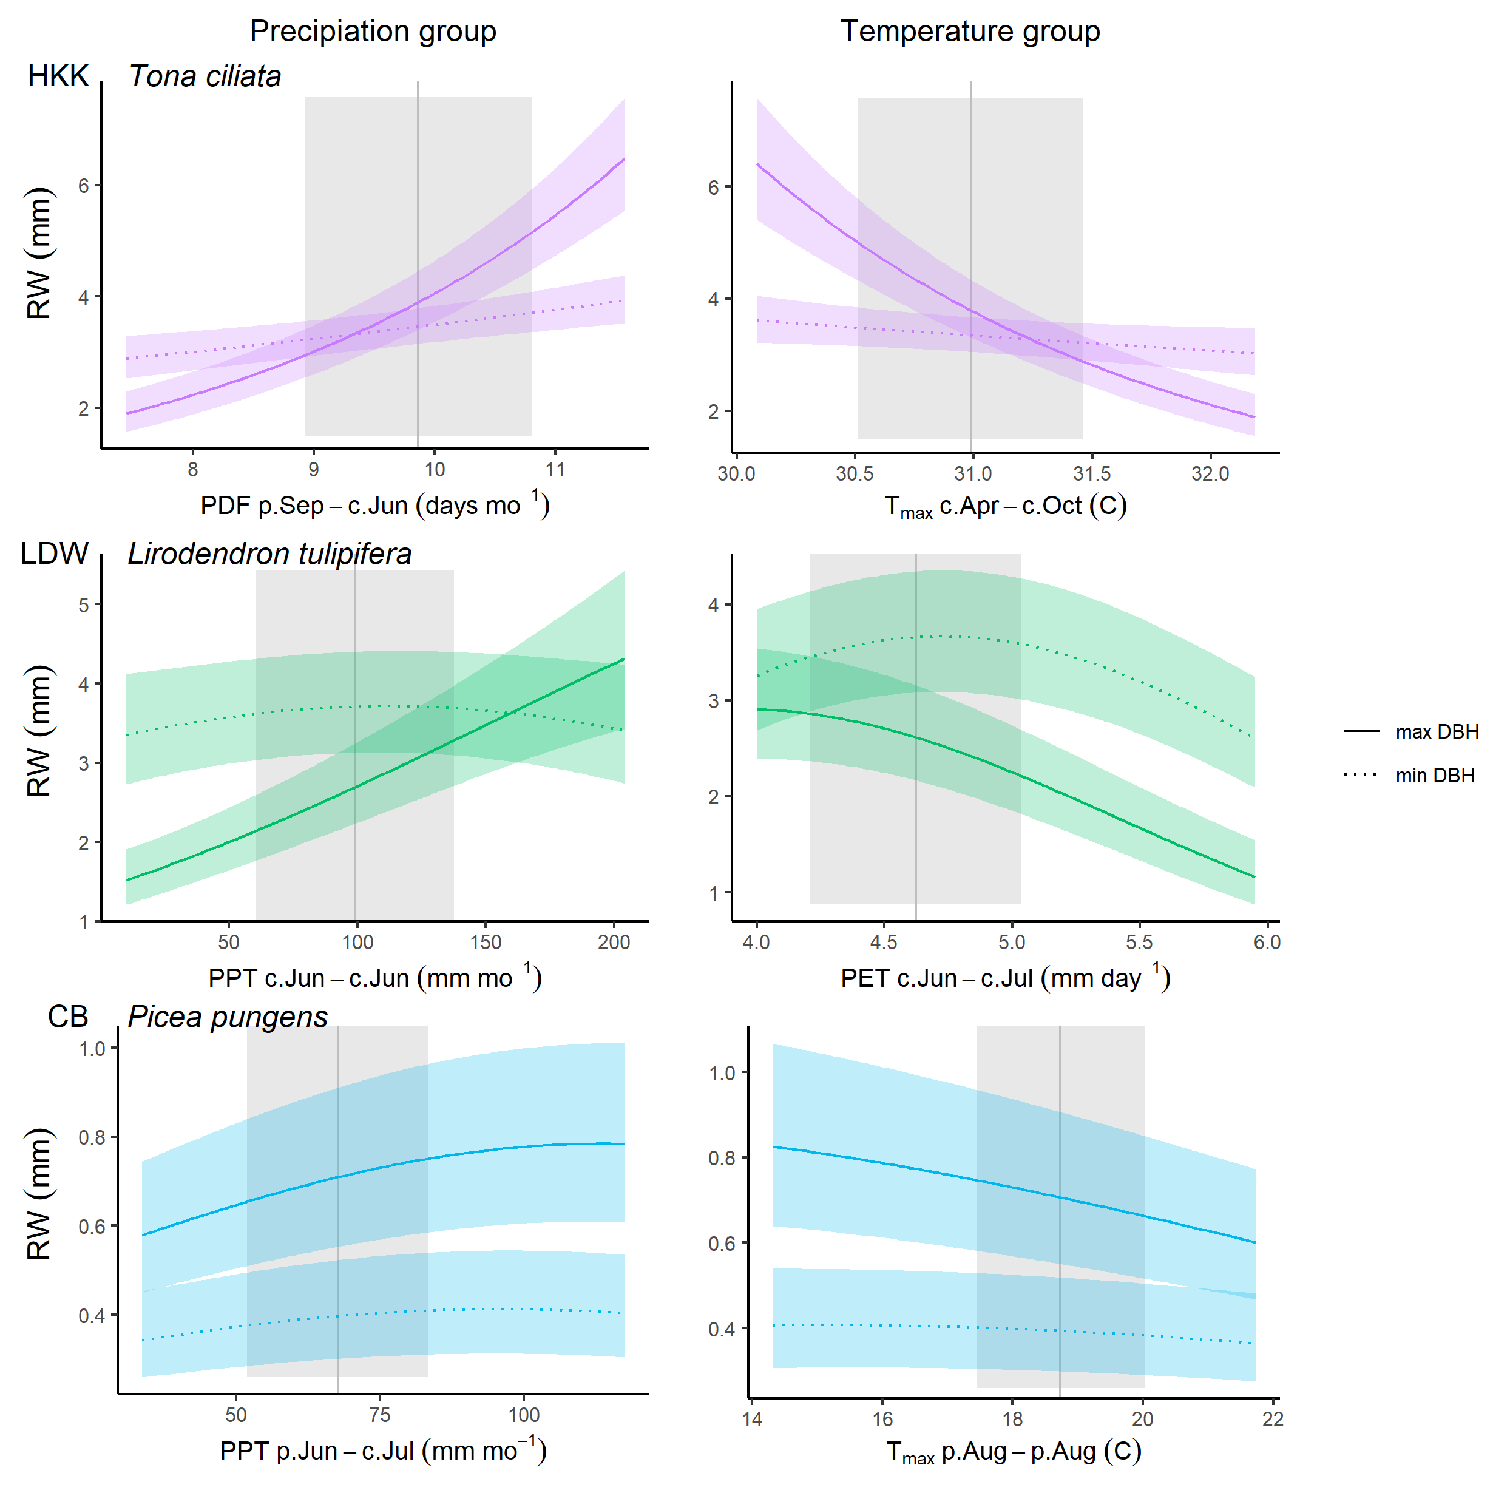

**Figure 5 | Examples of climate - DBH interactions for three species at three sites.** Shown are modeled response functions at the minimum and maximum and maximum ends of the range. Other terms in the model are held constant at their median. Transparent ribbons indicate 95% confidence intervals. Vertical grey lines indicate the long-term mean for the climate variable, shading indicates 1 SD.

## Effects of year

There was a significant effect of year in the GLS models for 31 - 32 (depending on growth metric) of the 37 species- site combinations tested (Figs. 6, S35-S54), and these trends were consistent with those observed in a separate analysis of -growth relationships by year (Figs. S58-S67). In 90-91% of cases (depending on growth metric), the growth trend over time was negative. Declines were particularly dramatic for *Picea mariana* at SC, *Pinus ponderosa* at LT, all four species at HF, and several species at SCBI (Fig. 6). In such cases, models without year predicted declines in growth at large DBH that should more properly be attributed to the effect of year (Figs. S35-S54). Significant positive growth trends were observed for only three species, *Fagus sylvatica* at ZOF, *Picea pungens* and *Pinus flexilis* at CB, and all were modest compared to the steep negative trends observed for some species. Growth rate was consistently independent of year for only four species: *Chukrasia tabularis* at HKK, *Pinus strobiformis* at LT, and *Picea engelmannii* and *Pinus longaeva* at CB.

Effects of year and interacted such that inclusion of year in in models altered the shape of responses, typically resulting in less pronounced growth declines with increasing (Figs. S35-S54).

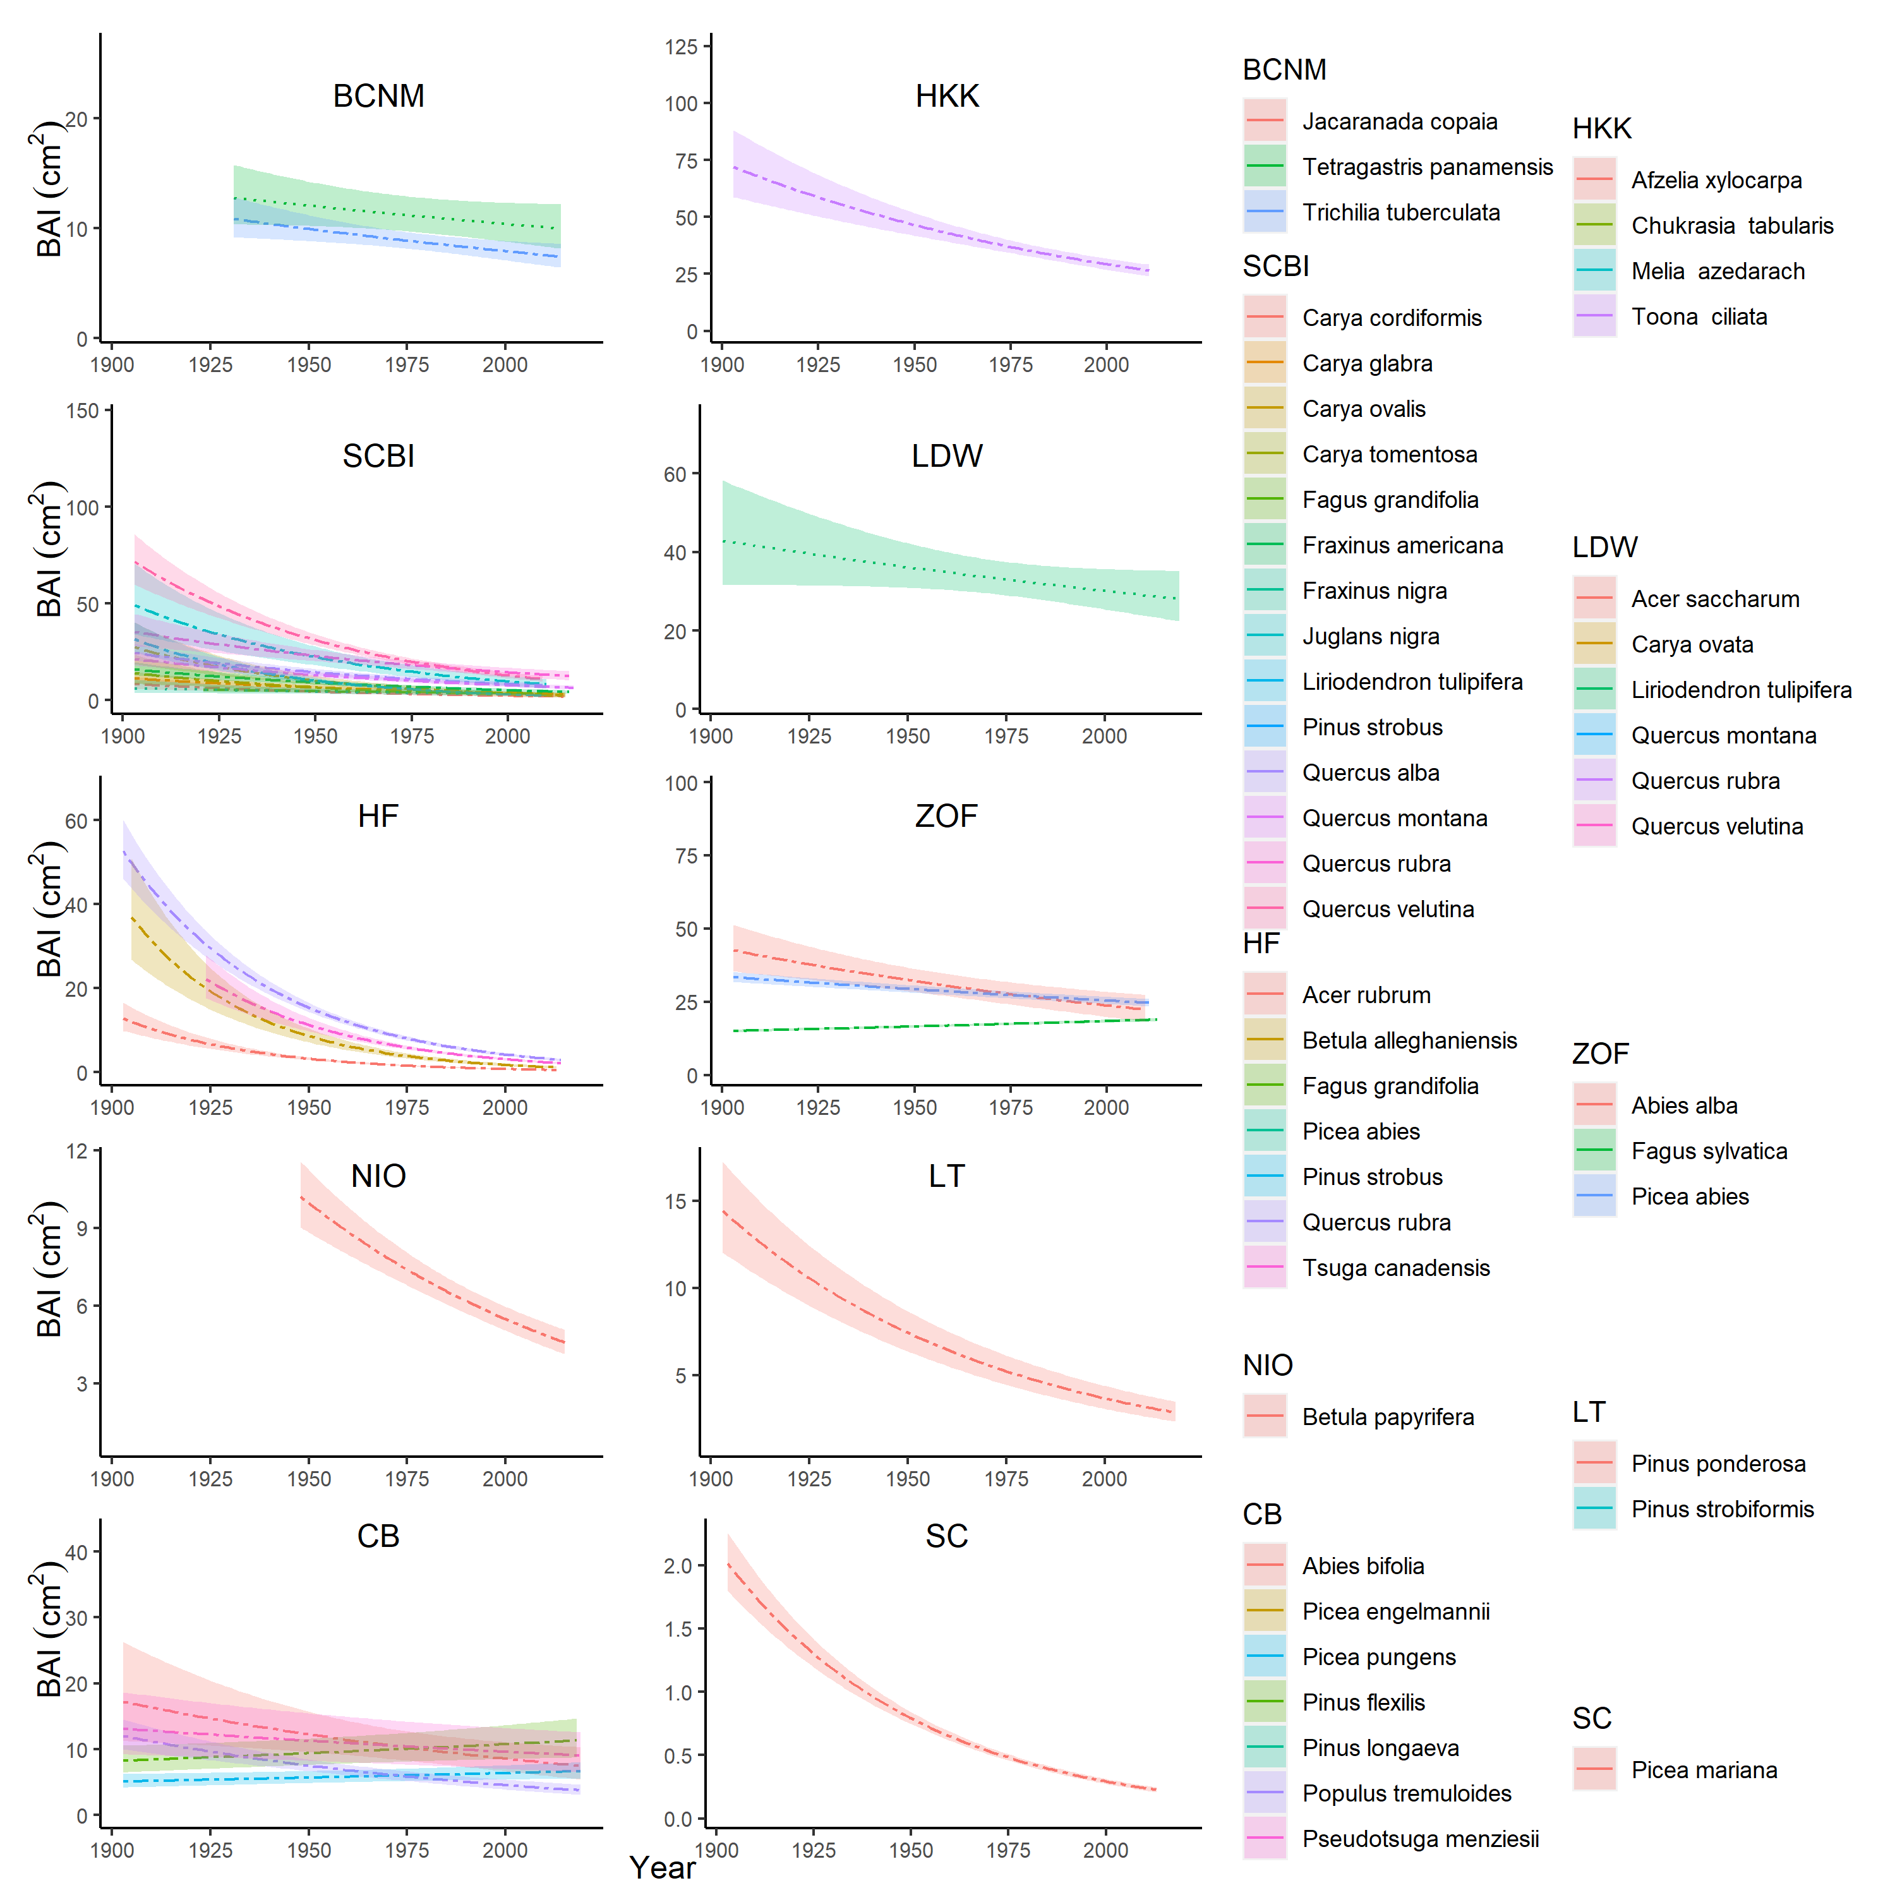

**Figure 6 | Effect of year, when included in the best model, on BAI.** For each species (all listed), relationships are plotted if the year effect could be analyzed and was included in top model. Other terms in the model are held constant at their median. Best-fit polynomials are plotted with solid lines when both first- and second-order terms are significant (t-test’s p-value <0.05), dashed lines when only one term is significant, and dotted lines when neither is significant. Transparent ribbons indicate 95% confidence intervals.

# Discussion

Our new tree-ring analysis method allows simultaneous consideration of the effects of dominant climate drivers, tree size, and slowly changing environmental conditions on annual growth (Fig. 1), yielding results that are consistent with those that would be obtained using conventional methods (Figs. 2, S11-S14; Table S5) while offering a fuller picture of the drivers of tree growth in an era of global change. Below, we summarize how our results on the effects of climate, tree size, and year corroborate current understanding of the drivers of tree growth while yielding new insights made possible by the approach.

## Climate sensitivity

Across diverse climates and forest types (Tables 1, S2), growth rates of 40 tree species generally responded positively to water availability ( or )–at least up until the long-term mean– and negatively to temperature (usually or ), with the exception of several positive responses at times and in places where temperature was limiting (Fig. 3). These findings are generally consistent with the global-scale analysis of Babst et al. (2019), which shows that the majority of forests globally are moisture limited and respond negatively to temperature, with a shrinking area of temperature-limited forests in cold, humid regions (with SC falling near the transition zone). Within warmer regions, forests in humid climates can sometimes benefit from warm winter or spring temperatures (Babst et al., 2019; Tumajer et al., 2017), as we show for all three species at ZOF and one species at HF (Fig. 3). However, the predominantly negative temperature responses (Fig. 3) imply that in most forests, tree growth is likely to be reduced by warming temperatures.

**(should I remove this paragraph?)** While our approach identifies similar climate sensitivities to those that would be identified using conventional methods (Figs. 2, S11-S14; Table S5), it differs in some substantive ways. First, in determining the most important climate drivers (step 1; Fig. 1), we consider the full sample of individual cores, as opposed to a residual chronology in which variance has been standardized and the individual cores have been averaged. Some differences in variables identified and the slope between growth and climate are to be expected giving the methodological differences (Appendix S4); however, as a whole the identified drivers and directions of response are consistent with conventional methods (2, S11-S14; Table S5). Another way in which the current analysis differed from conventional methods is that we pooled species by site when determining the top climate drivers (step 1; Fig. 1). This decision was motivated by the expectation that differences in optimal climate windows across species in one site would be minimal compared to cross-site differences (cf. Figs. 2, 3); however, analyses focused on interspecific differences could optimize species-specific climate sensitivity estimates by fitting *climwin* individually be species.

Another way in which our analysis differed fundamentally from most conventional approaches was in testing for non-linear responses of growth to climate, finding that nonlinear responses were prevalent Fig. 3). This result, which is consistent with physiological expectations (REFS, Wilmking et al., 2020), indicates that the majority of tree-ring records examined here cover climate variation beyond the range over which the response is linear. The nonlinear form of most climate growth responses implies that as the climate changes, non-stationary climate responses, already common (Wilmking et al., 2020), are likely to become more prevalent.

Finally, our analysis differed from conventional approaches in the use of GLS models to simultaneously quantify the effects of climate, , and year, while accounting for idiosyncratic growth trends of individual trees through an autocorrelation structure (step 2, Fig. 1; see also Evans et al., 2017; Rollinson et al., 2021). This approach allowed the consideration of additive and interactive effects of climate with variables that change over longer time frames–here, and year, although other slowly-changing drivers could also be used. We found that interactions between climate variables and were common (44% of cases analyzed; Figs. 5, S56, S57). The most coherent pattern observed in this analysis was a tendency for larger trees to be more sensitive to precipitation and high temperatures (Fig. 5), consistent with widespread observations that larger trees are more sensitive to drought (e.g., Bennett et al., 2015; Gillerot et al., 2020; Hacket-Pain et al., 2016; McGregor et al., 2020; Pretzsch et al., 2018). An analytical structure that can account for this and other such DBH-climate interactions (e.g., Rollinson et al., 2021; Rossi et al., 2007) will be critical to using tree-ring records to understand and forecast the effects of climate on tree growth and forest productivity. We note that a modification of our analysis method (modeling climate interactions instead of climate interactions) could potentially be used to account for directional changes in climate sensitivity, which have commonly been documented (e.g., Helcoski et al., 2019; Maxwell et al., 2016; Peltier & Ogle, 2020; Zuidema et al., 2020). In fact, a recent literature survey revealed that such non-stationarity in the climate sensitivity of tree growth occurs globally and in the majority of tested cases (Wilmking et al., 2020).

## Variation with

Growth rate–whether measured as , , or – varied nonlinearly with for the vast majority of site-species combinations (81 - 98% depending on growth metric; Fig. 4). Variation in these patterns–particularly for , for which variation was most pronounced–was driven by two primary, interrelated factors: species ecology and stand history. Species that would have established in fairly open conditions–*i.e.*, shade-intolerant species (Table S2) and those at sites with more open canopies (e.g., LT, SC)– exhibited rapid initial growth, measured as , followed by a roughly exponential decline. Such patterns are consistent with dendrochronology’s “textbook” patterns of studies primarily based on trees that established in high-light environments (Biondi & Qeadan, 2008; Fritts, 1976). However, within the forest settings studied here, the majority of species exhibited initially low, but increasing, . This latter pattern is consistent with the observation that when contemporary growth rates are compared across individuals within a stand (*i.e.*, a “cross-sectional” analysis), increases continuously with (e.g., K. J. Anderson-Teixeira, McGarvey, et al., 2015; Helcoski et al., 2019; Muller-Landau et al., 2006), or increases and subsequently decreases (Schelhaas et al., 2018).

We found evidence of saturation or decline in the majority (77%) of species-site combinations analyzed (Fig. 4), contrasting with findings of cross-sectional analyses showing that increases continuously with (Meakem et al., 2018; Stephenson et al., 2014), which has also been observed in tree-rings (Foster et al., 2016). In large part, this discrepancy can be explained by differences between cross-sectional analyses and “longitudinal” patterns of individual trees through time (Forrester, 2021; Sheil et al., 2017). Declines in and at larger are probably in part attributable to increasing allocation to reproduction (Thomas, 2011), and are also linked to slowly changing environmental conditions (e.g., successional changes in stand structure, climate change). Notably, inclusion of year in the GLS models tended to reduce the magnitude of and declines at larger (Figs. S35-S54), suggesting that some of such declines in Figure 4 are more properly attributed to the effect of year than that of .

## Changing growth rates

Growth rates changed directionally for the majority (73-78%, depending on growth metric) of site-species combinations selected for analysis based on the sampling representation of by (Fig. 6). These results were similar across growth metrics (Figs. S35-S54), and consistent with an independent analysis of growth- trends by decade (Figs. 6, S58-S67), indicating that our approach is robust in its analytical structure. Indeed, in a comparative analysis of several methods commonly used to detect growth trends, an approach parallel to that employed here (regional curve standardization) performed better at growth trend detection (Peters et al., 2015) than two of the most commonly used methods for analyzing growth trends, conservative detrending and basal area correction (see Peters et al., 2015), both of which would fail to capture the observed trends in and with (Fig. 4). For instance, based on our finding that tends to rise and fall with , basal area correction would generally be biased towards finding positive trends for smaller trees and negative trends for larger trees. However, our results remain subject to some potential sampling and survivorship biases that can influence overall trends in positive or negative directions (Brienen et al., 2017, Fig. 6, 2012; Groenendijk et al., 2015; Nehrbass-Ahles et al., 2014). While our analysis was designed to avoid some of the most severe potential biases (Brienen et al., 2012), it is difficult, if not impossible, to control for all potential demography and survivorship biases, or to design sampling in a way that ensures unbiased representation of a species’ growth rate at all points in the history of a stand (Bowman et al., 2013; Brienen et al., 2017, 2012). The observed trends should therefore be interpreted with caution, and as representative of only the sampled trees, as opposed to all individuals of the species that existed throughout the time frame analyzed. Within this context, signals of changing growth rate over time are attributable to some combination of stand dynamics (e.g., recruitment and succession, changing stand structure) and environmental drivers (e.g., climate drivers other than those selected by *climwin*, rising atmospheric CO2, deposition of SO2 and NOx).

The majority of negative growth trends observed here (Fig. 6) are probably attributable to successional stand dynamics as cohorts and stands age. For species exhibiting a pulse of recruitment in the past followed by little subsequent recruitment (e.g., *Acer rubrum* and *Betula alleghaniensis* at HF; Figs. S1-S10), persistent differences in growth rates among individuals could produce a trend of declining growth, as faster-growing individuals reach various size thresholds earlier (Brienen et al., 2017). Such a trend is not indicative of a directional response to changing environmental conditions that would be generalizable across stands (e.g., rising atmospheric CO2), but it does indicate declining growth of the species within the stand. This can occur, for example, when a species undergoes a dramatic decline in recruitment within a stand (e.g., *Quercus* spp. at SCBI; *Abies alba* at ZOF), such that fast-growing individuals disappear from progressively larger classes as time proceeds. In secondary stands, particularly those where many of the sampled species recruited in pulses that were followed by low recruitment (e.g., SCBI, HF; Appendix S1, Figs. S1-S10), growth declines are consistent with the tendency for faster tree growth during early succession (**REFS**), and with increasing competition and declining woody productivity as young stands mature (e.g., Goulden et al., 2011; Pregitzer & Euskirchen, 2004). Even within older forests, light-demanding species that establish in gaps (e.g., *Jacaranda copaia* at BCNM, *Populus tremuloides* at CB; Table S2) would tend to experience an increasingly competitive environment through time. For more shade-tolerant species in stands with no known major disturbance within the past 1.5 centuries (ZOF, CB), mixed growth trends probably reflect some combination of successional changes and shifting competitive advantages, perhaps in part driven by changing environmental conditions (Vrška et al., 2009).

In a few instances, directional changes in growth are likely attributable to abiotic drivers. In the Czech Republic (ZOF), acid deposition dramatically reduced growth in the late 20th century, with peak influence between the 1970s and the early 1990s (Elling et al., 2009; Šamonil & Vrška, 2008), as captured in our records (Fig. S63), and this influenced linear growth trends of different species in differently within the GLS model. In cases such as this, a non-linear response function to , or incorporation of data on pollution, would be needed to accurately capture changing growth trends, but that is beyond the scope of the current analysis. In New Mexico (LT), where growth rates of *Pinus Ponderosa* declined, we suspect that the dominant climate drivers identified here might not fully capture a strong regional drying trend (Touchan et al., 2011; Williams et al., 2013), although sampling biases remain possible. At Scotty Creek, rapid warming is thawing permafrost and altering hydrologic conditions (Baltzer et al. 2014), resulting in high mortality, growth declines, and low recruitment of *Picea mariana* (Dearborn et al., 2020; Sniderhan & Baltzer, 2016); we attribute pronounced negative growth trends to a combination of successional declines and indirect climatic stress.

There is a notable lack of evidence that growth rates of any species benefited substantially from increasing CO2, corroborating previous analyses from HKK Brienen et al. (2017) With a few potential exceptions (*Fagus sylvatica* at ZOF, *Picea pungens* and *Pinus flexilis* at CB; Fig. 6), any growth benefit from elevated CO2 was outweighed by some combination of demographic or successional changes and chronic environmental shifts. This aligns with the preponderance of studies using tree-rings to infer growth responses to rising CO2 (e.g., Girardin et al., 2016; Groenendijk et al., 2015; Hararuk et al., 2019; Walker et al., 2020), albeit contrasting with some (e.g., Hember et al., 2019; Voelker et al., 2006). A growth benefit of CO2 is potentially expected based on physiological mechanisms and has been observed in young forests in experimental settings (Walker et al., 2020). However, significant woody growth stimulation by elevated CO2 has not been observed in experimentally manipulated mature forests (Walker et al., 2020), and increasing CO2 does not appear to be a dominant growth driver for the trees in natural forest settings analyzed here.

## Conclusions

Altogether, our analysis method reveals a much richer picture of the factors influencing tree growth than has previously been possible. Specifically, it allows us to show that growth is generally simultaneously influenced by temperature and precipitation over different time windows, that nonlinear climate responses and interactive effects of climate with are common (Figs. 3 and 5, respectively), that growth–measured by any metric–almost universally varies with (Fig. 4), and that current or recently living trees commonly show growth declines in response to some combination of stand dynamics and environmental change (Fig. 6). While traditional dendrochronology methods, particularly those focused on climate reconstruction, generally sample and analyze data in order to minimize many of these effects, they are critical for understanding forest productivity in an era of global change. As global change pressures intensify and the need to understand changing forest dynamics becomes increasingly urgent (REFS, McDowell et al., 2020), we expect that this approach will prove valuable to understanding drivers of tree growth and forest change.

# Acknowledgements

Thanks to Helene Muller-Landau and Pete Kerby-Miller for bark thickness data. Helpful feedback was provided by Helene Muller-Landau, Albert Kim… This analysis was funded by a Smithsonian Scholarly Studies grant to KAT, SM, HCM, and CP. The participation of PS, JK, and IV from the Czech Republic was supported by the Czech Science Foundation, project No. 19-09427S. PRISM climate data were purchased under an NSF grant to KAT (#DEB-1353301).

# Authors’ contributions

KAT, VH, CR, RA, CP conceived the ideas and designed methodology; [most authors] collected the data; VH, BG, EGA, and NP organized and analysed the data; KAT led the writing of the manuscript. All authors contributed critically to the drafts and gave final approval for publication.

# Data availability

Code and full results are available via the project repository in GitHub (github.com/EcoClimLab/ForestGEO-climate-sensitivity) and archived in Zenodo (DOI: TBD) . Data for [# TBD] of the sites are archived in the The DendroEcological Network (DEN) database [SCBI, … ; Rayback et al. (2020)] and or the International Tree-Ring Data Bank, ITRDB (CB; …).

# Supplementary files

Appendix S1. Site Details

Appendix S2. Methods for reconstruction of

Appendix S3. Methods for climate data evaluation and correction

Appendix S4. Methods for comparing our approach with traditional methods

Appendix S5. Dealing with rapidly changing climate and tree growth

Table S1. Site Details.

Table S2. Species analyzed, their characteristics, and bark allometries applied.

Table S3. Sampling details for species by site.

Table S4. Allometric equations for bark thickness.

Table S5. Qualtiative comparison of results from this study with previous studies employing conventional methods.

Figures S1-S10. Density plots of core record start years by species for all sites.

Figures S11-S14. Comparison of our approach with traditional methods of identifying climate signals for four species.

Figures S15-S34. Climwin output for water and temperature variable groups at all sites.

Figures S35-S54. Best GLS models models excluding and including year for all sites.

Figure S55. Climate responses at SC before and after 1970.

Figure S56. All signficant climate - interactions with as the response metric.

Figure S57. All signficant climate - interactions with as the response metric.

Figures S58-S67. Relationships between and by decade for all sites.

# References

Alexander, M. R., Pearl, J. K., Bishop, D. A., Cook, E. R., Anchukaitis, K. J., & Pederson, N. (2019). The potential to strengthen temperature reconstructions in ecoregions with limited tree line using a multispecies approach. *Quaternary Research*, *92*(2), 583–597. <https://doi.org/10.1017/qua.2019.33>

Alexander, M. R., Rollinson, C. R., Babst, F., Trouet, V., & Moore, D. J. P. (2018). Relative influences of multiple sources of uncertainty on cumulative and incremental tree-ring-derived aboveground biomass estimates. *Trees*, *32*(1), 265–276. <https://doi.org/10.1007/s00468-017-1629-0>

Alfaro-Sánchez, R., Muller-Landau, H. C., Wright, S. J., & Camarero, J. J. (2017). Growth and reproduction respond differently to climate in three Neotropical tree species. *Oecologia*. <https://doi.org/10.1007/s00442-017-3879-3>

Amoroso, M. M., Daniels, L., Baker, P. J., & Camarero, J. J. (Eds.). (2017). *Dendroecology: Tree-Ring Analyses Applied to Ecological Studies*. Springer International Publishing. <https://doi.org/10.1007/978-3-319-61669-8>

Anderson-Teixeira, K., Gonzalez, B., ForestGEO, McGregor, I., Gonzalez-Akre, E., RHelcoski, Herrmann, V., Kim, A. Y., Terrell, A., & Camerondow35. (2020). *Forestgeo/Climate: Initial release*. Zenodo. <https://doi.org/10.5281/ZENODO.3958215>

Anderson-Teixeira, K. J., Davies, S. J., Bennett, A. C., Gonzalez-Akre, E. B., Muller-Landau, H. C., Joseph Wright, S., Abu Salim, K., Almeyda Zambrano, A. M., Alonso, A., Baltzer, J. L., Basset, Y., Bourg, N. A., Broadbent, E. N., Brockelman, W. Y., Bunyavejchewin, S., Burslem, D. F. R. P., Butt, N., Cao, M., Cardenas, D., … Zimmerman, J. (2015). CTFS-ForestGEO : A worldwide network monitoring forests in an era of global change. *Global Change Biology*, *21*(2), 528–549. <https://doi.org/10.1111/gcb.12712>

Anderson-Teixeira, K. J., McGarvey, J. C., Muller-Landau, H. C., Park, J. Y., Gonzalez-Akre, E. B., Herrmann, V., Bennett, A. C., So, C. V., Bourg, N. A., Thompson, J. R., McMahon, S. M., & McShea, W. J. (2015). Size-related scaling of tree form and function in a mixed-age forest. *Functional Ecology*, *29*(12), 1587–1602. <https://doi.org/10.1111/1365-2435.12470>

Babst, F., Bodesheim, P., Charney, N., Friend, A. D., Girardin, M. P., Klesse, S., Moore, D. J. P., Seftigen, K., Björklund, J., Bouriaud, O., Dawson, A., DeRose, R. J., Dietze, M. C., Eckes, A. H., Enquist, B., Frank, D. C., Mahecha, M. D., Poulter, B., Record, S., … Evans, M. E. K. (2018). When tree rings go global: Challenges and opportunities for retro- and prospective insight. *Quaternary Science Reviews*, *197*, 1–20. <https://doi.org/10.1016/j.quascirev.2018.07.009>

Babst, F., Bouriaud, O., Poulter, B., Trouet, V., Girardin, M. P., & Frank, D. C. (2019). Twentieth century redistribution in climatic drivers of global tree growth. *Science Advances*, *5*(1), eaat4313. <https://doi.org/10.1126/sciadv.aat4313>

Banbury Morgan, B., Herrmann, V., Kunert, N., Bond-Lamberty, B., Muller-Landau, H. C., & Anderson-Teixeira, K. J. (in press). Global patterns of forest autotrophic carbon fluxes. *Global Change Biology*.

Beedlow, P. A., Lee, E. H., Tingey, D. T., Waschmann, R. S., & Burdick, C. A. (2013). The importance of seasonal temperature and moisture patterns on growth of Douglas-fir in western Oregon, USA. *Agricultural and Forest Meteorology*, *169*, 174–185. <https://doi.org/10.1016/j.agrformet.2012.10.010>

Bennett, A. C., McDowell, N. G., Allen, C. D., & Anderson-Teixeira, K. J. (2015). Larger trees suffer most during drought in forests worldwide. *Nature Plants*, *1*(10), 15139. <https://doi.org/10.1038/nplants.2015.139>

Biondi, F., & Qeadan, F. (2008). A Theory-Driven Approach to Tree-Ring Standardization: Defining the Biological Trend from Expected Basal Area Increment. *Tree-Ring Research*, *64*(2), 81–96. <https://doi.org/10.3959/2008-6.1>

Birch, J. D., DeRose, R. J., & Lutz, J. A. (2020a). Birch - Cedar Breaks National Monument - ABBI - ITRDB UT545. *NOAA NCDC*. https://doi.org/<https://www.ncdc.noaa.gov/paleo-search/study/31994>

Birch, J. D., DeRose, R. J., & Lutz, J. A. (2020b). Birch - Cedar Breaks National Monument - PCEN - ITRDB UT546. *NOAA NCDC*. https://doi.org/<https://www.ncdc.noaa.gov/paleo-search/study/31995>

Birch, J. D., DeRose, R. J., & Lutz, J. A. (2020c). Birch - Cedar Breaks National Monument - PIFL - ITRDB UT547. *NOAA NCDC*. https://doi.org/<https://www.ncdc.noaa.gov/paleo-search/study/31996>

Birch, J. D., DeRose, R. J., & Lutz, J. A. (2020d). Birch - Cedar Breaks National Monument - PSME - ITRDB UT548. *NOAA NCDC*. https://doi.org/<https://www.ncdc.noaa.gov/paleo-search/study/31997>

Bowman, D. M. J. S., Brienen, R. J. W., Gloor, E., Phillips, O. L., & Prior, L. D. (2013). Detecting trends in tree growth: Not so simple. *Trends in Plant Science*, *18*(1), 11–17. <https://doi.org/10.1016/j.tplants.2012.08.005>

Bräker, O. U. (2002). Measuring and data processing in tree-ring research a methodological introduction. *Dendrochronologia*, *20*(1), 203–216. <https://doi.org/10.1078/1125-7865-00017>

Brienen, R. J. W., Gloor, E., & Zuidema, P. A. (2012). Detecting evidence for CO 2 fertilization from tree ring studies: The potential role of sampling biases: CO 2 FERTILIZATION FROM TREE RINGS. *Global Biogeochemical Cycles*, *26*(1), n/a–n/a. <https://doi.org/10.1029/2011GB004143>

Brienen, R. J. W., Gloor, M., & Ziv, G. (2017). Tree demography dominates long-term growth trends inferred from tree rings. *Global Change Biology*, *23*(2), 474–484. <https://doi.org/10.1111/gcb.13410>

Bumann, E., Awada, T., Wardlow, B., Hayes, M., Okalebo, J., Helzer, C., Mazis, A., Hiller, J., & Cherubini, P. (2019). Assessing responses of *Betula* *Papyrifera* to climate variability in a remnant population along the Niobrara River Valley in Nebraska, U.S.A., Through dendroecological and remote-sensing techniques. *Canadian Journal of Forest Research*, *49*(5), 423–433. <https://doi.org/10.1139/cjfr-2018-0206>

Buntgen, U., Tegel, W., Nicolussi, K., McCormick, M., Frank, D., Trouet, V., Kaplan, J. O., Herzig, F., Heussner, K.-U., Wanner, H., Luterbacher, J., & Esper, J. (2011). 2500 Years of European Climate Variability and Human Susceptibility. *Science*, *331*(6017), 578–582. <https://doi.org/10.1126/science.1197175>

Cailleret, M., Jansen, S., Robert, E. M. R., Desoto, L., Aakala, T., Antos, J. A., Beikircher, B., Bigler, C., Bugmann, H., Caccianiga, M., Čada, V., Camarero, J. J., Cherubini, P., Cochard, H., Coyea, M. R., Čufar, K., Das, A. J., Davi, H., Delzon, S., … Martínez-Vilalta, J. (2017). A synthesis of radial growth patterns preceding tree mortality. *Global Change Biology*, *23*(4), 1675–1690. <https://doi.org/10.1111/gcb.13535>

Cavin, L., & Jump, A. S. (2017). Highest drought sensitivity and lowest resistance to growth suppression are found in the range core of the tree Fagus sylvatica L. Not the equatorial range edge. *Global Change Biology*, *23*(1), 362–379. <https://doi.org/10.1111/gcb.13366>

Charney, N. D., Babst, F., Poulter, B., Record, S., Trouet, V. M., Frank, D., Enquist, B. J., & Evans, M. E. K. (2016). Observed forest sensitivity to climate implies large changes in 21st century North American forest growth. *Ecology Letters*, *19*(9), 1119–1128. <https://doi.org/10.1111/ele.12650>

Cherubini, P., Dobbertin, M., & Innes, J. L. (1998). Potential sampling bias in long-term forest growth trends reconstructed from tree rings: A case study from the Italian Alps. *Forest Ecology and Management*, *109*(1), 103–118. <https://doi.org/10.1016/S0378-1127(98)00242-4>

Cook, E. R., & Johnson, ArthurH. (1989). Climate change and forest decline: A review of the red spruce case. *Water, Air, and Soil Pollution*, *48*(1-2). <https://doi.org/10.1007/BF00282374>

Cook, E. R., & Peters, K. (1997). Calculating unbiased tree-ring indices for the study of climatic and environmental change. *The Holocene*, *7*(3), 361–370. <https://doi.org/10.1177/095968369700700314>

Davies, S. J., Abiem, I., Abu Salim, K., Aguilar, S., Allen, D., Alonso, A., Anderson-Teixeira, K., Andrade, A., Arellano, G., Ashton, P. S., Baker, P. J., Baker, M. E., Baltzer, J. L., Basset, Y., Bissiengou, P., Bohlman, S., Bourg, N. A., Brockelman, W. Y., Bunyavejchewin, S., … Zuleta, D. (2021). ForestGEO: Understanding forest diversity and dynamics through a global observatory network. *Biological Conservation*, *253*, 108907. <https://doi.org/10.1016/j.biocon.2020.108907>

Davis, S. C., Hessl, A. E., Scott, C. J., Adams, M. B., & Thomas, R. B. (2009). Forest carbon sequestration changes in response to timber harvest. *Forest Ecology and Management*, *258*(9), 2101–2109. <https://doi.org/10.1016/j.foreco.2009.08.009>

Dearborn, K. D., Wallace, C. A., Patankar, R., & Baltzer, J. L. (2020). Permafrost thaw in boreal peatlands is rapidly altering forest community composition. *Journal of Ecology*. <https://doi.org/10.1111/1365-2745.13569>

DeSoto, L., Cailleret, M., Sterck, F., Jansen, S., Kramer, K., Robert, E. M. R., Aakala, T., Amoroso, M. M., Bigler, C., Camarero, J. J., Čufar, K., Gea-Izquierdo, G., Gillner, S., Haavik, L. J., Hereş, A.-M., Kane, J. M., Kharuk, V. I., Kitzberger, T., Klein, T., … Martínez-Vilalta, J. (2020). Low growth resilience to drought is related to future mortality risk in trees. *Nature Communications*, *11*(1). <https://doi.org/10.1038/s41467-020-14300-5>

Dye, A., Barker Plotkin, A., Bishop, D., Pederson, N., Poulter, B., & Hessl, A. (2016). Comparing tree-ring and permanent plot estimates of aboveground net primary production in three eastern U.S. forests. *Ecosphere*, *7*(9), e01454. <https://doi.org/10.1002/ecs2.1454>

Elling, W., Dittmar, C., Pfaffelmoser, K., & Rötzer, T. (2009). Dendroecological assessment of the complex causes of decline and recovery of the growth of silver fir (Abies alba Mill.) In Southern Germany. *Forest Ecology and Management*, *257*(4), 1175–1187. <https://doi.org/10.1016/j.foreco.2008.10.014>

Enquist, B. J., & Niklas, K. J. (2002). Global Allocation Rules for Patterns of Biomass Partitioning in Seed Plants. *Science*, *295*(5559), 1517–1520. <https://doi.org/10.1126/science.1066360>

Esper, J., & Frank, D. (2009). Divergence pitfalls in tree-ring research. *Climatic Change*, *94*(3-4), 261–266. <https://doi.org/10.1007/s10584-009-9594-2>

Evans, M. E. K., Falk, D. A., Arizpe, A., Swetnam, T. L., Babst, F., & Holsinger, K. E. (2017). Fusing tree-ring and forest inventory data to infer influences on tree growth. *Ecosphere*, *8*(7), e01889. <https://doi.org/10.1002/ecs2.1889>

Finzi, A. C., Giasson, M.-A., Plotkin, A. A. B., Aber, J. D., Boose, E. R., Davidson, E. A., Dietze, M. C., Ellison, A. M., Frey, S. D., Goldman, E., Keenan, T. F., Melillo, J. M., Munger, J. W., Nadelhoffer, K. J., Ollinger, S. V., Orwig, D. A., Pederson, N., Richardson, A. D., Savage, K., … Foster, D. R. (2020). Carbon budget of the Harvard Forest Long-Term Ecological Research site: Pattern, process, and response to global change. *Ecological Monographs*, *90*(4), e01423. <https://doi.org/10.1002/ecm.1423>

Forrester, D. I. (2021). Does individual-tree biomass growth increase continuously with tree size? *Forest Ecology and Management*, *481*, 118717. <https://doi.org/10.1016/j.foreco.2020.118717>

Foster, J. R., Finley, A. O., D’Amato, A. W., Bradford, J. B., & Banerjee, S. (2016). Predicting tree biomass growth in the temperateboreal ecotone: Is tree size, age, competition, or climate response most important? *Global Change Biology*, *22*(6), 2138–2151. <https://doi.org/10.1111/gcb.13208>

Friedlingstein, P., Cox, P., Betts, R., Bopp, L., von Bloh, W., Brovkin, V., Cadule, P., Doney, S., Eby, M., Fung, I., Bala, G., John, J., Jones, C., Joos, F., Kato, T., Kawamiya, M., Knorr, W., Lindsay, K., Matthews, H. D., … Zeng, N. (2006). ClimateCarbon Cycle Feedback Analysis: Results from the C4MIP Model Intercomparison. *Journal of Climate*, *19*(14), 3337–3353. <https://doi.org/10.1175/JCLI3800.1>

Fritts, H. C. (1976). *Tree rings and climate*. Academic Press.

Fritts, H. C., & Swetnam, T. W. (1989). Dendroecology: A Tool for Evaluating Variations in Past and Present Forest Environments. In M. Begon, A. H. Fitter, E. D. Ford, & A. MacFadyen (Eds.), *Advances in Ecological Research* (Vol. 19, pp. 111–188). Academic Press. <https://doi.org/10.1016/S0065-2504(08)60158-0>

Gillerot, L., Forrester, D. I., Bottero, A., Rigling, A., & Lévesque, M. (2020). Tree Neighbourhood Diversity Has Negligible Effects on Drought Resilience of European Beech, Silver Fir and Norway Spruce. *Ecosystems*. <https://doi.org/10.1007/s10021-020-00501-y>

Girardin, M. P., Bouriaud, O., Hogg, E. H., Kurz, W., Zimmermann, N. E., Metsaranta, J. M., de Jong, R., Frank, D. C., Esper, J., Büntgen, U., Guo, X. J., & Bhatti, J. (2016). No growth stimulation of Canada’s boreal forest under half-century of combined warming and CO 2 fertilization. *Proceedings of the National Academy of Sciences*, 201610156. <https://doi.org/10.1073/pnas.1610156113>

Gonzalez-Akre, E., McGregor, I., Anderson-Teixeira, K., Dow, C., Herrmann, V., Terrell, A., Kim, A. Y., NidhiVinod, & RHelcoski. (2020). *SCBI-ForestGEO/SCBI-ForestGEO-Data: First release with hydraulic traits data*. Zenodo. <https://doi.org/10.5281/ZENODO.4070038>

Goulden, M. L., McMillan, A. M. S., Winston, G. C., Rocha, A. V., Manies, K. L., Harden, J. W., & Bond-Lamberty, B. P. (2011). Patterns of NPP, GPP, respiration, and NEP during boreal forest succession. *Global Change Biology*, *17*(2), 855–871.

Graumlich, L. J., Brubaker, L. B., & Grier, C. C. (1989). Long-Term Trends in Forest Net Primary Productivity: Cascade Mountains, Washington. *Ecology*, *70*(2), 405–410. <https://doi.org/10.2307/1937545>

Groenendijk, P., Sleen, P. van der, Vlam, M., Bunyavejchewin, S., Bongers, F., & Zuidema, P. A. (2015). No evidence for consistent long-term growth stimulation of 13 tropical tree species: Results from tree-ring analysis. *Global Change Biology*, *21*(10), 3762–3776. <https://doi.org/10.1111/gcb.12955>

Hacket-Pain, A. J., Cavin, L., Friend, A. D., & Jump, A. S. (2016). Consistent limitation of growth by high temperature and low precipitation from range core to southern edge of European beech indicates widespread vulnerability to changing climate. *European Journal of Forest Research*, *135*(5), 897–909. <https://doi.org/10.1007/s10342-016-0982-7>

Hararuk, O., Campbell, E. M., Antos, J. A., & Parish, R. (2019). Tree rings provide no evidence of a CO 2 fertilization effect in old-growth subalpine forests of western Canada. *Global Change Biology*, *25*(4), 1222–1234. <https://doi.org/10.1111/gcb.14561>

Harris, I., Jones, P. D., Osborn, T. J., & Lister, D. H. (2014). Updated high-resolution grids of monthly climatic observations - the CRU TS3.10 Dataset. *International Journal of Climatology*, *34*(3), 623–642. <https://doi.org/10.1002/joc.3711>

Harris, Ian, Osborn, T. J., Jones, P., & Lister, D. (2020). Version 4 of the CRU TS monthly high-resolution gridded multivariate climate dataset. *Scientific Data*, *7*(1). <https://doi.org/10.1038/s41597-020-0453-3>

Helcoski, R., Tepley, A. J., Pederson, N., McGarvey, J. C., Meakem, V., Herrmann, V., Thompson, J. R., & Anderson-Teixeira, K. J. (2019). Growing season moisture drives interannual variation in woody productivity of a temperate deciduous forest. *New Phytologist*, *223*(3), 1204–1216. <https://doi.org/10.1111/nph.15906>

Hember, R. A., Kurz, W. A., & Girardin, M. P. (2019). Tree Ring Reconstructions of Stemwood Biomass Indicate Increases in the Growth Rate of Black Spruce Trees Across Boreal Forests of Canada. *Journal of Geophysical Research: Biogeosciences*, *124*(8), 2460–2480. <https://doi.org/10.1029/2018JG004573>

Kašpar, K., Tumajer, J., Vašíčková, I., & Šamonil, P. (in review). *Species-specific climate-growth interactions determine the future tree species dynamics of the mixed Central European mountain forests*.

Klesse, S., DeRose, R. J., Guiterman, C. H., Lynch, A. M., O’Connor, C. D., Shaw, J. D., & Evans, M. E. K. (2018). Sampling bias overestimates climate change impacts on forest growth in the southwestern United States. *Nature Communications*, *9*(1), 5336. <https://doi.org/10.1038/s41467-018-07800-y>

Klesse, S., von Arx, G., Gossner, M. M., Hug, C., Rigling, A., & Queloz, V. (2020). Amplifying feedback loop between growth and wood anatomical characteristics of Fraxinus excelsior explains size-related susceptibility to ash dieback. *Tree Physiology*. <https://doi.org/10.1093/treephys/tpaa091>

Kumarathunge, D. P., Medlyn, B. E., Drake, J. E., Tjoelker, M. G., Aspinwall, M. J., Battaglia, M., Cano, F. J., Carter, K. R., Cavaleri, M. A., Cernusak, L. A., Chambers, J. Q., Crous, K. Y., Kauwe, M. G. D., Dillaway, D. N., Dreyer, E., Ellsworth, D. S., Ghannoum, O., Han, Q., Hikosaka, K., … Way, D. A. (2019). Acclimation and adaptation components of the temperature dependence of plant photosynthesis at the global scale. *New Phytologist*, *222*(2), 768–784. <https://doi.org/10.1111/nph.15668>

Levesque, M., Andreu-Hayles, L., & Pederson, N. (2017). Water availability drives gas exchange and growth of trees in northeastern US, not elevated CO2 and reduced acid deposition. *Scientific Reports*, *7*, 46158. <https://doi.org/10.1038/srep46158>

Ljungqvist, F. C., Thejll, P., Björklund, J., Gunnarson, B. E., Piermattei, A., Rydval, M., Seftigen, K., Støve, B., & Büntgen, U. (2020). Assessing non-linearity in European temperature-sensitive tree-ring data. *Dendrochronologia*, *59*, 125652. <https://doi.org/10.1016/j.dendro.2019.125652>

Mathias, J. M., & Thomas, R. B. (2018). Disentangling the effects of acidic air pollution, atmospheric CO 2 , and climate change on recent growth of red spruce trees in the Central Appalachian Mountains. *Global Change Biology*. <https://doi.org/10.1111/gcb.14273>

Maxwell, J. T., Harley, G. L., & Robeson, S. M. (2016). On the declining relationship between tree growth and climate in the Midwest United States: The fading drought signal. *Climatic Change*, *138*(1-2), 127–142. <https://doi.org/10.1007/s10584-016-1720-3>

McDowell, N. G., Allen, C. D., Anderson-Teixeira, K., Aukema, B. H., Bond-Lamberty, B., Chini, L., Clark, J. S., Dietze, M., Grossiord, C., Hanbury-Brown, A., Hurtt, G. C., Jackson, R. B., Johnson, D. J., Kueppers, L., Lichstein, J. W., Ogle, K., Poulter, B., Pugh, T. A. M., Seidl, R., … Xu, C. (2020). Pervasive shifts in forest dynamics in a changing world. *Science*, *368*(6494). <https://doi.org/10.1126/science.aaz9463>

McGregor, I. R., Helcoski, R., Kunert, N., Tepley, A. J., Gonzalez-Akre, E. B., Herrmann, V., Zailaa, J., Stovall, A. E. L., Bourg, N. A., McShea, W. J., Pederson, N., Sack, L., & Anderson-Teixeira, K. J. (2020). Tree height and leaf drought tolerance traits shape growth responses across droughts in a temperate broadleaf forest. *New Phytologist*. <https://doi.org/10.1111/nph.16996>

Meakem, V., Tepley, A. J., Gonzalez-Akre, E. B., Herrmann, V., Muller-Landau, H. C., Wright, S. J., Hubbell, S. P., Condit, R., & Anderson-Teixeira, K. J. (2018). Role of tree size in moist tropical forest carbon cycling and water deficit responses. *New Phytologist*, *219*(3), 947–958. <https://doi.org/10.1111/nph.14633>

Meko, D. M., Touchan, R., & Anchukaitis, K. J. (2011). Seascorr: A MATLAB program for identifying the seasonal climate signal in an annual tree-ring time series. *Computers & Geosciences*, *37*(9), 1234–1241. <https://doi.org/10.1016/j.cageo.2011.01.013>

Muller-Landau, H. C., Condit, R. S., Chave, J., Thomas, S. C., Bohlman, S. A., Bunyavejchewin, S., Davies, S., Foster, R., Gunatilleke, S., Gunatilleke, N., Harms, K. E., Hart, T., Hubbell, S. P., Itoh, A., Kassim, A. R., LaFrankie, J. V., Lee, H. S., Losos, E., Makana, J.-R., … Kiratiprayoon, S. (2006). Testing metabolic ecology theory for allometric scaling of tree size, growth and mortality in tropical forests. *Ecology Letters*, *9*(5), 575–588.

Naimi, B., Hamm, N. A. S., Groen, T. A., Skidmore, A. K., & Toxopeus, A. G. (2014). Where is positional uncertainty a problem for species distribution modelling? *Ecography*, *37*(2), 191–203. <https://doi.org/10.1111/j.1600-0587.2013.00205.x>

Nehrbass-Ahles, C., Babst, F., Klesse, S., Nötzli, M., Bouriaud, O., Neukom, R., Dobbertin, M., & Frank, D. (2014). The influence of sampling design on tree-ring-based quantification of forest growth. *Global Change Biology*, *20*(9), 2867–2885. <https://doi.org/10.1111/gcb.12599>

Nock, C. A., Baker, P. J., Wanek, W., Leis, A., Grabner, M., Bunyavejchewin, S., & Hietz, P. (2011). Long-term increases in intrinsic water-use efficiency do not lead to increased stem growth in a tropical monsoon forest in western Thailand. *Global Change Biology*, *17*(2), 1049–1063. <https://doi.org/10.1111/j.1365-2486.2010.02222.x>

Pederson, N., Leland, C., Bishop, D. A., Pearl, J. K., Anchukaitis, K. J., Mandra, T., Hopton-Ahmed, M., & Martin-Benito, D. (2020). A Framework for Determining Population-Level Vulnerability to Climate: Evidence for Growth Hysteresis in Chamaecyparis thyoides Along Its Contiguous Latitudinal Distribution. *Frontiers in Forests and Global Change*, *3*. <https://doi.org/10.3389/ffgc.2020.00039>

Peltier, D. M. P., & Ogle, K. (2020). Tree growth sensitivity to climate is temporally variable. *Ecology Letters*, *23*(11), 1561–1572. <https://doi.org/10.1111/ele.13575>

Peters, R. L., Groenendijk, P., Vlam, M., & Zuidema, P. A. (2015). Detecting long-term growth trends using tree rings: A critical evaluation of methods. *Global Change Biology*, *21*(5), 2040–2054. <https://doi.org/10.1111/gcb.12826>

Pregitzer, K. S., & Euskirchen, E. S. (2004). Carbon cycling and storage in world forests: Biome patterns related to forest age. *Global Change Biology*, *10*(12), 2052–2077.

Pretzsch, H., Schütze, G., & Biber, P. (2018). Drought can favour the growth of small in relation to tall trees in mature stands of Norway spruce and European beech. *Forest Ecosystems*, *5*(1), 20. <https://doi.org/10.1186/s40663-018-0139-x>

Rayback, S. A., Duncan, J. A., Schaberg, P. G., Kosiba, A. M., Hansen, C. F., & Murakami, P. F. (2020). The DendroEcological Network: A cyberinfrastructure for the storage, discovery and sharing of tree-ring and associated ecological data. *Dendrochronologia*, *60*, 125678. <https://doi.org/10.1016/j.dendro.2020.125678>

Réjou-Méchain, M., Tanguy, A., Piponiot, C., Chave, J., & Hérault, B. (2017). Biomass: An r package for estimating above-ground biomass and its uncertainty in tropical forests. *Methods in Ecology and Evolution*, *8*(9), 1163–1167. <https://doi.org/10.1111/2041-210X.12753>

Rollinson, C. R., Alexander, M. R., Dye, A. W., Moore, D. J. P., Pederson, N., & Trouet, V. (2021). Climate sensitivity of understory trees differs from overstory trees in temperate mesic forests. *Ecology*, *n/a*(n/a), e03264. <https://doi.org/10.1002/ecy.3264>

Rossi, S., Deslauriers, A., Anfodillo, T., & Carrer, M. (2007). Age-dependent xylogenesis in timberline conifers. *New Phytologist*, *0*(0), 071018051611001–??? <https://doi.org/10.1111/j.1469-8137.2007.02235.x>

Sánchez-Salguero, R., Linares, J. C., Camarero, J. J., Madrigal-González, J., Hevia, A., Sánchez-Miranda, Á., Ballesteros-Cánovas, J. A., Alfaro-Sánchez, R., García-Cervigón, A. I., Bigler, C., & Rigling, A. (2015). Disentangling the effects of competition and climate on individual tree growth: A retrospective and dynamic approach in Scots pine. *Forest Ecology and Management*, *358*, 12–25. <https://doi.org/10.1016/j.foreco.2015.08.034>

Schelhaas, M.-J., Hengeveld, G. M., Heidema, N., Thürig, E., Rohner, B., Vacchiano, G., Vayreda, J., Redmond, J., Socha, J., Fridman, J., Tomter, S., Polley, H., Barreiro, S., & Nabuurs, G.-J. (2018). Species-specific, pan-European diameter increment models based on data of 2.3 million trees. *Forest Ecosystems*, *5*(1). <https://doi.org/10.1186/s40663-018-0133-3>

Sheil, D., Eastaugh, C. S., Vlam, M., Zuidema, P. A., Groenendijk, P., van der Sleen, P., Jay, A., & Vanclay, J. (2017). Does biomass growth increase in the largest trees? Flaws, fallacies and alternative analyses. *Functional Ecology*, *31*(3), 568–581. <https://doi.org/10.1111/1365-2435.12775>

Sniderhan, A. E., & Baltzer, J. L. (2016). Growth dynamics of black spruce ( *Picea* *Mariana* ) in a rapidly thawing discontinuous permafrost peatland: Growth Dynamics Boreal Peatlands. *Journal of Geophysical Research: Biogeosciences*, *121*(12), 2988–3000. <https://doi.org/10.1002/2016JG003528>

Speer, J. H. (2010). *Fundamentals of tree-ring research*. Univ. of Arizona Press.

Stephenson, N. L., Das, A. J., Condit, R., Russo, S. E., Baker, P. J., Beckman, N. G., Coomes, D. A., Lines, E. R., Morris, W. K., Rüger, N., Álvarez, E., Blundo, C., Bunyavejchewin, S., Chuyong, G., Davies, S. J., Duque, á., Ewango, C. N., Flores, O., Franklin, J. F., … Zavala, M. A. (2014). Rate of tree carbon accumulation increases continuously with tree size. *Nature*, *507*, 90–93. <https://doi.org/10.1038/nature12914>

Stokes, M. A. (1968). *An Introduction to Tree-ring Dating*. University of Arizona Press.

Sullivan, M. J. P., Lewis, S. L., Affum-Baffoe, K., Castilho, C., Costa, F., Sanchez, A. C., Ewango, C. E. N., Hubau, W., Marimon, B., Monteagudo-Mendoza, A., Qie, L., Sonké, B., Martinez, R. V., Baker, T. R., Brienen, R. J. W., Feldpausch, T. R., Galbraith, D., Gloor, M., Malhi, Y., … Phillips, O. L. (2020). Long-term thermal sensitivity of Earth’s tropical forests. *Science*, *368*(6493), 869–874. <https://doi.org/10.1126/science.aaw7578>

Sullivan, P. F., Pattison, R. R., Brownlee, A. H., Cahoon, S. M. P., & Hollingsworth, T. N. (2016). Effect of tree-ring detrending method on apparent growth trends of black and white spruce in interior Alaska. *Environmental Research Letters*, *11*(11), 114007. <https://doi.org/10.1088/1748-9326/11/11/114007>

Šamonil, P., Doleželová, P., Vašíčková, I., Adam, D., Valtera, M., Král, K., Janík, D., & Šebková, B. (2013). Individual-based approach to the detection of disturbance history through spatial scales in a natural beech-dominated forest. *Journal of Vegetation Science*, *24*(6), 1167–1184. <https://doi.org/10.1111/jvs.12025>

Šamonil, P., & Vrška, T. (2008). Long-term vegetation dynamics in the Šumava Mts. Natural spruce-fir-beech forests. *Plant Ecology*, *196*(2), 197–214. <https://doi.org/10.1007/s11258-007-9345-2>

Teets, A., Fraver, S., Hollinger, D. Y., Weiskittel, A. R., Seymour, R. S., & Richardson, A. D. (2018). Linking annual tree growth with eddy-flux measures of net ecosystem productivity across twenty years of observation in a mixed conifer forest. *Agricultural and Forest Meteorology*, *249*, 479–487. <https://doi.org/10.1016/j.agrformet.2017.08.007>

Teets, A., Fraver, S., Weiskittel, A. R., & Hollinger, D. Y. (2018). Quantifying climate-growth relationships at the stand level in a mature mixed-species conifer forest. *Global Change Biology*, *24*(8), 3587–3602. <https://doi.org/10.1111/gcb.14120>

Thomas, S. C. (2011). Age-Related Changes in Tree Growth and Functional Biology: The Role of Reproduction. In F. C. Meinzer, B. Lachenbruch, & T. E. Dawson (Eds.), *Size- and Age-Related Changes in Tree Structure and Function* (Vol. 4, pp. 33–64). Springer Netherlands. <https://doi.org/10.1007/978-94-007-1242-3_2>

Tolwinski-Ward, S. E., Anchukaitis, K. J., & Evans, M. N. (2013). Bayesian parameter estimation and interpretation for an intermediate model of tree-ring width. *Climate of the Past*, *9*(4), 1481–1493. <https://doi.org/10.5194/cp-9-1481-2013>

Touchan, R., Woodhouse, C. A., Meko, D. M., & Allen, C. (2011). Millennial precipitation reconstruction for the Jemez Mountains, New Mexico, reveals changingb drought signal. *International Journal of Climatology*, *31*(6), 896–906. <https://doi.org/10.1002/joc.2117>

Trouillier, M., van der Maaten-Theunissen, M., Scharnweber, T., Würth, D., Burger, A., Schnittler, M., & Wilmking, M. (2019). Size mattersa comparison of three methods to assess age- and size-dependent climate sensitivity of trees. *Trees*, *33*(1), 183–192. <https://doi.org/10.1007/s00468-018-1767-z>

Tumajer, J., Altman, J., Štěpánek, P., Treml, V., Doležal, J., & Cienciala, E. (2017). Increasing moisture limitation of Norway spruce in Central Europe revealed by forward modelling of tree growth in tree-ring network. *Agricultural and Forest Meteorology*, *247*, 56–64. <https://doi.org/10.1016/j.agrformet.2017.07.015>

van de Pol, M., Bailey, L. D., McLean, N., Rijsdijk, L., Lawson, C. R., & Brouwer, L. (2016). Identifying the best climatic predictors in ecology and evolution. *Methods in Ecology and Evolution*, *7*(10), 1246–1257. <https://doi.org/10.1111/2041-210X.12590>

van der Sleen, P., Groenendijk, P., Vlam, M., Anten, N. P. R., Boom, A., Bongers, F., Pons, T. L., Terburg, G., & Zuidema, P. A. (2015). No growth stimulation of tropical trees by 150 years of CO2 fertilization but water-use efficiency increased. *Nature Geoscience*, *8*(1), 24–28. <https://doi.org/10.1038/ngeo2313>

Vlam, M., Baker, P. J., Bunyavejchewin, S., & Zuidema, P. A. (2014). Temperature and rainfall strongly drive temporal growth variation in Asian tropical forest trees. *Oecologia*, *174*(4), 1449–1461. <https://doi.org/10.1007/s00442-013-2846-x>

Voelker, S. L., Muzika, R.-M., Guyette, R. P., & Stambaugh, M. C. (2006). Historical Co2 Growth Enhancement Declines with Age in Quercus and Pinus. *Ecological Monographs*, *76*(4), 549–564. [https://doi.org/10.1890/0012-9615(2006)076[0549:HCGEDW]2.0.CO;2](https://doi.org/10.1890/0012-9615(2006)076%5b0549:HCGEDW%5d2.0.CO;2)

Vrška, T., Adam, D., Hort, L., Kolář, T., & Janík, D. (2009). European beech (Fagus sylvatica L.) And silver fir (Abies alba Mill.) Rotation in the CarpathiansA developmental cycle or a linear trend induced by man? *Forest Ecology and Management*, *258*(4), 347–356. <https://doi.org/10.1016/j.foreco.2009.03.007>

Walker, A. P., Kauwe, M. G. D., Bastos, A., Belmecheri, S., Georgiou, K., Keeling, R., McMahon, S. M., Medlyn, B. E., Moore, D. J. P., Norby, R. J., Zaehle, S., Anderson-Teixeira, K. J., Battipaglia, G., Brienen, R. J. W., Cabugao, K. G., Cailleret, M., Campbell, E., Canadell, J., Ciais, P., … Zuidema, P. A. (2020). Integrating the evidence for a terrestrial carbon sink caused by increasing atmospheric CO2. *New Phytologist*, *n/a*(n/a). <https://doi.org/10.1111/nph.16866>

Williams, A. P., Allen, C. D., Macalady, A. K., Griffin, D., Woodhouse, C. A., Meko, D. M., Swetnam, T. W., Rauscher, S. A., Seager, R., Grissino-Mayer, H. D., Dean, J. S., Cook, E. R., Gangodagamage, C., Cai, M., & McDowell, N. G. (2013). Temperature as a potent driver of regional forest drought stress and tree mortality. *Nature Climate Change*, *3*(3), 292–297. <https://doi.org/10.1038/nclimate1693>

Wilmking, M., Maaten-Theunissen, M. van der, Maaten, E. van der, Scharnweber, T., Buras, A., Biermann, C., Gurskaya, M., Hallinger, M., Lange, J., Shetti, R., Smiljanic, M., & Trouillier, M. (2020). Global assessment of relationships between climate and tree growth. *Global Change Biology*, *26*(6), 3212–3220. <https://doi.org/10.1111/gcb.15057>

Wood, S. N. (2011). Fast stable restricted maximum likelihood and marginal likelihood estimation of semiparametric generalized linear models: Estimation of Semiparametric Generalized Linear Models. *Journal of the Royal Statistical Society: Series B (Statistical Methodology)*, *73*(1), 3–36. <https://doi.org/10.1111/j.1467-9868.2010.00749.x>

Woodhouse, C. A. (1999). Artificial neural networks and dendroclimatic reconstructions: An example from the Front Range, Colorado, USA: *The Holocene*. <https://doi.org/10.1191/095968399667128516>

Zang, C., & Biondi, F. (2013). Dendroclimatic calibration in R: The bootRes package for response and correlation function analysis. *Dendrochronologia*, *31*(1), 68–74. <https://doi.org/10.1016/j.dendro.2012.08.001>

Zang, C., & Biondi, F. (2015). Treeclim : An R package for the numerical calibration of proxy-climate relationships. *Ecography*, *38*(4), 431–436. <https://doi.org/10.1111/ecog.01335>

Zuidema, P. A., Heinrich, I., Rahman, M., Vlam, M., Zwartsenberg, S. A., & Sleen, P. (2020). Recent CO 2 rise has modified the sensitivity of tropical tree growth to rainfall and temperature. *Global Change Biology*, *26*(7), 4028–4041. <https://doi.org/10.1111/gcb.15092>