Hi Kristina,

first of all, thank you very much for sharing the current version of manuscript. It is really amazing to receive the study in such unexpectedly short time and high quality. We are very positive on the manuscript, the study looks well designed and precisely processed and we are very happy to collaborate on such robust and novel approach. Anyway, we note just several issues which may potentially emphasize the study, see more below.

Last but not least we forgot that we cored a fourth tree species in Žofín, which is *Acer pseudoplatanus*. The data of that species are attached to the email. It is just a minor tree species present in one part of the forest. About the light demand, it is more or less similar to *Fagus sylvatica*. It has relatively weak environmental signal (weaker than *Fagus sylvatica*).

Also we put together a file with DBH of all trees in time when they were cored (this information was missing in one table).

Now four “administrative” points:

* Pavel Samonil has wrong first name in the list of authors.
* Affiliation of our department is “Department of Forest Ecology, The Silva Tarouca Research Institute for Landscape and Ornamental Gardening, Lidická 25/27, 602 00 Brno, Czech Republic”
* If possible we would like to add to the acknowledgement this sentence: “The participation of PS, JK, and IV from the Czech Republic was supported by the Czech Science Foundation, project No. 19-09427S”
* I do not know if is it necessary but our OrcID numbers are:
  + Jakub Kašpar (0000-0003-1780-6310)
  + Ivana Vašíčková (0000-0002-6070-5956)
  + Pavel Šamonil (0000-0002-7722-8797)

Major points:

* For all species within one site you chose a pair of climate metrics. However, it is not clear if this differs among species. E.g. the growth of ABAL in Žofín could correlate with temperature and number of rainy days and PCAB on the other hand with precipitation sums and temperature (just an example). Is possible to cover it or you prefer identification of one particular pair of climate metrics? Possibly it could improve the significance of the model.
* As far as we know, some dendrochronological studies are often based on the data from dominant or co-dominant individuals. As you pointed in the paper, the climate signal differs with changing tree size. That may be explained by the changing stability (lowering correlations with climate matric sang growth curve, residual chronology, etc.) of the climate signal over the time (this is poorly checked in those studies, you may see Wilmking, M., van der Maaten-Theunissen, M., van der Maaten, E., Scharnweber, T., Buras, A., Biermann, C., … Trouillier, M. (2020). Global assessment of relationships between climate and tree growth. Global Change Biology, 26(6), 3212–3220. doi:10.1111/gcb.15057). Second explanation could be difference in the onset, duration and ending of the growing season due to climate change. Therefore, two questions arise. Did you check the stability of the climate signal over the time, considering changing DBH? Is the window for evaluation of the climate metrics the same over the time or is it changing with DBH?
* You found that the influence of climate variables to individual metrics (TRW, BAI, AGB) sometimes differs. There is observed shift in onset of cambial activity and carbon assimilation (Cuny, H. E., Rathgeber, C. B. K., Frank, D., Fonti, P., Makinen, H., Prislan, P., … Fournier, M. (2015). Woody biomass production lags stem-girth increase by over one month in coniferous forests. Nature Plants, 1, 1–6. doi:10.1038/nplants.2015.160). This paper may help you discussing this difference.
* The approach presented in the paper looks promising. However, you are trying to identify suitable window for climate proxies based on monthly data. However, using a daily data would help you define more appropriate windows (you could simply split months) and check the suitability of the previous approach. For Žofín we have daily data from EOBS database for the period 1950-2018.
* When comparing climwin result with traditional methods, we recoment to avoid ABAL. This is due to the air pollution period culminating in the 70s and 80s of the 20th century. The result of the analysis could be distorted. Moreover, possible reviewers knows about this problem and could contradict this.
* Regarding raw data sharing we would need some additional information regarding data policy on that server. We would like to share only small part of data if access is fully open and complete dataset if access have some clear rules.

Minor points:

* How the temperature windows are overlap with photoperiod?
* Δr could be replaced by TRW or ΔTRW (tree-ring width). This abbreviation is very common in dendrochronological and related studies.
* *Picea abies* is usually abbreviated as PCAB (as it is used in appendix)
* Perhaps additional information regarding core series sampling would be helpful in appendix. In Žofín, one core per tree was extracted at 1.3m height above surface along contour line particularly from exposed trees. Randomised systematic design of tree selection was applied there.
* We appreciate linkage to allo-db R package in the study. Little bit deeper introduction of this still unpublished approach may help to reader. If the word limit has been already exceeded, it can be included into the appendix.
* Interactive effects of DBH and climate may suggest significant impact of different sampling strategy on results per individual site. Perhaps we can mention this potential influence in discussion.
* Changing tree sensitivity of different age to climate (and climate change) may be discussed together with social status of tree individuals, suppressed vs. exposed trees (this may be also related with the stability of climate signal over the evaluated period).
* Do you see any recommendation about strategy of future dendroclimatological data collection based on your findings? (e.g. number of samples on plot per species, dimensions, social status…). It may help in this rather methodological study.
* Is it possible that various climate drivers are found for one tree species in relation to changing DBH?
* May be some analyses with relative DBH (not absolute but related to maximal DBH) can help interpretation in direction to ecology of individual tree species.
* There are very few errors in grammar in ms – signficant, plottend, 2x growth

References to dendro-related papers

* For climate reconstructions you may cite Büntgen et al. 2011 and 2014 (*Büntgen, U., Tegel, W., Nicolussi, K., McCormick, M., Frank, D., Trouet, V., … Esper, J. (2011). 2500 Years of European Climate Variability and Human Susceptibility. Science, 331(6017), 578–582. doi:10.1126/science.1197175; Büntgen, U., Tegel, W., Kaplan, J. O., Schaub, M., Hagedorn, F., Bürgi, M., … Liebhold, A. (2014). Placing unprecedented recent fir growth in a European-wide and Holocene-long context. Frontiers in Ecology and the Environment, 12(2), 100–106. doi:10.1890/130089*) or Dobrovolný et al. 2015 (*Dobrovolný, P., Rybníček, M., Kolář, T., Brázdil, R., Trnka, M., & Büntgen, U. (2015). A tree-ring perspective on temporal changes in the frequency and intensity of hydroclimatic extremes in the territory of the Czech Republic since 761 AD. Climate of the Past, 11(10), 1453–1466. doi:10.5194/cp-11-1453-2015*)
* If you need a citation for changing climate influence with increasing DBH, you may cite Troiullier et al. 2019 (*Trouillier, M., van der Maaten-Theunissen, M., Scharnweber, T., Würth, D., Burger, A., Schnittler, M., & Wilmking, M. (2019). Size matters—a comparison of three methods to assess age- and size-dependent climate sensitivity of trees. Trees - Structure and Function, 33(1), 183–192. doi:10.1007/s00468-018-1767-z*)
* Concerning detrending, you may use reference of Briffa et al. 1992 (*Briffa, K. R., Jones, P. D., Bartholin, T. S., Eckstein, D., Schweingruber, F. H., Karlén, W., … Eronen, M. (1992). Fennoscandian summers from ad 500: temperature changes on short and long timescales. Climate Dynamics, 7(3), 111–119. doi:10.1007/BF00211153*)
* For estimation of the number of tree-rings to the pith we are following approach of Applequist 1958 (*Applequist, M. B. (1958). A simple pith locator for use with off-center increment cores. Journal of Forestry, 56, 141.*)

Comments to tables and appendix files

* Table 1: the original publication of the data source for Žofín is Šamonil et al. 2013 (*Samonil, P., Dolezelova, P., Vasickova, I., Adam, D., Valtera, M., Kral, K., … Sebkova, B. (2013). Individual-based approach to the detection of disturbance history through spatial scales in a natural beech-dominated forest. Journal of Vegetation Science, 24(6), 1167–1184. doi:10.1111/jvs.12025*), Tumajer et al. 2017 worked with different dataset and focused only on *Picea abies* climate-growth limitations. Anyway that study focused at the disturbace history of the forest. However, within a few next days we will be sending to the review (now it is being corrected by a native speaker) a paper focusing on climate-growth relationship of ABAL, PCAB and FASY in two Czech old growth forest. So it would be probably better to cite the paper under review, it will be Kašpar et al. under review (*Kašpar, K., Tumajer, J., Vašíčková, I., Šamonil, P. (under review). Species-specific climate-growth interactions determine the future tree species dynamics of the mixed Central European mountain forests*.). **If possible we would prefer both references (ans is done for NE site), if not, we prefer study Šamonil et al. (2013), there is better description of data sampling**
* Annual precipitation in Žofín are 866, January temperature XY °C, July temperatures XY °C, data are from Czech Hydrometeorological Institute (chim.cz).
* Figure 3: Scales of y-axes should be the same (at least for pairs of individual graphs)
* Table S1: altitude of Žofín is 736-829 m a.s.l., we were coring mostly living, occasionally dead trees, the dormant season is from OCT to MAR (that is the reason, why late winter and early spring temperatures are important, as they control the onset of the growing season as you are writing in results)
* Table S2: *Picea abies* is usually abbreviated as PCAB. *Fagus sylvatica* and *Abies alba* are shade-tolerant species, *Picea abies* is intermediately shade-tolerant. The information on sampling of *Picea abies* in Zofin is missing in 4th column.
* Table S3: DBH range of *Fagus sylvatica* and *Picea abies* is for both species 10-134 cm.
* Table S5: there are linear correlations of TRW with climate metrics from upcoming paper mentioned above from Blue cat team. Žofín is on the right side. 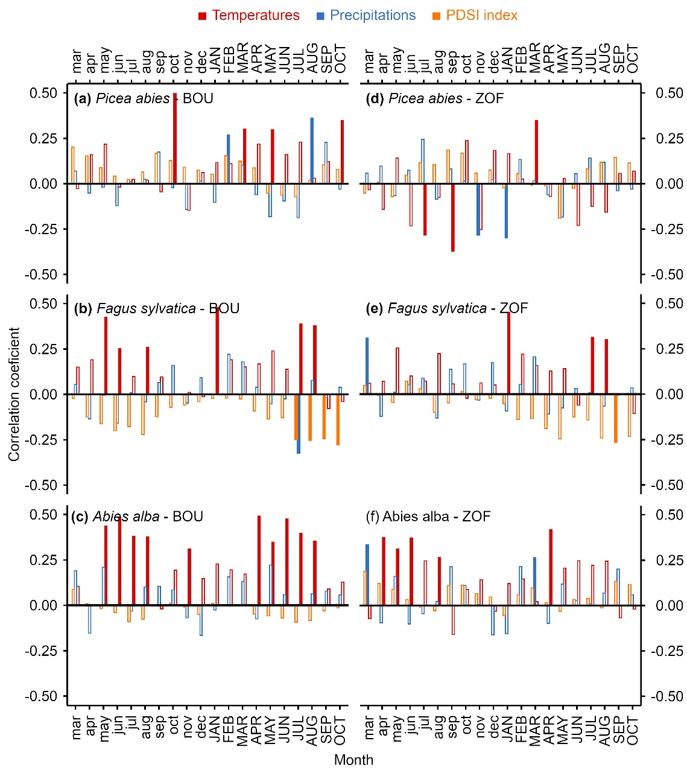
* Figure S2-S4: The set of all graphs is for one species?