**Title:** Warmer spring temperatures in temperate deciduous forests advance the timing of tree growth but have little effect on annual woody productivity

**Authors:**

Cameron Dow1 ( Orcid ID : 0000-0002-8365-598X)

Albert Y. Kim1,2

Loïc D’Orangeville3,4

Erika B. Gonzalez-Akre1 ( Orcid ID : 0000-0001-8305-6672)

Ryan Helcoski1

Valentine Herrmann1 ( Orcid ID : 0000-0002-4519-481X)

Grant L. Harley5

Justin T. Maxwell6

Ian R. McGregor1,7

William McShea1

Sean McMahon8,10 (Orcid ID : 0000-0001-8302-6908)

David A. Orwig3

Neil Pederson3 (Orcid ID : 0000-0003-3830-263X)

Alan J. Tepley1,9 ( Orcid ID : 0000-0002-5701-9613)

Kristina J. Anderson-Teixeira1,10* ( Orcid ID : 0000-0001-8461-9713)

**Author Affiliations:**

1. Conservation Ecology Center; Smithsonian Conservation Biology Institute; Front Royal, VA 22630, USA
2. Statistical & Data Sciences; Smith College; Northampton, MA 01063, USA
3. Harvard Forest, Petersham, MA 01366, USA
4. Faculty of Forestry and Environmental Management, University of New Brunswick, Fredericton, NB, E3B 5A3, Canada.
5. Department of Geography & Geological Sciences, University of Idaho, ID 83844, USA
6. Department of Geography, Indiana University, Bloomington, IN 47405, USA
7. Center for Geospatial Analytics; North Carolina State University; Raleigh, NC 27607, USA
8. Smithsonian Environmental Research Center, Edgewater, MD, USA
9. Canadian Forest Service, Northern Forestry Centre, Edmonton, Alberta, Canada
10. Forest Global Earth Observatory; Smithsonian Tropical Research Institute; Panama, Republic of Panama

*corresponding author: [teixeirak@si.edu](mailto:teixeirak@si.edu); +1 540 635 6546

*NOTE: We’re probably pretty close to the upper length limit. The typical length of an article with 3-4 modest display items (figures and tables) is 2000-2500 words (summary paragraph plus body text). We’re currently at ~2512 words (1609 intro + results, discussion 903) and 1 modest + 2 large display items. Articles typically have 30-50 references (currently ok there)*

# 1 (Summary paragraph)

As the climate changes, warmer spring temperatures are causing earlier leaf-out1–4 and commencement of net carbon dioxide (CO2) sequestration2,4 in temperate deciduous forests, resulting in a tendency towards increased growing season length1,4–7 and annual CO2 sequestration2,4,8–12. However, less is known about how spring temperatures affect tree stem growth, which sequesters carbon in wood that has a long residence time in the ecosystem13,14 or as wood products15. Here, we show that in two forests, warmer spring temperatures consistently shifted the woody growth of deciduous trees earlier but had no consistent effect on peak growing season length, maximum daily growth rates, or annual growth. The latter finding was confirmed on the centennial scale by 207 tree-ring chronologies from 108 forests across eastern North America, where annual growth was far more sensitive to temperatures during the peak growing season than in the spring. These findings imply that any extra CO2 sequestered in years with warmer springs8–10 is not allocated to long-lived woody biomass, where it could have a substantial and lasting impact on the forest C balance. Thus, in contrast to global carbon cycle model expectations2,3,16, warming spring temperatures are unlikely to increase the woody productivity or strengthen the carbon sink of temperate deciduous forests.

# 2 (Body)

In recent decades, Earth’s forests have sequestered ~20% of anthropogenic CO2 emissions, thereby slowing the pace of atmospheric CO2 accumulation and climate change17. A large portion of this CO2 sink occurs in temperate deciduous forests, with uptake of >100 Tg C yr-1 (>10% of the total forest C sink) attributable to environmental (as opposed to demographic) changes18. The future behavior of this CO2 sink will play an important yet uncertain role in influencing atmospheric CO2 and climate change19,20.

In temperate deciduous forests, spring warming generally results in an increased growing season length, measured as the period over which trees have photosynthetically active leaves1,5–7 and the ecosystem is a net CO2 sink2. The expectation is that as growing season length increases, net annual carbon sequestered (*i.e.*, net ecosystem exchange, *NEE*) will increase as well2,11,12,21, and this expectation is represented in models2,3,16. However, recent findings that sink factors can limit annual growth16,22,23 and that positive effects of warm springs are compensated by negative effects of accumulation of seasonal water deficits3 suggest that warmer spring temperatures may not have the expected positive effect on C sequestration in trees.

While the responses of leaf phenology and seasonal CO2 sequestration to warming spring temperatures have been relatively well-studied1–3,5–7, we know very little about how the longest-lived component of fixed carbon in trees, the woody growth, is responding to warming spring temperatures. In fact, we know little about the stem-growth phenology of temperate deciduous species, with multi-year records of growth phenology having been published for only one site *(to our knowledge)*24. The climate sensitivity of woody growth phenology and its link to annual growth has never been studied *in-situ* (but see Ref.23 for a controlled sapling experiment).

Tree-ring records, which can be used to examine correlations of annual growth to monthly temperatures but not to understand growth phenology, reveal that growth of temperate deciduous trees tends to be most sensitive to temperature or potential evapotranspiration between late spring and early summer25,26, with some hints that warmer springs may have a modest positive effect on growth26. Thus, tree-ring evidence does not necessarily align with the finding that warming spring temperatures increase annual forest CO2 sequestration2. Characterizing phenological responses of stem growth to warming spring temperatures is critical to bridging this conceptual disconnect and understanding how forest biomass growth is likely to change as the climate warms.

Here, we describe how early spring temperatures affect stem growth phenology, growth rates, and annual growth of temperate deciduous trees in two forests and annual growth across forests spanning eastern North America.

## Dendrometer band analysis

Using dendrometer band measurements taken throughout the growing season at the Smithsonian Conservation Biology Institute (SCBI; Virginia, USA; n = **125** trees from 2011-2020) and Harvard Forest (Massachusetts, USA; n = **340** trees from 1998-2003), we fit a growth model27 to determine the days of year where 25, 50, and 75% annual growth were achieved (, , ), peak growing season length (-), maximum growth rates () and the DOY on which they occurred (), and total annual increment in diameter at breast height (; Fig. 1). This analysis was performed separately for ring- and diffuse-porous species, which differ in growth phenology24, and set in the context of leaf phenology (measured at ecosystem level via remote sensing).

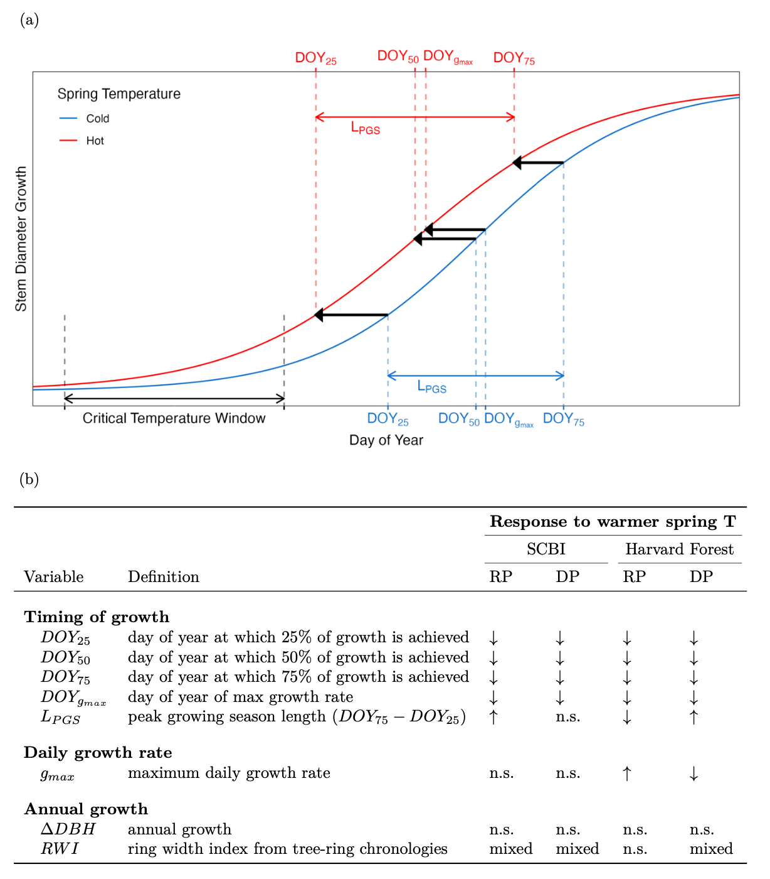

**Figure 1 | Summary of tree growth changes under warmer spring temperatures.** (a) Schematic illustrating parameters of interest and summarizing how each responds to warmer maximum temperatures during a ‘critical temperature window’, defined as that with the strongest control over ; (b) Variable definitions and summary responses to warmer spring temperatures at two temperate forests and for two groups of broadleaf deciduous species (RP=ring porous; DP=diffuse porous), where up and down arrows indicate increases and decreases, respectively, ‘n.s.’ indicates no signficant correlation, and ‘mixed’ indicates a mix of signficant and non-signficant correlations, often in different directions.

Both leaf phenology and stem growth milestones occurred earlier at SCBI than at Harvard Forest, with stem growth milestones achieved on average 6-10 days earlier at SCBI (Fig. 2, Extended Data Table 2). Consistent with the results of Ref24, ring-porous species began growing earlier, reaching the benchmark earlier (by 31 days at SCBI and 32 at Harvard Forest), and their growth was spread out over a longer growing season (average 21 and 19 days longer at SCBI and Harvard Forest, respectively; Fig. 2, Extended Data Figure 2, Extended Data Table 2). Growing season length was similar across sites, with being, on average, only two days longer at SCBI for ring-porous species and less than one day longer for diffuse-porous species (Extended Data Table 2).



**Figure 2 | Leaf (a,b) and stem growth (c,d) phenology at the Smithsonian Conservation Biology Institute (a,c) and Harvard Forest (b,d).** Panels (a-b) show ecosystem-level leaf phenology, obtained from the MODIS Global Vegetation Phenology product (2001-2018), where G = Greenup, M=Mid-greenup, P=peak, and S=Senescence (i.e., beginning of green-down). Panels (c-d) show the dates at which stem growth milestones were acheived, on average, for sampled populations of ring-porous and diffuse-porous trees at SCBI (2011-2020) and Harvard Forest (1998-2003). Mean temperature was calculated for each wood-type/site combination over the respective critical window, then turned into a ratio and assigned a color on a gradient where the coldest year in the sample is blue and the warmest is red.

Both leaf phenology and stem growth were sensitive to spring temperatures (Fig. 2, Extended Data Figures 4-5). While the results described below were qualitatively consistent considering both maximum and minimum temperatures ( and , respectively) across a range of spring time windows (Extended Data Figures 3-5), we focused our analyses on the strongest relationships: responses to over the consecutive weekly time window between Jan. 1 and for which the correlation between and was strongest (henceforth, critical temperature window; Fig. 1). The strongest relationships, including but not limited to the critical temperature window (Extended Data Table 2), occurred for time windows closing 5 weeks prior to (Extended Data Figure 3).

For ring- and diffuse- porous species at both sites, warmer in the critical temperature window resulted in earlier achievement of growth milestones (Figs. 1, Extended Data Figure 4). Consistent with findings from previous studies29, the DOY of leaf greenup advanced with increasing during the critical temperature window (p= 0.001 at SCBI; p= 0.1 at HF). Specifically, greenup DOY advanced 4.5 days/C at SCBI and 2.4 days/ C at Harvard Forest, and mid-greenup also advanced, but to a lesser extent (Fig. 2). Similarly, at both sites, , , , and all decreased with mean during the critical temperature window (Figs. 1, 2; Extended Data Figures 4-5). Specifically, at SCBI, RP growth advanced 1.9, 1.5, and 1.1 days/ C for , , and , respectively, while DP growth advanced 3.5, 3.5, and 3.6 days/ C for , , and , respectively. At Harvard Forest, RP growth advanced 2.8, 5.0, and 7.2 days/ C for , , and , respectively, while DP growth advanced 7.9, 7.3, and 6.6 days/ C for , , and , respectively. *(This might be better as a table. Add to an existing one? May be able to add to mean_growth_parameters table)*

Whereas the length of time between leaf greenup and senescence (*i.e.,* the day when greenness dropped below 90% of its peak) increased in years with warmer temperatures during the critical temperature window compared to those with cooler temperatures (Fig. 2), there was no consistent lengthening of . Specifically, because both and advanced in years with warm springs, displayed mixed responses to spring temperatures (Fig. 1, Extended Data Figures 4-5).

In contrast to the pronounced effects of on the timing of growth, its effects on and were weak and inconsistent (Figs. 1, Extended Data Figures 4-5). Specifically, , which occurred very close to (on ; Extended Data Table 2), displayed either no relationship to mean during the critical temperature window (SCBI), or extremely small changes in opposite directions for ring- and diffuse- porous species (Harvard Forest). displayed no relationship with mean during the critical temperature window (Extended Data Figure 4). Given the subtlety of these responses, a much longer record was needed to clarify what, if any, effect spring temperatures have on stem growth.

## Tree ring analysis

To understand how annual growth increments have responded to spring temperatures at the centennial scale, we analyzed tree-ring chronologies of 12 species at SCBI26 and 4 species at Harvard Forest (Extended Data Table 1), along with an additional 191 chronologies from 106 sites (Fig. 3; Extended Data Figure 1; Extended Data Table 3)25. In total, our analysis included 207 chronologies representing 24 broadleaf species at 108 sites distributed from Alabama (Lat = 34.35) to Michigan (Lat = 45.56) and spanning a 15 C range in April . Across all chronologies, RWI was significantly (at p=0.05) positively correlated with April for only 1% of records: 1 of 142 ring-porous and 2 of 66 diffuse-porous species-site combinations (Extended Data Table 3). In contrast, RWI was frequently negatively correlated with during peak growing season months (May-August), with significant correlations for 53% (May: 47/142, Jun: 108/142, Jul: 90/142, Aug: 57/142) and 46% (May: 11/66, Jun: 53/66, Jul: 37/66, Aug: 22/66) of species-site-month combinations for ring-porous and diffuse-porous species, respectively. generally exerted less influence over annual growth than , with few significant correlations between spring and RWI (Extended Data Figure 6).

To test whether a positive effect of spring temperatures might be offset by a negative effect of summer temperatures, we tested for the joint effects of April and June-July on RWI. Results were qualitatively similar to the univariate correlations (Fig. 3), with significant (at p = 0.05) positive correlations to April for only 7% of chronologies and significant negative correlations with June-July for 77% of chronologies (Extended Data Table 3).

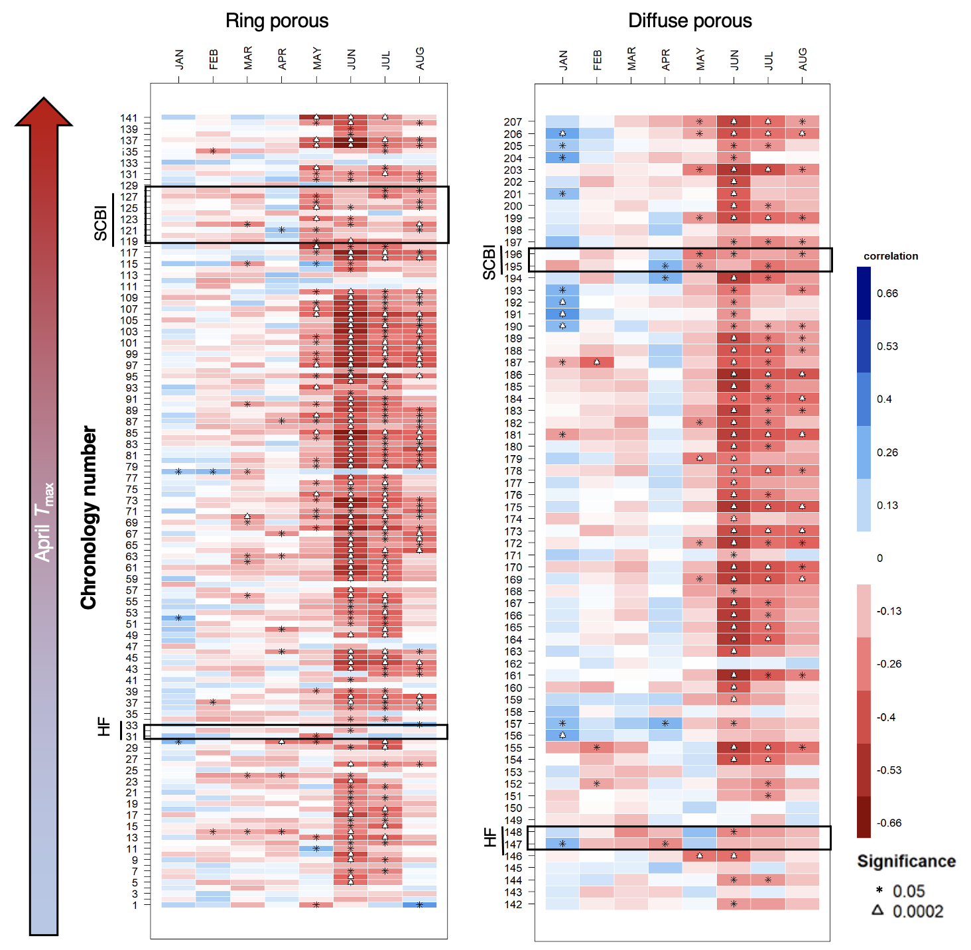

**Figure 3 | Sensitivity of annual growth, as derived from tree-rings, to monthly maximum temperatures, for 207 chronologies from 108 sites across eastern North America** (Extended Data Figure 1). Chronologies are grouped by xylem porosity and ordered by mean maximum April temperature. Chronology details are given in SI Table 1.

## Discussion

Together, our results demonstrate that warmer spring temperatures in the temperate deciduous forests of eastern North America advance the phenology of tree stem growth but have little effect on annual woody productivity (Figs. 1- 3). The observed phenological advance in the start of stem growth under warmer springs parallels phenological advances observed for leaf development (Fig. 2)2,4 and NEE.2,4 However, inconsistent with the concept that an earlier start to growth would increase annual woody productivity, we demonstrate that warmer springs advance the end to the period of most active stem growth and have negligible effect on total annual growth for most species and locations (Fig. 3). Our observations suggest that the cessation of rapid stem expansion, which occurs mid-summer near the time of peak leaf greenness (Extended Data Figure 2)4, is likely driven by cues other than carbon limitation, such as daylength or sink limitation, which also play an important role in autumn leaf senesence16,22. Rather than growing season length, the primary effect of temperature on annual growth is a negative effect of during the peak growing season, which is associated with drought stress25. Warm springs may also augment summer drought stress in some times and places, effectively canceling out any positive effects of an extended growing period3; however, spring temperatures and summer Standardized Precipitation Evapotranspiration Index30) were uncorrelated within our dendrometer band analysis.

Our finding that interannual variation in woody growth is more strongly linked to conditions during the peak growing season (Fig. 3) than to growing season length aligns with parallel findings for NEE.11,12 However, there is also a disconnect with findings that NEE increases – at least modestly – with spring temperatures2 or with the length of the carbon uptake period4,11,12. Warming advances spring phenology and may advance or delay autumn senescence depending on timing of warming and water availability10,31,32, with delays more common across eastern North America,2–4 implying that warming temperatures are resulting in a lengthening of the period between the slowing of stem growth and the cessation of ecosystem C uptake. As the extra C sequestration in years with warm springs does not substantially augment woody growth, it remains unclear how it is allocated within the ecosystem. There are two main possibilities, which hold contrasting implications for the response of forest C balance to rising spring temperatures.

First, extra C production in years with warm springs may be allocated to woody growth without affecting diameter growth in the current year. It is possible that extra carbon is allocated to cell wall thickening, a process that lags behind stem expansion33, resulting in formation of more carbon-dense cell walls in years with warm springs (**coauthors, do any of you know studies that have looked at this?**). Extra carbon could also be saved within trees as non-structural carbohydrates and used towards growth the following year34,35. Extension of our tree-ring analysis revealed little correlation between April and growth the following year (sig. pos. correlations for 5/142 RP and 3/66 DP species-site combinations, Fig. Extended Data Figure 7), although predominantly positive (non-significant) correlations in RP species suggests that this dynamic may weakly influence their annual growth. Finally, extra C may be allocated to growth of coarse roots23 or branches[**REF?**] and therefore be unapparent in the basal portions of trunks. Warm springs could increase woody productivity through any of these mechanisms, yet none are likely to provide substantial, sustained C sinks under warming spring temperatures.

A second possibility is that any additional C fixed during years with warm springs may be allocated, potentially in the following growing season, to plant functions other than stem growth, including respiration, reproduction, and production of foliage, fine roots23, or root exudates. Most of this carbon would have a shorter residence time within the ecosystem than C allocated to woody productivity but may remain in the ecosystem for more than a year34, such that the long-term effect of warm springs on the forest C balance would not be captured in analyses of interannual variation2,11,12. Studies within or including the temperate deciduous biome that examined long-term trends in growing season length and ecosystem C uptake2,4,8,9 – as opposed to their interannual variation – showed increasing trends in both variables, suggesting that the C not allocated to woody productivity within the current year growth has a multi-year residence time within the ecosystem. However, given our finding that warm springs do not significantly enhance woody productivity, this C is likely to have a relatively short residence time within the ecosystem.

Thus, a distinction between interannual variation and directional change may be critical when considering how directional climate change is likely to affect tree growth and ecosystem C dynamics. As discussed above, temporal lags between C uptake and release imply that the full effects of warm spring temperatures on forest woody productivity and carbon cycling are unlikely to be apparent in analyses of interannual variation (including this analysis). Moreover, acclimation of trees to warming temperatures[**REFS**] and, on longer time scales, species adaptations and shifts in community composition[**REFS**] are likely to alter the phenology of forest C cycling. If we look across spatial gradients where the latter have had time to play out, we see that longer growing seasons are correlated with greater tree growth36, woody productivity37, and NEE.21 Thus, warming spring temperatures are expected to increase the biophysical potential for annual tree growth, but that potential is not being realized on an interannual time frame.

As climate change accelerates and spring temperatures become increasingly warmer, growing seasons will start earlier; however, barring rapid acclimation of forests to the warming conditions, this is unlikely to provide the sustained increase in carbon sequestration and ensuant negative climate change feedback that is anticipated in most models2,3,16. Rather, the dominant effect of rising temperatures on forest woody productivity will be a negative effect of high summer temperatures, which constitutes a positive feedback to climate change.

# 3 content to incorporate or delete:

38

# Methods

## Dendrometer band analysis

Dendrometer band were collected at SCBI39 and Harvard Forest4,24, both part of the Forest Global Earth Observatory (ForestGEO)40,41. SCBI (38.8935° N, 78.1454° W; elevation 273–338 m.a.s.l.) is located in the Blue Ridge Mountains at the northern end of Shenandoah National Park, 5 km South of Front Royal, Virginia. The forest is secondary and mixed age, having established in the mid-19th century after conversion from agricultural fields39. Dominate canopy species within the 25.6 ha ForestGEO plot include tulip poplar (*Liriodendron tulipifera*), oaks (*Quercus spp.*), and hickories (*Carya spp.*)26. The climate is humid temperate, with 1950-2019 mean annual precipitation of 1018 mm and temperatures averaging 1° C in January and 24° C in July36.

Harvard Forest (42.5388° N, 72.1755° W, 340-368 m.a.s.l.) is located near the central Massachusetts town of Petersham. The forest is secondary and mixed age, having re-established around the beginning of the 20th century following agricultural use and significant hurricane damage in 1938. Dominate species within the 35 ha ForestGEO plot are hemlock (*Tsuga canadensis*), oak (*Quercus spp.*) and red maple (*Acer rubrum*). The climate is temperate continental, with 1950-2019 mean annual precipitation of 1104 mm and temperatures averaging -5° C in January and 22° C in July36.

Metal dendrometer bands were installed on a total of 941 trees within the SCBI and Harvard Forest ForestGEO plots. Bands were placed on dominant species, including two diffuse- and two ring-porous species at SCBI and eight diffuse- and three ring-porous species at Harvard Forest (Extended Data Table 1). Bands were measured with a digital caliper approximately every 1-2 weeks within the growing season from 2011-2020 at SCBI and 1998-2003 at Harvard Forest. The number of bands measured at each site fluctuated somewhat as trees were added or dropped (e.g., because of tree mortality) from the census. Across years, the number of bands sampled averaged 129 (range: 91-138) at SCBI and 717 (range: 700-755) at Harvard Forest. In total, our analysis included 2459 tree-years (Extended Data Table 1).

Measurements were timed to begin before the beginning of spring growth and to continue through the cessation of growth in the fall. At SCBI, the median start date was April 14, which was adjusted when early leaf-out of understory vegetation was observed, with the earliest start date being March 30 (in 2020). Measurements were continued through to fall leaf senescence, with the median end date being October 17 and the latest end date November 26 (2012). Timing of measurements at Harvard Forest were similar, with the median start date of April 23 and median end date of October 30. 1998 was an anomalous year where initial measurements were taken on January 5, but not taken again until April 15. The latest end date was November 11, 2002.

The raw dendrometer band data were manually cleaned by visual inspection before analysis. We screened for three classes of mistakes. First, when a measurement was drastically different from previous and following measurements, this was assumed to be an error and the datapoint was removed. Second, when measurements remained essentially unchanged for several readings, followed by a sudden jump then return to a normal growth pattern, this was assumed to be a case where the band was stuck and then released. In these cases, the full annual record for the tree was removed. Third, when data points deviated substantially from normal growth patterns, but with unknown causes, they were removed. If a majority of the data points fell into this class within a tree-year, the entire year was removed from the analysis.

We fit a five-parameter logistic growth model27 to dendrometer band data from each tree-year to define phenological dates and growth rates (Fig. 1):

Here, and are lower and upper asymptotes of the model, corresponding to stem diameter at breast height (DBH) at the beginning and end of the year, respectively. are the modeled days of year (*i.e.*, julian days), is the day of year where the inflection point in growth rate occurs, *shapes the slope of the curve at the inflection point*, and is a tuning parameter controlling the slope of the curve toward the upper asymptote. *We note that the DOY on which maximum growth occurs, (Fig. 1), occurs on only when .* The model was fit in R v 1.3.1093 using the functions developed in.27 These functions take the timeseries of manual dendrometer band measurements and return the optimized parameters to predict DBH throughout the year. We then modeled DBH throughout the year and extracted the intra-annual growth variables of interest (Fig. 1).

After fitting the growth model, we removed tree-years with poor fits. Models were judged to be poorly fit if certain modeled growth characteristics fell outside of the logical range. Modeled fits for tree-years were removed under five conditions: (1) single day growth rates were 2 standard deviations away from the mean for each wood-type (SCBI = 2, Harvard Forest = 34); (2) was standard deviations away from the mean for it’s xylem architecture group, year, and site (SCBI = 62, Harvard Forest = 106); (3) tree-years with small or negligible total growth ( mm; SCBI = 0, Harvard Forest = 66); (4) model fit predicted total yearly growth to take longer than 365 days, indicating poor model fit (SCBI = 181, Harvard Forest = 199); and (5) models with unexplained sharp spikes in growth rate (SCBI = 0, Harvard Forest = 3). At Harvard Forest the tag years removed through this method were proportional to the original sample size, indicating that no species or size class was disproportionately removed compared to others. At SCBI a higher proportion of RP trees were removed, the majority falling under condition 4.

Leaf phenology data for the years 2001-2018 were extracted for SCBI and Harvard Forest from the MCD12Q2 V6 Land Cover Dynamics product (a.k.a. MODIS Global Vegetation Phenology product)42. These data were used to determine timing of greenup, midgreenup, senescence, and enhanced vegetation index (EVI2) values for each year. (**IAN, I think this could use a bit more detail.**)

Climate data corresponding to the measurement periods at both sites were obtained from local weather stations. For SCBI, weather data were obtained from a meteorological tower adjacent to the SCBI ForestGEO plot, via the ForestGEO Climate Data Portal v1.0 (<https://forestgeo.github.io/Climate/>)43. The R package *clim.pact*44,**climpact_REF?** was used to plot temperatures for visual inspection and to identify readings that were >3 standard deviations away from yearly means, which were labeled as outliers and removed from the dataset. Gaps in the SCBI meteorological tower data were subsequently filled using temperature readings obtained from a National Center for Environmental Information (NCEI) weather station located in Front Royal, Virginia (<https://www.ncdc.noaa.gov/cdo-web/datasets/GHCND/stations/GHCND:USC00443229/detail>). For each site, we extracted daily maximum () and minimum temperatures (). Daily temperature records for Harvard Forest were obtained from the Harvard Forest weather station**boose_shaler_2021-1?**,**boose_fisher_2021-2?**. **(Cam, please be sure to sync these in Zotero.)** Climate data for Harvard Forest were complete and used as is.

The critical temperature window (Fig. 1), defined as the period over which was most strongly affected by early spring , was determined using the R package *climwin*45. This package tests the correlation between one or more climate variables and a biological variable over all consecutive time windows within a specified time-frame, reporting correlation and difference in Akaike information criterion corrected for small sample size relative to the null model, , of each window. Here, we tested for correlation between temperature (, ) and over the time window from January 1 to the mean for the species group (by xylem porosity) and site (Extended Data Table 2), selecting the critical temperature window as that with the lowest . Because proved to have a generally stronger influence over and other growth parameters, we focused on this variable, as opposed to . We focused on defining critical temperature windows for , as opposed to other growth phenology parameters, because we were interested in the influence of temperature on the initiation of woody growth.

To ensure that patterns were robust under an alternative definition of critical temperature window, and to parallel the monthly time windows used in our tree-ring analysis (detailed below; Fig. 3, Extended Data Figure 6-7), we also ran analyses defining the critical temperature window as the month of April. This was consistent with the periods identified by *climwin* for ring- and diffuse-porous species groups at both sites, all of which included all or part of April (Extended Data Table 2).

Correlation between growth parameters (, , , , , , and }, Fig. 1) and spring temperatures were assessed using a linear mixed model in a hierarchical Bayesian framework. Analyses were run for both and , with qualitatively similar results, but we present only results for , which had overall stronger correlation with growth parameters. Mixed effects models were used to test the response of growth phenology variables to fixed effects of xylem porosity and mean (or ) during the critical temperature window selected by *climwin*, along with random effects of species and tree. We ran separate models for each species group at each site, and for the response of all growth phenology variables to (or ). Models were run using the LME4 package in R.46 This mixed-effect model was run within a hierarchical Bayesian framework and fit using the rstanarm R interface to the Stan programming language47. In all cases unless otherwise specified, all prior distributions are set to be the weakly informative defaults.

## Tree-ring analysis

We analyzed tree-ring records for 108, including our focal sites. All cores had been previously collected, cross-dated, and measured using standard methodology48.

Dominant tree species were cored at both SCBI26,39 and Harvard Forest4,49,50 following sampling designs that covered a broad range of DBH. We analyzed records for the dominant ring- and diffuse- porous species at each site (Extended Data Table 1), excluding species with other xylem architectures (*Juglans nigra* L. at SCBI, *Tsuga canadensis* (L.) Carrière at Harvard Forest). In total, we analyzed 976 cores from 12 species at SCBI and 4 species at Harvard Forest (Extended Data Table 1).

The tree-ring records from our focal sites were complemented with a much larger collection spanning 106 deciduous and mixed forest sites in Eastern North America25,51–60 (**JUSTIN, please confirm that we got all the appropriate references here.**). Again, species were limited to broadleaf deciduous species with clearly defined xylem porosity (*i.e.*, excluding semi-ring porous).

We standardized ring-width series from each core via ARSTAN using a 2/3rds spline, where is the number of years in the series.61,62 *Chronologies were built using the methods described in Ref.26.* (**(NEIL/JUSTIN, is this accurate, and do you think it’s sufficient? If not, could you please provide a brief summary?**) We defined chronology start year (Extended Data Table 1) as the year where subsample signal strength (SSS) passed a threshold of SSS = 0.8, or where 80% of the population signal was captured in the chronology.

We obtained monthly and data for 1901-2019 from CRU v.4.04.63

Correlations between monthly climate and were assessed using ‘dplR’64 and ‘bootRes’65 in R v.1.3.1093 (R Core Team, 2020), which correlated functions and bootstrapped confidence intervals for these relationships66. We analyzed these correlations for January through September of the current year (presented in Fig. 3, Extended Data Figure 6). To test for potential lag effects effects of spring temperatures on the following year’s growth, we also ran a version of the analysis extending back to include climate of every month of the previous year (Extended Data Figure 7). Correlations and significance levels for months April-August are given in SI Table 1.

We used a multivariate model to test for joint effects of April and summer on RWI. We began by testing univariate correlations of over three summer windows: June, June-July, and May-August. Having determined that, among these, June-July explained the most variation, we then analyzed the joint effects of April and June-July on RWI for each chronology independently using the base lm() function in R. Slopes and p-values for each chronology are given in SI Table 1.

# Acknowledgements

* people: (everyone who helped collect data– see list on GitHub), Jess Shue (data)
* Funding: ForestGEO

**COAUTHORS, PLEASE ADD.**

# Author Contributions

Cameron Dow and Kristina J. Anderson-Teixeira conceived the ideas and designed the study; Cameron Dow, Loïc D’Orangeville, Erika B. Gonzalez-Akre, Ryan Helcoski, Grant L. Harley, Justin T. Maxwell, Ian R. McGregor, William McShea, David A. Orwig, Neil Pederson, Alan J. Tepley, and Kristina J. Anderson-Teixeira collected or oversaw collection of data; Cameron Dow, Albert Y. Kim, Valentine Herrmann, Justin T. Maxwell, Ian R. McGregor, Sean McMahon analyzed the data or provided analytical tools; Cameron Dow and Kristina J. Anderson-Teixeira led the writing of the manuscript. All authors contributed critically to the drafts and gave final approval for publication.

# Additional Information

**Supplementary Information** is available for this paper.

Correspondence and requests for materials should be addressed to Kristina Anderson-Teixeira ([teixeirak@si.edu](mailto:teixeirak@si.edu)).

# References

1. Jeong, S.-J., Ho, C.-H., Gim, H.-J. & Brown, M. E. Phenology shifts at start vs. End of growing season in temperate vegetation over the Northern Hemisphere for the period 1982. *Global Change Biology* **17**, 2385–2399 (2011).

2. Keenan, T. F. *et al.* Net carbon uptake has increased through warming-induced changes in temperate forest phenology. *Nature Climate Change* **4**, 598–604 (2014).

3. Buermann, W. *et al.* Widespread seasonal compensation effects of spring warming on northern plant productivity. *Nature* **562**, 110–114 (2018).

4. Finzi, A. C. *et al.* Carbon budget of the Harvard Forest Long-Term Ecological Research site: Pattern, process, and response to global change. *Ecological Monographs* **90**, e01423 (2020).

5. Menzel, A. & Fabian, P. Growing season extended in Europe. *Nature* **397**, 659–659 (1999).

6. Menzel, A. *et al.* European phenological response to climate change matches the warming pattern. *Global Change Biology* **12**, 1969–1976 (2006).

7. Ibáñez, I. *et al.* Forecasting phenology under global warming. *Philosophical Transactions of the Royal Society B: Biological Sciences* **365**, 3247–3260 (2010).

8. Keeling, C. D., Chin, J. F. S. & Whorf, T. P. Increased activity of northern vegetation inferred from atmospheric CO 2 measurements. *Nature* **382**, 146–149 (1996).

9. Dragoni, D. *et al.* Evidence of increased net ecosystem productivity associated with a longer vegetated season in a deciduous forest in south-central Indiana, USA. *Global Change Biology* **17**, 886–897 (2011).

10. Crabbe, R. A. *et al.* Extreme warm temperatures alter forest phenology and productivity in Europe. *Science of The Total Environment* **563–564**, 486–495 (2016).

11. Zhou, S. *et al.* Explaining inter-annual variability of gross primary productivity from plant phenology and physiology. *Agricultural and Forest Meteorology* **226–227**, 246–256 (2016).

12. Fu, Z. *et al.* Maximum carbon uptake rate dominates the interannual variability of global net ecosystem exchange. *Global Change Biology* **25**, 3381–3394 (2019).

13. Xue, B.-L. *et al.* Global patterns of woody residence time and its influence on model simulation of aboveground biomass. *Global Biogeochemical Cycles* **31**, 821–835 (2017).

14. Russell, M. B. *et al.* Residence Times and Decay Rates of Downed Woody Debris Biomass/Carbon in Eastern US Forests. *Ecosystems* **17**, 765–777 (2014).

15. Profft, I., Mund, M., Weber, G.-E., Weller, E. & Schulze, E.-D. Forest management and carbon sequestration in wood products. *European Journal of Forest Research* **128**, 399–413 (2009).

16. Zani, D., Crowther, T. W., Mo, L., Renner, S. S. & Zohner, C. M. Increased growing-season productivity drives earlier autumn leaf senescence in temperate trees. 7 (2020).

17. Pan, Y. *et al.* A Large and Persistent Carbon Sink in the World’s Forests. *Science* **333**, 988–993 (2011).

18. Pugh, T. A. M. *et al.* Role of forest regrowth in global carbon sink dynamics. *Proceedings of the National Academy of Sciences* **116**, 4382–4387 (2019).

19. Arora, V. K. *et al.* Carbonconcentration and carbonclimate feedbacks in CMIP6 models and their comparison to CMIP5 models. *Biogeosciences* **17**, 4173–4222 (2020).

20. Friedlingstein, P. *et al.* Global Carbon Budget 2020. *Earth System Science Data* **12**, 3269–3340 (2020).

21. Churkina, G., Schimel, D., Braswell, B. H. & Xiao, X. Spatial analysis of growing season length control over net ecosystem exchange. *Global Change Biology* **11**, 1777–1787 (2005).

22. Keenan, T. F. & Richardson, A. D. The timing of autumn senescence is affected by the timing of spring phenology: Implications for predictive models. *Global Change Biology* **21**, 2634–2641 (2015).

23. Zohner, C. M., Renner, S. S., Sebald, V. & Crowther, T. W. How changes in spring and autumn phenology translate into growth-experimental evidence of asymmetric effects. *Journal of Ecology* **109**, 2717–2728 (2021).

24. D’Orangeville, L. *et al.* Peak radial growth of diffuse-porous species occurs during periods of lower water availability than for ring-porous and coniferous trees. *Tree Physiology* (2021) doi:[10.1093/treephys/tpab101](https://doi.org/10.1093/treephys/tpab101).

25. D’Orangeville, L. *et al.* Drought timing and local climate determine the sensitivity of eastern temperate forests to drought. *Global Change Biology* **24**, 2339–2351 (2018).

26. Helcoski, R. *et al.* Growing season moisture drives interannual variation in woody productivity of a temperate deciduous forest. *New Phytologist* **223**, 1204–1216 (2019).

27. McMahon, S. M. & Parker, G. G. A general model of intra-annual tree growth using dendrometer bands. *Ecology and Evolution* **5**, 243–254 (2015).

28. Parmesan, C. & Yohe, G. A globally coherent fingerprint of climate change impacts across natural systems. *Nature* **421**, 37–42 (2003).

29. Friedl, M. A. *et al.* A tale of two springs: Using recent climate anomalies to characterize the sensitivity of temperate forest phenology to climate change. *Environmental Research Letters* **9**, 054006 (2014).

30. Vicente-Serrano, S. M., Beguería, S. & López-Moreno, J. I. A Multiscalar Drought Index Sensitive to Global Warming: The Standardized Precipitation Evapotranspiration Index. *Journal of Climate* **23**, 1696–1718 (2010).

31. Zohner, C. M. & Renner, S. S. Ongoing seasonally uneven climate warming leads to earlier autumn growth cessation in deciduous trees. *Oecologia* **189**, 549–561 (2019).

32. Xie, Y., Wang, X., Wilson, A. M. & Silander, J. A. Predicting autumn phenology: How deciduous tree species respond to weather stressors. *Agricultural and Forest Meteorology* **250–251**, 127–137 (2018).

33. Cuny, H. E. *et al.* Woody biomass production lags stem-girth increase by over one month in coniferous forests. *Nature Plants* **1**, 15160 (2015).

34. Trumbore, S., Gaudinski, J. B., Hanson, P. J. & Southon, J. R. Quantifying ecosystem-atmosphere carbon exchange with a 14C label. *Eos, Transactions American Geophysical Union* **83**, 265–268 (2002).

35. Richardson, A. D. *et al.* Seasonal dynamics and age of stemwood nonstructural carbohydrates in temperate forest trees. *New Phytologist* **197**, 850–861 (2013).

36. Anderson-Teixeira, K. J. *et al.* Joint effects of climate, tree size, and year on annual tree growth derived from tree-ring records of ten globally distributed forests. *Global Change Biology* **n/a**, (2021).

37. Banbury Morgan, R. *et al.* Global patterns of forest autotrophic carbon fluxes. *Global Change Biology* gcb.15574 (2021) doi:[10.1111/gcb.15574](https://doi.org/10.1111/gcb.15574).

38. Fu, Y. S. H. *et al.* Variation in leaf flushing date influences autumnal senescence and next year’s flushing date in two temperate tree species. *Proceedings of the National Academy of Sciences* **111**, 7355–7360 (2014).

39. Bourg, N. A., McShea, W. J., Thompson, J. R., McGarvey, J. C. & Shen, X. Initial census, woody seedling, seed rain, and stand structure data for the SCBI SIGEO Large Forest Dynamics Plot: *Ecological* *Archives* E094-195. *Ecology* **94**, 2111–2112 (2013).

40. Anderson-Teixeira, K. J. *et al.* CTFS-ForestGEO : A worldwide network monitoring forests in an era of global change. *Global Change Biology* **21**, 528–549 (2015).

41. Davies, S. J. *et al.* ForestGEO: Understanding forest diversity and dynamics through a global observatory network. *Biological Conservation* **253**, 108907 (2021).

42. Friedl, M., Gray, J. & Sulla-Menashe, D. MCD12Q2 MODIS/Terra+Aqua Land Cover Dynamics Yearly L3 Global 500m SIN Grid V006. (2019) doi:[10.5067/MODIS/MCD12Q2.006](https://doi.org/10.5067/MODIS/MCD12Q2.006).

43. Anderson-Teixeira, K. *et al.* Forestgeo/Climate: Initial release. (2020) doi:[10.5281/ZENODO.4041609](https://doi.org/10.5281/ZENODO.4041609).

44. Benestad, R. E., Hanssen-Bauer, I. & Chen, D. *Empirical-statistical downscaling*. (World Scientific Pub Co Inc, 2008).

45. van de Pol, M. *et al.* Identifying the best climatic predictors in ecology and evolution. *Methods in Ecology and Evolution* **7**, 1246–1257 (2016).

46. Bates, D., Mächler, M., Bolker, B. & Walker, S. Fitting Linear Mixed-Effects Models Using **Lme4**. *Journal of Statistical Software* **67**, (2015).

47. Gabry, J. *et al.* Rstanarm: Bayesian Applied Regression Modeling via Stan. (2020).

48. Stokes, M. A. & Smiley, T. L. *An Introduction to Tree-ring Dating*. (University of Arizona Press, 1968).

49. Alexander, M. R. *et al.* The potential to strengthen temperature reconstructions in ecoregions with limited tree line using a multispecies approach. *Quaternary Research* **92**, 583–597 (2019).

50. Dye, A. *et al.* Comparing tree-ring and permanent plot estimates of aboveground net primary production in three eastern U.S. forests. *Ecosphere* **7**, e01454 (2016).

51. Maxwell, J. T. *et al.* Sampling density and date along with species selection influence spatial representation of tree-ring reconstructions. *Climate of the Past* **16**, 1901–1916 (2020).

52. Maxwell, J. T. & Harley, G. L. Increased tree-ring network density reveals more precise estimations of sub-regional hydroclimate variability and climate dynamics in the Midwest, USA. *Climate Dynamics* **49**, 1479–1493 (2017).

53. Wilde, E. M. & Maxwell, J. T. Comparing climate-growth responses of urban and non-urban forests using L. Tulipifera tree-rings in southern Indiana, USA. *Urban Forestry & Urban Greening* **31**, 103–108 (2018).

54. Strange, B. M. *et al.* Comparing three approaches to reconstructing streamflow using tree rings in the Wabash River basin in the Midwestern, US. *Journal of Hydrology* **573**, 829–840 (2019).

55. Au, T. F. *et al.* Demographic shifts in eastern US forests increase the impact of late-season drought on forest growth. *Ecography* **43**, 1475–1486 (2020).

56. Matheus, T. J. & Maxwell, J. T. Placing modern droughts in historical context in the Ohio Valley using tree-rings. *Physical Geography* **39**, 343–353 (2018).

57. LeBlanc, D., Maxwell, J., Pederson, N., Berland, A. & Mandra, T. Radial growth responses of tulip poplar (Liriodendron tulipifera) to climate in the eastern United States. *Ecosphere* **11**, e03203 (2020).

58. Maxwell, J. T. *et al.* Higher CO2 Concentrations and Lower Acidic Deposition Have Not Changed Drought Response in Tree Growth But Do Influence iWUE in Hardwood Trees in the Midwestern United States. *Journal of Geophysical Research: Biogeosciences* **124**, 3798–3813 (2019).

59. Maxwell, J. T., Harley, G. L. & Matheus, T. J. Dendroclimatic reconstructions from multiple co-occurring species: A case study from an old-growth deciduous forest in Indiana, USA. *International Journal of Climatology* **35**, 860–870 (2015).

60. Schmidt, K. R. A 325-year reconstruction of St. Joseph River streamflow using tree rings. (Indiana University, 2015).

61. Cook, E. R. A Time Series Analysis Approach to Tree Ring Standardization. vol. PhD (University of Arizona, 1985).

62. *Methods of Dendrochronology: Applications in the Environmental Sciences*. (Springer Netherlands, 1990). doi:[10.1007/978-94-015-7879-0](https://doi.org/10.1007/978-94-015-7879-0).

63. Harris, I., Osborn, T. J., Jones, P. & Lister, D. Version 4 of the CRU TS monthly high-resolution gridded multivariate climate dataset. *Scientific Data* **7**, (2020).

64. Bunn, A. G. A dendrochronology program library in R (dplR). *Dendrochronologia* **26**, 115–124 (2008).

65. Zang, C. & Biondi, F. Dendroclimatic calibration in R: The bootRes package for response and correlation function analysis. *Dendrochronologia* **31**, 68–74 (2013).

66. Biondi, F. & Waikul, K. DENDROCLIM2002 : A C++ program for statistical calibration of climate signals in tree-ring chronologies. *Computers & Geosciences* **30**, 303–311 (2004).