**Title:** ~~Effect of spring temperatures on tree growth phenology in two temperate deciduous forests~~ Warmer spring temperatures in temperate deciduous forests cause earlier tree growth but have little effect on annual woody productivity

**Authors (not yet complete, just alphabetical for now–final order TBD):**

Cameron Dow1, Loïc D’Orangeville, Erika B. Gonzalez-Akre1, Ryan Helcoski1, Valentine Herrmann1, Ian McGregor1, Sean McMahon, Albert Kim1, David A. Orwig, Kristina J. Anderson-Teixeira1,n*

**Author Affiliations:**

1. Conservation Ecology Center; Smithsonian Conservation Biology Institute; Front Royal, VA 22630, USA
2. Center for Tropical Forest Science-Forest Global Earth Observatory; Smithsonian Tropical Research Institute; Panama, Republic of Panama

*corresponding author: [teixeirak@si.edu](mailto:teixeirak@si.edu); +1 540 635 6546

# 1 Abstract

I like the [Nature summary paragraph template](https://cbs.umn.edu/sites/cbs.umn.edu/files/public/downloads/Annotated_Nature_abstract.pdf):

* One or two sentences providing a basic introduction to the field, comprehensible to a scientist in any discipline.
* Two to three sentences ofmore detailed background, comprehensible to scientists in related disciplines.
* One sentence clearly stating the general problem being addressed by this particular study.
* One sentence summarising the main result (with the words “here we show” or their equivalent).
* Two or three sentences explaining what the main result reveals in direct comparison to what was thought to be the case previously, or how the main result adds to previous knowledge.
* One or two sentences to put the results into a more general context.
* Two or three sentences to provide a broader perspective, readily comprehensible to a scientist in any discipline

**Keywords**:

# 2 Introduction

## 2.1 (1. forests are critical for climate change regulation, so we need to understand better how they’re responding to climate change)

As global atmospheric greenhouse gas levels are rising,

## 2.4 (5. Here, we…)

Here, we characterize how early spring temperatures affect stem growth phenology and rates of temperate deciduous trees within **two/three** forest dynamics plots in the Eastern USA. Using data from dendrometer bands measured throughout the growing season, we fit a growth model to the time series of individual trees to determine the day of year (DOY) where 25, 50, and 75% annual growth was achieved; maximum growth rates and the DOY on which they occurred; total annual growth; and peak growing season length (75%-25% DOY) (Fig. 1; McMahon & Parker, 2015). We test the hypotheses that (1) warmer early springs result in earlier stem growth and a period of growth, but (2) maximum growth rates are independent of spring temperatures, and as a result (3) total annual growth increases in response to warmer spring temperatures (Table 1).

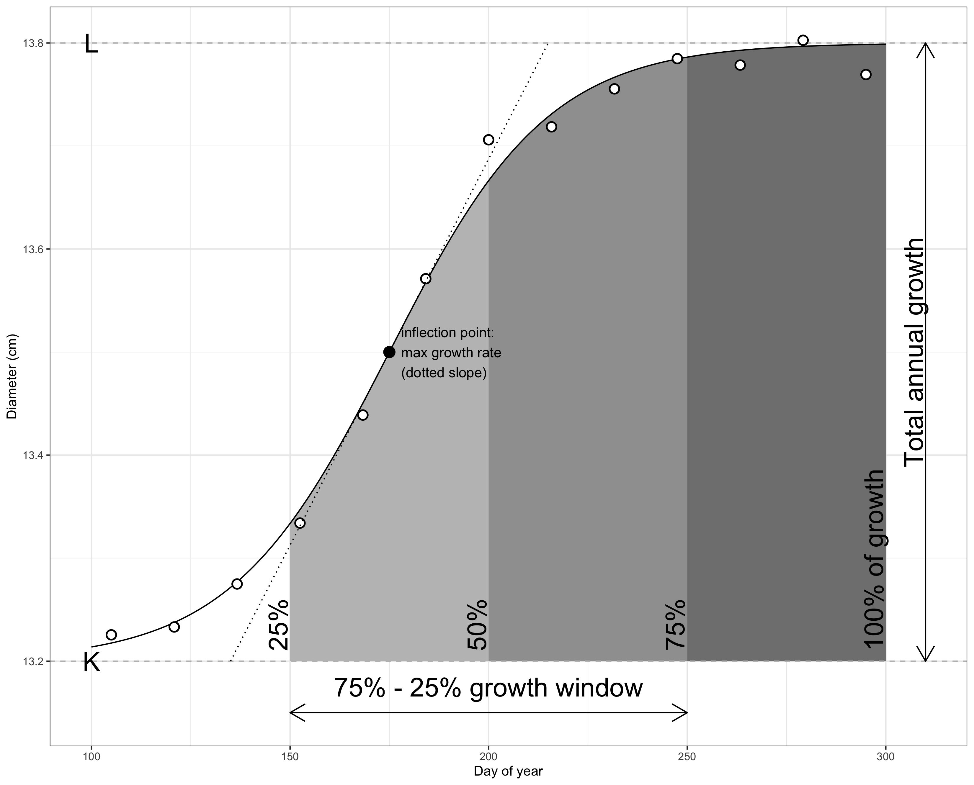

Figure 2.1: Figure 1. Schematic illustrating the parameters considered here. Shown are measurements for an example tree (## cm SPECIES), fit with the model of McMahon & Parker (2015), from which phenology and growth rate parameters are obtained.

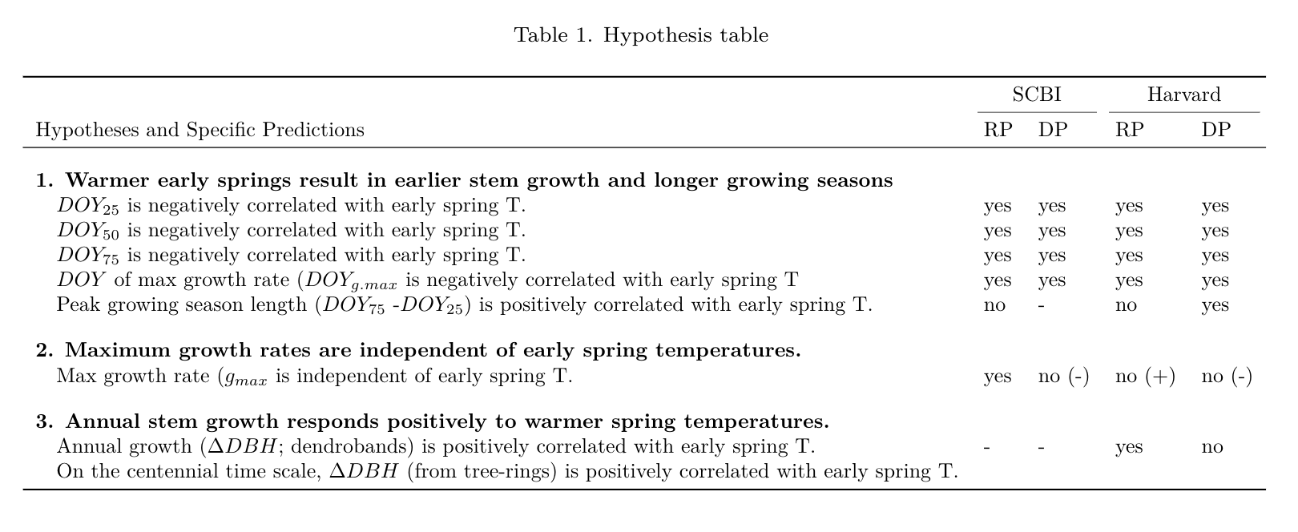

# 3 Materials and Methods

## 3.1 Study sites and data

Study sites included two temperate forests in the Eastern United States, both part of the Forest Global Earth Observatory [ForestGEO; Anderson-Teixeira et al. 2015].

*(Do we want a table of species here?? Columns would be Species, xylem porosity, n trees, n tree-years (after cleaning). Details will be in an SI table)*

|  |  |  |  |  |
| --- | --- | --- | --- | --- |
| Site | Species | Xylem porosity | trees | tree-years |
| SCBI | American Beech | diffuse | n | n |
|  | Tulip Poplar | diffuse | n | n |
|  | Red Oak | ring | n | n |
|  | White Oak | ring | n | n |
| Harvard | American Beech | diffuse | n | n |
|  | Black Birch | diffuse | n | n |
|  | Black Cherry | diffuse | n | n |
|  | Grey Birch | ring | n | n |
|  | Red Maple | ring | n | n |
|  | Striped Maple | ring | n | n |
|  | White Birch | ring | n | n |
|  | Yellow Birch | ring | n | n |
|  | Black Oak | ring | n | n |
|  | Red Oak | ring | n | n |
|  | White Ash | ring | n | n |