Blue text = has been transferred to .RmD and/or GitHub issues

**Thermal sensitivity of canopy versus understory leaves: patterns, mechanisms, and ecological implications**

**Authors (so far):**

Nidhi Vinod

Martijn Slot

Kristina Anderson-Teixeira

**Target journal:** ???

1. **Introduction**
   1. As the climate warms, understanding forest responses to temperature is critical.
      1. Forest canopy microclimate buffering is emerging as important for forest ecology in an era of climate change
         1. Forest canopies buffer temperatures and other conditions
            1. (Zellweger et al. 2019)
      2. We’re seeing increasing evidence that this impacts the ecology, with potential feedbacks to climate change
         1. (Zellweger et al. 2020) (Suggitt et al. 2018, Scheffers et. al 2014)
         2. Larger trees suffer more during drought (Bennett et al. 2015) – may be partially influenced by temperature
   2. However, we lack a systematic understanding of biophysical and biological patterns across this gradient, how these affect leaf-level processes, and in turn how it affects ecology (Fig. 1). This review addresses the following questions:
      1. How does the biophysical environment vary with height in forests?
      2. How do leaf traits vary with height in forests?
      3. How do biophysical environment and traits combine to affect leaf temperature?
      4. How does leaf metabolism respond to temperature in canopy and understory settings?
      5. What are the implications of these patterns for the ecology and climate change responses of canopy versus understory trees?
2. **The biophysical environment**
   1. Forest canopies buffer understory (Fig. 2) (see Bonan, *Ecological Climatology*)
      1. Solar radiation
         1. Higher in canopy (Mau et al. 2018?)
         2. (Bonan 2016) reviews this, points to appropriate refs
         3. Sunflecks: Leaky et al. 2003?
      2. Wind
         1. Higher in canopy
      3. Humidity
         1. Generally lower in understory
      4. Air temperature
         1. Lower max temperatures, higher min temperatures
            1. Across Europe (Zellweger et al. 2019)
            2. NW US (Davis et al. 2019)
         2. Lower max temperatures, similar min temperatures
            1. In Panama, during wet season. No difference during the dry season. (Rey-Sánchez et al. 2016)
            2. Atlantic forest during wet season (Fauset et al. 2018)
      5. VPD
         1. Lower in understory of Atlantic forest during wet season (Fauset et al. 2018)
      6. CO2
         1. Higher in understory, particularly at dusk (Koike et al. 2001)
         2. Higher in the understory overnight; difference persists during the day but is very small (Yang et al. 1999)
   2. Strength of this buffering varies …
      1. with canopy cover
         1. greater coverà lower max T and VPD, higher minT (Davis et al. 2019)
         2. greater coverà lower max T (Zellweger et al. 2019)
         3. (Thom et al. 2020)
      2. taller trees don’t necessarily increase buffering-to look into mor (Nidhi- Zellweger et al. 2019 ), SCA species increase T buffering (Zelllweger et al. 2019)
      3. geographically/ with climate
         1. (Davis et al. 2019)
         2. Distance to coast, topographic position, elevation (Zellweger et al. 2019)
3. **Trait variation with height / light** (Table 1)
   1. Many traits vary with height and/or between sun and shade leaves on the same species
      1. Leaf area / characteristic dimension
         1. [Recent paper on influence on leaf size/shape in PCE](https://onlinelibrary.wiley.com/doi/full/10.1111/pce.12857) – certain aspects of leaf shape were not as relevant as expected
      2. Max stomatal conductance
      3. Thermal time constant (probably not a lot out there)
         1. Curtis et. al, 2018 – higher in more exposed leaves (heat up slower, cool slower)
         2. Michaeletz has used this in theoretical calculations (Michaeletz et al. 2016 and 2015?
      4. Carotinoids
         1. photoprotective- disseminate heat, acclimate to high T
         2. antioxidant scavenging function- protect against cellular damage
         3. photoprotective pigments proportional to irradiance
      5. Isoprene production
         1. Within species, scales with light/ T
         2. Emission as a species trait- Tyeen Taylor, Marielle Smith (Krista’s collaborators)
   2. There are similar gradients across species at the community level
      1. Deciduous leaf habit (Meakem et al. 2018) and refs therein
   3. Are traits shaped more by height or light?
      1. “Height is more important than light in determining leaf morphology in a tropical forest” (Cavaleri et al. 2010)
      2. (Cavaleri et al. 2008)
4. **Leaf temperature**
   1. Many of the biophysical and trait variable reviewed above affect leaf temperature
   2. Tleaf- Rpackage (Muir 2019): <https://academic.oup.com/aobpla/article/11/6/plz054/5666155>
   3. Leaf temperature is driven by basic biophysical principles (Campbell and Norman 1998) (Fig. 3)
      1. Wider leaves will have temperatures deviating more from air temperature: small leaves remain within a few degrees of air T, regardless of stomatal conductance. (C&N 1998 Fig. 14.1)
      2. Large leaves can be significantly cooler than Tair under low radiation, open stomata, and significantly hotter under high radiation, stomata closed. (C&N 1998 Fig. 14.1)
      3. Leaves with open stomata and high radiation loads maintain Tleaf similar to Tair, with coolest leaves at intermediate sizes (~10mm) (C&N 1998 Fig. 14.1)
      4. Shaded understory leaves should tend to maintain cooler daytime leaf temperatures (for same level of stomatal conductance—regardless if open or shut) (Fig. 14.1)
      5. Per unit area, it takes less water to keep large leaf cool through latent heat loss
      6. Lower wind speed in understory would reduce latent heat loss (C&N 1998 Fig. 14.3)
         1. Thus, under wet, hot, windy conditions, canopy leaves more effective at latent cooling
   4. Aligning with biophysical expectations, observations show that leaf temperatures…
      1. Influenced by
         1. Air T
         2. Solar radiation
         3. Leaf traits
      2. Under certain conditions, differ little between understory and canopy
         1. (Bolstad et al. 1999)
         2. During dry season in Panama forest (Rey-Sánchez et al. 2016)
      3. Reach higher Tmax, and higher ∆T relative to air T, in canopy
         1. (Slot et al. 2019) and refs therein
         2. (Fauset et al. 2018)
      4. sun leaves were more cooled relative to air temperature than shade leaves (Rey-Sánchez et al. 2016). I’d have to look at the raw data to check the actual Tmin for sun vs shade leaves
      5. (show NEON biological temperature; Fig. 2)
5. **Leaf metabolism and thermal stress** (include plasticity)
   1. Photosynthesis
      1. Generally higher in sun leaves
      2. Temperature sensitivity
         1. Biophysically, (Campbell and Norman 1998),
            1. sun leaves should tend to have a stronger temperature-dependence than shade leaves, (Fig. 14.5)
            2. **sun leaves should tend to have a higher temperature optimum** (Fig. 14.5)
         2. **for 3 species in Panama, (Slot et al. 2019) found that the optimum temperature for sun leaves tended to be slightly higher than that of shade leaves, but differences not significant**
         3. Mau et al. found no trend along a height gradient in Puerto Rico, and no significant trend in temperate trees (Mau et al. 2018):
   2. Respiration
      1. (Bolstad et al. 1999) – Coweeta, including elev gradient
         1. Higher respiration (at reference T) in canopy leaves
         2. *Q*10 showed a variable pattern, with a slight tendency to increase down the canopy. (Potentially Martijn’s unpublished data)
         3. Together, there tends to be a modest net decrease in R for understory leaves relative to canopy leaves as T increases (Fig. 1)
         4. Thus, there’s evidence of acclimation, but there remains a declining trend of respiration with elevation.
   3. VOC production
   4. Leaf thermal tolerance (Tcrit/ T50)
      1. Define
      2. Typical values ~45-50°C, varying somewhat…
         1. across latitude/climate (O’sullivan et al. 2017) .
         2. with elevation (Feeley et al. 2020; and our unpublished data)
         3. with leaf traits (Sastry et al. 2018)
      3. T50 varies with exposure (no studies isolating effect of height)
         1. (Slot et al. 2019) - Slightly lower T50 for shade than sun-exposed leaves (both near ground level) leaves for 2/3 species
         2. (Curtis et al. 2019) – higher T50 in more exposed canopy positions
6. **Ecological** 
   1. Leaf deciduousness/ phenology
      1. Spring and fall leaf phenology in temperate deciduous forests (Augsburger)
         1. Mechanism: more moderate conditions (T, wind) in understory (REF)
      2. Among species that can be deciduous, greater proportion of deciduous individuals in larger size classes (Condit et al. 2000)
         1. One potential mechanism is lower temperature/hydraulic stress in understory
   2. Many observations of larger trees suffering more during drought (Bennett et al. 2015).
      1. Although drought is primarily a hydraulic problem, lack of water à lower gsàhigher leaf T, so leaves face tradeoffs of water loss vs potentially damaging leafT
   3. Tree growth (basically has to use tree-rings)
      1. In northeast US, understory trees suffer growth declines at high T (Alexander et al., in review)
   4. Appears to affect community change under warming (Zellweger et al. 2020)
   5. Co2 may lead to denser understory (Martijn) – more of future questions/ relevance
7. **Future questions**
   1. Are patterns (in traits, metabolism, ecology) driven by tree height or exposure?
8. **Conclusions**

**Table 1. Summary of observed variation in thermally-relevant leaf traits with canopy height and/or between sun and shade leaves**

|  |  |  |  |  |  |
| --- | --- | --- | --- | --- | --- |
| Trait | Location(s) Studied | Gradient: height (h), exposure (e), or both/ undifferentiated (u) | Individual (i)/ species (s)/ Community (c) | response | References |
|  |  |  |  |  |  |
|  |  |  |  |  |  |
|  |  |  |  |  |  |
| Drought deciduous leaf habit | Panama | u | c |  | (Meakem et al. 2018) |
|  |  |  |  |  |  |

**Fig. 1- (schematic of a forest summarizing most important gradients. Current fig is just a rough illustration of how this might look – a draft figure that KAT had on hand illustrating *hypotheses* (ignore specific content)*.* We could have a set of arrows for each of the major categories considered here.This would be a key figure, and should be beautifully illustrated—KAT could do a watercolor, or Nidhi could illustrate).**

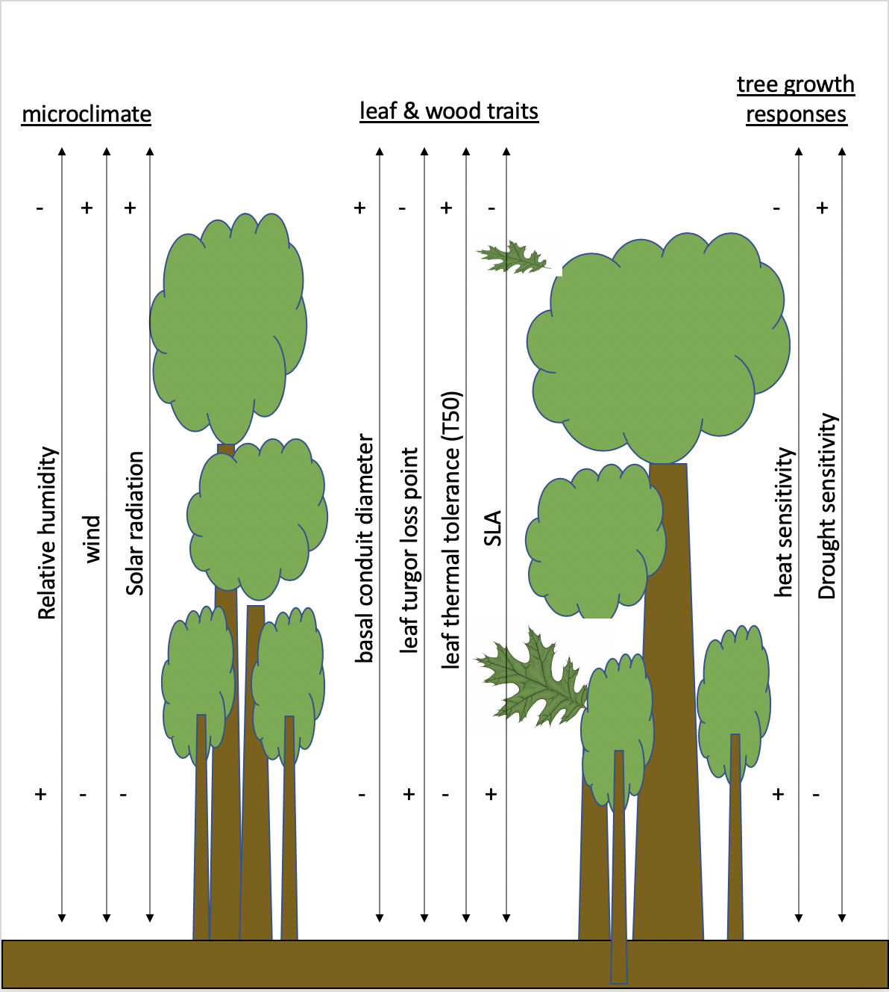

**Fig. 2- Vertical gradients in the biophysical environment, from NEON data. Current figure is old version from Ian McGregor’s in-revision paper, showing NEON data from SCBI. We could modify his code to analyze all forested NEON sites. We obviously wouldn’t present this much info per site.**

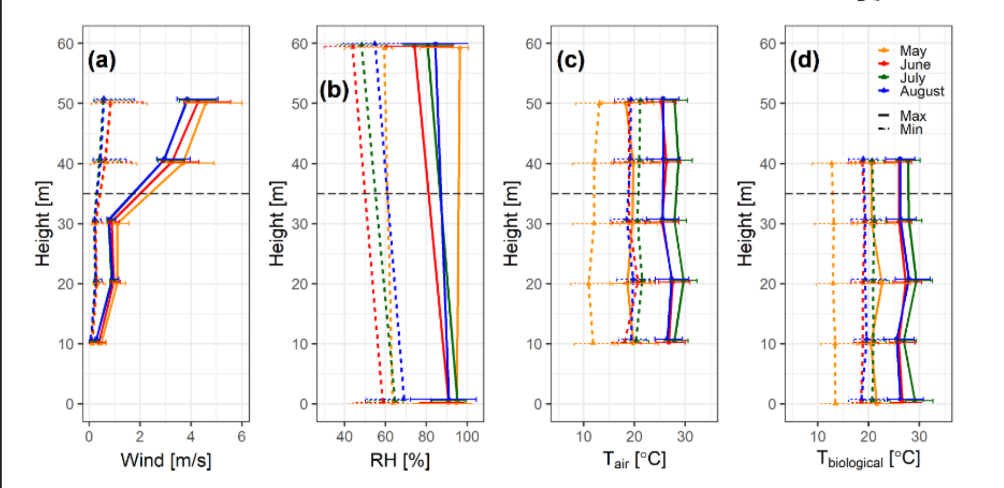

**Fig. 3- 3D plots of leaf T in response to some key parameters, based on Campbell & Norman?**

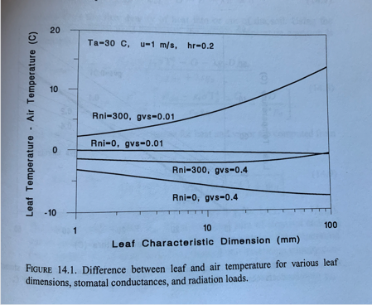

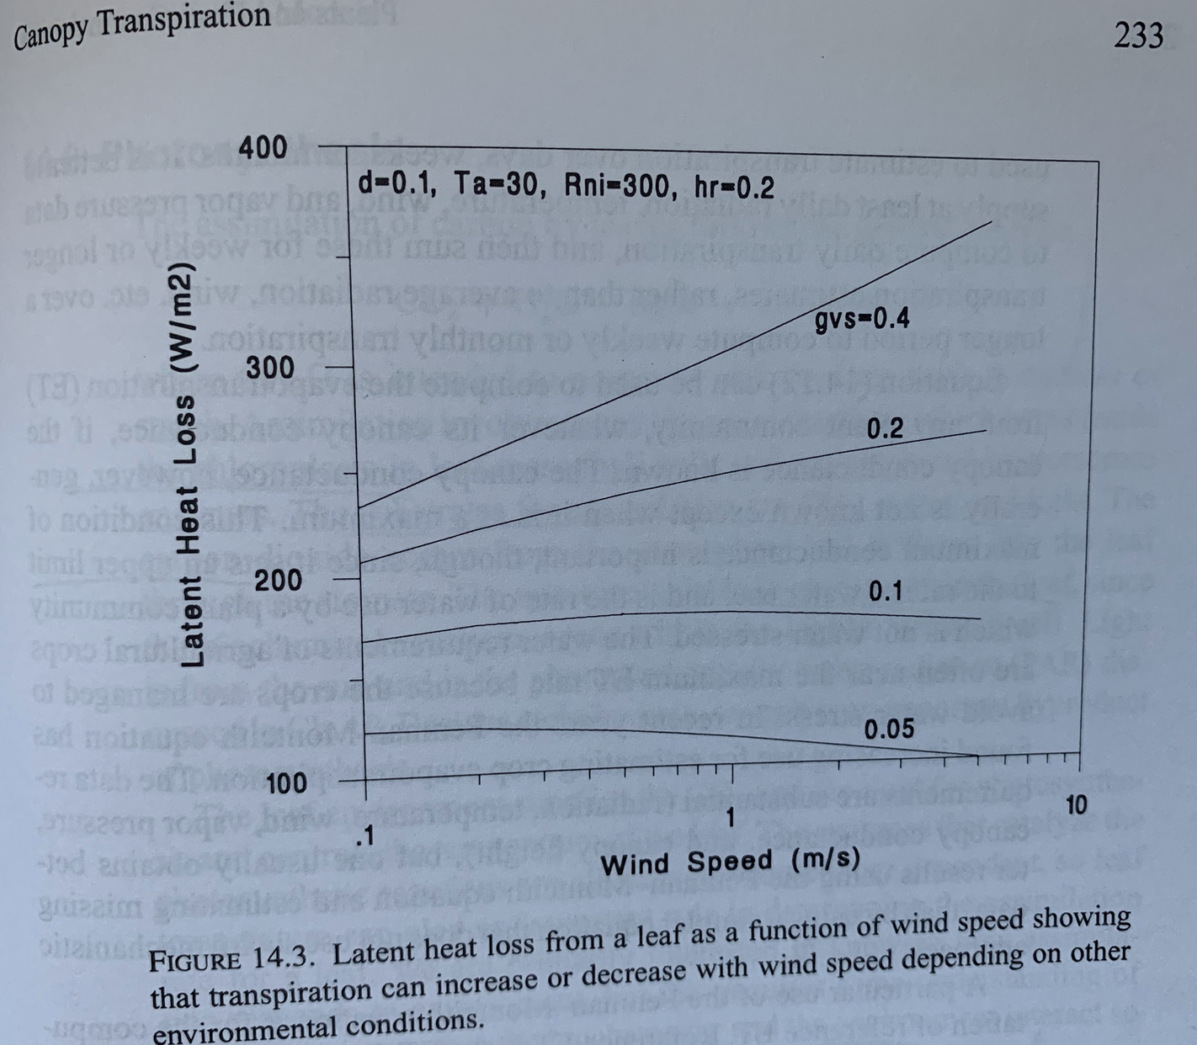

**References**

Bennett, A. C., N. G. McDowell, C. D. Allen, and K. J. Anderson-Teixeira. 2015. Larger trees suffer most during drought in forests worldwide. Nature Plants 1:15139.

Bolstad, P. V., K. Mitchell, and J. M. Vose. 1999. Foliar temperature–respiration response functions for broad-leaved tree species in the southern Appalachians. Tree Physiology 19:871–878.

Bonan, G. B. 2016. Ecological climatology: concepts and applications. Third edition. Cambridge University Press, New York, NY, USA.

Campbell, G., and J. Norman. 1998. An Introduction to Environmental Biophysics. Springer, New York.

Cavaleri, M. A., S. F. Oberbauer, D. B. Clark, D. A. Clark, and M. G. Ryan. 2010. Height is more important than light in determining leaf morphology in a tropical forest. Ecology 91:1730–1739.

Cavaleri, M. A., S. F. Oberbauer, and M. G. Ryan. 2008. Foliar and ecosystem respiration in an old-growth tropical rain forest. Plant, Cell & Environment 31:473–483.

Condit, R., K. Watts, S. A. Bohlman, R. Pérez, R. B. Foster, and S. P. Hubbell. 2000. Quantifying the deciduousness of tropical forest canopies under varying climates. Journal of Vegetation Science 11:649–658.

Curtis, E. M., C. A. Knight, and A. Leigh. 2019. Intracanopy adjustment of leaf-level thermal tolerance is associated with microclimatic variation across the canopy of a desert tree (Acacia papyrocarpa). Oecologia 189:37–46.

Davis, K. T., S. Z. Dobrowski, Z. A. Holden, P. E. Higuera, and J. T. Abatzoglou. 2019. Microclimatic buffering in forests of the future: the role of local water balance. Ecography 42:1–11.

Fauset, S., H. C. Freitas, D. R. Galbraith, M. J. P. Sullivan, M. P. M. Aidar, C. A. Joly, O. L. Phillips, S. A. Vieira, and M. U. Gloor. 2018. Differences in leaf thermoregulation and water use strategies between three co-occurring Atlantic forest tree species. Plant, Cell & Environment 41:1618–1631.

Koike, T., M. Kitao, Y. Maruyama, S. Mori, and T. T. Lei. 2001. Leaf morphology and photosynthetic adjustments among deciduous broad-leaved trees within the vertical canopy profile. Tree Physiology 21:951–958.

Mau, A., S. Reed, T. Wood, and M. Cavaleri. 2018. Temperate and Tropical Forest Canopies are Already Functioning beyond Their Thermal Thresholds for Photosynthesis. Forests 9:47.

Meakem, V., A. J. Tepley, E. B. Gonzalez‐Akre, V. Herrmann, H. C. Muller‐Landau, S. J. Wright, S. P. Hubbell, R. Condit, and K. J. Anderson‐Teixeira. 2018. Role of tree size in moist tropical forest carbon cycling and water deficit responses. New Phytologist 219:947–958.

Muir, C. D. 2019. tealeaves: an R package for modelling leaf temperature using energy budgets. AoB PLANTS 11.

O’sullivan, O. S., M. A. Heskel, P. B. Reich, M. G. Tjoelker, L. K. Weerasinghe, A. Penillard, L. Zhu, J. J. G. Egerton, K. J. Bloomfield, D. Creek, N. H. A. Bahar, K. L. Griffin, V. Hurry, P. Meir, M. H. Turnbull, and O. K. Atkin. 2017. Thermal limits of leaf metabolism across biomes. Global Change Biology 23:209–223.

Rey-Sánchez, A. C., M. Slot, J. M. Posada, and K. Kitajima. 2016. Spatial and seasonal variation in leaf temperature within the canopy of a tropical forest. Climate Research 71:75–89.

Sastry, A., A. Guha, and D. Barua. 2018. Leaf thermotolerance in dry tropical forest tree species: relationships with leaf traits and effects of drought. AoB PLANTS 10.

Slot, M., G. H. Krause, B. Krause, G. G. Hernández, and K. Winter. 2019. Photosynthetic heat tolerance of shade and sun leaves of three tropical tree species. Photosynthesis Research 141:119–130.

Thom, D., A. Sommerfeld, J. Sebald, J. Hagge, J. Müller, and R. Seidl. 2020. Effects of disturbance patterns and deadwood on the microclimate in European beech forests. Agricultural and Forest Meteorology 291:108066.

Yang, P. C., T. A. Black, H. H. Neumann, M. D. Novak, and P. D. Blanken. 1999. Spatial and temporal variability of CO2 concentration and flux in a boreal aspen forest. Journal of Geophysical Research: Atmospheres 104:27653–27661.

Zellweger, F., D. Coomes, J. Lenoir, L. Depauw, S. L. Maes, M. Wulf, K. J. Kirby, J. Brunet, M. Kopecký, F. Máliš, W. Schmidt, S. Heinrichs, J. den Ouden, B. Jaroszewicz, G. Buyse, F. Spicher, K. Verheyen, and P. De Frenne. 2019. Seasonal drivers of understorey temperature buffering in temperate deciduous forests across Europe. Global Ecology and Biogeography 28:1774–1786.

Zellweger, F., P. De Frenne, J. Lenoir, P. Vangansbeke, K. Verheyen, M. Bernhardt-Römermann, L. Baeten, R. Hédl, I. Berki, J. Brunet, H. Van Calster, M. Chudomelová, G. Decocq, T. Dirnböck, T. Durak, T. Heinken, B. Jaroszewicz, M. Kopecký, F. Máliš, M. Macek, M. Malicki, T. Naaf, T. A. Nagel, A. Ortmann-Ajkai, P. Petřík, R. Pielech, K. Reczyńska, W. Schmidt, T. Standovár, K. Świerkosz, B. Teleki, O. Vild, M. Wulf, and D. Coomes. 2020. Forest microclimate dynamics drive plant responses to warming. Science 368:772–775.