**Title:** Thermal sensitivity of canopy versus understory leaves: patterns, mechanisms, and ecological implications

**Authors (so far, not necessarily in final order):** Nidhi Vinod1 Martijn Slot2 Ian McGregor Elsa Ordway Marielle N. Smith3 Tyeen Taylor Kristina J. Anderson-Teixeira1,2*

**Author Affiliations:**

1. Conservation Ecology Center; Smithsonian Conservation Biology Institute; Front Royal, VA 22630, USA
2. Smithsonian Tropical Research Institute; Panama, Republic of Panama
3. Department of Forestry, Michigan State University, East Lansing, MI 48824, USA

*corresponding author: [teixeirak@si.edu](mailto:teixeirak@si.edu); +1 540 635 6546

## Abstract

## Introduction

Globally, temperatures have risen # C since YEAR and are expected to rise an additional #-#C by YEAR (IPCC REF). There is also increasing severity and frequency of heat waves (Perkins et al. 2012). This is expected to have profound effects on forest biodiversity and ecosystem function (REFS), and the resulting feedbacks to the climate system (e.g., decreased C storage, altered albedo and hydrology) will have a critical influence on the future of trajectory of climate change (e.g., Bonan 2008). With increases in temperature, temperate and tropical forest canopies are already or will soon be functioning beyond their optimal photosynthetic threshold (Mau et al. 2020; Huang et al. 2019). This, alongside climate change-driven disturbances such as drought, may contribute to increasing tree mortality in forests around the world (McDowell et al. 2020; Allen et al. 2015; Brienen et al. 2015).

**Rising temperatures are likely to have differential impacts on trees of different size and canopy position, in large part because small understory trees exist in a microenvironment that is substantially buffered by the more exposed canopy trees (Davis *et al.*, 2019; Zellweger *et al.*, 2019; Zellweger et al. 2020).** Globally, we’re seeing larger trees suffering more during drought (Bennett et al. 2015; Stovall et al. 2019). Increasing mortality of large trees, sometimes coupled with reduced tree growth rates, is driving a global trend towards more disturbed forests with younger trees (McDowell et al. 2020). Additionally, decrease in canopy cover or increase in canopy mortality as a result of increasing temperature (Cornelius Senf et al. 2018) has shown to increase understory temperatures which raises concern for understory species and forest biodiversity (Zellweger et al. 2019, Defrenne et al. 2013).

**The structure and microclimates of global forests are changing due to unprecedented disturbance rates.** Loss of canopy cover due to forest disturbances (e.g., deforestation, fire, and drought) is associated with reductions in canopy structural complexity, and altered microclimates and surface energy balance components (Zellweger et al. 2020; Stark et al. 2020). Reductions in canopy cover can lead to non-linear threshold responses, causing dramatic shifts from one forest state to another (e.g., transition from forest to savanna-like vegetation in tropical forest regions through “savannization”), with energy balance impacts and implications for forest-atmosphere interactions (Stark et al. 2020).

We’re seeing increasing evidence that this impacts the ecology, with potential feedbacks to climate change, especially in protecting cool-acclimated species (Suggitt et al. 2018, Scheffers et al. 2013, Defrenne et al. 2013). - Zellweger *et al.* (2020) - (Suggitt et al. 2018, Scheffers et. al 2014)

Understanding thermal sensitivity along the vertical canopy profile, from the understory to the top of the canopy will provide crucial insights for how raising temperature affects forest ecology and biodiversity, energy balance, ecosystem function, and biosphere-atmosphere interactions [with additional feedbacks to forest structure and microclimates].

**However, we lack a systematic understanding of biophysical and biological patterns across this gradient, how these affect leaf-level processes, and in turn how it affects ecology (Fig. 1).**

**This review addresses the following questions:**

1. How does the biophysical environment vary with height in forests?
2. How do leaf traits vary with height (or between sun and shade leaves) in forests?
3. How do biophysical environment and traits combine to affect leaf temperature?
4. How does leaf metabolism respond to temperature in canopy and understory settings?
5. What are the implications of these patterns for the ecology and climate change responses of canopy versus understory trees?

*Our primary interest is the gradient in height and exposure from the top of the canopy to the understory in forests. However, because a lot of the relevant research has focused on exposure gradients near ground level (e.g., comparisons of sun and shade leaves), and the implications [or utility] for ecosystem models, we also review studies focused on exposure gradients.*

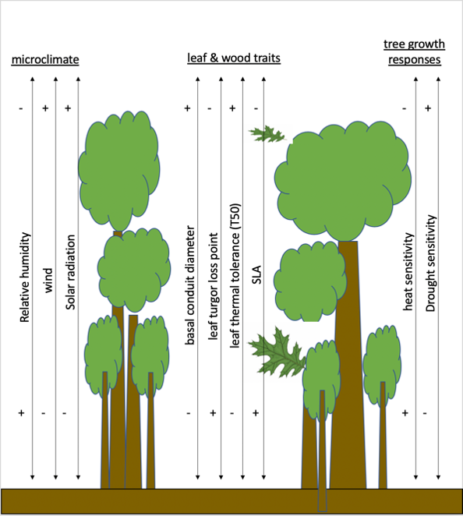

**Figure 1. (schematic of a forest summarizing most important gradients.** Current fig is just a rough illustration of how this might look – a draft figure that KAT had on hand illustrating hypotheses (ignore specific content). We could have a set of arrows for each of the major categories considered here. This would be a key figure, and should be beautifully illustrated—KAT could do a watercolor, or Nidhi could illustrate).

## The biophysical environment

[Maybe we should start this section with a brief definition of what we mean by “biophysical”? E.g. the physical structure of the forest canopy (from understory to the canopy top) and associated microclimates, which are in large part determined by the structure of the forest itself.]

**Forest canopies have a buffering effect on multiple aspects of the understory climate (Fig.** 2**).** Most notably, light conditions vary with canopy height due to cumulative layers of vegetation that limit light to lower canopy layers (Mau et. al 2018, Fauset et al. 2017, Niinemets et al.2009, Parker 1995) (Fig. **2x**). Solar radiation decreases along a vertical height profile (Mau et al. 2018, M.A. Caveleri et al , Niinemets, REFS; Stark et al. 2012; Parker et al. 2019), such that the forest floor of understory regions receives 1-2% of the light incident to the top of the canopy (Roberts et al. 1990; Chazdon & Fetcher 1984; XXXX). In heterogeneous canopies [with high gap fractions], distance from the outer canopy is a better proxy for light environment than height (Parker 1995) and lower canopy light environments are highly variable, ranging from high light gap to deeply shaded understory regions (Chazdon & Fetcher 1984; Tymen et al. 2017; Smith et al. 2019). In addition, the vertical structure and hence, microenvironments of forest canopies vary seasonally (Parker & Tibbs 2004; Smith et al. 2019; Parker et al. 2019) and following disturbance (e.g., Parker et al. 2002; Almeida et al. 2016; Stark et al. 2020 *in press*). Radiation is an important variable in determining differences in leaf traits and responses to temperature (Mau et. al 2018, Fauset et al. 2017, Rey Sanchez et al. 2016, Doughty and Gouden 2008) - (*Bonan (2016) reviews this and points to appropriate references*) - Sunflecks: Leaky et al. 2003?

**Wind speeds are also higher at the top of the canopy (Fig.** 2x**).** *(fill in some specifics from the NEON analysis)* Consistent with the results from NEON sites, higher wind speed at greater heights within a forest have previously been observed in both closed canopy forests (e.g., REFS; Niinemets et al. 2009 (& citations therein); McGregor *et al.*) and open savannas (Curtis et al. 2018). This results in higher boundary layer conductance, *DEFINE*, for canopy leaves [Martin *et al.* (1999); Roberts et al. 1990].

**Air temperature, , is sometimes significantly buffered by forest canopies (Fig.** 2x**).** Studies comparing under forest canopies with nearby clearings have found lower maximum temperatures under forest canopies across Europe (Zellweger *et al.*, 2019) and in the northwestern United States (Davis *et al.*, 2019). Similarly, maximum air temperatures were higher above than below tropical forest canopies during wet seasons in Panama (Rey-Sánchez et al. 2016) and coastal Brazil (Fauset et al. 2018). However, similar maximum temperatures have been observed during the dry season in Panama (Rey-Sánchez et al. 2016) and in a temperate deciduous forest in the eastern United States (McGregor *et al.*). Minimum is also buffered by forest canopies under some conditions. Higher minimum temperatures under forest canopies relative to nearby clearings have been observed across Europe (Zellweger *et al.*, 2019) and in the northwestern United States (Davis *et al.*, 2019). However, similar minimum temperatures under forest canopies have been observed in tropical forests in Panama (Rey-Sánchez et al. 2016) and coastal Brazil (Fauset et al. 2018), as well as in a temperate deciduous forest in the eastern United States (McGregor *et al.*). *(Add something about risk of freeze.)*

**Humidity also varies across the forest vertical profile, being generally higher in the understory (Fig.** 2x**).** - DETAILS - REFS - McGregor *et al.* RH, in combination with temperature, determines vapor pressure deficit, - is lower in understory of Atlantic forest during wet season (Fauset et al. 2018) This means that canopy leaves tend to be exposed to higher *evaporative demand*.

**Finally, carbon dioxide (CO2) concentrations tend to be higher in the understory.** - Higher in understory, particularly at dusk (Koike et al. 2001). - Higher in the understory overnight; difference persists during the day but is very small (Yang *et al.*, 1999). Differences in concentration are by far most pronounced near ground level. Given that differences are small during the day when photosynthesis is active, and that even nighttime differences are modest at the height of understory tree crowns, CO2 concentration is unlikely to have much effect on the energy balance and metabolism of leaves across the forest vertical gradient.

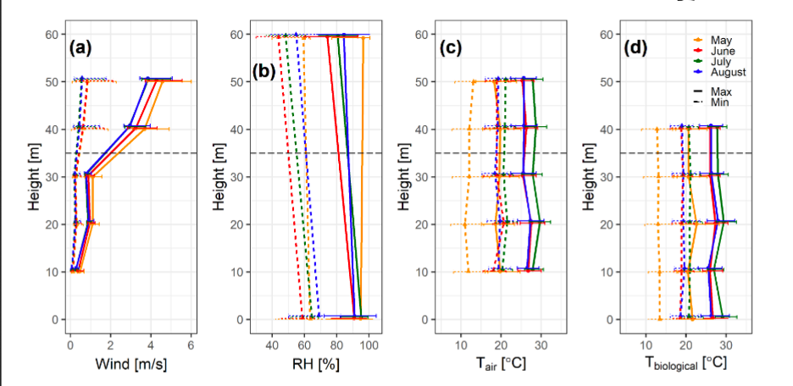

**Figure 2. Vertical gradients in the biophysical environment, from NEON data.** Current placeholder figure is old version from Ian McGregor’s in-review paper, showing NEON data from SCBI. See issue 2: <https://github.com/EcoClimLab/vertical-thermal-review/issues/2>.

**The strength of this buffering varies across forests, being influenced by both forest characteristics and the biophysical environment.** First, buffering increases with canopy cover. - greater cover –> lower max T and VPD, higher minT (Davis *et al.*, 2019) - greater cover –> lower max T and light availability (Zellweger *et al.*, 2019) - (Thom *et al.*, 2020; Tymen et al. 2017; Jucker et al. 2018; Hardwick et al. 2015) *Presumably, buffering would also be affected by canopy roughness, which affects turbulent air flow and the canopy boundary layer.* Taller trees don’t necessarily increase buffering (Zellweger *et al.*, 2019). SCA species increase T buffering (Zellweger *et al.*, 2019) The strength of buffering also varies with respect to geographic and climatic factors. - Distance to coast, topographic position, elevation (Zellweger *et al.*, 2019) - (Davis *et al.*, 2019)

## Trait variation

[Add something about how leaf traits along the vertical canopy profile are different than the expectation from leaf economic spectrum (LES)? Chen et al. 2020 is a good paper to help frame this. They make an important point in that paper that we may also want to make here: that the LES was ‘built’ using mainly sun (upper canopy) leaves; given the vastly different light environments at the bottom of the canopy (and that most leaves in the canopy are likely to be shade leaves) there is a strong research need to better characterise trait relationships and leaf responses through the whole vertical canopy – hence the importance of this review. Keenan & Niinemets 2016 will also be helpful in making this point.]

**Many traits vary with height and/or between sun and shade leaves on the same species (Table 1).** Here, we focus on traits that are important for shaping leaf temperature () and thermal sensitivity.

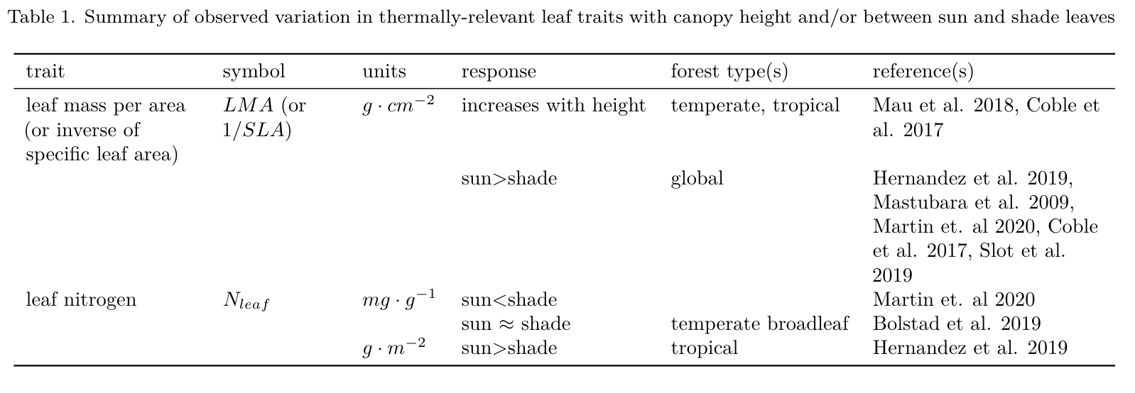

(For latest version of table, see tables.pdf.)

Are traits shaped more by height or light? - “Height is more important than light in determining leaf morphology in a tropical forest” (Cavaleri et al. 2010) - (Cavaleri et al. 2008) - from Martijn: “If I remember correctly, height and light exposure are closely correlated and things like LMA scale with both, but above a certain level of light exposure, the effect of additional light disappears, while the relationship of the morphological traits with height continues. I have often been a bit skeptical about assuming height drives morphology, as most of the work that convincingly shows that (and relates it to turgor pressure for example) is from 100 m tall redwoods.”

*Leaf area / characteristic dimension*: - Recent paper on influence on leaf size/shape in PCE – certain aspects of leaf shape were not as relevant as expected.

*Max stomatal conductance* – increases with canopy height (Kenzo et al. 2015).

*Max transpiration rate –* increases with canopy height (Kenzo et al. 2015).

*Thermal time constant (probably not a lot out there)* - Curtis et. al, 2018 – higher in more exposed leaves (heat up slower, cool slower) - Michaeletz has used this in theoretical calculations (Michaeletz et al. 2016 and 2015?

*Carotinoids* - photoprotective- disseminate heat, acclimate to high T. THese are proportional to irradiance - antioxidant scavenging function- protect against cellular damage - Königer et. al. 1995, and Matsubara et al. 2009?

*Isoprene production* - Isoprene production *capability* as a trait (actual isoprene production is in section 4. I’m not sure whether Ty’s content belongs here or in that section)

## Leaf temperature

**Many of the biophysical and trait variables reviewed above affect leaf temperature, , which in turn has a strong influence on leaf metabolism (see following section).** is determined by the energy balance of a leaf and can be estimated based on basic biophysical principles (Campbell & Norman, 1998; Muir, 2019) (Fig. 3). While small leaves remain within a few degrees of , regardless of stomatal conductance, wider leaves can have temperatures deviating more from air temperature. Large leaves can be significantly cooler than under low radiation with stomata open, and significantly hotter under high radiation with stomata closed.  
Leaves with open stomata and high radiation loads maintain similar to , with coolest leaves at intermediate sizes (~10mm). Shaded understory leaves should tend to maintain cooler daytime leaf temperatures for any given level of stomatal conductance. However, counteracting this, lower wind speed in understory would reduce latent heat loss. Thus, under hot conditions, canopy leaves exposed to higher wind speeds would be most effective at cooling when sufficient water is available to maintain high stomatal conductance; however, their can be highly elevated above when stomatal conductance is limiting.

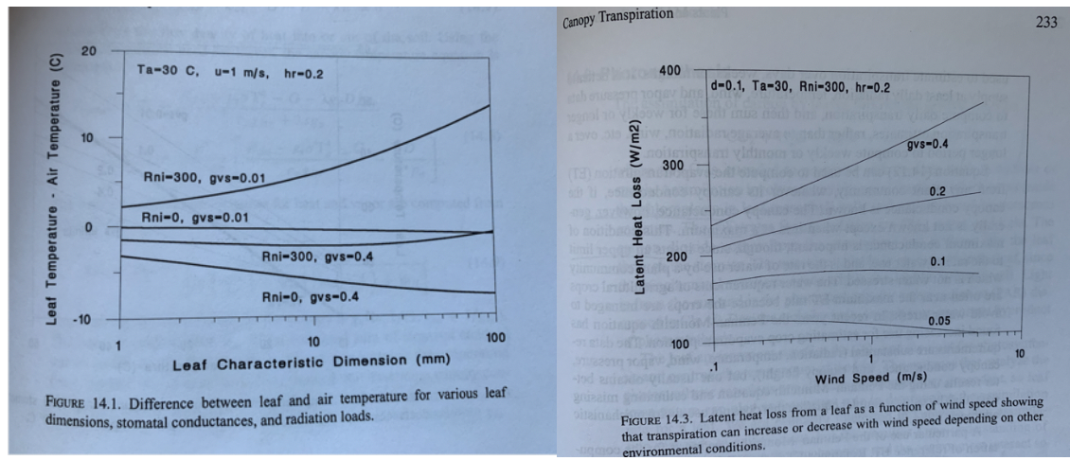

**Figure 3. Leaf temperature in response to (a) XXX, (b) XXX (key trait or environmental variables).** Examples to be produced based on energy balance model using the tealeaves R package of Muir (2019): <https://github.com/EcoClimLab/vertical-thermal-review/issues/6>. Current placeholder shows figures from Campbell&Norman.

**Aligning with biophysical expectations, field observations have shown that leaf temperatures are influenced by the biophysical environment and leaf traits.** 1. Air T 2. Solar radiation 3. Leaf traits - Michaletz et al have done some interesting work on leaf thermoregulation in relation to various leaf traits. I don’t think there is sun vs shade tests, but we could look at how this might translate, or how some of the traits he has calculated might differ between sun and shade leaves. For example, he has this thermal time constant parameter that is calculated from leaf mass per area, leaf dry matter content, and some environmental parameters. E.g.: DOI: 10.1038/nplants.2016.129, <http://dx.doi.org/10.1016/j.tree.2015.09.006>

**When vertical gradients in the biophysical environment and leaf traits combine to shape leaf energy budgets, often differs little from and between understory and canopy (Fig.** 2?**).** For instance… (Bolstad et al. 1999). Similarly, during the dry season in a tropical moist forest in Panama… (Rey-Sánchez et al. 2016). **However, canopy leaves can reach much higher maximum , and higher , than understory leaves.** - (Slot et al. 2019) and refs therein - (Fauset et al. 2018) Sun leaves can also be cooled relative to more than shade leaves (Rey-Sánchez et al. 2016).

## Leaf metabolism and thermal responses

Leaf metabolism is strongly shaped by leaf temperature, and by the traits and environmental drivers reviewed above, all of which vary across vertical forest gradients (Fig. 1). However, as we detail below, there are limited studies comparing thermal responses of sun and shade leaves (Table 2).

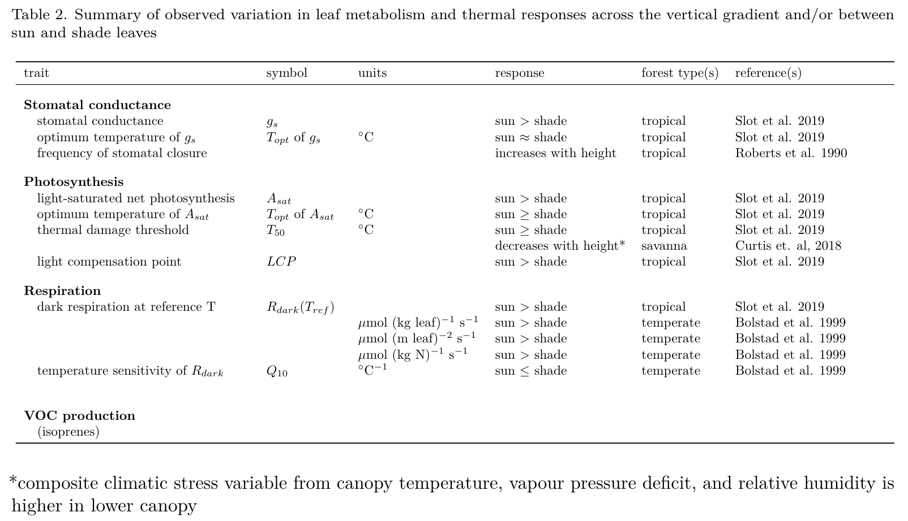

(For latest version of table, see tables.pdf.)

*Stomatal conductance*

*Photosynthesis*

**Photosynthesis is generally higher in sun leaves– a fact that is well-established (Niinemets 2007; Kenzo et al. 2015; Slot et al. 2019; Chen et al. 2020) and observed in numerous field studies.** This is primarily driven by the greater light available to sun leaves. In response to the greater light availability, sun leaves have traits allowing greater photosynthetic rates at high light, including …. The vertical gradient in photosythetic rates is also influenced by…[thoughts: plasticity vs change in tree species composition through the canopy; differences in variability of microenvironments through the profile – highest lower down in canopy?; life history / investment strategies and hence, leaf life spans at leaves at the top vs bottom of the canopy]

**While sun and shade leaves differ dramatically in , the temperature sensitivity of photosynthesis does not appear to differ substantially between sun and shade leaves** Biophysically, we might expect that sun leaves should tend to have a stronger temperature-dependence and higher temperature optima than shade leaves (Fig. 14.5; *revisit this!*) (Campbell and Norman 1998). However, this does not appear to be the case based on the limited number of field studies that have compared temperature sensitivity of photoshythesis in sun and shade leaves. For 3 species in Panama, (Slot et al. 2019) found that the optimum temperature for sun leaves tended to be slightly higher than that of shade leaves, but differences were not significant. Mau et al. found no trend along a height gradient in Puerto Rico, and no significant trend in temperate trees (Mau et al. 2018).

**Leaf thermal tolerance (Tcrit/ T50)** - define. Typical values ~45-50C, varying somewhat across latitude/climate (O’sullivan et al. 2017), with elevation [Feeley *et al.* (2020); Slot unpublished data], with leaf traits (Sastry et al. 2018, Zhang *et al.*, 2012).

**Thermal tolerance (e.g., ) varies with exposure, but there are no studies isolating effect of height.** For two of three species studied in a tropical moist forest in Panama, was slightly lower for shade than sun-exposed leaves, both measured near ground level (Slot et al. 2019). Similarly, for *Acacia Papyrocarpa* (Benth.) trees in an arid region of southern Australia, higher was observed in more exposed (North-facing) canopy positions (Curtis et al. 2019). We’re not aware of any other studies on this.

*Respiration*

**Similar to photosynthesis, respiration tends to be higher in sun leaves (Chen et al. 2020), but its temperature sensitivity appears to be similar between sun and shade leaves.** (Bolstad et al. 1999) did a study at Coweeta, including elev gradient. Found higher respiration (at reference T) in canopy leaves (Bolstad *et al.* (1999)). (*Martijn has some unpublished data on this that we might include:* [*https://github.com/EcoClimLab/vertical-thermal-review/issues/8*](https://github.com/EcoClimLab/vertical-thermal-review/issues/8)*.*) At Coweeta, Q10 showed a variable pattern, with a slight tendency to increase down the canopy (Bolstad *et al.*, 1999). (*Martijn has some unpublished data on this that we might include.unpublished data showing higher Q10 in shade than in sun leaves for 10 species or so. May make sense to include here:* [*https://github.com/EcoClimLab/vertical-thermal-review/issues/8*](https://github.com/EcoClimLab/vertical-thermal-review/issues/8)*.*) Combining reference respiration and , Bolstad *et al.* (1999) found a modest net decrease in R for understory leaves relative to canopy leaves as T increases (*see their Fig. 1*). Thus, Bolstad *et al.* (1999) found evidence of acclimation, but there remained a declining trend of respiration with elevation.

*VOC production*

**Isoprene production** - high emission rates occur in the mid-canopy, and even from very small statured trees and shrubs, at a site in the Brazilian Amazon (Taylor et al., in prep). - The high temperature carbon compensation point of sun leaves is higher in isoprene emitting species than in non-emitting species, so it is to be expected that other aspects of heat tolerance will be similarly affected by isoprenes (<https://doi.org/10.1111/pce.13564>). - Within species, isporene production scales with light/ T

## Ecology

**Differences across forest vertical gradients in biophysical conditions, plant traits, and metabolism and its thermal responses scale up to affect whole-tree ecology in several ways.** First, vertical gradients in the biophysical environment shape which plant strategies, or sets of traits, are competitive in understory versus canopy conditions. - *Spring and fall leaf phenology in temperate deciduous forests (Augsburger). Mechanism: more moderate conditions (T, wind) in understory (REF).* *Among species that can be deciduous, greater proportion of deciduous individuals in larger size classes (Condit et al. 2000). One potential mechanism is lower temperature/hydraulic stress in understory* - something on isoprene production?

**Vertical gradients also affect tree growth and survival, and how these respond to climatic variation.** There are numerous demographic differences between understory and canopy trees, which have been linked to both the physical environment and plant traits (e.g., REFS), and we will not attempt to review those here. More interesting in this context is how these shape differences in the climatic sensitivity of growth and mortality. Many observations of larger trees suffering more during drought (Bennett et al. 2015). One likely mechanism behind this pattern is that the crowns of larger trees exist higher in the vertical profile and therefore are exposed to higher evaporative demand and solar radiation (McGregor *et al.*). Although drought is primarily a hydraulic problem, lack of water –> lower gs –> higher leaf T, so leaves face tradeoffs of water loss vs potentially damaging leafT.

**There is also recently emerging evidence that understory trees tend to exhibit greater growth declines with under mesic conditions.** In eight forests across the northeast United States, growth rates of understory trees declined sharply at higher (Rollinson et al., in review). Similarly, our previously unpublished analysis shows that in a broadleaf deciduous forest in Virginia, understory trees in a Mid-Atlantic forest responded more negatively to warmer than did canopy trees (Fig. **4**; Appendix **S3**). This pattern is initially counter-intuitive in that sun-exposed leaves can experience greater elevation of over than shade leaves (Fig. **3?**). However, given adequate moisture to sustain high , canopy leaves exposed to more wind and lower humidity should be more effective at cooling when exceeds physiological optima (Fig. **3**). It is also possible that competition is accelerated under warmer temperatures.

**Appears to affect community change under warming (Zellweger et al. 2020).**

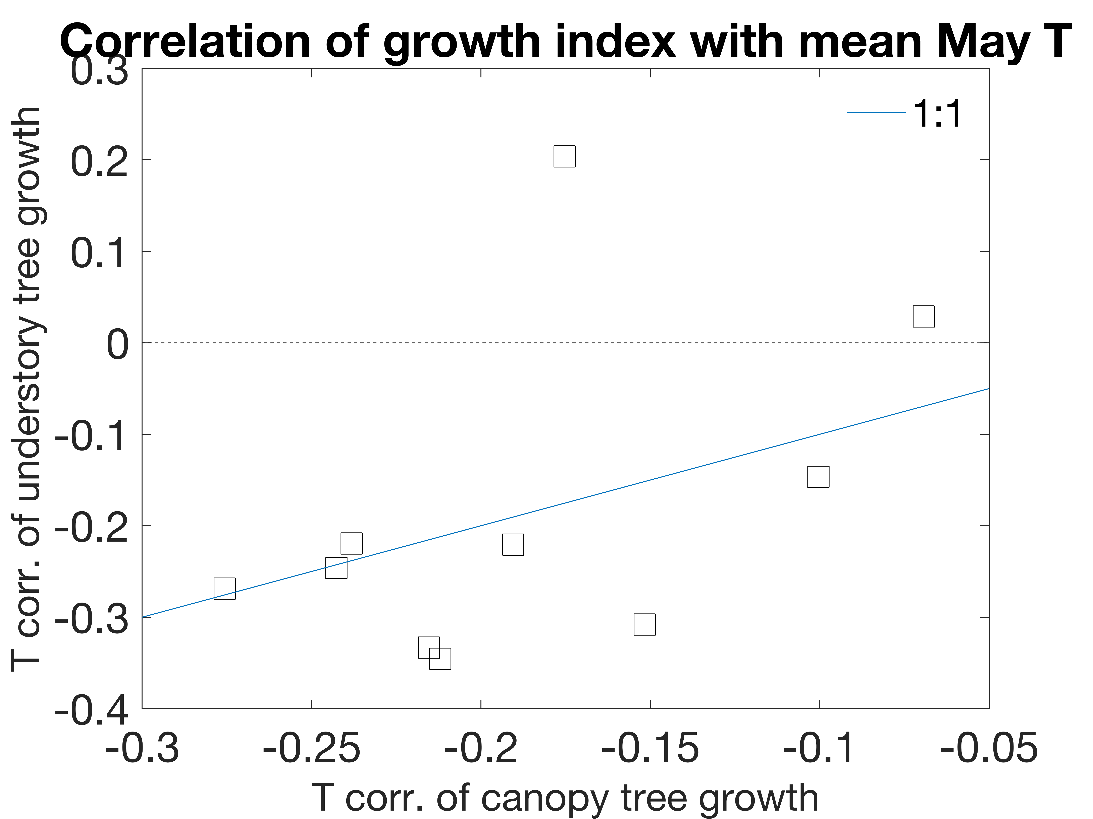

**Figure 4. Temperature sensitivity of tree growth for understory versus canopy trees.** Analysis methods described in Appendix S3. Data from Helcoski et al. 2019.

## Implications for Modeling / Scaling

E.g. see de Pury & Farquhar, 1997: though likely an improvement over ‘big-leaf’ models, models that separate the canopy into sunlit and shaded portions (sun/shade models) may not be able to capture important within-canopy variation in terms of leaf dynamics (e.g. seasonal shifts in vertical leaf area distributions, Smith et al. 2019) and functions (e.g. thermal responses, as we present in this paper). Hence, multi-layered ecosystem models may be necessary for accurately projecting future forest function.

## Future Questions

* Are patterns (in traits, metabolism, ecology) driven by tree height or exposure?
* CO2 may lead to denser understory (Martijn)
* Influence of increasing temperatures on species compositions and feedbacks to future forest microclimates and function?
* To what extent do sun vs shade leaves (or leaves along the whole vertical profile) contribute to forest photosynthesis? How is this likely to change under future higher temperatures (& the varied leaf thermal responses & microclimates along the profile)?
* How are vertical microclimate profiles affected by forest disturbance?

## Conclusions

## SI files

Appendix S1. Methods for NEON vertical profiles

Appendix S2. Methods for literature review

Appendix S3. Methods for SCBI tree-ring analysis

## References

**Bolstad PV, Mitchell K, Vose JM**. **1999**. Foliar temperature–respiration response functions for broad-leaved tree species in the southern Appalachians. *Tree Physiology* **19**: 871–878.

**Bonan GB**. **2016**. *Ecological climatology: Concepts and applications*. New York, NY, USA: Cambridge University Press.

**Campbell G, Norman J**. **1998**. *An Introduction to Environmental Biophysics*. New York: Springer.

**Davis KT, Dobrowski SZ, Holden ZA, Higuera PE, Abatzoglou JT**. **2019**. Microclimatic buffering in forests of the future: The role of local water balance. *Ecography* **42**: 1–11.

**Feeley K, Martinez-Villa J, Perez T, Silva Duque A, Triviño Gonzalez D, Duque A**. **2020**. The Thermal Tolerances, Distributions, and Performances of Tropical Montane Tree Species. *Frontiers in Forests and Global Change* **3**.

**Martin TA, Hinckley TM, Meinzer FC, Sprugel DG**. **1999**. Boundary layer conductance, leaf temperature and transpiration of Abies amabilis branches. *Tree Physiology* **19**: 435–443.

**McGregor I, Helcoski R, Kunert N, Tepley AJ, Gonzalez-Akre EB, Herrmann V, Zailaa J, Stovall AEL, Bourg NA, McShea WJ *et al.*** Tree height and drought tolerance traits shape growth responses across droughts in a temperate broadleaf forest. *Target journal: New Phytologist*.

**Muir CD**. **2019**. Tealeaves: An R package for modelling leaf temperature using energy budgets. *AoB PLANTS* **11**.

**Thom D, Sommerfeld A, Sebald J, Hagge J, Müller J, Seidl R**. **2020**. Effects of disturbance patterns and deadwood on the microclimate in European beech forests. *Agricultural and Forest Meteorology* **291**: 108066.

**Yang PC, Black TA, Neumann HH, Novak MD, Blanken PD**. **1999**. Spatial and temporal variability of CO2 concentration and flux in a boreal aspen forest. *Journal of Geophysical Research: Atmospheres* **104**: 27653–27661.

**Zellweger F, Coomes D, Lenoir J, Depauw L, Maes SL, Wulf M, Kirby KJ, Brunet J, Kopecký M, Máliš F *et al.*** **2019**. Seasonal drivers of understorey temperature buffering in temperate deciduous forests across Europe (A Algar, Ed.). *Global Ecology and Biogeography* **28**: 1774–1786.

**Zellweger F, De Frenne P, Lenoir J, Vangansbeke P, Verheyen K, Bernhardt-Römermann M, Baeten L, Hédl R, Berki I, Brunet J *et al.*** **2020**. Forest microclimate dynamics drive plant responses to warming. *Science* **368**: 772–775.

**Zhang J-L, Poorter L, Hao G-Y, Cao K-F**. **2012**. Photosynthetic thermotolerance of woody savanna species in China is correlated with leaf life span. *Annals of Botany* **110**: 1027–1033.