**Title:** Thermal sensitivity across forest vertical profiles: patterns, mechanisms, and ecological implications

**Authors (so far, not necessarily in final order):** Nidhi Vinod1, Martijn Slot2, Ian McGregor3, Elsa M. Ordway4, Marielle N. Smith5, Tyeen Taylor, Lawren Sack, Kristina J. Anderson-Teixeira1,2*

**Author Affiliations:**

1. Conservation Ecology Center; Smithsonian Conservation Biology Institute; Front Royal, VA 22630, USA
2. Smithsonian Tropical Research Institute; Panama, Republic of Panama
3. Center for Geospatial Analytics; North Carolina State University; Raleigh, NC 27607, USA
4. Department of Organismic and Evolutionary Biology, Harvard University, Cambridge, MA 02138, USA
5. Department of Forestry, Michigan State University, East Lansing, MI 48824, USA

*corresponding author: [teixeirak@si.edu](mailto:teixeirak@si.edu); +1 540 635 6546

## Summary

*(currently too long for NewPhyt)*

Rising temperatures are expected to have profound effects on forests; however, it is not well understood how responses will vary across forest strata. Here, we synthesize evidence as to how environmental conditions and foliar traits vary across vertical gradients, shaping leaf temperatures, metabolism, and ultimately whole-tree demography and ecosystem function. Strong vertical microclimatic gradients imply that canopy leaves are exposed to more solar radiation and higher evaporative demand than understory leaves, particularly in forests with dense canopies. However, foliar traits relevant to shaping leaf temperature () and metabolism also vary strongly across height or light gradients. Resulting ’s exceed air temperature () under conditions of high solar radiation, low wind, and low stomatal conductance. Differences are most pronounced when hydraulic limitations impede evaporative cooling such that ’s of sun-exposed canopy leaves become dramatically elevated above both and understory . While leaf metabolism generally increases with height across the vertical gradient, differences in thermal sensitivity, optimal temperatures, and thermal damage thresholds are modest. The implications for tree performance are mixed: whereas thermal buffering may contribute to the disproportionate stress of larger trees during drought, emerging tree-ring evidence suggests that understory trees experience relatively greater stress from high . Additional research will be important for improving our spotty understanding of the thermal sensitivity of metabolism and tree growth across vertical forest gradients. In the meantime, our findings imply that while large canopy trees are the most vulnerable to warming when combined with drought, understory trees may be more vulnerable under more mesic conditions.

# Introduction

**Forest responses and feedbacks to climate change will have a critical influence on the future of Earth’s climate.** Globally, temperatures have risen # C since YEAR and are expected to rise an additional #-#C by YEAR (IPCC REF), accompanied by increasing severity and frequency of heat waves (Perkins *et al.*, 2012) and hotter droughts [*Trenberth et al. 2014*]. These changes are expected to have profound effects on tree metabolism and forest ecosystem function (REFS; IPBES report), including altered rates of photosynthesis and respiration [REFS], foliar damage during heat waves [*O’Sullivan et al. 2017*], and reduced growth and elevated mortality during drought [REFS]. Individually or in combination, these changes have the potential to reduce forest C sequestration, as may already be occurring in some forests (REFS; Sullivan *et al.*, 2020). The resulting feedbacks to the climate system (e.g., decreased C storage, altered albedo and hydrology) will in turn have a critical influence on the future trajectory of climate change (Bonan, 2016, Bonan 2008), yet this influence remains extremely uncertain [REFS].

**Rising temperatures are likely to have differential impacts on trees of different size and canopy position, in large part because small understory trees exist in a microenvironment that is substantially buffered by the more exposed canopy trees (Davis *et al.*, 2019; Zellweger *et al.*, 2019).** Forests are vertically and horizontally stratified, with trees of different sizes through various successional stages. Overstory trees form canopies that play a crucial role in moderating macro-microclimate (Nakamura *et al.*, 2017; Ozanne *et al.*, 2003) by buffering extreme temperatures along with other macroclimatic conditions in the understory. This creates a vertical stratification of biophysical environmental conditions such as temperature, light, wind, humidity and CO2 that influences leaf traits, thermoregulation and metabolism along the gradient, with implications for whole plant performance (Fauset *et al.*, 2018; Michaletz *et al.*, 2016). Despite the fact that this vertical gradient inevitably shapes nearly every aspect of plant metabolism, demography, and ecology, we lack synthetic understanding of these gradients. *(Niinemets et al. (2004) highlights how biophysical and photosynthetic gradients vary along the vertical canopy profile, however our current knowledge of this topic is lacking.)* Importantly, this limits our ability to understand how warming temperatures will affect leaf-level metabolism, whole-plant performance, and, in turn, forest ecology and biodiversity, energy balance, ecosystem function, and biosphere-atmosphere interactions.

**Here we review how the biophysical environment and biological form and function vary across the vertical canopy gradient in forests.** We focus on five key themes (Fig. 1): (1) the biophysical environment; (3) leaf temperature (); (2) the leaf traits most strongly influence leaf temperature and metabolism; (4) foliar metabolism, including stomatal conductance, photosynthesis, respiration, and volatile organic compound (VOC) production; and (5) size-structuring of whole-tree and ecosystem function. *We then consider the implications for understanding forest responses to global change, including scaling across space and time.*

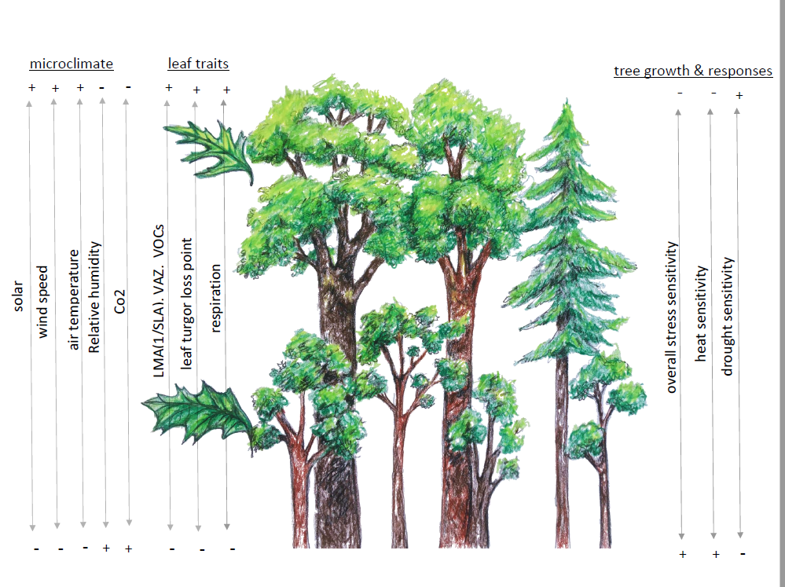

**Figure 1. DRAFT schematic of a forest summarizing most important gradients–sort of a “graphical abstract”.** [Issue #27](https://github.com/EcoClimLab/vertical-thermal-review/issues/27).

# Review of vertical gradients

## The biophysical environment

**The biophysical environment across the vertical gradient from the forest floor to the the top of the canopy is in large part determined by the structure of the forest itself.** Here, we define the biophysical environment to include the physical structure of the vegetation and associated physical conditions. In this section, we supplement a review of the existing literature with a new analysis of data on vegetation structure and vertical microclimate profiles from the U.S. National Ecological Observatory Network [NEON; Appendix S1; Schimel et al. 2007].

### Foliage density

**Canopy foliage, which is vertically structured in correspondence with the size structure of trees in the forest, acts as the primary physical barrier between the atmosphere and the forest floor, producing a buffering effect on multiple aspects of the understory conditions (Fig. 2).** Leaf area density…. *description of most common vertical pattern (Bonan (2016) reviews this and points to appropriate references)* Vertical profiles in leaf area density vary across forests, being… *summarize some key differences across forest types* (REFS), and are altered (*HOW?*) following disturbance (e.g., Parker *et al.*, 2002 ; Stark *et al.*, 2020; Almeida *et al.*, 2016 ). They also vary seasonally, … (Parker & Tibbs 2004; Smith *et al.* (2019) ; Parker *et al.* (2019)). *(can we say that there is more loss of leaves higher in the profile during cold/ drought dormant seasons? )* In this review, we focus primarily on growing season conditions, including leaf phenology at the edges of the growing season, but excluding periods when no leaves are present in deciduous forests.

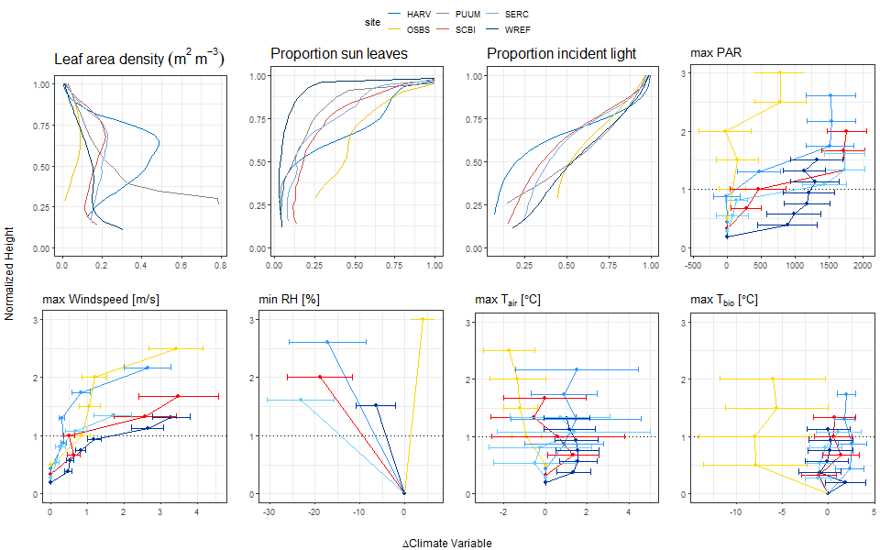

**Figure 2. Vertical gradients in the biophysical environment for 5/6 sites in the National Ecological Observatory Network (NEON)**. Shown are height profiles in growing season (a) leaf area density, (b) proportion light incidence, (c) proportion sun leaves, and July mean ± 1 standard deviation for (d) maximum photosyntehtically active ratiation (PAR), (e) maximum wind speed, (f) minimum humidity, (g) maximum , and (h) maximum biological temperature, . All variables are normalized relative to the height of the top of the canopy (**DETAILS**) and the conditions at the point of lowest measurement. ([issue 20](https://github.com/EcoClimLab/vertical-thermal-review/issues/20))

### Light environments

**Light conditions, specifically changes in proportion incident light and photosynthetically active radiation (PAR), vary along the vertical gradient with leaf area index (LAI), canopy height, canopy structure, and across species and forest types (Fig. 2; Koike *et al.*, 2001).** Generally, upper canopies in dense forests are exposed to greater PAR values and limit light penetration to canopy interiors, lower canopy layers, and the understory. Shaded regions experience lower values of PAR with different light quality [in ranges of blue, orange and red]. The light gradient is more pronounced under broadleaf forests than needleleaf forests (Fig. 2; Lowman & Rinker, 1995; Niinemets & Anten, 2009; Aussenac, 2000; Poorter *et al.*, 2019).

In heterogeneous canopies [with high gap fractions], the distance from the outer canopy [to X?] is a better proxy for light environment than height (Parker 1995) and lower canopy light environments are highly variable, ranging from high light gaps to deeply shaded understory regions (Chazdon & Fetcher, 1984; Smith *et al.*, 2019; Tymen *et al.*, 2017)

Tropical forests with densely packed overstory trees limit light to subsequent canopy layers and forest understories. Tropical forest floors receive approximately 1-2% of the incident light that hits the top of the canopy (Chazdon & Fetcher, 1984; Roberts *et al.*, 1990; Parker *et al.*, 2019), whereas mixed-wood boreal and northern temperate forest floors receive around 4-5% of full sunlight (Bartemucci *et al.*, 2006). However, vertical canopy layers and forest floors also receive light permeating through canopy gaps, as well as intermittent light penetration from tree, branch, and leaf movement caused by wind, defined collectively as sunflecks. Sunflecks can provide 10-80% of photon flux density for photosynthesis in canopy layers and understory, depending on canopy attributes such as foliage density, height and architecture (Way & Pearcy, 2012)

This difference in light regimes along a vertical profile is an important driver of plasticity in leaf traits, leaf physiology, adaptation, and thermal sensitivity. Leaves thus exhibit variation in leaf trait adaptations from sun to shade both along a vertical intra-canopy gradient, as well as inter-canopy [Michaletz *et al.* (2016); Fauset *et al.* (2018); (**???**); Sack *et al.* (2006); Niinemets (2006); Osnas et al. 2018].

* Sunflecks: Leaky et al. 2003–from Marielle, “This is another, higher resolution axis of the variability of microenvironments that is probably quite important to address. (Also see the papers by Robin Chazdon on temporal variability of light environments). Maybe we will want to add these sentences (above) and something about sunflecks to a separate section that specifically addresses sources of variation in forest structure & microenvironments (e.g., vertical, horizontal, seasonal, diurnal, and with disturbance)?”

### Wind speeds

**Wind speeds are also higher at the top of the canopy (Figs. 2, S1-S#), owing to… [REFS].** Across all **#** forested NEON sites, wind speeds increased with height, with daily maximum wind speeds at the top of the averaging up to **#** m s-1 higher at the top of the vertical profile than at the bottom. Consistent with these results from NEON sites, higher wind speeds at greater heights within a forest canopy have been observed in both closed canopy forests (Barnard & Bauerle, 2016; McGregor *et al.*) and open savannas (Curtis *et al.*, 2019).

### Air temperature

**Air temperature, $T_{air}$, is sometimes significantly buffered by forest canopies (Fig. 2).** Studies comparing $T_{air}$ under forest canopies with nearby clearings have found lower maximum temperatures under forest canopies globally (De Frenne *et al.*, 2019), and recent evidence shows a similar trend across Europe (von Arx *et al.*, 2012; Zellweger *et al.*, 2019) and in the northwestern United States (Davis *et al.*, 2019). Intact tropical forests have also been show to exhibit lower peak daytime than neighboring tree crop agricultural plantations (S. R. Hardwick et al., The relationship between leaf area index and microclimate in tropical forest and oil palm plantation: Forest disturbance drives changes in microclimate. Agric. Meteorol. 201, 187–195 (2015)). Even though canopy cover buffers maximum air temperatures in the understory, inevitable increases in understory temperatures continue to be observed as a result of global temperature increases. However, the buffering by canopy cover smooths this warming in the understory, thereby exhibiting an understory temperature lag (Bertrand *et al.*, 2020; Zellweger *et al.*, 2020b; Rollinson *et al.*)

The capacity to moderate diurnal temperature fluctuations differs among forests with varying canopy structure, crown density, and seasonality. Tropical, temperate broadleaved and non-pine conifer forests maintain lower daytime maximum temperatures relative to pine and boreal forests. Increases in crown density and leaf area index decrease light and higher maximum temperature permeability into the forest understory, thus maintaining lower maximum daytime temperatures. Comparatively open forests such as pine forests with sparse stands (stems?) resulting in decreased buffering capacity in the understory and air temperatures more similar to nearby clearings (von Arx *et al.*, 2012; De Frenne *et al.*, 2019). This relationship is reversed during the night, however, with open-canopy pine forests maintaining warmer understory temperatures than above canopy (von Arx *et al.*, 2012)

During the wet season, maximum air temperatures have been shown to be higher above forest canopies than below in tropical forests in Panama (Rey-Sánchez *et al.*, 2016), temperate forests in Switzerland (von Arx *et al.*, 2012) and coastal forests in Brazil (Fauset *et al.*, 2018, Tymen et al. 2017). Similarly, in these studies, maximum temperatures were higher while humidity was lower in gaps compared to understory regions (both at 1.5 m above the ground, see their Fig. 4 - again illustrating buffering effect of the canopy). However, similar maximum temperatures have been observed during the dry season of a semi-deciduous tropical forest in Panama, partially because in the dry season some canopy trees were leafless, resulting in more light reaching the sub-canopy, and more boundary layer turbulence (Rey-Sánchez *et al.*, 2016). Similar results were observed in a temperate deciduous forest in the eastern United States (McGregor *et al.*).

Minimum $T_{air}$ is also buffered by forest canopies under some conditions. Higher minimum temperatures under forest canopies relative to nearby clearings have been observed across Europe (Zellweger *et al.*, 2019) and in the northwestern United States (Davis *et al.*, 2019).(Martijn: should we refer to mechanisms at this point? (e.g., greater radiative heat loss in exposed areas resulting in lower Tmin)) However, similar minimum temperatures under forest canopies have been observed in tropical forests in Panama (Rey-Sánchez *et al.*, 2016) and coastal Brazil (Fauset *et al.*, 2018), as well as in a temperate deciduous forest in the eastern United States (Nakamura *et al.*, 2017; McGregor *et al.*).

*(Add something about risk of freeze.)*

### Humidity and evaporative demand

**Humidity also varies across the forest vertical profile, and is generally higher in the understory (Fig. 2).** - DETAILS - REFS - McGregor *et al.*

Along with temperature, forest canopies moderate relative humidity (RH) in below-canopy microclimates. In three European forest types (Broadleaved, Non-Pine Conifer, Pine), canopy buffering decreased daily maximum and increased daily minimum RH in below-canopy microclimate compared to a nearby open area. Moderating capacity was stronger under broadleaved and non-pine conifer forests than pine, and greater in wetter conditions, and in summer and autumn months than winter (von Arx *et al.*, 2012).

RH, in combination with temperature, determines vapor pressure deficit, . Atlantic forests in Brazil during the wet season tend to have higher , and in the upper canopy and canopy gaps than in the understory where and tend to be lower (Fauset *et al.*, 2018; Tymen *et al.*, 2017).  
This means that canopy leaves tend to be exposed to higher *evaporative demand*, higher stomatal constraints (Niinemets & Valladares, 2004).

### Carbon dioxide

**Atmopsheric carbon dioxide (CO2) concentrations tend to be higher near ground level at night, but largely dissipate during the day (Yang *et al.*, 1999; Koike *et al.*, 2001).** ~~concentrations of (CO~~~~2~~~~) mole fraction values have been observed to be higher in lower canopy leaves compared with upper canopy leaves [because of lower photosynthetic rate in shade leaves?] (Niinemets & Valladares, 2004)~~ *(KAT: I’m confused by this. We want to discuss just atmospheric CO2 here, so I think this doesn’t fit)* Given that differences are small during the day when photosynthesis is occurring, and that even nighttime differences are modest at the height of understory tree crowns, CO2 concentrations are unlikely to have much of an effect on the energy balance and metabolism of leaves across the forest vertical gradient. ~~If soil and stem respiration do not acclimate fully to rising temperatures, the greater amount of CO~~~~2~~ ~~emitted at the forest floor (i.e. from soils and decaying organic matter and leaf litter) could increase the vertical CO~~~~2~~ ~~gradient in the future, but this would still only be a short-term effect in the early morning, as the CO~~~~2~~ ~~would quickly diffuse through the canopy.~~ *(this last sentence could be cut for space)*

*ALL OF THE FOLLOWING CONTENT SHOULD BE WORKED INTO RELEVANT PARAGRAPHS EARLIER IN THIS SECTION:*

The strength of this buffering varies across forests, influenced by both forest characteristics and the biophysical environment. First, buffering increases with canopy cover and water availability. * greater cover –> lower max T and VPD, higher minT (Davis *et al.*, 2019) * greater cover –> lower max T and light availability (Zellweger *et al.*, 2019) * [Thom *et al.* (2020); Tymen et al. 2017 ; Jucker et al. 2018 ; Hardwick et al. 2015] The omega factor (McNaughton and Jarvis, 1983; Jarvis & McNaughton 1986) describes the degree of aerodynamic coupling between the vegetation and the atmospheric boundary layer; the lower the value of omega, the greater the coupling. "I wonder whether it would be useful to introduce such ‘formal’ terms used to describe what is essentially the same as buffering effect of canopies. I’d have to read up some more to see if there are papers showing what sort of canopy characteristics influence omega.

[https://doi.org/10.1016/S0065-2504(08)60119-1"-M.Slot](https://doi.org/10.1016/S0065-2504(08)60119-1%22-M.Slot)

*Presumably, buffering would also be affected by canopy roughness, which affects turbulent air flow and the canopy boundary layer.* Taller trees don’t necessarily increase buffering (Zellweger *et al.*, 2019). “They found that taller forests (which coincided with forests of higher LAI) had lower mean and max values of VPD and temperature” [Jucker, T., Hardwick, S.R., Both, S., Elias, D.M., Ewers, R.M., Milodowski, D.T., Swinfield, T. and Coomes, D.A., 2018. Canopy structure and topography jointly constrain the microclimate of human-modified tropical landscapes. Global change biology, 24(11), pp.5243-5258] .See Jucker et al. 2018 - max height was highly correlated to both LAI and surface roughness

Species that have higher shade casting ability such as broadleaved trees increase T buffering (Zellweger *et al.*, 2019, p. @vonarxSpatiotemporalEffectsForest2012) The strength of buffering also varies with respect to geographic and climatic factors. * Distance to coast, topographic position, elevation (Zellweger *et al.*, 2019) * (Davis *et al.*, 2019)–Proximity to riparian areas tends to sustain buffering, protecting understory temperatures even during increasing temperatures (Davis *et al.*, 2019) However vertical climate gradients within forests are known to be steeper than those driven by elevation and latitude (Nakamura *et al.*, 2017; Martin *et al.*, 2020)

## Leaf temperature

### Biophysical drivers

**Many of the biophysical and trait variables reviewed above affect leaf temperature, , which in turn has a strong influence on leaf metabolism (see following section).** is determined by the energy balance of a leaf and can be estimated based on basic biophysical principles (Campbell & Norman, 1998; Michaletz *et al.*, 2016; Muir, 2019) (Fig. 3). Leaf traits are influenced by biophysical environment in order to maintain metabolic optima so that the amount of carbon assimilated by a leaf throughout its life span is greater than the total carbon invested in the leaf (Perez & Feeley, 2020; Michaletz *et al.*, 2015) The difference between and is determined as a function of radiation input versus heat lost to the environment (Fig. 2; Michaletz *et al.*, 2015).

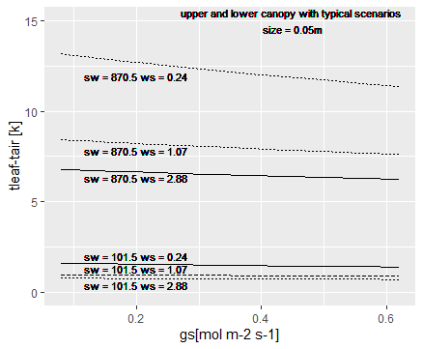

**Figure 3. Theoretical expectations for variation in the elevation of above in response to (a) shortwave radiation, (b) wind speed, (c) stomatal conductance (), and (d) leaf width.** Schematic produced using the tealeaves R package of Muir (2019). Current placeholder uses typical conditions for Harvard Forest, but model output deviates from real data (directions right, but Tleaf-Tair too high). [ISSUE #6](2020_12_draft).

**(paragraph on radiation as a driver)** Shaded understory leaves should tend to maintain cooler daytime leaf temperatures for any given level of stomatal conductance.

Greater upper canopy wind speeds (Fig. 2) result in higher boundary layer conductance () for canopy leaves, which increases linearly with wind velocity (Daudet *et al.*, 1999). Large to heat transfer, in turn, results in a smaller difference between and . In low wind conditions, because to heat transfer is comparatively small, in the upper canopy can become substantially elevated in relation to under high radiation (Leigh *et al.*, 2017; Martin *et al.*, 1999). Additionally, the thickness of the air layer is proportional to boundary layer resistance at the surface of the leaf through which water vapor diffuses after leaving the stomata (Roberts *et al.*, 1990; Martin *et al.*, 1999; Stokes *et al.*, 2006) this tends to be greater in the understory than canopy? [ref]

**(paragraph on hydraulics as a driver of leaf T:e.g., water on leaves - evaporative cooling - and leaf water content)** Leaves with open stomata can maintain similar to at high radiation loads, *with coolest leaves at intermediate sizes (~10mm)*. Under hot conditions, canopy leaves exposed to higher wind speeds would be most effective at cooling when sufficient water is available to maintain high stomatal conductance. However, increase in air temperature typically also increases VPD, decrease in stomatal conductance during midday lead to a decrease in leaf CO2, and consequently increasing leaf temperature in upper canopy (Fauset *et al.*, 2018). Thus, their can be highly elevated above when or is low.

**In addition, leaf size and morphology, which vary dramatically across the vertical gradient (reviewed in following section), impact and therefore leaf temperature.** *Smaller leaves have higher to heat transfer, allowing them to dissipate heat more efficiently than larger leaves (Bauerle & Bowden, 2011). (verify this statement and reference)* While small leaves remain within a few degrees of , regardless of stomatal conductance, wider leaves can have temperatures deviating more from air temperature (Fauset *et al.*, 2018). Large leaves (with greater leaf width) can be significantly cooler than under low radiation with stomata open (Leigh *et al.*, 2017), and significantly hotter under high radiation with stomata closed.

### In-situ observations

**Vertical profiles in microclimate (Fig. 2), leaf traits (see following section), and *evapotranspiration* (*where is this discussed? and do we say anything about evaporation?*) together shape in-situ leaf temperatures according to the principles outlined above (Fig. 3).** While the high-light environment of the upper canopy would tend to dramatically increase above , particularly under low-wind conditions, strong vertical gradients in leaf morphology and sometimes *evapotranspiration* have a counteractive effect, such that vertical trends in are much less pronounced than would be expected based on the physical setting alone. Under some conditions tracks and therefore differs little between understory and canopy (Fig. 2). For instance, during the dry season in a tropical moist forest in Panama… (Rey-Sánchez et al. 2016). Sun leaves can also be cooled relative to more than shade leaves (Rey-Sánchez et al. 2016). At night when solar radiation is not a factor, differences in across the vertical gradient are very modest; for instance, Bolstad *et al.* (1999) observed similar nighttime ’s in the canopy and understory of a temperate broadleaf forest.

**However, canopy leaves can reach much higher maximum , and higher , than understory leaves.** -Large leaf to air temperature differences and high leaf temperatures were found in upper canopy of Atlantic, Brazil forests due to high solar radiation loads. However, leaf temperatures themselves were moderated by air temperature. (Fauset *et al.*, 2018). - In three forest types– temperate, tropical wet and tropical moist, exceeded temperature optimum for photosynthesis in upper canopies of all sites, however exceeded at different heights and temperatures in all forests; with no significant relationship between and height. Additionally, With increasing height, difference increased in the upper canopies of all forests, exhibiting greatest in temperate deciduous forest compared to tropical moist and wet. - In a tropical wet and moist forests of Puerto Rico and temperate forests in Michigan, greater light input in exposed upper canopy leaves has been observed to increase leaf temperatures, sometimes 1-7C above ambient air temperature, making upper canopy leaves susceptible to heat stress, more than scattered light in lower shaded leaves (Mau *et al.*, 2018b) -“Sun exposed outer canopy leaves in tropical trees can experience temperatures up 48 C during diurnal cycle, midday stomtal closure reduces transpitrational cooling” thus elevating leaf temperature greater than air temperature (Slot et al. 2019)

* (Slot et al. 2019) and refs therein
* Elsa: I came across these two studies that could be relevent in the evapotranspiration/temperature feedback section hinted at above:
* Staudt, K., Serafimovich, A., Siebicke, L., Pyles, R.D. and Falge, E., 2011. Vertical structure of evapotranspiration at a forest site (a case study). Agricultural and Forest Meteorology, 151(6), pp.709-729.
* Sellin, A. and Lubenets, K., 2010. Variation of transpiration within a canopy of silver birch: effect of canopy position and daily versus nightly water loss. Ecohydrology, 3(4), pp.467-477.

## Leaf traits

Particularly in dense forests, the upper, outer canopy leaves of taller trees are exposed to dramatically different biophysical conditions than leaves in the canopy interior or understory (Figs. 2, S1-S#). Leaf traits are critical to maintaining desirable and, in turn, shaping leaf metabolism and carbon balance (following section). It is unsuprising, then, that leaf traits vary dramatically across vertical gradients.

#### *(clarify light vs height - 1 paragraph)*

Our primary interest is in how leaf traits and function vary across the vertical gradient from the top of the canopy to the understory in forests. However, the majority of relevant research has focused on exposure gradients near ground level, with by far the most common study type being comparisons of sun and shade leaves. Light based acclimation in leaf traits is well established, while research on solely height-based leaf trait variation is sparse due to the difficulty of isolating increased tree height from light. While light is the primary axis along which leaf traits vary, both theory and empirical evidence indicate that other factors–for example, height on a tree or exposure to evaporative demand (Fig. 2)– are important in shaping at least a subset of traits. In particular, hydraulic constraints increase with height on a tree [REFS; *McDowell-isotopes book chapter*; Coble & Cavaleri (2015); *Couvreur et al., 2018*], such that gas exchange is strongly constrained by at the tops of the world’s tallest trees (~100 m. tall *Sequoia sempervirens*; *Ambrose et al. 2009, 2010*). Disentangling the influences of hydraulic constraints, light, and other biophysical drivers that vary with height (Fig. 2) on leaf form and function remains an important area for research, but is beyond the scope of the current review. For the purposes of interpreting the results presented here, we note that patterns across light and height gradients age generally similar, at least in direction (Table 1), but likely to be modified by covarying biophysical constraints.

*(The following notes need to be condensed/ worked into the paragraph above or discussion of specific traits. No need to get very specific (listing species studied, traits)–what we want is generalization. The goal is to answer the question, “Do we expect light gradients to be equivalent to height gradients, or is there variation attributable to height that is not captured by light gradients?”)*

* However, studies that have measured LMA in relation to height have found that in tropical forests LMA-height predicted stronger correlation between area- based respiration versus foliar nutrients, whereas Q10 and E10 remained constant with height [Cavaleri et al. 2008].
* Height-based leaf trait variation in *Quercus alba* and *Quercus velutina* showed decrease in lobation with increased height in two tall species, suggesting an adaptation to hydraulic constraints in order to lower evapotranspiration with increasing height by decreasing lobation (Kusi & Karsai, 2020). However, Sack *et al.* (2006) did not observe trait variation based on height in Quercus spp.
* Height is more important than light in determining leaf morphology in a tropical forests (Cavaleri et al. 2010)
* (Cavaleri et al. 2008)
* from Martijn: “If I remember correctly, height and light exposure are closely correlated and things like LMA scale with both, but above a certain level of light exposure, the effect of additional light disappears, while the relationship of the morphological traits with height continues. I have often been a bit skeptical about assuming height drives morphology, as most of the work that convincingly shows that (and relates it to turgor pressure for example) is from 100 m tall redwoods.”
* Elsa: see also H. Poorter, U. Niinemets, L. Poorter, I. J. Wright, R. Villar, Causes and consequences of variation in leaf mass per area (LMA): A meta-analysis. New Phytol. 182, 565–588 (2009). – LMA responds to changes in light, with shade-intolerant species displaying higher plasticity in response to light.

#### *(clarify intra- vs inter-specific variation - 1 short paragraph)*

Across the vertical gradient, traits vary (1) across sun and shade leaves within individuals, (2) across canopy and understory individuals of the same species, and (3) across canopy and understory species. The majority of studies characterizing variation in leaf traits or metabolism examine intraspecific patterns (categories 1 and 2), which are therefore the main focus of this review (Table 1). However, when it comes to understanding and modeling forest ecosystem function, the relevant scale of variation is interspecific (e.g., *Lamour, Serbin in prep*).

### Intraspecific variation

**Within a species, leaf traits co-vary with their environment (Michaletz *et al.*, 2016) and show different degrees of foliar plasticity in accordance with the intensity and availability of light, optimizing water uptake, heat, C uptake and metabolism across forest vertical strata (Rozendaal *et al.*, 2006).** After the formation of leaves to integrated light, it takes 30-60 days for traits to stabilize in woody ~~and herbaceous~~ species (Niinemets, 2016; Keenan & Niinemets, 2016). A network of sensory photoreceptors in leaves, such as phytochromes, mediate leaf-level responses to PAR and the ratio of red to far red radiation intercepting the leaf surface. This enables acclimation or avoidance responses through the development of necessary leaf traits (Casal, 2013). Degrees of high irradiance give rise to variation in sun-leaf traits, while degrees of low irradiance– characterized by shade– result in variations of shade-leaf traits (Sack *et al.*, 2006; Poorter *et al.*, 2019), ultimately influencing leaf structural, chemical and physiological traits as well (Keenan & Niinemets, 2016).

*(Krista: the above paragraaph is really interesting, and I like the idea of starting off the section by mentioning what controls the formation of leaf traits. However, I think it gets into more detail than needed. Also, is there work out there on how they’re influenced by temperature/ water at the time of formation? I’d broaden to include the full microenviroment (without increasing length)*)

Several studies point towards common variations and differences in leaf trait plasticity within-species and at an intra-canopy gradient which influences leaf structural and biochemical traits (**???**; Sack *et al.*, 2006; Niinemets *et al.*, 2015). The differences among these traits contribute to leaf heat dissipation strategies and leaf temperature across the gradient (Fauset *et al.*, 2018; Michaletz *et al.*, 2016) Table 1 summarizes relevant traits for thermal sensitivity.

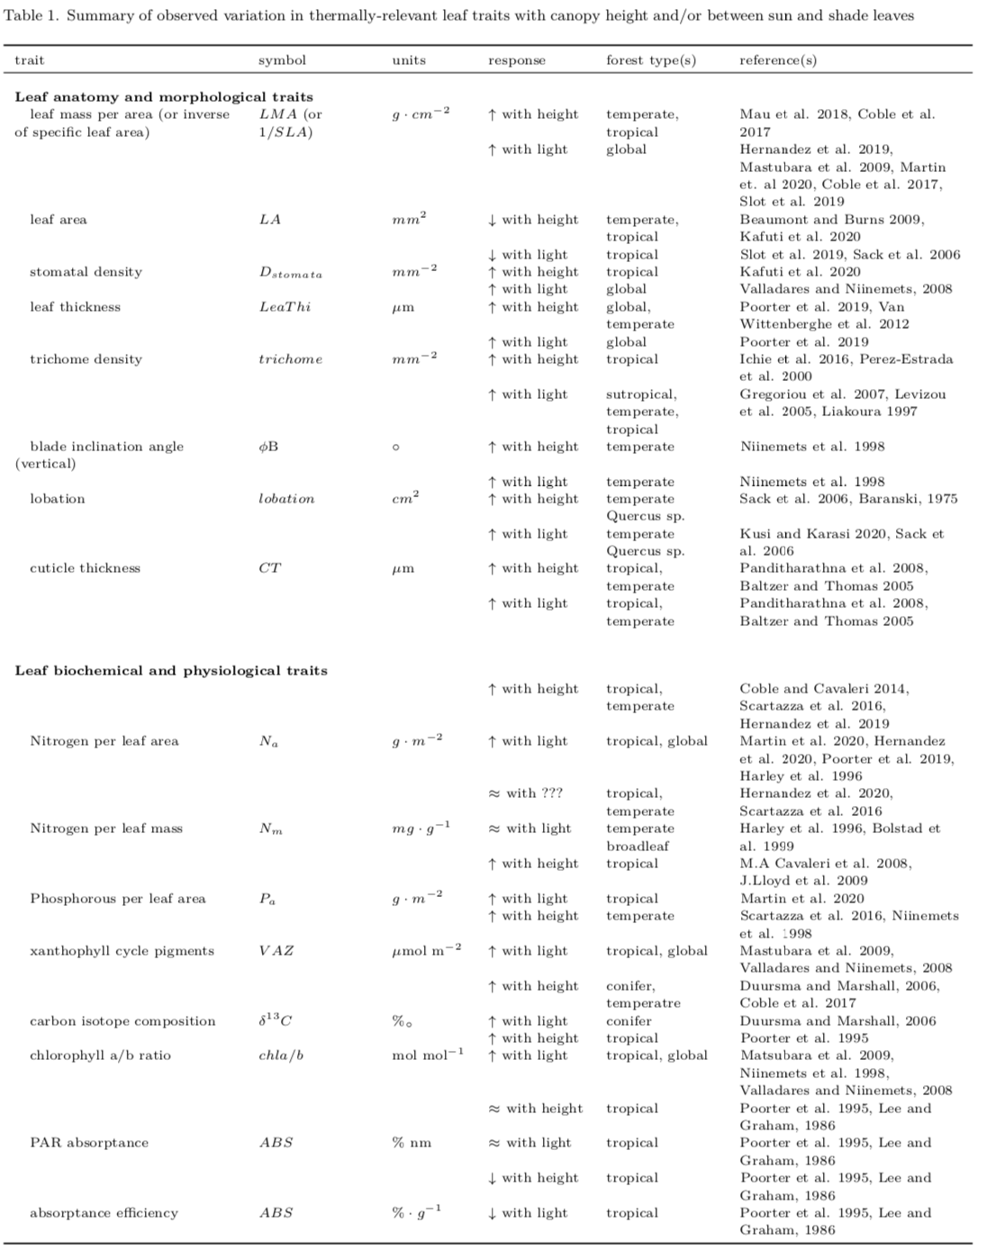

Table 1. (*For latest version of table, see tables.pdf.*)

#### Morphological traits

* Recent paper on influence on leaf size/shape in PCE – certain aspects of leaf shape were not as relevant as expected (Leigh et al. 2017? <https://onlinelibrary.wiley.com/doi/full/10.1111/pce.12857>)

Leaf temperature is generally assumed to increase with leaf area () [ Wright et al. 2019; Tserej & Feeley 2021]. Yet, thermal imagery shows that though leaf area can be a predictor for leaf temperatures ranges [] across the surface of the leaf, effective leaf width is a better predictor of leaf temperature changes and leaf thermal time constant (Leigh *et al.*, 2017). With increase in effective leaf width, boundary layer thickness and resistance increases along with stomatal resistance (Leigh *et al.*, 2017; Wright et al. 2019; Fauset *et al.*, 2018).This lowers evaporation from stomatal pores, and in turn transpirational cooling in large leaves (Fauset *et al.*, 2018). Because the rate of heat convection per unit area between leaf and air is lower for large leaves and greater for small leaves, small leaves are able to dissipate heat more efficiently than large leaves (Leigh *et al.*, 2017). Using leaf energy balance to compare leaf temperatures of two species and , Fauset et al. 2016 found leaf width to be a dominant factor in determining changes in leaf temperature, which was evidently greater for large width leaves of compared to . Leaf width and characteristic dimension is generally greater in shaded leaves along the vertical gradient than exposed upper canopy [ref]. Additionally, leaf characteristics such as lobes, leaf elongation and serration, which break the entirety of leaf dimension by enhancing a smaller characteristic dimension, all facilitate more efficient heat dissipation. Leaf lobes are deeper in exposed canopy than in shaded understory, as well as leaf elongation and serration are more pronounced in sun exposed canopies (Schuepp, 1993; Sack *et al.*, 2006; VOGEL, 1970).

#### Biochemical and physiological traits

In temperate Acer saccharum forest, within-canopy Acer saccharum exhibited greater LMA and with height early in the growing season as a result of hydrostatic constraints on leaf morphology; however, in later growing season LMA and continued to increase in the upper canopy due to light driven changes (Coble & Cavaleri, 2015, 2014; Coble *et al.*, 2016).In addition, carbon isotope composition also increased with height, independent of light (Coble & Cavaleri, 2015).

##### *(Carotenoids/Xanthophyll cycle pigments)*

High light stimulates the need for photoprotection in leaves in order to protect internal photosystem II from chronic photoinhibition through enabling D1 protein replacement. Thus, leaves exposed to greater irradiance have greater pools of xanthophyll pigments expressed on a mass or area basis–photoprotective pigments comprising of violaxanthin, antheraxanthin and zeaxanthin [] that convert excess light into heat energy dissipation through non photochemical quenching of excitation energy, enabling short-term acclimation to high temperature and light (Niinemets *et al.*, 1998; Mathur *et al.*, 2018). These are found to be proportional to within-canopy light gradient at an inter- and intra-species level. Therefore, is lower in shaded leaves and greater in sun leaves, as observed among temperate tree species (Niinemets *et al.*, 1998). In neotropical forest, foliage exposed to higher irradiance in the canopy showed greater b-carotene and vioxanthin-cycle pool on an area or chl basis compared to low light leaves that showed greater mass based chlorophyll, lutein and neoxanthin carotenoids [Mastubara et al. 2009]

* antioxidant scavenging function- protect against cellular damage
* Koniger et. al. 1995, and Matsubara et al. 2009

#### Leaf lifespan and Deciduousness (“Lifecycle / ecological traits?”)

##### *(lifespan)*

*Leaf turnover tends to be greater in the sun (in the tropics), so of your standing stock of leaves (at least in evergreen species) sun leaves should be younger than shade leaves. This is bound to affect metabolism, and may affect other aspects of their performance.*

##### *(Deciduousness)*

*Among species that can be deciduous, greater proportion of deciduous individuals in larger size classes (Condit et al. 2000).*  *Spring and fall leaf phenology in temperate deciduous forests (Augsburger).*

### Interspecific varaiation

*(KAT: a lot of this content should probably move up the the intro to this section)*

As a result of different light regimes, a sun and shade leaf trait dichotomy has been established across species by various studies where typical sun leaves are often smaller in size and width, thicker, and hairier, with thicker cuticle and greater lobation than shade leaves [Rozendaal et al. 2006, Mathur et al. 2018, more REFS].

“Additionally, shorter understory trees that spend the bulk of their lifecycle in the shade experience different pressures than plant that get the bulk of their carbon from sun-exposed leaves, but can maintain a few layers of shade leaves as well” -Martijn

The combination of stressors experienced by taller trees’ foliage are different from that experienced by understory trees. For example, overstory sun leaves experience greater loads of PAR, , elevated temperatures, higher wind speed, etc.. whereas understory leaves are subjected to shade or limitation of light, niche competition and herbivory. Overstory sun leaves are subjected to overheating pressures; thus, through developed traits of increased stomatal density, transpiration and water supply, along with increased convective heatloss via reduced boundary layer resistance, sun leaves are able to maintain optimum temperatures for photosynthesis and metabolic processes. Additionally, overstory sun leaves tend to have long-lived leaves[*double check*] with high LMA while shade leaves of canopy trees have large leaves with low LMA. Adaptive traits in understory enable light capture efficiency while maintaining larger width leaves with comparatively lower stomatal density due to low levels of photosynthesis in the shade, lesser , and wind speed. Those differences in traits are likely to affect their thermal properties as well. Leaves act as windows to plant performance, enhancing plant adaptation to changing environment, thus leaf traits acclimated to prior stressors have been suggested to enable whole plants to respond differently to forthcoming stress (Niinemets, 2010; Rozendaal *et al.*, 2006)

However, even with distinct features of sun and shade traits, trait adaptation to light maximizes light use efficiency for photosynthesis at both high and low light, while also adapting to other stressors as mentioned above. In light limited conditions, shade leaves increase light capture efficiency by increasing their specific leaf area [SLA] and by investing in chlorophyll on a mass basis, which “leads to a similar chlorophyll content on an area basis compared with sun leaves. This enables shade leaves to realize similar light capture to sun leaves at a lower biomass investment” (Chazdon et al. 1996, Poorter et al. 2000, Rozendaal *et al.*, 2006)

With increasing height and age, competition for light decreases as availability of light increases in dense forests. However, depending on growth strategies of species occupying the understory, leaf traits might differ due to species inherent light requirements. Early successional species are considered more shade intolerant than late successional species that are more shade tolerant. Ontogenetic differences between the two in the understory suggests lower leaf dry mass per area (), greater photosynthetic capacity in low light and greater carbon gain capacities in shade tolerators than in intolerators (Niinemets, 2006). However, the findings from the above review conflicts with Kitajima 1994 found for tropical seedlings; shade intolerance species grew faster in the sun AND in the shade, but at the cost of higher mortality in the shade. Lawren and Karoru had contrasting findinds, and so far appears that there is a consensus by now.

Shade intolerant species experience greater heterogeneity in light during ontogeny [why?-nidhi],thus LMA responds to changes in light, with shade-intolerant species displaying higher plasticity in response to light [H. Poorter, U. Niinemets, L. Poorter, I. J. Wright, R. Villar, Causes and consequences of variation in leaf mass per area (LMA): A meta-analysis. New Phytol. 182, 565–588 (2009).].Rozendaal et al. 2006 found no significant trait differences with ontogeny and adult stature trees. Koike et al. 2001 has more info about this.

*[Add something about how leaf traits along the vertical canopy profile are different than the expectation from leaf economic spectrum (LES)? Chen et al. 2020 is a good paper to help frame this . They make an important point in that paper that we may also want to make here: that the LES was ‘built’ using mainly sun (upper canopy) leaves; given the vastly different light environments at the bottom of the canopy (and that most leaves in the canopy are likely to be shade leaves) there is a strong research need to better characterise trait relationships and leaf responses through the whole vertical canopy - hence the importance of this review. Keenan & Niinemets 2016 will also be helpful in making this point.]–M N. Smith*

An increasing number of studies point towards the importance of incorporating sun and shade in modelling leaf economic spectrum (LES) traits within-canopy gradient (Chen *et al.*, 2020), because LES theory was developed using mainly sun exposed (upper canopy) leaves. Given the vastly different light environments at the bottom of the canopy and that most leaves in the canopy are likely to be shade leaves, there is a strong research need to better characterize trait relationships and leaf responses through the whole vertical canopy [Keenan and Niinemets 2016]. However, there is also concern for ambiguity in a simplified categorization of ‘sun’ and ‘shade’ leaves, due to variation based on within-canopy light, across functional groups, in canopy gaps, and with height and ontogeny (Niinemets *et al.*, 2015; Ishii *et al.*, 2018) as well as geographically (Ishii *et al.*, 2018).

##### Isoprene production

* Isoprene production *capability* as a trait

## Leaf metabolism and thermal responses

Leaf metabolism is strongly shaped by leaf temperature, and by the traits and environmental drivers reviewed above, all of which vary across vertical forest gradients (Fig. 1). However, as we detail below, there are limited studies comparing thermal responses of sun and shade leaves (Table 2).

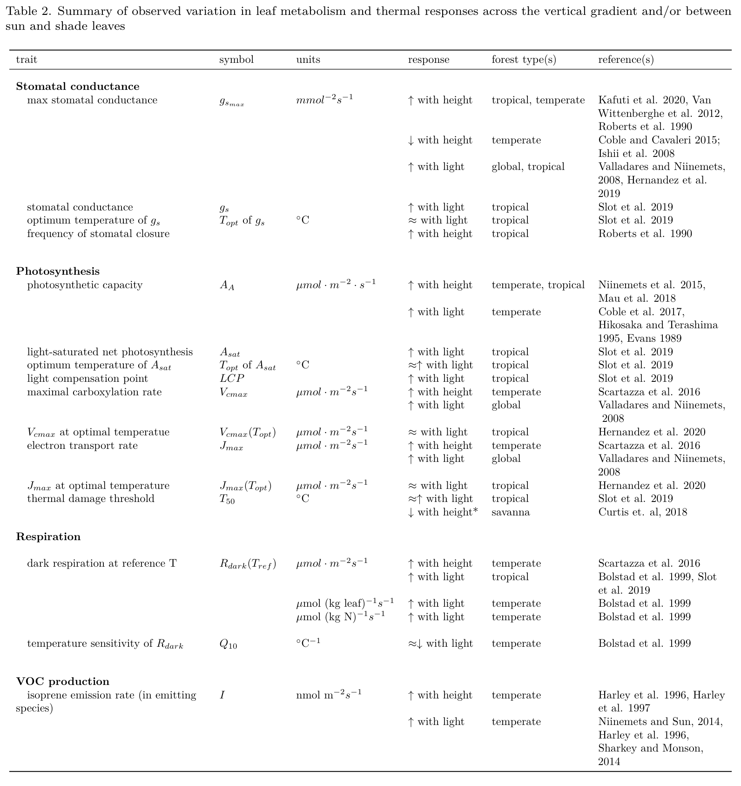

Table 2. (*For latest version of table, see tables.pdf.*)

### Stomatal conductance

Photosynthesis can be largely constrained by stomatal conductance.

* Max stomatal conductance - increases with canopy height (Kenzo et al. 2015) Max transpiration rate - increases with canopy height (Kenzo et al. 2015).

### Photosynthesis

**Photosynthesis is generally higher in sun leaves– a fact that is both theoretically expected and observed in numerous field studies (Table 2; Niinemets 2007 ; Kenzo et al. 2015 ; Slot et al. 2019; Chen et al. 2020).** This is primarily driven by the greater light available to sun leaves.

In response to the greater light availability, sun leaves have traits allowing greater photosynthetic rates at high light under sufficient nutrient and water conditions, including higher concentration of Rubsico, and multiple layers of palisade parenchyma. Light saturation level differs between leaves and canopies, with leaves saturating at lower light level than canopies (while a certain amount of light saturates the photosynthetic capacity of the leaf, increasing the amount of light in the canopy may increase photosynthesis in the shaded part of the canopy) The vertical gradient in photosynthetic rates is also influenced by available concentration of N and P. (and water availability) *[thoughts: plasticity vs change in tree species composition through the canopy; differences in variability of microenvironments through the profile - highest lower down in canopy?; life history / investment strategies and hence, leaf life spans at leaves at the top vs bottom of the canopy]– M N. Smith [agreed. Again the importance of differentiating between within-species and among species trait variation. Also; steepness of the vertical gradient in light and VPD. In very tall trees a gradient in water potential might cause a gradient in stomatal limitations of net photosynthesis]*

Photosynthesis increases with increasing irradiance, and saturates at quantum flux density of 400 to 700nm or greater in upper canopy.

Photosynthesis has a peaked response to temperature, where photosynthesis is commonly found to be maximized at the prevalent ambient growing season conditions (Tan et al. 2017; Slot & Winter 2017). Beyond the optimum, photosynthesis decreases as a result of stomatal closure (e.g. Slot & Winter 2017; Smith et al. 2020 [temperate/boreal refs needed) and eventually due to biochemical constraints (refs. e.g. Sage & Kubien 2007; Varhammer et al. 2015 ).

**While sun and shade leaves differ dramatically in , the temperature sensitivity of photosynthesis does not appear to differ substantially between sun and shade leaves.** Biophysically, we might expect that sun leaves should tend to have a stronger temperature-dependence and higher temperature optima than shade leaves (Fig. 14.5 in Campbell and Norman 1998; *revisit this!*) *as observed by earlier studies, suggesting that the interaction between light gradient and temperature response along vertical canopy profile implied a spectrum of temperature responses of , and along the gradient [Niinemets et al. (2004); Harley and Baldocchi 1995, Friend, 2001].* *(KAT: I’m confused by the second part of this sentence. Are these studies, or theoretical expectations?.)* However, such a trend is not apparent based on the limited number of field studies that have compared temperature sensitivity of photosynthesis in sun and shade leaves. For 3 species in Panama, the optimum temperature for sun leaves tended to be slightly higher than that of shade leaves, but differences were not significant (**???** ; Hernández *et al.*, 2020). Similar results were found for and (**???**, Hernandez et al.2020) Similarly, Mau et al. found no trend in the optimum temperature for net photosynthesis along a height gradient in Puerto Rico, and no significant trend in temperate trees (Mau *et al.*, 2018a).

*(KAT: let’s cut the portion on T50 down to one or at most two par:)*

Photosynthesis will also be affected by heat stress, when photoinhibition reduces photosynthesis either as a result of photoprotective; non-photochemical quenching or related to irreversible leaf damage leading to leaf necrosis. At increasing temperatures, photosynthetic system II [PSII] is particularly vulnerable. Damage to PSII can lead to decreased electron transport rates and photosynthetic failure. Irreversible damage to PSII is done at 40-60C (Baker 2008; Feeley *et al.*, 2020) Leaves in upper canopy tend to experience more heat stress and greater photoinhibition than lower canopy leaves in conditions of water stress or drought. (Niinemets *et al.*, 2015)

**Leaf thermal tolerance (Tcrit/ T50)** *(define)* Typical values ~45-50C, varying somewhat across latitude/climate (O’sullivan et al. 2017), with elevation [Feeley *et al.* (2020); Slot et al unpublished data], with leaf traits (Sastry et al. 2018, Zhang *et al.*, 2012). Perez and Feeley et al. 2020 found that across species sun leaves with higher photosynthetic heat tolerance experienced higher maximum temperatures and had narrower thermal safety margins. These species may thus be at a greater risk of thermal damage.  
[- Elsa: also see: - Perez, T.M. and Feeley, K.J., 2020. Weak phylogenetic and climatic signals in plant heat tolerance. Journal of Biogeography.]

Supporting the significant negative relationship between and thermal safety margins, photosynthesis [PS2] temperature regulation has been associated with leaf thermal tolerance in order to maximize net carbon assimilation. However, randomly collected within-canopy leaves of individual mature plants in Florida showed that Tmax is not directly coordinated with high PS2 heat tolerance and does not necessarily increase leaf thermal tolerance [shows no direct correlation]; nor does it increase carbon assimilation at higher temperature. Rather, high PS2 heat tolerance reduces optimum temperature for C assimilation [] because high PS2 heat tolerance requires a greater cost of PS2 metabolic activity maintenance, thus not contributing to increased C assimilation. Species exhibiting low carbon assimilation rates tended to have greater stress tolerance. In addition, species with low stomatal conductance exhibit greater PS2 heat tolerance because earlier closure of stomata ceases C assimilation before thermal limits are reached (Perez *et al.*, 2020)

**Thermal tolerance (e.g., ) varies with exposure, but there are no studies isolating effect of height.** For two of three species studied in a tropical moist forest in Panama, was slightly lower for shade than sun-exposed leaves, both measured near ground level (Slot et al. 2019). Similarly, for *Acacia Papyrocarpa* (Benth.) trees in an arid region of southern Australia, higher was observed in more exposed (North-facing) canopy positions (Curtis et al. 2019). We’re not aware of any other studies on this.“we may want to argue that we have no *a priori* reasons to expect thermal tolerance to scale with height per se (or do we?). I think it makes sense to expect variation with light exposure because of the associated differences in temperature you can expect the leaves to be exposed to, but height itself should not affect heat tolerance other than through associated traits perhaps”–Martijn Slot

T50 might not capture thermal stress or sensitivity to increasing temperature in foliage, because the degree at which T50 is observed in leaves is at an extreme temperature not usually experienced by leaves acclimated to different light environment, at a lower foliage thermal stress point T50 might be irrelevant, but variation to extreme temperature response might be better understood through T50 (Perez *et al.*, 2020)

increased irradiance = increased VPD = increased air temp = midday stomatal closure = decreased latent heat loss = increase leaf temperature = decreased C assimilation = greater PS2 heat tolerance = optimum rate of photosynthesis decreases = exhibiting lower t opt (optimum temp for c assimilation)

incr.humidity = decreased VPD = dec. latent heat loss = limited c assimilation (Perez *et al.*, 2020)

### Respiration

**Similar to photosynthesis, respiration tends to be higher in sun leaves (Chen et al. 2020), but its temperature sensitivity appears to be similar between between sun and shade leaves.** (Bolstad et al. 1999) did a study at Coweeta, including elev gradient. Found higher respiration (at reference T) in canopy leaves (Bolstad *et al.* (1999)). At Coweeta, Q10 showed a variable pattern, with a slight tendency to increase down the canopy (Bolstad *et al.*, 1999). (*Martijn has some unpublished data on this that we might include.unpublished data showing higher Q10 in shade than in sun leaves for 10 species or so. May make sense to include here:* [*https://github.com/EcoClimLab/vertical-thermal-review/issues/8*](https://github.com/EcoClimLab/vertical-thermal-review/issues/8)*.*) Combining reference respiration and , Bolstad *et al.* (1999) found a modest net decrease in R for understory leaves relative to canopy leaves as T increases (*see their Fig. 1*).“Higher values in the functional groups of upper canopy where temperatures are the highest may lead to exponential loses of C with increasing global temperatures depending upon the ability of canopy leaves to acclimate” (Cavaleri *et al.*, 2008) Thus, Bolstad *et al.* (1999) found evidence of acclimation, but there remained a declining trend of respiration with elevation. - Elsa: and see Perez, T.M., Socha, A., Tserej, O. and Feeley, K.J., 2020. PSII heat tolerances characterize thermal generalists and the upper limit of carbon assimilation. Plant, Cell & Environment.

With temperature increase, foliage photosynthesis and respiration are coupled at different rates upto photosynthetic thermal optimum. Beyond this inflection point, fluxnet global data analysis shows that photosynthesis declines whereas respiration increases exponentially, therefore, moving from carbon sink to carbon source with increasing temperature, independent of water and irradiance [Duffy et al.2021]

### VOC production

**Isoprene production** - high emission rates occur in the mid-canopy, and even from very small statured trees and shrubs, at a site in the Brazilian Amazon (Taylor et al., in prep). - The high temperature carbon compensation point of sun leaves is higher in isoprene emitting species than in non-emitting species, so it is to be expected that other aspects of heat tolerance will be similarly affected by isoprenes (<https://doi.org/10.1111/pce.13564>). - Within species, isporene production scales with light/ T; however regardless of light, isoprene emission increases with T such as in understory shaded leaves?

## Size-structuring within the ecosystem

**Differences across forest vertical gradients in biophysical conditions, plant traits, and metabolism and its thermal responses scale up to affect whole-tree ecology and ecosystem ecology in several ways.** Vertical gradients in the biophysical environment shape which plant strategies, or sets of traits, are competitive in understory versus canopy conditions.

### Demography

**Vertical gradients affect tree recruitment, growth and survival, and how these respond to climatic variation.** There are numerous demographic differences between understory and canopy trees, which have been linked to both the physical environment and plant traits (e.g., REFS), *and we will not review those here.* *(although maybe we should put one paragraph?)*

More interesting in this context is how these shape differences in the climatic sensitivity of growth and mortality. Many observations of larger trees suffering more during drought (Bennett et al. 2015). One likely mechanism behind this pattern is that the crowns of larger trees exist higher in the vertical profile and therefore are exposed to higher evaporative demand and solar radiation (McGregor *et al.*). Although drought is primarily a hydraulic problem, lack of water –> lower gs –> higher leaf T, so leaves face tradeoffs of water loss vs potentially damaging leafT.

**There is also recently emerging evidence that understory trees tend to exhibit greater growth declines with under mesic conditions.** In eight forests across the northeast United States, growth rates of understory trees declined sharply at higher (Fig 4 **???**; Rollinson *et al.*). This pattern is initially counter-intuitive in that sun-exposed leaves can experience greater elevation of over than shade leaves (Fig. 3 **???**). However, given adequate moisture to sustain high , canopy leaves exposed to more wind and lower humidity should be more effective at cooling when exceeds physiological optima (Fig. 3). It is also possible that higher temperatures reduce understorty tree growth in these forests through an indirect mechanism, such as accelerated competition under warmer temperatures.

Additionally, increased exposure to light increases non structural carbon reserve (NSC), plant height, foliage robustness, while also increasing evapotranspiration, decreasing hydraulic conductivity, increasing chances of photoinhibition in leaves should water availability become limited, however with available water overall sensitivity to stress decreases. Understory shaded/younger trees have comparatively less NSC reserve due to light limitation as a primary stressor [which differs among shade-tolerant/intolerant], decreased plant biomass, increased leaf biomass, and decreased evapotranpiration demands, as well as greater investment in light harvesting than in photosynthesis–with greater overall sensitivity to stress and reduced tolerance. Larger NSC reserves in trees with greater light and water availability allows them to tolerate greater number of stressors compared to understory/younger trees that are able to tolerate only a fewer stressors making them overall more sensitive to stress [such as temperature]. Thus, overall stress sensitivity decreases and tolerance increases with increasing height, light and age.(Niinemets, 2010)

*In this section we could perhaps also consider differences in biomass distribution between canopy trees an understory plants, and what that may mean for performance at high temperature. What I’m thinking is the temperature sensitivity of respiration that applies to leaves, stems, and roots, and even though thermal acclimation of leaf respiration is common, much less is known about acclimation of stem and root respiration, and incomplete acclimation still increases the respiration load at higher temperature. It is possible that an increased respiration load is more disadvantageous for understory plants because 1), I suspect that a greater fraction of their total biomass is life biomass that respires (as opposed dead heartwood in the stems of big trees), and 2), because they operate closer to their light compensation point, so if they lose more carbon in respiration, they would need to make up for lost carbon in photosynthesis, but might lack sunlight to do so*

Interaction between degrees of shade x ontogeny x height with rising temperature needs more scientific attention because a huge part of understory vegetation lies within variations of light and shade spatio-temporal gradient.

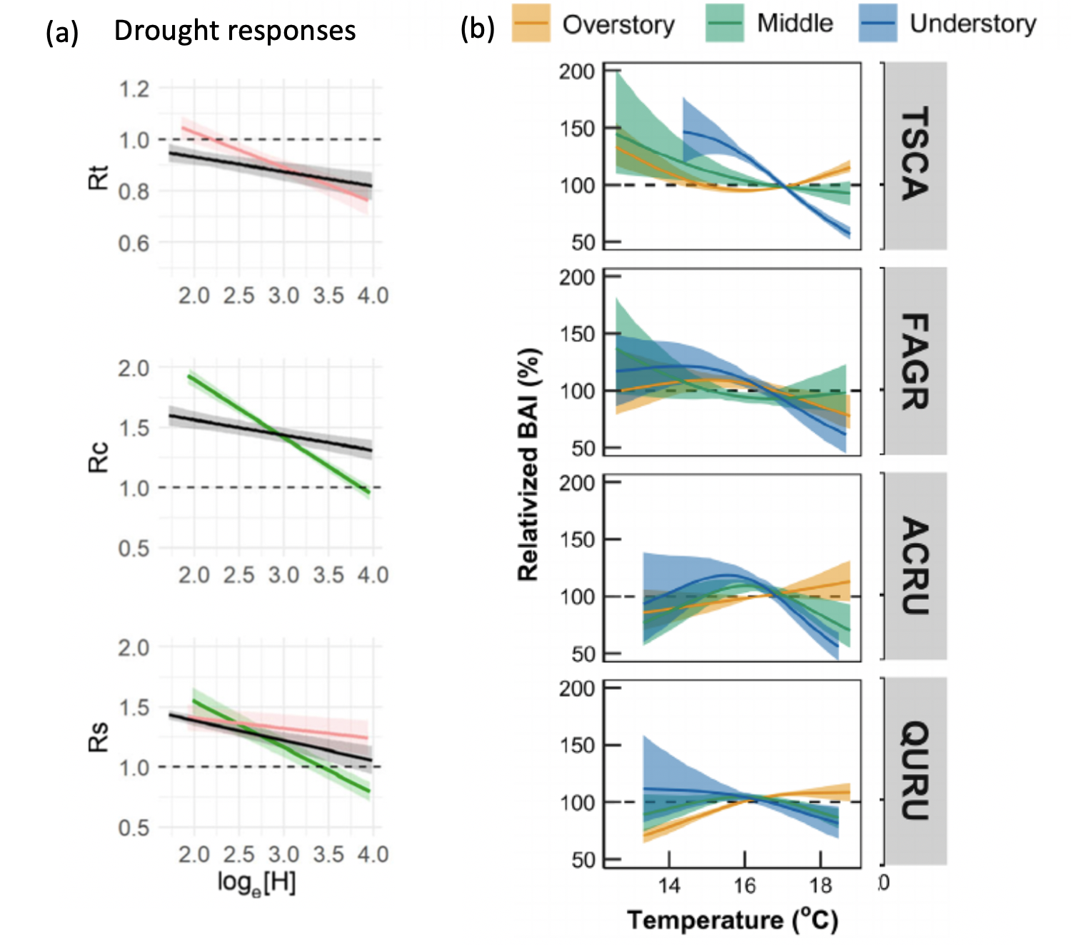

**Figure 4. DRAFT tree-rings figure. Current figure shows (a) drought responses as a function of height in a temperate broadleaf forest (SCBI), from McGregor et al. 2020; (b) responses to growing season temperature in eight New England forests, from Rollinson et al. 2020. I’M NOT SURE THIS IS WHAT WE WANT, BUT I THINK SOME SORT OF TREE-RING FIGURE WOULD BE GOOD. [ISSUE # 29](https://github.com/EcoClimLab/vertical-thermal-review/issues/29).

### C and water flux

*(here, it would be good to add some content on contributions to C cycling across the vertical gradient. If Camille’s paper is published ahead of this, that would be the best source. Meakem et al. 2018, New Phyt has a similar analysis for 3 sites.)*

Leaf-scale properties and processes aggregate non-linearly in vertical and horizontal space, influencing stand-level ecosystem processes, and in turn biosphere-atmosphere exchanges of water, carbon, energy, and trace gases. As described above, variation in temperature across vertical gradients can interact with local light conditions and other vertically varying meteorological conditions to affect species composition (e.g., see Nakamura *et al.* (2017)), leaf traits, and photosynthesis . Linked to this local biophysical variation is the partitioning of evapotranspiration () into soil evaporation, canopy evaporation, and transpiration, which occur across varying spatiotemporal scales depending on light availability, water stress, stomatal physiology, and turbulent transfer (Lawrence et al. 2007, Staudt et al. 2011). Vertical microclimate gradients interact with vertical variation in foliage density, influencing not only the location of evapotranspiration in the canopy, but also differences in rates and net gross primary productivity (, Banerjee & Linn 2018). It has been demonstrated that net carbon assimilation and transpiration can vary substantially for forest canopies with the same LAI but different leaf area density distributions (e.g., Katul et al 2004 , Banerjee & Linn 2018). Further, although transpiration tends to be the dominant component of ET, partitioning is more complex in open canopies where soil evaporation can become more dominant (Baldocchi et al. 2004, Ma et al. 2020), likely affecting vertical thermal gradients. In other words, it matters whether foliage is dense or sparse, and whether it is concentrated higher in the canopy, lower in the canopy, or evenly distributed throughout.

Still, partitioning into its constituent components, let alone vertically partitioning transpiration rates in the canopy, remains a challenge. Eddy covariance techniques, sap flow measurements, and stable isotope analysis offer useful tools, although errors can be large (Williams et al 2004, Herbst et al. 1996). To date, empirical analyses of ET vertical partitioning and interactions with temperature and vegetation structure have be concentrated in midlatitude ecosystems (e.g. Haverd et al 2009, 2011, Staudt et al. 2011, Ringgaard et al. 2014) *(KAT: but see Kunert et al. 2017 -not sure if this is equivalent)*. With respect to changing temperatures, the net effect of leaf- and plant-level thermal responses remains an active area of research, including both how vertical variation in thermal sensitivity influences forest ecosystem dynamics and biosphere-atmosphere interactions.

# Implications

Having established how physical conditions and biological form and function vary across vertical gradients, we now turn attention to the implications of these patterns for our understanding of how forest ecosystems may be impacted by global change, and our ability to project this across space and time.

## Global change responses

### warming

* Influence of increasing temperatures on species compositions and feedbacks to future forest microclimates and function?

*Frequent drought-related hydraulic limitation in forests alters species thermoregulation (Sastry et al., 2018), and also decreases tree canopy circumference (Aussenac, 2000) due to sensitivity of overstory trees to variability in water availability and precipitation (Rollinson et al., p. 2020). Larger trees suffer disproportionally greater hydraulic stress during drought [resulting in heat stressed canopy-leaves], which may contribute to increasing larger tree mortality in forests around the world should frequencies of drought continue to increase (McDowell et al., 2008; Brienen et al. 2015; Bennett et al., 2015; Stovall et al., 2019). Increases in loss of canopy cover (Senf et al., 2018; Senf & Seidl, 2020) are also associated with reduced canopy structural complexity, altering microclimates with local heating effects and surface energy balance components (Stark et al., 2020; Zellweger et al., 2020a). However, in mesic forest conditions, availability of soil water enables canopies with suitable foliar traits to remain cool through continuous evapotranspiration even during increasing air temperature, thereby buffering understory microclimates, unless relative humidity is so high as to reduce rate of evapotranspiration (Perez & Feeley, 2018).*

*While forest microclimates are insulated from macroclimatic extremes, they are still subjected to warming trends (Bertrand et al., 2020). Understories experience a distinct set of pressures as microclimatic warming combines with conditions of limited light and related foliar traits, inter-species resource competition, and herbivory (Bartholomew et al., 2020; Niinemets, 2010). Since temperature sensitivity is directly linked with plant metabolic processes and performance, even around 1 degree of warming can lead to changes in plant species composition and growth (Bertrand et al., 2011, 2020). Plant communities in forest microclimates are already undergoing thermophilization (Zellweger et al., 2019, 2020a; De Frenne et al., 2013; Duque et al., 2015). Tree-ring analysis in mesic temperate forests shows reduced growth of understory trees relative to overstory with warming temperatures (Rollinson et al., p. 2020). In addition, understory growth phenology is more sensitive to warming than canopy– showing earlier spring onset and later autumn senescense (Zohner & Renner, 2019).*

*The capacity of buffering largely depends on canopy cover and water availability (Davis et al., 2019), each of which is subjected to change through climate-driven disturbances such as drought, deforestation, fire and related disruptions (Senf et al., 2018). Increasing global temperatures can increase canopy leaf temperatures sometimes above ambient temperature when transpiration is low, leading to temperate and tropical forest canopies functioning beyond or close to their optimal photosynthetic threshold (Mau et al., 2018a; Huang et al., 2019). In wetter conditions, available water facilitates leaf transpiration through open stomata; however increased relative humidity in tropical regions indirectly caused by increased temperature reduces transpiration, leading to high leaf temperatures in the canopy (Tibbitts, 1979; Perez & Feeley, 2018).*

if we expect ‘shade’ plants to have a different sensitivity to climate change than sun leaves, the consequences of climate change for demography and species community composition of the forest will depend strongly on the category of shade plants being considered

### canopy disturbance

–Variation across horizontal biophysical gradients (climate, soils, etc.)(E.O)

*(there’s a lot of literature on canopy disturbance impacts–tap into that in this section)*

Microclimate warming has implications for forest regeneration (von Arx *et al.*, 2012). Temperature driven photosynthesis limitation is reducing tree growth rates, accompanying a global trend towards more frequently disturbed forests dominated by younger trees (McDowell *et al.*, 2020). Reductions in canopy cover can lead to non-linear threshold responses, causing dramatic shifts from one forest state to another (e.g., transition from forest to savanna-like vegetation in tropical forest regions through “savannization”), with energy balance impacts and implications for forest-atmosphere interactions (Stark *et al.*, 2020). Each of these changes have potential feedbacks to climate change.

increases in mortality of big trees (e.g. Senf *et al.* (2018)) would increase canopy roughness

## Scaling across space and time

*Scaling our understanding across space and time requires remote sensing and models.*

### Remote sensing

An increasing availability of airborne and spaceborne LiDAR remote sensing data offers a promising opportunity for mapping vertical thermal gradients and vegetation structure. [Drone based FLIR cams, tower thermal cams (Pau et al 2018), ECOSTRESS]. To evaluate large-scale ecosystem patterns, high resolution vertically resolved vegetation structure from LiDAR data can be analyzed in combination with collocated field measurements collected using towers (FluxNet REF), canopy cranes (Nakamura *et al.* (2017)), or by tree climbing (REF – e.g. Asner papers, Shenkin et al – Unding Jami’s work). Existing research efforts have already revealed incredibly heterogeneity in vegetation structure, diversity, traits, and properties both within and across ecosystems (REFS – Stovall, Schneider, …others).

### Representing Vertical Gradients in Models

Models are needed to predict future ecosystem dynamics, which remain one of the largest sources of uncertainty in Earth System Model (ESM) projections of the future of global carbon cycling and climate change (*Friedlingstein et al. 2006*). Dynamic global vegetation models (DGVMs) comprise the land surface models in ESMs used to predict the global distribution of vegetation types and biosphere-atmosphere feedbacks (Cao & Woodward, 1998; Foley et al., 1996; Sitch et al., 2003; Woodward & Lomas, 2004). DGVMs operate at a range of scales and have varying degrees of complexity, ranging from detailed individual-based models (*a.k.a.* forest gap models), which represent vegetation at the level of individual plants, capturing spatial variability in the light environment and microclimates at high vertical and horizontal resolution (Christoffersen et al., 2016; Fischer et al., 2016; Fyllas et al., 2014; Sato et al. 2007; Shuman et al. 2014; Smith et al., 2001; Bugmann, 2001; Dietze & Latimer, 2011), to big-leaf models that reduce 3D vegetation structure across the entire biosphere into a single vegetation layer (Fig. 5). This simplification results in greater computational efficiency and thus easier integration into ESMs (Arora & Boer, 2010; Bonan et al. 2003; Cox, 2001; Krinner et al., 2005), although it comes at a cost of a lack of representation of important demographic processes, canopy gap formation, vertical light competition, competitive exclusion, and successional recovery from disturbance (Feeley et al., 2007; Hurtt et al. 1998; Moorcroft et al., 2001; Smith et al. 2001; Stark et al., 2012). Improved representation of vegetation demographic processes in ESMs, specifically including forest canopy architectural variation in both horizontal and vertical directions, has repeatedly been identified as a critical step toward reduced uncertainty and more accurate characterization of biologically mediated feedbacks (Banerjee & Linn 2018, Evans, 2012; Moorcroft, 2006; Moorcroft, Hurtt, & Pacala, 2001; Purves & Pacala, 2008; Thomas, Brookshire, & Gerber, 2015). Still, as models increase in complexity, model developments and improvements have direct tradeoffs with increased computational cost and potentially decreased interpretability of model output, highlighting the need to identify and parsimoniously represent the most essential drivers of forest ecosystem function.

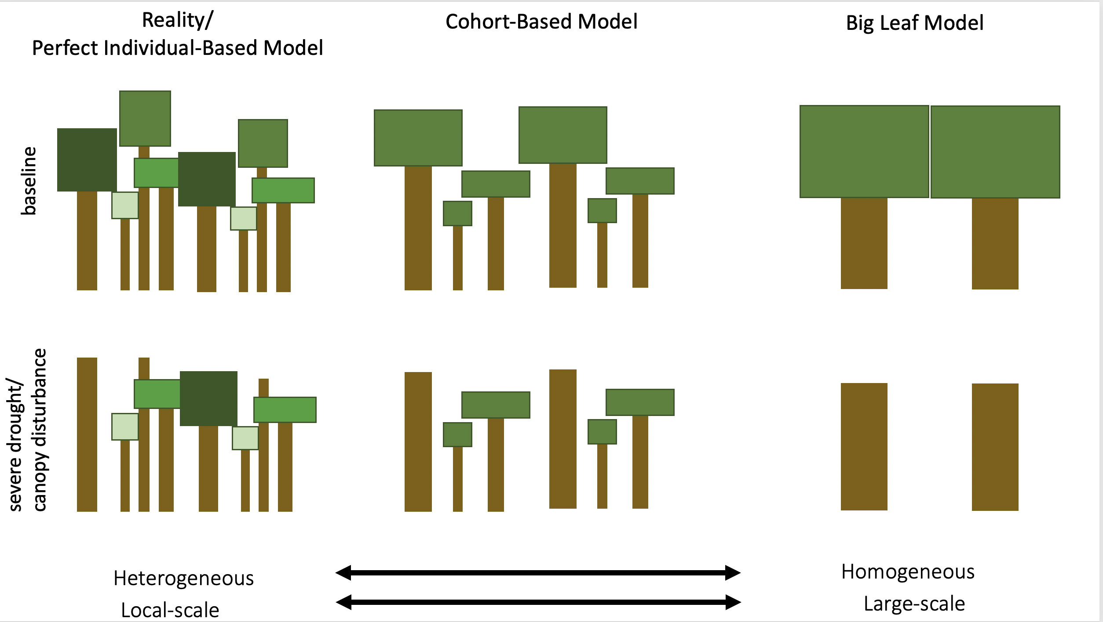

**Figure 5. DRAFT. Enrich this by showing 3-4 carefully selected scenarios (e.g., baseline, warming-mesic, warming-drought, canopy disturbance), and maybe a few key processes/ consequences (leaf T, C balance).** [Issue #42](https://github.com/EcoClimLab/vertical-thermal-review/issues/42).

**The findings of this review reinforce the notion that representing vertical structuring is essential to capturing forest dynamics under global change.** *[how?]*

~~In general, DGVMs range from Individual Based Models (IBMs) on one end of the complexity and scale spectrum to big-leaf models on the other end. Most climate models incorporate vegetation dynamics using big-leaf models, which include many first generation DGVMs that reduce 3D vegetation structure across the entire biosphere into a single vegetation layer. This simplification results in greater computational efficiency and thus easier integration into ESMs (Arora & Boer, 2010; Bonan et al. 2003; Cox, 2001; Krinner et al., 2005), although it comes at a cost of a lack of representation of important demographic processes, canopy gap formation, vertical light competition, competitive exclusion, and successional recovery from disturbance (Feeley et al., 2007; Hurtt et al. 1998; Moorcroft et al., 2001; Smith et al. 2001; Stark et al., 2012). On the other end of the spectrum are IBMs, also referred to as forest gap models, representing vegetation at the level of individual plants (Christoffersen et al., 2016; Fischer et al., 2016; Fyllas et al., 2014; Sato et al. 2007; Shuman et al. 2014; Smith et al., 2001; Bugmann, 2001; Dietze & Latimer, 2011). These models are often stochastic and spatially explicit, capturing spatial variability in the light environment and microclimates at high vertical and horizontal resolution. As a result, however, IBMs are computationally expensive and tend to be run at very local scales.~~

**The computationally feasible approach to representing vertical structuring in DVGMs lies in Cohort-based models (CBMs), which sit in the middle of this continuum between the oversimplified vegetation dynamics in big-leaf models and the computational expense of individual-based models.** CBMs represent vegetation as cohorts of individual plants, grouped together based on properties including size, age, and functional type (Haverd et al., 2013; Hurtt et al., 1998; Lischke et al. 2006; Medvigy et al. 2009; Moorcroft et al., 2001; Scherstjanoi et al. 2014; Smith et al., 2014; Weng et al., 2015). ~~Although this cohort approach serves as a compromise that incurs lower computational costs than IBMs while capturing many of the same dynamics, CBMs do not incorporate the stochastic processes of IBMs that typically allow for greater representation of functional diversity (Fisher et al., 2010).~~

*(KAT: I think all of the following content is great, but probably needs to be heavily tightened:)*

To review the vertical light environment and thermodynamics of CBMs in more detail, we focus here on the Ecosystem Demography model version 2 (ED2), a model that is actively undergoing continued development and application across a range of ecosystems and landscapes (Moorcroft et al. 2001, Longo et al 2019 Pt 1 & pt 2). ED2 is also the progenitor of the Functionally Assembled Terrestrial Ecosystem Simulator (FATES), the DGVM coupled with the Energy Exascale Earth System Model (E3SM) (Xu & Christoffersen 2017 ) . In ED2, cohorts are tracked across multiple size-classes or individuals within the same plant functional type (PFT). Each cohort can encounter multiple light environments within a single climatic grid cell depending on patch-level disturbance history and vertical light competition that modulates interactions between plant traits and resource acquisition. Heterogeneity in the light environment and canopy structure across patches within a grid cell gives rise to varying horizontal and vertical micro-environments that differ in temperature, humidity, soil moisture, and soil nutrient conditions (Fisher et al 2018). The energy, water, and carbon dioxide cycles are solved separately for each patch in ED2, while fluxes and storage associated with individual plants are solved for each cohort within patches (Longo et al 2019). As a result, vegetation structure and functional distributions are emergent properties in the model that depend on plant functional traits and their interactions with abiotic environmental conditions. Each plant perceives a unique environment, including incident light, temperature, and vapor pressure deficit that varies across local scales in association with the horizontal and vertical position of each cohort relative to other cohorts, in addition to patch level differences in topographic and edaphic conditions. Coexistence of different vegetation types emerges from different environmental niches, either along a successional gradient of light availability or vertical position in the canopy (Moorcroft et al., 2001; Smith et al., 2001; Purves & Pacala, 2008).

Temperature is an atmospheric boundary condition driving the ED2 model (Longo et al 2019). Each patch in each grid cell is defined by a thermodynamic envelope, comprised of distinct thermodynamic systems for each soil layer, temporary surface water or snow layer, the aboveground component of each cohort, and the canopy air space (Longo et al 2019). The atmosphere above and outside of the canopy air space is referred to as free air and is determined directly from boundary conditions in ED2. Patches exchange heat and mass with the free air and lose water and associated energy through surface and sub-surface runoff. The net enthalpy flux of soil, temporary surface water, and vegetation thermodynamic systems in ED2 are exclusively due to associated water fluxes, whereas the eddy flux between the free air and the canopy air space includes both water transport and flux associated with the mixing of air with different temperatures between the canopy air space and free air (Longo et al 2019).

Because most CBMs are spatially implicit within grid cells, direct and diffuse photosynthetically active radiation (PAR) is distributed to cohorts of differing heights using radiative transfer models that depend on designated rules associated with how crown architecture is represented, rather than via direct spatial competition determined by spatially explicit crown locations (Fisher et al. 2010?). The flat-top crown method used in ED and ED2 stacks cohort-layers vertically, and a radiative transfer model is used to determine radiation absorbed by each layer at its midpoint, meaning that each cohort is shaded by all taller cohorts. This is distinct from other models that represent crown architecture using a perfect plasticity approximation (PPA) approach, which assumes that tree crowns completely fill canopy gaps through phototropism (stem leaning) and crown filling (Strigul et al. 2008). Discrete canopy layers are comprised of self-organizing crowns that all receive the same incoming radiation. Once the canopy layer is filled with tree crowns, successive shorter trees inhabit the subsequent understory layer and are shaded by the trees in the canopy (Fisher et al 2010/2018?). Models using the PPA approach differ in number of understory layers (e.g. some only have one) (Fisher et al 2018). Though an improvement over big-leaf models, models that separate the canopy into only two layers (e.g., sunlit and shaded portions) may not be able to capture important within-canopy variation in terms of leaf dynamics (e.g., seasonal shifts in vertical leaf area distributions, Smith et al. 2019) and functions (e.g. thermal responses, as we present in this paper). Hence, multi-layered ecosystem models may be necessary for accurately projecting future forest function. (E.g. see de Pury & Farquhar, 1997).

## Conclusions

* across vertical gradients, directional trends in biophysical environment and leaf traits are the rule, suggesting that the physiology and ecology that have these as their underpinnings should also vary
* a number of studies confirm that this is the case.
* However, when we ask the critical question of how the temperature sensitivities of metabolism and woody growth varies across these different environments, we can’t say much– there are only a small number of studies, often showing insignificant differences or mixed results.
* We lean towards the conclusion that while large canopy trees ware the most vulnerable to warming when combined with drought, understory trees may be more vulnerable under more mesic conditions, but more research is needed.
* Critically, change to the vertical gradient–e.g., through increased mortality of canopy trees–will change processses across forest strata, with potentially dramatic consequences. (some of the literature on forest degredation or fragmentation could inform what happens when those gradients change)

## SI files

Appendix S1. Methods for NEON vertical profiles

Appendix S2. Methods for leaf energy balance modeling

Appendix S3. Methods for literature review

## References

Almeida DRA de**,** Nelson BW**,** Schietti J**,** Gorgens EB**,** Resende AF**,** Stark SC**,** Valbuena R. **2016**. Contrasting fire damage and fire susceptibility between seasonally flooded forest and upland forest in the Central Amazon using portable profiling LiDAR. *Remote Sensing of Environment* **184**: 153–160.

Aussenac G. **2000**. Interactions between forest stands and microclimate: Ecophysiological aspects and consequences for silviculture. *Ann. For. Sci.* **57**: 287–301.

Barnard DM**,** Bauerle WL. **2016**. Seasonal Variation in Canopy Aerodynamics and the Sensitivity of Transpiration Estimates to Wind Velocity in Broadleaved Deciduous Species. *Journal of Hydrometeorology* **17**: 3029–3043.

Bartemucci P**,** Messier C**,** Canham CD. **2006**. Overstory influences on light attenuation patterns and understory plant community diversity and composition in southern boreal forests of Quebec. *Can. J. For. Res.* **36**: 2065–2079.

Bartholomew DC**,** Bittencourt PRL**,** Costa ACL da**,** Banin LF**,** Costa P de B**,** Coughlin SI**,** Domingues TF**,** Ferreira LV**,** Giles A**,** Mencuccini M ***et al.*** **2020**. Small tropical forest trees have a greater capacity to adjust carbon metabolism to long-term drought than large canopy trees. *Plant, Cell & Environment* **43**: 2380–2393.

Bauerle WL**,** Bowden JD. **2011**. Separating foliar physiology from morphology reveals the relative roles of vertically structured transpiration factors within red maple crowns and limitations of larger scale models. *Journal of Experimental Botany* **62**: 4295–4307.

Bennett AC**,** McDowell NG**,** Allen CD**,** Anderson-Teixeira KJ. **2015**. Larger trees suffer most during drought in forests worldwide. *Nature Plants* **1**: 15139.

Bertrand R**,** Aubret F**,** Grenouillet G**,** Ribéron A**,** Blanchet S. **2020**. Comment on ‘Forest microclimate dynamics drive plant responses to warming’. *Science* **370**.

Bertrand R**,** Lenoir J**,** Piedallu C**,** Riofrío-Dillon G**,** de Ruffray P**,** Vidal C**,** Pierrat J-C**,** Gégout J-C. **2011**. Changes in plant community composition lag behind climate warming in lowland forests. *Nature* **479**: 517–520.

Bolstad PV**,** Mitchell K**,** Vose JM. **1999**. Foliar temperature–respiration response functions for broad-leaved tree species in the southern Appalachians. *Tree Physiology* **19**: 871–878.

Bonan GB. **2016**. *Ecological climatology: Concepts and applications*. New York, NY, USA: Cambridge University Press.

Campbell G**,** Norman J. **1998**. *An Introduction to Environmental Biophysics*. New York: Springer.

Casal JJ. **2013**. Photoreceptor Signaling Networks in Plant Responses to Shade. *Annu. Rev. Plant Biol.* **64**: 403–427.

Cavaleri MA**,** Oberbauer SF**,** Ryan MG. **2008**. Foliar and ecosystem respiration in an old-growth tropical rain forest. *Plant, Cell & Environment* **31**: 473–483.

Chazdon RL**,** Fetcher N. **1984**. Photosynthetic Light Environments in a Lowland Tropical Rain Forest in Costa Rica. *Journal of Ecology* **72**: 553–564.

Chen X**,** Sun J**,** Wang M**,** Lyu M**,** Niklas KJ**,** Michaletz ST**,** Zhong Q**,** Cheng D. **2020**. The Leaf Economics Spectrum Constrains Phenotypic Plasticity Across a Light Gradient. *Front. Plant Sci.* **11**.

Coble AP**,** Cavaleri MA. **2015**. Light acclimation optimizes leaf functional traits despite height-related constraints in a canopy shading experiment. *Oecologia* **177**: 1131–1143.

Coble AP**,** Cavaleri MA. **2014**. Light drives vertical gradients of leaf morphology in a sugar maple (Acer saccharum) forest. *Tree Physiol* **34**: 146–158.

Coble AP**,** VanderWall B**,** Mau A**,** Cavaleri MA. **2016**. How vertical patterns in leaf traits shift seasonally and the implications for modeling canopy photosynthesis in a temperate deciduous forest. *Tree Physiology* **36**: 1077–1091.

Curtis EM**,** Knight CA**,** Leigh A. **2019**. Intracanopy adjustment of leaf-level thermal tolerance is associated with microclimatic variation across the canopy of a desert tree (Acacia papyrocarpa). *Oecologia* **189**: 37–46.

Daudet FA**,** Le Roux X**,** Sinoquet H**,** Adam B. **1999**. Wind speed and leaf boundary layer conductance variation within tree crown: Consequences on leaf-to-atmosphere coupling and tree functions. *Agricultural and Forest Meteorology* **97**: 171–185.

Davis KT**,** Dobrowski SZ**,** Holden ZA**,** Higuera PE**,** Abatzoglou JT. **2019**. Microclimatic buffering in forests of the future: The role of local water balance. *Ecography* **42**: 1–11.

De Frenne P**,** Rodríguez-Sánchez F**,** Coomes DA**,** Baeten L**,** Verstraeten G**,** Vellend M**,** Bernhardt-Römermann M**,** Brown CD**,** Brunet J**,** Cornelis J ***et al.*** **2013**. Microclimate moderates plant responses to macroclimate warming. *Proc Natl Acad Sci U S A* **110**: 18561–18565.

De Frenne P**,** Zellweger F**,** Rodríguez-Sánchez F**,** Scheffers BR**,** Hylander K**,** Luoto M**,** Vellend M**,** Verheyen K**,** Lenoir J. **2019**. Global buffering of temperatures under forest canopies. *Nature Ecology & Evolution* **3**: 744–749.

Duque A**,** Stevenson PR**,** Feeley KJ. **2015**. Thermophilization of adult and juvenile tree communities in the northern tropical Andes. *Proc Natl Acad Sci USA* **112**: 10744–10749.

Fauset S**,** Freitas HC**,** Galbraith DR**,** Sullivan MJP**,** Aidar MPM**,** Joly CA**,** Phillips OL**,** Vieira SA**,** Gloor MU. **2018**. Differences in leaf thermoregulation and water use strategies between three co-occurring Atlantic forest tree species. *Plant, Cell & Environment* **41**: 1618–1631.

Feeley K**,** Martinez-Villa J**,** Perez T**,** Silva Duque A**,** Triviño Gonzalez D**,** Duque A. **2020**. The Thermal Tolerances, Distributions, and Performances of Tropical Montane Tree Species. *Frontiers in Forests and Global Change* **3**.

Harley P**,** Guenther A**,** Zimmerman P. **1996**. Effects of light, temperature and canopy position on net photosynthesis and isoprene emission from sweetgum (Liquidambar styraciflua) leaves. *Tree Physiol* **16**: 25–32.

Hernández GG**,** Winter K**,** Slot M. **2020**. Similar temperature dependence of photosynthetic parameters in sun and shade leaves of three tropical tree species. *Tree Physiol* **40**: 637–651.

Huang M**,** Piao S**,** Ciais P**,** Peñuelas J**,** Wang X**,** Keenan TF**,** Peng S**,** Berry JA**,** Wang K**,** Mao J ***et al.*** **2019**. Air temperature optima of vegetation productivity across global biomes. *Nature Ecology & Evolution* **3**: 772–779.

Ishii HR**,** Horikawa S-i**,** Noguchi Y**,** Azuma W. **2018**. Variation of intra-crown leaf plasticity of Fagus crenata across its geographical range in Japan. *Forest Ecology and Management* **429**: 437–448.

Kafuti C**,** Bourland N**,** De Mil T**,** Meeus S**,** Rousseau M**,** Toirambe B**,** Bolaluembe P-C**,** Ndjele L**,** Beeckman H. **2020**. Foliar and Wood Traits Covary along a Vertical Gradient within the Crown of Long-Lived Light-Demanding Species of the Congo Basin Semi-Deciduous Forest. *Forests* **11**: 35.

Keenan TF**,** Niinemets Ü. **2016**. Global leaf trait estimates biased due to plasticity in the shade. *Nature Plants* **3**: 1–6.

Koike T**,** Kitao M**,** Maruyama Y**,** Mori S**,** Lei TT. **2001**. Leaf morphology and photosynthetic adjustments among deciduous broad-leaved trees within the vertical canopy profile. *Tree Physiology* **21**: 951–958.

Kusi J**,** Karsai I. **2020**. Plastic leaf morphology in three species of Quercus: The more exposed leaves are smaller, more lobated and denser. *Plant Species Biology* **35**: 24–37.

Leigh A**,** Sevanto S**,** Close JD**,** Nicotra AB. **2017**. The influence of leaf size and shape on leaf thermal dynamics: Does theory hold up under natural conditions? *Plant, Cell & Environment* **40**: 237–248.

Lowman M**,** Rinker HB. **1995**. Forest Canopies. In: Endeavour.

Martin RE**,** Asner GP**,** Bentley LP**,** Shenkin A**,** Salinas N**,** Huaypar KQ**,** Pillco MM**,** Ccori Álvarez FD**,** Enquist BJ**,** Diaz S ***et al.*** **2020**. Covariance of Sun and Shade Leaf Traits Along a Tropical Forest Elevation Gradient. *Front. Plant Sci.* **10**: 1810.

Martin TA**,** Hinckley TM**,** Meinzer FC**,** Sprugel DG. **1999**. Boundary layer conductance, leaf temperature and transpiration of Abies amabilis branches. *Tree Physiology* **19**: 435–443.

Mathur S**,** Jain L**,** Jajoo A. **2018**. Photosynthetic efficiency in sun and shade plants. *Photosynt.* **56**: 354–365.

Mau A**,** Reed S**,** Wood T**,** Cavaleri M. **2018a**. Temperate and Tropical Forest Canopies are Already Functioning beyond Their Thermal Thresholds for Photosynthesis. *Forests* **9**: 47.

Mau A**,** Reed S**,** Wood T**,** Cavaleri M. **2018b**. Temperate and Tropical Forest Canopies are Already Functioning beyond Their Thermal Thresholds for Photosynthesis. *Forests* **9**: 47.

McDowell NG**,** Allen CD**,** Anderson-Teixeira K**,** Aukema BH**,** Bond-Lamberty B**,** Chini L**,** Clark JS**,** Dietze M**,** Grossiord C**,** Hanbury-Brown A ***et al.*** **2020**. Pervasive shifts in forest dynamics in a changing world. *Science* **368**: eaaz9463.

McDowell N**,** Pockman WT**,** Allen CD**,** Breshears DD**,** Cobb N**,** Kolb T**,** Plaut J**,** Sperry J**,** West A**,** Williams DG ***et al.*** **2008**. Mechanisms of plant survival and mortality during drought: Why do some plants survive while others succumb to drought? *New Phytologist* **178**: 719–739.

McGregor I**,** Helcoski R**,** Kunert N**,** Tepley AJ**,** Gonzalez-Akre EB**,** Herrmann V**,** Zailaa J**,** Stovall AEL**,** Bourg NA**,** McShea WJ ***et al.*** Tree height and drought tolerance traits shape growth responses across droughts in a temperate broadleaf forest. *Target journal: New Phytologist*.

Michaletz ST**,** Weiser MD**,** McDowell NG**,** Zhou J**,** Kaspari M**,** Helliker BR**,** Enquist BJ. **2016**. The energetic and carbon economic origins of leaf thermoregulation. *Nature Plants* **2**: 16129.

Michaletz ST**,** Weiser MD**,** Zhou J**,** Kaspari M**,** Helliker BR**,** Enquist BJ. **2015**. Plant Thermoregulation: Energetics, Trait–Environment Interactions, and Carbon Economics. *Trends in Ecology & Evolution* **30**: 714–724.

Muir CD. **2019**. Tealeaves: An R package for modelling leaf temperature using energy budgets. *AoB PLANTS* **11**.

Nakamura A**,** Kitching RL**,** Cao M**,** Creedy TJ**,** Fayle TM**,** Freiberg M**,** Hewitt CN**,** Itioka T**,** Koh LP**,** Ma K ***et al.*** **2017**. Forests and Their Canopies: Achievements and Horizons in Canopy Science. *Trends in Ecology & Evolution* **32**: 438–451.

Niinemets Ü. **2010**. Responses of forest trees to single and multiple environmental stresses from seedlings to mature plants: Past stress history, stress interactions, tolerance and acclimation. *Forest Ecology and Management* **260**: 1623–1639.

Niinemets Ü. **2016**. Leaf age dependent changes in within-canopy variation in leaf functional traits: A meta-analysis. *J Plant Res* **129**: 313–338.

Niinemets Ü. **2006**. The controversy over traits conferring shade‐tolerance in trees: Ontogenetic changes revisited. *Journal of Ecology* **94**: 464–470.

Niinemets Ü**,** Anten NPR. **2009**. Packing the Photosynthetic Machinery: From Leaf to Canopy. In: Laisk A, Nedbal L, Govindjee, eds. Advances in Photosynthesis and Respiration. Photosynthesis in silico: Understanding Complexity from Molecules to Ecosystems. Dordrecht: Springer Netherlands, 363–399.

Niinemets Ü**,** Bilger W**,** Kull O**,** Tenhunen JD. **1998**. Acclimation to high irradiance in temperate deciduous trees in the field: Changes in xanthophyll cycle pool size and in photosynthetic capacity along a canopy light gradient. *Plant, Cell & Environment* **21**: 1205–1218.

Niinemets Ü**,** Keenan TF**,** Hallik L. **2015**. A worldwide analysis of within-canopy variations in leaf structural, chemical and physiological traits across plant functional types. *New Phytologist* **205**: 973–993.

Niinemets Ü**,** Kull O**,** Tenhunen JD. **2004**. Within-canopy variation in the rate of development of photosynthetic capacity is proportional to integrated quantum flux density in temperate deciduous trees. *Plant, Cell & Environment* **27**: 293–313.

Niinemets Ü**,** Sun Z. **2015**. How light, temperature, and measurement and growth [CO2] interactively control isoprene emission in hybrid aspen. *J Exp Bot* **66**: 841–851.

Niinemets Ü**,** Valladares F. **2004**. Photosynthetic Acclimation to Simultaneous and Interacting Environmental Stresses Along Natural Light Gradients: Optimality and Constraints. *Plant Biology* **6**: 254–268.

Ozanne CMP**,** Anhuf D**,** Boulter SL**,** Keller M**,** Kitching RL**,** Körner C**,** Meinzer FC**,** Mitchell AW**,** Nakashizuka T**,** Dias PLS ***et al.*** **2003**. Biodiversity Meets the Atmosphere: A Global View of Forest Canopies. *Science* **301**: 183–186.

Parker GG**,** Davis MM**,** Chapotin SM. **2002**. Canopy light transmittance in Douglas-fir–western hemlock stands. *Tree Physiol* **22**: 147–157.

Parker GG**,** Fitzjarrald DR**,** Gonçalves Sampaio IC. **2019**. Consequences of environmental heterogeneity for the photosynthetic light environment of a tropical forest. *Agricultural and Forest Meteorology* **278**: 107661.

Perez TM**,** Feeley KJ. **2020**. Photosynthetic heat tolerances and extreme leaf temperatures. *Functional Ecology* **34**: 2236–2245.

Perez TM**,** Feeley KJ. **2018**. Increasing Humidity Threatens Tropical Rainforests. *Front. Ecol. Evol.* **6**: 68.

Perez TM**,** Socha A**,** Tserej O**,** Feeley KJ. **2020**. PSII heat tolerances characterize thermal generalists and the upper limit of carbon assimilation. *Plant Cell Environ*: pce.13990.

Perkins SE**,** Alexander LV**,** Nairn JR. **2012**. Increasing frequency, intensity and duration of observed global heatwaves and warm spells. *Geophysical Research Letters* **39**.

Poorter H**,** Niinemets Ü**,** Ntagkas N**,** Siebenkäs A**,** Mäenpää M**,** Matsubara S**,** Pons T. **2019**. A meta-analysis of plant responses to light intensity for 70 traits ranging from molecules to whole plant performance. *New Phytol.* **223**: 1073–1105.

Rey-Sánchez A**,** Slot M**,** Posada J**,** Kitajima K. **2016**. Spatial and seasonal variation in leaf temperature within the canopy of a tropical forest. *Climate Research* **71**: 75–89.

Roberts J**,** Cabral OMR**,** Aguiar LFD. **1990**. Stomatal and Boundary-Layer Conductances in an Amazonian terra Firme Rain Forest. *The Journal of Applied Ecology* **27**: 336.

Rollinson CR**,** Alexander MR**,** Dye AW**,** Moore DJP**,** Pederson N**,** Trouet V. Climate sensitivity of understory trees differs from overstory trees in temperate mesic forests. *Ecology* **n/a**: e03264.

Rozendaal DMA**,** Hurtado VH**,** Poorter L. **2006**. Plasticity in leaf traits of 38 tropical tree species in response to light; relationships with light demand and adult stature. *Functional Ecology* **20**: 207–216.

Sack L**,** Melcher PJ**,** Liu WH**,** Middleton E**,** Pardee T. **2006**. How strong is intracanopy leaf plasticity in temperate deciduous trees? *American Journal of Botany* **93**: 829–839.

Sastry A**,** Guha A**,** Barua D. **2018**. Leaf thermotolerance in dry tropical forest tree species: Relationships with leaf traits and effects of drought. *AoB PLANTS* **10**.

Schuepp PH. **1993**. Tansley Review No. 59. Leaf Boundary Layers. *The New Phytologist* **125**: 477–507.

Senf C**,** Pflugmacher D**,** Zhiqiang Y**,** Sebald J**,** Knorn J**,** Neumann M**,** Hostert P**,** Seidl R. **2018**. Canopy mortality has doubled in Europe’s temperate forests over the last three decades. *Nature Communications* **9**: 4978.

Senf C**,** Seidl R. **2020**. Mapping the forest disturbance regimes of Europe. *Nature Sustainability*: 1–8.

Sharkey TD**,** Monson RK. **2014**. The future of isoprene emission from leaves, canopies and landscapes. *Plant, Cell & Environment* **37**: 1727–1740.

Smith MN**,** Stark SC**,** Taylor TC**,** Ferreira ML**,** Oliveira E de**,** Restrepo‐Coupe N**,** Chen S**,** Woodcock T**,** Santos DB dos**,** Alves LF ***et al.*** **2019**. Seasonal and drought-related changes in leaf area profiles depend on height and light environment in an Amazon forest. *New Phytologist* **222**: 1284–1297.

Stark SC**,** Breshears DD**,** Aragón S**,** Villegas JC**,** Law DJ**,** Smith MN**,** Minor DM**,** Assis RL de**,** Almeida DRA de**,** Oliveira G de ***et al.*** **2020**. Reframing tropical savannization: Linking changes in canopy structure to energy balance alterations that impact climate. *Ecosphere* **11**: e03231.

Stokes VJ**,** Morecroft MD**,** Morison JIL. **2006**. Boundary layer conductance for contrasting leaf shapes in a deciduous broadleaved forest canopy. *Agricultural and Forest Meteorology* **139**: 40–54.

Stovall AEL**,** Shugart H**,** Yang X. **2019**. Tree height explains mortality risk during an intense drought. *Nature Communications* **10**: 4385.

Sullivan MJP**,** Lewis SL**,** Affum-Baffoe K**,** Castilho C**,** Costa F**,** Sanchez AC**,** Ewango CEN**,** Hubau W**,** Marimon B**,** Monteagudo-Mendoza A ***et al.*** **2020**. Long-term thermal sensitivity of Earth’s tropical forests. *Science* **368**: 869–874.

Thom D**,** Sommerfeld A**,** Sebald J**,** Hagge J**,** Müller J**,** Seidl R. **2020**. Effects of disturbance patterns and deadwood on the microclimate in European beech forests. *Agricultural and Forest Meteorology* **291**: 108066.

Tibbitts TW. **1979**. Humidity and Plants. *BioScience* **29**: 358–363.

Tymen B**,** Vincent G**,** Courtois EA**,** Heurtebize J**,** Dauzat J**,** Marechaux I**,** Chave J. **2017**. Quantifying micro-environmental variation in tropical rainforest understory at landscape scale by combining airborne LiDAR scanning and a sensor network. *Annals of Forest Science* **74**: 32.

VOGEL S. **1970**. Convective Cooling at Low Airspeeds and the Shapes of Broad Leaves. *Journal of Experimental Botany* **21**: 91–101.

von Arx G**,** Dobbertin M**,** Rebetez M. **2012**. Spatio-temporal effects of forest canopy on understory microclimate in a long-term experiment in Switzerland. *Agricultural and Forest Meteorology* **166-167**: 144–155.

Way DA**,** Pearcy RW. **2012**. Sunflecks in trees and forests: From photosynthetic physiology to global change biology. *Tree Physiol* **32**: 1066–1081.

Yang PC**,** Black TA**,** Neumann HH**,** Novak MD**,** Blanken PD. **1999**. Spatial and temporal variability of CO2 concentration and flux in a boreal aspen forest. *Journal of Geophysical Research: Atmospheres* **104**: 27653–27661.

Zellweger F**,** Coomes D**,** Lenoir J**,** Depauw L**,** Maes SL**,** Wulf M**,** Kirby KJ**,** Brunet J**,** Kopecký M**,** Máliš F ***et al.*** **2019**. Seasonal drivers of understorey temperature buffering in temperate deciduous forests across Europe (A Algar, Ed.). *Global Ecology and Biogeography* **28**: 1774–1786.

Zellweger F**,** De Frenne P**,** Lenoir J**,** Vangansbeke P**,** Verheyen K**,** Bernhardt-Römermann M**,** Baeten L**,** Hédl R**,** Berki I**,** Brunet J ***et al.*** **2020a**. Forest microclimate dynamics drive plant responses to warming. *Science* **368**: 772–775.

Zellweger F**,** Frenne PD**,** Lenoir J**,** Vangansbeke P**,** Verheyen K**,** Bernhardt-Römermann M**,** Baeten L**,** Hédl R**,** Berki I**,** Brunet J ***et al.*** **2020b**. Response to Comment on ‘Forest microclimate dynamics drive plant responses to warming’. *Science* **370**.

Zhang J-L**,** Poorter L**,** Hao G-Y**,** Cao K-F. **2012**. Photosynthetic thermotolerance of woody savanna species in China is correlated with leaf life span. *Annals of Botany* **110**: 1027–1033.

Zohner CM**,** Renner SS. **2019**. Ongoing seasonally uneven climate warming leads to earlier autumn growth cessation in deciduous trees. *Oecologia* **189**: 549–561.