New insights into the Weddell Sea ecosystem applying a network approach

Tomás I. Marina, Leonardo A. Saravia and Susanne Kortsch

## Abstract

Network approaches can shed light on the structure and stability of complex marine communities. In recent years, such approaches have been successfully applied to study polar ecosystems, improving our knowledge on how they might respond to ongoing environmental changes. The Weddell Sea is one of the most studied marine ecosystems outside the Antarctic Peninsula in the Southern Ocean. Yet, few studies consider the known complexity of the Weddell Sea food web which in its current form comprises 490 species and 16041 predator-prey interactions. Here we analysed the Weddell Sea food web, focusing on trophic interactions that underpin ecosystem structure and stability. We estimated the strength for each interaction in the food web, characterised species position in the food web using unweighted and weighted properties, and analysed species’ roles with respect to the stability of the food web. On one hand, we found that the distribution of the interaction strength at the food web level is asymmetric, where weak interactions are prevalent. Including such information as a (weighted) property for species we detected a positive relationship between species mean interaction strength and two unweighted properties, trophic level and the total number of interactions. We also found that only a few species are key in terms of food web stability, presenting high mean interaction strength, mid to high trophic level, relatively high number of interactions, and mid to low trophic similarity. In the same analysis we have integrated food web and species information, enabling a more complete assessment of the ecosystem structure and function, likely highlighting the ecological processes at play in the Weddell Sea. We consider that our results provide new insights important for the development of effective policies and management strategies, particularly given the ongoing initiative to implement a Marine Protected Area (MPA) in the Weddell Sea.

## Introduction

The objective of this work was to improve the knowledge on how the Weddell Sea and the species therein may respond to perturbations from ongoing environmental changes. To achieve this we: 1) estimated the strength for each interaction in the Weddell Sea food web, 2) characterised species considering weighted and unweighted properties, and 3) analysed the species’ role in the stability of the food web.

## Methodology

### Study area

The high Antarctic Weddell Sea shelf is situated between 74 and 78ºS stretching approximately 450 km from East to West (Figure 1). Water depth varies between 200 and 500 meters, and shallower areas are covered by continental ice, which forms the coastline along the eastern and southern part of the Weddell Sea. The shelf area contains a complex benthic three-dimensional habitat with large benthic biomasses, intermediate to high diversity in comparison to benthic boreal communities and a spatially patchy distribution of organisms (Dayton 1990; Teixidó, Garrabou, and Arntz 2002).

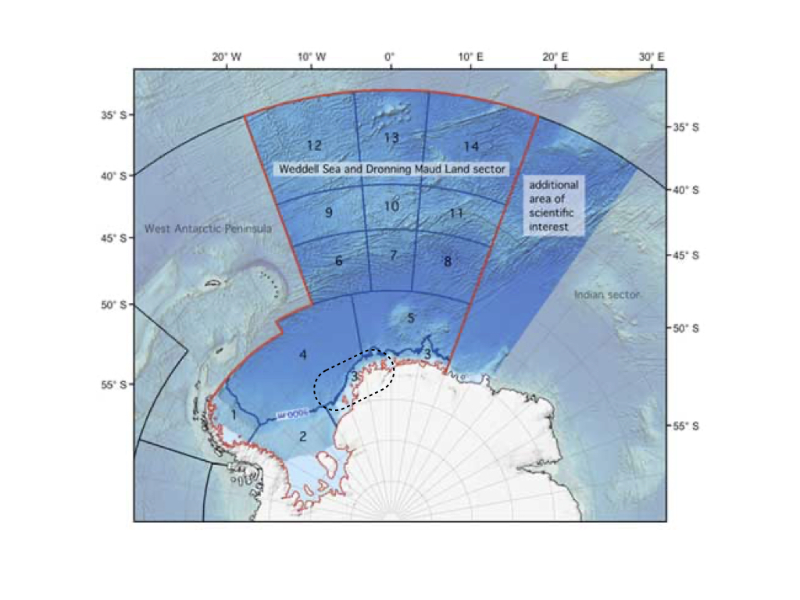

Figure 1. Map of the Weddell Sea and Dronning Maud Land sector highlighting the high Antarctic shelf as a dashed-line contour. Modified from www.soos.aq.

### Weddell Sea food web dataset

The Weddell Sea food web was retrieved from the GlobAL daTabasE of traits and food Web Architecture (GATEWAy, version 1.0) of the German Centre for Integrative Biodiversity Research (iDiv) Halle-Jena-Leipzig (Brose 2018). In addition to predator-prey interactions, the database contains information on other biological data such as the mean body mass and movement type for each species in the food web. Furthermore, it incorporates information about the interaction itself, such as the dimension of the predator search space (2 or 3 dimensions). In its current form the Weddell Sea food web comprises 490 species and 16041 predator-prey interactions and constitutes one of the most resolved food webs constructed to date (Jacob et al. 2011).

### Dataset analyses

#### Interaction strength estimation and distribution

To estimate the strength of each pairwise interaction in the food web we followed the methodology proposed by Pawar, Dell, and Van M. Savage (2012). The minimum data requirements are body mass of the consumer (predator) and resource (prey), and the interaction dimensionality (ID) classified as 2 or 3 dimensions. The ID is defined as the dimension of the search space of the predator, that is equivalent to the movement space of the prey. Thus, the ID is classified as 2D when both predator and prey move in 2D (e.g., both are benthic) or if a predator moves in 3D and a prey in 2D (e.g., pelagic predator on benthic prey). The ID is classified as 3D when both predator and prey move in 3D (e.g., both pelagic) or if the predator moves in 2D and the prey in 3D (e.g., benthic predator, pelagic prey) (Pawar, Dell, and Van M. Savage 2012). GATEWAy v.1.0 provides information on the mean body mass for consumers and resources, except for ‘detritus’ and ‘sediment’, and the dimensionality for the majority of the interactions, though the latter is missing in some cases (924 interactions). To complete the missing data on species ‘dimensionality’, we used information about the movement type of predators and prey included in GATEWAy.

The main equation we used for estimating the interaction strength IS was:

where is the search rate, is the resource density, and and are the body mass for the resource and the consumer, respectively (Pawar, Dell, and Van M. Savage 2012).

We obtained estimates for resource density and the search rate from the scaling relationships with the resource and the consumer mass, respectively (Pawar, Dell, and Van M. Savage 2012). The coefficients of such relationships, determined by ordinary least squares regression, vary with the interaction dimensionality. On one hand, resource density scales with resource mass as power-law with exponents in 2D and in 3D. Since mean mass for resources ‘phytodetritus’ and ‘sediment’ were not available in GATEWAy, we considered the body mass of the smallest phytoplankton species (‘Fragilariopsis cylindrus’) as a proxy. This is justified by the fact that ‘phytodetritus’ and ‘sediment’ are mainly composed of dead or senescent phytoplankton reaching the seabed (Wolanski et al. 2011). On the other hand, search rate scales with consumer mass as power-law with exponents in 2D and in 3D.

We fitted six candidate models (Exponential, Gamma, log-Normal, Normal, Power-law and Uniform) the interaction strength distribution using maximum likelihood (McCallum 2008), and selected the best fitting model by computing the Akaike Information Criterion AIC (Burnham and Anderson 2002).

### Species properties

To characterise the role of each species in the food web, we considered unweighted and weighted food web properties (Figure 2). Unweighted properties are related to properties commonly used in qualitative food web studies and only describe the presence or absence of interactions without any information on strength between a pairwise species link (Martinez 1991; Dunne, Williams, and Martinez 2002b; Borrelli and Ginzburg 2014). In contrast, weighted properties capture the importance of interaction strength.

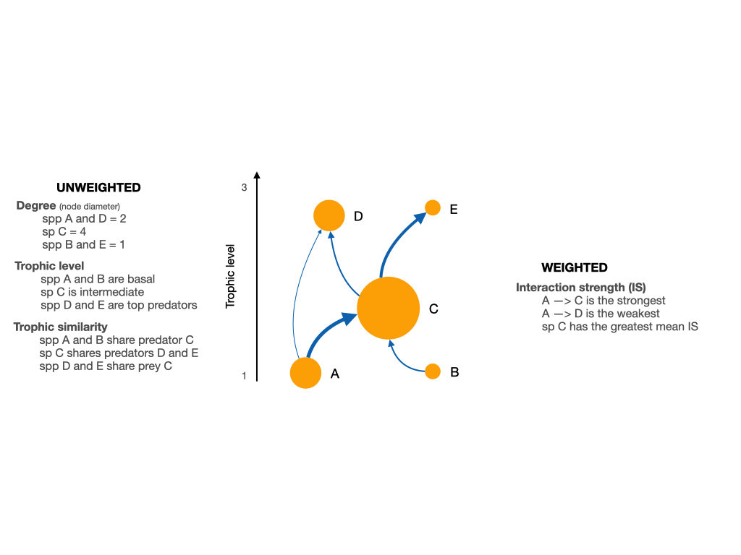

Figure 2. Scheme of a network showing the weighted and unweighted properties we used to characterize the species of the Weddell Sea food web.

To assess species roles as a function of the weighted food web, we focused on mean interaction strength defined as the average strength of all interactions for a given species. Further we calculated three unweighted species properties: a) species degree, i.e., the sum of in- and out-going interactions ; b) trophic level ; and c) trophic similarity, i.e., the trophic overlap based on shared and unique resources and consumers. These metrics were chosen to assess a species role based on the unweighted food web. The species degree has often been equated with species importance to the structure and functioning within a food web, i.e. perturbations to high-degree species may therefore have more significant effects on the food web robustness to perturbations than low-degree species (Dunne, Williams, and Martinez 2002a; references in Cirtwill et al. 2018). The trophic level offers information about how important a species is to its biotic community, i.e., top predators and primary producers are expected to have particularly large effects on the rest of their communities through top-down and bottom-up control, respectively (references in Cirtwill et al. 2018). Trophic similarity is an index of trophic overlap considering the set of prey and predators for a pair of species; it measures one of the most important aspects of species’ niches, the trophic niche, and functional aspects of biodiversity (Martinez 1991; Williams and Martinez 2000).

Furthermore, we took a species’ habitat into account, which describes the physical position of a species within the ecosystem. Species were categorised as: 1) benthic, if a species lives on the seafloor; 2) pelagic, if a species lives close to the surface; 3) benthopelagic, if it moves between and connects the mentioned environments; 4) demersal, if it lives and feeds on or near the bottom of the sea; and 5) land-based, if the consumer is not strictly aquatic but feeds predominantly on marine species. Species habitat affiliation was retrieved from Jacob et al. (2011).

With the aim of studying the relationship between the interaction strength of the species (weighted property) and its unweighted properties we performed linear regression analyses between the log mean interaction strength and each of the mentioned unweighted properties. Thus we considered the interaction strength as the dependent variable and the given unweighted property as the independent variable, and obtained the coefficients (slope and intercept) for the linear model. Models were fitted using the least squares approach. We also explored the mean interaction strength distribution with the species habitat.

Formulas used to obtain the above species properties are described in Supplementary Material.

### Extinction simulations and stability

To analyse the impact of species on food web stability, we performed extinction simulations deleting one species at a time, that is for every extinction network size was reduced by one species only. After each extinction, we calculated the stability of the network minus the targeted species (489 nodes) and compared it with that of the whole network (490 nodes in total). To calculate stability, we used the mean of the real part of the maximum eigenvalue of the Jacobian matrix using randomized Jacobians and keeping the predator-prey sign structure fixed (Allesina and Pascual 2008; Grilli, Rogers, and Allesina 2016). This index indicates a more stable food web when it is negative. We performed 1000 simulations for each species extinction and obtained a mean maximum eigenvalue for each case. At last we statistically analysed such a difference with an Anderson-Darling test considering a p-value < 0.01 (Scholz and Stephens 1987). If this difference is positive, then the stability of the food web is higher if a species was removed, and vice versa. A detailed description on the stability calculations can be found in Supplementary Material.

Once we had the results for the impact on stability for each species extinction, we plotted them considering weighted (interaction strength) and unweighted properties, and species habitat. With this we aim to characterise those species with a relatively high effect on the stability of the food web.

All analyses were performed in R software, using the R packages igraph (Csardi and Nepusz 2005), cheddar (Hudson et al. 2013), and multiweb (Saravia 2019). The source code and data are available at <https://github.com/EcoComplex/WeddellSea>.

## Results

### Interaction strength distribution

The statistical distribution that best fitted the empirical interaction strength distribution was a ‘gamma’ due to the high proportion of weak interactions and the existence of a few strong interactions (Figure 3, Table S3).

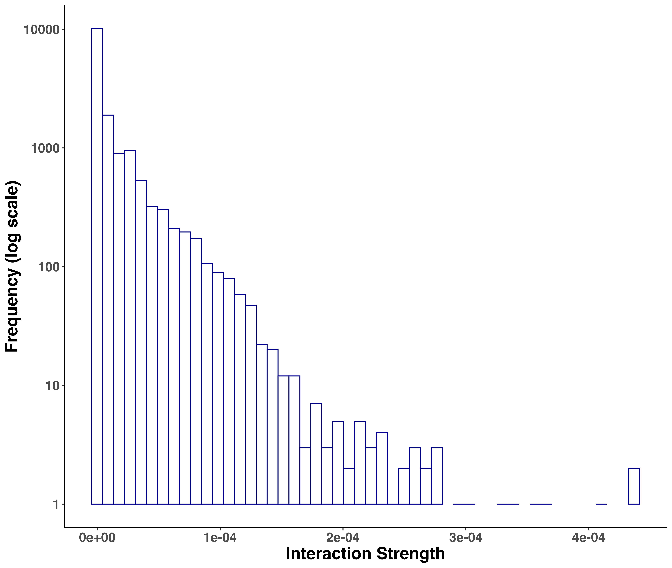

Figure 3. Frequency distribution of interaction strengths for the Weddell Sea food web. Total number of interactions = 16041. The distribution was best fitted to a ‘gamma’ model.

### Species’ role related to their mean interaction strength

We found that the species’ mean interaction strength (weighted property) shows different relationships with the unweighted properties analysed (Figure 4A-D). In this regard, there is a positive relationship between interaction strength and trophic level, i.e., the higher the trophic level of the species, the higher its mean interaction strength. We also found a significant but less evident positive relationship with species degree. Contrary, there was no significant relationship between mean interaction strength and trophic similarity. Considering species habitat affiliation, the “Benthopelagic” and “Pelagic” categories contained the two species with the highest mean interaction strength, the killer whale Orcinus orca and the colossal squid Mesonychoteuthis hamiltoni, respectively. However, the majority of the species with relatively higher interaction strength belonged to the “Demersal” and “Land-based” habitats groups. Species inhabiting the benthic realm showed the lowest mean interaction strength (Figure 4D).

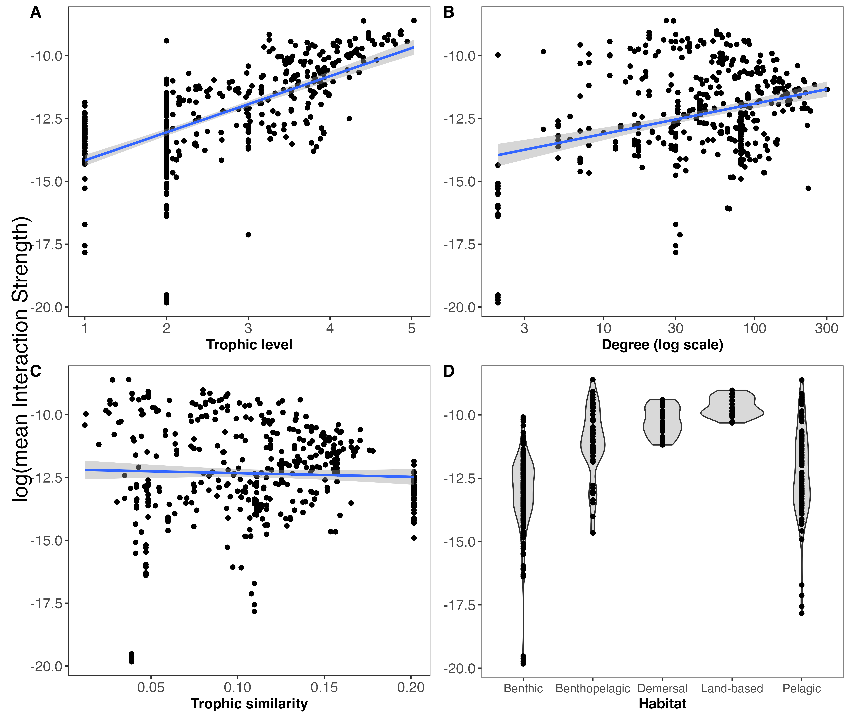

Figure 4. Relationships between weighted (mean Interaction Strength) and unweighted properties including habitat. Linear regressions are shown between log(mean interaction strength) and trophic level (A), degree (B) and trophic similarity (C). Linear regressions for trophic level (), degree () and trophic similarity ().

### Species impact on food web stability

Our extinction analyses showed that the majority of species had no significant impact on food web stability after being removed (Figure 5). Most of the species (black points in figure 5) did not change the stability of the network considerably after being removed, except for a few species. Only 15 out of 490 species (3.06%) gave rise to significant changes in the food web’s stability after their removal (Table 2). Most of these species had a positive impact on food web stability, i.e., network stability increased after their removal. Only two species significantly decreased network stability after being removed, the demersal fish Pagetopsis macropterus and the benthopelagic amphipod Maxilliphimedia longipes.

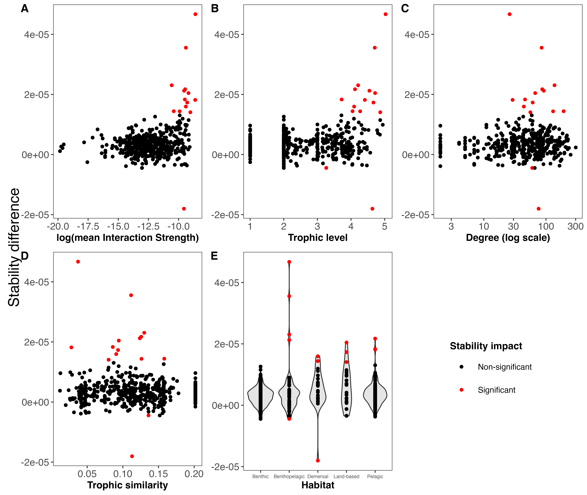

Figure 5. Stability difference (mean maximum eingenvalue) between the whole Weddell Sea food web (n = 490) and the food web minus one species (n = 489) for weighted (interaction strength) and unweighted species properties, and habitat. Point color indicates the impact on the stability; if significant the extinction of that species altered the stability of the food web.

After exploring the stability difference against the species properties (Figure 5), we found that those species that generated a significant impact on the stability of the food web were characterised by: 1) high mean interaction strength; 2) mid to high trophic levels (TL > 3.2); 3) relatively high number of interactions (Degree > 25); and 4) mid to low trophic similarity (TS < 0.16). Habitat wise, species with a significant impact on the stability were present in all habitats, except for the benthic realm. Table 2 shows these results for such species.

Properties of the species that when become extinct generated a significant impact on the stability of the Weddell Sea food web, ordered by significance (Anderson-Darling p-value). References: meanIS = mean interaction strength, TL = trophic level, Deg = degree, TS = trophic similarity, StabDif = stability difference, ADvalue = Anderson-Darling p-value.

| Species | MeanIS | TL | Deg | TS | Habitat | StabDif | ADvalue |
| --- | --- | --- | --- | --- | --- | --- | --- |
| Orcinus orca | 0.0001825 | 5.03 | 26 | 0.037 | Benthopelagic | 4.67e-05 | 2.0000e-41 |
| Macrourus holotrachys | 0.0000830 | 4.70 | 85 | 0.112 | Benthopelagic | 3.55e-05 | 2.7314e-23 |
| Pagetopsis macropterus | 0.0000708 | 4.64 | 76 | 0.113 | Demersal | -1.80e-05 | 2.3777e-12 |
| Abyssorchomene nodimanus | 0.0000256 | 4.21 | 137 | 0.130 | Benthopelagic | 2.30e-05 | 8.5197e-10 |
| Dissostichus mawsoni | 0.0000782 | 4.12 | 87 | 0.126 | Pelagic | 2.17e-05 | 1.5670e-09 |
| Macrourus whitsoni | 0.0000714 | 4.55 | 92 | 0.124 | Benthopelagic | 2.12e-05 | 3.3043e-08 |
| Hydrurga leptonyx | 0.0001031 | 4.72 | 67 | 0.094 | Land-based | 2.04e-05 | 9.6647e-06 |
| Mesonychoteuthis hamiltoni | 0.0001802 | 4.41 | 29 | 0.028 | Pelagic | 1.82e-05 | 4.5869e-05 |
| Champsocephalus gunnari | 0.0000762 | 3.72 | 46 | 0.086 | Pelagic | 1.83e-05 | 6.7872e-05 |
| Notothenia marmorata | 0.0000827 | 4.09 | 44 | 0.091 | Demersal | 1.60e-05 | 1.2256e-04 |
| Arctocephalus gazella | 0.0000928 | 4.67 | 61 | 0.093 | Land-based | 1.73e-05 | 2.0857e-04 |
| Trematomus pennellii | 0.0000304 | 4.04 | 192 | 0.158 | Demersal | 1.44e-05 | 1.0022e-03 |
| Mirounga leonina | 0.0001203 | 4.87 | 56 | 0.080 | Land-based | 1.41e-05 | 1.2783e-03 |
| Notothenia coriiceps | 0.0000494 | 4.27 | 130 | 0.126 | Demersal | 1.44e-05 | 1.6612e-03 |
| Maxilliphimedia longipes | 0.0000022 | 3.26 | 60 | 0.136 | Benthopelagic | -4.50e-06 | 9.7397e-03 |

## Discussion

### Many weak and a few strong interactions

Our analyses show that the distribution of species interaction strength at the network level is asymmetric, i.e., the Weddell Sea food web contains many weak interactions and only a few strong ones. This finding is consistent with many previous theoretical and empirical studies (e.g. McCann, Hastings, and Huxel 1998; Neutel, Heesterbeek, and de Ruiter 2002; Emmerson and Raffaelli 2004; Wootton and Emmerson 2005; Kortsch et al. 2021). The asymmetric distribution of interaction strength in food webs has been interpreted as an explanation for the persistence of complex communities in nature (Bascompte, Melián, and Sala 2005; Allesina et al. 2015; Nilsson and McCann 2016). Here we show that this pattern is also prevalent in one of the most complex empirical (marine) food webs to date, comprising 490 species and 16041 predator-prey interactions. This finding reinforces the call for the inclusion of interaction strength in food web studies to better understand the ecosystem functioning, and species and whole network responses to environmental perturbations.

### Species’s role related to their mean interaction strength

We employed a range of descriptors using both unweighted and weighted food web properties to characterise the dynamic and multifaceted nature of the Weddell Sea food web. Our results show a positive relationship between interaction strength and trophic level, and between interaction strength and species degree. Mean interaction strength increases with trophic level and species degree. The former relationship might contradict those studies that suggest that mid-trophic level species are involved in the major pathways of energy flow in high-latitude marine ecosystems (Pinkerton and Bradford-Grieve 2014; Murphy et al. 2016; McCormack et al. 2020; Riccialdelli et al. 2020). This could be explained by the lack of species biomass data in our interaction strength estimations; the methodology we applied here (Pawar, Dell, and Van M. Savage 2012) allows empirical data for the density of the resource to be included, though this data is not for the majority of food web species at the study site. On the other hand, the positive relationship between interaction strength and degree reinforces the importance of species with many interactions: species with high degree (hubs) have a large impact on overall food web structure and functioning (Dunne, Williams, and Martinez 2002a; Kortsch et al. 2015). In the Weddell Sea, species with high degree also tend to have high mean interaction strengths. This information on the quantity and quality of interactions and its relationship enables a robust assessment of the species’ role in the stability of the food web (Cirtwill et al. 2018).

### Species impact on food web stability

Only a few species play a key role with respect to the Weddell Sea food web stability, according to the mean maximum eingenvalue stability index employed in this study. This is in concordance with other studies on complex empirical food webs in marine ecosystems in the Arctic and other locations in Antarctica (Kortsch et al. 2015; Marina et al. 2018; Rodriguez et al. 2022). These key species are characterised by a particular set of food web properties: high to mean interaction strength; mid to high trophic level; relatively high number of interactions; and mid to low trophic similarity. In a previous study on sequential extinction simulations for the Weddell Sea food web, it was found that larger bodied-sized species could be lost without causing a collapse of the network. A major caveat of this finding, also recognised by the authors, was that population dynamics were ignored and hence no top-down extinctions, or other indirect effects, could occur. In our study we considered such top-down effects by including information on the species interaction strength, which is of paramount importance when analysing the response of perturbations in ecological communities (McCann, Hastings, and Huxel 1998; Montoya et al. 2009; Novak et al. 2011). Thus, our study suggests that species with high mean interaction strength and high trophic level need to be considered with particular attention when trying to predict the effects of perturbations on the Weddell Sea ecosystem. This conclusion is further reinforced by the finding that these species have mid to low trophic similarity, which means that few other species of the food web can occupy the same trophic role. In a review, it was emphasised that polar pelagic communities are particularly sensitive to changes due to a low functional redundancy at key trophic levels (Murphy et al. 2016). Here we provide broader analyses of species impact on food web robustness by including species from all habitats (benthic, pelagic and land-based). This suggests that the sensitivity of marine polar ecosystems to environmental perturbations is a concern also beyond the pelagic realm.

## Conclusions

Our study goes beyond the current understanding of how species influence ecosystem structure and stability in the Weddell Sea in particular and in most polar regions in general (Murphy et al. 2016; McCormack et al. 2021). In the same analysis we have integrated information about weighted (interaction strength) and unweighted species properties, enabling a more complete assessment of the species’ role in the food web structure and function, likely highlighting the ecological processes at play in the Weddell Sea ecosystem.

We consider that the information provided in this study is important for the development of effective policies and management strategies, particularly given the ongoing initiative to implement a Marine Protected Area (MPA) in the Weddell Sea (Teschke et al. 2021).

## References

## Extras

It’s also noteworthy that our study is the first of its type to consider the dimensionality of the interaction (2 or 3 dimensions) to estimate predator-prey relationships within a food web framework. After analysing more than 2900 predator-prey interactions from several ecosystems, Pawar, Dell, and Van M. Savage (2012) concluded that interaction dimensionality is a critical factor driving consumer-resource dynamics, which will lead to better predictions of food web and ecosystem functioning. This arises as crucial to better understand how a complex system such as the Weddell Sea might respond to environmental change, which is an ongoing issue in that region of the Antarctic (Gutt et al. 2022 and references herein).

Allesina, Stefano, Jacopo Grilli, György Barabás, Si Tang, Johnatan Aljadeff, and Amos Maritan. 2015. “Predicting the Stability of Large Structured Food Webs.” *Nature Communications* 6 (1): 7842. <https://doi.org/10.1038/ncomms8842>.

Allesina, Stefano, and Mercedes Pascual. 2008. “Network Structure, Predatorprey Modules, and Stability in Large Food Webs.” *Theoretical Ecology* 1 (1): 55–64. <https://doi.org/10.1007/s12080-007-0007-8>.

Bascompte, Jordi, Carlos J Melián, and Enric Sala. 2005. “Interaction Strength Combinations and the Overfishing of a Marine Food Web.” *Proceedings of the National Academy of Sciences* 102 (15): 5443–47. <https://doi.org/10.1073/pnas.0501562102>.

Borrelli, Jonathan J., and Lev R. Ginzburg. 2014. “Why There Are so Few Trophic Levels: Selection Against Instability Explains the Pattern.” *Food Webs* 1 (1): 10–17. <https://doi.org/10.1016/j.fooweb.2014.11.002>.

Brose, Ulrich. 2018. “GlobAL daTabasE of Traits and Food Web Architecture (GATEWAy) Version 1.0.” German Centre for Integrative Biodiversity Research (iDiv) Halle-Jena-Leipzig. <https://doi.org/10.25829/IDIV.283-3-756>.

Burnham, KP, and DR Anderson. 2002. “Model Selection and Multimodel Inference: A Practical Information-Theoretic Approach.” *Springer, New YorkBurnham KP, Anderson DR, Huyvaert KP (2011) AIC Model Selection and Multimodel Inference in Behavioral Ecology: Some Background, Observations, and Comparisons. Behav Ecol Sociobiol* 65: 2335Cardoso.

Cirtwill, Alyssa R., Giulio Valentino Dalla Riva, Marilia P. Gaiarsa, Malyon D. Bimler, E. Fernando Cagua, Camille Coux, and D. Matthias Dehling. 2018. “A Review of Species Role Concepts in Food Webs.” *Food Webs* 16 (September): e00093. <https://doi.org/10.1016/j.fooweb.2018.e00093>.

Csardi, Gabor, and Tamas Nepusz. 2005. “The Igraph Software Package for Complex Network Research.” *InterJournal* Complex Systems (November): 1695.

Dayton, PK. 1990. “Polar Benthos. Polar Oceanography Part B: Chemistry, Biology and Geology.” Academic Press.

Dunne, Jennifer A., Richard J. Williams, and Neo D. Martinez. 2002a. “Network Structure and Biodiversity Loss in Food Webs: Robustness Increases with Connectance.” *Ecology Letters* 5 (4): 558–67. <https://doi.org/10.1046/j.1461-0248.2002.00354.x>.

———. 2002b. “Food-Web Structure and Network Theory: The Role of Connectance and Size.” *Proceedings of the National Academy of Sciences* 99 (20): 12917–22. <https://doi.org/10.1073/pnas.192407699>.

Emmerson, Mark C, and Dave Raffaelli. 2004. “Predatorprey Body Size, Interaction Strength and the Stability of a Real Food Web.” *Journal of Animal Ecology* 73 (3): 399–409. <https://doi.org/10.1111/j.0021-8790.2004.00818.x>.

Grilli, Jacopo, Tim Rogers, and Stefano Allesina. 2016. “Modularity and Stability in Ecological Communities.” *Nature Communications* 7 (1): 12031. <https://doi.org/10.1038/ncomms12031>.

Hudson, Lawrence N., Rob Emerson, Gareth B. Jenkins, Katrin Layer, Mark E. Ledger, Doris E. Pichler, Murray S. A. Thompson, Eoin J. O’Gorman, Guy Woodward, and Daniel C. Reuman. 2013. “Cheddar: Analysis and Visualisation of Ecological Communities in R.” *Methods in Ecology and Evolution* 4 (1): 99–104. <https://doi.org/10.1111/2041-210X.12005>.

Jacob, Ute, Aaron Thierry, Ulrich Brose, Wolf E Arntz, Sofia Berg, Thomas Brey, Ingo Fetzer, et al. 2011. “The Role of Body Size in Complex Food Webs: A Cold Case.” In *Advances In Ecological Research*, edited by Andrea Belgrano B T - Advances in Ecological Research, 45:181–223. Elsevier B. V. https://doi.org/<http://dx.doi.org/10.1016/B978-0-12-386475-8.00005-8>.

Kortsch, Susanne, Romain Frelat, Laurene Pecuchet, Pierre Olivier, Ivars Putnis, Erik Bonsdorff, Henn Ojaveer, et al. 2021. “Disentangling Temporal Food Web Dynamics Facilitates Understanding of Ecosystem Functioning.” *Journal of Animal Ecology* 90 (5): 1205–16. <https://doi.org/10.1111/1365-2656.13447>.

Kortsch, Susanne, Raul Primicerio, Maria Fossheim, Andrey V. Dolgov, and Michaela Aschan. 2015. “Climate Change Alters the Structure of Arctic Marine Food Webs Due to Poleward Shifts of Boreal Generalists.” *Proceedings of the Royal Society B: Biological Sciences* 282 (1814): 20151546. <https://doi.org/10.1098/rspb.2015.1546>.

Marina, Tomás I., Vanesa Salinas, Georgina Cordone, Gabriela Campana, Eugenia Moreira, Dolores Deregibus, Luciana Torre, et al. 2018. “The Food Web of Potter Cove (Antarctica): Complexity, Structure and Function.” *Estuarine, Coastal and Shelf Science* 200 (January): 141–51. <https://doi.org/10.1016/j.ecss.2017.10.015>.

Martinez, Neo D. 1991. “Artifacts or Attributes? Effects of Resolution on the Little Rock Lake Food Web.” *Ecological Monographs* 61 (4): 367–92. <https://doi.org/10.2307/2937047>.

McCallum, Hamish. 2008. *Population Parameters: Estimation for Ecological Models*. John Wiley & Sons.

McCann, Kevin, Alan Hastings, and Gary R. Huxel. 1998. “Weak Trophic Interactions and the Balance of Nature.” *Nature* 395 (6704): 794–98. <https://doi.org/10.1038/27427>.

McCormack, Stacey A., Jessica Melbourne-Thomas, Rowan Trebilco, Julia L. Blanchard, and Andrew Constable. 2020. “Alternative Energy Pathways in Southern Ocean Food Webs: Insights from a Balanced Model of Prydz Bay, Antarctica.” *Deep Sea Research Part II: Topical Studies in Oceanography*. <https://doi.org/10.1016/j.dsr2.2019.07.001>.

McCormack, Stacey A., Jessica Melbourne-Thomas, Rowan Trebilco, Gary Griffith, Simeon L. Hill, Carie Hoover, Nadine M. Johnston, et al. 2021. “Southern Ocean Food Web Modelling: Progress, Prognoses, and Future Priorities for Research and Policy Makers.” *Frontiers in Ecology and Evolution* 9: 626. <https://doi.org/10.3389/fevo.2021.624763>.

Montoya, JoséM., Guy Woodward, Mark C. Emmerson, and Ricard V. Solé. 2009. “Press Perturbations and Indirect Effects in Real Food Webs.” *Ecology* 90 (9): 2426–33. <https://doi.org/10.1890/08-0657.1>.

Murphy, E. J., R. D. Cavanagh, K. F. Drinkwater, S. M. Grant, J. J. Heymans, E. E. Hofmann, G. L. Hunt, and N. M. Johnston. 2016. “Understanding the Structure and Functioning of Polar Pelagic Ecosystems to Predict the Impacts of Change.” *Proceedings of the Royal Society B: Biological Sciences* 283 (1844): 20161646. <https://doi.org/10.1098/rspb.2016.1646>.

Neutel, Anje-Margriet, Johan A. P. Heesterbeek, and Peter C. de Ruiter. 2002. “Stability in Real Food Webs: Weak Links in Long Loops.” *Science* 296 (5570): 1120–23. <https://doi.org/10.1126/science.1068326>.

Nilsson, Karin A., and Kevin S. McCann. 2016. “Interaction Strength Revisitedclarifying the Role of Energy Flux for Food Web Stability.” *Theoretical Ecology* 9 (1): 59–71. <https://doi.org/10.1007/s12080-015-0282-8>.

Novak, Mark, J. Timothy Wootton, Daniel F. Doak, Mark Emmerson, James A. Estes, and M. Timothy Tinker. 2011. “Predicting Community Responses to Perturbations in the Face of Imperfect Knowledge and Network Complexity.” *Ecology* 92 (4): 836–46. <https://doi.org/10.1890/10-1354.1>.

Pawar, Samraat, Anthony I Dell, and Van M. Savage. 2012. “Dimensionality of Consumer Search Space Drives Trophic Interaction Strengths.” *Nature* 486 (May): 485. <https://doi.org/10.1038/nature11131>.

Pinkerton, Matthew H., and Janet M. Bradford-Grieve. 2014. “Characterizing Foodweb Structure to Identify Potential Ecosystem Effects of Fishing in the Ross Sea, Antarctica.” *ICES Journal of Marine Science* 71 (7): 1542–53. <https://doi.org/10.1093/icesjms/fst230>.

Riccialdelli, Luciana, Yamila A. Becker, Nicolás E. Fioramonti, Mónica Torres, Daniel O. Bruno, Andrea Raya Rey, and Daniel A. Fernández. 2020. “Trophic Structure of Southern Marine Ecosystems: A Comparative Isotopic Analysis from the Beagle Channel to the Oceanic Burdwood Bank Area Under a Wasp-Waist Assumption.” *Marine Ecology Progress Series* 655 (November): 1–27. <https://doi.org/10.3354/meps13524>.

Rodriguez, Iara Diamela, Tomás I. Marina, Irene Ruth Schloss, and Leonardo Ariel Saravia. 2022. “Marine Food Webs Are More Complex but Less Stable in Sub-Antarctic (Beagle Channel, Argentina) Than in Antarctic (Potter Cove, Antarctic Peninsula) Regions.” *Marine Environmental Research* 174 (February): 105561. <https://doi.org/10.1016/j.marenvres.2022.105561>.

Saravia, L. A. 2019. “Multiweb: R Package for Multiple Interaction Ecological Networks.” Zenodo. <https://doi.org/10.5281/zenodo.3370396>.

Scholz, F. W., and M. A. Stephens. 1987. “K-Sample Anderson.” *Journal of the American Statistical Association* 82 (399): 918–24. <https://doi.org/10.1080/01621459.1987.10478517>.

Teixidó, N, J Garrabou, and We Arntz. 2002. “Spatial Pattern Quantification of Antarctic Benthic Communities Using Landscape Indices.” *Marine Ecology Progress Series* 242: 1–14. <https://doi.org/10.3354/meps242001>.

Teschke, Katharina, Patricia Brtnik, Stefan Hain, Heike Herata, Alexander Liebschner, Hendrik Pehlke, and Thomas Brey. 2021. “Planning Marine Protected Areas Under the CCAMLR Regime The Case of the Weddell Sea (Antarctica).” *Marine Policy* 124 (February): 104370. <https://doi.org/10.1016/j.marpol.2020.104370>.

Williams, Richard J., and Neo D. Martinez. 2000. “Simple Rules Yield Complex Food Webs.” *Nature* 404 (6774): 180–83. <https://doi.org/10.1038/35004572>.

Wolanski, Eric, Donald McLusky, J. G. Wilson, and J. J. Luczkovich. 2011. *Trophic Relationships of Coastal and Estuarine Ecosystems*. Vol. 6. London, UK: Academic Press.

Wootton, J. Timothy, and Mark Emmerson. 2005. “Measurement of Interaction Strength in Nature.” *Annual Review of Ecology, Evolution, and Systematics* 36: 419–44. <https://www.jstor.org/stable/30033811>.