

Royal Education Society’s

# College of Computer Science and Information Technology, Latur.

Affiliated to

**Swami Ramanand Teerth Marathwada University, Nanded.**

**A Project Report on**

Online Clothing Website

Submitted for the award of degree of

# Bachelor of Computer Application

**By:**

1. **Futane Shubham Ganesh : Exam Seat No. ZI27813**
2. **Gorte Rushikesh Rohidash : Exam Seat No. ZI278**

In

Year: 2024 – 2025

Ms. P.D.Salunke Mr V.D Patil sir

**Project Guide HOD**

# ACKNOWLEDGEMENT

We would like to convey our gratitude to **Dr. V. A. Jadhav**, Principal of **College of Computer Science and Information Technology, Latur** who gave us necessary information and guidance for project.

We are grateful to **Swami Ramanand Teerth Marathwada University, Nanded** for giving an opportunity to deliver project.

We would like to thank Project In-Charge and Project Guide

**Dr. Vaijinath Vishwanath Bhosale** who guided us through doing these project development process, provided with invaluable advice, helped us in difficult periods and provided practical assistant for our project. Their willingness to motivate us contributed tremendously to the success of this project.

We would like to express our special thanks of gratitude to our Head of the Department of Computer Science **Dr. D.H. Mahamuni** Mam/ Department of Computer Application **Mr V.D Patil sir** / Department of Software Engineering **Mr. B. M. Sontakke sir** who helped us a lot in finalizing this project.

Besides we would like to thank all staff members who helped us by giving advice and providing equipment which we needed.

Last but not in least we would like to thank all who helped and motivated us.

**With Sincere Thanks,**

1. **Futane Shubham Ganesh with signuture**
2. **Gorte Sudarshan Narsing with signuture**

**Index**

|  |  |  |
| --- | --- | --- |
| **Sr. No.** | **Topic Name** | **Page No.** |
| **1** | **Abstract** | **05** |
| **2** | **Introduction:** | **06 - 07** |
|  | 2.1 Project Overview |  |
|  | 2.2 Project Plan (Gantt chart) |  |
| **3** | **Project Requirement:** | **08 - 10** |
|  | 3.1 Hardware Requirement |  |
|  | 3.2 Software Requirement |  |
|  | 3.3 Field Work |  |
|  | 3.4 Front End <IDE and Programming Lang.> |  |
|  | 3.5 Back End <Database> |  |
| **4** | **System Design:** | **11 - 13** |
|  | 4.1 Database Design (Tables Schema) |  |
|  | 4.2 E-R Diagram |  |
|  | 4.3 Data Flow Diagram (First Level) |  |
| **5** | **Designing:** | **14 - 19** |
| **6** | **Coding:** | **20 -29** |
| **7** | **Future scope of project:** | **30** |
| **8** | **Conclusion:** | **31** |
| **9** | **Bibliography:** | **32** |
|  | 9.1 Book(s) <Use MLA referencing style> |  |
|  | 9.2 Website(s) <Use Full URL web references> |  |

**Formatting Rules:**

* **Bibliography Rules:**

**1. Books:**

* Use MLA referencing style in your book reference: MLA-(Modern Language Association)
* In your citation, the elements should be listed in the following order:
  1. Author.
  2. Title of Book.
  3. Version,
  4. Publisher,
  5. Publication date.

**Example:**

1. Jeffrey L. Whitten, and Lonnie D. Bentey, “Systems analysis and Design Methods”, 4th edition, Tata McGraw-Hill year 2018.
2. **Web references**: It should be full URL:

**Example:**

1. <https://en.wikipedia.org/wiki/MLA_Style_Manual>
2. <https://www.library.cornell.edu/sites/default/files/mla_style_revised.pdf>
   * **Main Heading** - Font Size = 18, Times New Roman, Bold
   * **Sub Heading** - Font Size = 16, Times New Roman, Bold

## **Contents** - Font Size = 14, Times New Roman, Align=Justify

* + **Line Spacing** - 1.5”.
  + **Margin** - Left Margin - 1.0cm, 1.0cm on Top, Bottom & Right – 1.0cm.
  + **Single side page printing with no borders.**
  + **Paper Size -** A-4.

# Abstract :

EcoEden is an innovative e-commerce platform designed to simplify and enhance the online plant shopping experience. Catering to nature enthusiasts, EcoEden offers a diverse collection of indoor and outdoor plants, gardening tools, and eco-friendly products, all aimed at fostering greener lifestyles. The website provides users with an intuitive shopping interface, detailed plant care guides, and personalized recommendations based on user preferences and environmental factors. With features like secure payment gateways, fast delivery services, and a dedicated customer support system, EcoEden is committed to promoting sustainable living while making plant shopping convenient and accessible for all..

# Project Overview:

# Introduction :

**EcoEden** is an innovative **e-commerce platform** designed to revolutionize the way users purchase plants and gardening products. Built on the **MERN stack** (MongoDB, Express.js, React, Node.js), it caters to nature enthusiasts by offering a seamless online shopping experience for indoor/outdoor plants, gardening tools, and eco-friendly products. The platform emphasizes sustainability, user education, and convenience, bridging the gap between green living and modern technology.

**2.Objective**

* **Simplify Plant Shopping**: Provide an intuitive interface for browsing, purchasing, and tracking plant orders.
* **Promote Sustainability**: Curate eco-friendly products and encourage greener lifestyles.
* **Enhance User Experience**: Deliver personalized recommendations, detailed care guides, and secure transactions.
* **Streamline Operations**: Centralize inventory management for sellers and automate order processing.

#### ****3.Key Features****

1. **User Authentication & Profile Management**:

* Role-based access (customer, seller, admin) with JWT authentication.
* Profile customization, order history, and address management.

1. **Plant Catalog Management**:

* Dynamic dashboard for uploading/editing plant details (images, pricing, stock).
* Bulk CSV uploads and Cloudinary integration for image hosting.

1. **Advanced Search & Filters**:
   * Fuzzy search by plant names, filters by price, size, and care needs.
2. **Interactive Product Pages**:
   * Detailed plant descriptions, care instructions, and user reviews.
3. **Shopping Cart & Checkout**:
   * Persistent cart for logged-in users, Redux for state management.

**Project Plan (Gantt chart) :**

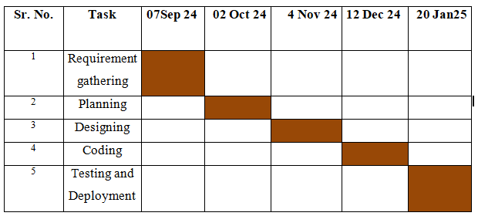

# Project Requirement :

1. **Hardware Requirement :**
   * Processor: Intel i3 and above
   * RAM: 2 GB and above
   * Hard Disk: 160 GB or above
   * Input device: keyboard, Mouse
   * Output device: Monitor or LCD/LED, Printer
   * LAN Network or Internet Connection
2. **Software Requirement :**
   * Web Technologies : HTML, JavaScript, CSS , Bootstrap, React
   * Web Server : Node.js
   * Backend: Express.js
   * Database : MongoDB
3. **Field Work :**
4. **Market Research :**

#### ****Industry Overview****

* **Market Size**: The global indoor plant market is projected to grow at a **CAGR of 5.8%** (2023–2030), driven by urbanization, wellness trends, and sustainability awareness.
* **Key Trends**:
  + Post-pandemic surge in houseplant purchases (+30% growth in 2020–2021).
  + Demand for **rare/exotic plants** (e.g., variegated Monstera) and **low-maintenance succulents**.
  + Rising preference for **eco-friendly packaging** and **carbon-neutral delivery**.

.

#### ****Target Audience Segmentation****

| **Segment** | **Characteristics** | **Needs** |
| --- | --- | --- |
| **Urban Millennials** | Ages 25–40, tech-savvy, eco-conscious | Stylish plants for small spaces, quick delivery |
| **Experienced Gardeners** | Ages 35–60, plant enthusiasts | Rare species, detailed care guides |
| **Eco-Conscious Buyers** | All ages, prioritize sustainability | Organic soil, biodegradable pots, ethical sourcing |

#### ****Competitor Analysis****

| **Competitor** | **Strengths** | **Weaknesses** | **Opportunities for EcoEden** |
| --- | --- | --- | --- |
| **The Sill** | Strong branding, subscription boxes | Limited rare plant variety | Offer exotic plants |
| **Bloomscape** | Premium packaging, plant health guarantee | High pricing | Competitive pricing tiers |
| **Local Nurseries** | Personalized service | Limited online presence | Digital-first experience |

#### ****Marketing & Positioning Strategies****

1. **Product Differentiation**:
   * Offer **"Eco-Friendly Kits"** (plant + biodegradable pot + organic fertilizer).
   * Launch a **"Plant Parent Club"** with exclusive workshops and discounts.
2. **Digital Marketing**:
   * **Social Media**: Instagram/Pinterest campaigns showcasing plant styling tips.
   * **Influencers**: Partner with gardening influencers (@HouseplantJournal) for reviews.

Define your target demographic based on age, gender, fashion preferences, and spending habits. Conduct surveys or focus groups to gather insights into their shopping behavior.

## Trends Analysis:

Identify current fashion trends and consumer preferences. Look at seasonal trends, popular styles, and emerging fashion movements.

1. **Financial Analysis :**

## Cost Estimation:

Estimate the costs involved in starting and running an online clothing store, including website development, inventory purchase, marketing, and operations .

## Revenue Streams:

Explore different revenue models, such as direct sales, subscriptions, or affiliate marketing. Analyze how these can be optimized for profitability.

1. **Case Studies :**

## Successful Brands:

Study case studies of successful online clothing stores to understand their journey, challenges, and strategies that led to their success.

## Failures:

Analyze failed online clothing stores to learn what went wrong and how to avoid similar pitfalls.

1. **Front End <IDE and Programming Lang.> :**

* IDE: Vs Code
* Programming Lang: HTML, CSS, Javascript ,React

1. **Back End <Database> :**

* Database: MongoDB (NoSQL, Flexible)
* Backend Framework: Express.js

# System Design:

1. **Database Design (Tables Schema) :**

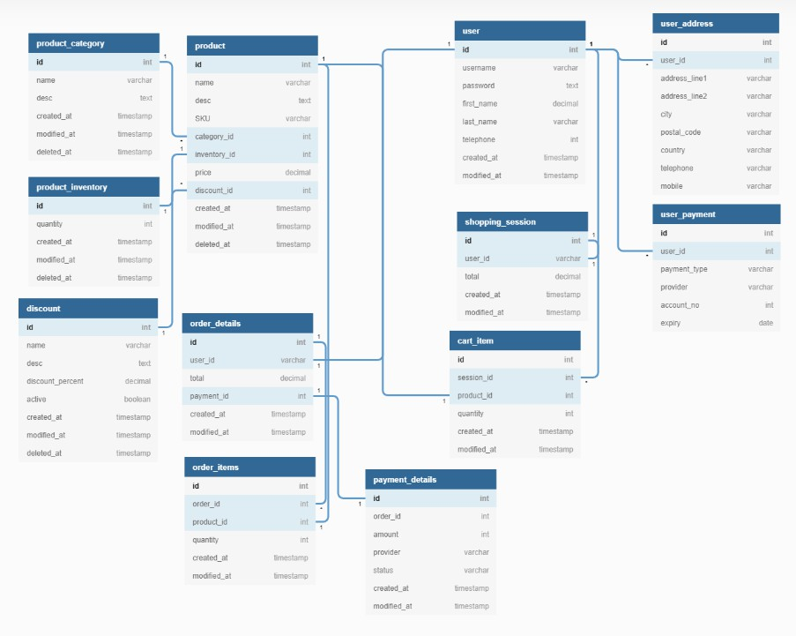

1. **E-R Diagram:**

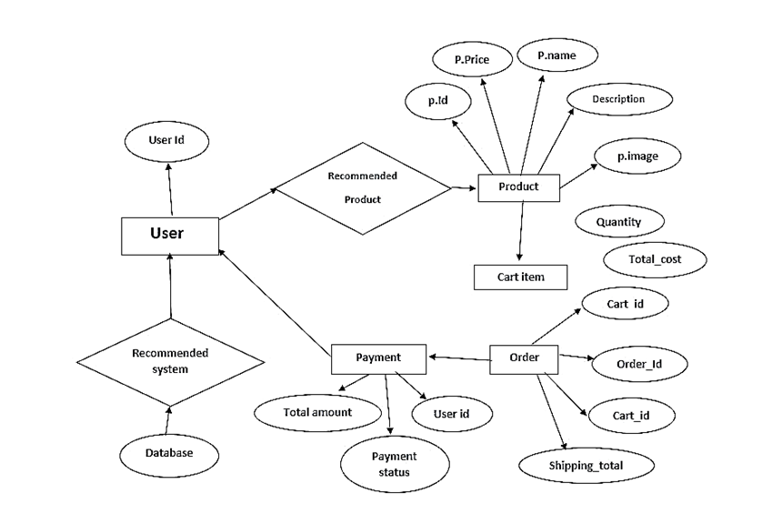

1. **Data Flow Diagram:**

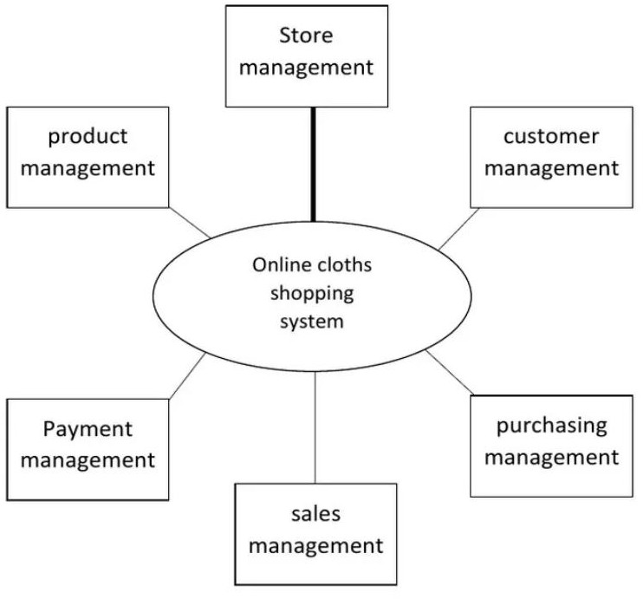

**Nursery Administration**

# Designing:

1. **Signup :**

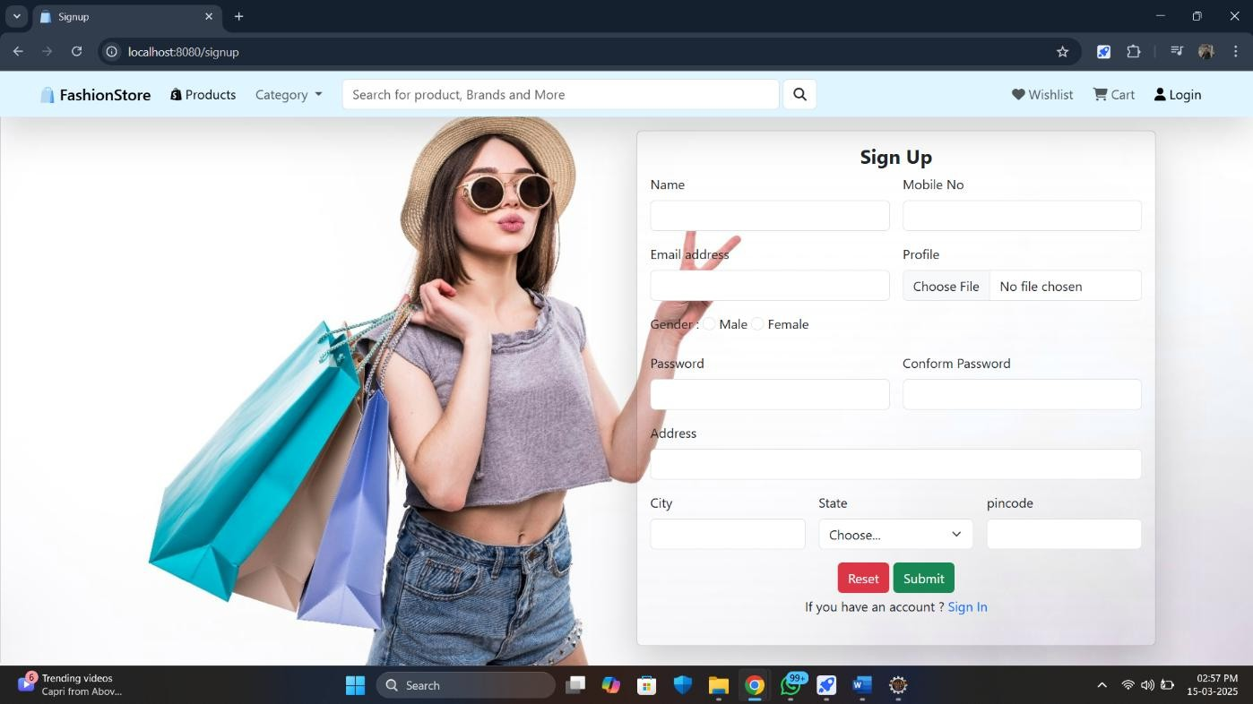

1. **Login :**

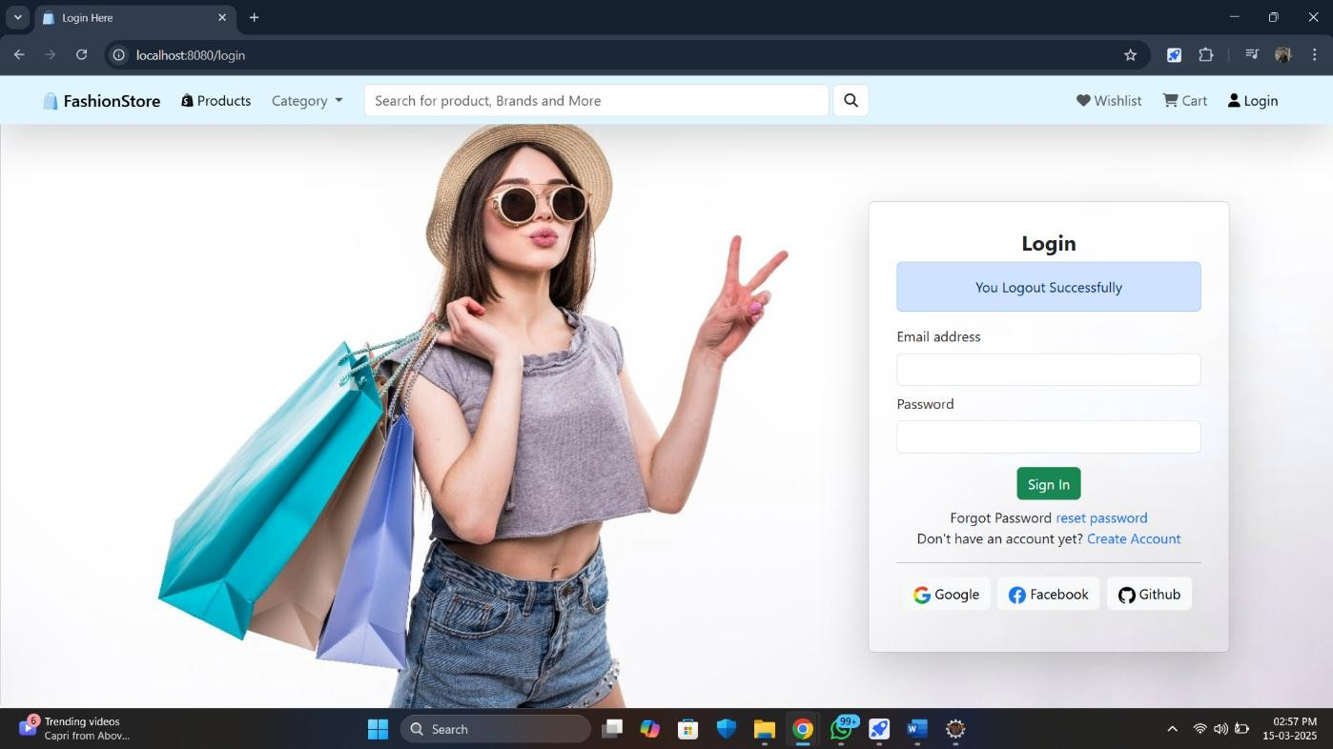

1. **Home :**

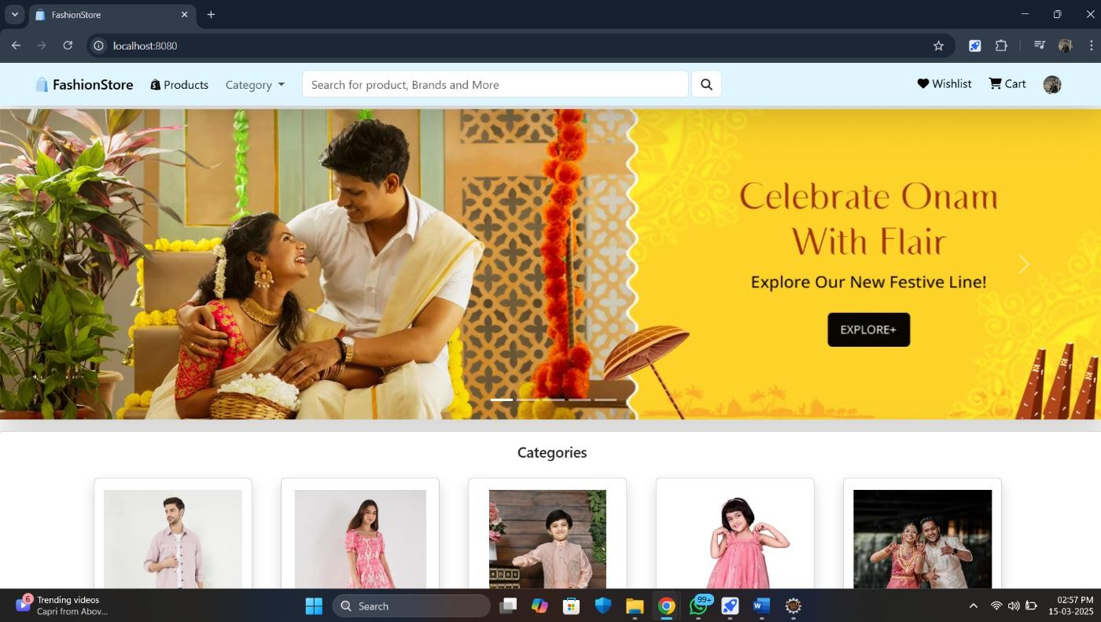

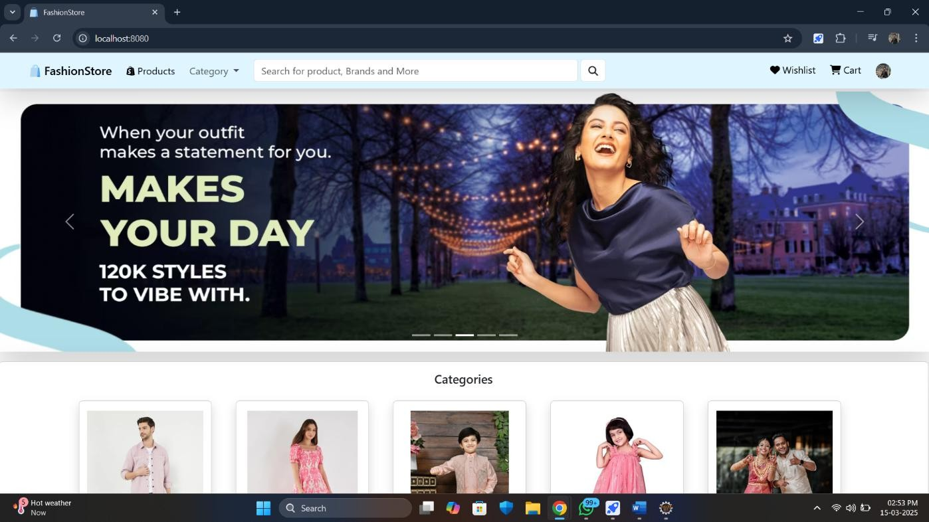

1. **ProductsList:**

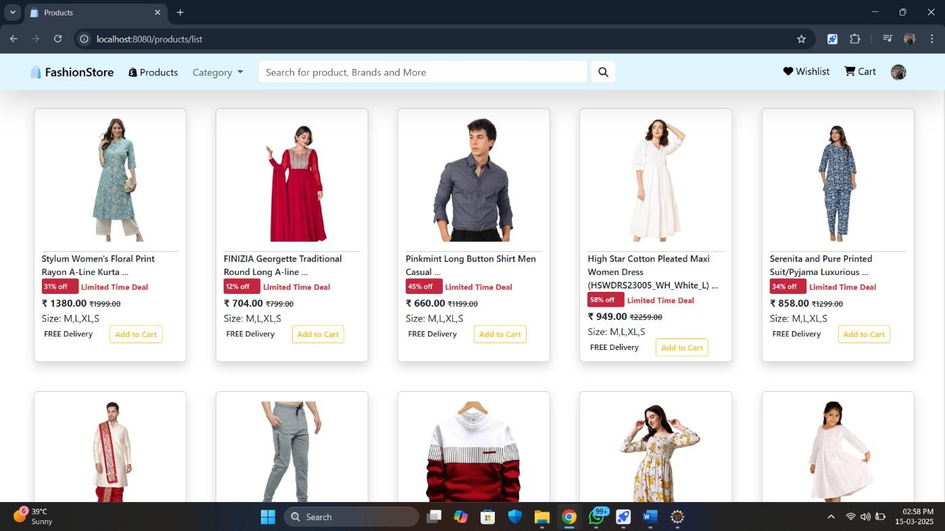

1. **Product View :**

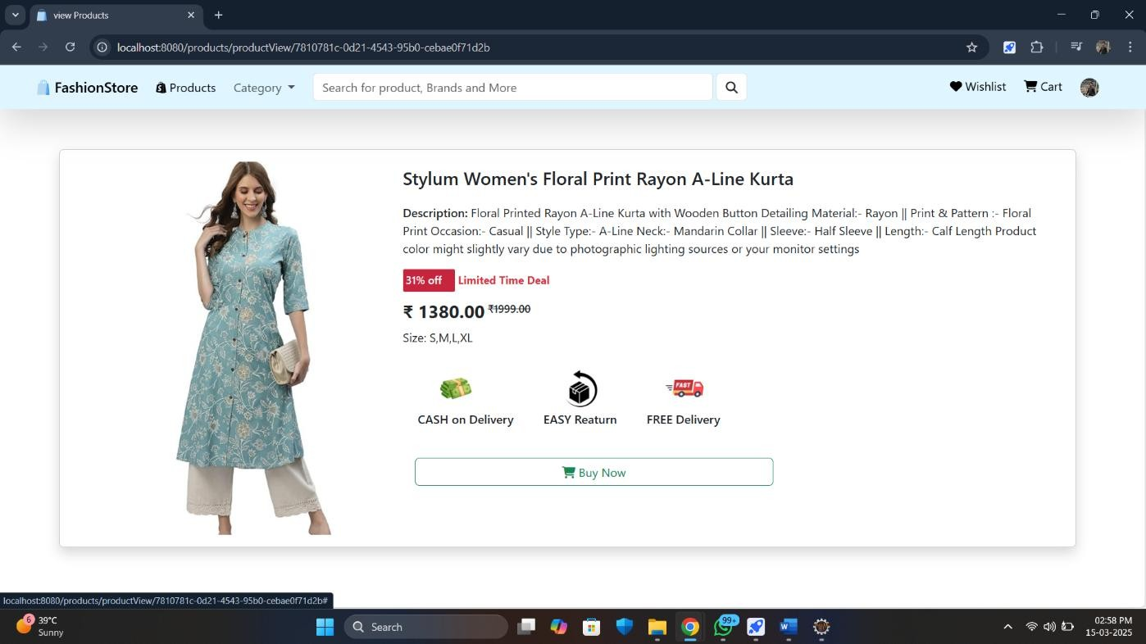

1. **Order Details :**

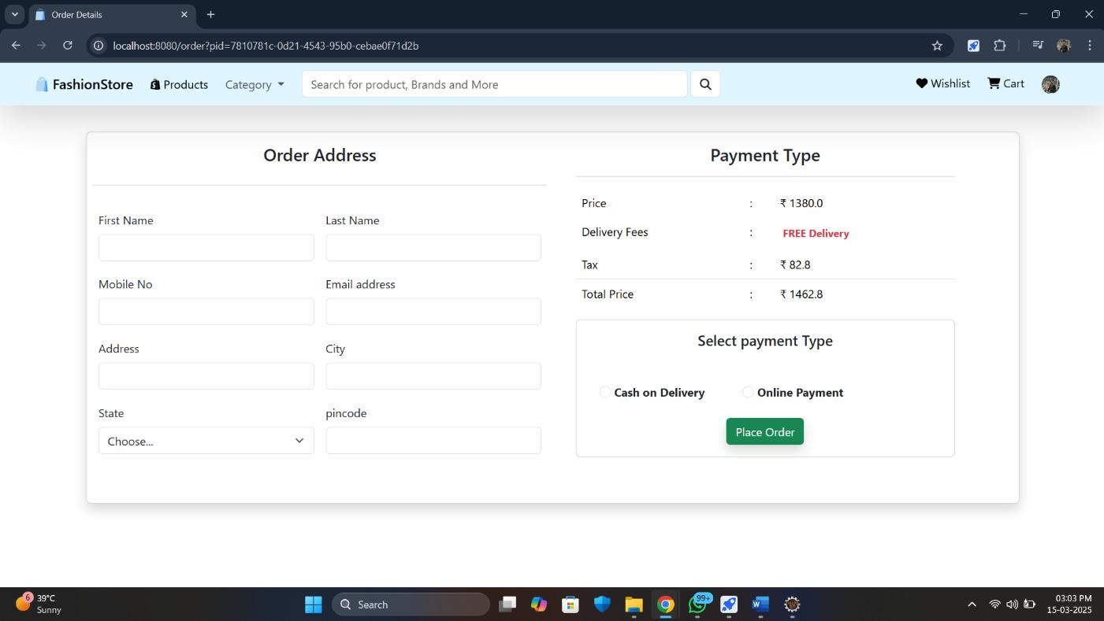

1. **Cart :**

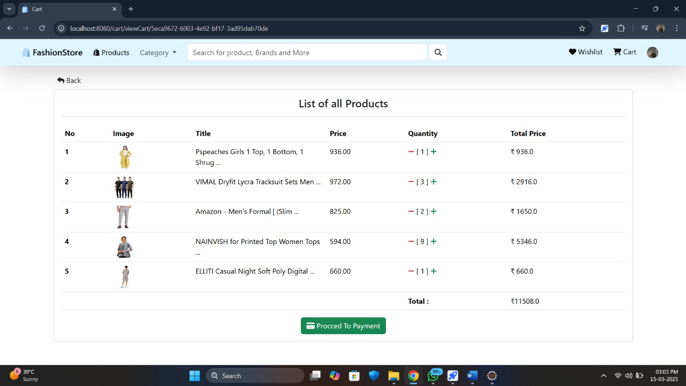

1. **Admin Pannel :**

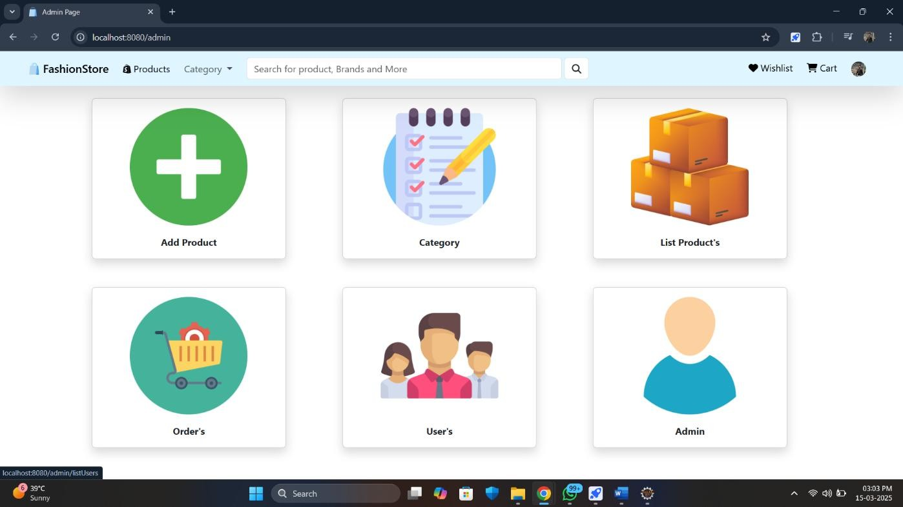

1. **Edit Profile :**

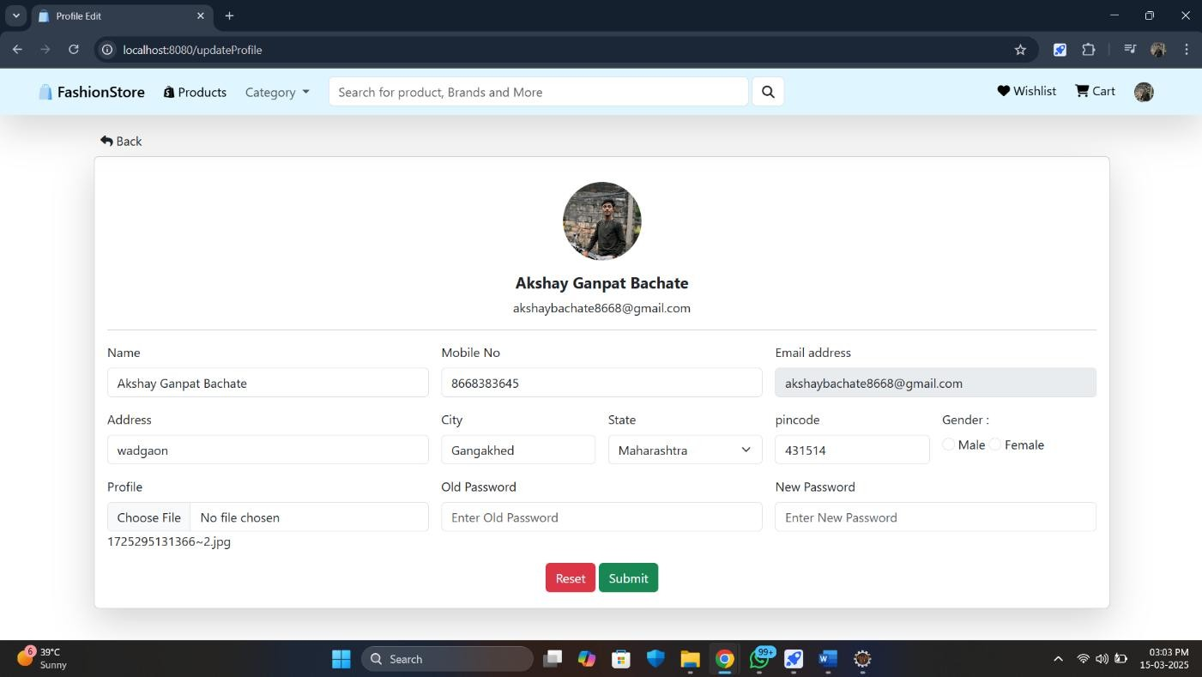

1. **My Orders :**

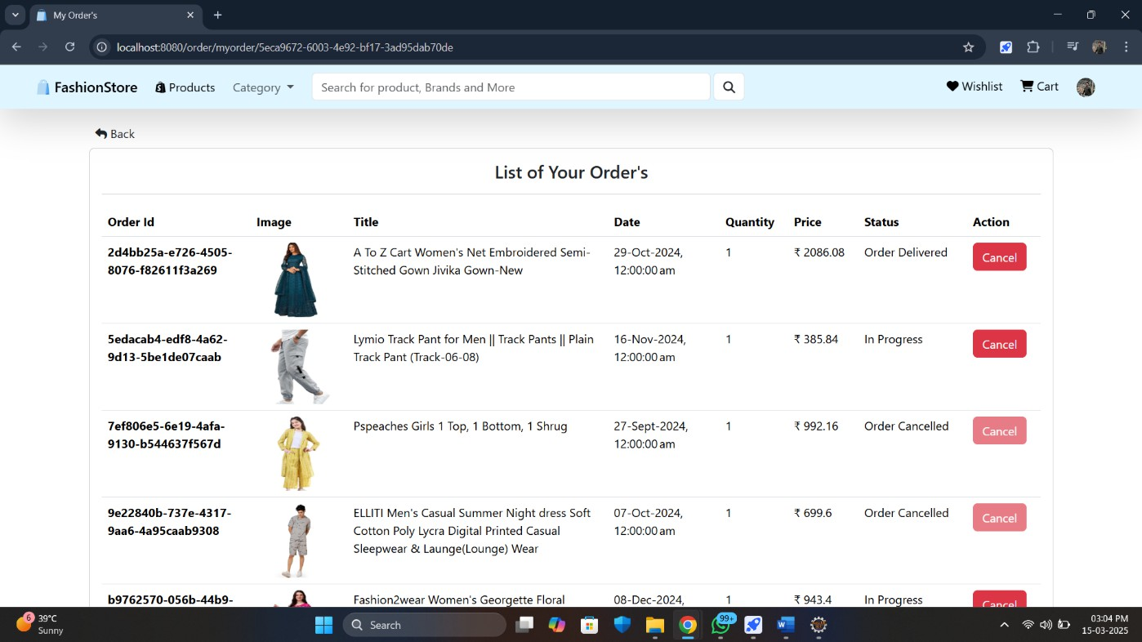

1. **Users List :**

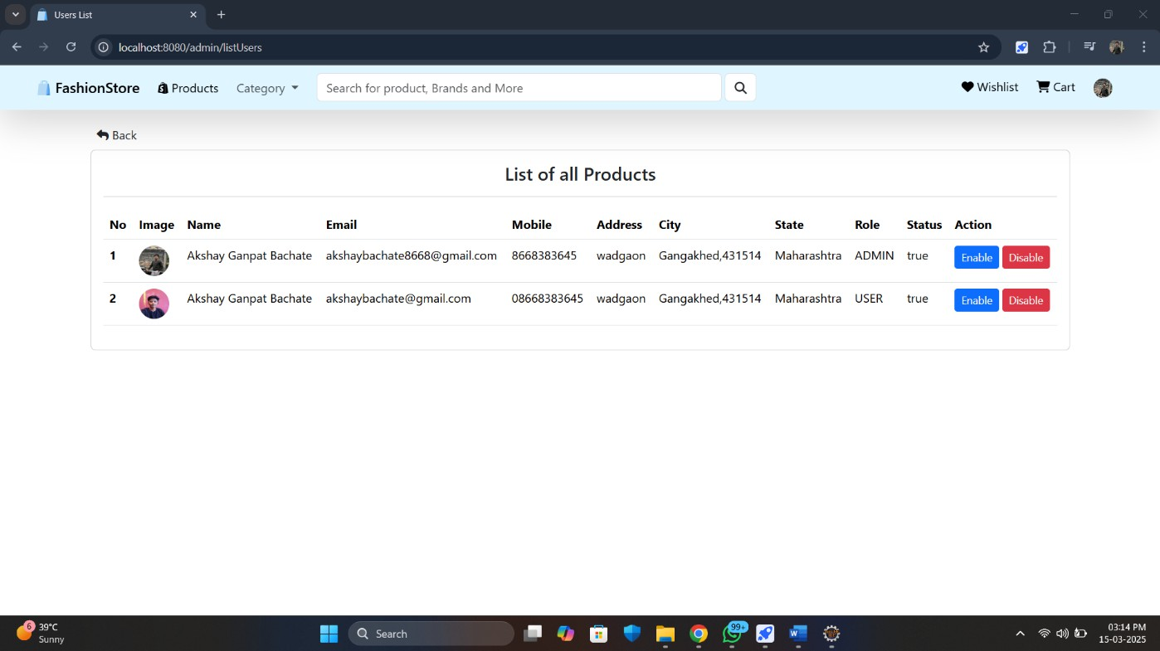

# Coding :

1. **Signup :**

<%@page import="com.Helper.Message"%>

<%@ page language="java" contentType="text/html; charset=UTF-8" pageEncoding="UTF-8"%>

<%@page errorPage="error.jsp" %>

<!DOCTYPE html>

<html>

<head>

<meta charset="UTF-8">

<title>Signup</title>

<%@include file="base.jsp"%>

</head>

<%@include file="navbar.jsp"%>

<body style="margin-top:2em">

<div class="container mt-2">

<div class="row">

<div class="col-md-6 offset-md-6 mt-3">

<%--card Start Here --%>

<div class="card bg-transparent bg-gradient shadow-lg rounded">

<div class="card-body">

<%--Message --%>

<%Message msg=(Message)session.getAttribute("signupMsg"); if(msg!=null)

{

%>

<div class=" text-center fw-bold <%=msg.getType()%>" role="alert">

<form class="row g-3" action="/saveUser" method="post" enctype="multipart/form-data">

<div class="col-md-6">

<label for="name" class="form-label">Name</label>

<input type="text" name="name" class="form-control" required="required" id="name" aria-describedby="name">

</div>

<div class="col-md-6">

<label for="number" class="form-label">Mobile No</label>

<input type="text" name="mobile" required="required" class="form- control" id="mobile" aria-describedby="mobile">

<option>Chandigarh (UT)</option>

<option>Dadra & Nagar Haveli and Daman & Diu

<div class="col-md-4">

<label for="pincode" class="form-label">pincode</label>

<input type="text" name="pincode" class="form-control" id="pincode" required="required">

</div>

<div class="mb-1 text-center">

<button type="reset" class="btn btn-danger">Reset</button>

<button type="submit" class="btn btn-success">Submit</button>

<p class="pt-1">If you have an account ? <a href="/login" style="text- decoration: none;"> Sign In</a></P> </div>

</body>

</html>

1. **Login :**

<%@page import="com.Helper.Message"%>

<%@ page language="java" contentType="text/html; charset=UTF-8" pageEncoding="UTF-8"%>

<%@page errorPage="error.jsp" %>

<!DOCTYPE html>

<html>

<head>

<meta charset="UTF-8">

<title>Login Here</title>

<%@include file="base.jsp"%>

</head>

<%@include file="navbar.jsp"%>

<body style="margin-top:2em">

<div class="card col-md-12">

<%

Message msg=(Message)session.getAttribute("Login"); if(msg!=null)

{

%>

<div class="alert <%=msg.getType()%> text-center" role="alert">

<%=msg.getContent() %></div>

<%

}

session.removeAttribute("Login");

%>

<form action="/do_login" method="post">

<div class="mb-2">

<label for="exampleInputEmail1" class="form-label">Email address</label>

<input type="email" name="email" required="required" class="form- control" id="exampleInputEmail1" aria-describedby="emailHelp">

</div>

<div class="mb-3">

<label for="exampleInputPassword1" class="form- label">Password</label>

<input type="password" name="password" required="required" class="form-control" id="exampleInputPassword1">

<hr>

<div class="mb-3 text-center">

<a class="btn btn-light me-1" href="/oauth2/authorization/google"><img src="/img/google.png" style="width: 20px"> Google</a>

<a class="btn btn-light me-1" href="/oauth2/authorization/facebook"><img src="/img/facebook.png" style="width: 20px"> Facebook</a>

<a class="btn btn-light me-1" href="/oauth2/authorization/github"><img src="/img/github.png" style="width: 20px"> Github</a>

</div>

</form>

</div>

</div>

</div>

</div>

</div>

</body>

</html>

1. **Home :**

<%@ page language="java" contentType="text/html; charset=UTF-8" pageEncoding="UTF-8"%>

<%@page errorPage="error.jsp" %>

<!DOCTYPE html>

<html>

<head>

<meta charset="UTF-8">

<title>FashionStore</title>

<%@include file="base.jsp" %>

</head>

<body>

<%@include file="navbar.jsp" %>

<%-- Slider --%>

<div class="shadow-lg rounded" style="margin-top: 4em">

<div id="carouselExampleIndicators" class="carousel slide bg-dark" data- bs-ride="carousel">

<div class="carousel-indicators">

<button type="button" data-bs-target="#carouselExampleIndicators" data-bs-slide-to="0" class="active" aria-current="true" aria-label="Slide 1"></button>

<button type="button" data-bs-target="#carouselExampleIndicators" data-bs-slide-to="1" aria-label="Slide 2"></button>

<button type="button" data-bs-target="#carouselExampleIndicators" data-bs-slide-to="4" aria-label="Slide 5"></button>

</div>

<div class="carousel-inner">

<div class="carousel-item ">

<a href="/products/categoryLoad/men">

<img src="/img/slider1.png" style="height: 430px;width: 100%;object- fit:fill;" >

</a>

</div>

<div class="carousel-item ">

<a href="/products/categoryLoad/women"> </a>

</div>

<div class="carousel-item ">

<a href="/products/categoryLoad/women">

<img src="/img/slider3.png" style="height: 430px;width: 100%;object- fit:fill;" >

</div>

<%--Category 4 --%>

<div class="card col-md-2 m-3 ms-4 shadow">

<a href="/products/categoryLoad/Girl" class="text-decoration- none text-dark">

<div class="d-flex justify-content-center">

<img class="m-3" src="/img/girl.png" style="width: 200px; height: 200px">

<p class="text-center fw-bold">Traditional</p>

</div>

</body>

<%-- Footer Start Here --%>

<footer>

<%@include file="footer.jsp" %>

</footer>

</html>

1. **Products :**

<%@page import="com.Helper.Message"%>

<%@page import="java.util.Collections"%>

<%@page import="com.Entity.Product"%>

<%@page import="java.util.List"%>

<%@ page language="java" contentType="text/html; charset=UTF-8" pageEncoding="UTF-8"%>

<%@page errorPage="error.jsp" %>

<!DOCTYPE html>

<html>

<head>

<meta charset="UTF-8">

<title>Products</title>

</head>

<%@include file="base.jsp" %>

<body>

<%@include file="navbar.jsp" %>

<div class="row col-md-12 mt-5">

<div class="card me-0 shadow-lg rounded" style=" margin-left: 10px">

<div class="card-body ms-3">

<div class="row ">

<%--Products Listing --%>

<%

Message msg=(Message)session.getAttribute("Products"); if(msg!=null)

{

%>

<div class="alert <%=msg.getType()%> text-center fw-bold" role="alert"><%=msg.getContent()%> </div>

<%

}

session.removeAttribute("Products");

<img class="m-3 card-img" src="https://res.cloudinary.com/dqg87xvqe/image/upload/v1725644115/<

%=product.getpImage()%>.png"style="width: 210px; height: 200px;object-fit:contain; ">

</div>

<hr style="margin: 0em">

<%-- Div Offer --%>

<div class="d-flex">

<div style="background-color: #C7253E ;width: 60px;border-radius: 7%;height: 25px">

<p class="text-light m-1" style="font-weight: 600;font-size: 0.7rem"><%=product.getpDiscount()%>% off</p>

<div class="m-0">

<p class="m-1" style="font-weight: 500;font-size: 0.8rem ;text- decoration: line-through;"> ₹<%=product.getpPrize()%>.00</p>

</div>

</div>

<p class="m-0">Size: M,L,XL,S </p>

<%--Buy Div--%>

<div class="d-flex" >

</div>

</body></html>

1. **Admin Pannel :**

<%@page import="com.Helper.Message"%>

<%@ page language="java" contentType="text/html; charset=UTF-8" pageEncoding="UTF-8"%>

<%@page errorPage="error.jsp" %>

<!DOCTYPE html>

<html>

<head>

<meta charset="UTF-8">

<title>Admin Page</title>

</head>

<%@include file="base.jsp" %>

<body>

<%@include file="navbar.jsp" %>

<%@include file="addProductModal.jsp"%>

<div class="container" style="margin-top: 5em;">

<div class="row">

<!-- Msg Model -->

<%

Message msg= (Message)session.getAttribute("productMsg"); if(msg!=null)

{

%>

<div class="alert text-center <%=msg.getType()%>" role="alert">

<%=msg.getContent() %></div>

<%

session.removeAttribute("productMsg");

<div class="card col-md-3 m-5 mb-0 shadow">

<a href="/admin/listOrders" class="text- decoration-none text-dark">

src="/img/shopping-cart.png" 200px">

</a>

</div>

<div class="d-flex justify-content-center">

<img class="m-3"

style="width: 200px; height:

</div>

<p class="text-center fw-bold">User's</p>

dark">

<div class="card col-md-3 m-5 mb-0 shadow">

<a href="#" class="text-decoration-none text-

<div class="d-flex justify-content-center">

<img class="m-3"

src="/img/user.png" 200px">

</div>

style="width: 200px; height:

<p class="text-center fw-

bold">Admin</p>

</a>

</div><body>

</html>

# Future scope of project:

The future of e-commerce websites lies in personalization, AI integration, immersive experiences, and sustainable practices, with a focus on mobile optimization and seamless customer journeys.

Here's a more detailed look at the key trends and opportunities:

* + **Personalized Shopping Experiences:**

AI will be used to analyze customer data and provide tailored product recommendations, pricing, and even shopping experiences.

* + **AI-Powered Chatbots:**

AI-powered chatbots will offer 24/7 customer support, answer questions, and guide customers through the purchasing process.

* + **Predictive Analytics:**

AI will help businesses predict customer behavior and optimize inventory management, promotions, and marketing efforts.

* + **Interactive Product Demonstrations:**

E-commerce websites will feature interactive product demonstrations, 360- degree product views, and virtual product tours.

1. Mobile Optimization and Omnichannel Commerce:

* **Mobile-First Approach:**

With the majority of internet traffic coming from mobile devices, e-commerce websites must be optimized for mobile devices and offer a seamless mobile shopping experience.

* **Eco-Friendly Options:**

Customers are increasingly seeking sustainable and eco-friendly products and packaging, so e-commerce websites will need to offer these options and promote their sustainability efforts.

# Conclusion:

This online clothing website project successfully bridges the gap between technology and fashion retail, offering a platform that is not only user-friendly and secure but also adaptable to future needs. It provides a foundation upon which additional features and innovations can be built, ensuring its relevance in the ever-evolving e-commerce landscape.

# Bibliography :

* **Books:**
* Bloch, Joshua. Effective Java. 3rd ed., Addison-Wesley, 2018.
* Freeman, Eric, and Elisabeth Robson. Head First Design Patterns. 2nd ed., O'Reilly Media, 2020.
* **Documentation:**
* "Spring Boot Reference Documentation." Spring Framework, <https://docs.spring.io/spring-boot/docs/current/reference/htmlsingle/>.
* "Angular Documentation." Angular, <https://angular.io/docs>.
* "Stripe API Reference." Stripe Developer Documentation, <https://stripe.com/docs/api>.
* **Websites:**
* W3Schools. "HTML, CSS, JavaScript Tutorials." <https://www.w3schools.com/>.
* MDN Web Docs. "JavaScript Reference." Mozilla Foundation, <https://developer.mozilla.org/en-US/docs/Web/JavaScript/Reference>.

•Bootstrap."BootstrapDocumentation." [https://getbootstrap.com/docs/5.0/getting-](https://getbootstrap.com/docs/5.0/getting-started/introduction/) [started/introduction/](https://getbootstrap.com/docs/5.0/getting-started/introduction/).