Group Name: California_fire_area_forecast (Aka Fired Up About Forecasting)

Group Members: Tess McCabe, Vivien Chen, Shijuan Chen, Yingtong Zhang, Qianning Qin

**Project Proposal**

**Introduction**

In light of climate change, California has seen an increased frequency and intensity of fires. Wildfires in 2018 was the most destructive record of California, with 766,439 ha of the burned area. Fires have a multitude of adverse consequences on human and vegetation health, air pollution, property damages, and loss of biodiversity, while also release valuable nutrients stored in the forest floor and stimulate new growth. By creating a reliable forecast on fires, we can determine which time periods that are more conducive to greater fire hazards and better characterize California’s disturbance regime. We are hindcasting Shasta national forest in California. Shasta county houses Shasta-Trinity national forest, which suffered several severe wildfires in 2018 and is planning for prescribed fires now to reduce the threat of unplanned fires later, help provide community protection and improve forest health. Being able to forecast how the burned area grows is of significant importance for this plan.

**State Variables of Hindcast**

The variable of interest in our hindcast is the area burned by fires in Shasta county in California from May, 1st, 2018 to Dec, 31st, 2018. We will be making a hindcast that begins a little before the start of last year’s fire season in California. The temporal resolution of the hindcast will be on a 8-day basis, as aggregated from daily data. We will model fire area as a function of climate and as vegetation index. For climate variables, we use the NCAR reanalysis product. Daily resolution can be accommodated for via the [NCAR reanalysis product.](http://iridl.ldeo.columbia.edu/SOURCES/.NOAA/.NCEP-NCAR/.CDAS-1/.DAILY/.Diagnostic/.above_ground/.temp/) NCAR provides data on **air temperature** and **precipitation**. Our vegetation index will be the [MODIS EVI product](https://modis.gsfc.nasa.gov/data/dataprod/mod13.php). MODIS EVI data product is based on a 16-day time-window. We will be checking our 8-day hindcast against the [MODIS/Terra Thermal Anomalies & Fire data product](https://modis.gsfc.nasa.gov/data/dataprod/mod14.php). We will make weekly hindcasts of cumulative area burned in California up until the 8-day window after the present 8 day window. At the end of a full year, we will have a curve of the cumulative area burned over the course of a fire season. We will not be making a spatial hindcast, but rather a temporal hindcast that is informed by multiple samples (different pixels) within Shasta county California.

**Mock-up output**

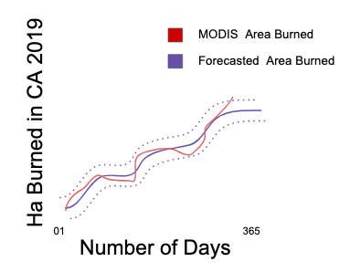

Figure 1

Datasets:

[Temperature data from reanalysis product (at daily scale resolution)](http://iridl.ldeo.columbia.edu/SOURCES/.NOAA/.NCEP-NCAR/.CDAS-1/.DAILY/.Diagnostic/.above_ground/.temp/)

[Precipitation data from reanalysis product (at daily resolution)](http://iridl.ldeo.columbia.edu/SOURCES/.NOAA/.NCEP-NCAR/.CDAS-1/.DAILY/.Diagnostic/.surface/.prate/)

[MODIS EVI product](https://modis.gsfc.nasa.gov/data/dataprod/mod13.php) (at 16-Day resolution)

[MODIS/Terra Thermal Anomalies & Fire data product](https://modis.gsfc.nasa.gov/data/dataprod/mod14.php) (at 8-Day resolution)

Repo: <https://github.com/EcoForecast/fire_area_forecast>