实行三模态RTK定位导航
odom+imu+RTK
计划使用双卡滤波，RTK精准定位，ODOM与imu平滑辅助的功能
总体导航采用雷达建图，航点导航
首先插上RTK的移动端，C口要插小板子，SB陈星宇插错了导致我识别不到CH340
而且要把中介拿掉，不然会串，因为中介也是CH340
ros2 launch nmea_navsat_driver um982.launch.py启动
话题列表为
cat@lubancat:~$ ros2 topic list
/fix
/heading
/parameter_events
/rosout
/time_reference
/vel
cat@lubancat:~$

打开imu和odom和雷达
cd ~/ranger_ws/src/ranger_ros2/ranger_bringup/scripts
sudo bash setup_can2usb.bash
ros2 launch ranger_bringup ranger_mini_v3.launch.py
ros2 launch rslidar_sdk start.py
ros2 run rs_to_velodyne rs_to_velodyne_node
ros2 launch hipnuc_imu imu_spec_msg.launch.py
cat@lubancat:~$ ros2 topic list
/IMU_data
/actuator_state
/battery_state
/cmd_vel
/euler_data
/fix
/heading
/magnetic_data
/motion_state
/odom
/parameter_events
/rosout
/rslidar_points
/system_state
/tf
/time_reference
/vel
/velodyne_points
cat@lubancat:~$
RTK原始数据
[nmea_serial_driver-1] [INFO] [1779254089.826826673] [um982_driver]: [RAW]: $GNRMC,051450.00,A,4544.40570896,N,12643.03778429,E,0.055,102.6,200526,10.5,W,A,C*67
[nmea_serial_driver-1] [INFO] [1779254089.830328715] [um982_driver]: [RAW]: $GPHDT,0.0000,T*05
[nmea_serial_driver-1] [INFO] [1779254090.818632273] [um982_driver]: [RAW]: $GNGGA,051451.00,4544.40571296,N,12643.03784459,E,1,19,0.7,147.1690,M,14.4363,M,,*7B
[nmea_serial_driver-1] [INFO] [1779254090.827055024] [um982_driver]: [RAW]: $GNRMC,051451.00,A,4544.40571296,N,12643.03784459,E,0.073,193.4,200526,10.5,W,A,C*67
启动RTK双卡定位
ros2 launch rtk_localization rtk_localization.launch.py
如果启动不了
就在工作空间中
source install/setup.bash ros2 launch rtk_localization rtk_localization.launch.py
启动我们自己制作的
ros2 topic echo /odometry/gps

查看原始ros数据
ros2 topic echo /fix
在出去测试之前，我需要知道我们各传感器的相对位置，组成一个属于小车底盘中心与传感器之间的tf
cat@lubancat:~$ ros2 run tf2_ros tf2_echo base_footprint rslidar
[INFO] [1779257680.408615598] [tf2_echo]: Waiting for transform base_footprint -> rslidar: Invalid frame ID "base_footprint" passed to canTransform argument target_frame - frame does not exist
At time 0.0
- Translation: [-0.019, 0.000, 0.830]
- Rotation: in Quaternion (xyzw) [0.000, 0.000, 0.000, 1.000]
- Rotation: in RPY (radian) [0.000, -0.000, 0.000]
- Rotation: in RPY (degree) [0.000, -0.000, 0.000]
- Matrix:
1.000 0.000 0.000 -0.019
0.000 1.000 0.000 0.000
0.000 0.000 1.000 0.830
0.000 0.000 0.000 1.000
At time 0.0
- Translation: [-0.019, 0.000, 0.830]
- Rotation: in Quaternion (xyzw) [0.000, 0.000, 0.000, 1.000]
- Rotation: in RPY (radian) [0.000, -0.000, 0.000]
- Rotation: in RPY (degree) [0.000, -0.000, 0.000]
- Matrix:
1.000 0.000 0.000 -0.019
0.000 1.000 0.000 0.000
0.000 0.000 1.000 0.830
0.000 0.000 0.000 1.000
^C[INFO] [1779257682.975918356] [rclcpp]: signal_handler(signum=2)
cat@lubancat:~$ ros2 run tf2_ros tf2_echo base_footprint imu_link
[INFO] [1779257690.852663314] [tf2_echo]: Waiting for transform base_footprint -> imu_link: Invalid frame ID "base_footprint" passed to canTransform argument target_frame - frame does not exist
At time 0.0
- Translation: [-0.087, 0.000, 0.596]
- Rotation: in Quaternion (xyzw) [0.000, 0.000, 0.000, 1.000]
- Rotation: in RPY (radian) [0.000, -0.000, 0.000]
- Rotation: in RPY (degree) [0.000, -0.000, 0.000]
- Matrix:
1.000 0.000 0.000 -0.087
0.000 1.000 0.000 0.000
0.000 0.000 1.000 0.596
0.000 0.000 0.000 1.000
At time 0.0
- Translation: [-0.087, 0.000, 0.596]
- Rotation: in Quaternion (xyzw) [0.000, 0.000, 0.000, 1.000]
- Rotation: in RPY (radian) [0.000, -0.000, 0.000]
- Rotation: in RPY (degree) [0.000, -0.000, 0.000]
- Matrix:
1.000 0.000 0.000 -0.087
0.000 1.000 0.000 0.000
0.000 0.000 1.000 0.596
0.000 0.000 0.000 1.000
^C[INFO] [1779257693.357793816] [rclcpp]: signal_handler(signum=2)
cat@lubancat:~$
ros2 bag record -o rtk_test_0520 \
/fix \
/heading \
/odom \
/IMU_data \
/rslidar_points \
/tf \
/tf_static \
/odometry/gps \
/odometry/local \
/odometry/global
录制
cd /home/cat/rtk_verify_ws/bags
ros2 bag record -o trajectory_comparison1 /odom /odometry/gps /odometry/global /tf /tf_static
使用这个工具查看轨迹
ros2 run plotjuggler plotjuggler
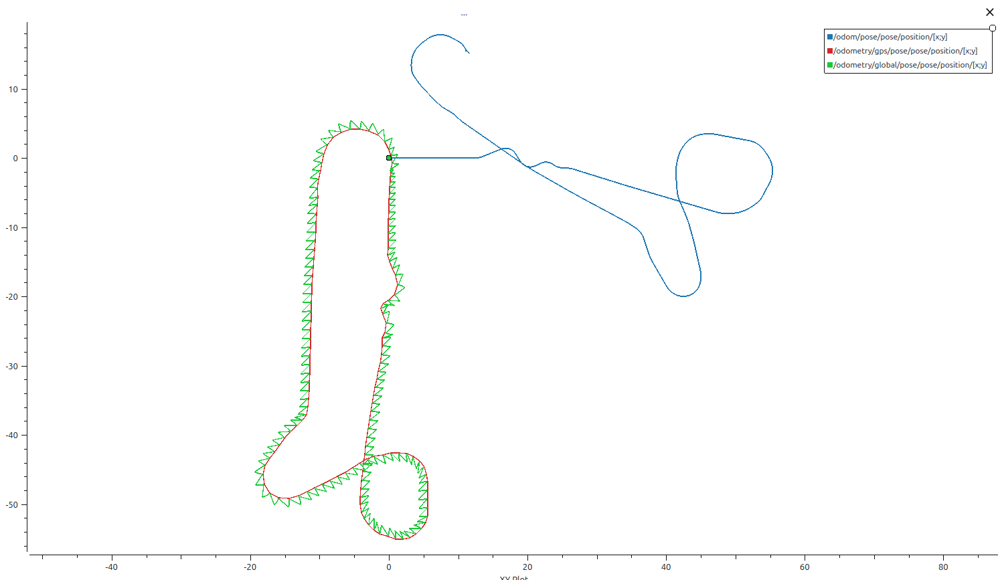
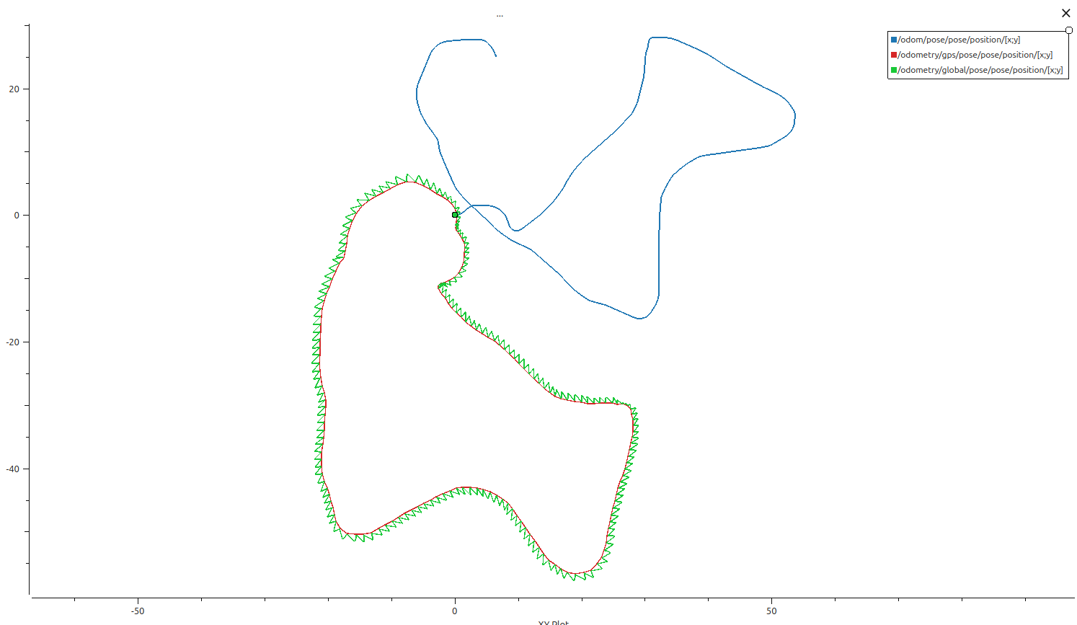
根据这个图像，我得知，
# [纬度, 经度, 初始航向角] -> -1.5707963
代表开机车头朝向正南 datum: [45.7394912333, 126.7170297150, -1.5707963]
因此我改进
此时为了验证改进后的效果
1.再跑一圈，看轨迹
2.静止时抓imu的零点朝向
ros2 topic echo /IMU_data –once
---
header:
stamp:
sec: 1779292478
nanosec: 717697915
frame_id: imu_link
orientation:
x: -0.013481708243489265
y: -0.004365943837910891
z: 0.9997484087944031
w: 0.017387231811881065
orientation_covariance:
- 0.0
- 0.0
- 0.0
- 0.0
- 0.0
- 0.0
- 0.0
- 0.0
- 0.0
angular_velocity:
x: -0.0009326623507938161
y: 0.0011156045214189589
z: 0.00023342519060146064
angular_velocity_covariance:
- 0.0
- 0.0
- 0.0
- 0.0
- 0.0
- 0.0
- 0.0
- 0.0
- 0.0
linear_acceleration:
x: -0.2703101623803377
y: -0.09828399233520031
z: 9.921640634536743
linear_acceleration_covariance:
- 0.0
- 0.0
- 0.0
- 0.0
- 0.0
- 0.0
- 0.0
- 0.0
- 0.0
---
ros2 topic echo /odom –once
---
header:
stamp:
sec: 1779292539
nanosec: 573920488
frame_id: odom
child_frame_id: base_footprint
pose:
pose:
position:
x: 0.0
y: 0.0
z: 0.0
orientation:
x: 0.0
y: 0.0
z: 0.0
w: 1.0
covariance:
- 0.0
- 0.0
- 0.0
- 0.0
- 0.0
- 0.0
- 0.0
- 0.0
- 0.0
- 0.0
- 0.0
- 0.0
- 0.0
- 0.0
- 0.0
- 0.0
- 0.0
- 0.0
- 0.0
- 0.0
- 0.0
- 0.0
- 0.0
- 0.0
- 0.0
- 0.0
- 0.0
- 0.0
- 0.0
- 0.0
- 0.0
- 0.0
- 0.0
- 0.0
- 0.0
- 0.0
twist:
twist:
linear:
x: 0.0
y: 0.0
z: 0.0
angular:
x: 0.0
y: 0.0
z: 0.0
covariance:
- 0.0
- 0.0
- 0.0
- 0.0
- 0.0
- 0.0
- 0.0
- 0.0
- 0.0
- 0.0
- 0.0
- 0.0
- 0.0
- 0.0
- 0.0
- 0.0
- 0.0
- 0.0
- 0.0
- 0.0
- 0.0
- 0.0
- 0.0
- 0.0
- 0.0
- 0.0
- 0.0
- 0.0
- 0.0
- 0.0
- 0.0
- 0.0
- 0.0
- 0.0
- 0.0
- 0.0
---
行走几米后
---
header:
stamp:
sec: 1779292644
nanosec: 93902490
frame_id: odom
child_frame_id: base_footprint
pose:
pose:
position:
x: 12.043475356424375
y: 0.0
z: 0.0
orientation:
x: 0.0
y: 0.0
z: 0.0
w: 1.0
covariance:
- 0.0
- 0.0
- 0.0
- 0.0
- 0.0
- 0.0
- 0.0
- 0.0
- 0.0
- 0.0
- 0.0
- 0.0
- 0.0
- 0.0
- 0.0
- 0.0
- 0.0
- 0.0
- 0.0
- 0.0
- 0.0
- 0.0
- 0.0
- 0.0
- 0.0
- 0.0
- 0.0
- 0.0
- 0.0
- 0.0
- 0.0
- 0.0
- 0.0
- 0.0
- 0.0
- 0.0
twist:
twist:
linear:
x: 0.0
y: 0.0
z: 0.0
angular:
x: 0.0
y: 0.0
z: 0.0
covariance:
- 0.0
- 0.0
- 0.0
- 0.0
- 0.0
- 0.0
- 0.0
- 0.0
- 0.0
- 0.0
- 0.0
- 0.0
- 0.0
- 0.0
- 0.0
- 0.0
- 0.0
- 0.0
- 0.0
- 0.0
- 0.0
- 0.0
- 0.0
- 0.0
- 0.0
- 0.0
- 0.0
- 0.0
- 0.0
- 0.0
- 0.0
- 0.0
- 0.0
- 0.0
- 0.0
- 0.0
开回原点大致位置
ros2 topic echo /odometry/gps –once
---
header:
stamp:
sec: 1779292765
nanosec: 437755599
frame_id: map
child_frame_id: ''
pose:
pose:
position:
x: -0.0319956829778838
y: 0.2921979754736149
z: 0.0
orientation:
x: 0.0
y: 0.0
z: 0.0
w: 1.0
covariance:
- 0.0001
- 9.390921076858088e-23
- 0.0
- 0.0
- 0.0
- 0.0
- 1.8947645956639246e-22
- 0.0001
- 0.0
- 0.0
- 0.0
- 0.0
- 0.0
- 0.0
- 0.0016
- 0.0
- 0.0
- 0.0
- 0.0
- 0.0
- 0.0
- 0.0
- 0.0
- 0.0
- 0.0
- 0.0
- 0.0
- 0.0
- 0.0
- 0.0
- 0.0
- 0.0
- 0.0
- 0.0
- 0.0
- 0.0
twist:
twist:
linear:
x: 0.0
y: 0.0
z: 0.0
angular:
x: 0.0
y: 0.0
z: 0.0
covariance:
- 0.0
- 0.0
- 0.0
- 0.0
- 0.0
- 0.0
- 0.0
- 0.0
- 0.0
- 0.0
- 0.0
- 0.0
- 0.0
- 0.0
- 0.0
- 0.0
- 0.0
- 0.0
- 0.0
- 0.0
- 0.0
- 0.0
- 0.0
- 0.0
- 0.0
- 0.0
- 0.0
- 0.0
- 0.0
- 0.0
- 0.0
- 0.0
- 0.0
- 0.0
- 0.0
- 0.0
---
3.我想要在小车启动后让小车朝南方走几米，抓取odom与imu与gps与heading的三个输出数据，然后以txt形式存在/home/cat/rtk_verify_ws/bags里
cd /home/cat/rtk_verify_ws/bags
然后
ros2 topic echo /odom > odom.txt
ros2 topic echo /IMU_data > imu.txt
ros2 topic echo /heading > heading.txt
ros2 topic echo /fix > gps.txt

