ATMS/OCN/ESS 588 Global Carbon Cycle and Climate

Winter 2022

Abigail Swann, aswann@uw.edu

**Problem Set 2 – Terrestrial Box Model of the Carbon Cycle**

The goal of this assignment is to investigate carbon balance of an ecosystem in response to climate variability and disturbance. We will be using the land component of a coupled carbon cycle box model, which will also be used in other configurations for PS3 and PS5.

**Copy the Carbon Cycle Box Model to Jupyter Hub:**

You will use our [class jupyter hub](https://rttl.axdd.s.uw.edu/2022-winter-atm-s-588-a/) to run the same carbon cycle box model for three different problem sets (PS2, PS3, PS5).

Create a folder in the top directory of your jupyter hub – I suggest calling it boxmodel_carboncycle

The model consists of three total files:

box_model.ipynb

seawater_functions.py

box_model_functions.py

Copy these three files into your boxmodel_carboncycle folder. There is one jupyter notebook file that you will interact with, and two files that contain functions needed by the model. Open the box_model.ipynb file to do the problem set.

**Overview of the Carbon Cycle Box Model:**

For the rest of this course, we will be building up a simple computer model for simulating climate-carbon cycle interactions. The model is assembled from component pieces – ocean, land, and climate - developed by scientists seeking conceptual insight rather than realism and complexity. A series of problem sets will be assigned to introduce each component model, including a brief description and schematic illustration of the sub-model, highlighting important differences from their original published form. The components can be disconnected using a set of switches in **Section A** of the jupyter notebook. The model can be forced by user-prescribed fossil fuel emissions or other sources of radiative forcing, to which the ocean and land reservoirs respond. The emissions are currently set to follow historical values from 1750-2005, and then follow a scenario (RCP8.5) in which CO2 rises to yield an 8.5 W/m2 radiative forcing by 2100. For PS1 we will assume that the land doesn’t respond to increases in CO2, but you will still see those increases in the atmosphere.

The terrestrial part of our carbon cycle box model consists of 9 carbon pools, with fluxes between them (see diagram on next page). Leaf, root and wood are the live pools. We represent the dead material with 6 pools - their different composition is captured by their turnover times – with litter decomposing faster than woody debris and varying rates of decomposition in soil organic matter. During decomposition, microbes respire, and the microbial respiration from the dead pools sum to heterotrophic respiration. The (im)balance between NPP and heterotrophic respiration is the net exchange with the atmosphere.

We can write the equation for any given pool as the change in mass per unit time equal to the input of carbon – the output of carbon. For the Litter1 pool that would look like:



Each carbon pool has a timescale, tau (τ) associated with it. For the live pools (leaves, roots, and wood) that timescale represents the average lifetime before that part of the plant will die (mortality). For the dead pools it represents the average time carbon spends in that pool before either being respired or transferred to another dead pool. τ values are called residence times or turnover times. The timescale of a given carbon pool depends on the environment and ecosystem in which it exists. *We are going to try out different timescales to see how that changes the storage of carbon in the terrestrial system*.

The model will solve the set of equations like the one above for all pools to find the mass of each pool at each time step. We can then plot the time series of change in mass over time. We will also look at what happens when photosynthesis varies across years by creating oscillations in Net Primary Production inputs.

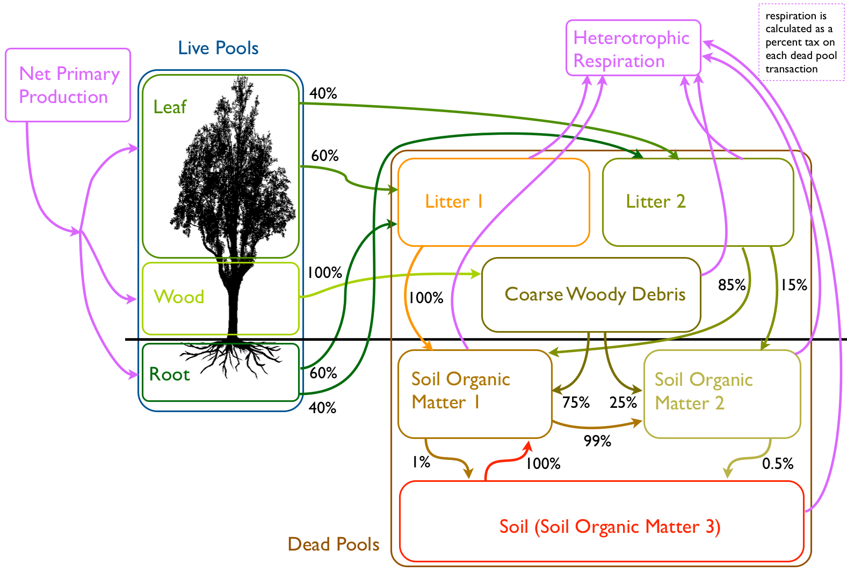

**Tour of the code:**

Most of the changes you need to make are in **Section A** but take a look at the turnover values (τ) in **Section B.2.**

** note that the # symbol means “comment” and all text following a # is ignored by the code **

For PS1 you will need to make sure that the land is turned on and the ocean is turned off in **Section A** (it should be set like that when you first download the code)

###### Choose if land and ocean should be active (1=active, 0=not active)

PS['DoOcn'] = 0 # include ocean

PS['DoTer'] = 1 # include land

Also turn off the Radiative Forcing option (it should be off when you get the code):

PS['DoRadCO2'] = 0 # let climate respond to CO2 changes

**How to change the turnover times:**

The code lists typical values turnover times and productivity values for four ecosystems. You can switch between them in **Section A** under

# Specity Ecosystem Type Here

# Options: 'Global', 'TropicalForest', 'TempForest', 'BorealForest', 'Grass'

PS['VegName'] = 'Global'

You can also view or change individual turnover times directly in **Section B.2**

**How to change the NPP variability (in Section A):**

# specify NPP forcing

PS['NPPamp'] = 0 # fractional amplitude of imposed NPP oscillations (0.5 means 50% change)

PS['NPPper'] = 10 # period of oscillatory forcing [yr]

You can modify the period and amplitude of oscillatory variations in NPP here. If you set amplitude to zero, there will be no oscillation. The period is in years.

**How to save figures from multiple runs with different parameter choices:**

in **Section A** there is a place to give each experiment a name:

# Give your run a name

PS['runName'] = 'Land_Global_10yr'

and this name is appended to all of the figures that get made (in this example a name I chose for a run of land only with “Global” values for turnover times and a 10 year oscillation in NPP). You can update this with a new name before running the code every time you change a parameter value and your figures will get saved with new fileanames.

**If you want to make more plots:**

The plots are made at the end of the jupyter notebook in **Section C**. You are welcome to copy those cells to make additional plots over different time periods, etc. For example if you wanted to only plot the last 50 years you could change the leaf pool line (as an example) from:

ax.plot(tcal[pt], res['cla'][PL['iLeaf'],:]*12e-15, color=np.divide([64, 128, 0],255), label='Leaf')

to (changed parts in **bold**)

ax.plot(tcal**[-50:-1]**, res['cla'][PL['iLeaf'],**-50:-1**]*12e-15, color=np.divide([64, 128, 0],255), label='Leaf')

**PS2 Questions:**

Please give a descriptive answer supported by calculations with the box model. Include figures if this helps to support your answer. Explore these answers for the different ecosystems and **note when the answer depends on ecosystem**. *This is not just meant to be busy work running the model, but an open-ended exploration that you can tell me a bit about.*

1. Explore how an oscillatory signal in NPP is propagated through the ecosystem depending on the oscillation period and amplitude.

Some examples of possible NPP Periods=

* 1 year (annual cycle)
* 5 years (El-Nino Southern Oscillation)
* 10 years (Northern Annular Mode)

You can set the NPP amplitude to something like 0.5 or 1 to start exploring amplitude when you are ready (in **Section A**).

PS['NPPamp'] = 0.5 # fractional amplitude of imposed NPP oscillations (0.5 means 50% change)

1. What are the amplitude and period of oscillation in the mass of the live wood pool relative to NPP? the dead pools relative to NPP?
2. Which parameter is most important in setting the characteristics of the response of these pools? (Parameters specified in **Section B.2**)
3. How does the response vary in different ecosystems?
4. Try changing some of the turnover times for the pools directly in **Section B.2**. How does this vary the carbon pool size (equilibrium mass of the pool)?

2. Why do turnover times vary across the globe? (You don’t need to use the box model for this – qualitative description is ok)