ATMS/OCN/ESS 588 Global Carbon Cycle and Climate

Abigail Swann, aswann@uw.edu

**Problem Set 4 – Inverting for Sources and Sinks of Carbon**

**The assignment explores the principal observations about the contemporary carbon cycle, and uses an atmospheric 2-box mixing model to infer the distribution of carbon sinks over the last few decades.**

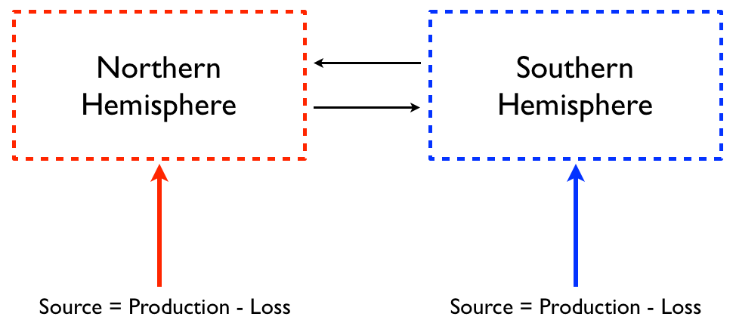

The 2-box model for atmospheric mixing: Sn and Ss are the net fluxes into each hemisphere = production (sources) – loss (sinks). There are two parameters: ****, interhemispheric mixing time, and ****, the ratio of the surface hemispheric gradient to the column-averaged hemispheric gradient.









We will use observations from Mauna Loa Observatory and South Pole Observatory to represent the mass of carbon in the Northern Hemisphere and Southern Hemisphere. ** **the ratio of surface measurement to the total column mass, will be multiplied by the observations to represent the total mass (Ms or Mn).

We will also use the fossil fuel emissions dataset from the first problem set to estimate emissions.

Files needed for PS4:

* Fossil Fuel data is from the Global Carbon Project (same data as from PS1): <https://doi.org/10.5281/zenodo.5569235>
  + Filename: GCB2021v34_MtCO2_flat.csv
* CO2 Flask data is from ESRL: <http://www.esrl.noaa.gov/gmd/dv/data/>
  + Filename for MLO: co2_mlo_surface-flask_1_ccgg_month.txt
  + Filename for SPO: co2_spo_surface-flask_1_ccgg_month.txt
* Python code is in a Jupyter notebook called: PS4_Inversion.ipynb
  + Section 1 also loads Fossil Fuel and CO2 flask data
    - ***You will define parameters at the top of Section 1***
  + Section 2 is a Forward integration of the 2-box model
  + Section 3 is the Inverse calculation
  + Section 4 has some additional calculations

The code performs a forward and inverse calculation of the sinks of CO2 from 1981 to present. To start use  = 1 year, and **** = 1. These are the defaults that are set - you will vary these parameters for questions 3 and 4 by changing them at the top of Section 1. NOTE: In the forward integration of the model (Section 2 in the code) we are assuming that FF is 100% airborne.

The filenames for plots will be automatically named with your choice of tau and gamma, so you will get new saved figures each time you change a parameter.

-----PS 4 Questions-----

1. In Section (2) of the code – Forward Integration of a 2-Box Model. In the forward integration of the code (Section 2) we are assuming that Fossil Fuel remains 100% airborne. The plot created in this section compares the modeled surface hemispheric difference in CO2 to the observed difference (MLO-SPO). What does the difference between the modeled result and the observations imply about the sinks (Sn, Ss, Ln and Ls)? Why is this a good or bad assumption? Answer should be qualitative and possibly include equations (not primarily numeric).
2. In Section (3) of the code – “Inverse calculation”. In the inverse calculation the code calculates the NH and SH sinks (Ln and Ls) from the observed MLO-SPO difference. See section 4 of the code for “additional calculations”. Note the following numbers (and come back to these in questions 3 and 4).
   1. What is the cumulative total sink over this time period (in PgC)?
   2. What is the Cumulative sink expressed as a percent of the cumulative FF emission over this time period? How does this compare to what we learned in PS1 about the airborne fraction?
   3. What is the NH fraction of the total sink, averaged over the period? Does this number match your prior expectations?
3. An uncertainty in the determination of Ln and Ls is , an index of the vertical gradient of CO2.
   1. Why is there a vertical gradient in CO2?
   2. What is the NH fraction of the total sink, for  = 1.0, 1.2, 1.5, 2?
   3. Why does NH sink vary as it does in (3b)?
4. The interhemispheric exchange time  is determined using mid-latitude industrial emissions.
   1. What would a shift of emissions to China and India do to ?
   2. What is the NH fraction of the total sink, for  = 0.8, 1, 1.2, 1.5, 2?
   3. Can you guess why our estimate of NH fraction of the sink changes as it does in (4b)?

\frac{\partial M_n}{\partial t} = -\frac{M_n - M_s}{\tau} + S_n

\frac{\partial M_s}{\partial t} = \frac{M_n - M_s}{\tau} + S_s

S_s = P_s - L_s

