ATMS/OCN/ESS 588 Global Carbon Cycle and Climate
PS5 –Carbon Climate Coupling
Let’s explore the interaction between the carbon cycle and climate. We’d like to find out under what conditions the warming of the climate from rising CO₂ will lead to a greater loss of CO₂ from the ocean and land, producing a positive feedback.
You may also wish to refresh your memory of the component models, described in previous problem sets and lectures.
Procedure:
Let’s examine climate-carbon coupling. Perform a set of model runs with and without the influence of climate on carbon fluxes. Reproduce Figures 1 and 2 from the Friedlingstein et al (2006) study, shown at the end of this document and in lectures. We have omitted the panel on the gain factor (Fig. 2b) since we didn’t discuss that. The code will make these plots for you if you follow the steps below.
Steps:
  - Run the model in its coupled configuration, and turn on the flag to initiate a comparison between coupled and uncoupled versions of the model. In Section A set:
PS['DoRadCO2'] = 1 # let climate respond to CO2 changes
PS['DoCplVUncpl'] = 1 # calculate both coupled and uncoupled solutions and compare output
  - We also need to set “beta” for land back to default value of 1.25 to create photosynthesis responses to CO₂ (we had it turned to 1 for PS2 to eliminate responses to changing CO2). In Section A set:
PS['beta_550'] = 1.25
Also make sure that you re-set any changes you might have made in earlier problem sets back to standard values in Section A:
- all the switches for carbon-climate coupling are turned on (these are also in Section A and denoted CCC_***, where 0 means off, 1 means on),
- both land and ocean are turned on (PS['DoOcn'] = 1, PS['DoTer'] = 1)
- ocean components are turned on and scaling factors are set back to 1
- the non-CO₂ radiative forcing should be turned off (PS[‘RFamp’]=0) or else you’ll get wavy pattern on top of your warming trend.
- set the NPP amplitude from PS1 back to zero (PS['NPPamp'] = 0) so we don’t have oscillations in NPP on land.
You can give a run name such as “coupled” at the top of Section A, so that the plots will be saved with a specific filename each time.
Note the rising inventories of C in most reservoirs.
  - With the PS['DoCplVUncpl'] = 1 flag set to one, the code will automatically produce two figures that mimic Figures 1 and 2 from Friedlingstein et al. 2006 (reproduced at the end of this document. If you want to further explore any of the individual carbon pools here are the different carbon pools and fluxes you can find (and you can use the plotting code (Sections E.1, E.2) as examples too:
res['dCla '] = carbon flux from land (PgC)
res['dCatm '] = carbon flux to the atmosphere(PgC)
res['dCoc '] = carbon flux from the ocean (PgC)
res['cla '] = mass of C in each of 9 land carbon pools, see Section B.1 for which index is which pool (gC)
res['coc '] = mass of C in each of 7 ocean carbon pools, see Section C.0 for which index is which pool (gC)
tcal = time index in years

Questions:
- Run the model coupled and in comparison mode - compare the plots from Section E with Figures 1 and 2 from Friedlingstein et al. 2006 (also at the end of this document). Write a 2 sentence caption for each of the plots matching Friedlingstein et al. 2006, conveying the interpretation of each panel. How does the box model compare to the state-of-the-art models we saw in class?

- We have discussed 3 parameters that govern carbon-climate feedbacks and are very uncertain:
- the CO₂ fertilization effect on terrestrial photosynthesis (beta_550)
- the temperature response of terrestrial respiration (Q10_resp)
- the climate response of ocean circulation (dPsidb)
Repeat the calculations in problem #1 for different values of these parameters (you can choose a useful name each time to save new versions of the plots!), and determine the effect on ocean, land, and total CO₂ flux for each one. These parameters can be set in Section A. You can assume the following uncertainties in each parameter:
- beta_550=1-1.5
- Q10_resp=1.5-2.5
- dPsidb=0-0.5
Discuss your results, using whatever graphs or numbers you think are most appropriate and informative. (You shouldn't need to use the same figures as above, although some of them could be quite helpful.) Part of the goal here is to simulate the freer, more open-ended experience of doing science and less the experience of doing homework here.
Reference
P. Friedlingstein, P. Cox, R. Betts, L. Bopp, W. Von Bloh, V. Brovkin, P. Cadule, S. Doney, M. Eby, I. Fung, G. Bala, J. John, C. Jones, F. Joos, T. Kato, M. Kawamiya, W. Knorr, K. Lindsay, H. D. Matthews, T. Raddatz, P. Rayner, C. Reick, E. Roeckner, K. G. Schnitzler, R. Schnur, K. Strassmann, A. J. Weaver, C. Yoshikawa, and N. Zeng. Climate-carbon cycle feedback analysis: results from the c4mip model intercomparison. Journal of Climate, 19(14):3337–3353, 2006.

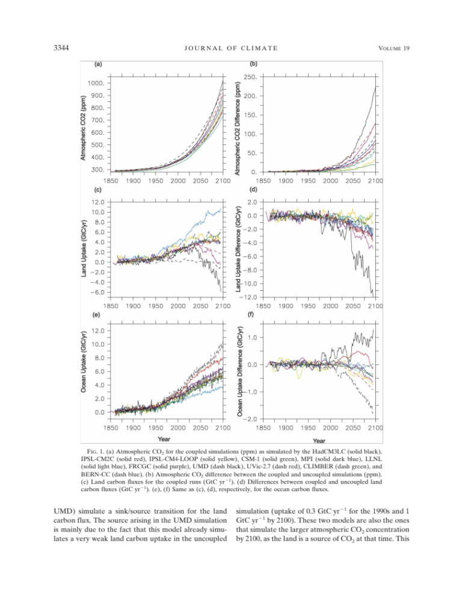
Figure 1 from Friedlingstein et al. 2016
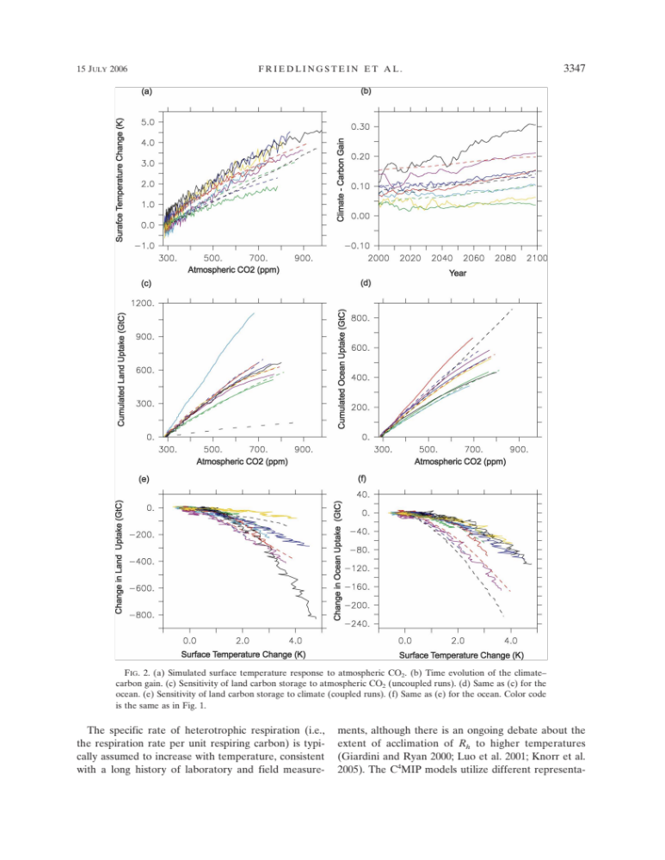
Figure 2 from Friedlingstein et al. 2016

