CE-QUAL-W2 Water Quality Modeling Workshop
Case Study and Workshop Projects

1. DeGray Reservoir
1). Objectives
This case study is used to
- Review the W2 model inputs
- Run the W2 model
- Review the W2 model outputs
- Evaluate how the spatial resolutions (Dx and Dz) of the W2 model domain affect the model results of water temperature and dissolved oxygen in a reservoir

2). W2 model grids
DeGray Reservoir is located on the Caddo River in south central Arkansas, DeGray is classified as a monomictic, deep storage reservoir.
DeGray Reservoir was originally modeled as a one-branch system with no tributary inflows. The outlet location is in layer 13.
- Branch length 30 km
- Segment lengths 1000 m
- Maximum width 5530 m
- Layer height 2 m
- Upstream segment 2
- Downstream segment 31

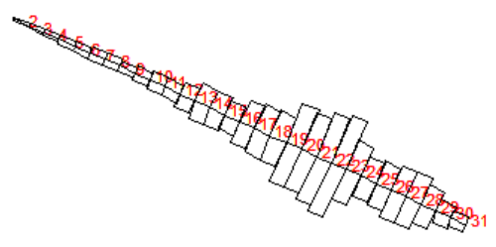
W2 model segment layout for the DeGray Reservoir.

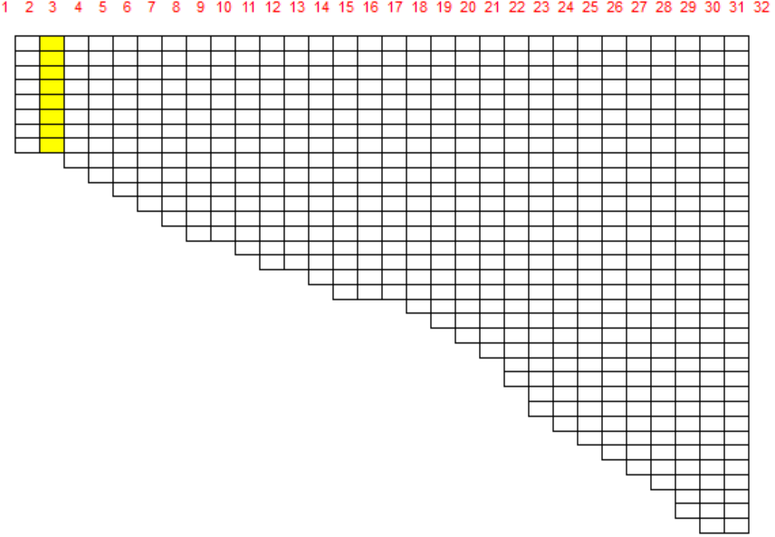
W2 model vertical layers (Δz = 2m) for the DeGray Reservoir.

3). W2 model input files
w2_DeGray.xmls w2_con.csv
File type | File name
QGT FILE QGTFN - gate | qgt.npt
WSC FILE WSCFN - wind sheltering | wsc.npt
SHD FILE SHDFN - shading | shade.npt
BTHFN bathymetry file | bth1.csv
METFN meteorological file | met.npt
EXTFN light extinction | ext_1.npt
QINFN branch inflow | qin_br1_equal.npt
TINFN branch temp inflow | tin_br1.npt
CINFN branch conc inflow | cin_br1.csv
QOTFN branch structure outflow | qot_br1_equal.npt

Original model bathymetry was changed with the following two different layer thickness heights:
- Layer height = 1 m (bth1-1m.csv)
- Layer height = 4 m (bth1-4m.csv)

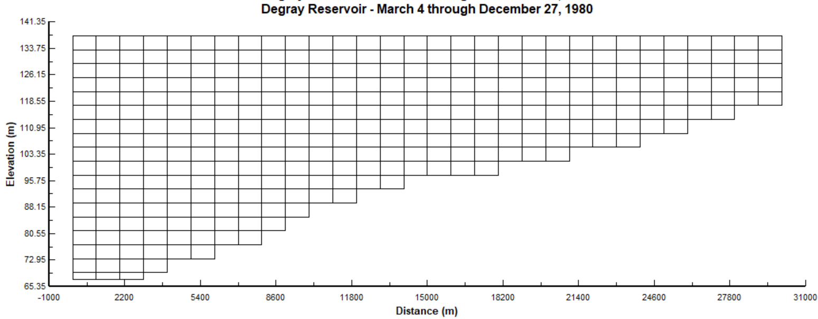
W2 model vertical layers (Δz = 4m) for the DeGray Reservoir.

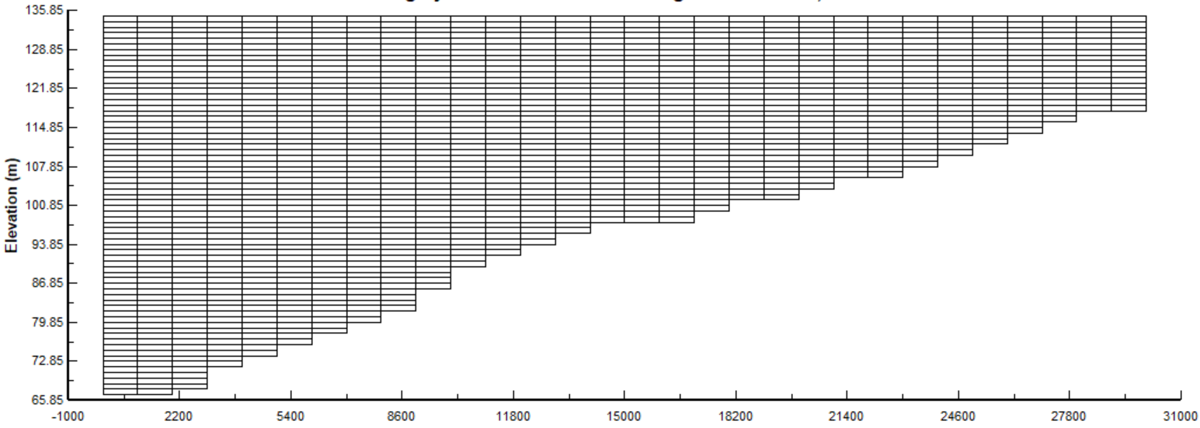
W2 model vertical layers (Δz = 1m) for the DeGray Reservoir.

4) W2 model output files
After running w2_v5beta.exe, the following model outputs are created.
a) TSR PLOT- time series plot output
The time series outputs at a user specified segment for
- active constituent concentrations
- derived constituent concentrations
- instantaneous kinetic flux rates
- instantaneous algae growth rate limitation fractions for P, N, and light [0 to 1] for each algal group.

tsr_1_seg31.csv

b) SPR PLOT - spreadsheet output
The spreadsheet profile output file consists of variable name, Julian date, depth below water surface, elevation, and temperature and/or concentrations for the output segment.
spr.csv

c) FLUXES- water quality kinetic flux output
The fluxes represent the average flux in kg/day over the time interval of flux output (FLX FREQ) and is in the same output format as the Snapshot [SNP] file. A summation of all active fluxes for each waterbody over all segments and layers is output to another file with a filename “kflux_wb#.csv” where # is the waterbody number.
flx.opt
kflux_wb1.csv

d) WITH OUTPUT- withdrawal output
The withdrawal outflow file [WDOFN] for outflow, outflow temperature, outflow constituent concentrations, outflow derived constituent concentrations, and vertical distribution of layer-specific outflow rates.
qwo_31.csv
two_31.csv
cwo_31.csv
dwo_31.csv
qwo_layers_31_wdo.csv

e) Water level output
The file consists of Julian day followed by the water surface elevation at each model segment in m.

wl.csv

f) Flow balance output
This file is a summary of the flow balance for each waterbody based on the output interval for Contour output or CPL output.

flowbal.csv

g) N and P mass balance output
massbal.csv

h) DSI W2Linkage File for W2Post (The installation of W2_Post.exe is required.)
degray.w2l

i) HDF5 File (The installation of HDF5 Viewer is required. It can be freely downloaded from https://www.hdfgroup.org/downloads/hdfview/)
W2_output.hdf5

j) SNP PRINT - Snapshot print

snp.opt

2. Bonneville Dam

1). Objectives
This case study is used to demonstrate Total Dissolved Gas (SYSTDG) modeling capabilities in W2 model.

Bonneville reservoir on the lower Columbia River was selected as a demonstration site for validating the TDG prediction. Bonneville Dam is located on Columbia River Mile (RM) 146.1 and is a run-of-river dam. The reservoir is 48 miles long, from Bonneville Dam to the foot of Dalles Dam upstream, with a surface area of 29.5 square miles, and a capacity of 537,000 acre-feet. The full forebay elevation is 77 feet, and the maximum forebay elevation is 82.5 feet. The Dam is 171 feet high and 2,477 feet long. Bonneville Dam is equipped with 2 powerhouse units, 18 spillbays, and 1 fish ladder.

2). W2 model grids
The Bonneville W2 model domain extends upstream for 45.9 river miles to the Dalles Dam and has 75 longitudinal segments of varying widths and 56 vertical layers of varying heights. The model includes 2 powerhouse units and 18 spillbays. Powerhouse No. 1 flows were modeled as a “line” source 313 m in length. Powerhouse No. 2 flows were modeled as a “line” source 300.5 m in length, but limited to 242 m by the model’s geometry at the discharge elevation. The spillway flows were modeled as a “line” source 442 m in length, limited by the model width of 316 m at the discharge depth. The fish ladder flow and any flows not accounted for in the spillway and powerhouse were combined into a single miscellaneous flow category. Only incoming flow to the reservoir considered in the model was the upstream Columbia River, as no other significant tributaries are present in the system.

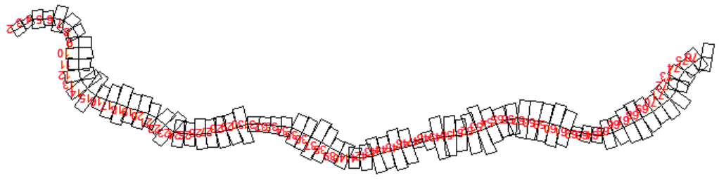
W2 model segment layout for the Bonneville reservoir.

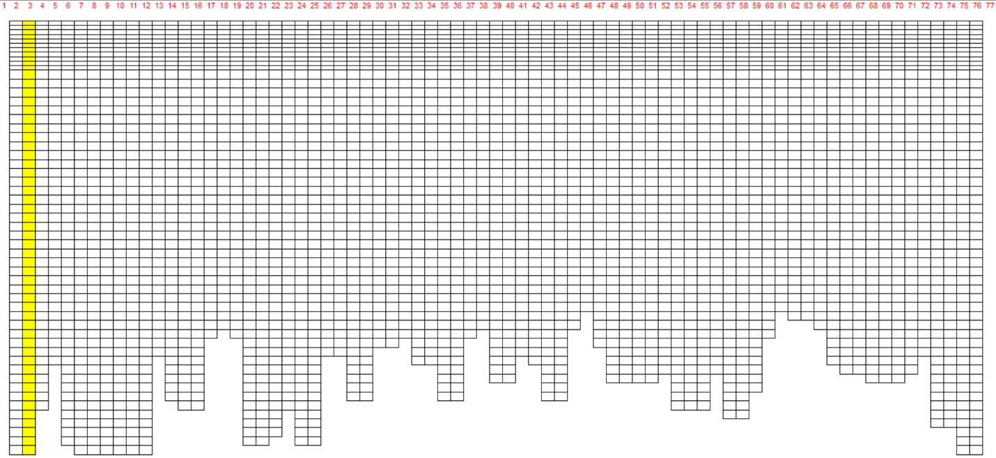
W2 model vertical layers for the Bonneville reservoir.

3). W2 model input files
- w2_con.csv
- w2_systdg.npt

File type |  | File name
Wind sheltering | WSC FILE WSCFN | BON_WSC.npt
Shading | SHDFN | BON_SHD_1.npt
Bathymetry | BTHFN | BON_NAVD88_BTH_2011.csv
Meteorological | METFN | BON_2011_2015_MET.csv
Branch inflow | QINFN branch inflow | DALLES_OUTFLOW.csv
 | TINFN branch temp | two_41_TDA.opt
 | CINFN branch conc | cwo_41_TDA.opt
 | QDTFN Distributed flow | BON_DistributedTribInflow.npt
 | TDTFN Distributed temp | two_41_TDA.opt
 | CDTFN Distributed conc | cwo_41_TDA.opt
Spillway/Gate | QGTFN | QGT_BON_2011_2015.csv

4). Hands-on exercises
a) Review the model inputs
b) Run the model and review the model outputs of withdrawal TDG in dwo_76.csv
c) Compare TDG computed from “N2+DO” and observed data (CCIW_TDG_Temp_2011-2015.csv).
d) Change the following water quality parameters and rerun the model and see the difference of TDG in dwo_76.csv
TDG production coefficients:
Eq 1: $TDG(\%)=a*Q_{s}+b$

Eq 4: ${TDG}_{sp}=P1*\left(twe-twce\right)+P2 *{q_{s}}^{P3}+P4+ bp$

3. Detroit Lake
1). Objectives
This case study is used to demonstrate selective withdrawal blending algorithms in W2 model. The W2 model estimates the temperatures released by those flows through the priority outlets, then adjusts the temperature target for the blended releases accordingly.

This project includes 4 outlets:
1: floating weir, priority 1, 2.3 m depth, minimum 400 cfs, maximum 5600 cfs
2: spillway, priority -1 (nonblended)
3: lower power outlet, priority 1, maximum 5600 cfs
4: regulating outlet, priority -1 (nonblended), maximum 5600 cfs

Outlets 2 and 4 represent outlets used to "spill" excess flow that the other outlets cannot handle. These two outlets of the same priority balancing flows from a fixed elevation (outlet #3) and from a floating outlet (#1).

Detroit lake captures several rivers that drain an area on the western slopes of Mt. Jefferson in the Cascade Range, and impounds 455,100 acre-ft of water at full pool, making it one of the largest reservoirs in the Willamette River Basin. The North Santiam River is one of several major tributaries to the Willamette River. The fixed-elevation outlet was given a centerline elevation of 408.4 m (1,340 ft). The floating outlet was given a depth (DEPTH) of 2 m (6.56 ft) and a minimum flow of 11.327 m3/s (400 ft3/s).

2). W2 model grids
Detroit lake CE-QUAL-W2 model has 4 branches and 58 segments. The vertical layer height is about 2 meters. The spatial layout of the branches and inflows is shown below.
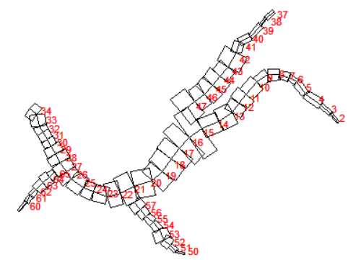
W2 model segment layout for the Detroit Lake.

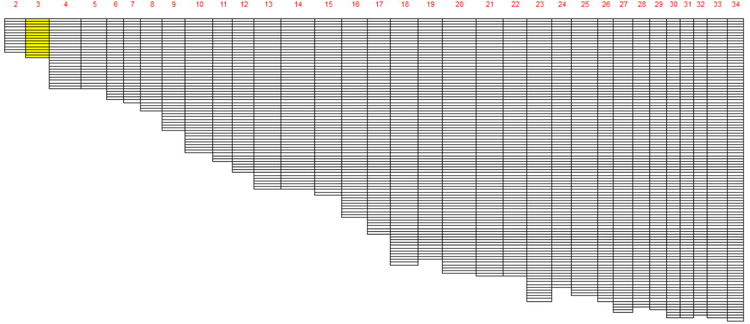
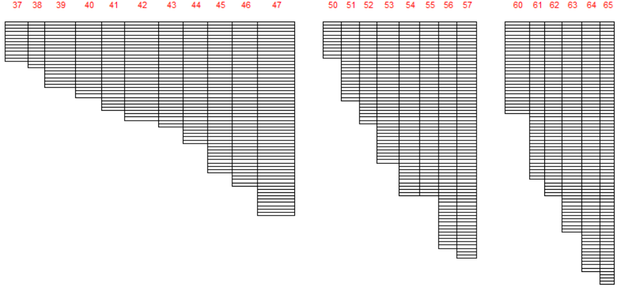
W2 model vertical layers for the Detroit Lake.

3). W2 model input files
- w2_con.csv
- w2_selective.npt

File type |  | File name
Wind sheltering | WSCFN | wsc.npt
Shading | SHDFN | shade.npt
Bathymetry | BTHFN | bth1.csv
Met | METFN | 0609_met_stay_raws.npt
Tributary inflow | QTRFN - tributary flow | 0609_french_q_est.npt | 0609_boxCan_q_est.npt
 | TTRFN - tributary temp | 0609_french_t_est.npt | 0609_boxCan_t_est.npt
Branch inflow | QINFN branch inflow | 0609_nsboulder_q.npt | 0609_breitenbush_q.npt | 0609_blowout_q.npt | 0609_kinney_q_est.npt
 | TINFN branch temp | 0609_nsboulder_t.npt | 0609_breitenbush_t.npt | 0609_blowout_t.npt | 0609_kinney_t_est.npt
 | QDTFN Distributed flow | 0609_qdt_br1_est.npt | 0609_qdt_br2.npt | 0609_qdt_br3.npt | 0609_qdt_br4.npt
 | TDTFN Distributed temp | 0609_tdt_br1_est.npt | 0609_tdt_br2.npt | 0609_tdt_br3.npt | 0609_tdt_br4.npt
Precipitation | PREFN flow | 0609_pre_detroit.npt | 0609_pre_detroit2.npt | 0609_pre_detroit3.npt | 0609_pre_detroit4.npt
 | TPRFN temp | 0609_tpr_detroit.npt | 0609_tpr_detroit2.npt | 0609_tpr_detroit3.npt | 0609_tpr_detroit4.npt
Structure outflow | QOTFN | 0609_qot_det_max.npt

4). Hands-on exercises
a) Review the W2 model inputs
b) Run the W2 model and review the model outputs of structure water temperature
c) Turn on selective withdrawal in the control file ---> “USGS”
d) Review the USGS selective withdrawal control file: w2_selective.npt
e) Rerun the W2 model
h) Change the following parameters in the selective input file (w2_selective.npt) and rerun the W2 model and see the difference of withdrawal water temperatures in two_34.csv.
Temperature target:
10 ºC
15 ºC

4. Lower Minnesota River
1). Objectives
This case study is used to demonstrate the model calibration and validation for dissolved oxygen, algae, nutrients, etc.

The CE-QUAL-W2 model domain encompasses the lower forty miles of the Minnesota River. Eleven tributaries were identified for their contribution to this reach. There are numerous point source discharges from industrial facilities and small wastewater treatment plants (WWTP). Four monitoring stations at RM 25.1, 14.3, 8.5, and 3.5 from the downstream mouth were used for evaluating model performance during calibration. RM 3.5 station near Fort Snelling contains the most complete observed water quality data set.

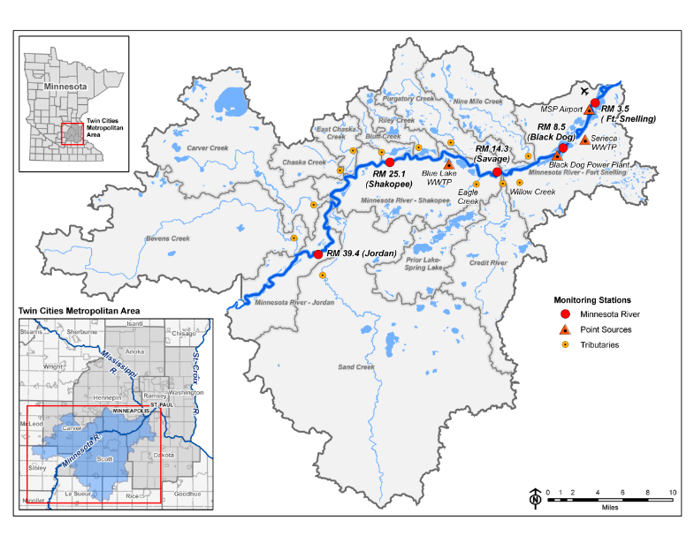
Lower Minnesota River.

2). W2 model grids
The Lower Minnesota River (LMNR) CE-QUAL-W2 model domain was split into two branches and was modeled with 90 longitudinal segments, varying in length from 134.0-2321.4 m, and 111 vertical segments, varying in height from 0.2-0.6 m. Four monitoring stations at RM 25.1, 14.3, 8.5, and 3.5 correspond to segment numbers in W2 model are 23, 46, 68 and 83.
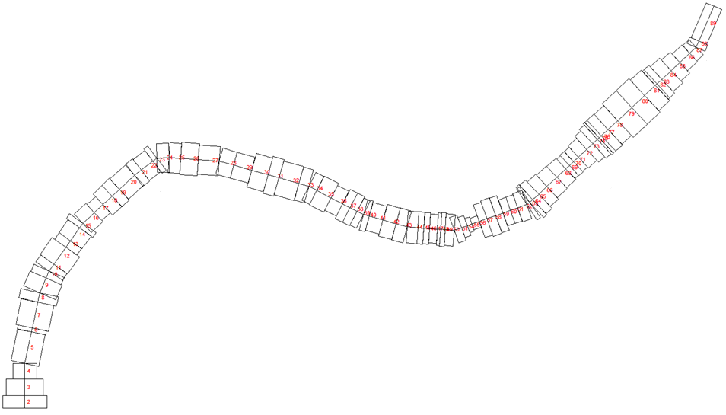
W2 model segment layout for the LMNR.

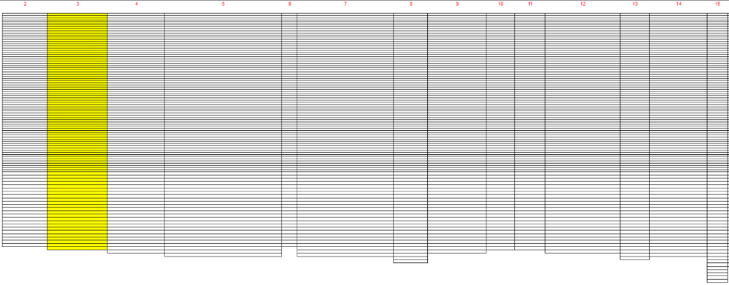
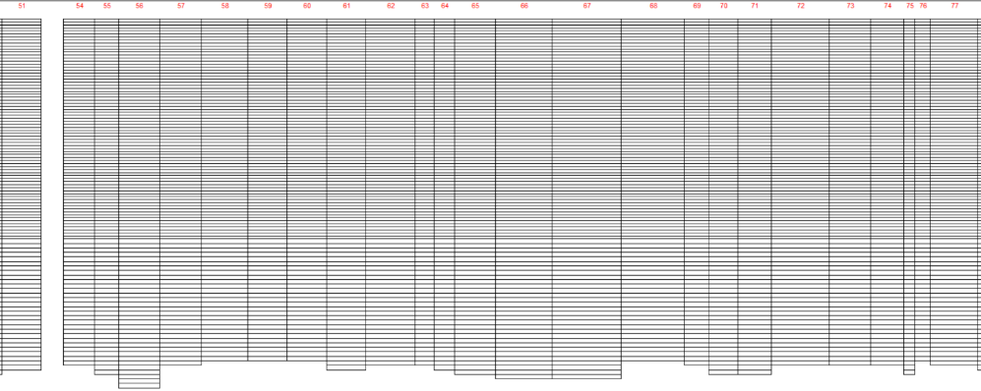
W2 model vertical layers for the lower Minnesota river.

3). W2 model input files
- w2_con.csv

File type |  | File name
Wind sheltering | WSCFN | wsc.npt
Shading | SHDFN | shd.npt
Bathymetry | BTHFN | bth1.csv
Meteorological | METFN | WY01_MET_CLOUD.NPT
Tributary inflow | QTRFN - tributary flow | 01QT355.INP  01QT341.INP  01QD205.INP  01QT137.INP  01QT125.INP  01QD107H.INP  01QD076H.INP  01QD065.INP  01QD041.INP  01QD038.INP  01QD030.INP
 | TTRFN - tributary temp | 01TT355H.INP  01TT341H.INP  01TD205D.INP  01TT137H.INP  01TT125H.INP  01TD107H.INP  01TD076H.INP  01TD065D.INP  01TD041.INP  01TD038.INP  01TD030.INP
 | CTRFN - tributary conc | 01CTR_355_RUN06.NPT  01CTR_341_RUN06.NPT  01CTR_205_RUN04.NPT  01CTR_137_RUN06.NPT  01CTR_125_RUN06.NPT  01CTR_107_RUN06_REF.NPT  01CTR_076_RUN06_REF.NPT  01CTR_065_RUN04.NPT  01CTR_041_RUN04.NPT  01CTR_038_RUN04.NPT  01CTR_030_RUN04.NPT
Branch inflow | QINFN branch inflow | 01QR394.INP
 | TINFN branch temp | 01TR394H.INP | 01TR035H.INP
 | CINFN branch conc | 01CIN_394_RUN06.NPT
 | EDHFN Downstream head |  | BR2_WSL.npt
 | TDHFN Downstream temp |  | BR2_T.NPT
 | CDHFN Downstream conc |  | BR2_C.NPT

W2 model input files
QTRFN - tributary flow file | 01QT355.INP | 01QT341.INP | 01QD205.INP
TTRFN - tributary temperature file | 01TT355H.INP | 01TT341H.INP | 01TD205D.INP
CTRFN - tributary concentration file | 01CTR_355_RUN06.NPT | 01CTR_341_RUN06.NPT | 01CTR_205_RUN04.NPT

01QT137.INP | 01QT125.INP | 01QD107H.INP | 01QD076H.INP
01TT137H.INP | 01TT125H.INP | 01TD107H.INP | 01TD076H.INP
01CTR_137_RUN06.NPT | 01CTR_125_RUN06.NPT | 01CTR_107_RUN06_REF.NPT | 01CTR_076_RUN06_REF.NPT
01QD065.INP | 01QD041.INP | 01QD038.INP | 01QD030.INP
01TD065D.INP | 01TD041.INP | 01TD038.INP | 01TD030.INP
01CTR_065_RUN04.NPT | 01CTR_041_RUN04.NPT | 01CTR_038_RUN04.NPT | 01CTR_030_RUN04.NPT

QWD FILE QWDFN - withdrawals | 01QW088.INP
BTHFN bathymetry file | bth06_90seg.NPT
METFN meteorological file | WY01_MET_CLOUD.NPT
QINFN branch inflow | 01QR394.INP
TINFN branch temp inflow | 01TR394H.INP | 01TR035H.INP
CINFN branch conc inflow | 01CIN_394_RUN06.NPT
EDHFN Downstream head file | edh_br1.npt | BR2_WSL.npt
TDHFN Downstream temperature file | tdh_br1.npt | BR2_T.NPT
CDHFN Downstream concentration file | cdh_br1.npt | BR2_C.NPT

4). Hands-on exercises
a) Review the model inputs
b) Run the model and review the model outputs of DO, CHLA, NH4, NO3, PO4 from Segment 83.
The location at RM3.5 corresponds to W2 model Segment 83, modeled time series results for Segment 83 are included in LMNR_tsr_8_seg83.csv, observed water quality data along the river are provided in LMNRsegmentobservedWQ.xlsx. Comparations of modeled DO, CHLA, PO4, NH4 and observed data at RM3.5 are given below:

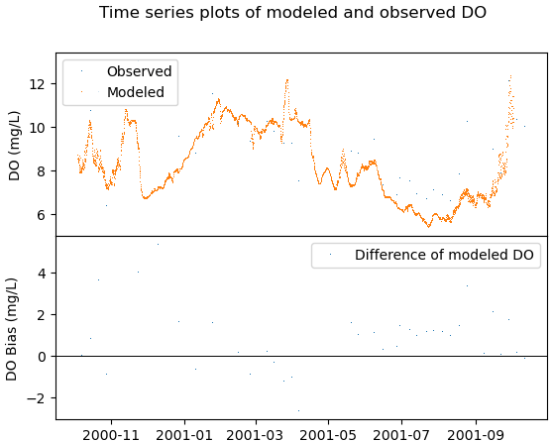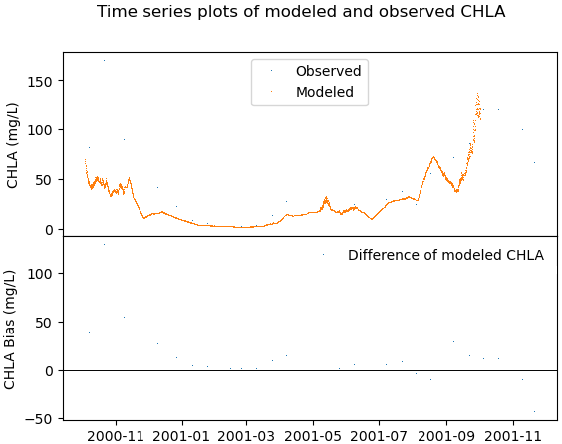

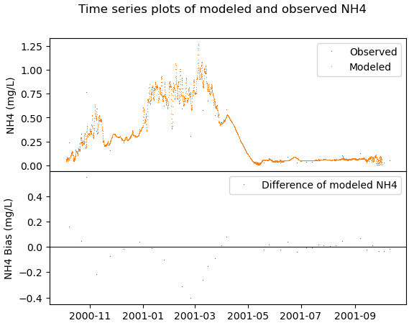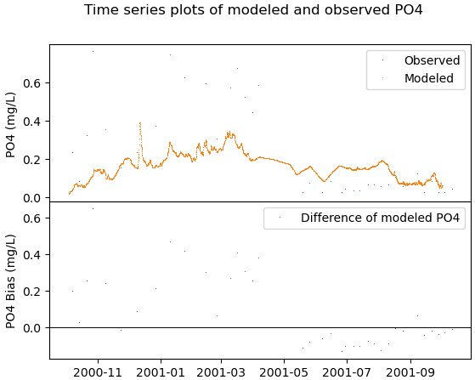

c) Change the following parameters in the input file and rerun the model and see the difference of DO, NH4, PO4 from Segment 83
AG - maximum algal growth rate (d⁻¹)
POM settling rate (m d⁻¹)
PO4R - sediment release rate of PO4
NH4REL - sediment release rate
NO3S - denitrification rate from sediments (m d⁻¹)

