# **Development of New Capabilities and Enhancements to the USACE Two-Dimensional Reservoir Water Quality Model (CE-QUAL-W2)**

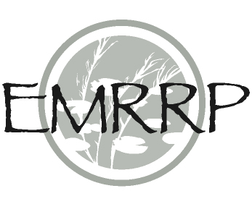

**Reference SON:** *ENV 1174 and ENV 1550*

**Lead PI(s):** *Todd Steissberg*

**Project Development Team (PDT):** *Zhonglong Zhang (Portland State University, PSU), Scott Wells (PSU), Isaac Mudge (USACE-MVN/ERDC), John Kucharski (ERDC), Billy Johnson (LimnoTech), Barry Bunch (ERDC)*

**Proponent(s)/District Collaborators:** *Brian Zettle (TNTCX, CoP Lead), Kathryn Tackley (NWP), Mishael Umlor (NWW), Dan Turner (NWD), Alexis Mills (NWD), Mark Campbell (LRN), Sarah Pedrick (LRN)*

**Other Partners:** *Richard Webb (USGS), Rebecca Muenich (Arizona State University)*

**Funded:** *FY20-FY23*

**Keywords:** *Water quality modeling, Reservoirs, Lakes, Rivers, Estuaries, Ecohydrology, Environmental flows*

**Wiki [wiki page to be populated with factsheet information and hyperlinked]**

**Research Need**

There is an increasing demand to include water quality operating objectives in hydrodynamic and water quality reservoir simulation models to improve water management decision-making. Deriving the most effective method to manage reservoir and riverine systems while addressing water quality considerations has emerged in recent years as a significant and complex challenge. Currently, CE-QUAL-W2 functions as a proven and evidence-based two-dimensional (2D) longitudinal/vertical, hydrodynamic and water quality model. CE-QUAL-W2 was first released by ERDC in 1986. Since that time, more than 300 model applications have been developed worldwide (https://www.erdc.usace.army.mil/Media/Fact-Sheets/Fact-Sheet-Article-View/Article/554171/ce-qual-w2). CE-QUAL-W2 has been the subject of, or cited by, thousands of journal and other professional publications over the past 36 years. At least 1,500 publications have utilized or referenced CE-QUAL-W2 in the year 2022 alone. CE-QUAL-W2 is being upgraded to incorporate the latest water quality modeling research and development conducted at ERDC, add support for modern and robust data formats to enable seamless linking with other models and data, and to decouple the water quality kinetics from the hydrodynamics to enable significantly faster simulating times.

The updated CE-QUAL-W2 model will support the Corps’ high priority need for environmental assessment, restoration, and management. Incorporation of reservoir operations capabilities will enable water quality and other environmental objectives to influence the reservoir release-decision process. This will improve model accuracy within the reservoir and deliver high quality multi-objective decision-making to achieve ecosystem benefits. Critical downstream habitat will be better managed for water quantity (volume, velocity, depths, etc.) as well as water quality objectives (water temperature, dissolved oxygen, total dissolved gas, etc.). Many U.S. Army Corps of Engineers Districts and other organizations use CE-QUAL-W2 to perform real-reservoir simulations as part of daily decision support for reservoir releases and assessment of operations for ecosystem restoration. This work unit will develop improved reservoir water quality modeling capabilities that are readily available to those projects, thus reducing the time and cost typically associated with upgrading existing water quality models and implementing new model capabilities.

**Project Purpose & Objectives**

This project seeks to provide an upgraded version of CE-QUAL-W2, user documentation, and technical guidance to improve the ability of CE-QUAL-W2 to meet multiple project objectives, including river-reservoir system flow and water quality evaluation for ecosystem restoration, environmental impacts assessment, multiple-model project planning, multi-objective decision-making, and real-time simulation Six deliverables are proposed for this project:

* Upgrading the current W2 model to incorporate the latest water quality modeling research and development conducted at ERDC
* Restructuring the current W2 model source code to use robust data storage file formats that adhere to modern standards and are widely and publicly supported, such as HDF5 and JSON. These formats enable seamless linking with other models such as HEC-RAS and HEC-ResSim, which will significantly improve multi-model system reliability, thus reducing maintenance cost of the software, models, and linked modeling systems.
* Decoupling the water quality component from the hydrodynamics in the current W2 model, allowing the water quality simulation to run multiple times with the same hydrodynamic results, eliminating the need for costly repeated hydrodynamic computations

**Value of Research and Development (Payoff)**

The updated CE-QUAL-W2 model will support the Corps’ high priority need for environmental assessment, restoration, and management. Incorporation of reservoir operations capabilities will enable water quality and other environmental objectives to inform reservoir release decisions, improving model accuracy and delivering high quality multi-objective decision-making to achieve ecosystem benefits. Critical downstream habitat will be better managed for water quantity (volume, velocity, depths, etc.) in addition to water quality (water temperature, dissolved oxygen, total dissolved gas, etc.) Linkage of water temperature and water quality constituents with multi-objective decision analysis increases project benefits while decreasing modeling and project costs. CE-QUAL-W2 is very widely used by USACE and other federal, state, and local agencies, e.g., USGS, USBR, State of California for environmental impact assessments, planning studies, etc. It is also used as a research tool by researchers at universities and other organizations. At least 1,500 publications have utilized or referenced CE-QUAL-W2 in the year 2022 alone.

**Products**

Conference Presentations/Webinars/Workshops

Steissberg, T.E., Zhang, Z., Mudge, I.M., Bunch, B. (2022) CE-QUAL-W2 Water Quality Modeling Workshop. Environmental Laboratory, U.S. Army Engineer Research and Development Center, Vicksburg, MS.

Zhang, Z., Steissberg, T.E., Zhang Z. (2022). Surface Water Quality Modeling with CE-QUAL-W2. Workshop. American Water Resources Association Conference. Seattle, WA.

**

# **Figure 1. Schematic of a typical watershed modeled with CE-QUAL-W2**

**

# **Figure 2. CE-QUAL-W2 is used to model the hydrodynamics and water quality of rivers as well as reservoirs. Free-flowing and unstratified rivers may be modeled by one-dimensional (1D) river models, such as HEC-RAS-WQ. Stratified reservoirs may be modeled by 1D reservoir models, such as HEC-ResSim-WQ, if evaluating aggregate or long-term in-reservoir water quality or downstream impacts. In-reservoir studies of long stratified reservoirs requires a two-dimensional (2D) hydrodynamic reservoir model to accurately represent important vertically stratified processes while capturing the effects of point- and non-point pollutant inputs along the direction of flow in the reservoir.**

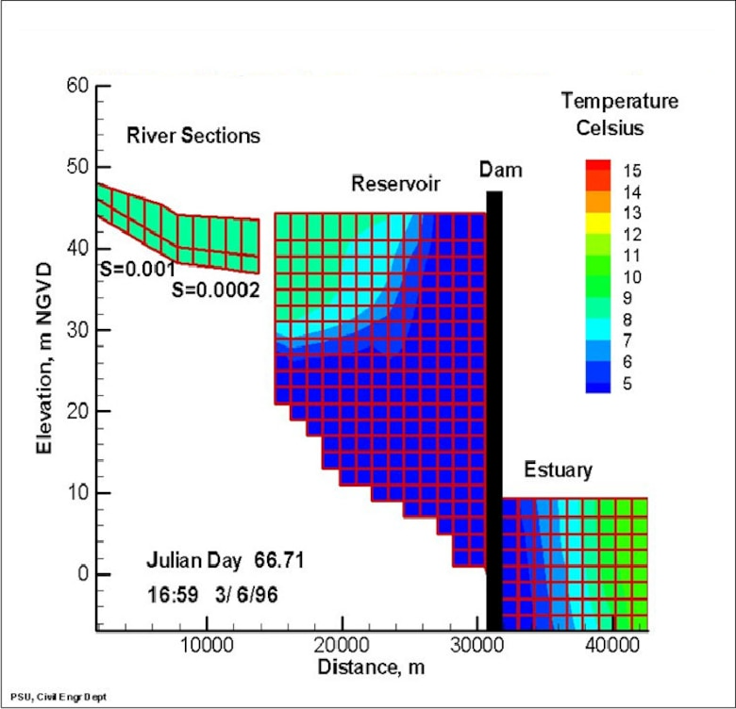

**Figure 3. Longitudinal view of temperature output for a riverine section, a reservoir, and an estuary, from a CE‐QUAL‐W2 model application.**