DEEP LEARNING ASSIGNMENT 2 REPORT
Automatic Image Captioning With Model Benchmarking And Robustness Analysis

Team Name: T4 Tornadoes (Team ID: 20)
- Tuhin Mondal (Roll No : 22CS10087)
- Diganta Mandal (Roll No: 22CS30062)
- Gayathri Anant (Roll No: 22CS30026)

Part A: Implementing and Benchmarking a Custom Encoder-Decoder Model

SmolVLM Implementation:
We utilized the SmolVLM-Instruct model for zero-shot image captioning, and despite its compact size, it delivered impressive results. We followed the guidelines provided in the SmolVLM documentation on Hugging Face, which offered clear instructions on model loading and caption generation. For evaluation, we computed BLEU, ROUGE-L, METEOR and BERT scores to establish a baseline.
Performance:
Evaluation Metrics | SmolVLM Scores
BLEU Score (Sentence) | 0.0145
BLEU Score (Corpus) | 0.0115
ROUGE-L Score | 0.2679
METEORScore | 0.1155
BERT Score | 0.8767

Analysis: These scores evaluate the quality of captions generated by SmolVLM. The BLEU scores (Sentence: 0.0145, Corpus: 0.0115) are very low, indicating poor n-gram overlap with reference captions. The ROUGE-L score of 0.2679 suggests limited recall of longest matching sequences, while the METEOR score of 0.1155 reflects weak semantic and morphological alignment. Despite this, the BERT Score of 0.8767 implies that captions are somewhat contextually relevant, even if not lexically precise. Overall, SmolVLM struggles with both surface-level and deeper semantic accuracy in caption generation.

Custom Model Implementation:
We implemented a lightweight image captioning model class by combining a pre-trained Vision Transformer (ViT) with GPT-2 in a modular architecture. The model has the following components:
Image Encoder: We used ViT as the Visual Backbone, more specifically google/vit-base-patch16-224-in21k to extract high-level image features. We specifically took the [CLS] token output, which encodes global image information. This [CLS] embedding has a shape of [batch_size, 768], which serves as our compact, high-level image feature vector.
Projection Layer: Since ViT and GPT-2 operate in different embedding spaces, we introduced a linear layer to project the ViT output into GPT-2’s embedding dimension. It maps from 768 to 768. Given that both the ViT encoder and GPT-2 decoder have matching hidden sizes of 768, the projection layer serves to align the output from the ViT encoder to the input space of the GPT-2 decoder and allows a bit of flexibility. This layer learns to map visual representations into a format the language model can understand.
Decoder: We used GPT-2 (gpt2) as the language decoder to generate captions based on the image features. The projected [CLS] token from ViT is treated as a prefix embedding. AutoModelForCausalLM was used to load GPT-2 with a language modelling head.
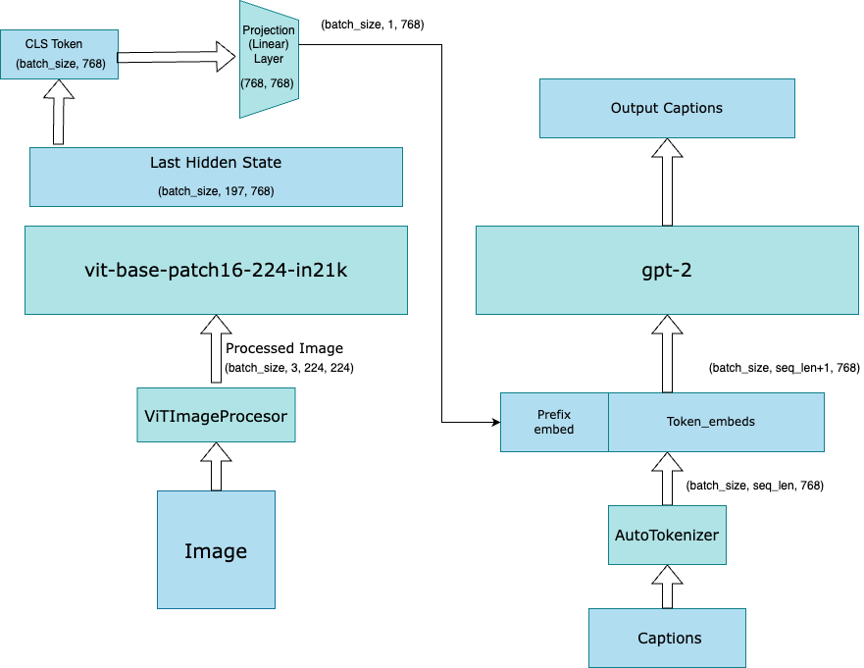
Training:
In our training process, we fine-tuned a model that combines Vision Transformer (ViT) for image feature extraction and GPT-2 for caption generation. The ViT model, which is pre-trained on a large dataset, is used to extract high-level visual features from images. We froze the weights of ViT to avoid retraining it, as it already provides rich, meaningful image representations. These extracted features are passed through a linear layer to align with GPT-2’s embedding space.
The GPT-2 model is then trained to generate captions based on these visual features. The training is focused on fine-tuning GPT-2, optimizing it to generate accurate and relevant captions while the ViT weights remain fixed. This approach ensures we leverage the powerful pre-trained ViT without needing to retrain it, saving both time and computational resources. Through this, we successfully build a model that generates contextually relevant captions based on images.
Inference:
For inference, we first encoded the image using ViT to extract its features. These features were then projected into the GPT-2 embedding space and used as a prefix to condition the language model. We utilized the generate() function from Hugging Face's Transformers, applying beam search with a beam width of 5 and a no-repeat n-gram constraint to prevent repetitive sequences. Finally, the output token IDs were decoded into human-readable captions, resulting in coherent and contextually relevant descriptions of the input image.
Tools Used:
- AutoTokenizer from Hugging Face — to handle GPT-2 tokenization.
- ViTImageProcessor — to preprocess images for the ViT model.
- AutoModelForCausalLM — to load GPT-2 with a language modelling head.
- PyTorch — for custom model composition and training logic.

Evaluation Metrics | Custom Model Scores (1) | SmolVLM Scores (2) | Difference ( 1 – 2)
BLEU Score (Sentence) | 0.0277 | 0.0145 | 0.0132
BLEU Score (Corpus) | 0.0266 | 0.0115 | 0.0151
ROUGE-L Score | 0.3450 | 0.2679 | 0.0771
METEORScore | 0.1764 | 0.1155 | 0.0609
BERT Score | 0.8875 | 0.8767 | 0.0108

Analysis: The custom model clearly outperforms SmolVLM across all evaluation metrics, demonstrating its superior captioning capability under ideal conditions. Notably, it achieves substantial gains in ROUGE-L (+0.0771) and METEOR (+0.0609), highlighting its strength in capturing longer sequence matches and semantic alignment. Improvements in BLEU (Corpus) (+0.0151) and Sentence-level BLEU (+0.0132) indicate better precision and consistency in generated captions, while the higher BERT Score (+0.0108) suggests improved contextual understanding.

Part B: Studying Performance Change Under Image Occlusion
SmolVLM:
Evaluation Metrics | Occlusion Level
 | 0 percent | 10 percent | 50 percent | 80 percent
BLEU Score (Sentence) | 0.0145 | 0.0108 (-0.0037) | 0.0059 (-0.0086) | 0.0029 (-0.0116)
BLEU Score (Corpus) | 0.0115 | 0.0080 (-0.0035) | 0.0031 (-0.0084) | 0.0010 (-0.0105)
ROUGE-L Score | 0.2679 | 0.2579 (-0.0100) | 0.2393 (-0.0286) | 0.1835 (-0.0844)
METEORScore | 0.1155 | 0.1074 (-0.0081) | 0.0872 (-0.0283) | 0.0649 (-0.0506)
BERT Score | 0.8767 | 0.8744 (-0.0023) | 0.8687 (-0.0080) | 0.8510 (-0.0257)

Custom Model:
Evaluation Metrics | Occlusion Level
 | 0 percent | 10 percent | 50 percent | 80 percent
BLEU Score (Sentence) | 0.0277 | 0.0289 (+0.0012) | 0.0216 (-0.0061) | 0.0199 (-0.0078)
BLEU Score (Corpus) | 0.0266 | 0.0280 (+0.0014) | 0.0196 (-0.0007) | 0.0175 (-0.0091)
ROUGE-L Score | 0.3450 | 0.3358 (-0.0092) | 0.3050 (-0.0400) | 0.2966 (-0.0484)
METEORScore | 0.1764 | 0.1791 (+0.0027) | 0.1599 (-0.0165) | 0.1555 (-0.0214)
BERT Score | 0.8875 | 0.8838 (-0.0037) | 0.8744 (-0.0131) | 0.8688 (-0.0187)

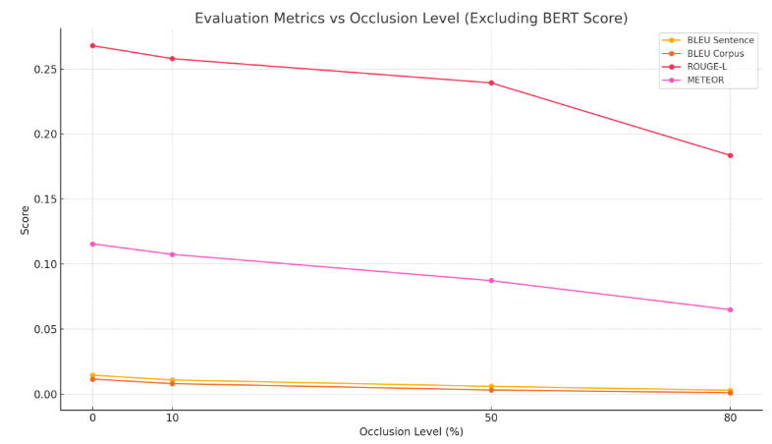
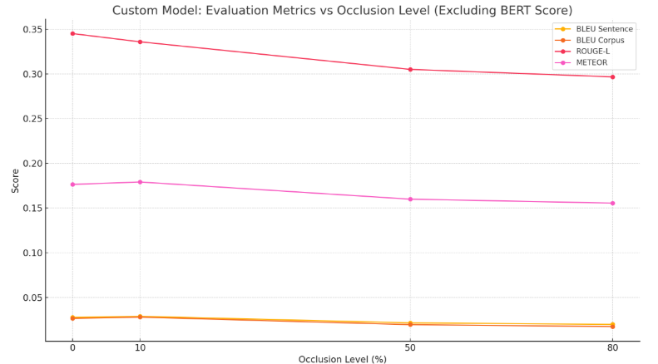
Effect of Occlusions: SmolVLM v/s Custom Model

Analysis: The custom model consistently outperforms SmolVLM across all evaluation metrics at every occlusion level, showing higher robustness and baseline performance. Unlike SmolVLM, which degrades sharply with increasing occlusion (e.g., ROUGE-L drops by 0.0844), the custom model exhibits more stable scores (ROUGE-L drops only 0.0484). Notably, the custom model even shows slight improvements at 10% occlusion for BLEU and METEOR, suggesting potential resilience to mild visual noise. Overall, the custom model maintains better semantic and lexical fidelity under occlusion.

Part C: Building a BERT-based Classifier for Model Identification

Dataset Construction:
The training dataset was constructed by combining captions from different sources with varying levels of image occlusion (0%, 10%, 50%, and 80%). Other details:

Input Text Format: <original_caption> <SEP> <generated_caption> <SEP> <perturbation_percentage>
Output Labels: 0: SmolVLM Model 1: Custom Model
Training set: 85% (Train: 6304 samples)
Test set: 15% of images (Test: 1120 samples)

Implementation:

The CaptionClassifier is a binary classification model built on top of the pre-trained BERT-base-uncased encoder, which provides rich contextual embeddings. It utilizes the [CLS] token's output representation (dimension 768) as input to a lightweight classification head. This head consists of a linear layer reducing dimensions to 256, followed by a ReLU activation and dropout (0.3) to prevent overfitting. Finally, an output layer maps the features to two logits representing the target classes.
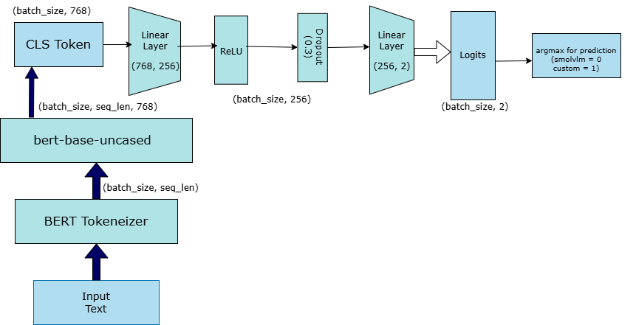

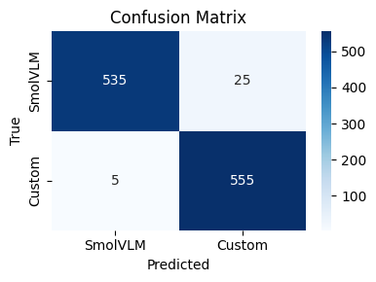

Performance:

Metric | Value
Accuracy | 0.9700
Macro Precision | 0.9738
Macro Recall | 0.9732
Macro F1 Score | 0.9732

Class-wise Performance:

Class | Precision | Recall | F1 Score | Support
SmolVLM | 0.99 | 0.96 | 0.97 | 560
Custom | 0.96 | 0.99 | 0.97 | 560

Analysis: The BERT-based classifier achieves exceptional performance with a macro F1 score of 0.972, highlighting its strong capability in distinguishing between SmolVLM and custom model captions. Both classes exhibit balanced F1 scores of 0.97, indicating consistent performance across sources. An asymmetric error pattern is observed: 5% of SmolVLM captions are misclassified as Custom, while only 1% of Custom are misclassified. These results confirm that the two models produce consistently distinguishable linguistic patterns, which BERT captures effectively.

