For Linux users:

Open a terminal in the folder which contains the installer for Linux

Type the following commands:

> sha256sum Anaconda3-2020.11-Linux-x86_64.sh

Output: <hash> Anaconda3-2020.11-Linux-x86_64.sh

> bash Anaconda3-2020.11-Linux-x86_64.sh

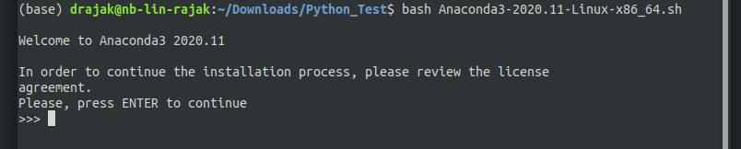
press ENTER.

On pressing ENTER you get to read the license. Agree to the terms and conditions if you feel comfortable with it (if you have a Facebook account you don’t get to opt out).
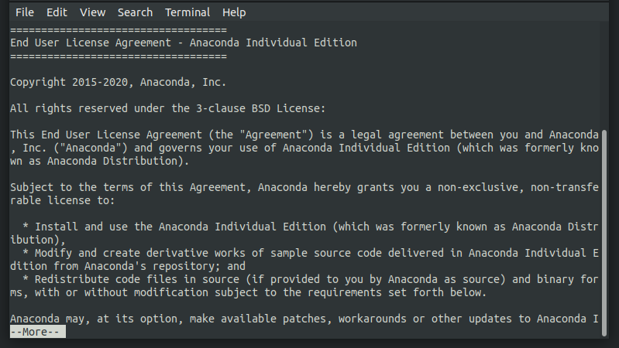

Press ENTER to continue reading

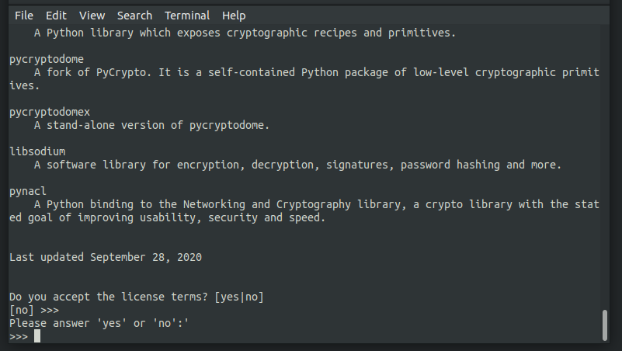

Type yes in the console

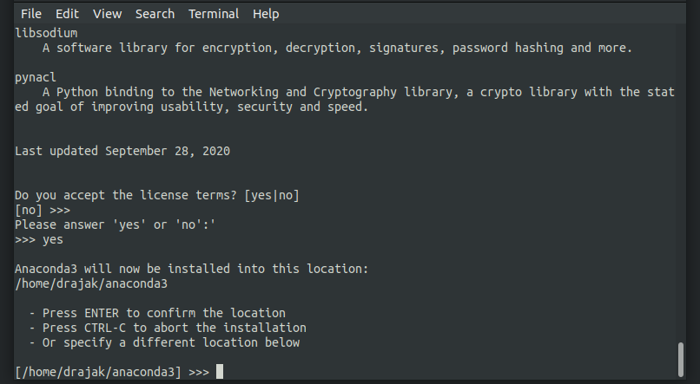
Press ENTER or specify your install location

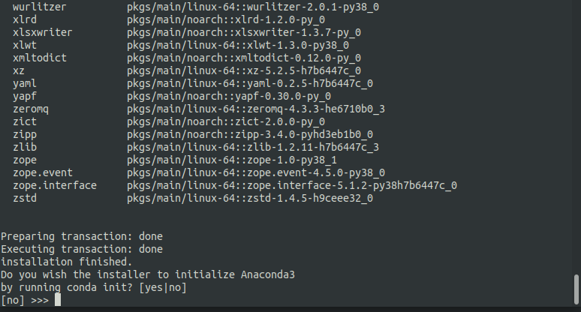
Type “yes” in the console.

(Optional) Open .bashrc file

> gedit ~/.bashrc

At the end of the .bashrc script where the conda environment is setup copy paste the following

> conda config --set auto_activate_base true

