SUPPORTING INFORMATION

The effect of species composition dissimilarity on plant-herbivore network structure is not consistent over time

Lucas Pereira Martins^{1,2}. Departamento de Ecologia, Laboratório de Interações Ecológicas e Biodiversidade, Universidade Federal de Goiás, Goiânia, Goiás, Brazil
Anderson Matos Medina. Departamento de Ecologia, Laboratório de Interações Ecológicas e Biodiversidade, Universidade Federal de Goiás, Goiânia, Goiás, Brazil
Thomas M. Lewinsohn. Laboratório de Interações Insetos-Plantas, Departamento de Biologia Animal, Universidade Estadual de Campinas, Campinas, São Paulo, Brazil
Mário Almeida-Neto. Departamento de Ecologia, Laboratório de Interações Ecológicas e Biodiversidade, Universidade Federal de Goiás, Goiânia, Goiás, Brazil

¹ Present address: Centre for Integrative Ecology, School of Biological Sciences, University of Canterbury, Private Bag 4800, Christchurch, New Zealand
² Correspondence: Lucas Pereira Martins. E-mail: martinslucas.p@gmail.com

Table S1. List of plant species (family Asteraceae) from ten remnants of Brazilian Cerrado. Values represent species abundance in each remnant.
Species | Remnants
 | R1 |  | R2 | R3 | R4 | R5 | R6 | R7 | R8 | R9 | R10
Baccharis dracunculifolia | 0 | 0 |  | 4 | 0 | 1 | 0 | 0 | 0 | 0 | 0
Bidens gardneri | 13 | 12 |  | 0 | 18 | 37 | 8 | 2 | 10 | 41 | 9
Calea verticillata | 1 | 0 |  | 0 | 0 | 0 | 1 | 1 | 0 | 0 | 0
Campuloclinium chlorolepis | 14 | 0 |  | 2 | 5 | 6 | 0 | 1 | 8 | 1 | 0
Chaptalia integerrima | 1 | 0 |  | 0 | 0 | 0 | 0 | 0 | 0 | 3 | 0
Chresta sphaerocephala | 0 | 0 |  | 0 | 0 | 0 | 0 | 0 | 0 | 1 | 0
Chromolaena chaseae | 0 | 0 |  | 9 | 4 | 7 | 0 | 0 | 6 | 6 | 14
Chromolaena odorata | 10 | 0 |  | 14 | 1 | 11 | 10 | 8 | 16 | 4 | 11
Chromolaena pedunculosa | 17 | 8 |  | 12 | 6 | 14 | 29 | 13 | 21 | 29 | 25
Chromolaena pungens | 18 | 2 |  | 14 | 20 | 15 | 7 | 23 | 46 | 15 | 29
Chromolaena squalida | 15 | 1 |  | 15 | 17 | 7 | 1 | 12 | 10 | 17 | 20
Chrysolaena herbacea | 0 | 0 |  | 0 | 4 | 1 | 0 | 8 | 0 | 0 | 0
Conyza canadensis | 0 | 0 |  | 0 | 5 | 1 | 0 | 0 | 2 | 0 | 1
Dimerostemma rotundifolium | 3 | 0 |  | 0 | 0 | 1 | 0 | 0 | 7 | 0 | 0
Elephantopus biflorus | 0 | 0 |  | 0 | 0 | 4 | 0 | 4 | 0 | 0 | 2
Elephantopus mollis | 1 | 0 |  | 0 | 0 | 17 | 0 | 0 | 0 | 20 | 0
Heterocondylus alatus | 0 | 0 |  | 0 | 19 | 0 | 0 | 4 | 0 | 0 | 4
Lepidaploa psilostachya | 1 | 0 |  | 1 | 0 | 0 | 3 | 2 | 2 | 0 | 0
Lepidaploa remotiflora | 0 | 0 |  | 0 | 0 | 0 | 0 | 0 | 0 | 1 | 0
Lessingianthus bardanoides | 8 | 4 |  | 0 | 1 | 3 | 0 | 9 | 3 | 0 | 5
Mikania cordifolia | 7 | 9 |  | 7 | 10 | 10 | 4 | 3 | 6 | 13 | 11
Mikania hirsutissima | 0 | 0 |  | 0 | 4 | 0 | 0 | 0 | 0 | 0 | 0
Moquiniastrum barrosoae | 0 | 1 |  | 0 | 5 | 1 | 0 | 0 | 0 | 6 | 6
Moquiniastrum polymorphum | 0 | 0 |  | 0 | 0 | 0 | 0 | 0 | 0 | 3 | 0
Moquiniastrum pulchrum | 4 | 1 |  | 0 | 13 | 19 | 13 | 8 | 21 | 11 | 14
Orthopappus angustifolius | 2 | 1 |  | 2 | 0 | 4 | 0 | 0 | 10 | 22 | 0
Piptocarpha rotundifolia | 7 | 20 |  | 27 | 13 | 13 | 0 | 16 | 19 | 21 | 5
Pluchea sagitallis | 0 | 0 |  | 0 | 0 | 0 | 0 | 0 | 0 | 2 | 0
Porophyllum ruderale | 2 | 0 |  | 0 | 3 | 0 | 0 | 0 | 0 | 0 | 0
Pterocaulon alopecuroides | 0 | 0 |  | 0 | 0 | 0 | 0 | 0 | 0 | 2 | 0
Pterocaulon rugosum | 4 | 8 |  | 0 | 0 | 0 | 0 | 0 | 0 | 0 | 0
Stenocephalum apiculatum | 1 | 2 |  | 0 | 0 | 0 | 0 | 0 | 8 | 0 | 0
Tilesia baccata | 0 | 0 |  | 0 | 0 | 0 | 0 | 0 | 0 | 3 | 0
Trichogonia salviaefolia | 0 | 0 |  | 0 | 0 | 0 | 0 | 0 | 0 | 0 | 11
Trixis verbasciformis | 1 | 0 |  | 0 | 1 | 0 | 0 | 0 | 0 | 0 | 0
Vernonanthura brasiliana | 4 | 0 |  | 0 | 0 | 0 | 1 | 0 | 0 | 0 | 3
Vernonanthura ferruginea | 0 | 12 |  | 13 | 0 | 0 | 5 | 0 | 0 | 15 | 0
Vernonanthura membranacea | 4 | 14 |  | 12 | 10 | 11 | 6 | 5 | 14 | 15 | 17
Vernonanthura phosphorica | 0 | 0 |  | 1 | 1 | 0 | 0 | 0 | 0 | 3 | 0
Viguiera arenaria | 4 | 0 |  | 0 | 14 | 0 | 1 | 1 | 13 | 0 | 2
Table S2. List of herbivore species from ten remnants of Brazilian Cerrado. Values represent species abundance in each remnant.
Species | Remnants
 | R1 | R2 | R3 | R4 | R5 | R6 | R7 | R8 | R9 | R10
Adaina bipunctata | 19 | 1 | 3 | 1 | 1 | 0 | 7 | 4 | 0 | 0
Adaina fuscahodias | 0 | 0 | 0 | 0 | 0 | 0 | 0 | 0 | 0 | 4
Apion sp.1 | 0 | 5 | 11 | 19 | 29 | 2 | 1 | 25 | 119 | 329
Apion sp.2 | 0 | 0 | 0 | 0 | 0 | 0 | 0 | 0 | 0 | 1
Apion sp.3 | 0 | 0 | 0 | 1 | 0 | 0 | 3 | 0 | 0 | 0
Apion sp.4 | 0 | 0 | 0 | 0 | 1 | 3 | 0 | 5 | 2 | 68
Apion sp.5 | 0 | 0 | 3 | 0 | 0 | 0 | 0 | 0 | 0 | 1
Apion sp.6 | 0 | 0 | 0 | 0 | 12 | 0 | 0 | 0 | 0 | 0
Apion sp.7 | 0 | 23 | 0 | 0 | 0 | 0 | 0 | 28 | 0 | 0
Apion sp.8 | 0 | 0 | 0 | 0 | 0 | 0 | 0 | 6 | 0 | 0
Argyrotaenia sp.1 | 0 | 0 | 0 | 0 | 0 | 0 | 0 | 0 | 0 | 1
Argyrotaenia sp.2 | 0 | 0 | 0 | 0 | 1 | 0 | 0 | 0 | 0 | 0
Asphondylia sp.1 | 0 | 0 | 0 | 0 | 0 | 0 | 0 | 0 | 8 | 0
Asphondylia sp.2 | 2 | 0 | 0 | 0 | 0 | 0 | 0 | 0 | 2 | 2
Asphondylia sp.3 | 0 | 6 | 0 | 0 | 0 | 0 | 4 | 2 | 0 | 0
Asphondylia sp.4 | 0 | 0 | 0 | 0 | 0 | 2 | 2 | 2 | 2 | 0
Asphondylia sp.5 | 0 | 0 | 0 | 0 | 0 | 0 | 2 | 0 | 0 | 2
Asphondylia sp.6 | 0 | 0 | 0 | 0 | 0 | 0 | 0 | 0 | 18 | 0
Asphondylia sp.7 | 0 | 0 | 0 | 0 | 0 | 0 | 0 | 0 | 0 | 2
Asphondylia sp.8 | 0 | 0 | 0 | 0 | 0 | 2 | 0 | 0 | 0 | 0
Asphondylia sp.9 | 0 | 2 | 0 | 0 | 0 | 0 | 0 | 0 | 0 | 0
Asphondylia sp.10 | 0 | 0 | 0 | 0 | 0 | 0 | 2 | 0 | 6 | 0
Asphondylia sp.11 | 0 | 0 | 0 | 5 | 0 | 0 | 0 | 0 | 0 | 0
Asphondylia sp.12 | 0 | 8 | 0 | 0 | 0 | 0 | 0 | 0 | 0 | 0
Asphondylia sp.13 | 1 | 0 | 0 | 0 | 0 | 0 | 0 | 0 | 0 | 0
Asphondylia sp.14 | 10 | 13 | 2 | 0 | 0 | 22 | 2 | 14 | 2 | 0
Asphondylia sp.15 | 0 | 0 | 0 | 0 | 0 | 0 | 0 | 0 | 22 | 0
Asphondylia sp.16 | 0 | 0 | 0 | 0 | 0 | 2 | 0 | 0 | 0 | 0
Caenoriata pertinax | 0 | 4 | 13 | 3 | 1 | 0 | 7 | 2 | 0 | 3
Cecidochares connexa | 6 | 2 | 2 | 3 | 6 | 3 | 24 | 26 | 9 | 6
Cecidochares fluminensis | 0 | 0 | 0 | 0 | 1 | 0 | 0 | 1 | 1 | 3
Cecidochares sp. | 13 | 0 | 52 | 179 | 6 | 15 | 5 | 22 | 7 | 36
Clinodiplosis sp.1 | 21 | 0 | 0 | 0 | 0 | 0 | 0 | 0 | 0 | 0
Clinodiplosis sp.2 | 0 | 9 | 2 | 6 | 7 | 8 | 0 | 1 | 1 | 1
Clinodiplosis sp.3 | 0 | 18 | 46 | 0 | 0 | 1 | 0 | 0 | 4 | 0
Clinodiplosis sp.4 | 0 | 0 | 0 | 0 | 0 | 0 | 1 | 0 | 0 | 0
Cochylini sp.1 | 0 | 0 | 0 | 0 | 0 | 1 | 0 | 0 | 0 | 0
Cochylini sp.2 | 0 | 1 | 0 | 0 | 0 | 0 | 0 | 0 | 0 | 0
Cochylini sp.3 | 0 | 0 | 0 | 0 | 0 | 0 | 0 | 1 | 0 | 0
Cochylini sp.4 | 0 | 0 | 0 | 0 | 0 | 0 | 0 | 1 | 1 | 0
Cochylis cf. sagittifera | 0 | 2 | 0 | 2 | 3 | 0 | 0 | 0 | 1 | 0
Contarinia sp.1 | 0 | 0 | 0 | 0 | 0 | 0 | 0 | 0 | 0 | 1
Contarinia sp.2 | 0 | 0 | 0 | 0 | 0 | 0 | 0 | 0 | 0 | 6
Dasineura sp.1 | 0 | 0 | 0 | 0 | 3 | 0 | 0 | 0 | 0 | 0
Dasineura sp.2 | 3 | 2 | 2 | 1 | 1 | 0 | 0 | 1 | 0 | 2
Dasineura sp.3 | 1 | 0 | 0 | 5 | 24 | 9 | 0 | 38 | 1 | 3
Dasineura sp.4 | 0 | 0 | 14 | 0 | 0 | 8 | 1 | 1 | 0 | 0
Dasineura sp.5 | 31 | 0 | 3 | 6 | 0 | 5 | 11 | 1 | 0 | 0
Dasineura sp.6 | 20 | 0 | 13 | 7 | 1 | 0 | 16 | 0 | 0 | 2
Dasineura sp.7 | 0 | 6 | 0 | 2 | 0 | 0 | 0 | 0 | 1 | 3
Dasineura sp.8 | 0 | 0 | 0 | 162 | 136 | 117 | 9 | 315 | 9 | 14
Dasineura sp.9 | 18 | 4 | 23 | 3 | 0 | 13 | 13 | 5 | 3 | 0
Dasineura sp.10 | 0 | 0 | 3 | 4 | 1 | 0 | 0 | 1 | 0 | 0
Dictyotrypeta sp.1 | 0 | 0 | 0 | 0 | 0 | 2 | 0 | 0 | 0 | 0
Dictyotrypeta sp.2 | 0 | 0 | 0 | 0 | 0 | 0 | 0 | 1 | 0 | 0
Dioxyna chilensis | 3 | 0 | 0 | 0 | 0 | 0 | 0 | 0 | 0 | 0
Dioxyna thomae | 2 | 0 | 0 | 0 | 11 | 0 | 0 | 0 | 11 | 2
Dyseuaresta sp. | 8 | 0 | 0 | 0 | 0 | 0 | 0 | 0 | 0 | 0
Euarestoides sp. | 0 | 0 | 0 | 3 | 1 | 1 | 0 | 0 | 3 | 0
Gelechiinae sp.1 | 2 | 0 | 0 | 0 | 0 | 0 | 0 | 0 | 0 | 0
Gelechiinae sp.2 | 0 | 0 | 0 | 0 | 0 | 0 | 0 | 1 | 0 | 0
Lioptilodes parvus | 0 | 1 | 5 | 5 | 0 | 0 | 0 | 1 | 7 | 0
Lioptilodes sp. | 0 | 0 | 6 | 0 | 0 | 0 | 0 | 0 | 0 | 0
Liriomyza sp. | 0 | 0 | 0 | 0 | 2 | 0 | 0 | 0 | 0 | 0
Melanagromyza bidentis | 4 | 1 | 24 | 4 | 5 | 6 | 12 | 11 | 5 | 2
Melanagromyza floris | 3 | 1 | 0 | 0 | 3 | 7 | 1 | 0 | 2 | 0
Melanagromyza minima | 2 | 0 | 0 | 18 | 1 | 7 | 2 | 8 | 1 | 1
Melanagromyza minimoides | 0 | 0 | 0 | 0 | 1 | 0 | 0 | 0 | 1 | 0
Melanagromyza neotropica | 9 | 5 | 0 | 22 | 30 | 3 | 1 | 17 | 43 | 0
Melanagromyza sp.1 | 0 | 0 | 0 | 0 | 6 | 0 | 0 | 1 | 1 | 0
Melanagromyza sp.2 | 2 | 0 | 1 | 2 | 0 | 0 | 0 | 0 | 2 | 0
Melanagromyza sp.3 | 1 | 1 | 5 | 0 | 4 | 0 | 0 | 2 | 2 | 2
Melanagromyza sp.4 | 0 | 0 | 3 | 0 | 0 | 0 | 0 | 0 | 0 | 0
Neolasioptera sp.1 | 0 | 0 | 6 | 0 | 0 | 0 | 0 | 0 | 0 | 0
Neolasioptera sp.2 | 2 | 8 | 6 | 16 | 5 | 1 | 1 | 0 | 2 | 0
Neolasioptera sp.3 | 0 | 0 | 3 | 0 | 0 | 0 | 0 | 0 | 0 | 0
Neomyopites paulensis | 3 | 0 | 14 | 7 | 10 | 5 | 2 | 16 | 4 | 33
Oidematophorus cf. angulofuscus | 0 | 0 | 0 | 0 | 0 | 0 | 0 | 0 | 1 | 0
Paroxyna sp. | 1 | 0 | 0 | 0 | 0 | 0 | 0 | 0 | 0 | 0
Phalonidia cf. squalida | 0 | 3 | 0 | 4 | 16 | 2 | 0 | 1 | 5 | 12
Phycitinae sp. | 0 | 0 | 0 | 0 | 0 | 0 | 0 | 2 | 0 | 0
Recurvaria sp.1 | 1 | 8 | 2 | 2 | 1 | 5 | 1 | 3 | 13 | 16
Recurvaria sp.2 | 0 | 0 | 0 | 0 | 0 | 0 | 0 | 0 | 2 | 0
Rotruda sp. | 0 | 0 | 0 | 0 | 0 | 2 | 0 | 0 | 0 | 0
Tetreuaresta sp.1 | 3 | 0 | 0 | 0 | 9 | 0 | 0 | 8 | 22 | 0
Tetreuaresta sp.2 | 0 | 0 | 0 | 0 | 0 | 0 | 30 | 0 | 0 | 1
Tomoplagia achromoptera | 8 | 4 | 0 | 0 | 3 | 0 | 15 | 5 | 0 | 5
Tomoplagia deringi | 0 | 0 | 5 | 1 | 1 | 0 | 1 | 0 | 0 | 0
Tomoplagia formosa | 0 | 0 | 0 | 1 | 0 | 0 | 0 | 0 | 1 | 0
Tomoplagia minuta | 3 | 2 | 0 | 0 | 1 | 0 | 0 | 0 | 26 | 0
Tomoplagia reimoseri | 1 | 10 | 0 | 0 | 6 | 0 | 1 | 2 | 0 | 3
Tomoplagia sp.1 | 0 | 0 | 9 | 0 | 0 | 0 | 0 | 0 | 0 | 0
Tomoplagia sp.2 | 0 | 0 | 1 | 0 | 0 | 0 | 0 | 0 | 0 | 0
Tomoplagia sp.3 | 0 | 0 | 0 | 0 | 0 | 0 | 0 | 0 | 1 | 0
Tomoplagia sp.4 | 0 | 0 | 0 | 1 | 2 | 0 | 1 | 4 | 2 | 0
Tomoplagia sp.5 | 0 | 0 | 1 | 8 | 0 | 0 | 0 | 2 | 0 | 0
Tomoplagia sp.6 | 11 | 11 | 44 | 3 | 3 | 1 | 3 | 20 | 155 | 10
Tomoplagia trivitata | 6 | 1 | 0 | 1 | 3 | 4 | 2 | 6 | 1 | 5
Trigonorhinus sp. | 7 | 19 | 0 | 0 | 0 | 0 | 0 | 0 | 1 | 0
Trupanea sp.1 | 1 | 2 | 1 | 0 | 0 | 4 | 0 | 1 | 2 | 0
Trupanea sp.2 | 0 | 0 | 0 | 1 | 0 | 0 | 0 | 0 | 0 | 0
Trupanea sp.3 | 0 | 0 | 0 | 0 | 0 | 0 | 0 | 0 | 2 | 0
Trupanea sp.4 | 0 | 0 | 0 | 0 | 0 | 0 | 0 | 0 | 3 | 0
Unadilla cf. erronela | 5 | 2 | 2 | 13 | 3 | 5 | 8 | 7 | 3 | 3
Xanthaciura biocellata | 14 | 0 | 13 | 8 | 4 | 3 | 8 | 14 | 4 | 16
Xanthaciura chrysura | 62 | 4 | 214 | 23 | 24 | 5 | 27 | 143 | 55 | 43
Xanthaciura insecta | 3 | 27 | 0 | 5 | 21 | 3 | 0 | 3 | 17 | 25
Xanthaciura sp. | 68 | 22 | 181 | 189 | 156 | 132 | 145 | 124 | 811 | 509
Xanthaciura mallochi | 0 | 0 | 0 | 174 | 0 | 0 | 13 | 0 | 0 | 16
Table S3. Temporal beta-diversity of asteraceous plants and endophagous herbivores among three periods: April-May (sampling period 1), August-September (sampling period 2) and January-February (sampling period 3). We partitioned β_{sor} into the components of species replacement (β₋₃) and richness differences (β_{rich}).
 | Plants |  |  | Herbivores
Comparison | β_{sor} | β₋₃ | β_{rich} |  | β_{sor} | β₋₃ | β_{rich}
Sampling period 1 x Sampling period 2 | 0.75 | 0.34 | 0.41 |  | 0.73 | 0.23 | 0.50
Sampling period 1 x Sampling period 3 | 0.29 | 0.15 | 0.14 |  | 0.68 | 0.39 | 0.29
Sampling period 2 x Sampling period 3 | 0.82 | 0.53 | 0.29 |  | 0.68 | 0.44 | 0.24
Mean | 0.62 | 0.34 | 0.28 |  | 0.69 | 0.35 | 0.34
Table S4. Modularity’s Z-scores (Z_{Q}) generated by a null model in which the probability of each cell being occupied is the average of probabilities of occupancy of its rows and columns. Z_{Q} values representing significant differences between the observed and null modularity are shown in bold.
Sites/Networks | Sampling period 1 | Sampling period 2 | Sampling period 3
R1 | 1.287 | 1.926 | 2.471
R2 | 4.096 | 1.747 | 1.935
R3 | 0.792 | 2.262 | 1.855
R4 | 0.634 | 2.268 | 1.648
R5 | 1.736 | 1.681 | 1.035
R6 | 1.622 | 1.184 | 1.519
R7 | 0.632 | 2.067 | 2.292
R8 | 0.507 | 1.059 | 2.179
R9 | 2.050 | 1.831 | 3.356
R10 | 0.547 | 2.242 | 2.262

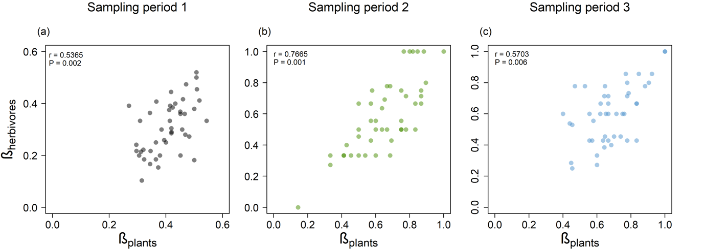
Figure S1. Relationship between species beta-diversity of plants (β_{plants}) and herbivores (β_{herbivores}) for each sampling period. Correlation coefficients (r) and significance (P calculated using Mantel tests) are also shown.
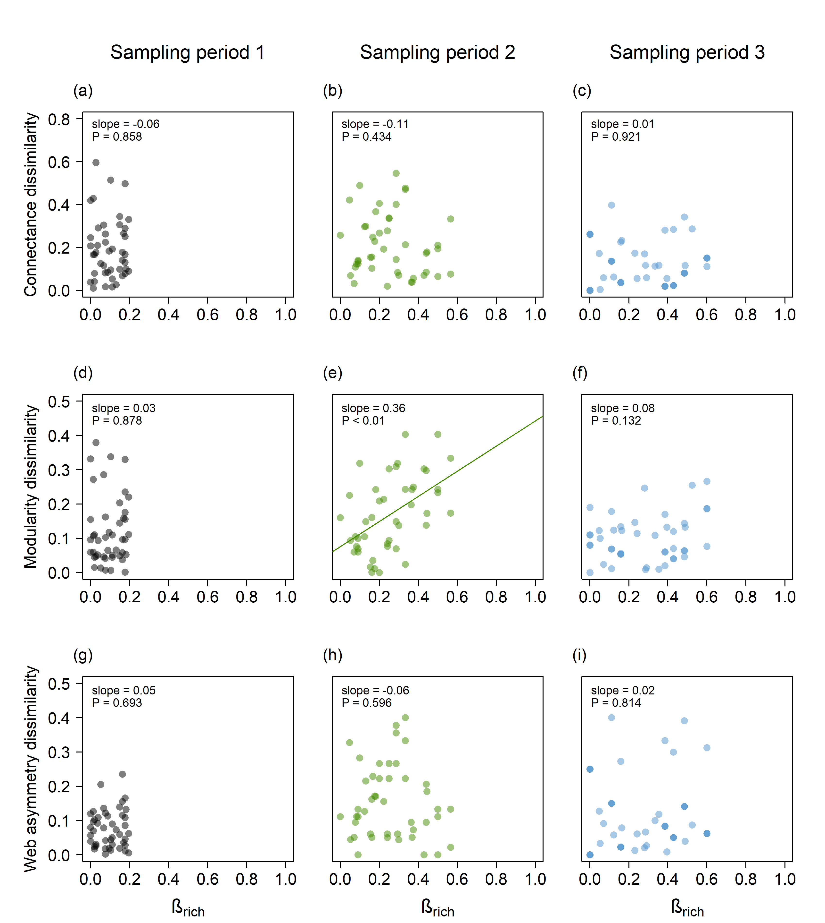
Figure S2. Relationship between richness differences (β_{rich}) and the dissimilarities in network structure measured by (a-c) connectance, (d-f) modularity and (g-i) web asymmetry. Points represent pairs of networks in each period. Solid lines represent significant relationships. Slopes and P values are also shown.

