Softimpute – Canary Islands analysis

Working code: softimpute_bootstrap.R in the softimpute github repository
Yielded a very large csv files for the pollination networks inthe Canary Islands (in the Google Drive Research folder), with 100 iterations for removing zeros.
The amount of removed zeros is equal to the amount of ones removed (which are 20% of ones). Otherwise the amount of removed zeros is huge.
Analysis code: brazil_canary_analysis.R in the github repository.

Results:
For predicting the binary version of these networks
Check if they are for all iterations or just 1!! <- repeated the analysis for all iterations.

K and lambda (tested on 1 iteration)

K = 2 is the best k value out of the 3 that were tested.
Lambda = 0.1 gives a bit better result than the other 2 values but the difference is not great.
The same trends were observed for both Brazil and the Canary Islands; therefore I continued the analysis using only these values of k and lambda.

Canary

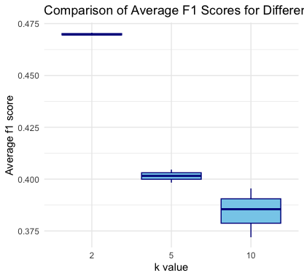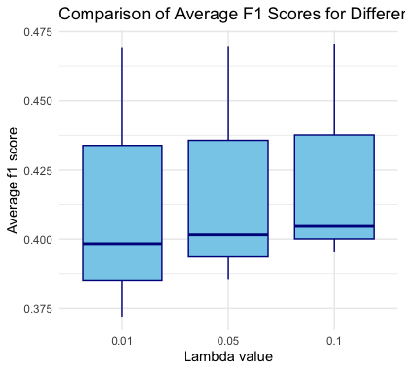

Classification

I tried different ways to classify the predicted values. (these results are for 1 iteration).
Sigmoid = converting the predicted values using sigmoid function, than probabilities over 0.5 are considered links.
Min-max = same but converting to probabilities using min-max function.
Prob > 0 = no conversion to probabilities, whoever has predicted value over 0 is a link.
Sigmoid 0.5 = if the probability based on the sigmoid is other than 0.5, it’s a link.

None of these give “rational” results:
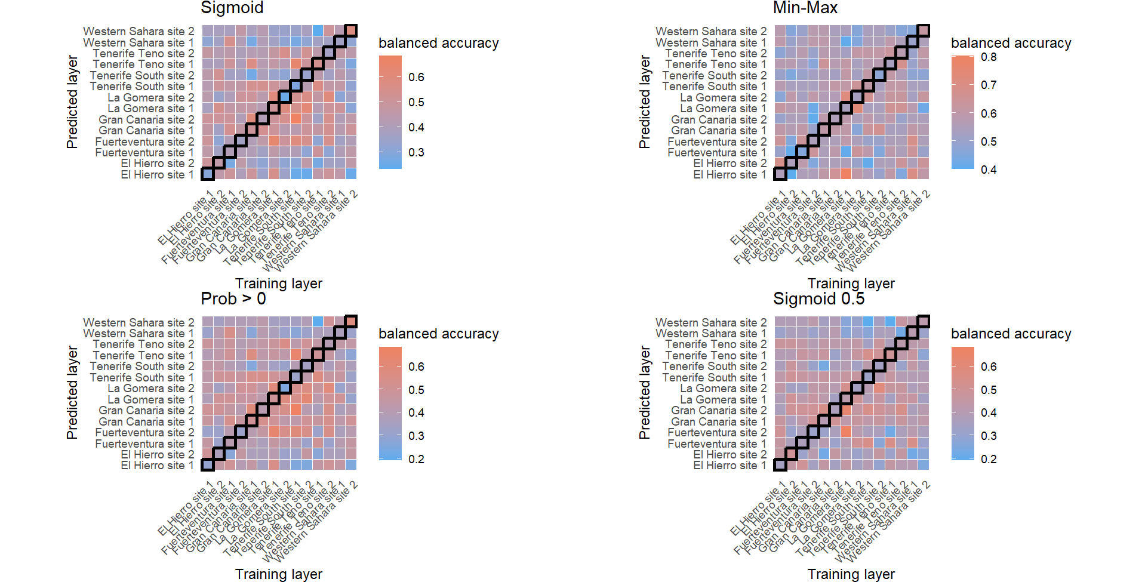for f1 scores:
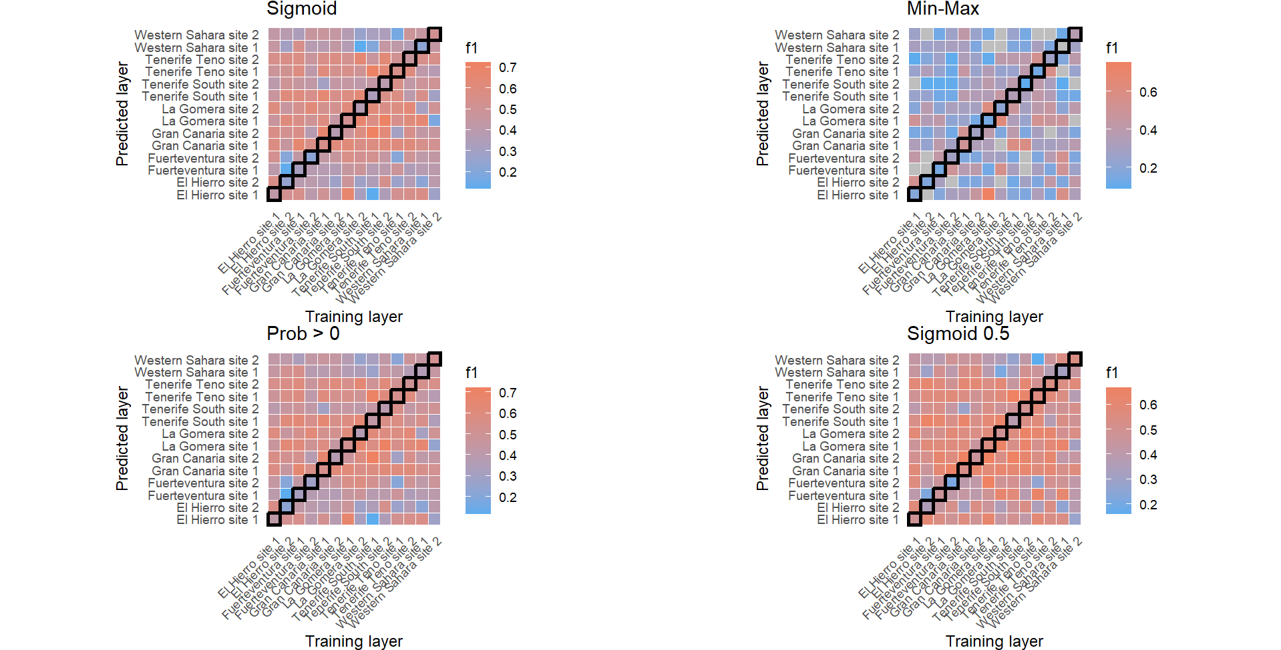the min-max looks like the worse option since it cannot calculate the f1 score in some cases. The sigmoid and prob above 0 have similar results, with higher maximal f1 than sigmoid 0.5 .
Max f1 for sigm and > 0 are the same (checked on 1 iteration in the Canaries): 0.72 .
Average f1 sigm = 0.468, average f1 > 0 = 0.476. pretty much the same. This was tested for one iteration.

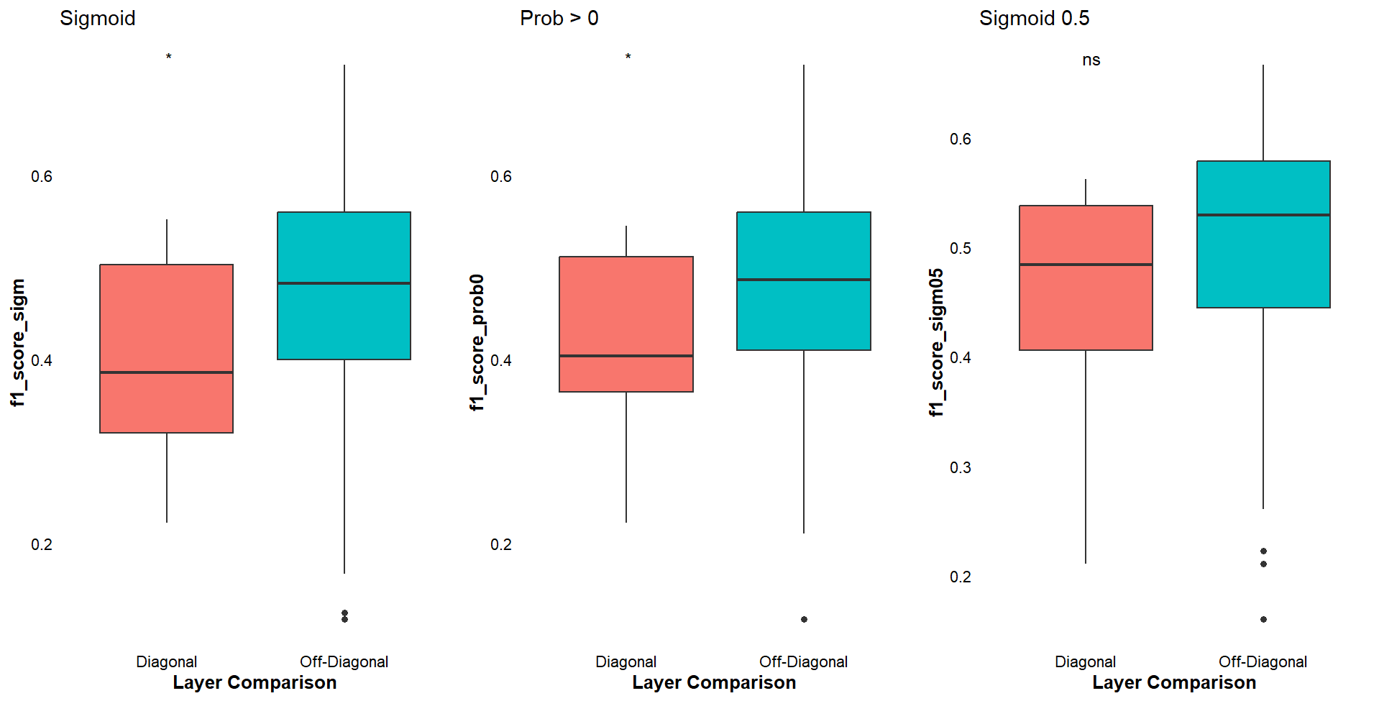

The predictions for the off-diagonals are actually better than for the diagonal.

Iterations
We reduced the number of bootstrapping iterations from 100 to 10 since 100 iterations yield huge csvs.

Layer to layer predictive capacity (all 10 iterations)
Links are considered as ones if sigmoid prob based on the predicted svd value is larger than 0.5 .

The analysis shows what appears to be, at first, non intuitive results.

Check if the results for the 1 off-diagonal are right.

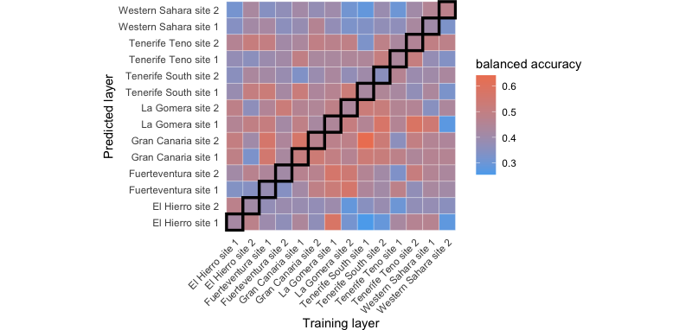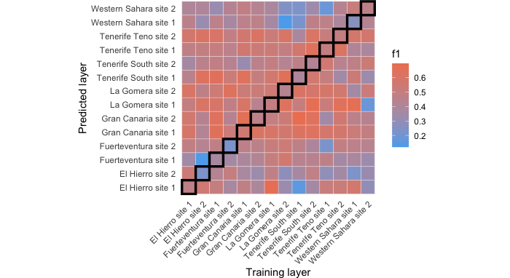
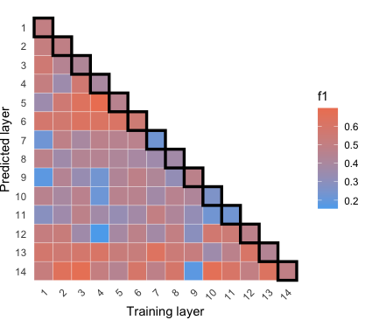is that right?

Checking if the difference between the diagonal and off-diagonals is significant:
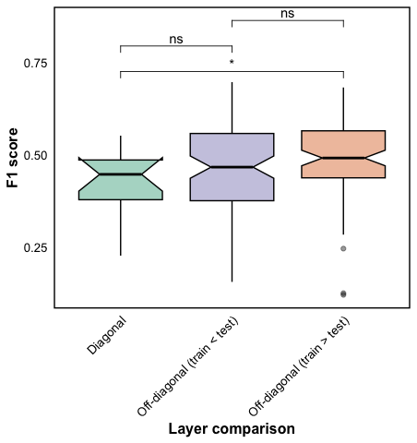
There is a difference. This is a t-test, replace with ANOVA. It shows marginally significant results, that in my opinion is actually meaningful.

Correlation with variables (make sure that you used the same off-diagonal in all)

Geographical distance
All layer-to-layer predictions:

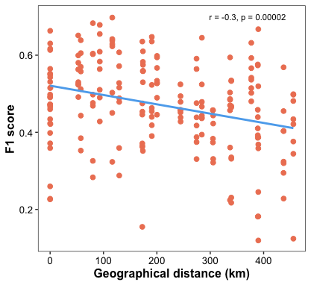

Check n.
Repeated, used only one off-diagonal (the one from the heatmap) + diagonal:
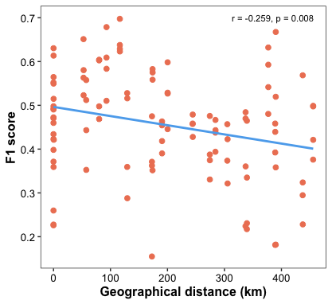

Here the performance is a bit better in comparison to Brazil. We see a distance decay but still the predictive capacity for the diagonal is lower in comparison to the off-diagonals.
יש חשיבות לאילו לינקים מורידים. לכן טוב עשינו כשמיצענו איטרציות.

Check off-diagonal and diagonal separately

Conclusion
This algorithm tells us if adding information from other networks can help us impute links that we have no clue about (because they are also missing from the combined matrix c). The results show that adding information from other layers indeed helps us predicting these links – the off-diagonals are better than the diagonals (the diagonal is no info added).

That’s not due to the increase in matrix size or density when adding interactions (ran this analysis again and got different results for density. Check that there is no mistake):

Size and density of C (the combined matrix with Nas):
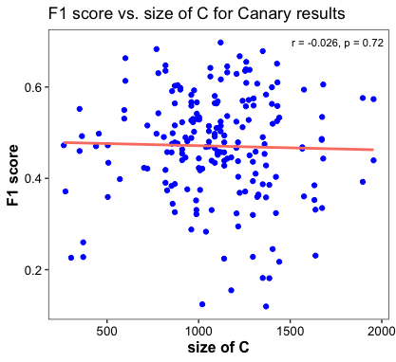
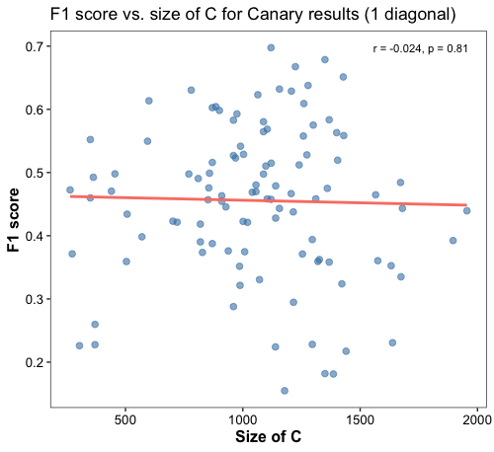
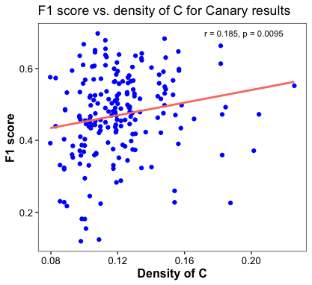

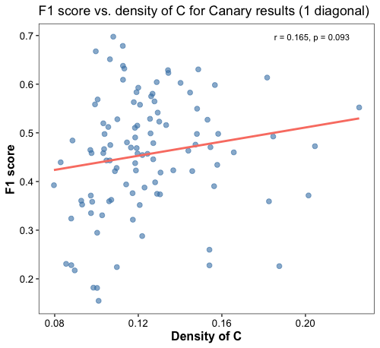
*1 diagonal = off diagonal
להכין פלוטים על facets של: size P, size C, density P, density C
עבור 1 diag+ diag
1 diag no diag

Ask Shai if that’s a conclusion that can go into the thesis. <- Yes
All the trends are the same when using only one off-diagonal.

Similarity in species composition:

Overall Bray-Curtis similarity (all layer-to layer predictions, plants and pollinators combined):

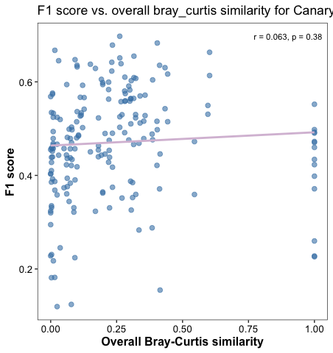

for 1 off-diagonal:
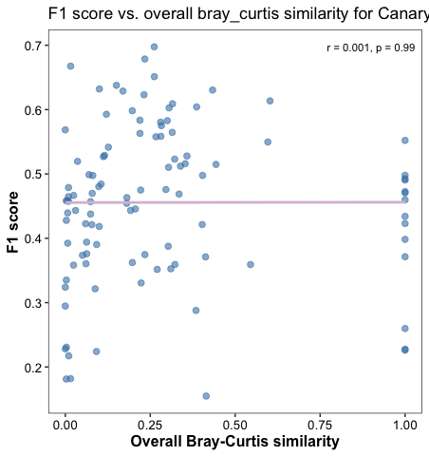

Jaccard:
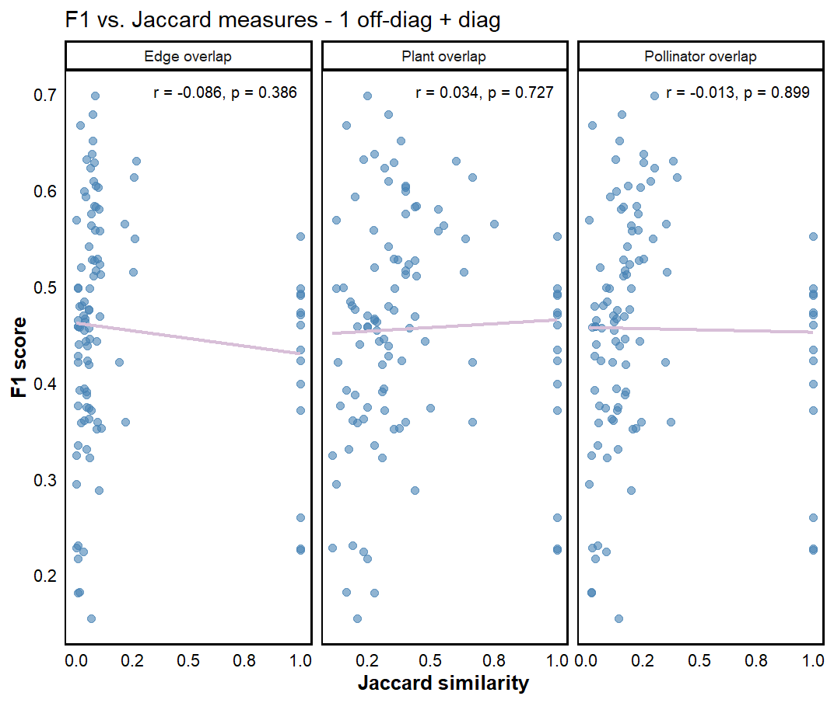
But when we remove the diagonal:

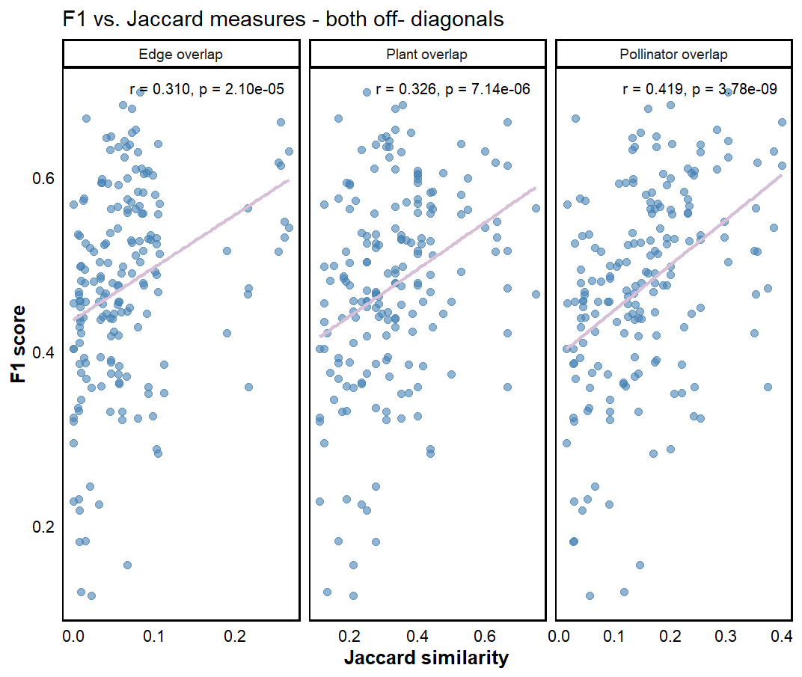
For only 1 off-diagonal (no diagonal):
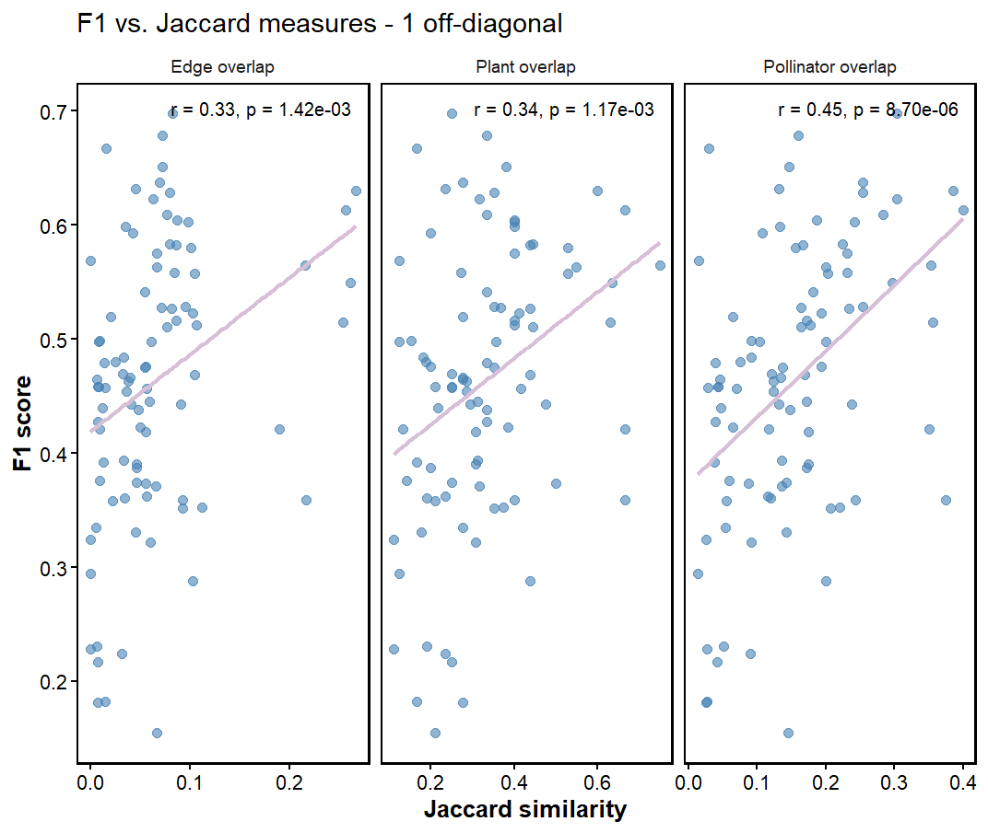
לאחד צירי x בכל הפלוטים ומספר ספרות. להוסיף שנתות.

