Softimpute – Canary Islands analysis

Working code: softimpute_bootstrap.R in the softimpute github repository
Yielded a very large csv files for the pollination networks inthe Canary Islands (in the Google Drive Research folder), with 100 iterations for removing zeros.
The amount of removed zeros is equal to the amount of ones removed (which are 20% of ones). Otherwise the amount of removed zeros is huge.
Analysis code: brazil_canary_analysis.R in the github repository.

Results:
For predicting the binary version of these networks
Check if they are for all iterations or just 1!! <- repeated the analysis for all iterations.

K and lambda (tested on 1 iteration)

K = 2 is the best k value out of the 3 that were tested.
Lambda = 0.1 gives a bit better result than the other 2 values but the difference is not great.
The same trends were observed for both Brazil and the Canary Islands; therefore I continued the analysis using only these values of k and lambda.

Canary

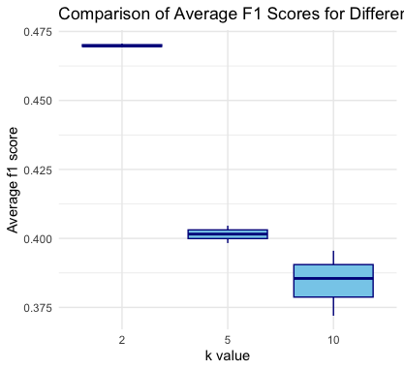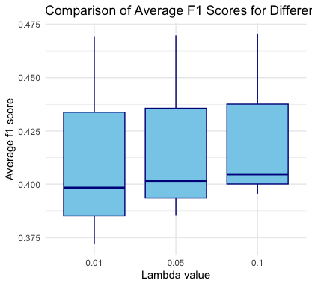

Classification

I tried different ways to classify the predicted values. (these results are for 1 iteration).
Sigmoid = converting the predicted values using sigmoid function, than probabilities over 0.5 are considered links.
Min-max = same but converting to probabilities using min-max function.
Prob > 0 = no conversion to probabilities, whoever has predicted value over 0 is a link.
Sigmoid 0.5 = if the probability based on the sigmoid is other than 0.5, it’s a link.

None of these give “rational” results:
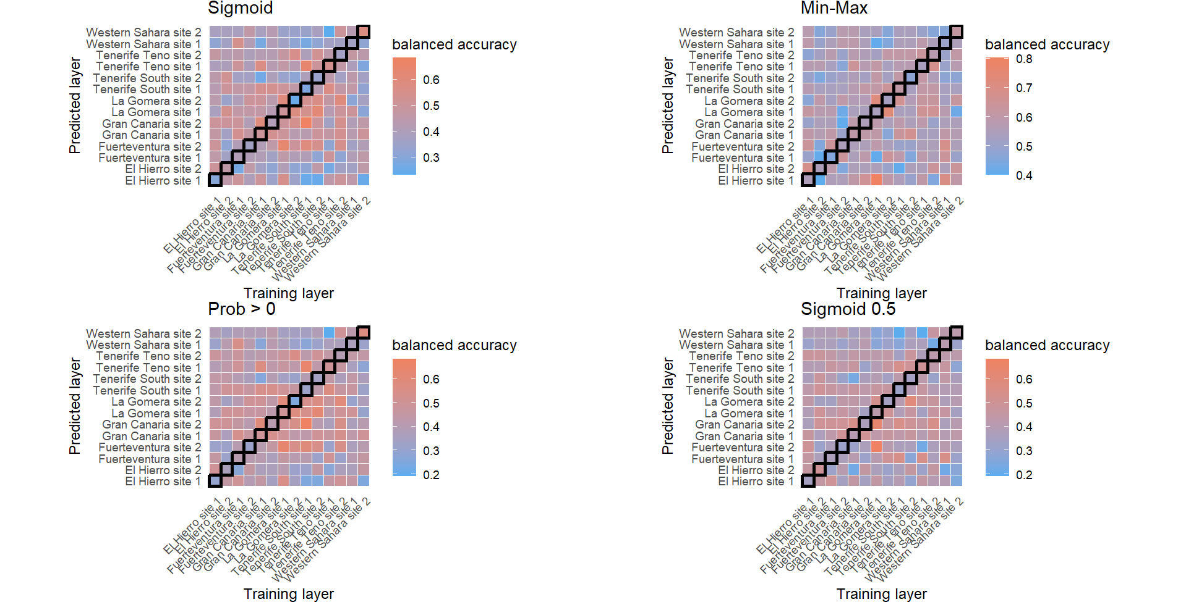for f1 scores:
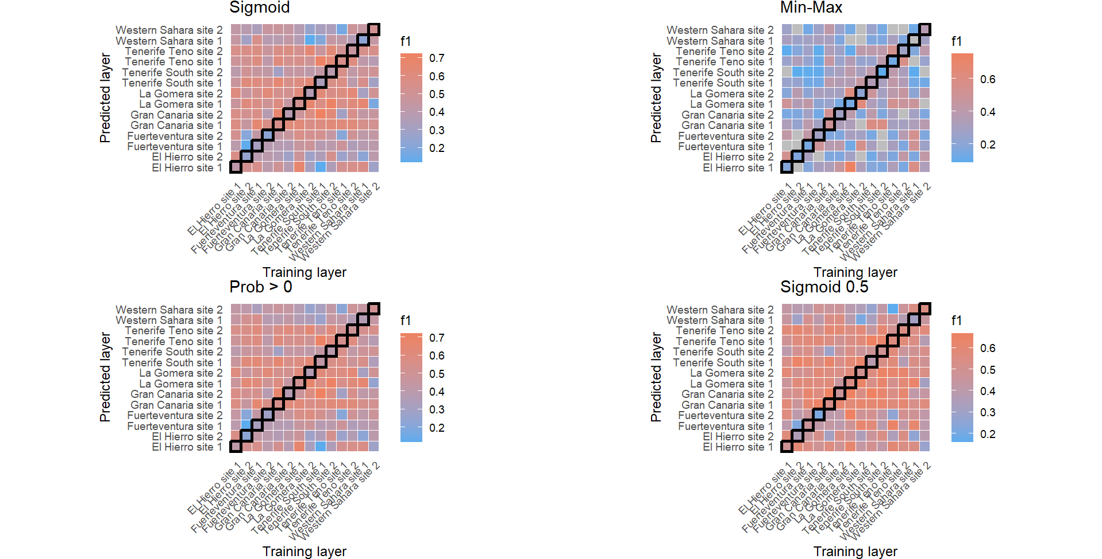the min-max looks like the worse option since it cannot calculate the f1 score in some cases. The sigmoid and prob above 0 have similar results, with higher maximal f1 than sigmoid 0.5 .
Max f1 for sigm and > 0 are the same (checked on 1 iteration in the Canaries): 0.72 .
Average f1 sigm = 0.468, average f1 > 0 = 0.476. pretty much the same. This was tested for one iteration.

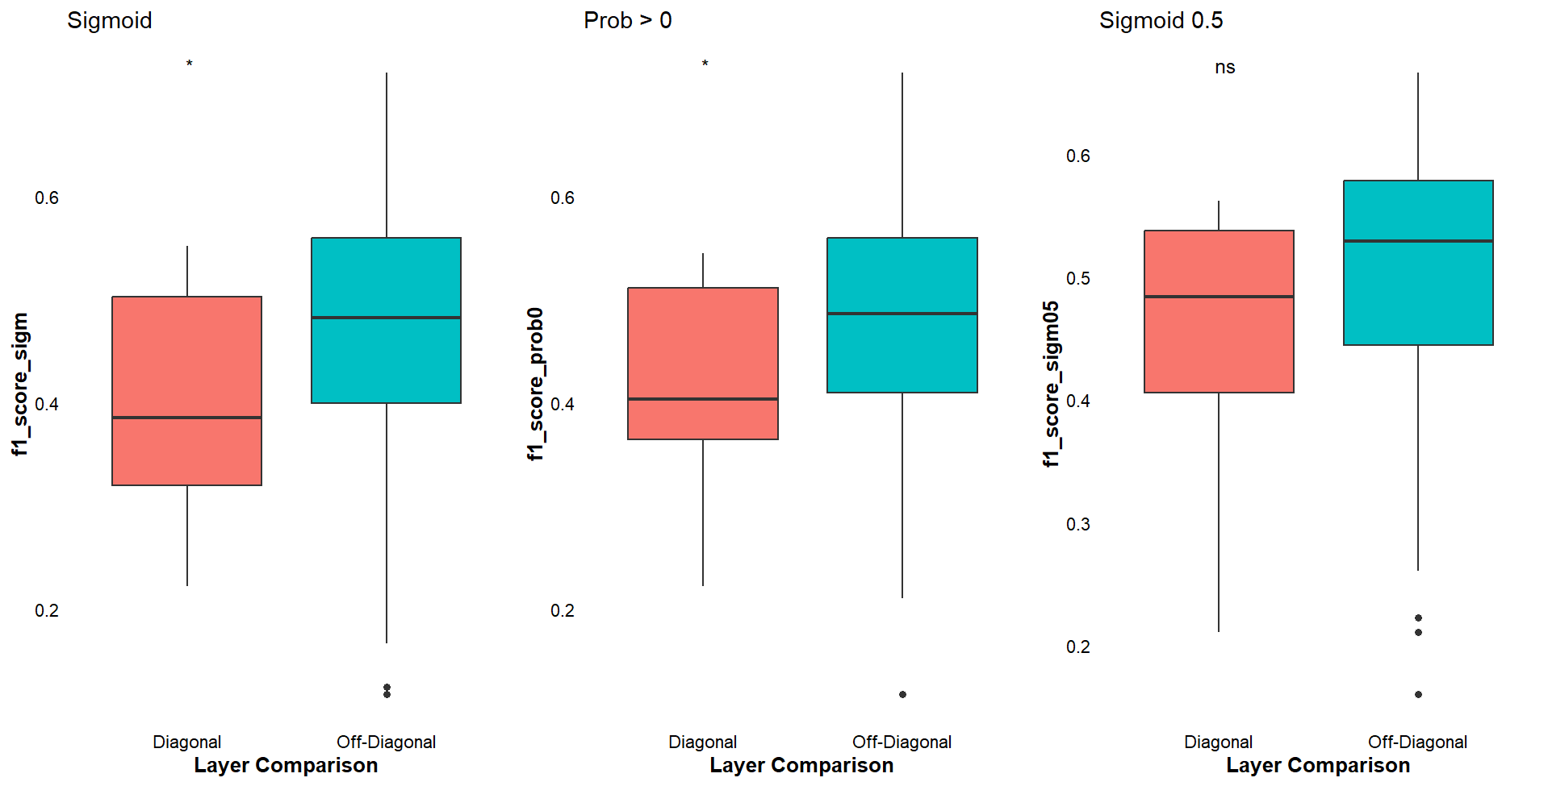

The predictions for the off-diagonals are actually better than for the diagonal.

Iterations
We reduced the number of bootstrapping iterations from 100 to 10 since 100 iterations yield huge csvs.

Layer to layer predictive capacity (all 10 iterations)
Links are considered as ones if sigmoid prob based on the predicted svd value is larger than 0.5 .

The analysis shows what appears to be, at first, non intuitive results.

Check if the results for the 1 off-diagonal are right.
Site scale:

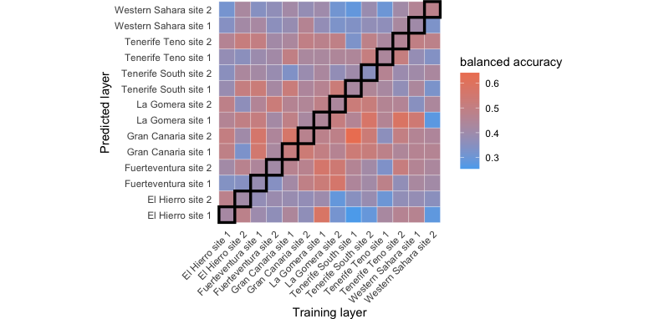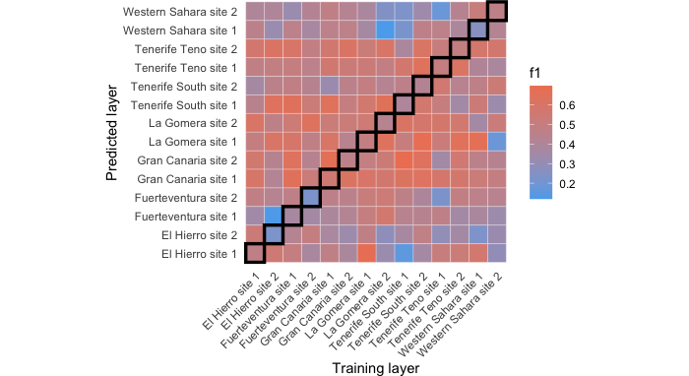
island scale:
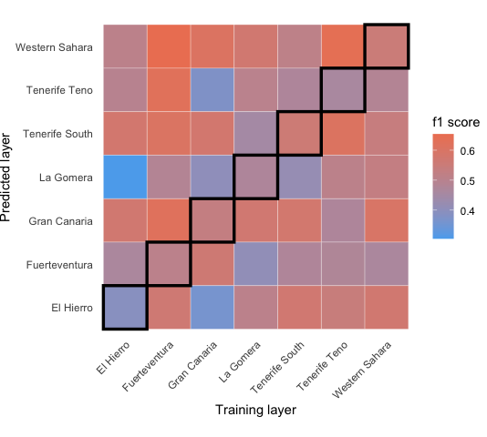
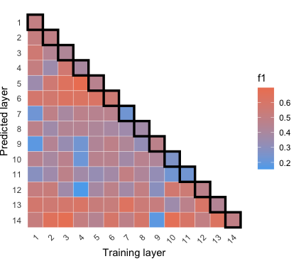is that right?

Checking if the difference between the diagonal and off-diagonals is significant:
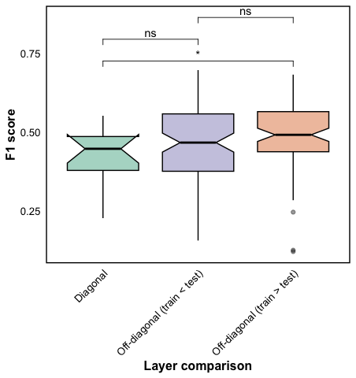
> anova_result <- aov(f1_score ~ layer_comparison, data = result_table)
> summary(anova_result)
Df Sum Sq Mean Sq F value Pr(>F)
layer_comparison 2 0.0802 0.04010 3.021 0.0511 .
Residuals 193 2.5624 0.01328
---
Signif. codes: 0 ‘***’ 0.001 ‘**’ 0.01 ‘*’ 0.05 ‘.’ 0.1 ‘ ’ 1

There is a difference. This is a t-test, replace with ANOVA. It shows marginally significant results, that in my opinion is actually meaningful.

Island scale:
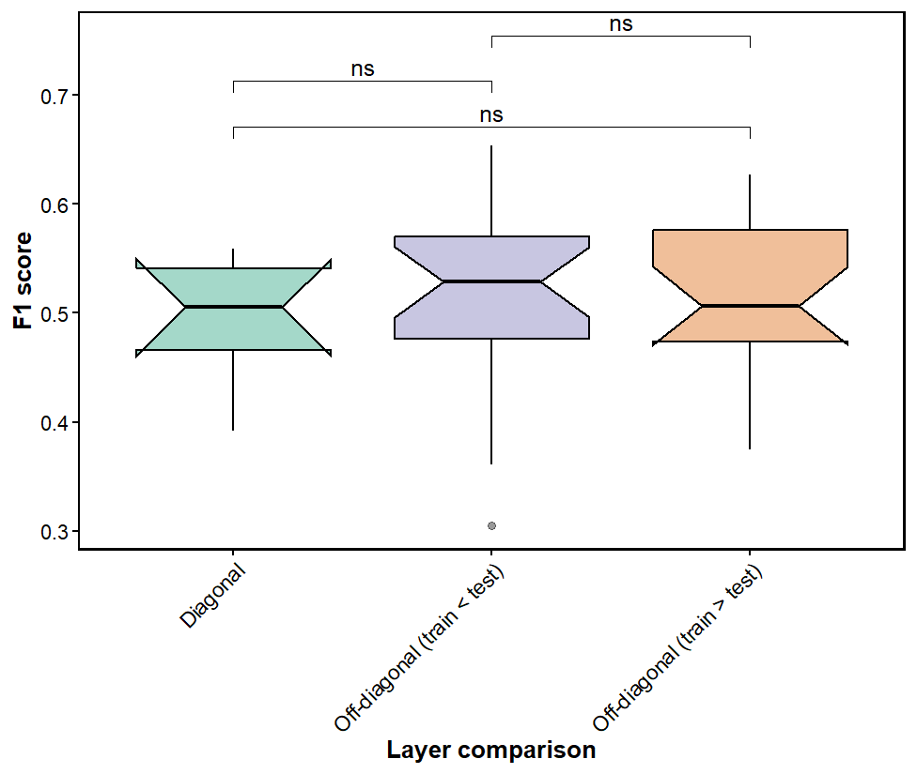
> anova_result <- aov(f1_score ~ layer_comparison, data = result_table)
> summary(anova_result)
Df Sum Sq Mean Sq F value Pr(>F)
layer_comparison 2 0.00405 0.002027 0.33 0.72
Residuals 46 0.28225 0.006136

Correlation with variables (make sure that you used the same off-diagonal in all)

Geographical distance
All layer-to-layer predictions (site scale):

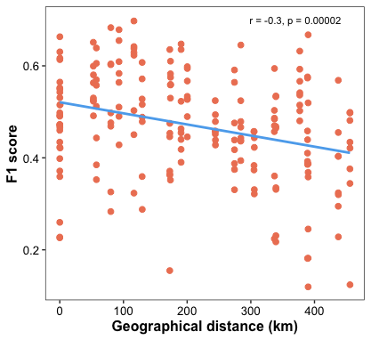

Check n.

Island scale (off-diags and diag):
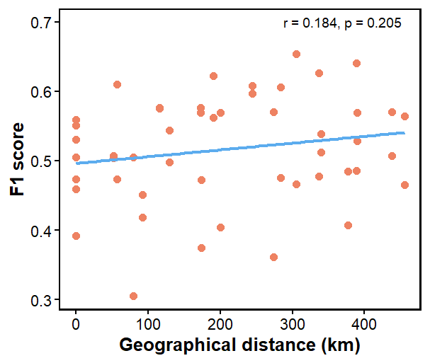
Pumpumpummmm
No significant relationship, the tendency is reverse decay

Repeated for site scale, used only one off-diagonal (the one from the heatmap) + diagonal:
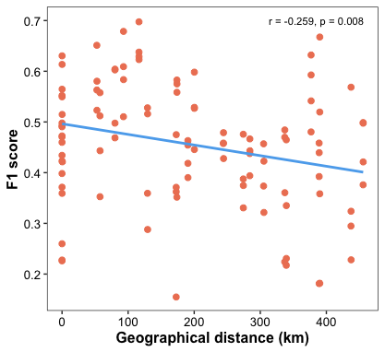

Here the performance is a bit better in comparison to Brazil. We see a distance decay but still the predictive capacity for the diagonal is lower in comparison to the off-diagonals.
יש חשיבות לאילו לינקים מורידים. לכן טוב עשינו כשמיצענו איטרציות.

Check off-diagonal and diagonal separately

Conclusion
This algorithm tells us if adding information from other networks can help us impute links that we have no clue about (because they are also missing from the combined matrix c). The results show that adding information from other layers indeed helps us predicting these links – the off-diagonals are better than the diagonals (the diagonal is no info added).

That’s not due to the increase in matrix size or density when adding interactions (ran this analysis again and got different results for density. Check that there is no mistake):

Size and density of C (the combined matrix with Nas):
(I looked at only 1 off-diagonal since size C is the same for both and I wanted to be consistent with the other features – we focus on added information from other layers)
Site scale:
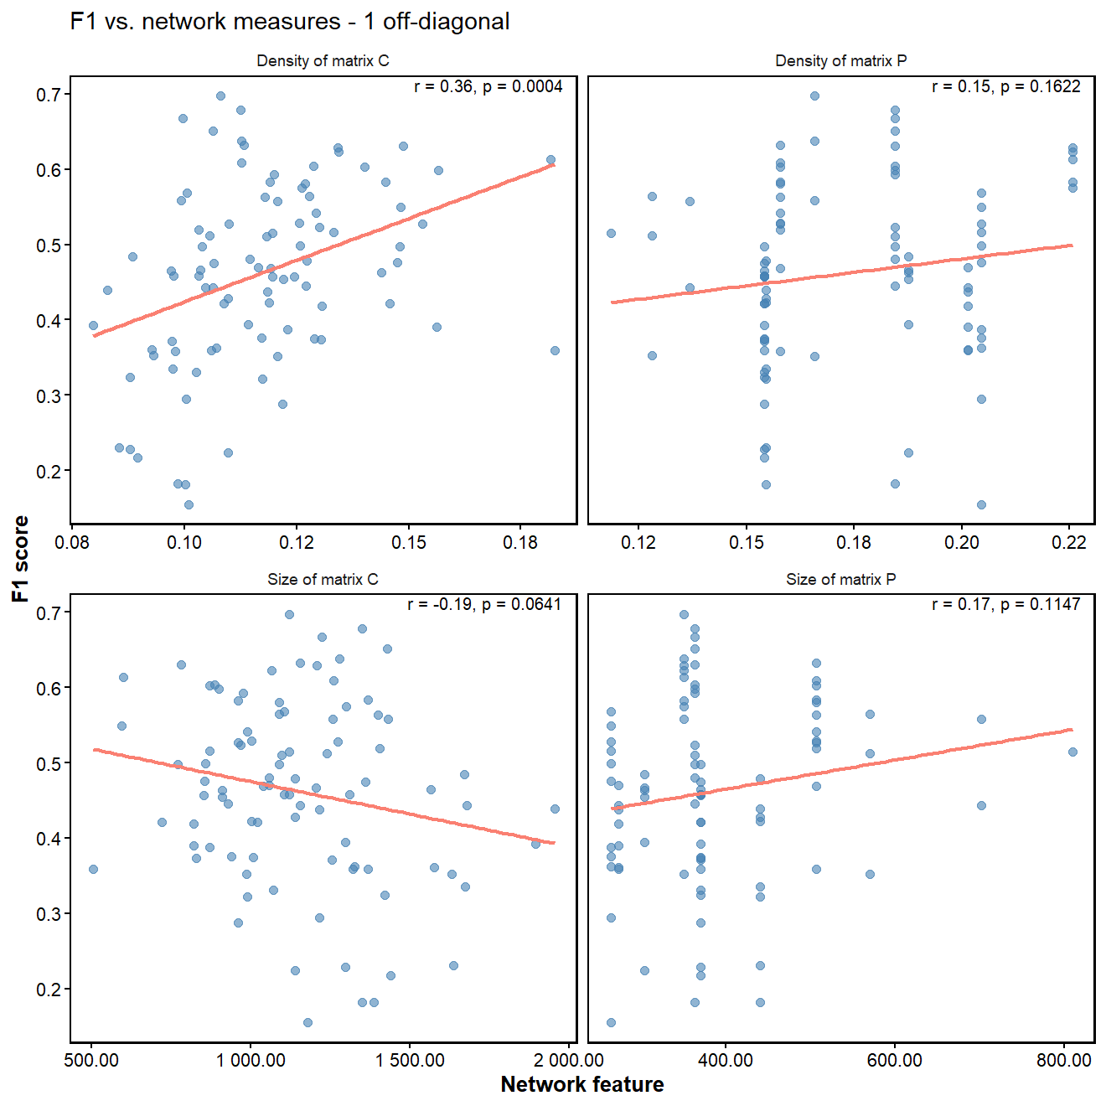
Island scale:
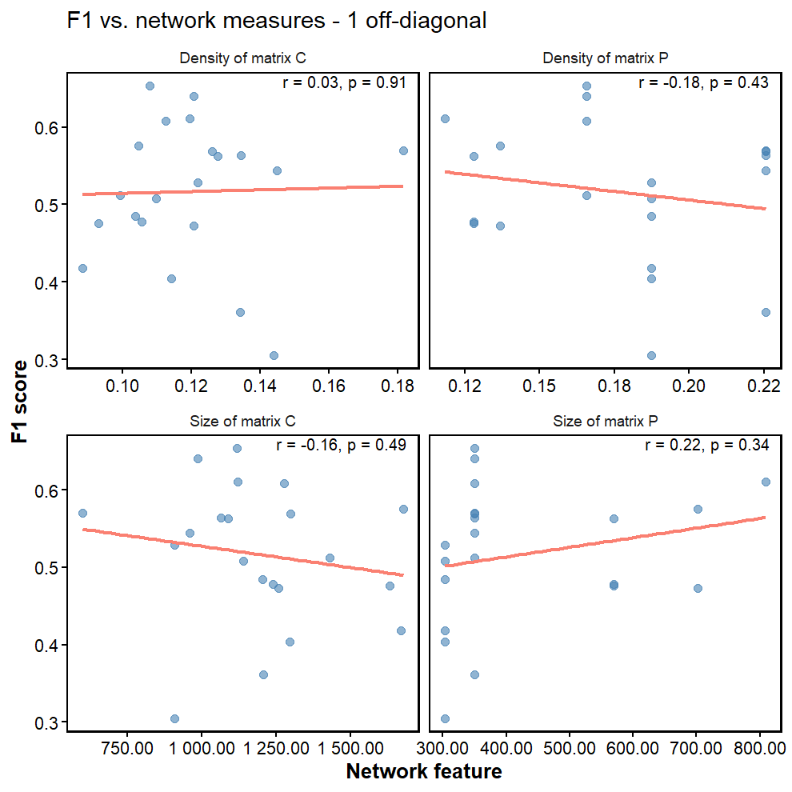

Ask Shai if that’s a conclusion that can go into the thesis. <- Yes
All the trends are the same when using only one off-diagonal.
The results of the evaluators are average of all 10 iterations.

Similarity in species composition:
Site scale

Overall Bray-Curtis similarity (all layer-to layer predictions, plants and pollinators combined):

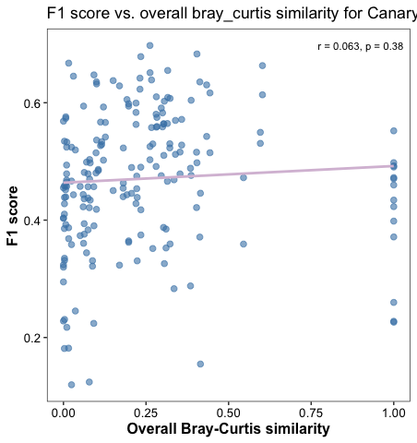

for 1 off-diagonal+diagonal:
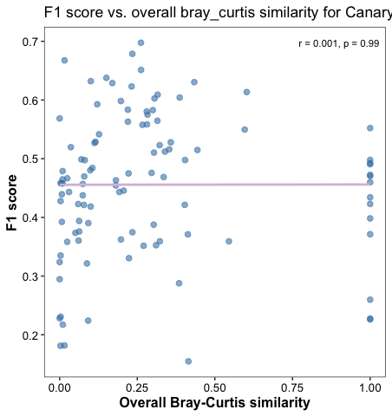

Jaccard:
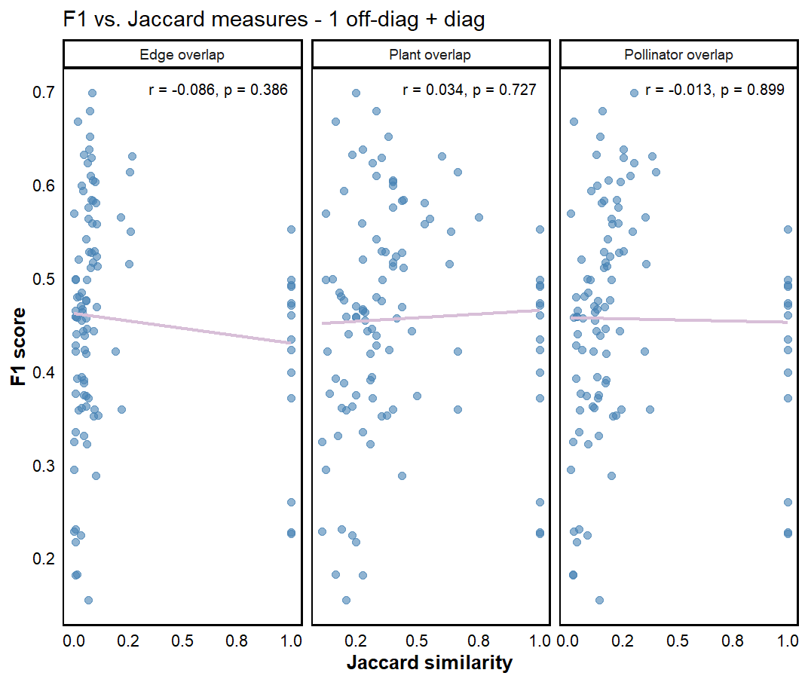
But when we remove the diagonal:

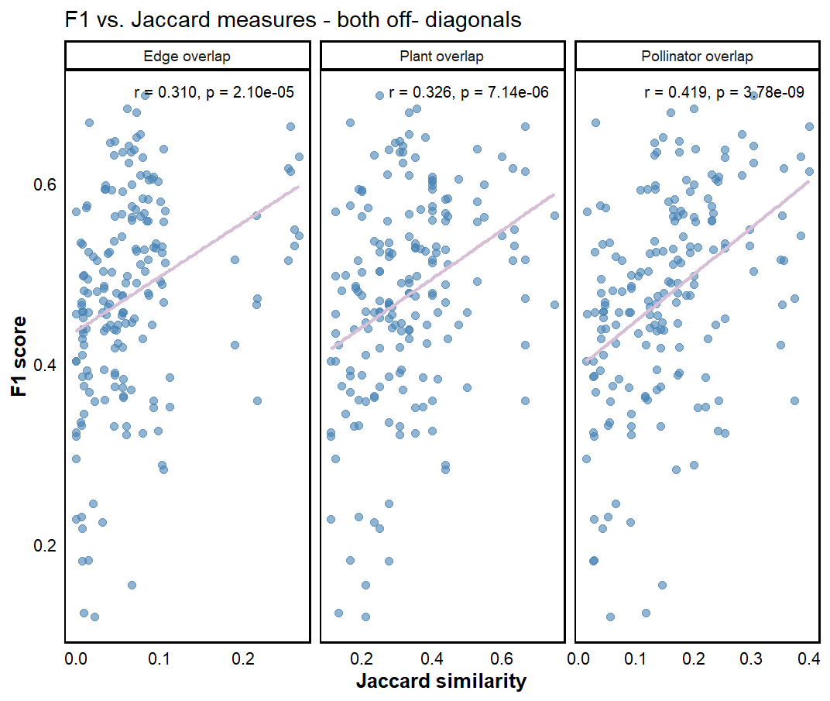
For only 1 off-diagonal (no diagonal):
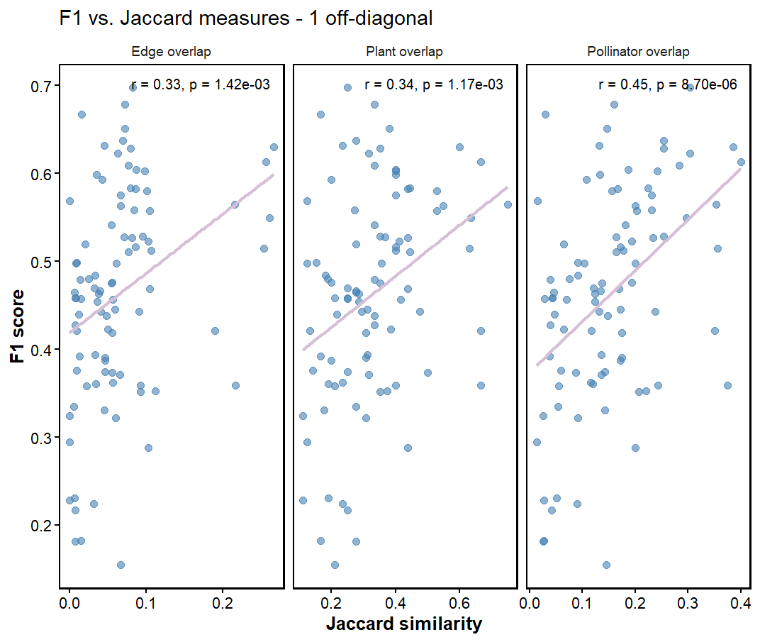
לאחד צירי x בכל הפלוטים ומספר ספרות. להוסיף שנתות.

Island scale:
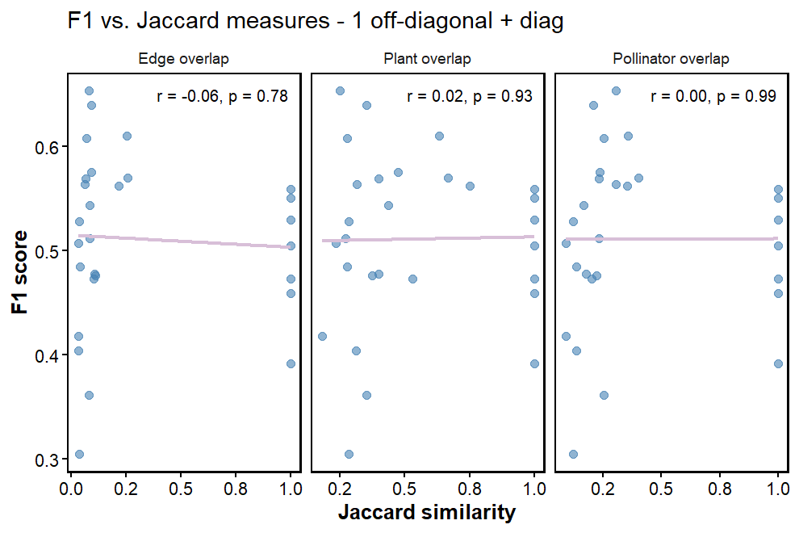
Remove the diagonal:
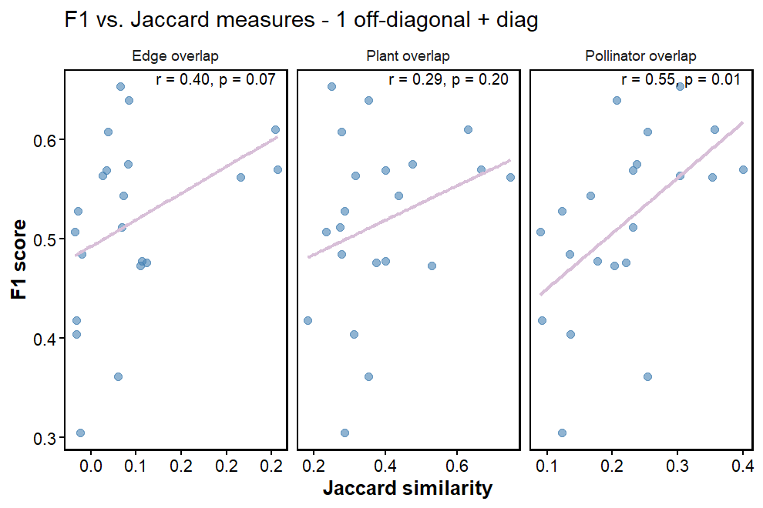
Predictive capacity increases when we use data from other layers that are similar in their species composition.

Using predictions for weighted interactions
Checking relationship of sigmoid predicted values with original interaction weights (only best k and lambda):
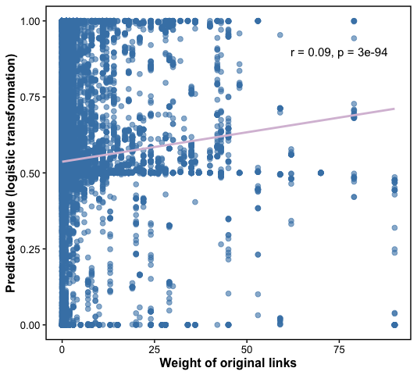
Average Pearson’s correlation of the iterations for each train and test layer combination between the sigmoid predicted values and original weights:
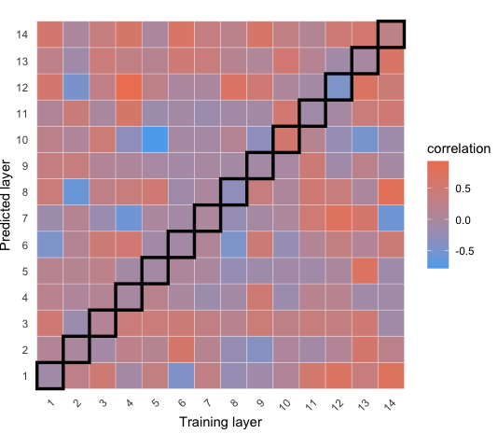
Sometimes there is a strong correlation, especially positive correlation, and there is a variance according to the instance.

Partner fidelity
Here iterations are not averaged. Results for only one off-diagonal (no diagonal). The results are similar when adding the diagonal. Do it for both off-diagonals. Might be wrong, check the code

Updated: partner fidelity was calculated for 1 iteration based on existing links in the diagonal. The correlation needs to be calculated for diagonal and off-diagonals (together and separately).
Results – not updated (site scale):
Plants:
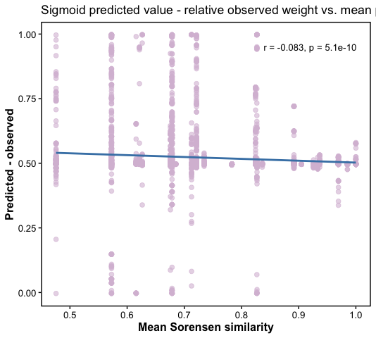
With diagonal:
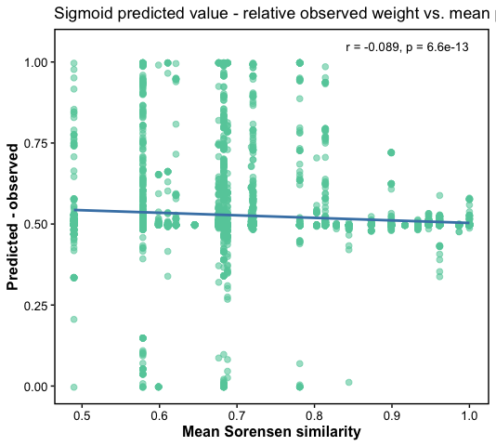
The variance in predictions is decreasing with higher partner fidelity but this may arise from sampling size.
Island scale (one off-diagonal):
All iterations, island scale, original links =1+0, off diagonals and diagonals
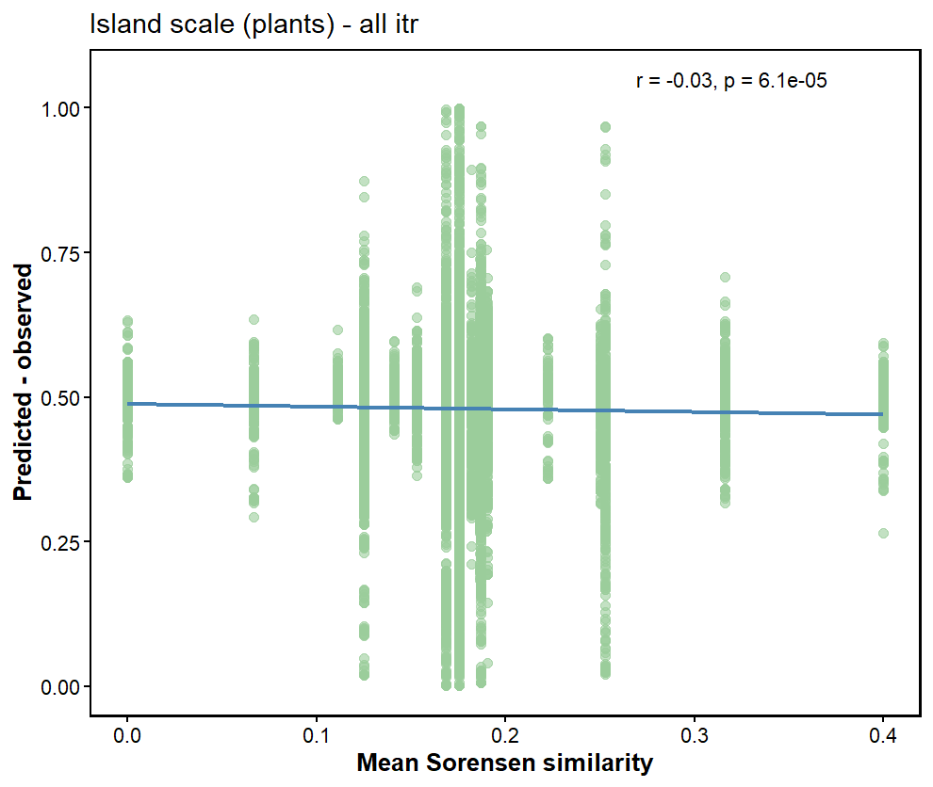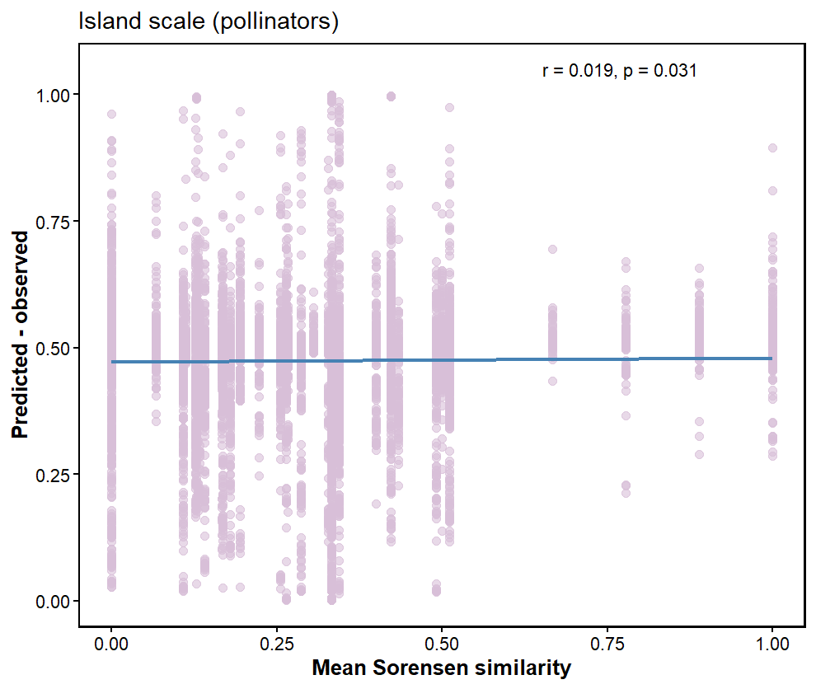
Results are almost the same when removing the diagonal:
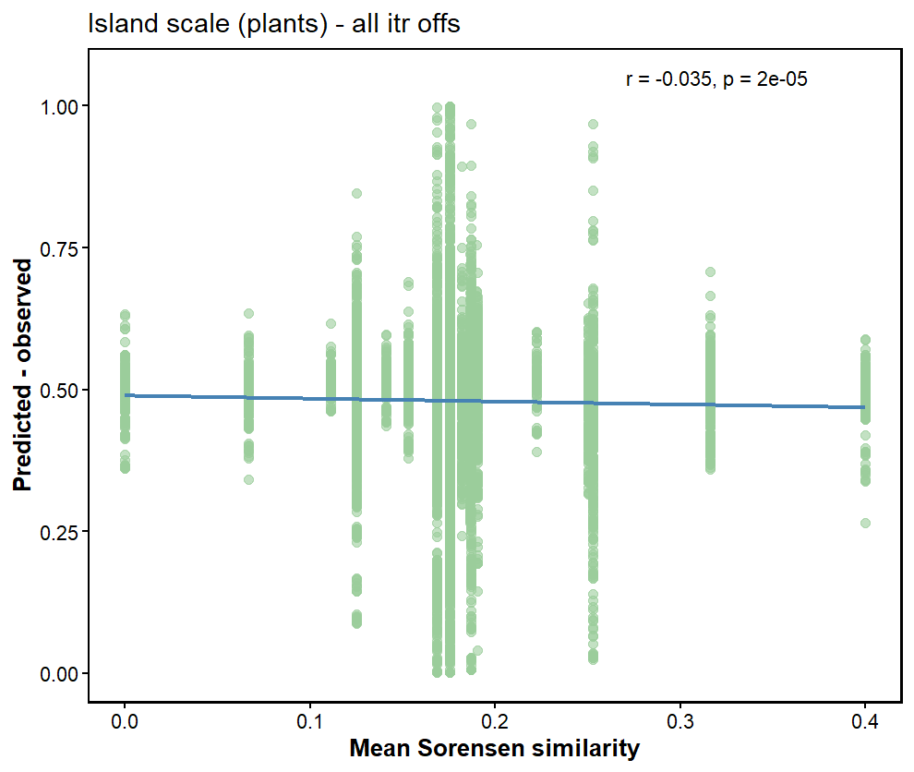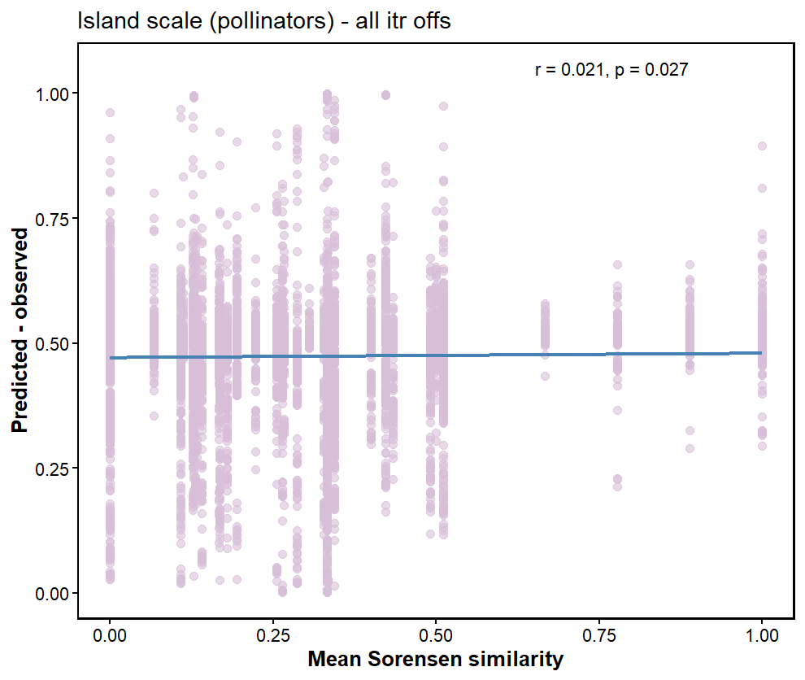
For the off-diagonals, when looking at 1 iteration the trends are the same but not significant:
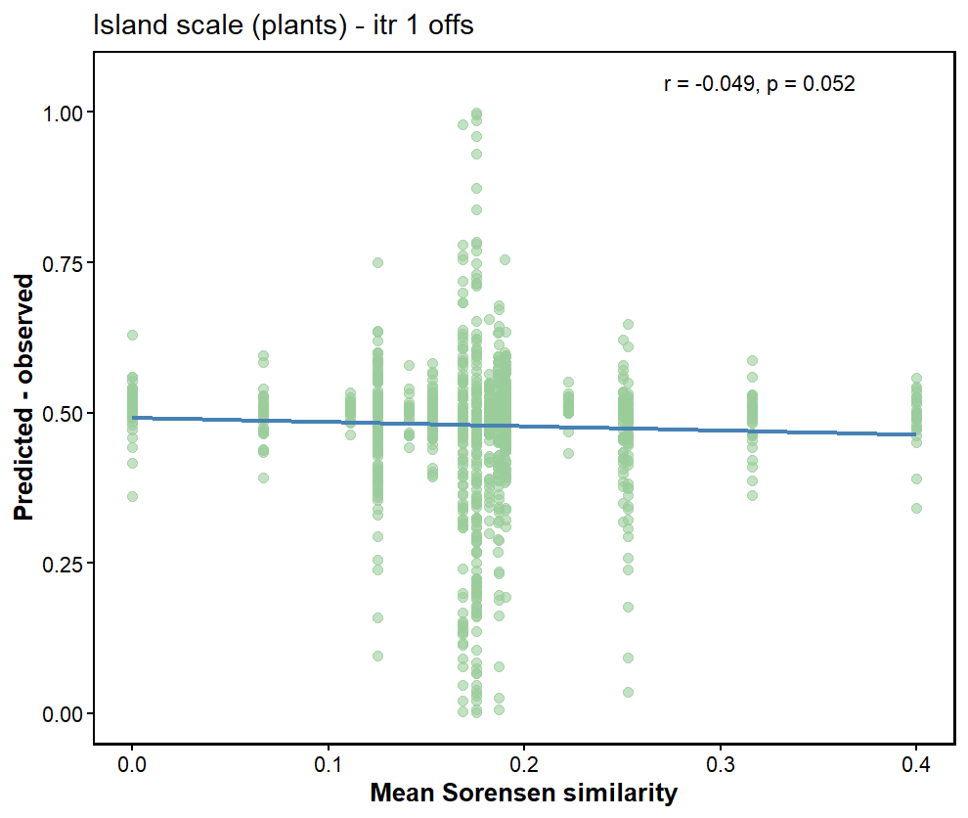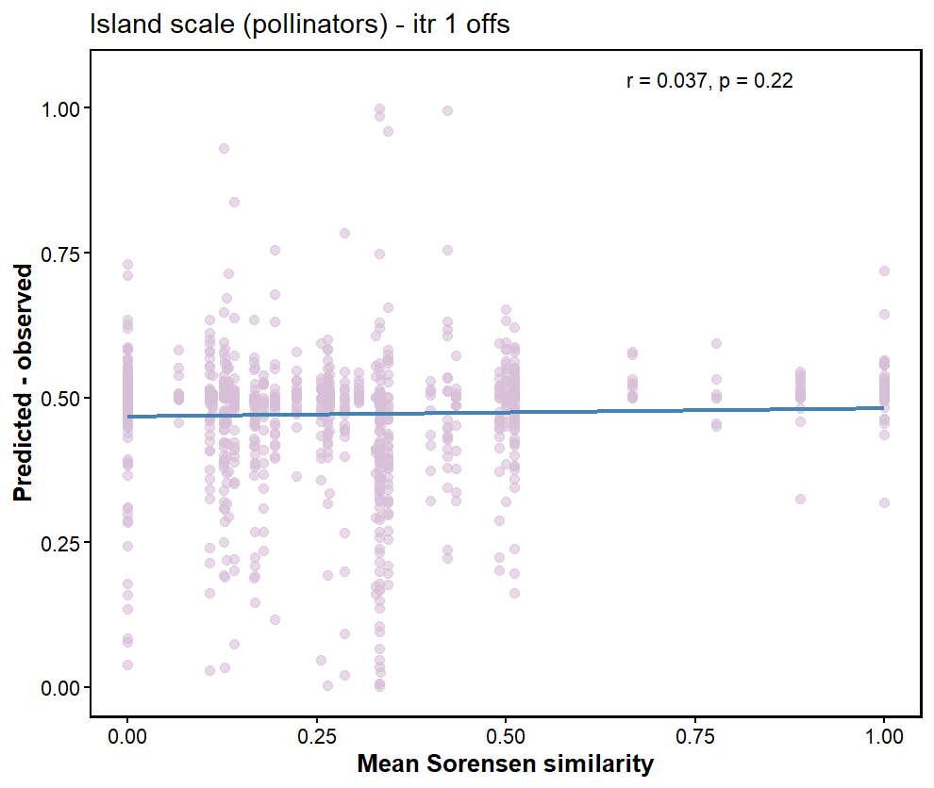
When looking at the correlations in different iterations, in some cases the cor is positive, sometimes negative, for some cases significant and in others not (table “pollinator_fidelity_itr_corr.csv”). So we need to average the iterations.
Mean partner fidelity (island scale):
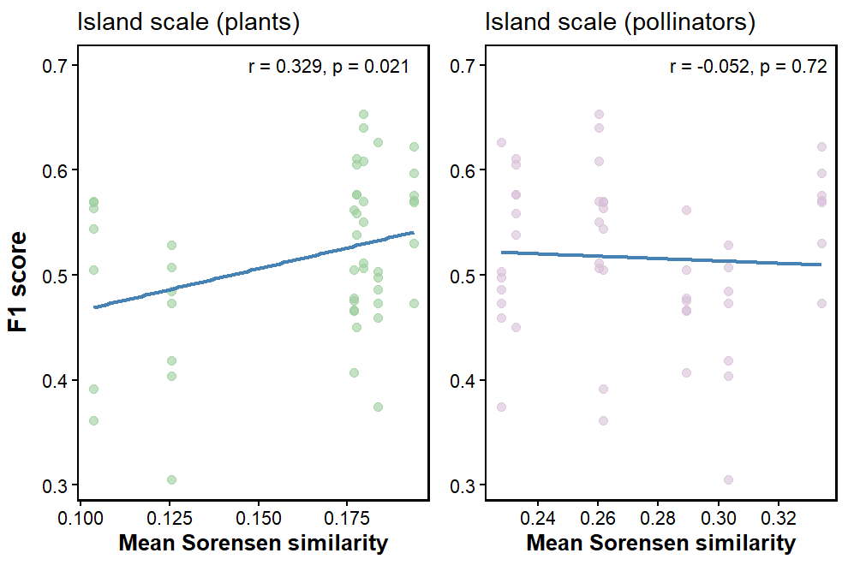
Predictive performance tends to increase with increasing average partner fidelity of plants but slightly decreased with increasing partner fidelity of pollinators

20 most significant interactions that were not observed (original links == 0) and have sigmoid observed value larger than 0.5:
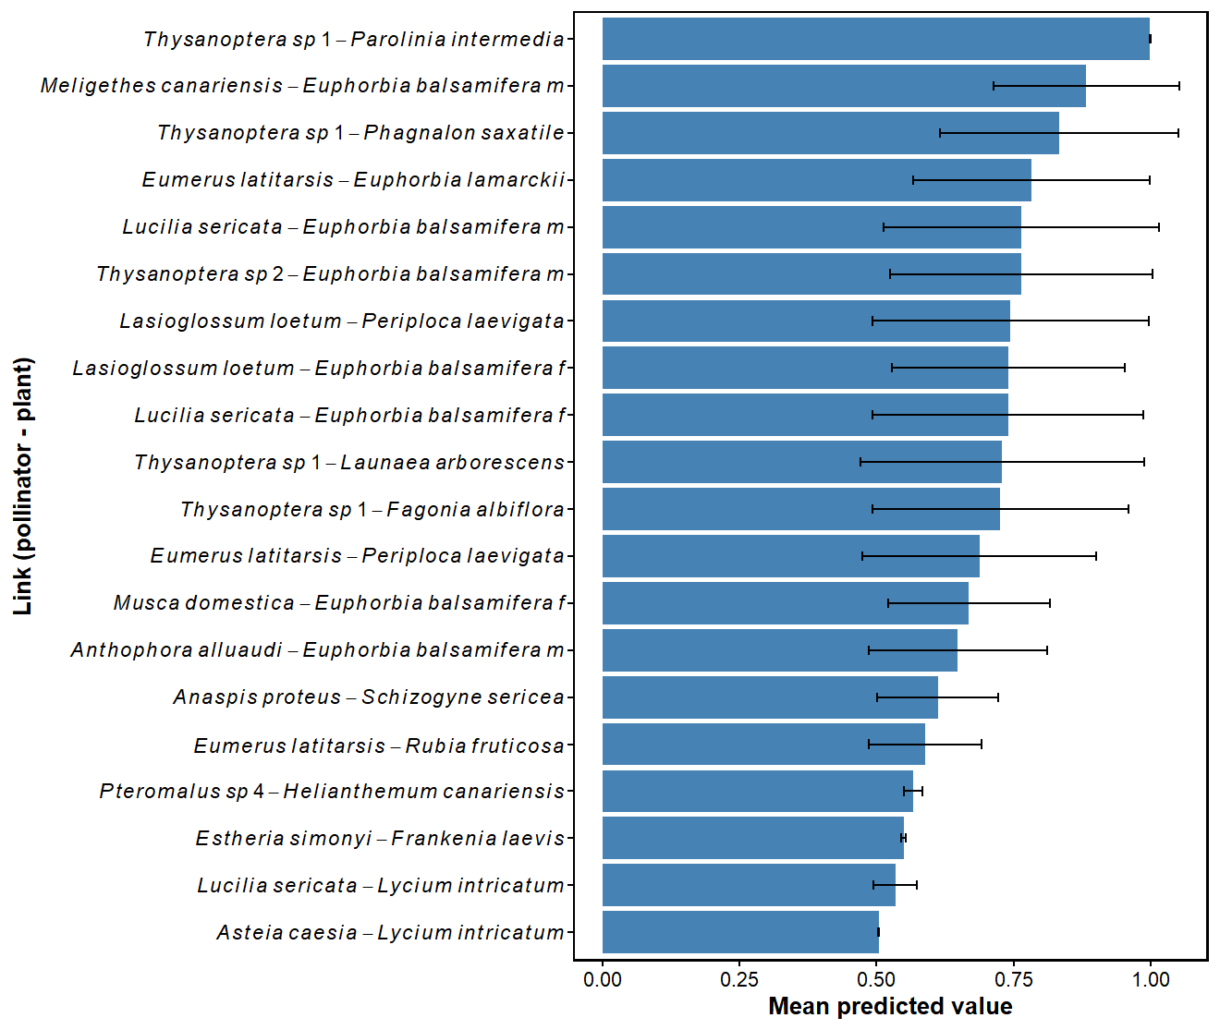
This is based on the weighted data, taking into consideration all layer combinations and iterations. Only interactions that appear in the data enough times to conduct a t-test were taken into consideration in the analysis.
This is based on the binary-based predictions:
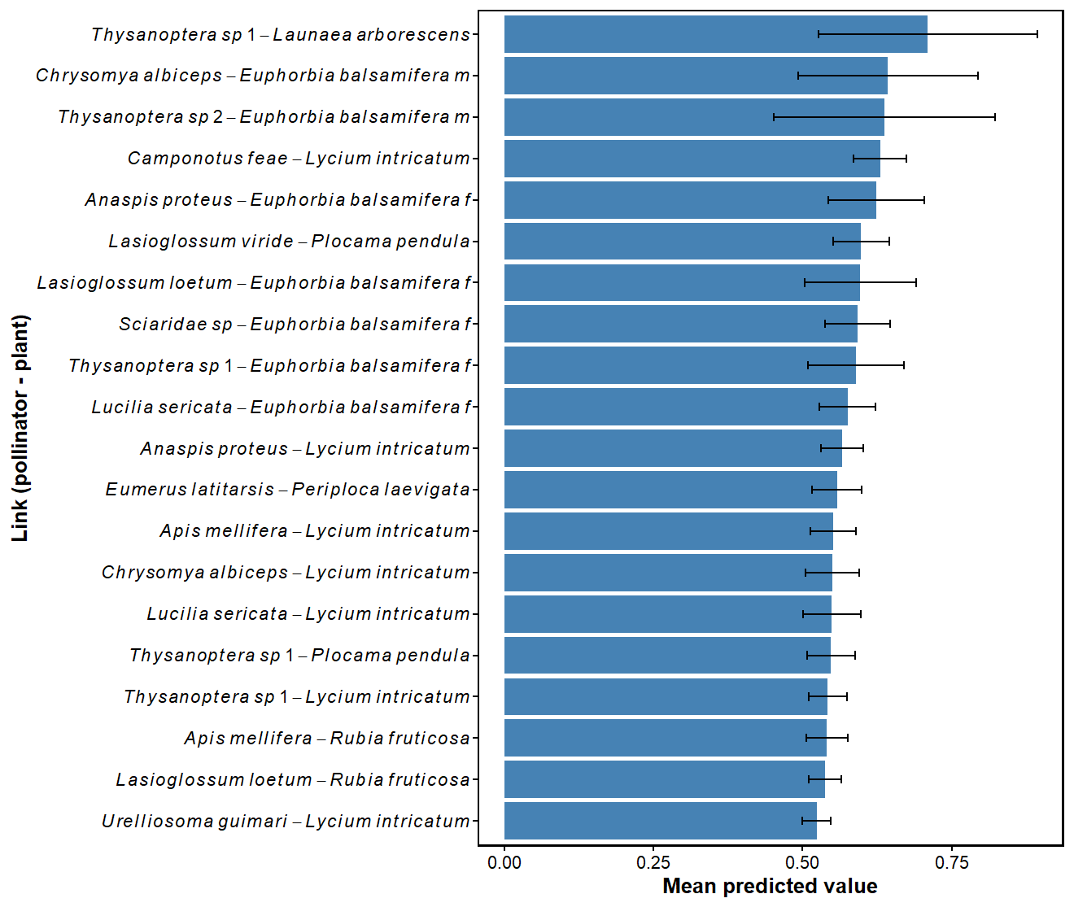

There is a difference between the probable links predicted with binary and weighted data:
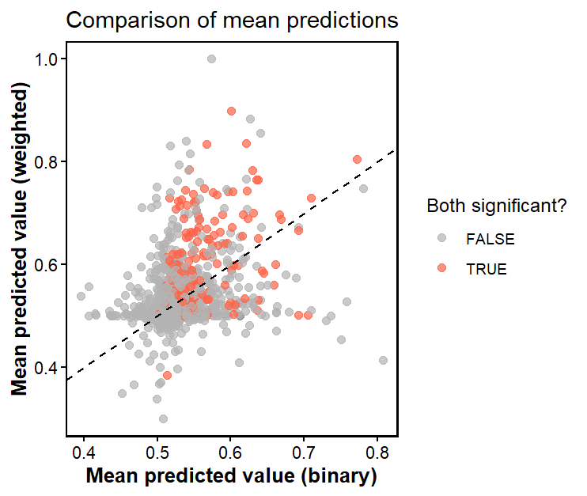

Try to validate with Web of Life database
Check what species are concentrated around pred-obs = 0
Check correlation with degree.

Comparing scales
I used Wilcoxon’s test if the distributions were not normal and t-tests otherwise
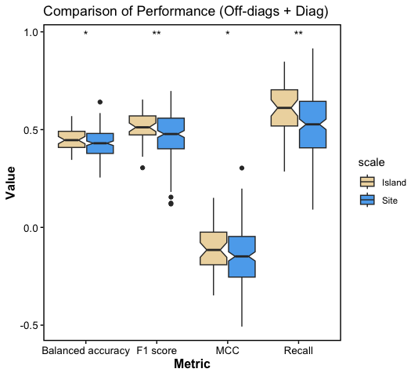

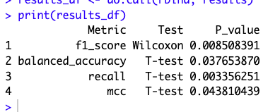

Only off-diagonals:
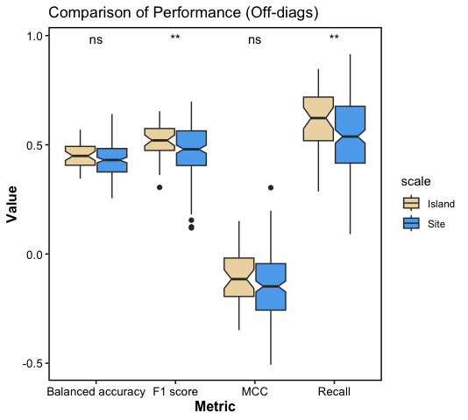
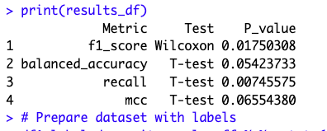

Diagonal:
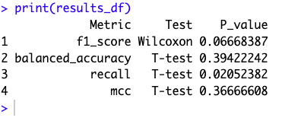
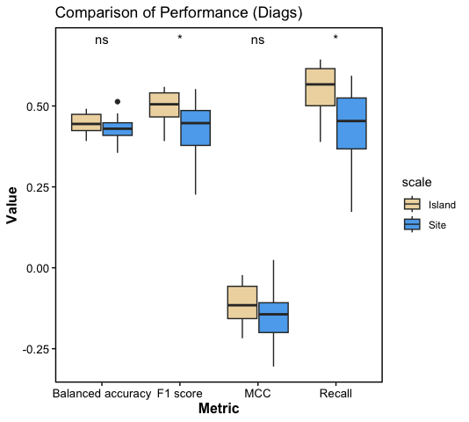


the predictions for island scale tend to be better.

Island scale: autocorrelation between explanatory variables
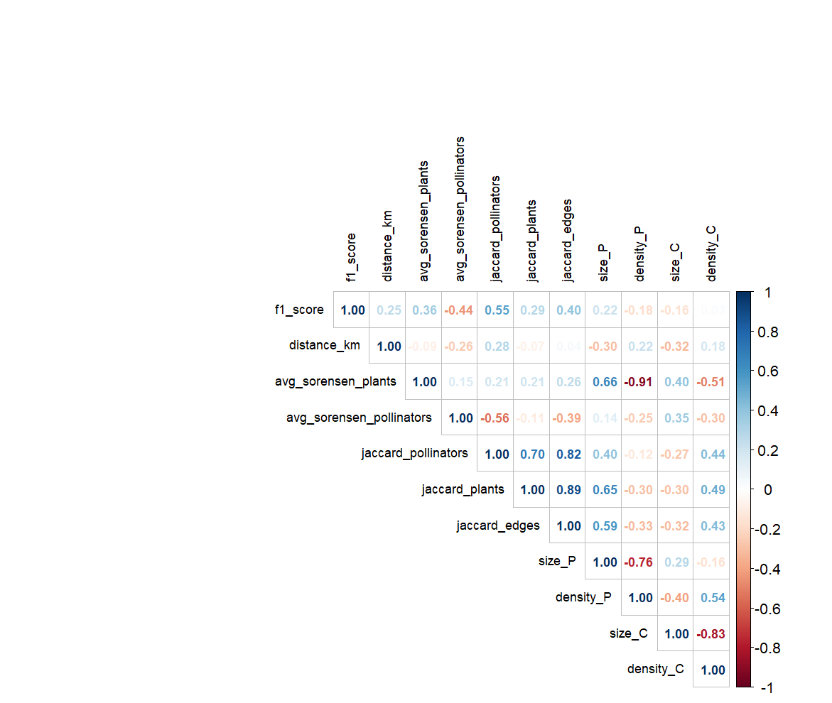
Variable importance
Netsize and density were tested for 1 off-diagonal, hence variable importance was analyzed for this off-diagonal.

Island scale -

Linear model:

Call:
lm(formula = f1_score ~ distance_km + avg_sorensen_plants + avg_sorensen_pollinators +
jaccard_pollinators + jaccard_plants + jaccard_edges + size_P +
density_P + size_C + density_C, data = df)
Residuals:
Min 1Q Median 3Q Max
-0.165530 -0.031493 0.004162 0.043171 0.099709
Coefficients:
Estimate Std. Error t value Pr(>|t|)
(Intercept) 6.214e-02 3.151e-01 0.197 0.8447
distance_km 7.295e-05 1.035e-04 0.705 0.4852
avg_sorensen_plants 1.538e+00 6.859e-01 2.242 0.0309 *
avg_sorensen_pollinators -1.077e-01 2.753e-01 -0.391 0.6978
jaccard_pollinators 3.902e-01 2.514e-01 1.552 0.1289
jaccard_plants 1.449e-01 1.149e-01 1.261 0.2148
jaccard_edges -4.416e-01 2.528e-01 -1.747 0.0888 .
size_P 3.088e-04 1.220e-04 2.531 0.0156 *
density_P 2.466e+00 9.437e-01 2.613 0.0128 *
size_C -1.339e-04 7.886e-05 -1.697 0.0978 .
density_C -2.266e+00 9.115e-01 -2.486 0.0174 *
---
Signif. codes: 0 ‘***’ 0.001 ‘**’ 0.01 ‘*’ 0.05 ‘.’ 0.1 ‘ ’ 1
Residual standard error: 0.06826 on 38 degrees of freedom
Multiple R-squared: 0.3816, Adjusted R-squared: 0.2189
F-statistic: 2.345 on 10 and 38 DF, p-value: 0.02864

Random forest importance:
%IncMSE shows how each variable impacts prediction accuracy, while IncNodePurity (Gini importance) indicates the reduction in node impurities from splitting on that variable.
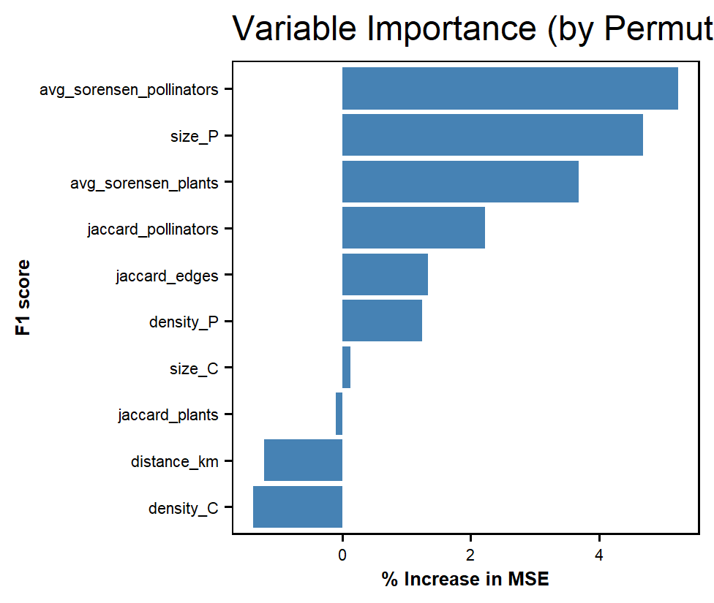
Pca:
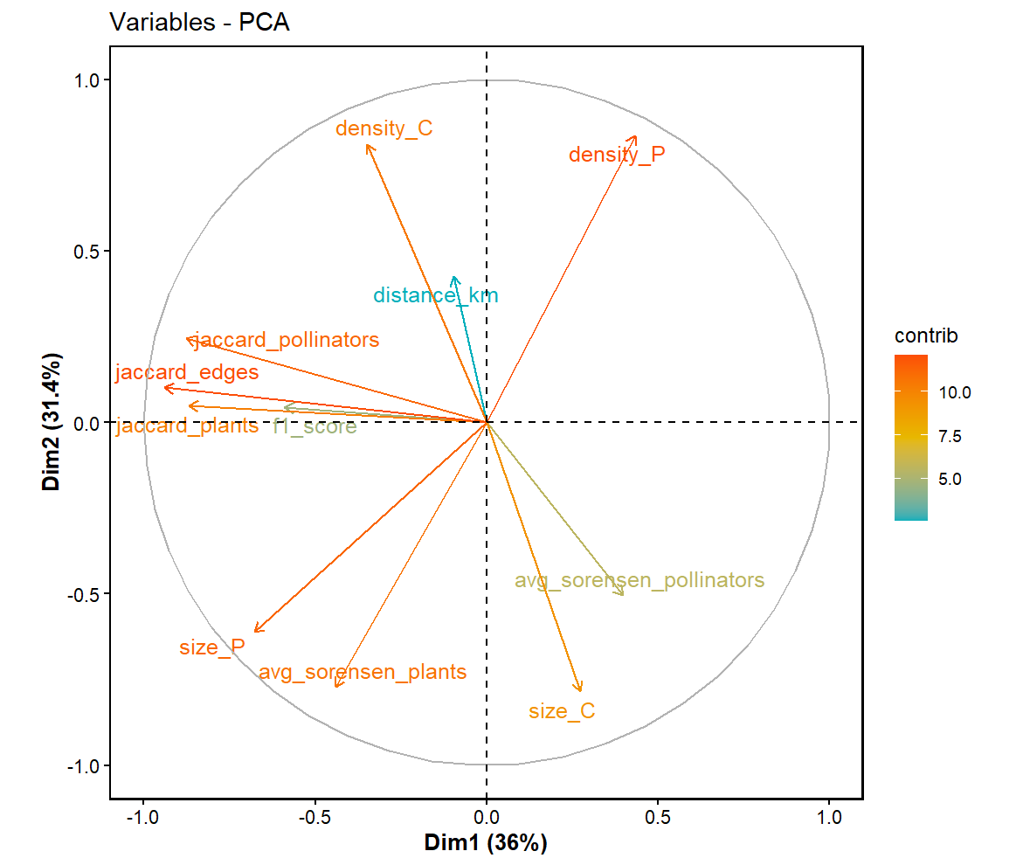

הכללת מידע שונה אך בעל דפוסים עקביים במרחב משפר את היכולת לחזות
אגרגציה משפרת את התחזיות

