CO2 Adapters — WVS Wave 7 Option-Distribution Grids
Target population (blue) vs adapter (orange) response distributions per question, grouped by GPS dimension. Base model: Llama-3.1-8B-Instruct + QLoRA-DPO adapter per country. Unconditioned prompting (anti-leakage): each adapter emits a single fixed distribution, scored against each country's survey-weighted population.

IND_adapter on IND — matched TVD 0.511 (base 0.494, Δ -0.017)
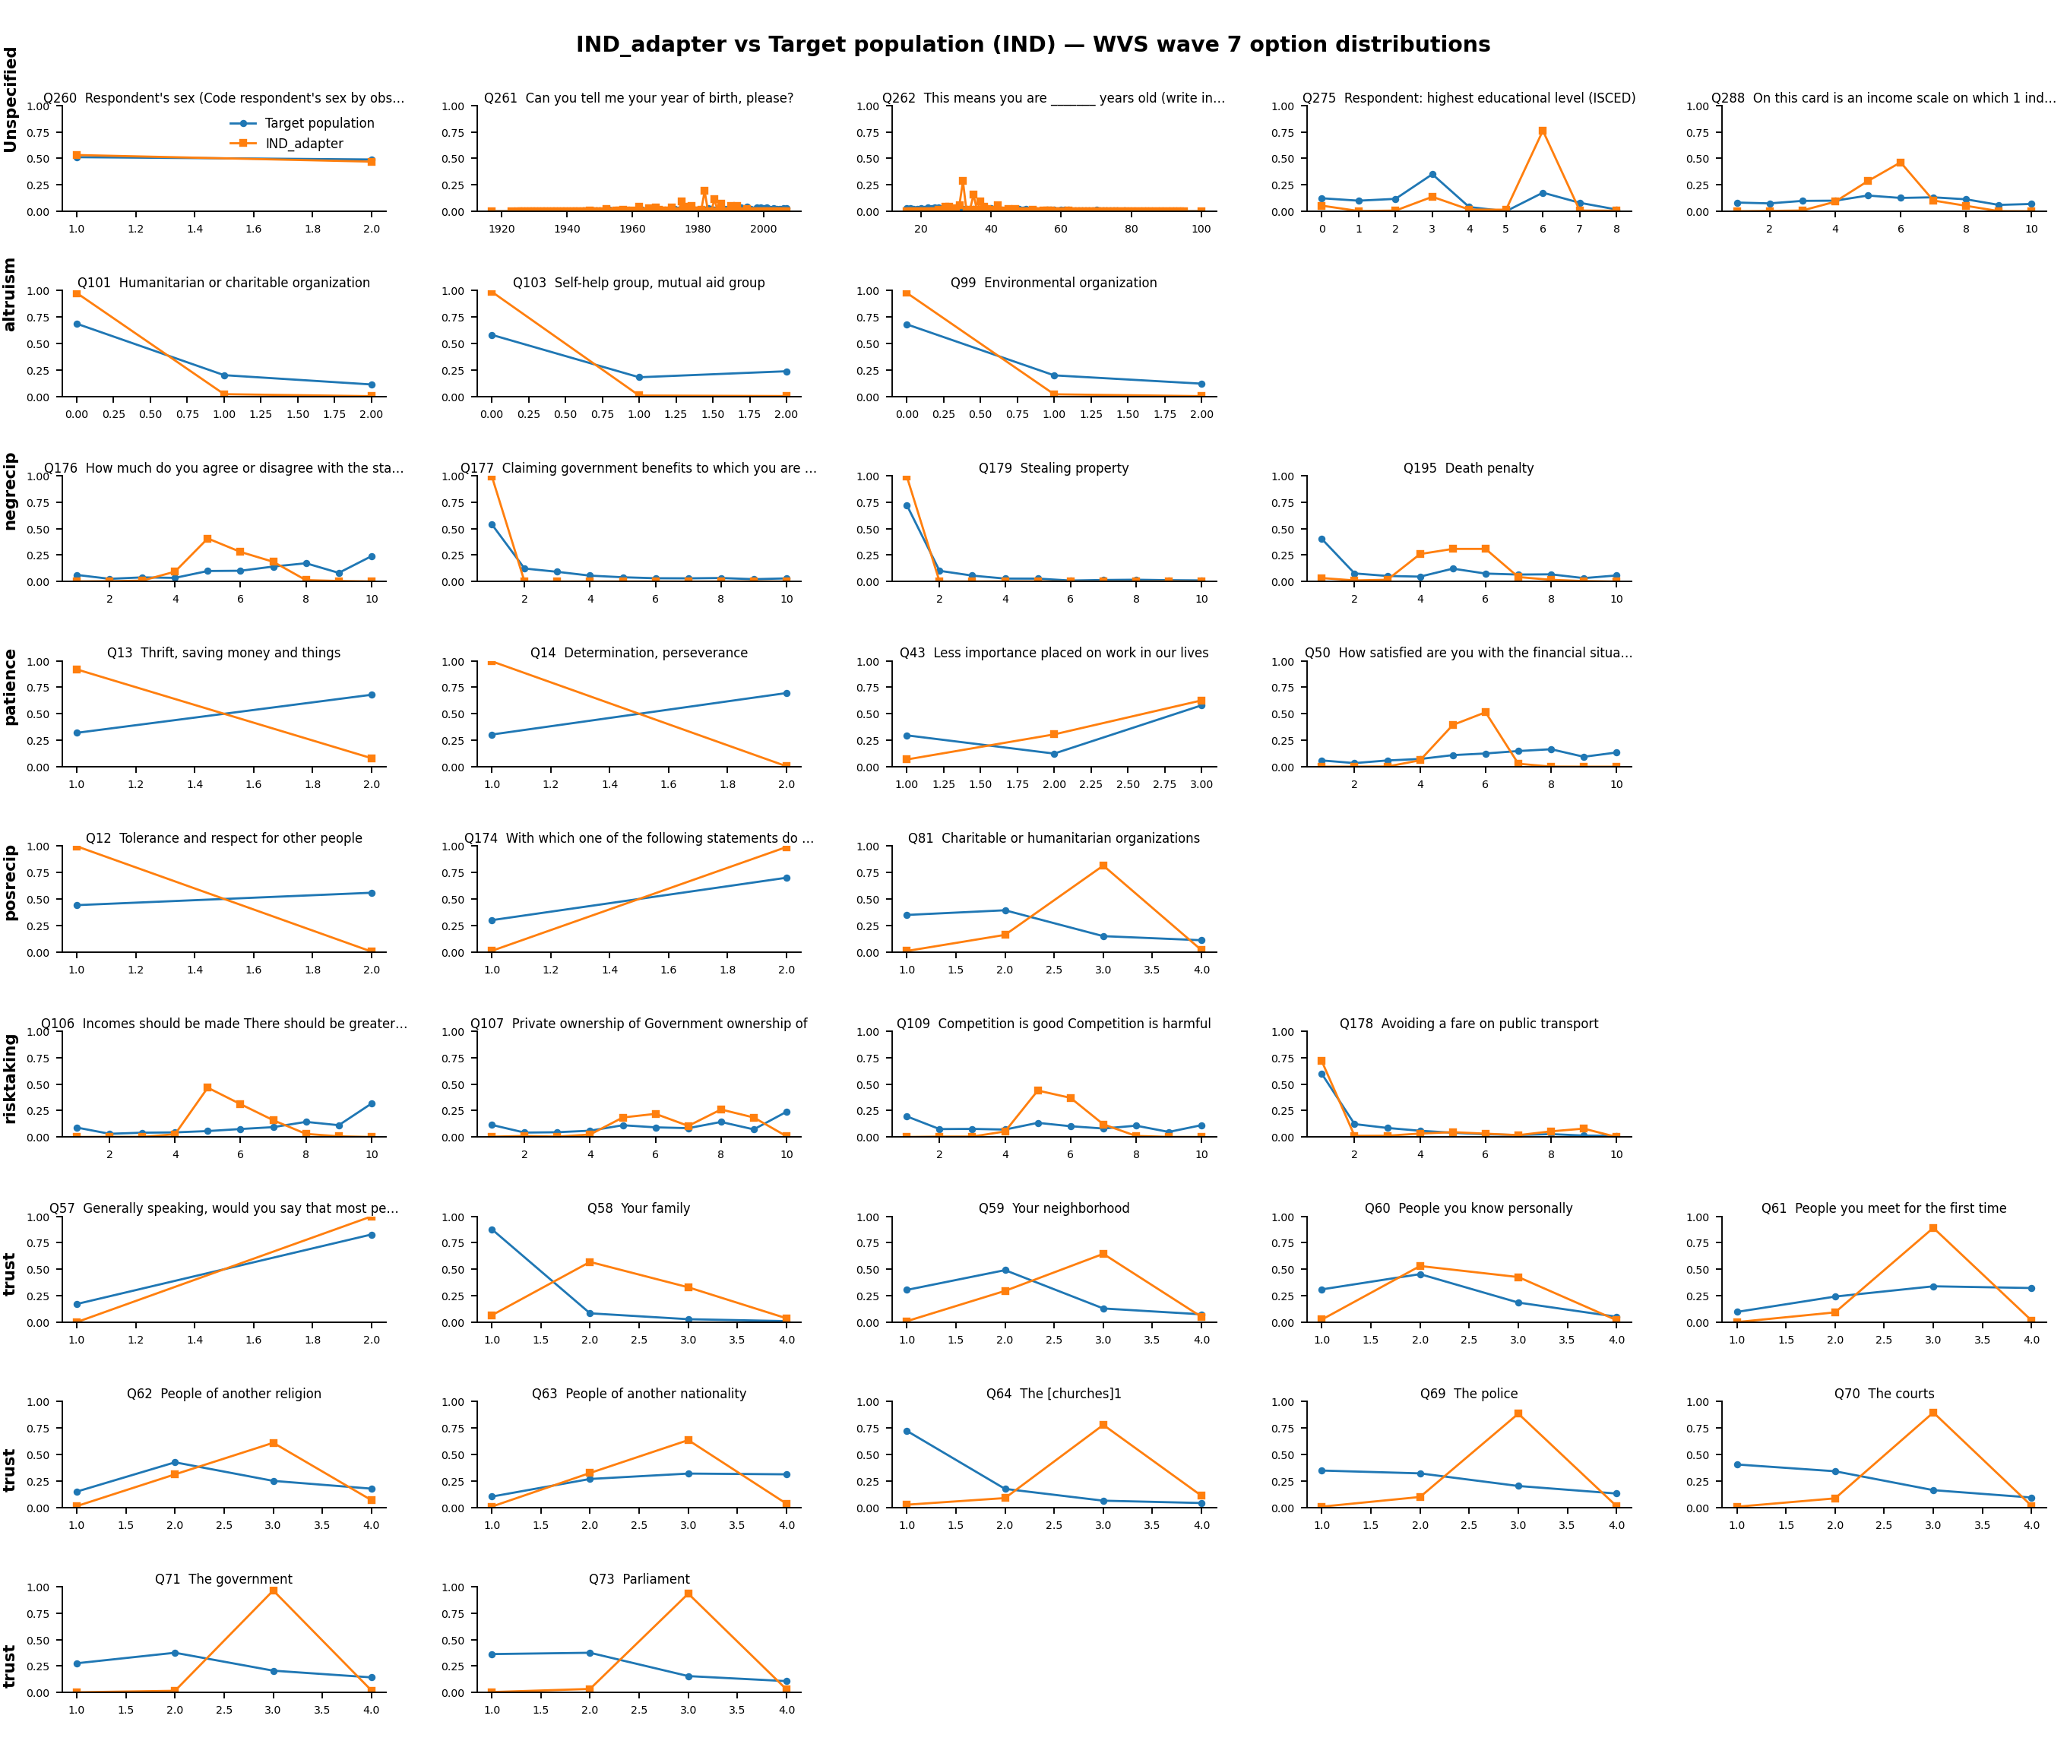

IDN_adapter on IDN — matched TVD 0.574 (base 0.517, Δ -0.056)
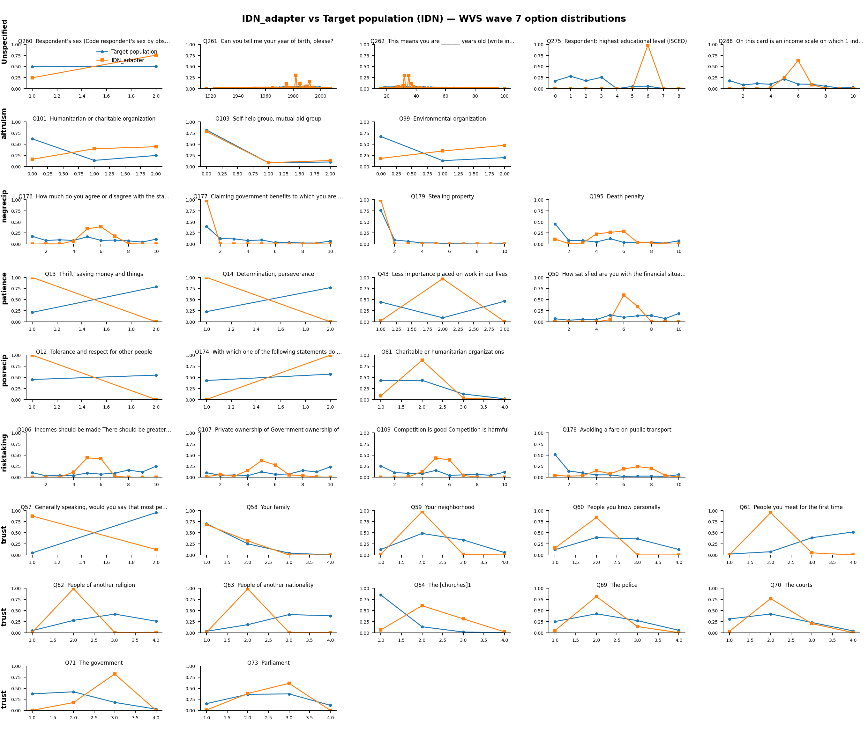

NGA_adapter on NGA — matched TVD 0.495 (base 0.515, Δ +0.019)
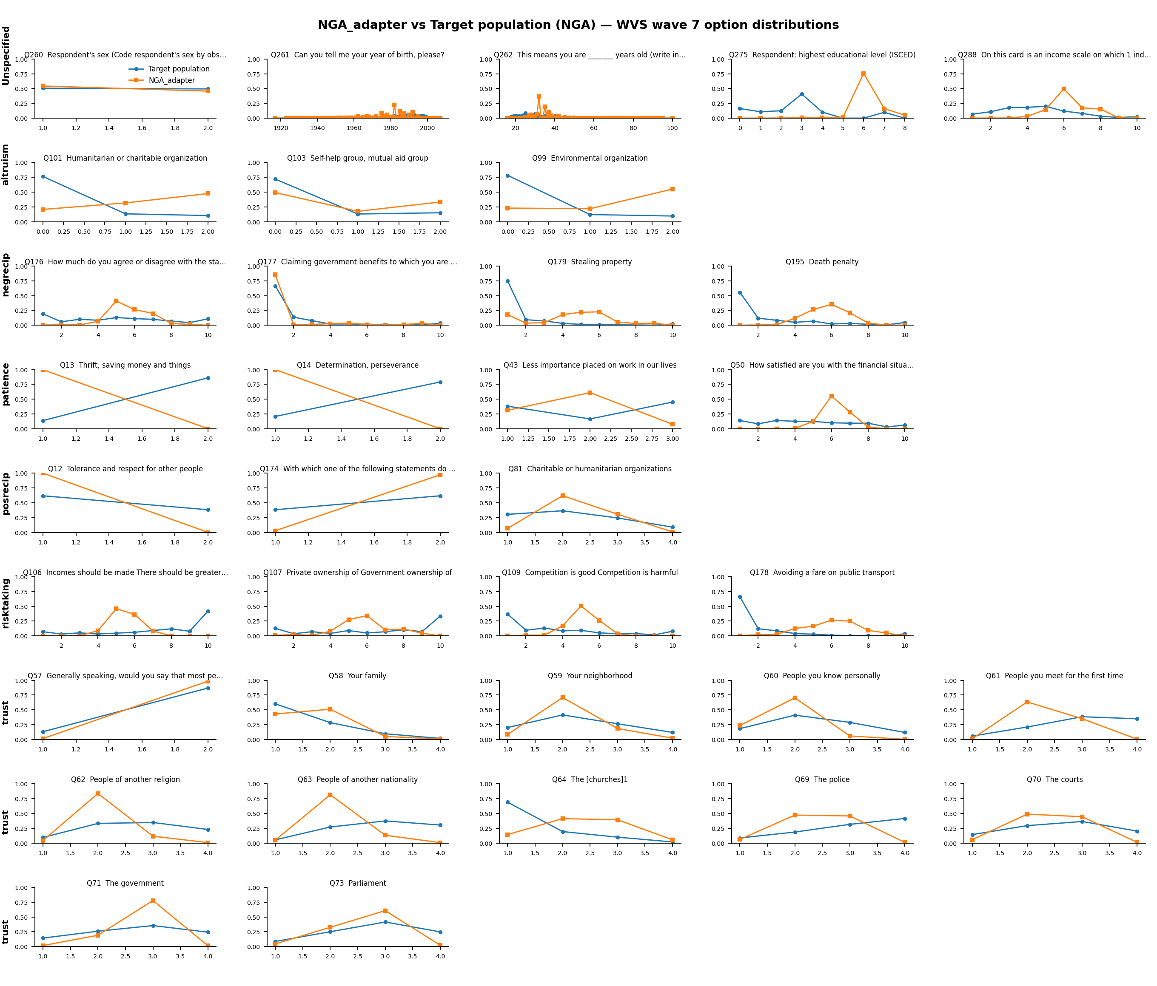

EGY_adapter on EGY — matched TVD 0.577 (base 0.532, Δ -0.046)
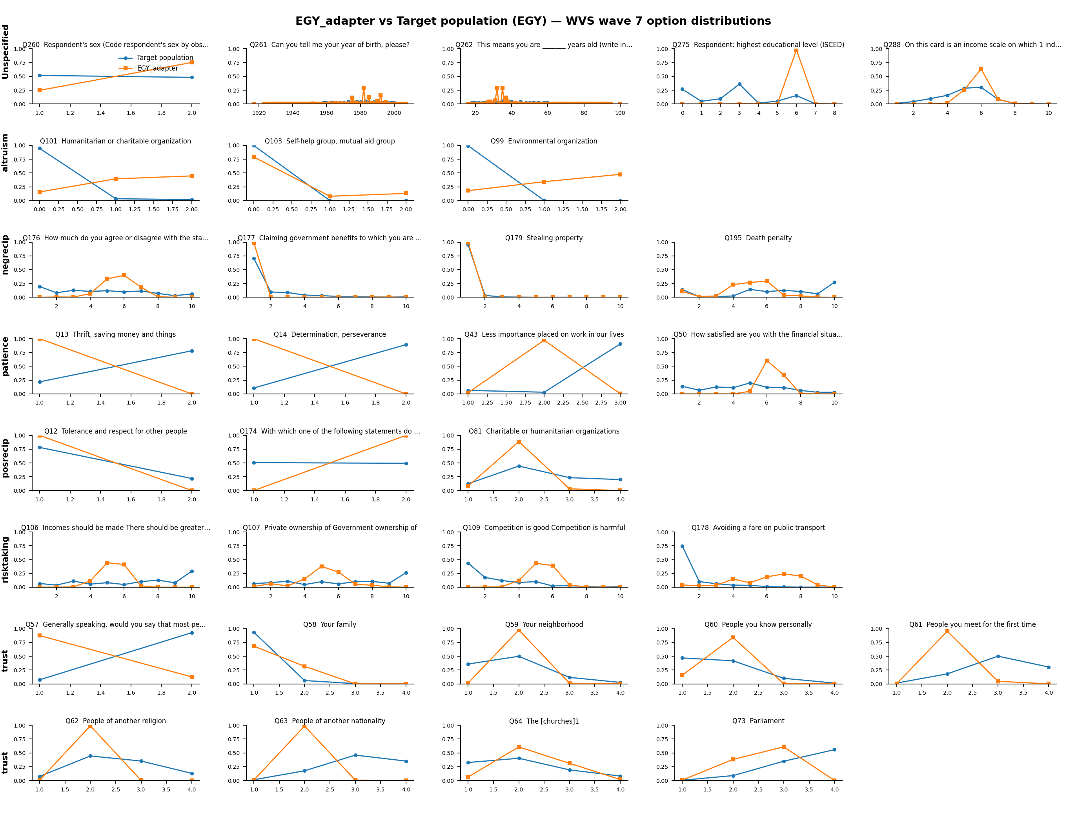

TUR_adapter on TUR — matched TVD 0.464 (base 0.446, Δ -0.018)
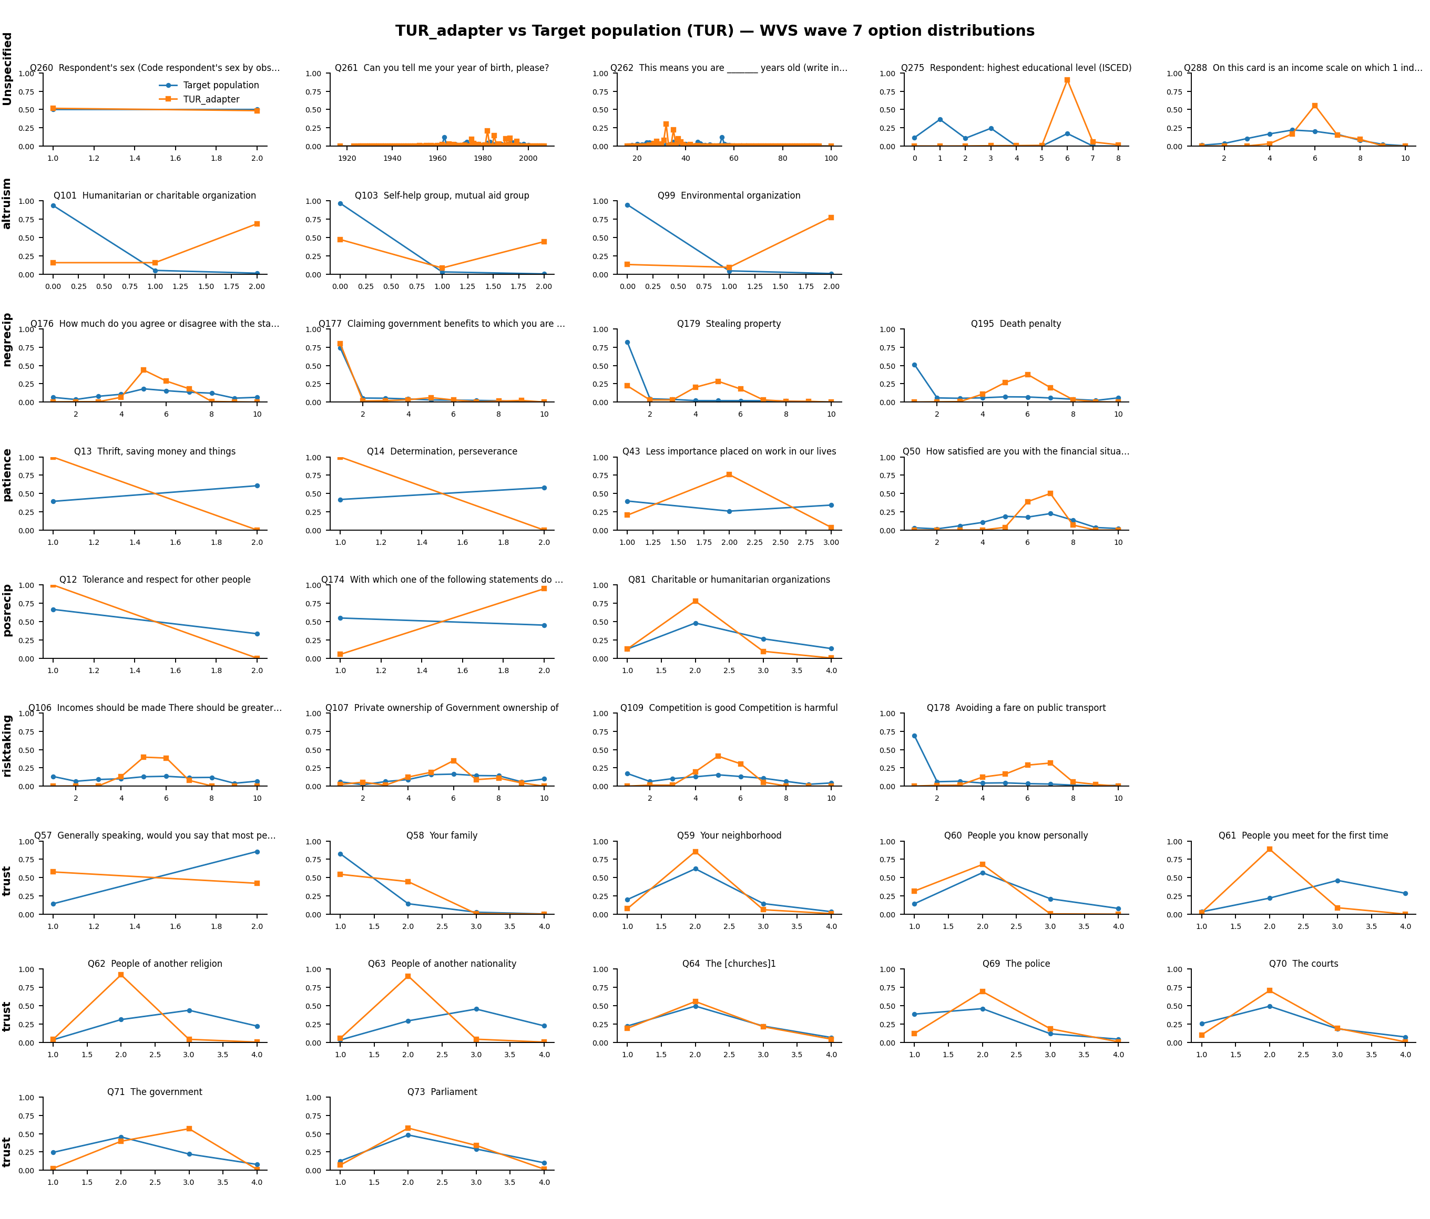

NLD_adapter on NLD — matched TVD 0.504 (base 0.411, Δ -0.093)
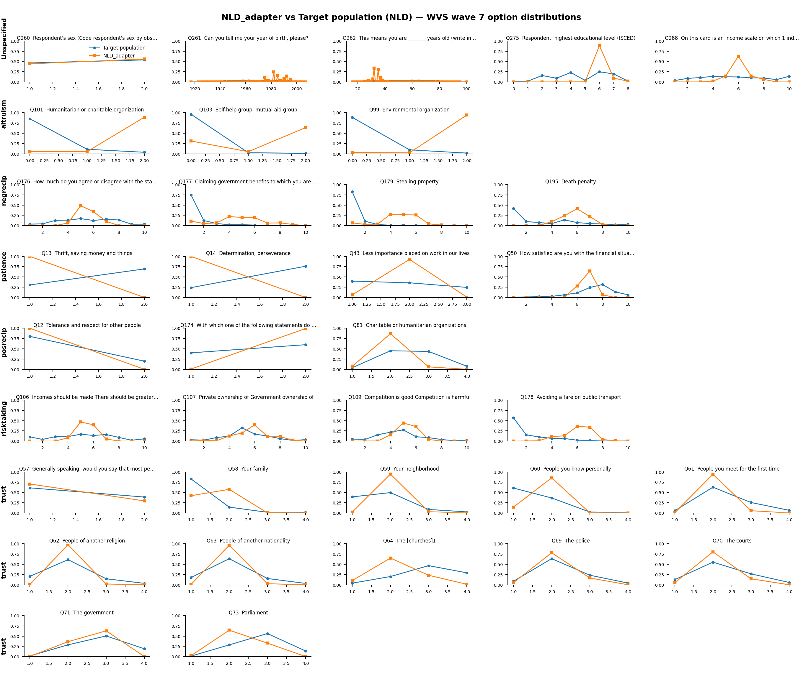

BRA_adapter on BRA — matched TVD 0.478 (base 0.486, Δ +0.008)
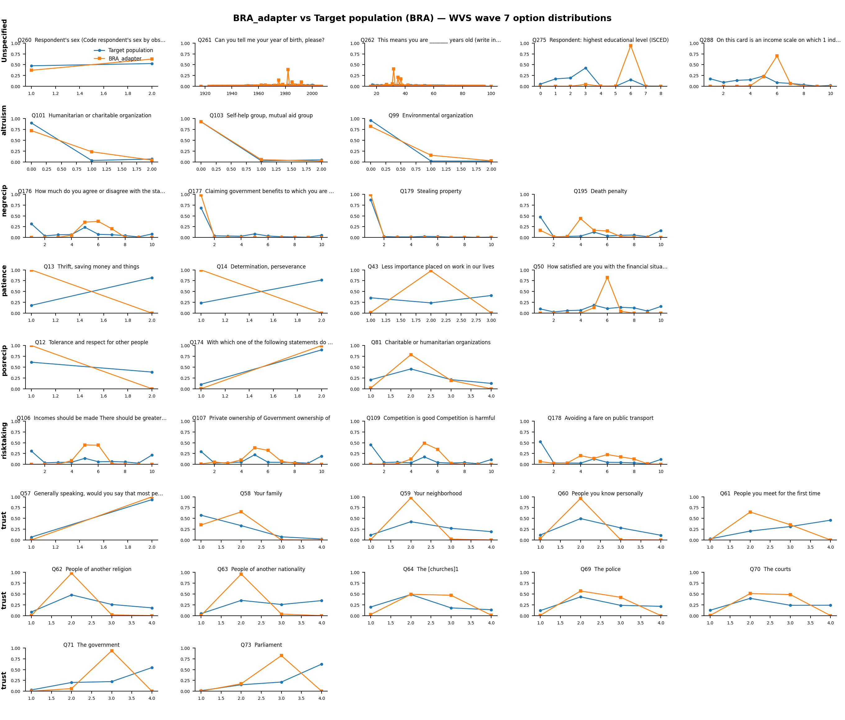

GRC_adapter on GRC — matched TVD 0.404 (base 0.479, Δ +0.075)
